UNITED STATES

SECURITIES AND EXCHANGE COMMISSION

Washington, D.C. 20549

SCHEDULE 14A

PROXY STATEMENT PURSUANT TO SECTION 14(a) OF THE SECURITIES

EXCHANGE ACT OF 1934

(Amendment No. )

Filed by the Registrant Filed by a Party other than the Registrant
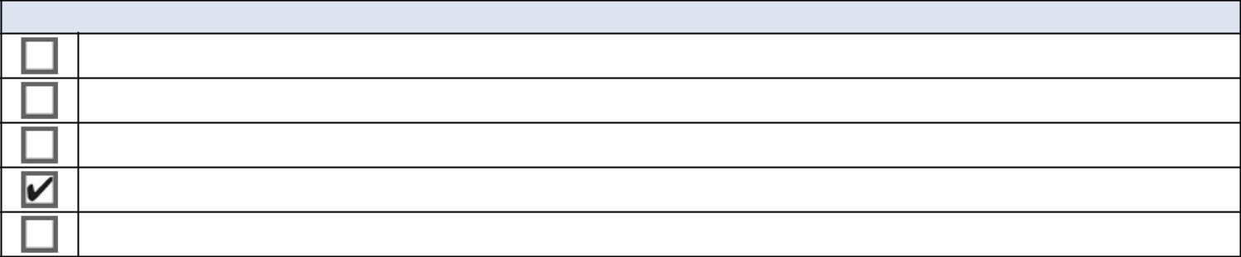

Check the appropriate box:

Preliminary Proxy Statement

Confidential, for Use of the Commission Only (as permitted by Rule 14A-6(E)(2))

Definitive Proxy Statement

Definitive Additional Materials

Soliciting Material under §240.14a-12

Amneal Pharmaceuticals, Inc.

(Name of Registrant as Specified in Its Charter)

(Name of Person(s) Filing Proxy Statement, if other than the Registrant)
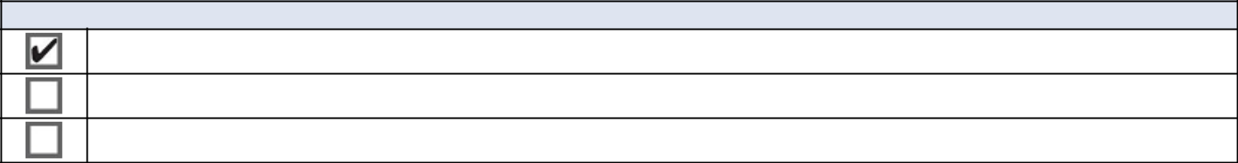

Payment of Filing Fee (Check all boxes that apply):

No fee required.

Fee paid previously with preliminary materials.

Fee computed on table in exhibit required by Item 25(b) per Exchange Act Rules 14a-6(i)(1) and 0-11.

