SEC Form 4

FORM 4

Check this box if no longer subject
- to Section 16. Form 4 or Form 5 obligations may continue. See Instruction 1(b).

UNITED STATES SECURITIES AND EXCHANGE COMMISSION
Washington, D.C. 20549
 |  | OMB APPROVAL
STATEMENT OF CHANGES IN BENEFICIAL OWNERSHIP
 |  | OMB Number: | 3235-0287
 |  | Estimated average burden
Filed pursuant to Section 16(a) of the Securities Exchange Act of 1934 |  | hours per response: | 0.5
or Section 30(h) of the Investment Company Act of 1940
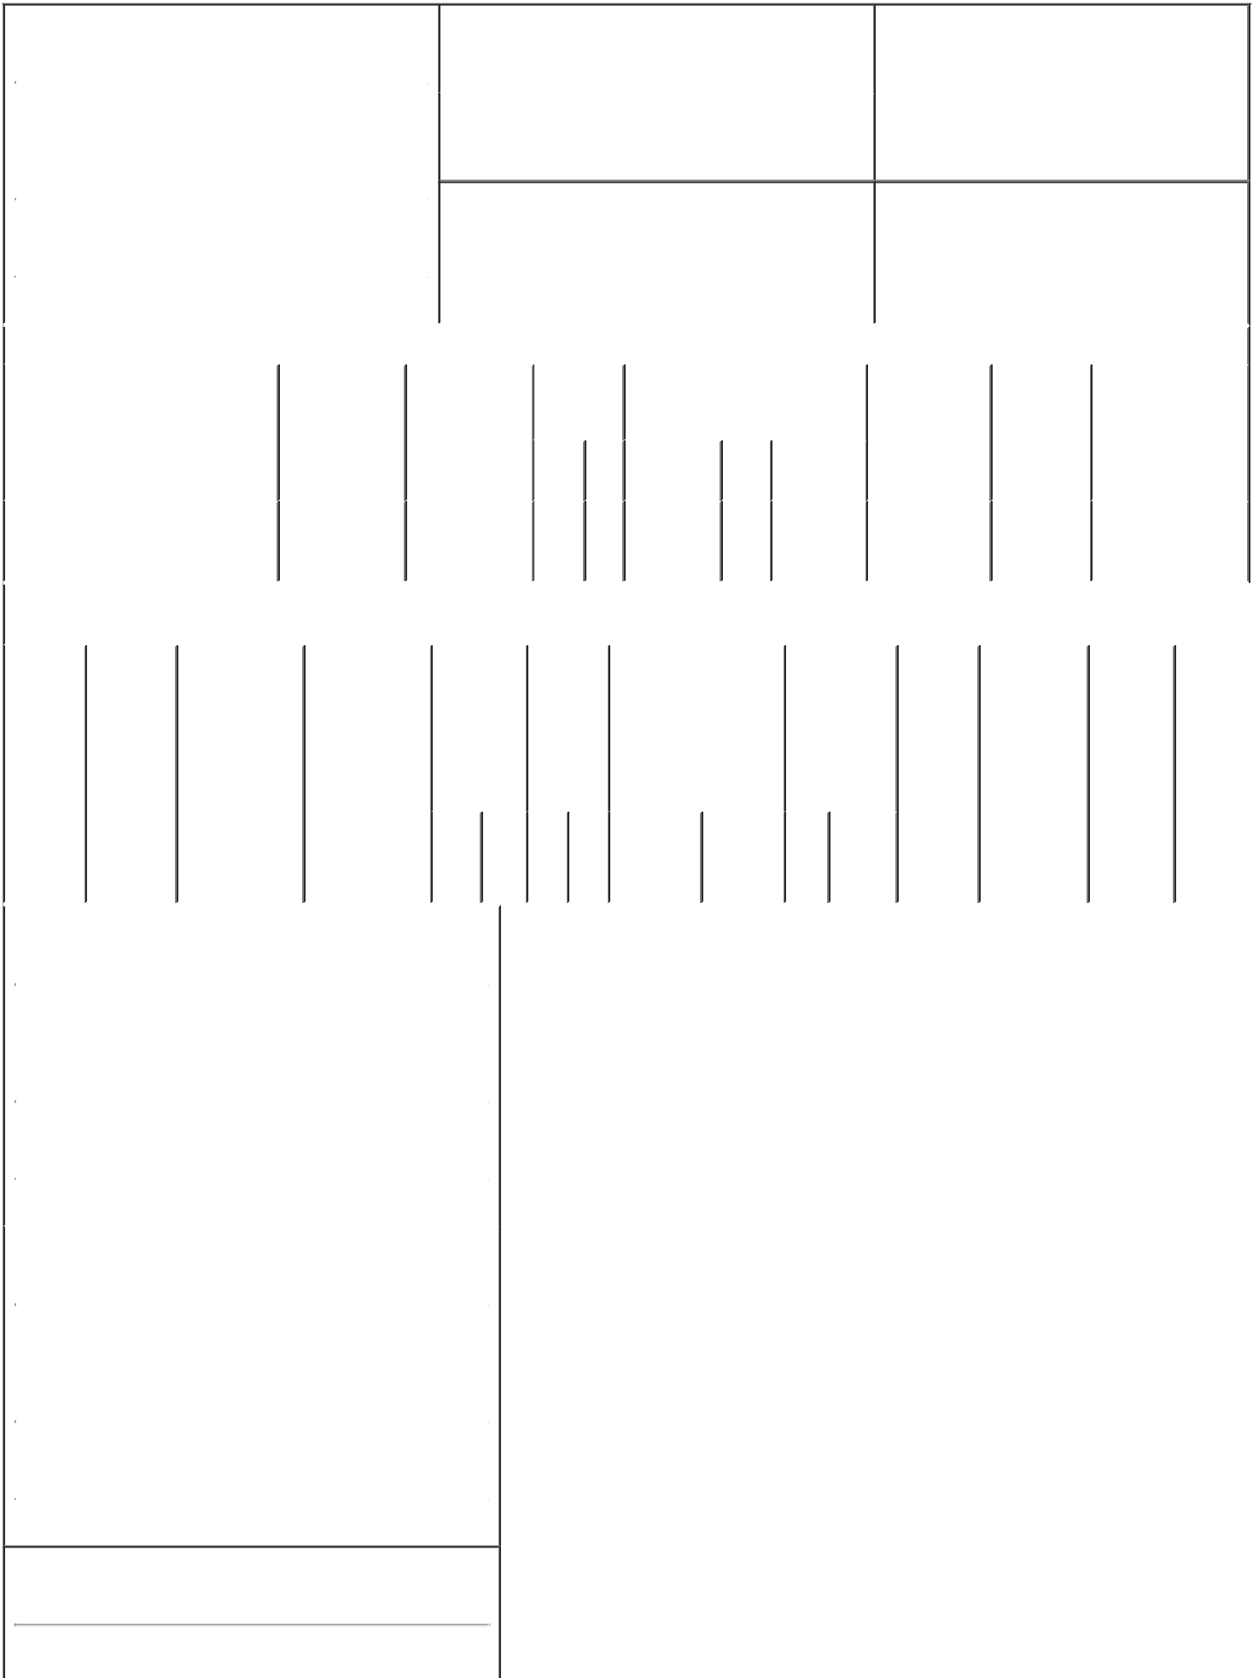

1. Name and Address of Reporting Person* |  |  |  |  |  |  | 2. Issuer Name and Ticker or Trading Symbol
 | TPG GP A, LLC |  |  |  |  |  | Amneal Pharmaceuticals, Inc. [ AMRX ]
 | (Last) | (First) |  | (Middle) |  |  | 3. Date of Earliest Transaction (Month/Day/Year)
 | C/O TPG INC. |  |  |  | 12/12/2022

301 COMMERCE STREET, SUITE 3300

- Relationship of Reporting Person(s) to Issuer (Check all applicable)

Director |  | 10% Owner
Officer (give title | X | Other (specify
below) |  | below)

Former 10% Owner

 |  |  |  |  |  |  |  |  |  | 4. If Amendment, Date of Original Filed (Month/Day/Year) |  |  |  |  |  |  |  |  | 6. Individual or Joint/Group Filing (Check Applicable
 | (Street) |  |  |  |  |  |  |  |  |  |  |  |  |  |  |  |  |  | Line)
 |  |  |  |  |  |  |  |  |  |  |  |  |  |  |  |  |  |  |  |  | Form filed by One Reporting Person
 |  | FORT WORTH TX |  |  |  |  | 76102
 |  |  |  |  |  |  |  |  |  |  |  |  |  |  |  |  |  |  |  | X | Form filed by More than One Reporting
 |  |  |  |  |  |  |  |  |  |  |  |  |  |  |  |  |  |  |  |  | Person
 |  | (City) | (State) |  |  |  | (Zip)
 |  |  |  |  | Table I - Non-Derivative Securities Acquired, Disposed of, or Beneficially Owned
 | 1. Title of Security (Instr. 3) |  |  |  |  |  | 2. Transaction | 2A. Deemed |  |  |  |  |  | 3. |  | 4. Securities Acquired (A) or |  |  | 5. Amount of |  |  | 6. | 7. Nature of Indirect
 |  |  |  |  |  |  | Date | Execution Date, |  |  |  |  |  | Transaction Disposed Of (D) (Instr. 3, 4 and 5) |  |  |  |  | Securities |  |  | Ownership | Beneficial Ownership
 |  |  |  |  |  |  | (Month/Day/Year) | if any |  |  |  |  |  | Code (Instr. |  |  |  |  | Beneficially |  |  | Form: Direct | (Instr. 4)
 |  |  |  |  |  |  |  | (Month/Day/Year) |  |  |  |  |  | 8) |  |  |  |  | Owned |  |  | (D) or
 |  |  |  |  |  |  |  |  |  |  |  |  |  |  |  |  |  |  | Following |  |  | Indirect (I)
 |  |  |  |  |  |  |  |  |  |  |  |  |  |  |  |  | (A) |  | Reported |  |  | (Instr. 4)
 |  |  |  |  |  |  |  |  |  |  |  |  |  | Code | V | Amount | or | Price | Transaction(s)
 |  |  |  |  |  |  |  |  |  |  |  |  |  |  |  |  | (D) |  | (Instr. 3 and 4)
 | Class A Common Stock |  |  |  |  |  | 12/12/2022 |  |  |  |  |  |  |  |  | 3,884,600 D |  | $2.3414⁽³⁾ | 12,328,767 |  |  | I | See Explanation
 |  |  |  |  |  |  |  |  |  |  |  |  |  | S |  |  |  |  |  |  |  |  | of Responses⁽¹⁾⁽²⁾
 |  |  |  |  |  |  |  |  |  |  |  |  |  |  |  |  |  |  |  |  |  |  | (4)(5)
 |  |  |  |  |  |  | Table II - Derivative Securities Acquired, Disposed of, or Beneficially Owned
 |  |  |  |  |  |  | (e.g., puts, calls, warrants, options, convertible securities)
 | 1. Title of |  | 2. |  | 3. Transaction |  | 3A. Deemed |  | 4. |  |  |  |  | 5. Number |  | 6. Date Exercisable and |  | 7. Title and |  | 8. Price of |  | 9. Number of | 10. | 11. Nature
 | Derivative |  | Conversion |  | Date |  | Execution Date, |  |  | Transaction |  |  |  | of |  | Expiration Date |  | Amount of |  | Derivative |  | derivative | Ownership | of Indirect
 | Security |  | or Exercise |  | (Month/Day/Year) if any |  |  |  |  | Code (Instr. |  |  |  | Derivative |  | (Month/Day/Year) |  | Securities |  | Security |  | Securities | Form: | Beneficial
 | (Instr. 3) |  | Price of |  |  |  | (Month/Day/Year) |  | 8) |  |  |  |  | Securities |  |  |  | Underlying |  | (Instr. 5) |  | Beneficially | Direct (D) | Ownership
 |  |  | Derivative |  |  |  |  |  |  |  |  |  |  | Acquired |  |  |  | Derivative |  |  |  | Owned | or Indirect | (Instr. 4)
 |  |  | Security |  |  |  |  |  |  |  |  |  |  | (A) or |  |  |  | Security (Instr. |  |  |  | Following | (I) (Instr. 4)
 |  |  |  |  |  |  |  |  |  |  |  |  |  | Disposed |  |  |  | 3 and 4) |  |  |  | Reported
 |  |  |  |  |  |  |  |  |  |  |  |  |  | of (D) |  |  |  |  |  |  |  | Transaction(s)
 |  |  |  |  |  |  |  |  |  |  |  |  |  | (Instr. 3, 4 |  |  |  |  |  |  |  | (Instr. 4)
 |  |  |  |  |  |  |  |  |  |  |  |  |  | and 5)
 |  |  |  |  |  |  |  |  |  |  |  |  |  |  |  |  |  | Amount
 |  |  |  |  |  |  |  |  |  |  |  |  |  |  |  |  |  | or
 |  |  |  |  |  |  |  |  |  |  |  |  |  |  |  |  |  | Number
 |  |  |  |  |  |  |  |  |  |  |  |  |  |  |  | Date | Expiration | of
 |  |  |  |  |  |  |  |  |  | Code V |  |  |  | (A) | (D) | Exercisable | Date | Title Shares
 | 1. Name and Address of Reporting Person*
 |  | TPG GP A, LLC
 |  | (Last) |  | (First) |  |  | (Middle)
 |  | C/O TPG INC.
 |  | 301 COMMERCE STREET, SUITE 3300
 | (Street)
 |  | FORT WORTH |  | TX |  |  | 76102
 |  | (City) |  | (State) |  |  | (Zip)
 | 1. Name and Address of Reporting Person*
 |  | BONDERMAN DAVID
 |  | (Last) |  | (First) |  |  | (Middle)
 |  | C/O TPG INC.
 |  | 301 COMMERCE STREET, SUITE 3300
 | (Street)
 |  | FORT WORTH |  | TX |  |  | 76102
 |  | (City) |  | (State) |  |  | (Zip)

1. Name and Address of Reporting Person*
COULTER JAMES G

(Last) (First) (Middle)

C/O TPG INC.

301 COMMERCE STREET, SUITE 3300

(Street)
 | FORT WORTH | TX |  | 76102
 | (City) | (State) |  | (Zip)
1. Name and Address of Reporting Person*
 | WINKELRIED JON
 | (Last) | (First) |  | (Middle)
 | C/O TPG INC.
 | 301 COMMERCE STREET, SUITE 3300
(Street)
 | FORT WORTH | TX |  | 76102
 | (City) | (State) |  | (Zip)

Explanation of Responses:

- Each of David Bonderman, James G. Coulter and Jon Winkelried own entities that own TPG GP A, LLC (together with Messrs. Bonderman, Coulter and Winkelried, the "Reporting Persons"), which is the managing member of TPG Group Holdings (SBS) Advisors, LLC, which is the general partner of TPG Group Holdings (SBS), L.P., which holds 100% of the shares of Class B common stock (which represents a majority of the combined voting power of the common stock) of TPG Inc., which is the controlling shareholder of TPG GPCo, LLC, which is the managing member of each of (i) TPG Holdings I-A, LLC and (ii) TPG Holdings III-A, LLC. TPG Holdings I-A, LLC is the general partner of TPG Operating Group I, L.P., which is the sole member of TPG GenPar VII Advisors, LLC, which is the general partner of TPG GenPar VII, L.P., which is the general partner of TPG Improv Holdings, L.P., which directly holds 12,328,767 shares of Class A common stock ("Class A Shares") of Amneal Pharmaceuticals, Inc. (the "Issuer").

- TPG Holdings III-A, LLC is the general partner of TPG Holdings III-A, L.P., which is the general partner of TPG Operating Group III, L.P., which is general partner of TPG PEP GenPar Advisors, L.P., which is the general partner of TPG PEP GenPar Governance, L.P., which is the general partner of each of (i) TPG Public Equity Partners, LP, which directly held Class A Shares, and (ii) TPG Public Equity Partners Master Fund, L.P. (together with TPG Improv Holdings, L.P. and TPG Public Equity Partners, LP, the "TPG Funds"), which directly held Class A Shares.

- The price reported in Column 4 is a weighted average price. These shares were sold in multiple transactions at prices ranging from $2.34 to $2.465, inclusive. The Reporting Persons undertake to provide to the Issuer, any security holder of the Issuer, or the staff of the Securities and Exchange Commission (the "Commission"), upon request, full information regarding the number of shares sold at each separate price within the range set forth above.

- Because of the relationship between the Reporting Persons and the TPG Funds, the Reporting Persons may be deemed to beneficially own the securities reported herein to the extent of the greater of their respective direct or indirect pecuniary interests in the profits or capital accounts of the TPG Funds. Each of the TPG Funds and each Reporting Person disclaims beneficial ownership of the securities reported herein, except to the extent of the TPG Fund's or such Reporting Person's pecuniary interest therein, if any.

- Pursuant to Rule 16a-1(a)(4) under the Exchange Act, this filing shall not be deemed an admission that the Reporting Persons are, for purposes of Section 16 of the Securities Exchange Act of 1934, as amended (the "Exchange Act") or otherwise, the beneficial owners of any equity securities in excess of their respective pecuniary interests.

Remarks:

- The Reporting Persons are jointly filing this Form 4 pursuant to Rule 16a-3(j) under the Exchange Act. 7. Gerald Neugebauer is signing on behalf of both Messrs. Bonderman and Coulter pursuant to authorization and designation letters dated February 26, 2020, which were previously filed with the Commission. 8. Gerald Neugebauer is signing on behalf of Mr. Winkelried pursuant to the authorization and designation letter dated October 12, 2020, which was previously filed with the Commission.

/s/ Bradford Berenson,

General Counsel, TPG GP A, 12/14/2022
LLC (6)

/s/ Gerald Neugebauer, on

behalf of David Bonderman 12/14/2022
(6) (7)

/s/ Gerald Neugebauer, on

behalf of James G. Coulter (6) 12/14/2022
(7)

/s/ Gerald Neugebauer, on

behalf of Jon Winkelried (6) 12/14/2022
(8)

** Signature of Reporting Person Date

Reminder: Report on a separate line for each class of securities beneficially owned directly or indirectly.

* If the form is filed by more than one reporting person, see Instruction 4 (b)(v).

- Intentional misstatements or omissions of facts constitute Federal Criminal Violations See 18 U.S.C. 1001 and 15 U.S.C. 78ff(a). Note: File three copies of this Form, one of which must be manually signed. If space is insufficient, see Instruction 6 for procedure.

Persons who respond to the collection of information contained in this form are not required to respond unless the form displays a currently valid OMB Number.

