SEC Form 4

FORM 4

Check this box if no longer subject to Section 16. Form 4 or Form 5 obligations may continue. See Instruction 1(b).

UNITED STATES SECURITIES AND EXCHANGE COMMISSION
Washington, D.C. 20549
 |  | OMB APPROVAL
STATEMENT OF CHANGES IN BENEFICIAL OWNERSHIP
 |  | OMB Number: | 3235-0287
 |  | Estimated average burden
Filed pursuant to Section 16(a) of the Securities Exchange Act of 1934 |  | hours per response: | 0.5
or Section 30(h) of the Investment Company Act of 1940
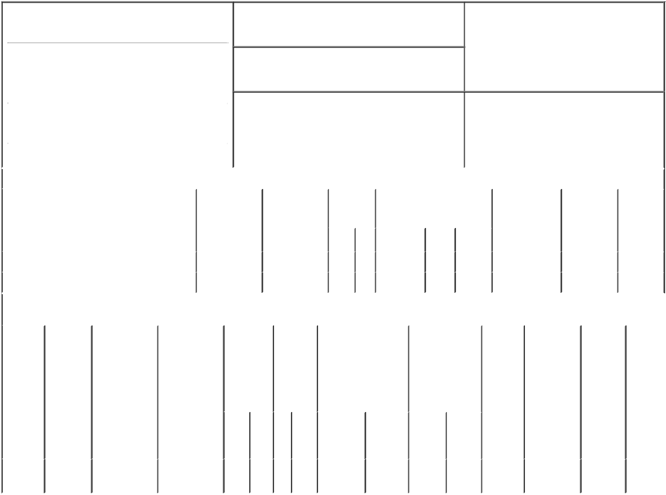

1. Name and Address of Reporting Person*
Todisco Joseph

(Last) (First) (Middle)

C/O AMNEAL PHARMACEUTICALS, INC. 400 CROSSING BOULEVARD

2. Issuer Name and Ticker or Trading Symbol

Amneal Pharmaceuticals, Inc. [ AMRX ]

3. Date of Earliest Transaction (Month/Day/Year)
05/07/2021

- Relationship of Reporting Person(s) to Issuer (Check all applicable)

 | Director | 10% Owner
X | Officer (give title | Other (specify
 | below) | below)

Executive Vice President

 |  |  |  |  |  |  | 4. If Amendment, Date of Original Filed (Month/Day/Year) |  |  |  |  |  |  |  |  | 6. Individual or Joint/Group Filing (Check Applicable
 | (Street) |  |  |  |  |  |  |  |  |  |  |  |  |  |  | Line)
 |  |  |  |  |  |  |  |  |  |  |  |  |  |  |  | X Form filed by One Reporting Person
 |  | BRIDGEWATER NJ |  |  | 08807
 |  |  |  |  |  |  |  |  |  |  |  |  |  |  |  |  |  |  | Form filed by More than One Reporting
 |  |  |  |  |  |  |  |  |  |  |  |  |  |  |  |  |  |  | Person
 |  | (City) | (State) |  | (Zip)
 |  |  |  | Table I - Non-Derivative Securities Acquired, Disposed of, or Beneficially Owned
 | 1. Title of Security (Instr. 3) |  |  |  | 2. Transaction |  |  | 2A. Deemed |  | 3. |  |  | 4. Securities Acquired (A) or |  |  |  |  |  | 5. Amount of |  | 6. Ownership |  | 7. Nature
 |  |  |  |  | Date |  |  | Execution Date, |  |  | Transaction |  | Disposed Of (D) (Instr. 3, 4 and |  |  |  |  |  | Securities |  | Form: Direct |  | of Indirect
 |  |  |  |  | (Month/Day/Year) |  |  | if any |  |  | Code (Instr. |  | 5) |  |  |  |  |  | Beneficially |  | (D) or Indirect |  | Beneficial
 |  |  |  |  |  |  |  | (Month/Day/Year) 8) |  |  |  |  |  |  |  |  |  |  | Owned Following |  | (I) (Instr. 4) |  | Ownership
 |  |  |  |  |  |  |  |  |  |  |  |  |  |  |  |  |  |  | Reported |  |  |  | (Instr. 4)
 |  |  |  |  |  |  |  |  |  |  | Code V |  | Amount |  | (A) or | Price |  |  | Transaction(s)
 |  |  |  |  |  |  |  |  |  |  |  |  |  |  | (D) |  |  |  | (Instr. 3 and 4)
 | Class A Common Stock |  |  |  | 05/07/2021 |  |  |  |  |  | M |  | 4,441⁽¹⁾ |  | A | (2) |  | 284,381 |  |  |  | D
 | Class A Common Stock |  |  |  | 05/07/2021 |  |  |  |  |  | F |  | 1,562⁽³⁾ |  | D | $5.2 |  | 282,819 |  |  |  | D
 |  |  |  | Table II - Derivative Securities Acquired, Disposed of, or Beneficially Owned
 |  |  |  |  | (e.g., puts, calls, warrants, options, convertible securities)
 | 1. Title of |  | 2. | 3. Transaction | 3A. Deemed |  | 4. |  | 5. Number | 6. Date Exercisable and |  |  |  | 7. Title and |  |  |  | 8. Price of |  | 9. Number of |  | 10. | 11. Nature
 | Derivative |  | Conversion | Date | Execution Date, |  | Transaction |  | of | Expiration Date |  |  |  | Amount of |  |  |  | Derivative |  | derivative |  | Ownership | of Indirect
 | Security |  | or Exercise | (Month/Day/Year) | if any |  | Code (Instr. |  | Derivative | (Month/Day/Year) |  |  |  | Securities |  |  |  | Security |  | Securities |  | Form: | Beneficial
 | (Instr. 3) |  | Price of |  | (Month/Day/Year) |  | 8) |  | Securities |  |  |  |  | Underlying |  |  |  | (Instr. 5) |  | Beneficially |  | Direct (D) | Ownership
 |  |  | Derivative |  |  |  |  |  | Acquired |  |  |  |  | Derivative Security |  |  |  |  |  | Owned |  | or Indirect | (Instr. 4)
 |  |  | Security |  |  |  |  |  | (A) or |  |  |  |  | (Instr. 3 and 4) |  |  |  |  |  | Following |  | (I) (Instr. 4)
 |  |  |  |  |  |  |  |  | Disposed |  |  |  |  |  |  |  |  |  |  | Reported
 |  |  |  |  |  |  |  |  | of (D) |  |  |  |  |  |  |  |  |  |  | Transaction(s)
 |  |  |  |  |  |  |  |  | (Instr. 3, 4 |  |  |  |  |  |  |  |  |  |  | (Instr. 4)
 |  |  |  |  |  |  |  |  | and 5)
 |  |  |  |  |  |  |  |  |  |  |  |  |  |  |  | Amount
 |  |  |  |  |  |  |  |  |  |  |  |  |  |  |  | or
 |  |  |  |  |  |  |  |  |  |  |  |  |  |  |  | Number
 |  |  |  |  |  |  |  |  |  | Date |  | Expiration |  |  |  | of
 |  |  |  |  |  |  | Code V |  | (A) (D) | Exercisable |  | Date |  | Title |  | Shares
 | Restricted |  | (2) |  |  |  |  |  |  | (4) |  |  | (4) | Class A |  | 4,441
 | Stock |  |  | 05/07/2021 |  |  | M |  | 4,441 |  |  |  |  | Common |  |  |  | $0.00 |  | 4,442 |  | D
 | Units |  |  |  |  |  |  |  |  |  |  |  |  |  | Stock

Explanation of Responses:

- Represents the gross number of shares of common stock awarded to the reporting person in connection with the vesting of restricted stock units. The actual number of shares issued was reduced by the number of shares withheld to satisfy tax withholding obligations. See footnote 3.

- Each restricted stock unit represents a contingent right to receive one share of the Issuer's Class A Common Stock.

- Represents shares of common stock withheld to satisfy tax withholding obligations relating to the vesting of restricted stock units.

- On May 7, 2018, the reporting person was granted 17,766 restricted stock units, vesting in four equal installments beginning on the first anniversary of the grant date.

Remarks:

/s/ Meredith Cook, Attorney- |  |  | 05/11/2021
in-Fact
** Signature of Reporting Person |  |  | Date

Reminder: Report on a separate line for each class of securities beneficially owned directly or indirectly.

* If the form is filed by more than one reporting person, see Instruction 4 (b)(v).

- Intentional misstatements or omissions of facts constitute Federal Criminal Violations See 18 U.S.C. 1001 and 15 U.S.C. 78ff(a). Note: File three copies of this Form, one of which must be manually signed. If space is insufficient, see Instruction 6 for procedure.
Persons who respond to the collection of information contained in this form are not required to respond unless the form displays a currently valid OMB Number.

POWER OF ATTORNEY

Know all by these presents, that the undersigned hereby constitutes and appoints each of (i) the

General Counsel of Amneal Pharmaceuticals, Inc., a Delaware corporation (the "Company") and who is

currently Stephen Manzano, (ii) the Associate General Counsel of the Company and who is currently

Meredith Cook, and (iii) the Assistant Secretary of the Company and who is currently Guy Chayoun, signing

singly, and their respective successors (including anyone serving in such capacities on an interim or acting

basis), with full powers of substitution, as the undersigned's true and lawful attorney-in-fact to:

- prepare, execute in the undersigned's name and on the undersigned's behalf, and submit to the U.S.

Securities and Exchange Commission (the "SEC") a Form ID, including amendments thereto, and

any other documents necessary or appropriate to obtain codes and passwords enabling the

undersigned to make electronic filings with the SEC of reports required by Section 16(a) of the

Securities Exchange Act of 1934 or any rule or regulation of the SEC;

- execute for and on behalf of the undersigned, in the undersigned's capacity as an officer and/or

director of the Company, and/or 10% holder of the Company's capital stock, Forms 3, 4, and 5 and

any amendments thereto in accordance with Section 16(a) of the Securities Exchange Act of 1934

and the rules thereunder;

- do and perform any and all acts for and on behalf of the undersigned which may be necessary or

desirable to complete and execute any such Form 3, 4, or 5, complete and execute any amendment or

amendments thereto, and timely file such form with the SEC and any stock exchange or similar

authority; and

- take any other action of any type whatsoever in connection with the foregoing which, in the opinion

of such attorney-in-fact, may be of benefit to, in the best interest of, or legally required by, the

undersigned, it being understood that the documents executed by such attorney-in-fact on behalf of

the undersigned pursuant to this Power of Attorney shall be in such form and shall contain such

terms and conditions as such attorney-in-fact may approve in such attorney-in-fact's discretion.

The undersigned hereby grants to each such attorney-in-fact full power and authority to do and

perform any and every act and thing whatsoever requisite, necessary, or proper to be done in the exercise of

any of the rights and powers herein granted, as fully to all intents and purposes as the undersigned might or

could do if personally present, with full power of substitution or revocation, hereby ratifying and confirming

all that such attorney-in-fact, or such attorney-in-fact's substitute or substitutes, shall lawfully do or cause to

be done by virtue of this power of attorney and the rights and powers herein granted. The undersigned

acknowledges that the foregoing attorneys-in-fact, in serving in such capacity at the request of the

undersigned, are not assuming, nor is the Company assuming, any of the undersigned's responsibilities to

comply with Section 16 of the Securities Exchange Act of 1934.

This Power of Attorney shall remain in full force and effect until the undersigned is no longer

required to file Forms 3, 4, and 5 with respect to the undersigned's holdings of and transactions in securities

issued by the Company, unless earlier revoked by the undersigned in a signed writing delivered to the

foregoing attorneys-in-fact.

IN WITNESS WHEREOF, the undersigned has caused this Power of Attorney to be executed as of this

8th day of April 2021.

/s/ Joseph Todisco

By: Joseph Todisco

