SEC Form 4

FORM 4

Check this box if no longer subject to Section 16. Form 4 or Form 5 obligations may continue. See Instruction 1(b).

UNITED STATES SECURITIES AND EXCHANGE COMMISSION
Washington, D.C. 20549
 |  | OMB APPROVAL
STATEMENT OF CHANGES IN BENEFICIAL OWNERSHIP
 |  | OMB Number: | 3235-0287
 |  | Estimated average burden
Filed pursuant to Section 16(a) of the Securities Exchange Act of 1934 |  | hours per response: | 0.5
or Section 30(h) of the Investment Company Act of 1940

1. Name and Address of Reporting Person*
BOYER ANDREW S

(Last) (First) (Middle)

C/O AMNEAL PHARMACEUTICALS, INC.

2. Issuer Name and Ticker or Trading Symbol

Amneal Pharmaceuticals, Inc. [ AMRX ]

3. Date of Earliest Transaction (Month/Day/Year)
02/27/2021

- Relationship of Reporting Person(s) to Issuer (Check all applicable)

 | Director | 10% Owner
X | Officer (give title | Other (specify
 | below) | below)

Executive Vice President

(Street)
 | BRIDGEWATER NJ |  | 08807
 | (City) | (State) | (Zip)

4. If Amendment, Date of Original Filed (Month/Day/Year) 6. Individual or Joint/Group Filing (Check Applicable
Line)
X Form filed by One Reporting Person

Form filed by More than One Reporting
Person

Table I - Non-Derivative Securities Acquired, Disposed of, or Beneficially Owned

 | 1. Title of Security (Instr. 3) |  |  | 2. Transaction |  | 2A. Deemed | 3. |  |  | 4. Securities Acquired (A) or |  |  |  |  |  | 5. Amount of |  | 6. Ownership |  | 7. Nature
 |  |  |  | Date |  | Execution Date, |  | Transaction |  | Disposed Of (D) (Instr. 3, 4 and |  |  |  |  |  | Securities |  | Form: Direct |  | of Indirect
 |  |  |  | (Month/Day/Year) |  | if any |  | Code (Instr. |  | 5) |  |  |  |  |  | Beneficially |  | (D) or Indirect |  | Beneficial
 |  |  |  |  |  | (Month/Day/Year) 8) |  |  |  |  |  |  |  |  |  | Owned Following |  | (I) (Instr. 4) |  | Ownership
 |  |  |  |  |  |  |  |  |  |  |  |  |  |  |  | Reported |  |  |  | (Instr. 4)
 |  |  |  |  |  |  |  | Code V |  | Amount |  | (A) or | Price |  |  | Transaction(s)
 |  |  |  |  |  |  |  |  |  |  |  | (D) |  |  |  | (Instr. 3 and 4)
 | Class A Common Stock |  |  | 02/27/2021 |  |  |  | M |  | 31,662⁽¹⁾ |  | A | (2) |  | 141,595 |  |  |  | D
 | Class A Common Stock |  |  | 02/27/2021 |  |  |  | F |  | 16,301⁽³⁾ |  | D | $5.39 |  | 125,294 |  |  |  | D
 | Class A Common Stock |  |  | 03/01/2021 |  |  |  | M |  | 12,346⁽¹⁾ |  | A | (2) |  | 137,640 |  |  |  | D
 | Class A Common Stock |  |  | 03/01/2021 |  |  |  | F |  | 6,192⁽³⁾ |  | D | $5.18 |  | 131,448 |  |  |  | D
 |  |  |  | Table II - Derivative Securities Acquired, Disposed of, or Beneficially Owned
 |  |  |  | (e.g., puts, calls, warrants, options, convertible securities)
 | 1. Title of | 2. | 3. Transaction | 3A. Deemed | 4. | 5. Number | 6. Date Exercisable and |  |  |  | 7. Title and Amount |  |  |  | 8. Price of |  | 9. Number of |  | 10. | 11. Nature
 | Derivative | Conversion | Date | Execution Date, | Transaction | of | Expiration Date |  |  |  | of Securities |  |  |  | Derivative |  | derivative |  | Ownership | of Indirect
 | Security | or Exercise | (Month/Day/Year) | if any | Code (Instr. | Derivative | (Month/Day/Year) |  |  |  | Underlying |  |  |  | Security |  | Securities |  | Form: | Beneficial
 | (Instr. 3) | Price of |  | (Month/Day/Year) | 8) | Securities |  |  |  |  | Derivative Security |  |  |  | (Instr. 5) |  | Beneficially |  | Direct (D) | Ownership
 |  | Derivative |  |  |  | Acquired |  |  |  |  | (Instr. 3 and 4) |  |  |  |  |  | Owned |  | or Indirect | (Instr. 4)
 |  | Security |  |  |  | (A) or |  |  |  |  |  |  |  |  |  |  | Following |  | (I) (Instr. 4)
 |  |  |  |  |  | Disposed |  |  |  |  |  |  |  |  |  |  | Reported
 |  |  |  |  |  | of (D) (Instr. |  |  |  |  |  |  |  |  |  |  | Transaction(s)
 |  |  |  |  |  | 3, 4 and 5) |  |  |  |  |  |  |  |  |  |  | (Instr. 4)
 |  |  |  |  |  |  |  |  |  |  |  |  | Amount
 |  |  |  |  |  |  |  |  |  |  |  |  | or
 |  |  |  |  |  |  |  |  |  |  |  |  | Number
 |  |  |  |  |  |  | Date |  | Expiration |  |  |  | of
 |  |  |  |  | Code V | (A) (D) | Exercisable |  | Date |  | Title |  | Shares
 | Restricted | (2) |  |  |  |  | (4) |  |  | (4) | Class A |  | 31,662
 | Stock |  | 02/27/2021 |  | M | 31,662 |  |  |  |  | Common |  |  |  | $0.00 |  | 94,987 |  | D
 | Units |  |  |  |  |  |  |  |  |  |  | Stock
 | Restricted | (2) |  |  |  |  | (5) |  |  | (5) | Class A |  | 12,346
 | Stock |  | 03/01/2021 |  | M | 12,346 |  |  |  |  | Common |  |  |  | $0.00 |  | 24,692 |  | D
 | Units |  |  |  |  |  |  |  |  |  |  | Stock
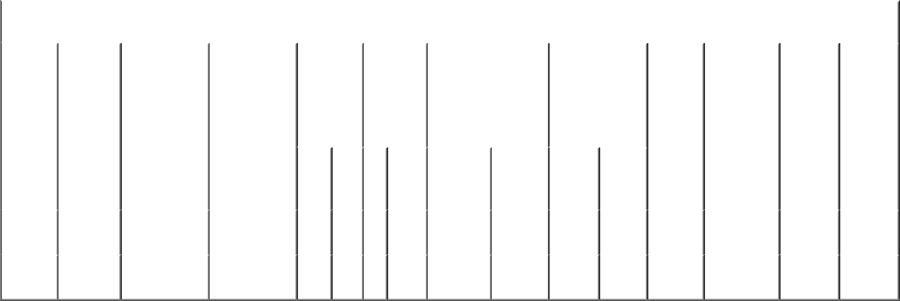

Explanation of Responses:

- Represents the gross number of shares of common stock awarded to the reporting person in connection with the vesting of restricted stock units. The actual number of shares issued was reduced by the number of shares withheld to satisfy tax withholding obligations. See footnote 3.

- Each restricted stock units represents a contingent right to receive one share of the Issuer's Class A Common Stock.

- Represents shares of common stock withheld to satisfy tax withholding obligations relating to the vesting of restricted stock units.

- On February 27,2020, the reporting person was granted 126,649 restricted stock units, vesting in four equal installments beginning on the first anniversary of the grant date.

- On March 1, 2019, the reporting person was granted 49,383 restricted stock units, vesting in four equal installments beginning on the first anniversary of the grant date.

Remarks:

/s/ Meredith Cook, Attorney- |  |  | 03/02/2021
in-fact
** Signature of Reporting Person |  |  | Date

Reminder: Report on a separate line for each class of securities beneficially owned directly or indirectly.

* If the form is filed by more than one reporting person, see Instruction 4 (b)(v).

- Intentional misstatements or omissions of facts constitute Federal Criminal Violations See 18 U.S.C. 1001 and 15 U.S.C. 78ff(a). Note: File three copies of this Form, one of which must be manually signed. If space is insufficient, see Instruction 6 for procedure.
Persons who respond to the collection of information contained in this form are not required to respond unless the form displays a currently valid OMB Number.

