SEC Form 4

FORM 4

Check this box if no longer subject to Section 16. Form 4 or Form 5 obligations may continue. See Instruction 1(b).

UNITED STATES SECURITIES AND EXCHANGE COMMISSION
Washington, D.C. 20549
 |  | OMB APPROVAL
STATEMENT OF CHANGES IN BENEFICIAL OWNERSHIP
 |  | OMB Number: | 3235-0287
 |  | Estimated average burden
Filed pursuant to Section 16(a) of the Securities Exchange Act of 1934 |  | hours per response: | 0.5
or Section 30(h) of the Investment Company Act of 1940
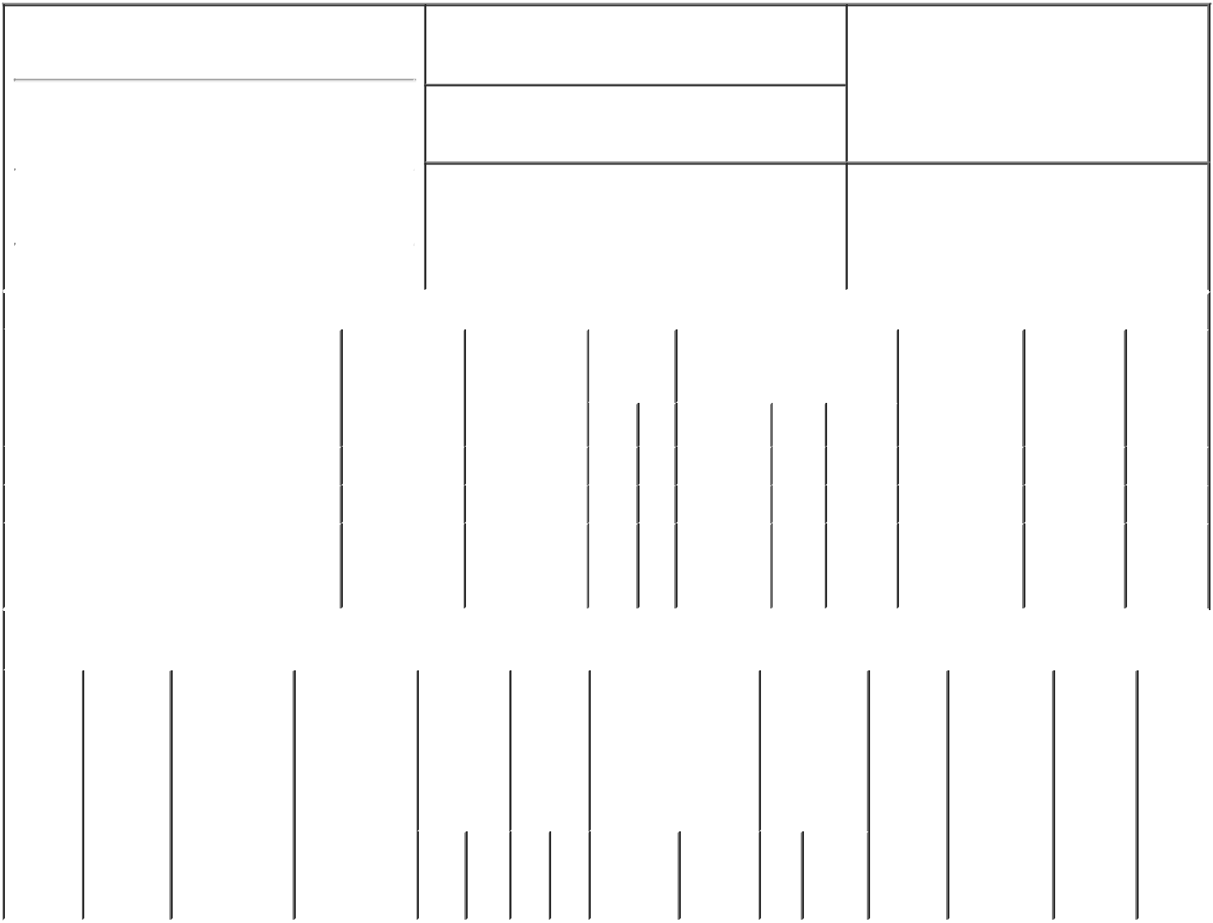

1. Name and Address of Reporting Person*
MITCHELL SAMUEL J

(Last) (First) (Middle)

100 VALVOLINE WAY

2. Issuer Name and Ticker or Trading Symbol

VALVOLINE INC [ VVV ]

3. Date of Earliest Transaction (Month/Day/Year)

11/17/2022

- Relationship of Reporting Person(s) to Issuer (Check all applicable)

X | Director | 10% Owner
X | Officer (give title | Other (specify
 | below) | below)

Chief Executive Officer

 |  |  |  |  |  |  | 4. If Amendment, Date of Original Filed (Month/Day/Year) |  |  |  |  |  |  | 6. Individual or Joint/Group Filing (Check Applicable
 | (Street)
 |  |  |  |  |  |  |  |  |  |  |  |  |  | Line)
 |  | LEXINGTON KY |  |  | 40509 |  |  |  |  |  |  |  |  |  | X Form filed by One Reporting Person
 |  |  |  |  |  |  |  |  |  |  |  |  |  |  |  |  | Form filed by More than One Reporting
 |  | (City) | (State) |  | (Zip) |  |  |  |  |  |  |  |  |  |  |  | Person
 |  |  |  | Table I - Non-Derivative Securities Acquired, Disposed of, or Beneficially Owned
 | 1. Title of Security (Instr. 3) |  |  |  | 2. Transaction |  |  | 2A. Deemed |  | 3. | 4. Securities Acquired (A) or |  |  |  |  |  | 5. Amount of |  | 6. Ownership | 7. Nature
 |  |  |  |  | Date |  |  | Execution Date, |  | Transaction | Disposed Of (D) (Instr. 3, 4 and |  |  |  |  |  | Securities |  | Form: Direct | of Indirect
 |  |  |  |  | (Month/Day/Year) |  |  | if any |  | Code (Instr. | 5) |  |  |  |  |  | Beneficially |  | (D) or Indirect | Beneficial
 |  |  |  |  |  |  |  | (Month/Day/Year) |  | 8) |  |  |  |  |  |  | Owned Following |  | (I) (Instr. 4) | Ownership
 |  |  |  |  |  |  |  |  |  |  |  |  |  |  |  |  | Reported |  |  | (Instr. 4)
 |  |  |  |  |  |  |  |  |  | Code V | Amount | (A) or |  | Price |  |  | Transaction(s)
 |  |  |  |  |  |  |  |  |  |  |  | (D) |  |  |  |  | (Instr. 3 and 4)
 | Common Stock |  |  |  | 11/17/2022 |  |  |  |  | A | 128,640⁽¹⁾ | A |  | (2) |  |  | 502,593 |  | D
 | Common Stock |  |  |  | 11/17/2022 |  |  |  |  | F | 60,590 | D |  | $32.87 |  |  | 442,003 |  | D
 |  |  |  |  |  |  |  |  |  |  |  |  |  |  |  |  |  |  |  | By
 | Common Stock |  |  |  |  |  |  |  |  |  |  |  |  |  |  |  | 5,672⁽³⁾ |  | I | 401(k)
 |  |  |  |  |  |  |  |  |  |  |  |  |  |  |  |  |  |  |  | Plan
 |  |  |  |  | Table II - Derivative Securities Acquired, Disposed of, or Beneficially Owned
 |  |  |  |  | (e.g., puts, calls, warrants, options, convertible securities)
 | 1. Title of |  | 2. | 3. Transaction | 3A. Deemed | 4. |  |  | 5. Number | 6. Date Exercisable and |  | 7. Title and |  |  |  | 8. Price of |  | 9. Number of 10. |  | 11. Nature
 | Derivative |  | Conversion | Date | Execution Date, |  | Transaction |  | of | Expiration Date |  | Amount of |  |  |  | Derivative |  | derivative | Ownership | of Indirect
 | Security |  | or Exercise | (Month/Day/Year) if any |  |  | Code (Instr. |  | Derivative | (Month/Day/Year) |  | Securities |  |  |  | Security |  | Securities | Form: | Beneficial
 | (Instr. 3) |  | Price of |  | (Month/Day/Year) | 8) |  |  | Securities |  |  | Underlying |  |  |  | (Instr. 5) |  | Beneficially | Direct (D) | Ownership
 |  |  | Derivative |  |  |  |  |  | Acquired |  |  | Derivative |  |  |  |  |  | Owned | or Indirect | (Instr. 4)
 |  |  | Security |  |  |  |  |  | (A) or |  |  | Security (Instr. |  |  |  |  |  | Following | (I) (Instr. 4)
 |  |  |  |  |  |  |  |  | Disposed |  |  | 3 and 4) |  |  |  |  |  | Reported
 |  |  |  |  |  |  |  |  | of (D) |  |  |  |  |  |  |  |  | Transaction(s)
 |  |  |  |  |  |  |  |  | (Instr. 3, 4 |  |  |  |  |  |  |  |  | (Instr. 4)
 |  |  |  |  |  |  |  |  | and 5)
 |  |  |  |  |  |  |  |  |  |  |  |  | Amount
 |  |  |  |  |  |  |  |  |  |  |  |  | or
 |  |  |  |  |  |  |  |  |  |  |  |  | Number
 |  |  |  |  |  |  |  |  |  | Date | Expiration |  | of
 |  |  |  |  |  |  | Code | V | (A) (D) | Exercisable | Date | Title | Shares

Explanation of Responses:

- Represents shares earned from the FY20-FY22 performance stock unit ("PSU") award granted on November 14, 2019, as certified by the Compensation Committee of the Board of Directors on November 17, 2022. Earned PSUs became 100% vested on the last day of the performance period. The PSUs were measured against EPS performance goals over three separate one-year measurement periods for each of FY20, FY21 and FY22, and a fourth cumulative FY20-FY22 measurement period with a potential payout of 0% to 200% of Target. Each measurement period was weighted equally at 25%. The entire PSU payout was subject to a payment modifier (-25%, 0% or +25%) based on Valvoline's FY20-FY22 total shareholder return relative to the companies in the S&P MidCap 400 Index. Based on Valvoline's EPS performance and relative TSR performance, the Compensation Committee awarded a PSU payout equal to 200% of Target.

- PSUs convert into Valvoline common stock on a one-for-one basis.

- Represents the approximate number of shares of Valvoline common stock held by the Reporting Person in the Valvoline 401(k) Plan based on the closing price of Valvoline common stock on the earliest Transaction Date.

Remarks:

/s/ Ian C. Lofwall, Attorney- |  |  | 11/21/2022
in-Fact
** Signature of Reporting Person |  |  | Date

Reminder: Report on a separate line for each class of securities beneficially owned directly or indirectly.

* If the form is filed by more than one reporting person, see Instruction 4 (b)(v).

- Intentional misstatements or omissions of facts constitute Federal Criminal Violations See 18 U.S.C. 1001 and 15 U.S.C. 78ff(a). Note: File three copies of this Form, one of which must be manually signed. If space is insufficient, see Instruction 6 for procedure.

Persons who respond to the collection of information contained in this form are not required to respond unless the form displays a currently valid OMB Number.

