SEC Form 4

FORM 4

Check this box if no longer subject to Section 16. Form 4 or Form 5 obligations may continue. See Instruction 1(b).

UNITED STATES SECURITIES AND EXCHANGE COMMISSION
Washington, D.C. 20549
 |  | OMB APPROVAL
STATEMENT OF CHANGES IN BENEFICIAL OWNERSHIP
 |  | OMB Number: | 3235-0287
 |  | Estimated average burden
Filed pursuant to Section 16(a) of the Securities Exchange Act of 1934 |  | hours per response: | 0.5
or Section 30(h) of the Investment Company Act of 1940
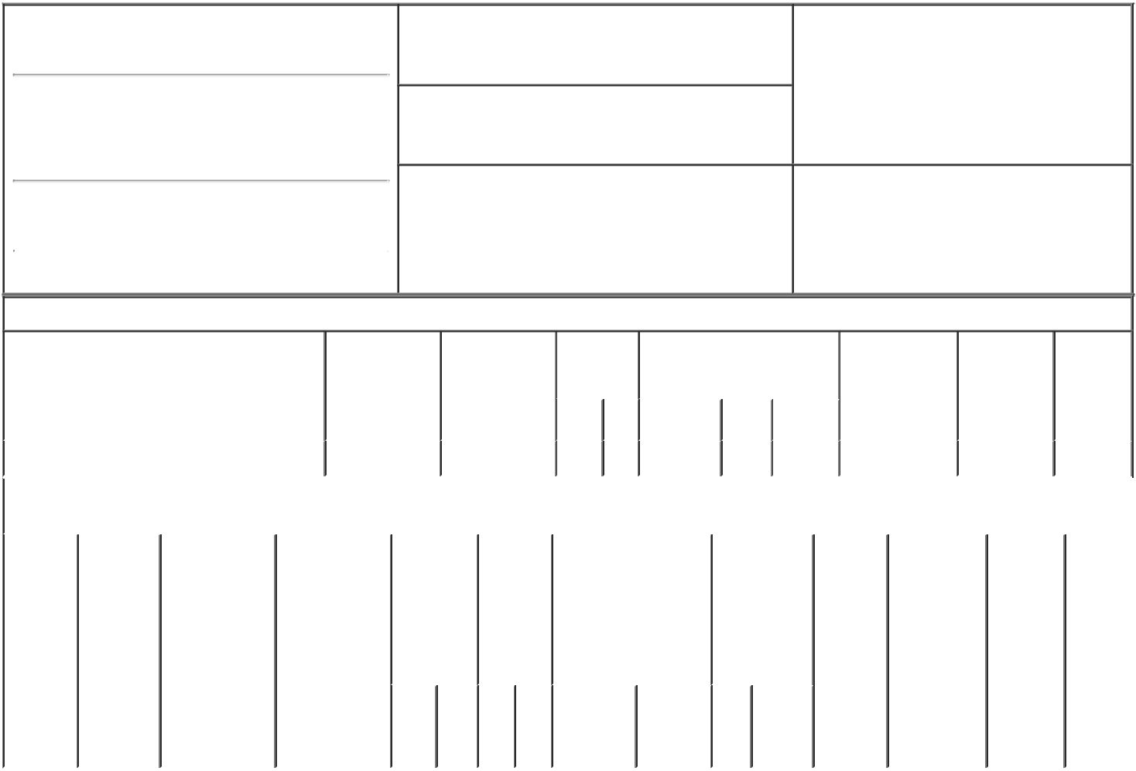

1. Name and Address of Reporting Person*
Maher David Eugene

(Last) (First) (Middle)

C/O ACUSHNET HOLDINGS CORP., 333 BRIDGE STREET

2. Issuer Name and Ticker or Trading Symbol

Acushnet Holdings Corp. [ GOLF ]

3. Date of Earliest Transaction (Month/Day/Year)

09/16/2022

- Relationship of Reporting Person(s) to Issuer (Check all applicable)

X | Director | 10% Owner
X | Officer (give title | Other (specify
 | below) | below)

President and CEO

(Street)
 | FAIRHAVEN | MA | 02719
 | (City) | (State) | (Zip)

4. If Amendment, Date of Original Filed (Month/Day/Year) 6. Individual or Joint/Group Filing (Check Applicable

Line)

X Form filed by One Reporting Person

Form filed by More than One Reporting

Person

Table I - Non-Derivative Securities Acquired, Disposed of, or Beneficially Owned

 | 1. Title of Security (Instr. 3) |  |  | 2. Transaction |  | 2A. Deemed |  | 3. | 4. Securities Acquired (A) or |  |  |  |  |  | 5. Amount of |  | 6. Ownership | 7. Nature
 |  |  |  | Date |  | Execution Date, |  | Transaction | Disposed Of (D) (Instr. 3, 4 and |  |  |  |  |  | Securities |  | Form: Direct | of Indirect
 |  |  |  | (Month/Day/Year) |  | if any |  | Code (Instr. | 5) |  |  |  |  |  | Beneficially |  | (D) or Indirect | Beneficial
 |  |  |  |  |  | (Month/Day/Year) |  | 8) |  |  |  |  |  |  | Owned Following |  | (I) (Instr. 4) | Ownership
 |  |  |  |  |  |  |  |  |  |  |  |  |  |  | Reported |  |  | (Instr. 4)
 |  |  |  |  |  |  |  | Code V | Amount | (A) or |  | Price |  |  | Transaction(s)
 |  |  |  |  |  |  |  |  |  | (D) |  |  |  |  | (Instr. 3 and 4)
 | Common Stock |  |  | 09/16/2022 |  |  |  | _{A}(1) | 1,743 | A |  | $48.03 |  |  | 580,858 |  | D
 |  |  | Table II - Derivative Securities Acquired, Disposed of, or Beneficially Owned
 |  |  |  | (e.g., puts, calls, warrants, options, convertible securities)
 | 1. Title of | 2. | 3. Transaction | 3A. Deemed | 4. |  | 5. Number | 6. Date Exercisable and |  | 7. Title and |  |  |  | 8. Price of |  | 9. Number of 10. |  | 11. Nature
 | Derivative | Conversion | Date | Execution Date, | Transaction |  | of | Expiration Date |  | Amount of |  |  |  | Derivative |  | derivative | Ownership | of Indirect
 | Security | or Exercise | (Month/Day/Year) | if any | Code (Instr. |  | Derivative | (Month/Day/Year) |  | Securities |  |  |  | Security |  | Securities | Form: | Beneficial
 | (Instr. 3) | Price of |  | (Month/Day/Year) | 8) |  | Securities |  |  | Underlying |  |  |  | (Instr. 5) |  | Beneficially | Direct (D) | Ownership
 |  | Derivative |  |  |  |  | Acquired |  |  | Derivative |  |  |  |  |  | Owned | or Indirect | (Instr. 4)
 |  | Security |  |  |  |  | (A) or |  |  | Security (Instr. |  |  |  |  |  | Following | (I) (Instr. 4)
 |  |  |  |  |  |  | Disposed |  |  | 3 and 4) |  |  |  |  |  | Reported
 |  |  |  |  |  |  | of (D) |  |  |  |  |  |  |  |  | Transaction(s)
 |  |  |  |  |  |  | (Instr. 3, 4 |  |  |  |  |  |  |  |  | (Instr. 4)
 |  |  |  |  |  |  | and 5)
 |  |  |  |  |  |  |  |  |  |  | Amount
 |  |  |  |  |  |  |  |  |  |  | or
 |  |  |  |  |  |  |  |  |  |  | Number
 |  |  |  |  |  |  |  | Date | Expiration |  | of
 |  |  |  |  | Code | V | (A) (D) | Exercisable | Date | Title | Shares

Explanation of Responses:

- Represents dividend equivalent rights in connection with the Issuer's quarterly dividend and accrued to the Reporting Person on restricted and performance stock units, adjusted for rounding of fractional amounts, under the Issuer's deferred compensation plan.

/s/ Chad M. Van Ess, as |  |  | 09/20/2022
attorney-in-fact
** Signature of Reporting PersonDate

Reminder: Report on a separate line for each class of securities beneficially owned directly or indirectly.

* If the form is filed by more than one reporting person, see Instruction 4 (b)(v).

- Intentional misstatements or omissions of facts constitute Federal Criminal Violations See 18 U.S.C. 1001 and 15 U.S.C. 78ff(a). Note: File three copies of this Form, one of which must be manually signed. If space is insufficient, see Instruction 6 for procedure.

Persons who respond to the collection of information contained in this form are not required to respond unless the form displays a currently valid OMB Number.

