SEC Form 3
FORM 3 | UNITED STATES SECURITIES AND EXCHANGE
 | COMMISSION
 |  |  | OMB APPROVAL
 | Washington, D.C. 20549
 |  |  | OMB Number: | 3235-
 |  |  |  | 0104
 | INITIAL STATEMENT OF BENEFICIAL OWNERSHIP OF
 |  |  | Estimated average burden
 | SECURITIES |  | response: | 0.5
 |  |  | hours per

Filed pursuant to Section 16(a) of the Securities Exchange Act of 1934

or Section 30(h) of the Investment Company Act of 1940
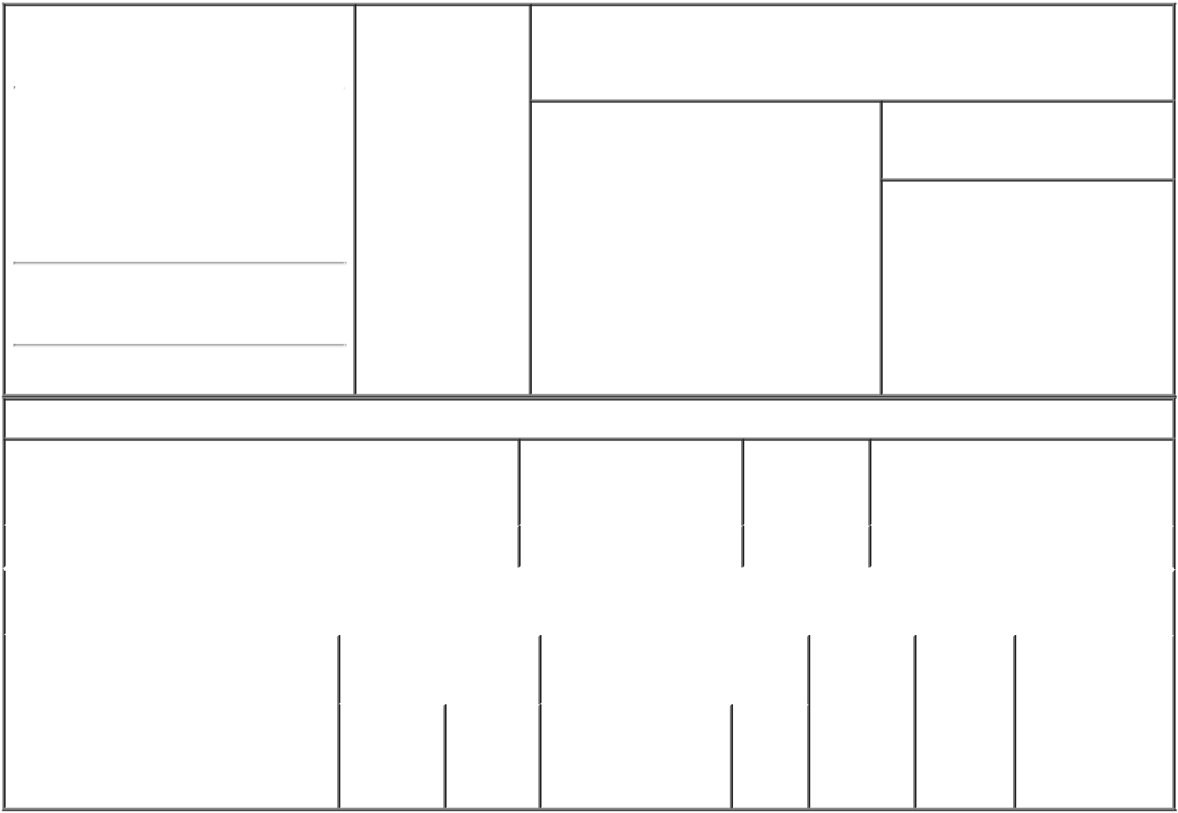

1. Name and Address of Reporting Person* |  |  | 2. Date of Event
 | Lee Ho Yeon (Aaron) |  | Requiring Statement
 |  |  | (Month/Day/Year)
 |  |  | 07/26/2022

3. Issuer Name and Ticker or Trading Symbol

Acushnet Holdings Corp. [ GOLF ]

(Last) (First) (Middle)

FILA HOLDINGS CORP.EAST CENTRAL TOWER18F
1077 CHEONHO-DAERO,

GANGDONG-GU

(Street)
SEOULM5 | 05340

- Relationship of Reporting Person(s) to Issuer
(Check all applicable)

X Director X 10% Owner

Officer (give Other (specify

title below) below)

- If Amendment, Date of Original Filed (Month/Day/Year)

- Individual or Joint/Group Filing (Check Applicable Line)

- Form filed by One Reporting Person

Form filed by More than One Reporting Person

(City) (State) (Zip)

Table I - Non-Derivative Securities Beneficially Owned

1. Title of Security (Instr. 4) | 2. Amount of Securities | 3. Ownership | 4. Nature of Indirect Beneficial
 | Beneficially Owned (Instr. | Form: Direct | Ownership (Instr. 5)
 | 4) | (D) or Indirect
 |  | (I) (Instr. 5)

 | Common Stock |  |  |  | 37,104,008 |  | I |  | See footnote⁽¹⁾
 |  |  | Table II - Derivative Securities Beneficially Owned
 |  | (e.g., puts, calls, warrants, options, convertible securities)
 | 1. Title of Derivative Security (Instr. 4) |  | 2. Date Exercisable and |  | 3. Title and Amount of Securities |  |  |  | 4. | 5. | 6. Nature of
 |  |  | Expiration Date |  | Underlying Derivative Security |  |  |  | Conversion | Ownership | Indirect Beneficial
 |  |  | (Month/Day/Year) |  | (Instr. 4) |  |  |  | or Exercise | Form: | Ownership (Instr.
 |  |  |  |  |  |  |  |  | Price of | Direct (D) | 5)
 |  |  |  |  |  | Amount
 |  |  |  |  |  |  |  |  | Derivative | or Indirect
 |  |  |  |  |  | or |  |  | Security | (I) (Instr. 5)
 |  |  |  |  |  | Number
 |  |  | Date | Expiration |  | of
 |  |  | Exercisable | Date | Title | Shares

Explanation of Responses:

- These shares are held directly by Magnus Holdings Co., Ltd., a subsidiary of Fila Holdings Corp. The reporting person is the Chief Financial Officer of Fila Holdings Corp. and may be deemed to be the beneficial owner and have voting and dispositive power with respect to the shares held by Magnus Holdings Co., Ltd. The reporting person disclaims beneficial ownership over the shares of Issuer common stock held by Magnus Holdings Co., Ltd., except to the extent of his pecuniary interest therein.

Remarks:

Exhibit 24 - Power of Attorney

 | /s/ Chad M. Van Ess, as |  |  | 07/28/2022
 | attorney-in-fact
 | ** Signature of Reporting |  |  | Date
 | Person
Reminder: Report on a separate line for each class of securities beneficially owned directly or indirectly.
* If the form is filed by more than one reporting person, see Instruction 5 (b)(v).

- Intentional misstatements or omissions of facts constitute Federal Criminal Violations See 18 U.S.C. 1001 and 15 U.S.C. 78ff(a). Note: File three copies of this Form, one of which must be manually signed. If space is insufficient, see Instruction 6 for procedure.

Persons who respond to the collection of information contained in this form are not required to respond unless the form displays a currently valid OMB Number.

POWER OF ATTORNEY

Know all by these presents that the undersigned, does hereby make, constitute and appoint each of Roland A. Giroux, Chad M. Van Ess and Kristen L. Foley, or any one of them, as a true and lawful attorney-in-fact of the undersigned with full powers of substitution and revocation, for and in the name, place and stead of the undersigned (in the undersigned?s individual capacity), to execute and deliver such forms that the undersigned may be required to file with the U.S. Securities and Exchange Commission as a result of the undersigned?s ownership of or transactions in securities of Acushnet Holdings Corp. (i) pursuant to Section 16(a) of the Securities Exchange Act of 1934, as amended, including without limitation, statements on Form 3, Form 4 and Form 5 (including any amendments thereto) and (ii) in connection with any applications for EDGAR access codes, including without limitation the Form ID. The Power of Attorney shall remain in full force and effect until the undersigned is no longer required to file Forms 3, 4 and 5 with regard to his or her ownership of or transactions in securities of Acushnet Holdings Corp., unless earlier revoked in writing. The undersigned acknowledges that Roland A. Giroux, Chad M. Van Ess and Kristen L. Foley are not assuming any of the undersigned?s responsibilities to comply with Section 16 of the Securities Exchange Act of 1934, as amended.

By:___/s/ Ho Yeon Lee________

Name: Ho Yeon Lee

Date: June 30, 2022

