SEC Form 4

FORM 4

Check this box if no longer subject to Section 16. Form 4 or Form 5 obligations may continue. See Instruction 1(b).

UNITED STATES SECURITIES AND EXCHANGE COMMISSION
Washington, D.C. 20549
 |  | OMB APPROVAL
STATEMENT OF CHANGES IN BENEFICIAL OWNERSHIP
 |  | OMB Number: | 3235-0287
 |  | Estimated average burden
Filed pursuant to Section 16(a) of the Securities Exchange Act of 1934 |  | hours per response: | 0.5
or Section 30(h) of the Investment Company Act of 1940
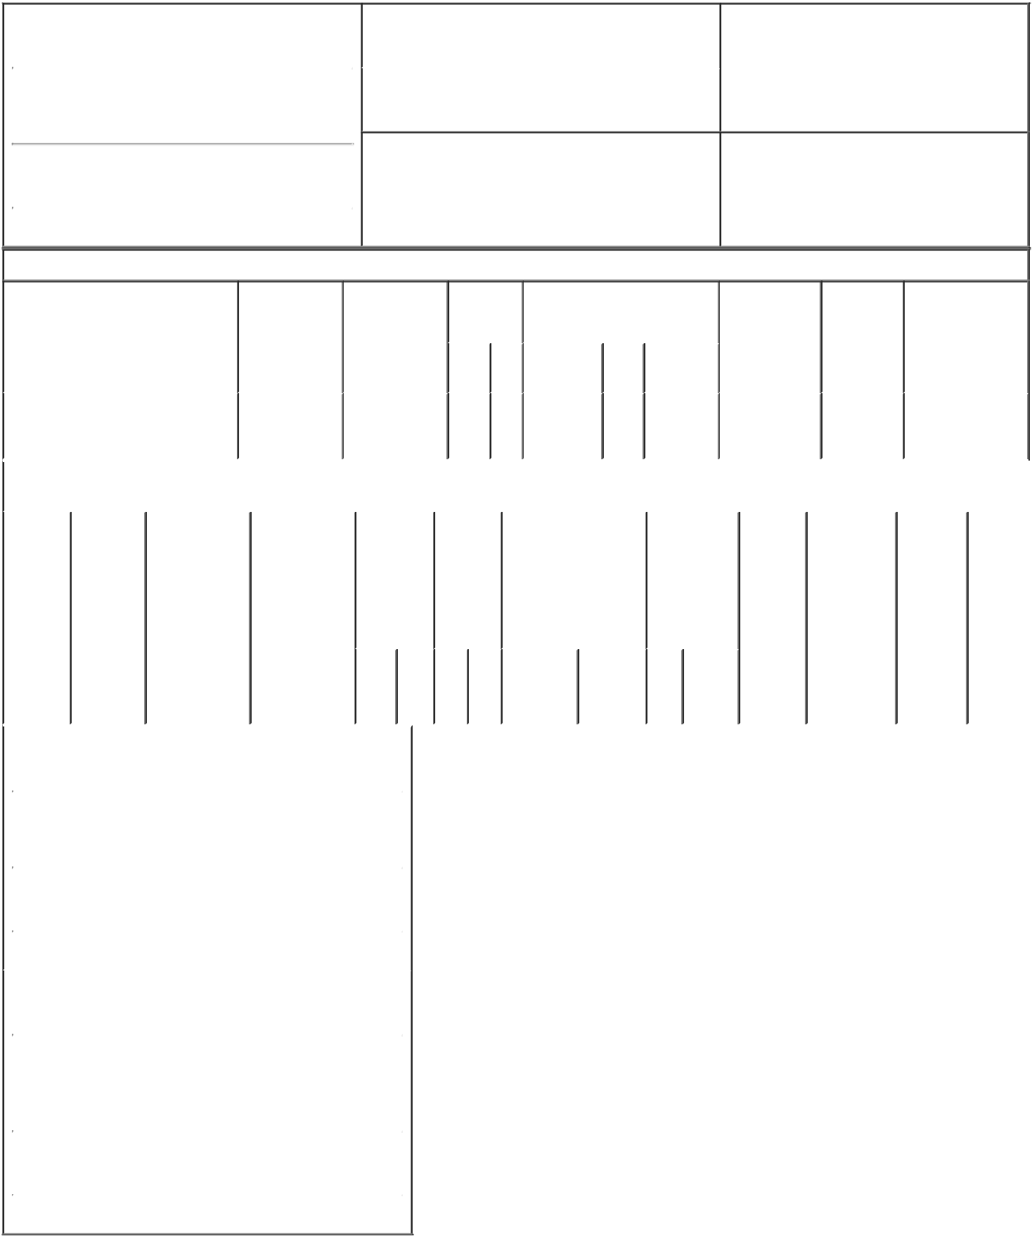

1. Name and Address of Reporting Person* |  |  |  |  | 2. |  |  | Issuer Name and Ticker or Trading Symbol
 | FILA Holdings Corp. |  |  |  |  |  | Acushnet Holdings Corp. [ GOLF ]
 | (Last) | (First) |  | (Middle) | 3. |  |  | Date of Earliest Transaction (Month/Day/Year)
 |  |  |  |  | 04/02/2021
1077 CHEONHO-DAERO, GANGDONG-GU

- Relationship of Reporting Person(s) to Issuer (Check all applicable)
X Director X 10% Owner

Officer (give title Other (specify
below) below)

(Street)
 | SEOUL | M5 | 05340
 | (City) | (State) | (Zip)

4. If Amendment, Date of Original Filed (Month/Day/Year) 6. Individual or Joint/Group Filing (Check Applicable Line)

 | Form filed by One Reporting Person
X | Form filed by More than One Reporting
 | Person

Table I - Non-Derivative Securities Acquired, Disposed of, or Beneficially Owned

1. Title of Security (Instr. 3) | 2. Transaction | 2A. Deemed | 3. | 4. Securities Acquired (A) or |  |  | 5. Amount of | 6. | 7. Nature of Indirect
 | Date | Execution Date, | Transaction | Disposed Of (D) (Instr. 3, 4 and 5) |  |  | Securities | Ownership | Beneficial
 | (Month/Day/Year) | if any | Code (Instr. |  |  |  | Beneficially | Form: Direct | Ownership (Instr. 4)
 |  | (Month/Day/Year) | 8) |  |  |  | Owned | (D) or
 |  |  |  |  |  |  | Following | Indirect (I)
 |  |  |  |  | (A) |  | Reported | (Instr. 4)
 |  |  | Code V | Amount | or | Price | Transaction(s)
 |  |  |  |  | (D) |  | (Instr. 3 and 4)

 | Common Stock |  |  |  |  |  | 04/02/2021 |  |  |  |  | D | 355,341⁽¹⁾ D |  | $31.3085 | 38,453,827 |  | I | See explanation
 |  |  |  |  |  |  |  |  |  |  |  |  |  |  |  |  |  |  | of responses⁽²⁾⁽³⁾
 |  |  |  |  |  |  |  |  |  |  |  |  |  |  |  |  |  |  | (4)(5)
 |  |  |  |  | Table II - Derivative Securities Acquired, Disposed of, or Beneficially Owned
 |  |  |  |  |  |  | (e.g., puts, calls, warrants, options, convertible securities)
 | 1. Title of |  | 2. | 3. Transaction |  |  | 3A. Deemed | 4. |  |  |  | 5. Number | 6. Date Exercisable and |  | 7. Title and |  | 8. Price of | 9. Number of | 10. | 11. Nature
 | Derivative |  | Conversion | Date |  |  | Execution Date, | Transaction |  |  |  | of | Expiration Date |  | Amount of |  | Derivative | derivative | Ownership | of Indirect
 | Security |  | or Exercise | (Month/Day/Year) |  |  | if any | Code (Instr. |  |  |  | Derivative | (Month/Day/Year) |  | Securities |  | Security | Securities | Form: | Beneficial
 | (Instr. 3) |  | Price of |  |  |  | (Month/Day/Year) | 8) |  |  |  | Securities |  |  | Underlying |  | (Instr. 5) | Beneficially | Direct (D) | Ownership
 |  |  | Derivative |  |  |  |  |  |  |  |  | Acquired |  |  | Derivative |  |  | Owned | or Indirect | (Instr. 4)
 |  |  | Security |  |  |  |  |  |  |  |  | (A) or |  |  | Security (Instr. |  |  | Following | (I) (Instr. 4)
 |  |  |  |  |  |  |  |  |  |  |  | Disposed |  |  | 3 and 4) |  |  | Reported
 |  |  |  |  |  |  |  |  |  |  |  | of (D) |  |  |  |  |  | Transaction(s)
 |  |  |  |  |  |  |  |  |  |  |  | (Instr. 3, 4 |  |  |  |  |  | (Instr. 4)
 |  |  |  |  |  |  |  |  |  |  |  | and 5)
 |  |  |  |  |  |  |  |  |  |  |  |  |  |  | Amount
 |  |  |  |  |  |  |  |  |  |  |  |  |  |  | or
 |  |  |  |  |  |  |  |  |  |  |  |  |  |  | Number
 |  |  |  |  |  |  |  |  |  |  |  |  | Date | Expiration | of
 |  |  |  |  |  |  |  | Code V |  |  |  | (A) (D) | Exercisable | Date | Title Shares
 | 1. Name and Address of Reporting Person*
 |  | FILA Holdings Corp.
 |  | (Last) |  | (First) |  |  | (Middle)
 |  | 1077 CHEONHO-DAERO, GANGDONG-GU
 | (Street)
 |  | SEOUL |  | M5 |  |  | 05340
 |  | (City) |  | (State) |  |  | (Zip)
 | 1. Name and Address of Reporting Person*
 |  | Magnus Holdings Co., Ltd.
 |  | (Last) |  | (First) |  |  | (Middle)
 |  | 1077 CHEONHO-DAERO,
 |  | GANGDONG-GU,
 | (Street)
 |  | SEOUL |  | M5 |  |  | 05340
 |  | (City) |  | (State) |  |  | (Zip)

Explanation of Responses:

- Represents shares sold to Acushnet Holdings Corp. pursuant to the Stock Repurchase Agreement dated May 10, 2019.

- Magnus Holdings Co., Ltd., directly holds 38,453,827 shares. The sole shareholder of Magnus Holdings Co., Ltd. is FILA Holdings Corp. Because of FILA Holdings Corp.'s relationship to Magnus Holdings Co., Ltd., FILA Holdings Corp. may be deemed to beneficially own the shares directly held by Magnus Holdings Co., Ltd.

- Magnus Holdings Co., Ltd. and FILA Holdings Corp. (together, the "Reporting Persons") disclaim beneficial ownership of these securities except to the extent of their pecuniary interest therein, and the inclusion of these securities in this report shall not be deemed an admission of beneficial ownership of the reported securities for purposes of Section 16 or for any other purpose.
- Solely for the purposes of Section 16 of the Exchange Act, each of Magnus Holdings Co., Ltd. and FILA Holdings Corp. may be deemed a director-by-deputization by virtue of the fact that (i) Yoon Soo Yoon is the Chairman of the Board of Directors of Acushnet Holdings Corp. and the Chairman of FILA Holdings Corp., (ii) Keun Chang Yoon is a Director on the Board of Directors of Acushnet

Holdings Corp. and is the President and Chief Executive Officer of FILA Holdings Corp. and (iii) Jennifer Estabrook is a Director on the Board of Directors of Acushnet Holdings Corp. and the President of Fila North America, an affiliate of FILA Holdings Corp.

- As a result of their roles at FILA Holdings Corp., each of Yoon Soo Yoon and Keun Chang Yoon may be deemed to be the beneficial owner and have voting and dispositive power with respect to the shares directly held by Magnus Holdings Co., Ltd. Each of Yoon Soo Yoon and Keun Chang Yoon disclaims beneficial ownership over the shares held by Magnus Holdings Co., Ltd., except to the extent of his pecuniary interest therein.

Remarks:

6. The Reporting Persons are jointly filing this Form 4 pursuant to Rule 16a-3(j) under the Exchange Act.

/s/ Keun Chang Yoon, Chief

Executive Officer, FILA 04/06/2021
Holdings Corp. (6)

/s/ Ho Yeon Lee, Chief

Executive Officer, Magnus 04/06/2021
Holdings Co., Ltd. (6)

** Signature of Reporting Person Date

Reminder: Report on a separate line for each class of securities beneficially owned directly or indirectly.

* If the form is filed by more than one reporting person, see Instruction 4 (b)(v).

- Intentional misstatements or omissions of facts constitute Federal Criminal Violations See 18 U.S.C. 1001 and 15 U.S.C. 78ff(a). Note: File three copies of this Form, one of which must be manually signed. If space is insufficient, see Instruction 6 for procedure.
Persons who respond to the collection of information contained in this form are not required to respond unless the form displays a currently valid OMB Number.

