UNITED STATES

SECURITIES AND EXCHANGE COMMISSION

Washington, D.C. 20549

SCHEDULE 13G/A

INFORMATION TO BE INCLUDED IN STATEMENTS PURSUANT TO RULES 13d-1(b),(c) AND (d) AND AMENDMENTS THERETO FILED PURSUANT TO 13d-2 UNDER THE SECURITIES EXCHANGE ACT OF 1934*

(Amendment No. 1)

Acushnet Holdings Corp.

(Name of Issuer)

Common Stock, par value $0.0001 per share

(Title of Class of Securities)

005098108

(CUSIP Number)

December 31, 2019

(Date of Event Which Requires Filing of this Statement)

Check the appropriate box to designate the rule pursuant to which this Schedule is filed:

  - Rule 13d-1(b)

  - Rule 13d-1(c)

    - Rule 13d-1(d)

* The remainder of this cover page shall be filled out for a reporting person’s initial filing on this form with respect to the subject class of securities, and for any subsequent amendment containing information which would alter disclosures provided in a prior cover page.

The information required in the remainder of this cover page shall not be deemed to be “filed” for the purpose of Section 18 of the Securities Exchange Act of 1934 (“Act”) or otherwise subject to the liabilities of that section of the Act but shall be subject to all other provisions of the Act (however, see the Notes).

Page 1 of 7

CUSIP No. 005098108 | 13G/A | Page 2 of 7 Pages
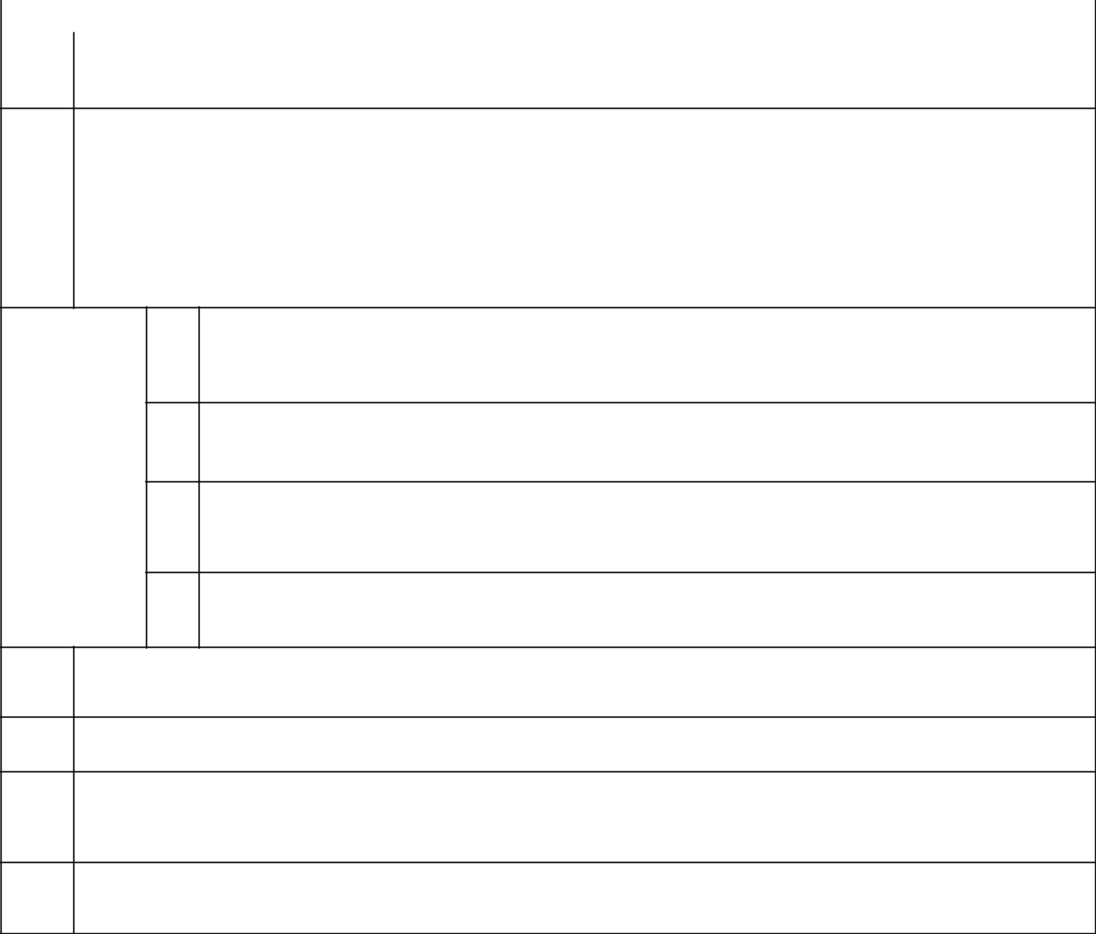
- NAME OF REPORTING PERSON Fila Holdings Corp. (1)

2 | CHECK THE APPROPRIATE BOX IF A MEMBER OF A GROUP*
 | (a) ☐
 | (b) ☐
3 | SEC USE ONLY
4 | CITIZENSHIP OR PLACE OF ORGANIZATION
 | Republic of Korea

NUMBER OF

SHARES

BENEFICIALLY

OWNED BY

EACH

REPORTING

PERSON

WITH

SOLE VOTING POWER
5

38,809,168 (2)
- SHARED VOTING POWER

- 0 -
SOLE DISPOSITIVE POWER
7

38,809,168 (2)

- SHARED DISPOSITIVE POWER - 0 -

AGGREGATE AMOUNT BENEFICIALLY OWNED BY EACH REPORTING PERSON
9
38,809,168
CHECK BOX IF THE AGGREGATE AMOUNT IN ROW (9) EXCLUDES CERTAIN SHARES* ☐
10
PERCENT OF CLASS REPRESENTED BY AMOUNT IN ROW 9
11
52% (3)

TYPE OF REPORTING PERSON
12

CO

- Fila Holdings Corp. was formerly known as Fila Korea Ltd.

- Magnus Holdings Co., Ltd. (“Magnus Holdings”) directly holds 38,809,168 shares of Acushnet Holdings Corp. (the “Issuer”). The sole shareholder of Magnus Holdings is Fila Holdings Corp. (“Fila Holdings”). Because of Fila Holdings’ relationship to Magnus Holdings, Fila Holdings may be deemed to beneficially own the shares directly held by Magnus Holdings.

- Based on a total of 74,629,121 shares of Common Stock, par value $0.001 per share (“Common Stock”) of the Issuer outstanding, which is the difference between (i) 75,165,104 shares of Common Stock outstanding as of October 25, 2019, as reported by the Issuer in its Quarterly Report on Form 10-Q filed with the Securities and Exchange Commission (the “Commission”) on October 31, 2019 and (ii) 535,983 shares of Common Stock sold by Magnus Holdings to the Issuer pursuant to a Stock Repurchase Agreement on December 11, 2019, as reported by the Reporting Persons in a Form 4 filed with the Commission on December 17, 2019.

Page 2 of 7 Pages

CUSIP No. 005098108 | 13G/A | Page 3 of 7 Pages
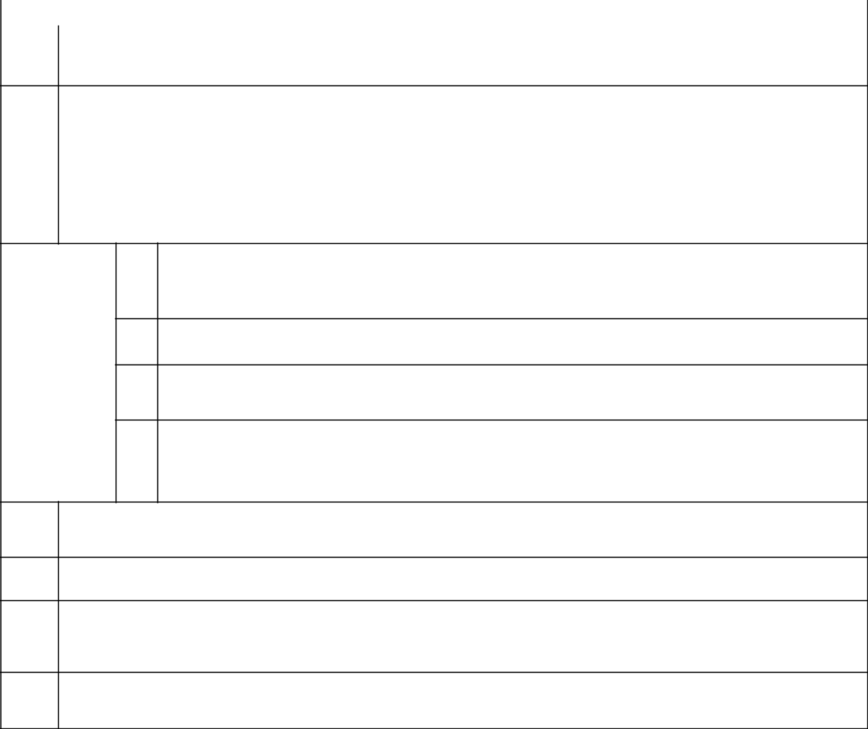
- NAME OF REPORTING PERSON Magnus Holdings Co., Ltd.

2 | CHECK THE APPROPRIATE BOX IF A MEMBER OF A GROUP*
 | (a) ☐
 | (b) ☐
3 | SEC USE ONLY
4 | CITIZENSHIP OR PLACE OF ORGANIZATION
 | Republic of Korea

NUMBER OF

SHARES

BENEFICIALLY

OWNED BY

EACH

REPORTING

PERSON

WITH

SOLE VOTING POWER
5

38,809,168

- SHARED VOTING POWER - 0 -
SOLE DISPOSITIVE POWER
7
38,809,168

- SHARED DISPOSITIVE POWER - 0 -

AGGREGATE AMOUNT BENEFICIALLY OWNED BY EACH REPORTING PERSON
9
38,809,168
CHECK BOX IF THE AGGREGATE AMOUNT IN ROW (9) EXCLUDES CERTAIN SHARES* ☐
10
PERCENT OF CLASS REPRESENTED BY AMOUNT IN ROW 9
11
52% (1)

TYPE OF REPORTING PERSON
12

CO

- Based on a total of 74,629,121 shares of Common Stock of the Issuer outstanding, which is the difference between (i) 75,165,104 shares of Common Stock outstanding as of October 25, 2019, as reported by the Issuer in its Quarterly Report on Form 10-Q filed with the Commission on October 31, 2019 and (ii) 535,983 shares of Common Stock sold by Magnus Holdings to the Issuer pursuant to a Stock Repurchase Agreement on December 11, 2019, as reported by the Reporting Persons in a Form 4 filed with the Commission on December 17, 2019.

Page 3 of 7 Pages

Item 1(a). Name of Issuer:

Acushnet Holdings Corp.

Item 1(b). Address of Issuer’s Principal Executive Offices:

333 Bridge Street

Fairhaven, Massachusetts

Item 2(a). Name of Person Filing:

This Schedule 13G is being filed jointly by Fila Holdings Corp. and Magnus Holdings Co., Ltd., pursuant to an Agreement of Joint Filing, a copy of which is filed with this Schedule 13G as Exhibit 1, in accordance with Rule 13d-1(k)(1) under the Act.

Magnus Holdings directly holds 38,809,168 shares of Common Stock of the Issuer. The sole shareholder of Magnus Holdings is Fila Holdings Corp. Because of Fila Holdings Corp.’s relationship to Magnus Holdings, Fila Holdings Corp. may be deemed to beneficially own the shares directly held by Magnus Holdings.

Item 2(b). Address of Principal Business Office or, if none, Residence:

Fila Holdings Corp.

1077 Cheonho-daero, Gangdong-gu,

Seoul, Korea 15F,16F,17F,18F, 05340

Magnus Holdings Co., Ltd.

1077 Cheonho-daero, Gangdong-gu,

Seoul, Korea 18F, 05340

Item 2(c). Citizenship:

See response to Item 4 on each cover page.

Item 2(d). Title of Class of Securities:

Common Stock, $0.001 par value.

Item 2(e). CUSIP NUMBER: 005098108

Item 3. If This Statement is Filed Pursuant to Rule 13d-1(b), or 13d-2(b) or (c), Check Whether the Person Filing is a:

- ☐ Broker or dealer registered under Section 15 of the Exchange Act

- ☐ Bank as defined in Section 3(a)(6) of the Exchange Act

- ☐ Insurance company as defined in Section 3(a)(19) of the Exchange Act

- ☐ Investment company registered under Section 8 of the Investment Company Act of 1940

Page 4 of 7 Pages

- ☐ Investment Adviser registered under Section 203 of the Investment Advisers Act of 1940: see Rule 13d-1(b)(1)(ii)(E)

- ☐ Employee Benefit Plan, Pension Fund which is subject to the provisions of the Employee Retirement Income Security Act of 1974 or Endowment Fund; see Rule 13d-1(b)(1)(ii)(F)

- ☐ Parent holding company, in accordance with Rule 13d-1(b)(1)(ii)(G).

- ☐ Savings Association as defined in Section 3(b) of the Federal Deposit Insurance Act.

- ☐ Church Plan that is excluded from the definition of an investment company under Section 3(c)(14) of the Investment Company Act of 1940.

- ☐ Non-U.S. institution in accordance with Rule 240.13d-1(b)(1)(ii)(J). If filing as a non-U.S. institution in accordance with Rule

240.13d-1(b)(1)(ii)(J), please specify the type of institution:

- ☐ Group, in accordance with Rule 240.13d-1(b)(1)(ii)(K).

Item 4. Ownership

- Amount Beneficially Owned:

See responses to Item 9 on each cover page.

- Percent of Class:

See responses to Item 11 on each cover page.

- Number of shares as to which such person has:

  - Sole power to vote or to direct the vote: See responses to Item 5 on each cover page.
  - Shared power to vote or to direct the vote: See responses to Item 6 on each cover page.

  - Sole power to dispose or to directo the disposition of: See responses to Item 7 on each cover page.
  - Shared power to dispose or to direct the disposition of: See responses to Item 8 on each cover page.

Page 5 of 7 Pages

Item 5. Ownership of Five Percent or Less of a Class.

If this statement is being filed to report the fact that as of the date hereof the Reporting Person has ceased to be the beneficial owner of more than five percent of the class of securities, check the following ☐.

Item 6. Ownership of More than Five Percent on Behalf of Another Person.

Not Applicable.

Item 7. Identification and Classification of the Subsidiary Which Acquired the Security Being Reported on by the Parent Holding Company.

See response to Item 2(a) above.

Item 8. Identification and Classification of Members of the Group.

Not applicable.

Item 9. Notice of Dissolution of Group.

Not applicable

Item 10. Certification. (if filing pursuant to Rule 13d-1(c))

Page 6 of 7 Pages

SIGNATURE

After reasonable inquiry and to the best of my knowledge and belief, I certify that the information set forth in this statement is true, complete and

correct.

Dated: February 12, 2020

Fila Holdings Corp.

By: | /s/ Keun Chang (Kevin) Yoon
Name: | Keun Chang (Kevin) Yoon
Title: | Representative Director
Magnus Holdings Co., Ltd.
By: | /s/ Keun Chang (Kevin) Yoon
Name: | Keun Chang (Kevin) Yoon
Title: | Representative Director and
 | Chairman of the Board

Page 7 of 7 Pages

