SEC Form 4

FORM 4

Check this box if no longer subject to Section 16. Form 4 or Form 5 obligations may continue. See Instruction 1(b).

UNITED STATES SECURITIES AND EXCHANGE COMMISSION
Washington, D.C. 20549
 |  | OMB APPROVAL
STATEMENT OF CHANGES IN BENEFICIAL OWNERSHIP
 |  | OMB Number: | 3235-0287
 |  | Estimated average burden
Filed pursuant to Section 16(a) of the Securities Exchange Act of 1934 |  | hours per response: | 0.5
or Section 30(h) of the Investment Company Act of 1940
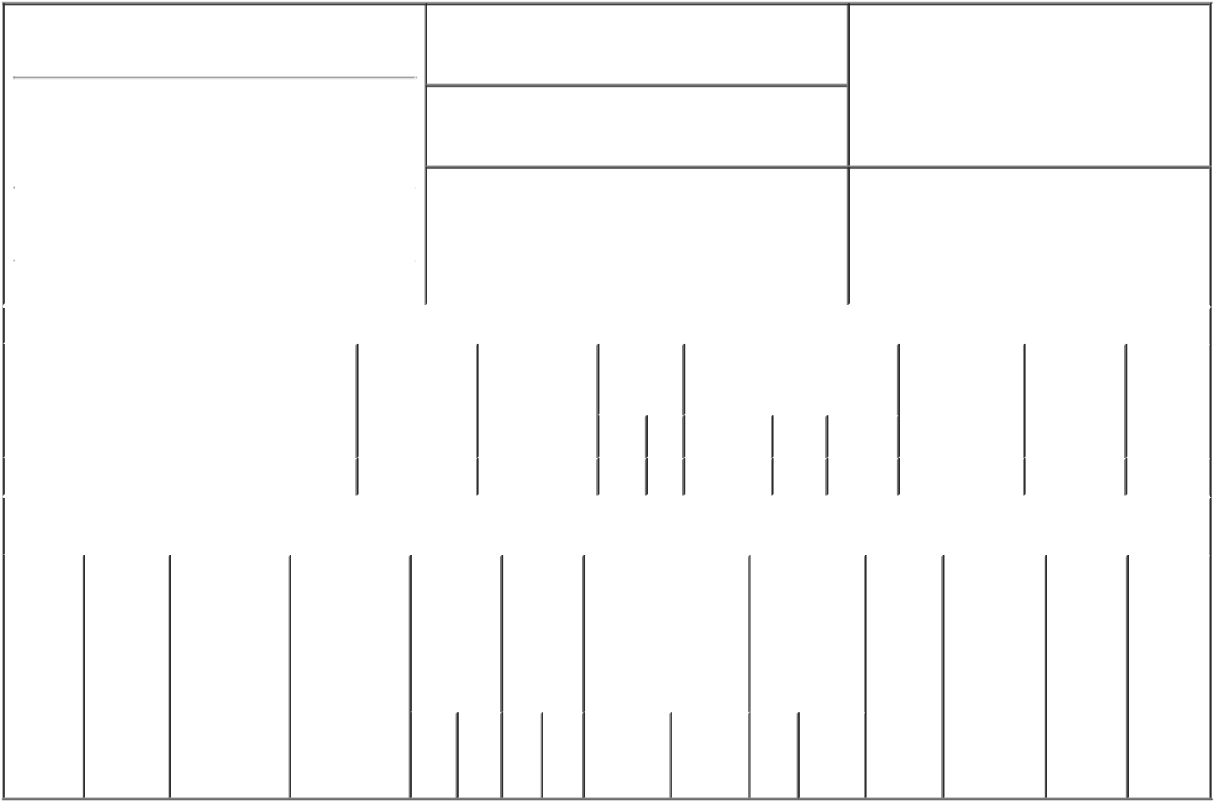

1. Name and Address of Reporting Person*
Bohn Mary Louise

(Last) (First) (Middle)

C/O ACUSHNET HOLDINGS CORP., 333 BRIDGE STREET

2. Issuer Name and Ticker or Trading Symbol

Acushnet Holdings Corp. [ GOLF ]

3. Date of Earliest Transaction (Month/Day/Year)

02/01/2018

- Relationship of Reporting Person(s) to Issuer (Check all applicable)

 | Director | 10% Owner
X | Officer (give title | Other (specify
 | below) | below)

See Remarks

 |  |  |  |  |  |  |  | 4. If Amendment, Date of Original Filed (Month/Day/Year) |  |  |  |  |  |  | 6. Individual or Joint/Group Filing (Check Applicable
 | (Street) |  |  |  |  |  |  |  |  |  |  |  |  |  | Line)
 |  |  |  |  |  |  |  |  |  |  |  |  |  |  |  | X Form filed by One Reporting Person
 |  | FAIRHAVEN |  | MA |  | 02719
 |  |  |  |  |  |  |  |  |  |  |  |  |  |  |  |  | Form filed by More than One Reporting
 |  |  |  |  |  |  |  |  |  |  |  |  |  |  |  |  | Person
 |  | (City) |  | (State) |  | (Zip)
 |  |  |  |  | Table I - Non-Derivative Securities Acquired, Disposed of, or Beneficially Owned
 | 1. Title of Security (Instr. 3) |  |  |  |  | 2. Transaction |  |  | 2A. Deemed |  | 3. |  | 4. Securities Acquired (A) or |  |  |  | 5. Amount of |  | 6. Ownership | 7. Nature
 |  |  |  |  |  | Date |  |  | Execution Date, |  |  | Transaction | Disposed Of (D) (Instr. 3, 4 and |  |  |  | Securities |  | Form: Direct | of Indirect
 |  |  |  |  |  | (Month/Day/Year) |  |  | if any |  |  | Code (Instr. | 5) |  |  |  | Beneficially |  | (D) or Indirect | Beneficial
 |  |  |  |  |  |  |  |  | (Month/Day/Year) |  | 8) |  |  |  |  |  | Owned Following |  | (I) (Instr. 4) | Ownership
 |  |  |  |  |  |  |  |  |  |  |  |  |  |  |  |  | Reported |  |  | (Instr. 4)
 |  |  |  |  |  |  |  |  |  |  |  | Code V | Amount | (A) or | Price |  | Transaction(s)
 |  |  |  |  |  |  |  |  |  |  |  |  |  | (D) |  |  | (Instr. 3 and 4)
 | Common Stock |  |  |  |  | 02/01/2018 |  |  |  |  |  | _{F}(1) | 6,353 | D | $21.45 |  |  | 59,084 | D
 |  |  |  |  | Table II - Derivative Securities Acquired, Disposed of, or Beneficially Owned
 |  |  |  |  |  | (e.g., puts, calls, warrants, options, convertible securities)
 | 1. Title of |  | 2. |  | 3. Transaction | 3A. Deemed |  | 4. |  | 5. Number | 6. Date Exercisable and |  |  | 7. Title and |  | 8. Price of |  | 9. Number of | 10. | 11. Nature
 | Derivative |  | Conversion |  | Date | Execution Date, |  | Transaction |  | of | Expiration Date |  |  | Amount of |  | Derivative |  | derivative | Ownership | of Indirect
 | Security |  | or Exercise |  | (Month/Day/Year) | if any |  | Code (Instr. |  | Derivative | (Month/Day/Year) |  |  | Securities |  | Security |  | Securities | Form: | Beneficial
 | (Instr. 3) |  | Price of |  |  | (Month/Day/Year) |  | 8) |  | Securities |  |  |  | Underlying |  | (Instr. 5) |  | Beneficially | Direct (D) | Ownership
 |  |  | Derivative |  |  |  |  |  |  | Acquired |  |  |  | Derivative |  |  |  | Owned | or Indirect | (Instr. 4)
 |  |  | Security |  |  |  |  |  |  | (A) or |  |  |  | Security (Instr. 3 |  |  |  | Following | (I) (Instr. 4)
 |  |  |  |  |  |  |  |  |  | Disposed |  |  |  | and 4) |  |  |  | Reported
 |  |  |  |  |  |  |  |  |  | of (D) |  |  |  |  |  |  |  | Transaction(s)
 |  |  |  |  |  |  |  |  |  | (Instr. 3, 4 |  |  |  |  |  |  |  | (Instr. 4)
 |  |  |  |  |  |  |  |  |  | and 5)
 |  |  |  |  |  |  |  |  |  |  |  |  |  | Amount
 |  |  |  |  |  |  |  |  |  |  |  |  |  | or
 |  |  |  |  |  |  |  |  |  |  |  |  |  | Number
 |  |  |  |  |  |  |  |  |  |  | Date |  | Expiration | of
 |  |  |  |  |  |  |  | Code V |  | (A) (D) | Exercisable |  | Date | Title Shares

Explanation of Responses:

- This transaction is not a sale of shares by the Reporting Person. Instead, this represents shares that have been withheld by the Issuer to satisfy its income tax and withholding and remittance obligations in connection with the vesting and net settlement of previously reported restricted stock units.

Remarks:

Title: President, Titleist Golf Balls, Exhibit 24 - Power of Attorney

/s/ Roland A. Giroux, as |  |  | 02/02/2018
attorney-in-fact
** Signature of Reporting Person |  |  | Date

Reminder: Report on a separate line for each class of securities beneficially owned directly or indirectly.

* If the form is filed by more than one reporting person, see Instruction 4 (b)(v).

- Intentional misstatements or omissions of facts constitute Federal Criminal Violations See 18 U.S.C. 1001 and 15 U.S.C. 78ff(a). Note: File three copies of this Form, one of which must be manually signed. If space is insufficient, see Instruction 6 for procedure.
Persons who respond to the collection of information contained in this form are not required to respond unless the form displays a currently valid OMB Number.

POWER OF ATTORNEY

Know all by these presents that the undersigned, does hereby make, constitute and appoint each of Brendan M. Gibbons, Roland A. Giroux and Chad M. Van Ess, or any one of them, as a true and lawful attorney-in-fact of the undersigned with full powers of substitution and revocation, for and in the name, place and stead of the undersigned (in the undersigned?s individual capacity), to execute and deliver such forms that the undersigned may be required to file with the U.S. Securities and Exchange Commission as a result of the undersigned?s ownership of or transactions in securities of Acushnet Holdings Corp. (i) pursuant to Section 16(a) of the Securities Exchange Act of 1934, as amended, including without limitation, statements on Form 3, Form 4 and Form 5 (including any amendments thereto) and (ii) in connection with any applications for EDGAR access codes, including without limitation the Form ID. The Power of Attorney shall remain in full force and effect until the undersigned is no longer required to file Forms 3, 4 and 5 with regard to his or her ownership of or transactions in securities of Acushnet Holdings Corp., unless earlier revoked in writing. The undersigned acknowledges that Brendan M. Gibbons, Roland A. Giroux and Chad M. Van Ess are not assuming any of the undersigned?s responsibilities to comply with Section 16 of the Securities Exchange Act of 1934, as amended.

By: /s/ Mary Lou Bohn
Name: Mary Lou Bohn

Date: December 12, 2017

