SEC Form 4

FORM 4

Check this box if no longer subject to Section 16. Form 4 or Form 5 obligations may continue. See Instruction 1(b).

UNITED STATES SECURITIES AND EXCHANGE COMMISSION
Washington, D.C. 20549
 |  | OMB APPROVAL
STATEMENT OF CHANGES IN BENEFICIAL OWNERSHIP
 |  | OMB Number: | 3235-0287
 |  | Estimated average burden
Filed pursuant to Section 16(a) of the Securities Exchange Act of 1934 |  | hours per response: | 0.5
or Section 30(h) of the Investment Company Act of 1940
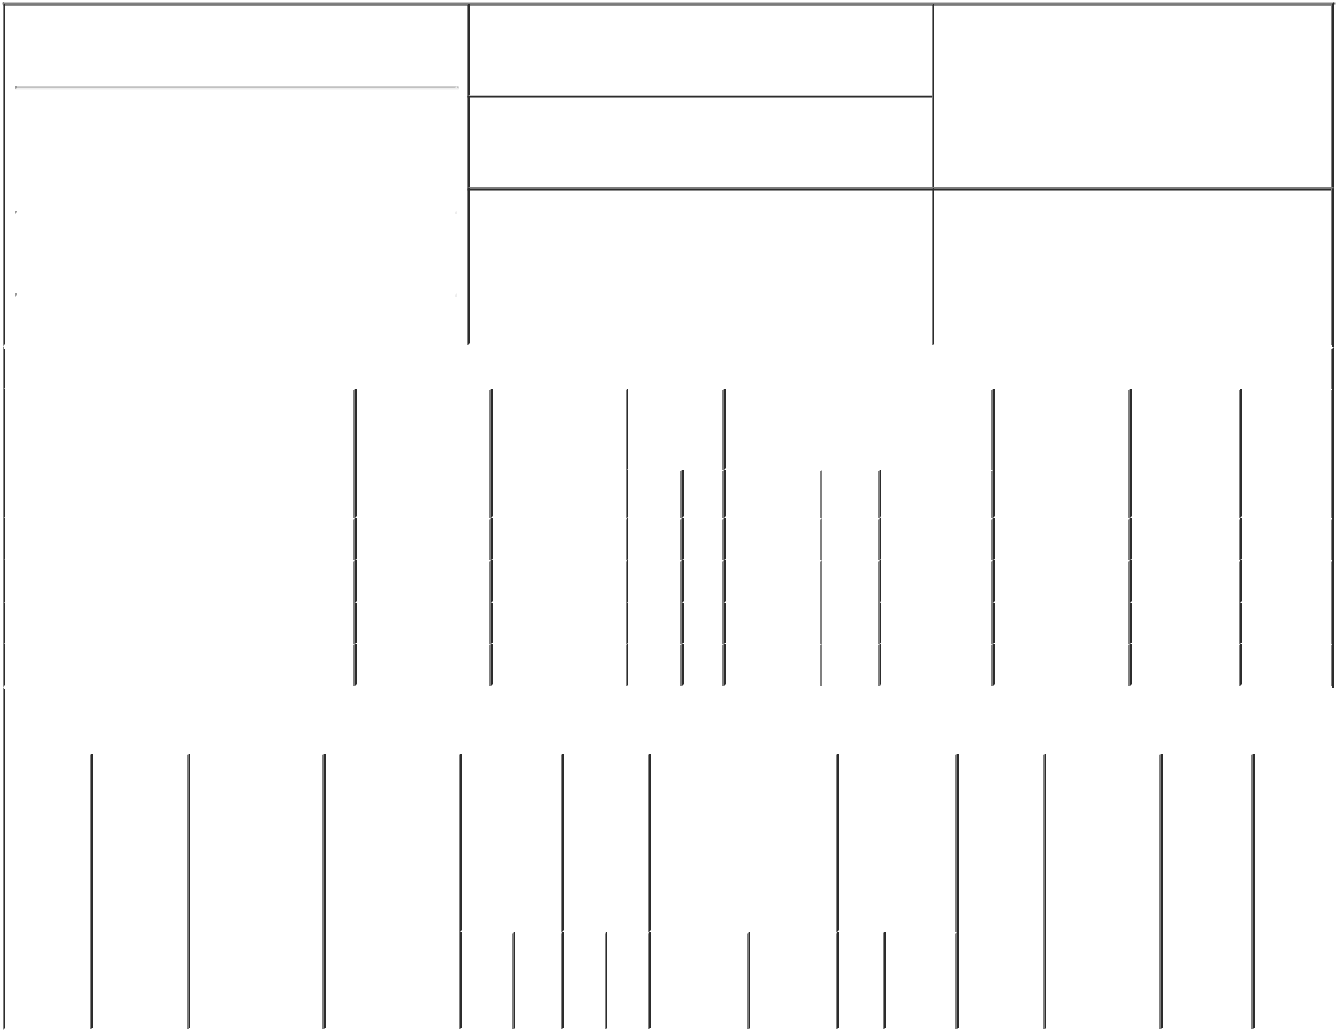

1. Name and Address of Reporting Person*
Leonard Frank X

(Last) (First) (Middle)

C/O NOVOCURE INC.

1550 LIBERTY RIDGE DRIVE, SUITE 115

2. Issuer Name and Ticker or Trading Symbol

NovoCure Ltd [ NVCR ]

3. Date of Earliest Transaction (Month/Day/Year)

03/03/2023

- Relationship of Reporting Person(s) to Issuer (Check all applicable)

 | Director | 10% Owner
X | Officer (give title | Other (specify
 | below) | below)

President, CNS Cancers US

 |  |  |  |  |  |  |  | 4. If Amendment, Date of Original Filed (Month/Day/Year) |  |  |  |  |  |  | 6. Individual or Joint/Group Filing (Check Applicable
 | (Street) |  |  |  |  |  |  |  |  |  |  |  |  |  | Line)
 |  |  |  |  |  |  |  |  |  |  |  |  |  |  |  |  | X Form filed by One Reporting Person
 |  | WAYNE | PA |  | 19087
 |  |  |  |  |  |  |  |  |  |  |  |  |  |  |  |  |  | Form filed by More than One Reporting
 |  |  |  |  |  |  |  |  |  |  |  |  |  |  |  |  |  | Person
 |  | (City) | (State) |  | (Zip)
 |  |  |  | Table I - Non-Derivative Securities Acquired, Disposed of, or Beneficially Owned
 | 1. Title of Security (Instr. 3) |  |  |  | 2. Transaction |  |  | 2A. Deemed |  |  | 3. |  | 4. Securities Acquired (A) or |  |  |  |  | 5. Amount of |  | 6. Ownership | 7. Nature
 |  |  |  |  | Date |  |  | Execution Date, |  |  | Transaction |  | Disposed Of (D) (Instr. 3, 4 and 5) |  |  |  |  | Securities |  | Form: Direct | of Indirect
 |  |  |  |  | (Month/Day/Year) if any |  |  |  |  |  | Code (Instr. |  |  |  |  |  |  | Beneficially |  | (D) or | Beneficial
 |  |  |  |  |  |  |  | (Month/Day/Year) |  |  | 8) |  |  |  |  |  |  | Owned Following |  | Indirect (I) | Ownership
 |  |  |  |  |  |  |  |  |  |  |  |  |  |  |  |  |  | Reported |  | (Instr. 4) | (Instr. 4)
 |  |  |  |  |  |  |  |  |  |  | Code V |  | Amount | (A) or | Price |  |  | Transaction(s)
 |  |  |  |  |  |  |  |  |  |  |  |  |  | (D) |  |  |  | (Instr. 3 and 4)
 | Ordinary Shares |  |  |  | 03/03/2023 |  |  |  |  |  |  | S | 4,403⁽¹⁾ | D | $76.1594 |  |  | 63,490 |  | D
 | Ordinary Shares |  |  |  | 03/03/2023 |  |  |  |  |  |  | S | 888⁽¹⁾ | D | $76.1594 |  |  | 62,602 |  | D
 | Ordinary Shares |  |  |  | 03/07/2023 |  |  |  |  |  |  | S | 6,003 | D | $74.9968⁽²⁾ |  |  | 56,599 |  | D
 | Ordinary Shares |  |  |  | 03/07/2023 |  |  |  |  |  |  | S | 2,315 | D | $75.5937⁽³⁾ |  |  | 54,284 |  | D
 |  |  |  |  | Table II - Derivative Securities Acquired, Disposed of, or Beneficially Owned
 |  |  |  |  | (e.g., puts, calls, warrants, options, convertible securities)
 | 1. Title of |  | 2. | 3. Transaction | 3A. Deemed |  |  | 4. | 5. Number |  |  | 6. Date Exercisable and |  | 7. Title and |  |  | 8. Price of |  | 9. Number of 10. |  | 11. Nature
 | Derivative |  | Conversion | Date | Execution Date, |  |  | Transaction | of |  |  | Expiration Date |  | Amount of |  |  | Derivative |  | derivative | Ownership | of Indirect
 | Security |  | or Exercise | (Month/Day/Year) if any |  |  |  | Code (Instr. | Derivative |  |  | (Month/Day/Year) |  | Securities |  |  | Security |  | Securities | Form: | Beneficial
 | (Instr. 3) |  | Price of |  | (Month/Day/Year) |  |  | 8) | Securities |  |  |  |  | Underlying |  |  | (Instr. 5) |  | Beneficially | Direct (D) | Ownership
 |  |  | Derivative |  |  |  |  |  | Acquired |  |  |  |  | Derivative |  |  |  |  | Owned | or Indirect | (Instr. 4)
 |  |  | Security |  |  |  |  |  | (A) or |  |  |  |  | Security (Instr. |  |  |  |  | Following | (I) (Instr. 4)
 |  |  |  |  |  |  |  |  | Disposed |  |  |  |  | 3 and 4) |  |  |  |  | Reported
 |  |  |  |  |  |  |  |  | of (D) |  |  |  |  |  |  |  |  |  | Transaction(s)
 |  |  |  |  |  |  |  |  | (Instr. 3, 4 |  |  |  |  |  |  |  |  |  | (Instr. 4)
 |  |  |  |  |  |  |  |  | and 5)
 |  |  |  |  |  |  |  |  |  |  |  |  |  |  | Amount
 |  |  |  |  |  |  |  |  |  |  |  |  |  |  | or
 |  |  |  |  |  |  |  |  |  |  |  |  |  |  | Number
 |  |  |  |  |  |  |  |  |  |  |  | Date | Expiration |  | of
 |  |  |  |  |  |  |  | Code V | (A) (D) |  |  | Exercisable Date |  | Title | Shares

Explanation of Responses:

- Represents the number of shares required to be sold by the reporting person to cover tax withholding obligations in connection with the vesting of Restricted Stock Units. This sale is mandated by the issuer's award agreement under its equity incentive plans to require the satisfaction of tax withholding obligations to be funded by a "sell to cover" transaction and does not represent a discretionary trade by the reporting person.

- On the transaction date, pursuant to a Rule 10b5-1 trading plan adopted by the reporting person, the reporting person sold 6,003 shares in multiple trades at prices ranging from $74.33 to $75.32. The price reported above reflects the weighted average sale price. The reporting person hereby undertakes to provide to the Staff, the issuer for any security holder of the issuer, upon request, full information regarding the number of shares and prices at which the transaction was effected.

- On the transaction date, pursuant to a Rule 10b5-1 trading plan adopted by the reporting person, the reporting person sold 2,315 shares in multiple trades at prices ranging from $75.33 to $75.94. The price reported above reflects the weighted average sale price. The reporting person hereby undertakes to provide to the Staff, the issuer for any security holder of the issuer, upon request, full information regarding the number of shares and prices at which the transaction was effected.

Remarks:

Steven Robbins, as attorney in

fact for Leonard, Frank X.

** Signature of Reporting Person

Reminder: Report on a separate line for each class of securities beneficially owned directly or indirectly.

* If the form is filed by more than one reporting person, see Instruction 4 (b)(v).

- Intentional misstatements or omissions of facts constitute Federal Criminal Violations See 18 U.S.C. 1001 and 15 U.S.C. 78ff(a). Note: File three copies of this Form, one of which must be manually signed. If space is insufficient, see Instruction 6 for procedure.

03/07/2023

Date

Persons who respond to the collection of information contained in this form are not required to respond unless the form displays a currently valid OMB Number.

