SEC Form 4

FORM 4

Check this box if no longer subject to Section 16. Form 4 or Form 5 obligations may continue. See Instruction 1(b).

UNITED STATES SECURITIES AND EXCHANGE COMMISSION
Washington, D.C. 20549
 |  | OMB APPROVAL
STATEMENT OF CHANGES IN BENEFICIAL OWNERSHIP
 |  | OMB Number: | 3235-0287
 |  | Estimated average burden
Filed pursuant to Section 16(a) of the Securities Exchange Act of 1934 |  | hours per response: | 0.5
or Section 30(h) of the Investment Company Act of 1940
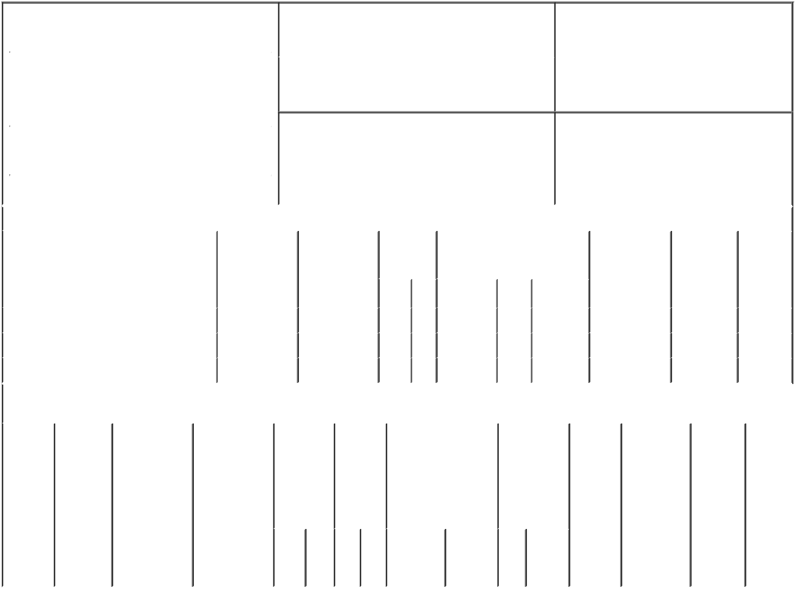

1. Name and Address of Reporting Person* |  |  |  |  |  |  | 2. Issuer Name and Ticker or Trading Symbol
 | GROENHUYSEN WILHELMUS CM |  |  |  |  |  | NovoCure Ltd [ NVCR ]
 | (Last) | (First) | (Middle) |  |  |  | 3. Date of Earliest Transaction (Month/Day/Year)
 | C/O NOVOCURE INC. |  |  |  | 03/02/2023

1550 LIBERTY RIDGE DRIVE, SUITE 115

- Relationship of Reporting Person(s) to Issuer (Check all applicable)

 | Director | 10% Owner
X | Officer (give title | Other (specify
 | below) | below)

Chief Operating Officer

 |  |  |  |  |  |  | 4. If Amendment, Date of Original Filed (Month/Day/Year) |  |  |  |  |  |  |  | 6. Individual or Joint/Group Filing (Check Applicable
 | (Street) |  |  |  |  |  |  |  |  |  |  |  |  |  | Line)
 |  |  |  |  |  |  |  |  |  |  |  |  |  |  |  | X Form filed by One Reporting Person
 |  | WAYNE | PA |  | 19087
 |  |  |  |  |  |  |  |  |  |  |  |  |  |  |  |  | Form filed by More than One Reporting
 |  |  |  |  |  |  |  |  |  |  |  |  |  |  |  |  | Person
 |  | (City) | (State) |  | (Zip)
 |  |  |  | Table I - Non-Derivative Securities Acquired, Disposed of, or Beneficially Owned
 | 1. Title of Security (Instr. 3) |  |  |  | 2. Transaction |  |  | 2A. Deemed |  |  | 3. | 4. Securities Acquired (A) or |  |  |  |  | 5. Amount of |  | 6. Ownership | 7. Nature
 |  |  |  |  | Date |  |  | Execution Date, |  |  | Transaction | Disposed Of (D) (Instr. 3, 4 and 5) |  |  |  |  | Securities |  | Form: Direct | of Indirect
 |  |  |  |  | (Month/Day/Year) |  |  | if any |  |  | Code (Instr. |  |  |  |  |  | Beneficially |  | (D) or Indirect | Beneficial
 |  |  |  |  |  |  |  | (Month/Day/Year) |  |  | 8) |  |  |  |  |  | Owned Following |  | (I) (Instr. 4) | Ownership
 |  |  |  |  |  |  |  |  |  |  |  |  |  |  |  |  | Reported |  |  | (Instr. 4)
 |  |  |  |  |  |  |  |  |  |  | Code V | Amount | (A) or | Price |  |  | Transaction(s)
 |  |  |  |  |  |  |  |  |  |  |  |  | (D) |  |  |  | (Instr. 3 and 4)
 | Ordinary Shares |  |  |  | 03/02/2023 |  |  |  |  |  | S | 1,213⁽¹⁾ | D | $75.2779 |  |  | 183,402 |  | D
 | Ordinary Shares |  |  |  | 03/03/2023 |  |  |  |  |  | A | 48,050⁽²⁾ | A | $0.00 |  |  | 231,452 |  | D
 | Ordinary Shares |  |  |  | 03/03/2023 |  |  |  |  |  | A | 3,936⁽²⁾ | A | $0.00 |  |  | 235,388 |  | D
 |  |  |  |  | Table II - Derivative Securities Acquired, Disposed of, or Beneficially Owned
 |  |  |  |  | (e.g., puts, calls, warrants, options, convertible securities)
 | 1. Title of |  | 2. | 3. Transaction | 3A. Deemed | 4. |  |  | 5. Number |  | 6. Date Exercisable and |  | 7. Title and |  |  | 8. Price of |  | 9. Number of 10. |  | 11. Nature
 | Derivative |  | Conversion | Date | Execution Date, |  | Transaction |  | of |  | Expiration Date |  | Amount of |  |  | Derivative |  | derivative | Ownership | of Indirect
 | Security |  | or Exercise | (Month/Day/Year) if any |  |  | Code (Instr. |  | Derivative |  | (Month/Day/Year) |  | Securities |  |  | Security |  | Securities | Form: | Beneficial
 | (Instr. 3) |  | Price of |  | (Month/Day/Year) | 8) |  |  | Securities |  |  |  | Underlying |  |  | (Instr. 5) |  | Beneficially | Direct (D) | Ownership
 |  |  | Derivative |  |  |  |  |  | Acquired |  |  |  | Derivative |  |  |  |  | Owned | or Indirect | (Instr. 4)
 |  |  | Security |  |  |  |  |  | (A) or |  |  |  | Security (Instr. |  |  |  |  | Following | (I) (Instr. 4)
 |  |  |  |  |  |  |  |  | Disposed |  |  |  | 3 and 4) |  |  |  |  | Reported
 |  |  |  |  |  |  |  |  | of (D) |  |  |  |  |  |  |  |  | Transaction(s)
 |  |  |  |  |  |  |  |  | (Instr. 3, 4 |  |  |  |  |  |  |  |  | (Instr. 4)
 |  |  |  |  |  |  |  |  | and 5)
 |  |  |  |  |  |  |  |  |  |  |  |  |  | Amount
 |  |  |  |  |  |  |  |  |  |  |  |  |  | or
 |  |  |  |  |  |  |  |  |  |  |  |  |  | Number
 |  |  |  |  |  |  |  |  |  |  | Date | Expiration |  | of
 |  |  |  |  |  |  | Code | V | (A) (D) |  | Exercisable | Date | Title | Shares

Explanation of Responses:

- Represents the number of shares required to be sold by the reporting person to cover tax withholding obligations in connection with the vesting of Restricted Stock Units. This sale is mandated by the issuer's award agreement under its equity incentive plans to require the satisfaction of tax withholding obligations to be funded by a "sell to cover" transaction and does not represent a discretionary trade by the reporting person.

- Represents vesting of performance-based restricted stock units.

Remarks:

Steven Robbins, as attorney in

fact for Groenhuysen, 03/06/2023
Wilhelmus CM

** Signature of Reporting Person Date

Reminder: Report on a separate line for each class of securities beneficially owned directly or indirectly.

* If the form is filed by more than one reporting person, see Instruction 4 (b)(v).

- Intentional misstatements or omissions of facts constitute Federal Criminal Violations See 18 U.S.C. 1001 and 15 U.S.C. 78ff(a). Note: File three copies of this Form, one of which must be manually signed. If space is insufficient, see Instruction 6 for procedure.

Persons who respond to the collection of information contained in this form are not required to respond unless the form displays a currently valid OMB Number.

LIMITED POWER OF ATTORNEY

FOR

SECTION 16 REPORTING PURPOSES

Know all by these presents, that the

undersigned hereby makes, constitutes and

appoints Barak Ben-Arye, Steven Robbins,

Ovie Onobrakpeya and Carrie Kane,

individually, as the undersigned's true and

lawful attorneys-in-fact, with full power and

authority as hereinafter described on behalf

of and in the name, place and stead of the

undersigned to:

- execute for, and on behalf of, the undersigned, in the undersigned's capacity as an officer, director and/or 10% beneficial owner of Novocure Limited (the "Company"), Forms 3, 4, and 5 in accordance with Section 16(a) of the Securities Exchange Act of 1934 and the rules and regulations promulgated thereunder (the "Exchange Act");

- seek or obtain, as the undersigned's representative and on the undersigned's behalf, information on transactions in the Company's securities from any third party, including brokers, employee benefit plan administrators and trustees, and the undersigned hereby authorizes any such person to release any such information to any attorneys-in-fact and further approves and ratifies any such release of information;

- do and perform any and all acts for and on behalf of the undersigned that may be necessary or desirable to prepare, complete and execute any such Form 3, 4 or 5, and any amendments thereto, or other required report and timely file such Forms or reports with the United States Securities and Exchange Commission, the New York Stock Exchange and any stock exchange or similar authority as considered necessary or advisable under Section 16(a) of the Exchange Act; and

- take any other action of any type whatsoever in connection with the foregoing which, in the opinion of such attorneys-in-fact, may be of benefit to, in the best interest of, or legally required by, the undersigned, it being understood that the documents

executed by such attorneys-in-fact on behalf of the undersigned pursuant to this Limited Power of Attorney shall be in such form and shall contain such terms and conditions as such attorneys-in-fact may approve in such attorney-in-fact's sole discretion.

The undersigned hereby gives and grants to

each such attorneys-in-fact full power and

authority to do and perform any and every

act and thing whatsoever requisite,

necessary, or proper to be done in the

exercise of any of the rights and powers

herein granted, as fully to all intents and

purposes as the undersigned might or could

do if personally present, with full power of

substitution or revocation, hereby ratifying

and confirming all that such attorneys-in-

fact, or such attorneys-in-fact's substitute or

substitutes, shall lawfully do or cause to be

done by virtue of this power of attorney and

the rights and powers herein granted.

The undersigned hereby acknowledges that

- the foregoing attorneys-in-fact are serving in such capacity at the request of the undersigned; (b) this Limited Power of Attorney authorizes, but does not require,

each such attorneys-in-fact to act in his or

her discretion on information provided to

such attorneys-in-fact without independent

verification of such information; (c) any

documents prepared and/or executed by any

attorneys-in-fact on behalf of the

undersigned pursuant to this Limited Power

of Attorney shall be in such form and shall

contain such information and disclosure as

such attorneys-in-fact, in his or her sole

discretion, deems necessary or advisable; (d)

neither the Company nor any attorneys-in-

fact assumes (i) any liability for the

undersigned's responsibility to comply with

the requirements of the Exchange Act,

- any liability of the undersigned for any failure to comply with such requirements or
- any obligation or liability of the undersigned for profit disgorgement under Section 16(b) of the Exchange Act; and (e) this Limited Power of Attorney does not relieve the undersigned from responsibility for compliance with the undersigned's obligations under the Exchange Act, including, without limitation, the reporting requirements under Section 16 of the Exchange Act.

This Limited Power of Attorney shall

remain in full force and effect until the

undersigned is no longer required to file

Forms 3, 4, and 5 with respect to the

undersigned's holdings of, and transactions

in, securities issued by the Company, unless

earlier revoked as to any attorneys-in-fact by

the undersigned in a signed writing

delivered to such attorneys-in-fact.

IN WITNESS WHEREOF, the undersigned

has caused this Power of Attorney to be

executed as of this 26th day of July, 2022.

/s/ Wilhelmus Groenhuysen

Signature

Wilhelmus Groenhuysen

Print Name

