SEC Form 4

FORM 4

Check this box if no longer subject to Section 16. Form 4 or Form 5 obligations may continue. See Instruction 1(b).

UNITED STATES SECURITIES AND EXCHANGE COMMISSION
Washington, D.C. 20549
 |  | OMB APPROVAL
STATEMENT OF CHANGES IN BENEFICIAL OWNERSHIP
 |  | OMB Number: | 3235-0287
 |  | Estimated average burden
Filed pursuant to Section 16(a) of the Securities Exchange Act of 1934 |  | hours per response: | 0.5
or Section 30(h) of the Investment Company Act of 1940
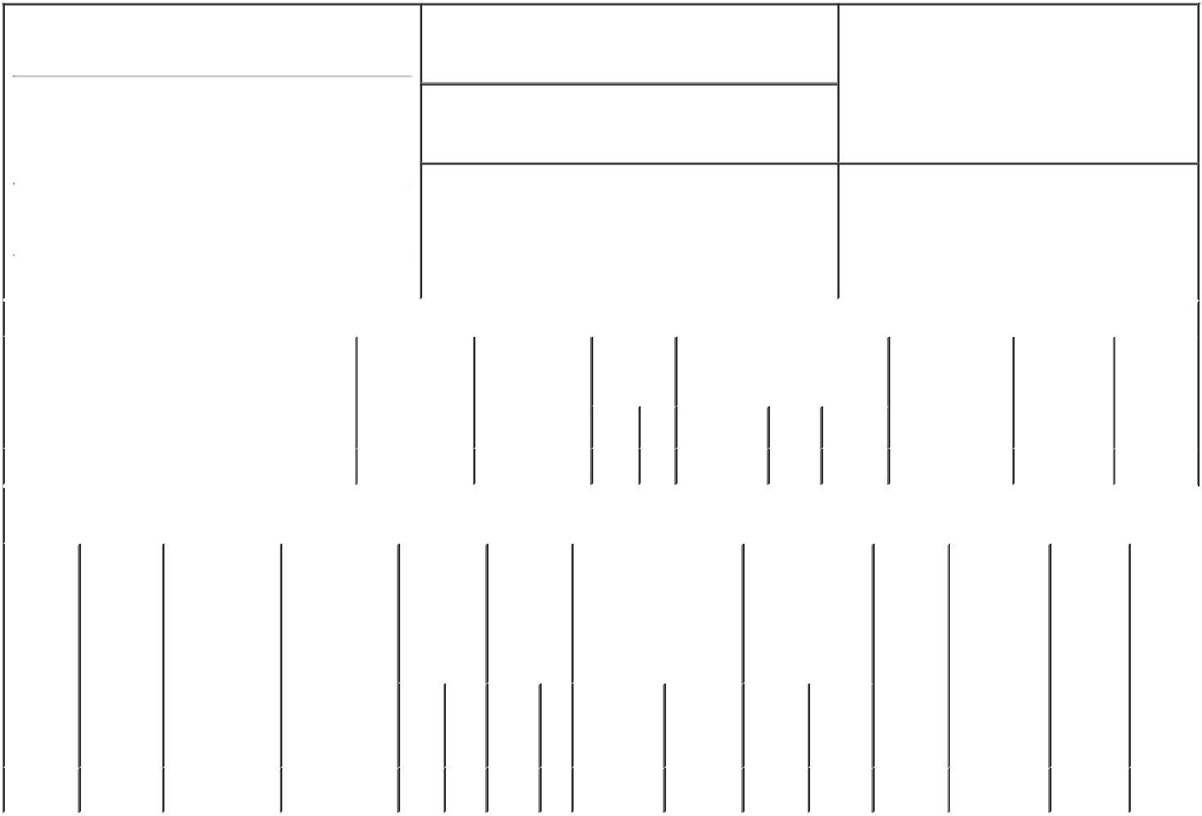

1. Name and Address of Reporting Person*
Ben Arye Barak

(Last) (First) (Middle)

C/O NOVOCURE INC.,

1550 LIBERTY RIDGE DRIVE, SUITE 115

2. Issuer Name and Ticker or Trading Symbol

NovoCure Ltd [ NVCR ]

3. Date of Earliest Transaction (Month/Day/Year)

02/28/2023

- Relationship of Reporting Person(s) to Issuer (Check all applicable)

 | Director | 10% Owner
X | Officer (give title | Other (specify
 | below) | below)

General Counsel

 |  |  |  |  |  |  | 4. If Amendment, Date of Original Filed (Month/Day/Year) |  |  |  |  |  |  |  | 6. Individual or Joint/Group Filing (Check Applicable
 | (Street) |  |  |  |  |  |  |  |  |  |  |  |  |  | Line)
 |  |  |  |  |  |  |  |  |  |  |  |  |  |  | X Form filed by One Reporting Person
 |  | WAYNE | PA |  | 19087
 |  |  |  |  |  |  |  |  |  |  |  |  |  |  |  |  | Form filed by More than One Reporting
 |  |  |  |  |  |  |  |  |  |  |  |  |  |  |  |  | Person
 |  | (City) | (State) |  | (Zip)
 |  |  |  | Table I - Non-Derivative Securities Acquired, Disposed of, or Beneficially Owned
 | 1. Title of Security (Instr. 3) |  |  |  | 2. Transaction |  |  | 2A. Deemed |  | 3. |  | 4. Securities Acquired (A) or |  |  |  |  | 5. Amount of |  | 6. Ownership |  | 7. Nature of
 |  |  |  |  | Date |  |  | Execution Date, |  |  | Transaction | Disposed Of (D) (Instr. 3, 4 and 5) |  |  |  |  | Securities |  | Form: Direct |  | Indirect
 |  |  |  |  | (Month/Day/Year) |  |  | if any |  |  | Code (Instr. |  |  |  |  |  | Beneficially |  | (D) or Indirect |  | Beneficial
 |  |  |  |  |  |  |  | (Month/Day/Year) 8) |  |  |  |  |  |  |  |  | Owned Following |  | (I) (Instr. 4) |  | Ownership
 |  |  |  |  |  |  |  |  |  |  |  |  |  |  |  |  | Reported |  |  |  | (Instr. 4)
 |  |  |  |  |  |  |  |  |  |  | Code V | Amount |  | (A) or | Price |  | Transaction(s)
 |  |  |  |  |  |  |  |  |  |  |  |  |  | (D) |  |  | (Instr. 3 and 4)
 | Ordinary Shares |  |  |  | 02/28/2023 |  |  |  |  |  | A | 17,755⁽¹⁾ |  | A | $0 |  | 34,907 |  |  | D
 |  |  |  |  | Table II - Derivative Securities Acquired, Disposed of, or Beneficially Owned
 |  |  |  |  | (e.g., puts, calls, warrants, options, convertible securities)
 | 1. Title of |  | 2. | 3. Transaction | 3A. Deemed | 4. |  | 5. Number |  | 6. Date Exercisable and |  |  | 7. Title and |  |  | 8. Price of |  | 9. Number of |  | 10. | 11. Nature
 | Derivative |  | Conversion | Date | Execution Date, | Transaction |  | of |  | Expiration Date |  |  | Amount of |  |  | Derivative |  | derivative |  | Ownership of Indirect
 | Security |  | or Exercise | (Month/Day/Year) | if any | Code (Instr. |  | Derivative |  | (Month/Day/Year) |  |  | Securities |  |  | Security |  | Securities |  | Form: | Beneficial
 | (Instr. 3) |  | Price of |  | (Month/Day/Year) | 8) |  | Securities |  |  |  |  | Underlying |  |  | (Instr. 5) |  | Beneficially |  | Direct (D) | Ownership
 |  |  | Derivative |  |  |  |  | Acquired |  |  |  |  | Derivative Security |  |  |  |  | Owned |  | or Indirect | (Instr. 4)
 |  |  | Security |  |  |  |  | (A) or |  |  |  |  | (Instr. 3 and 4) |  |  |  |  | Following |  | (I) (Instr. 4)
 |  |  |  |  |  |  |  | Disposed |  |  |  |  |  |  |  |  |  | Reported
 |  |  |  |  |  |  |  | of (D) (Instr. |  |  |  |  |  |  |  |  |  | Transaction(s)
 |  |  |  |  |  |  |  | 3, 4 and 5) |  |  |  |  |  |  |  |  |  | (Instr. 4)
 |  |  |  |  |  |  |  |  |  |  |  |  |  |  | Amount
 |  |  |  |  |  |  |  |  |  |  |  |  |  |  | or
 |  |  |  |  |  |  |  |  |  |  |  |  |  |  | Number
 |  |  |  |  |  |  |  |  |  | Date |  | Expiration |  |  | of
 |  |  |  |  |  | Code V |  | (A) | (D) | Exercisable |  | Date | Title |  | Shares
 | Ordinary |  | $76.97 | 02/28/2023 |  |  | A | 29,531 |  | 02/28/2024⁽²⁾ |  | 02/27/2033 | Ordinary |  | 29,531 |  | $76.97 | 29,531 |  | D
 | Shares |  |  |  |  |  |  |  |  |  |  |  |  | Shares

Explanation of Responses:

- Represents restricted share units that are scheduled to vest in equal installments on each of February 28, 2024, 2025 and 2026, subject to the reporting person's continued employment through such dates.

- Options to buy 29,531 ordinary shares will vest and become exercisable in equal installments on each of February 28, 2024, 2025, 2026 and 2027, subject to the reporting person's continued employment through such dates.

Remarks:

By: /s/ Steven Robbins,
Attorney in Fact for Barak Ben 03/02/2023
Arye

** Signature of Reporting Person Date

Reminder: Report on a separate line for each class of securities beneficially owned directly or indirectly.

* If the form is filed by more than one reporting person, see Instruction 4 (b)(v).

- Intentional misstatements or omissions of facts constitute Federal Criminal Violations See 18 U.S.C. 1001 and 15 U.S.C. 78ff(a). Note: File three copies of this Form, one of which must be manually signed. If space is insufficient, see Instruction 6 for procedure.
Persons who respond to the collection of information contained in this form are not required to respond unless the form displays a currently valid OMB Number.

