SEC Form 4

FORM 4

Check this box if no longer subject to Section 16. Form 4 or Form 5 obligations may continue. See Instruction 1(b).

UNITED STATES SECURITIES AND EXCHANGE COMMISSION
Washington, D.C. 20549
 |  | OMB APPROVAL
STATEMENT OF CHANGES IN BENEFICIAL OWNERSHIP
 |  | OMB Number: | 3235-0287
 |  | Estimated average burden
Filed pursuant to Section 16(a) of the Securities Exchange Act of 1934 |  | hours per response: | 0.5
or Section 30(h) of the Investment Company Act of 1940
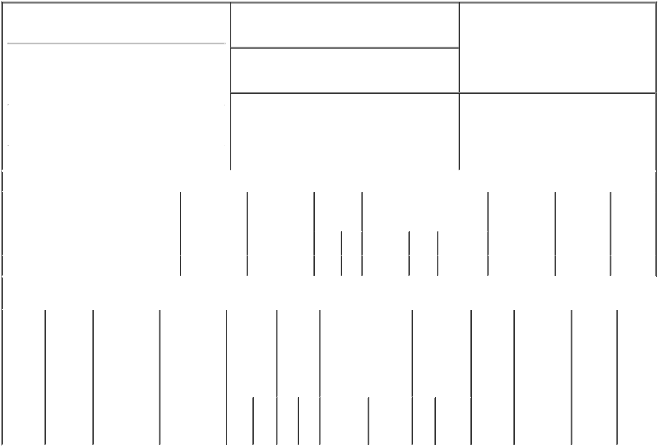

1. Name and Address of Reporting Person*
Benaim Ely

(Last) (First) (Middle)

C/O NOVOCURE INC.,

1550 LIBERTY RIDGE DRIVE, SUITE 115

2. Issuer Name and Ticker or Trading Symbol

NovoCure Ltd [ NVCR ]

3. Date of Earliest Transaction (Month/Day/Year)

01/06/2023

- Relationship of Reporting Person(s) to Issuer (Check all applicable)

 | Director | 10% Owner
X | Officer (give title | Other (specify
 | below) | below)

Chief Medical Officer

 |  |  |  |  |  |  | 4. If Amendment, Date of Original Filed (Month/Day/Year) |  |  |  |  |  |  |  | 6. Individual or Joint/Group Filing (Check Applicable
 | (Street) |  |  |  |  |  |  |  |  |  |  |  |  |  | Line)
 |  |  |  |  |  |  |  |  |  |  |  |  |  |  |  |  | X Form filed by One Reporting Person
 |  | WAYNE | PA |  | 19087
 |  |  |  |  |  |  |  |  |  |  |  |  |  |  |  |  |  | Form filed by More than One Reporting
 |  |  |  |  |  |  |  |  |  |  |  |  |  |  |  |  |  | Person
 |  | (City) | (State) |  | (Zip)
 |  |  |  | Table I - Non-Derivative Securities Acquired, Disposed of, or Beneficially Owned
 | 1. Title of Security (Instr. 3) |  |  |  | 2. Transaction |  |  | 2A. Deemed |  |  | 3. |  | 4. Securities Acquired (A) or |  |  |  |  | 5. Amount of |  | 6. Ownership | 7. Nature
 |  |  |  |  | Date |  |  | Execution Date, |  |  | Transaction |  | Disposed Of (D) (Instr. 3, 4 and 5) |  |  |  |  | Securities |  | Form: Direct | of Indirect
 |  |  |  |  | (Month/Day/Year) |  |  | if any |  |  | Code (Instr. |  |  |  |  |  |  | Beneficially |  | (D) or Indirect | Beneficial
 |  |  |  |  |  |  |  | (Month/Day/Year) |  |  | 8) |  |  |  |  |  |  | Owned Following |  | (I) (Instr. 4) | Ownership
 |  |  |  |  |  |  |  |  |  |  |  |  |  |  |  |  |  | Reported |  |  | (Instr. 4)
 |  |  |  |  |  |  |  |  |  |  | Code | V | Amount | (A) or | Price |  |  | Transaction(s)
 |  |  |  |  |  |  |  |  |  |  |  |  |  | (D) |  |  |  | (Instr. 3 and 4)
 | Ordinary Shares⁽¹⁾ |  |  |  | 01/06/2023 |  |  |  |  |  | A | V | 98 | A | $62.305⁽²⁾ |  |  | 28,770 |  | D
 |  |  |  |  | Table II - Derivative Securities Acquired, Disposed of, or Beneficially Owned
 |  |  |  |  | (e.g., puts, calls, warrants, options, convertible securities)
 | 1. Title of |  | 2. | 3. Transaction | 3A. Deemed | 4. |  |  | 5. Number |  | 6. Date Exercisable and |  |  | 7. Title and |  |  | 8. Price of |  | 9. Number of 10. |  | 11. Nature
 | Derivative |  | Conversion | Date | Execution Date, |  | Transaction |  | of |  | Expiration Date |  |  | Amount of |  |  | Derivative |  | derivative | Ownership | of Indirect
 | Security |  | or Exercise | (Month/Day/Year) if any |  |  | Code (Instr. |  | Derivative |  | (Month/Day/Year) |  |  | Securities |  |  | Security |  | Securities | Form: | Beneficial
 | (Instr. 3) |  | Price of |  | (Month/Day/Year) | 8) |  |  | Securities |  |  |  |  | Underlying |  |  | (Instr. 5) |  | Beneficially | Direct (D) | Ownership
 |  |  | Derivative |  |  |  |  |  | Acquired |  |  |  |  | Derivative |  |  |  |  | Owned | or Indirect | (Instr. 4)
 |  |  | Security |  |  |  |  |  | (A) or |  |  |  |  | Security (Instr. |  |  |  |  | Following | (I) (Instr. 4)
 |  |  |  |  |  |  |  |  | Disposed |  |  |  |  | 3 and 4) |  |  |  |  | Reported
 |  |  |  |  |  |  |  |  | of (D) |  |  |  |  |  |  |  |  |  | Transaction(s)
 |  |  |  |  |  |  |  |  | (Instr. 3, 4 |  |  |  |  |  |  |  |  |  | (Instr. 4)
 |  |  |  |  |  |  |  |  | and 5)
 |  |  |  |  |  |  |  |  |  |  |  |  |  |  | Amount
 |  |  |  |  |  |  |  |  |  |  |  |  |  |  | or
 |  |  |  |  |  |  |  |  |  |  |  |  |  |  | Number
 |  |  |  |  |  |  |  |  |  |  | Date |  | Expiration |  | of
 |  |  |  |  |  |  | Code | V | (A) (D) |  | Exercisable |  | Date | Title | Shares

Explanation of Responses:

- The reporting person is voluntarily reporting the acquisition of shares of the issuer's ordinary shares pursuant to the NovoCure Limited Employee Share Purchase Plan ("ESPP"), for the ESPP purchase period of July 1, 2022 through December 30, 2022. This transaction is also exempt under Rule 16b-3(c).

- In accordance with the ESPP, these shares were purchased based on 85% of the closing price of the issuer's ordinary shares on July 1, 2022.

Remarks:
/s/ Steven Robbins Attorney in _{01/10/2023}
Fact for Ely Benaim

** Signature of Reporting Person Date

Reminder: Report on a separate line for each class of securities beneficially owned directly or indirectly.

* If the form is filed by more than one reporting person, see Instruction 4 (b)(v).

- Intentional misstatements or omissions of facts constitute Federal Criminal Violations See 18 U.S.C. 1001 and 15 U.S.C. 78ff(a). Note: File three copies of this Form, one of which must be manually signed. If space is insufficient, see Instruction 6 for procedure.

Persons who respond to the collection of information contained in this form are not required to respond unless the form displays a currently valid OMB Number.

