SEC Form 4

FORM 4

Check this box if no longer subject to Section 16. Form 4 or Form 5 obligations may continue. See Instruction 1(b).

UNITED STATES SECURITIES AND EXCHANGE COMMISSION
Washington, D.C. 20549
 |  | OMB APPROVAL
STATEMENT OF CHANGES IN BENEFICIAL OWNERSHIP
 |  | OMB Number: | 3235-0287
 |  | Estimated average burden
Filed pursuant to Section 16(a) of the Securities Exchange Act of 1934 |  | hours per response: | 0.5
or Section 30(h) of the Investment Company Act of 1940
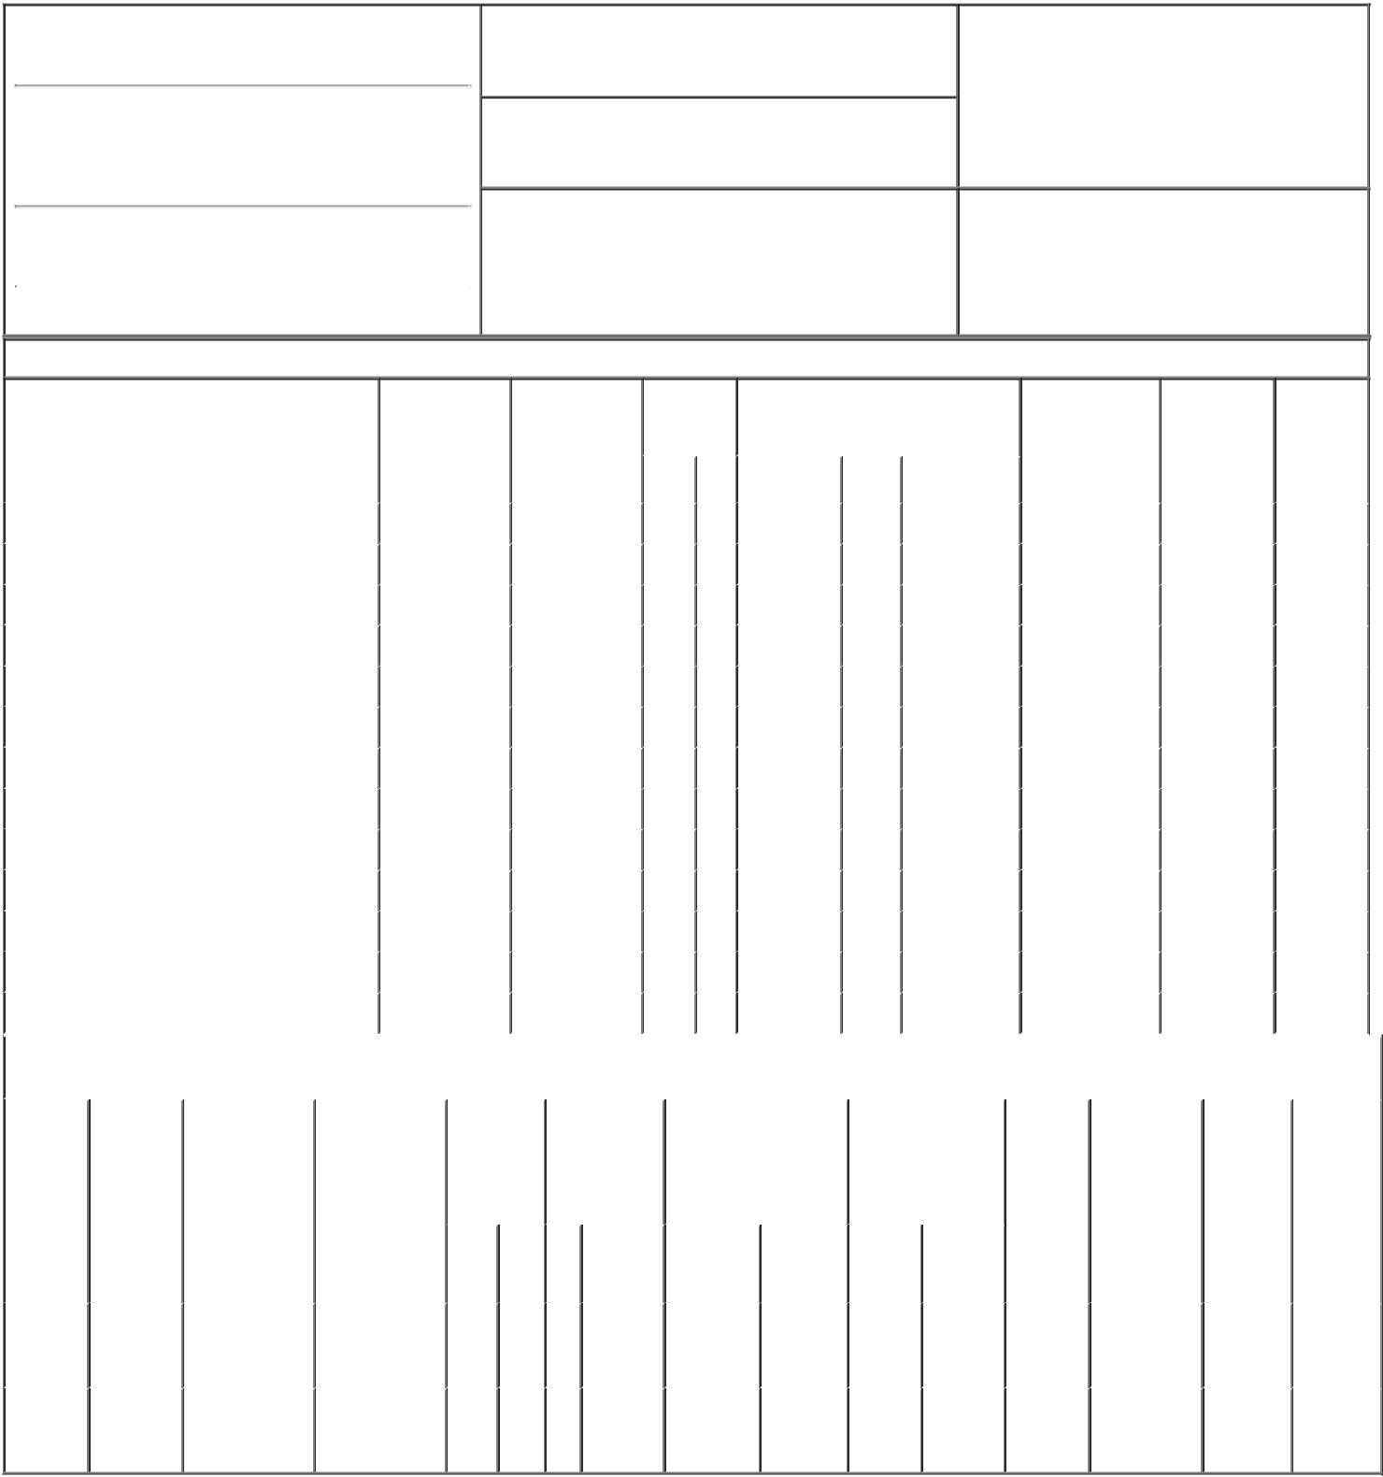

1. Name and Address of Reporting Person*
Danziger Asaf

(Last) (First) (Middle)

C/O NOVOCURE INC.

1550 LIBERTY RIDGE DRIVE, SUITE 115

2. Issuer Name and Ticker or Trading Symbol
NovoCure Ltd [ NVCR ]

3. Date of Earliest Transaction (Month/Day/Year)

01/05/2023

- Relationship of Reporting Person(s) to Issuer (Check all applicable)

X | Director | 10% Owner
X | Officer (give title | Other (specify
 | below) | below)

Chief Executive Officer

(Street)
 | WAYNE | PA | 19087
 | (City) | (State) | (Zip)

4. If Amendment, Date of Original Filed (Month/Day/Year) 6. Individual or Joint/Group Filing (Check Applicable

Line)
X Form filed by One Reporting Person

Form filed by More than One Reporting

Person

Table I - Non-Derivative Securities Acquired, Disposed of, or Beneficially Owned

 | 1. Title of Security (Instr. 3) |  |  | 2. Transaction |  | 2A. Deemed |  | 3. |  | 4. Securities Acquired (A) or Disposed |  |  |  |  |  | 5. Amount of |  | 6. Ownership |  | 7. Nature of
 |  |  |  | Date |  | Execution Date, |  | Transaction |  | Of (D) (Instr. 3, 4 and 5) |  |  |  |  |  | Securities |  | Form: Direct |  | Indirect
 |  |  |  | (Month/Day/Year) |  | if any |  | Code (Instr. |  |  |  |  |  |  |  | Beneficially |  | (D) or Indirect |  | Beneficial
 |  |  |  |  |  | (Month/Day/Year) |  | 8) |  |  |  |  |  |  |  | Owned Following |  | (I) (Instr. 4) |  | Ownership
 |  |  |  |  |  |  |  |  |  |  |  |  |  |  |  | Reported |  |  |  | (Instr. 4)
 |  |  |  |  |  |  |  | Code | V | Amount | (A) or | Price |  |  |  | Transaction(s)
 |  |  |  |  |  |  |  |  |  |  | (D) |  |  |  |  | (Instr. 3 and 4)
 | Ordinary Shares |  |  | 01/05/2023 |  |  |  | M |  | 25,000⁽¹⁾ | A |  | $11.46 |  | 38,583 |  |  |  | D
 | Ordinary Shares |  |  | 01/05/2023 |  |  |  | S |  | 8,369 | D | $111.2338⁽²⁾ |  |  | 30,214 |  |  |  | D
 | Ordinary Shares |  |  | 01/05/2023 |  |  |  | S |  | 2,000 | D | $112.8632⁽³⁾ |  |  | 28,214 |  |  |  | D
 | Ordinary Shares |  |  | 01/05/2023 |  |  |  | S |  | 4,568 | D | $114.3524⁽⁴⁾ |  |  | 23,646 |  |  |  | D
 | Ordinary Shares |  |  | 01/05/2023 |  |  |  | S |  | 3,702 | D | $115.2113⁽⁵⁾ |  |  | 19,944 |  |  |  | D
 | Ordinary Shares |  |  | 01/05/2023 |  |  |  | S |  | 1,395 | D | $116.0618⁽⁶⁾ |  |  | 18,549 |  |  |  | D
 | Ordinary Shares |  |  | 01/05/2023 |  |  |  | S |  | 999 | D | $117.0111⁽⁷⁾ |  |  | 17,550 |  |  |  | D
 | Ordinary Shares |  |  | 01/05/2023 |  |  |  | S |  | 2,123 | D | $118.4714⁽⁸⁾ |  |  | 15,427 |  |  |  | D
 | Ordinary Shares |  |  | 01/05/2023 |  |  |  | S |  | 1,344 | D | $119.3493⁽⁹⁾ |  |  | 14,083 |  |  |  | D
 | Ordinary Shares |  |  | 01/05/2023 |  |  |  | S |  | 500 | D | $119.987⁽¹⁰⁾ |  |  | 13,583 |  |  |  | D
 | Ordinary Shares |  |  | 01/05/2023 |  |  |  | M |  | 187,500⁽¹⁾ | A |  | $7.15 |  | 201,083 |  |  |  | D
 | Ordinary Shares |  |  | 01/05/2023 |  |  |  | S |  | 187,500⁽¹⁾ | D |  | $108 |  | 13,583 |  |  |  | D
 | Ordinary Shares |  |  | 01/06/2023 |  |  |  | A | V | 39 | A |  | $62.305⁽¹¹⁾ |  | 13,622 |  |  |  | D
 |  |  |  | Table II - Derivative Securities Acquired, Disposed of, or Beneficially Owned
 |  |  |  | (e.g., puts, calls, warrants, options, convertible securities)
 | 1. Title of | 2. | 3. Transaction | 3A. Deemed | 4. |  | 5. Number of | 6. Date Exercisable and |  |  | 7. Title and Amount |  |  |  | 8. Price of |  | 9. Number of |  | 10. | 11. Nature
 | Derivative | Conversion | Date | Execution Date, | Transaction |  | Derivative | Expiration Date |  |  | of Securities |  |  |  | Derivative |  | derivative |  | Ownership of Indirect
 | Security | or Exercise | (Month/Day/Year) | if any | Code (Instr. |  | Securities | (Month/Day/Year) |  |  | Underlying |  |  |  | Security |  | Securities |  | Form: | Beneficial
 | (Instr. 3) | Price of |  | (Month/Day/Year) | 8) |  | Acquired (A) or |  |  |  | Derivative Security |  |  |  | (Instr. 5) |  | Beneficially |  | Direct (D) | Ownership
 |  | Derivative |  |  |  |  | Disposed of |  |  |  | (Instr. 3 and 4) |  |  |  |  |  | Owned |  | or Indirect | (Instr. 4)
 |  | Security |  |  |  |  | (D) (Instr. 3, 4 |  |  |  |  |  |  |  |  |  | Following |  | (I) (Instr. 4)
 |  |  |  |  |  |  | and 5) |  |  |  |  |  |  |  |  |  | Reported
 |  |  |  |  |  |  |  |  |  |  |  |  |  |  |  |  | Transaction(s)
 |  |  |  |  |  |  |  |  |  |  |  |  | Amount |  |  |  | (Instr. 4)
 |  |  |  |  |  |  |  |  |  |  |  |  | or
 |  |  |  |  |  |  |  | Date |  | Expiration |  |  | Number
 |  |  |  |  | Code V |  | (A) (D) | Exercisable Date |  |  | Title |  | of Shares
 | Options to
 | Buy | $11.46 | 01/05/2023 |  | M |  | 25,000⁽¹⁾ |  | (12) | 02/24/2026 | Ordinary |  | 25,000 |  | $0 |  | 0 |  | D
 | Ordinary |  |  |  |  |  |  |  |  |  | Shares
 | Shares
 | Options to
 | Buy | $7.15 | 01/05/2023 |  | M |  | 187,500⁽¹⁾ |  | (12) | 02/22/2027 | Ordinary _{187,500} |  |  |  | $0 |  | 0 |  | D
 | Ordinary |  |  |  |  |  |  |  |  |  | Shares
Shares

Explanation of Responses:

- Transaction was made pursuant to a Rule 10b-5-1 trading plan adopted by Mr. Danziger.

- On January 5, 2023, pursuant to a Rule 10b5-1 trading plan adopted by Mr. Danziger, Mr. Danziger sold 8,369 shares in multiple trades at prices ranging from $111.00 to $111.97. The price reported above reflects the weighted average sale price. Mr. Danziger hereby undertakes to provide to the Staff, the issuer or any security holder of the issuer upon request, full information regarding the number of shares and prices at which the transaction was effected.

- On January 5, 2023, pursuant to a Rule 10b5-1 trading plan adopted by Mr. Danziger, Mr. Danziger sold 2,000 shares in multiple trades at prices ranging from $112.29 to $113.26. The price reported above reflects the weighted average sale price. Mr. Danziger hereby undertakes to provide to the Staff, the issuer or any security holder of the issuer upon request, full information regarding the number of shares and prices at which the transaction was effected.

- On January 5, 2023, pursuant to a Rule 10b5-1 trading plan adopted by Mr. Danziger, Mr. Danziger sold 4,568 shares in multiple trades at prices ranging from $113.76 to $114.75. The price reported above reflects the weighted average sale price. Mr. Danziger hereby undertakes to provide to the Staff, the issuer or any security holder of the issuer upon request, full information regarding the number of shares and prices at which the transaction was effected.

- On January 5, 2023, pursuant to a Rule 10b5-1 trading plan adopted by Mr. Danziger, Mr. Danziger sold 3,702 shares in multiple trades at prices ranging from $114.79 to $115.78. The price reported above reflects the weighted average sale price. Mr. Danziger hereby undertakes to provide to the Staff, the issuer or any security holder of the issuer upon request, full information regarding the number of shares and prices at which the transaction was effected.

- On January 5, 2023, pursuant to a Rule 10b5-1 trading plan adopted by Mr. Danziger, Mr. Danziger sold 1,395 shares in multiple trades at prices ranging from $115.79 to $116.45. The price reported above reflects the weighted average sale price. Mr. Danziger hereby undertakes to provide to the Staff, the issuer or any security holder of the issuer upon request, full information regarding the number of shares and prices at which the transaction was effected.

- On January 5, 2023, pursuant to a Rule 10b5-1 trading plan adopted by Mr. Danziger, Mr. Danziger sold 999 shares in multiple trades at prices ranging from $116.85 to $117.82. The price reported above reflects

the weighted average sale price. Mr. Danziger hereby undertakes to provide to the Staff, the issuer or any security holder of the issuer upon request, full information regarding the number of shares and prices at which the transaction was effected.

- On January 5, 2023, pursuant to a Rule 10b5-1 trading plan adopted by Mr. Danziger, Mr. Danziger sold 2,123 shares in multiple trades at prices ranging from $117.91 to $118.90. The price reported above reflects the weighted average sale price. Mr. Danziger hereby undertakes to provide to the Staff, the issuer or any security holder of the issuer upon request, full information regarding the number of shares and prices at which the transaction was effected.

- On January 5, 2023, pursuant to a Rule 10b5-1 trading plan adopted by Mr. Danziger, Mr. Danziger sold 1,344 shares in multiple trades at prices ranging from $118.95 to $119.84. The price reported above reflects the weighted average sale price. Mr. Danziger hereby undertakes to provide to the Staff, the issuer or any security holder of the issuer upon request, full information regarding the number of shares and prices at which the transaction was effected.

- On January 5, 2023, pursuant to a Rule 10b5-1 trading plan adopted by Mr. Danziger, Mr. Danziger sold 500 shares in multiple trades at prices ranging from $119.98 to $120.00. The price reported above reflects the weighted average sale price. Mr. Danziger hereby undertakes to provide to the Staff, the issuer or any security holder of the issuer upon request, full information regarding the number of shares and prices at which the transaction was effected.

- In accordance with the issuer's Employee Share Purchase Plan, these shares were purchased based on 85% of the closing price of the issuer's ordinary shares on July 1, 2022.

- Fully vested as of the date hereof.

Remarks:

By: /s/ Steven Robbins,

Attorney in Fact for Asaf 01/09/2023
Danziger

** Signature of Reporting Person Date

Reminder: Report on a separate line for each class of securities beneficially owned directly or indirectly.

* If the form is filed by more than one reporting person, see Instruction 4 (b)(v).

- Intentional misstatements or omissions of facts constitute Federal Criminal Violations See 18 U.S.C. 1001 and 15 U.S.C. 78ff(a). Note: File three copies of this Form, one of which must be manually signed. If space is insufficient, see Instruction 6 for procedure.
Persons who respond to the collection of information contained in this form are not required to respond unless the form displays a currently valid OMB Number.

