SEC Form 4

FORM 4

Check this box if no longer subject to Section 16. Form 4 or Form 5 obligations may continue. See Instruction 1(b).

UNITED STATES SECURITIES AND EXCHANGE COMMISSION
Washington, D.C. 20549
 |  | OMB APPROVAL
STATEMENT OF CHANGES IN BENEFICIAL OWNERSHIP
 |  | OMB Number: | 3235-0287
 |  | Estimated average burden
Filed pursuant to Section 16(a) of the Securities Exchange Act of 1934 |  | hours per response: | 0.5
or Section 30(h) of the Investment Company Act of 1940
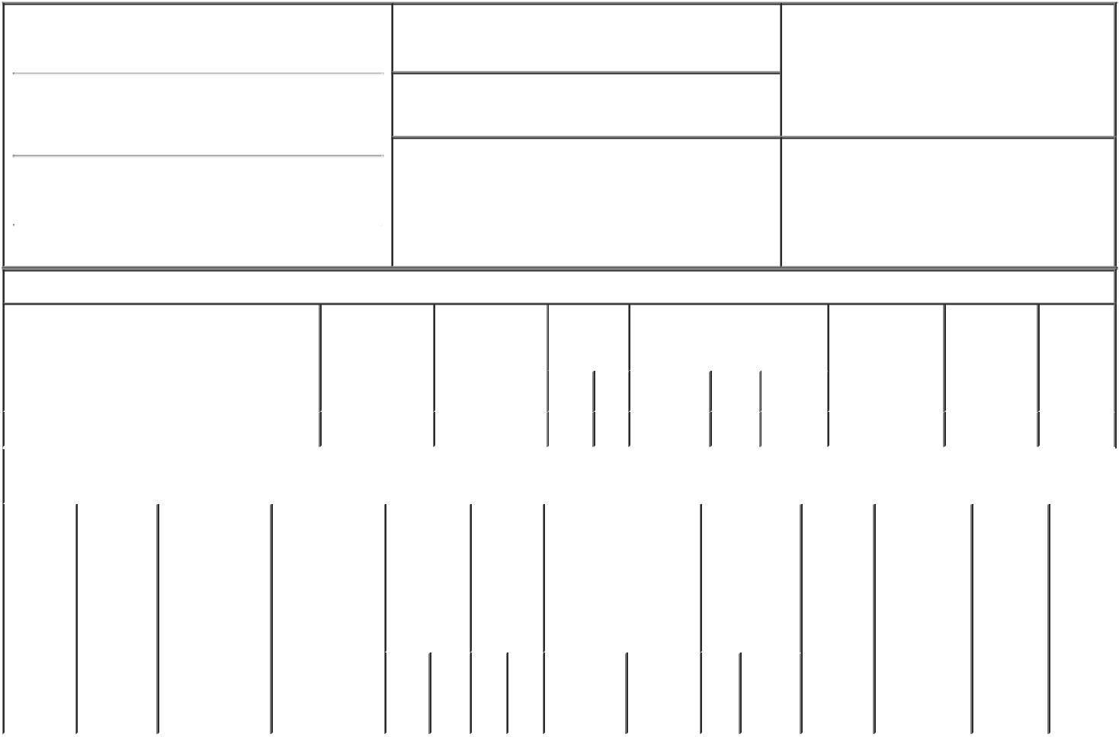

1. Name and Address of Reporting Person*
Anderson Enshalla

(Last) (First) (Middle)

4 LIBERTY LANE WEST

2. Issuer Name and Ticker or Trading Symbol

Planet Fitness, Inc. [ PLNT ]

3. Date of Earliest Transaction (Month/Day/Year)

07/01/2022

- Relationship of Reporting Person(s) to Issuer (Check all applicable)
X Director 10% Owner

Officer (give title Other (specify
below) below)

(Street)
 | HAMPTON | NH | 03842
 | (City) | (State) | (Zip)

4. If Amendment, Date of Original Filed (Month/Day/Year) 6. Individual or Joint/Group Filing (Check Applicable
Line)
X Form filed by One Reporting Person

Form filed by More than One Reporting
Person

Table I - Non-Derivative Securities Acquired, Disposed of, or Beneficially Owned

 | 1. Title of Security (Instr. 3) |  |  | 2. Transaction |  | 2A. Deemed |  | 3. | 4. Securities Acquired (A) or |  |  |  |  |  | 5. Amount of |  | 6. Ownership | 7. Nature
 |  |  |  | Date |  | Execution Date, |  | Transaction | Disposed Of (D) (Instr. 3, 4 and Securities |  |  |  |  |  |  |  | Form: Direct | of Indirect
 |  |  |  | (Month/Day/Year) |  | if any |  | Code (Instr. | 5) |  |  |  |  |  | Beneficially |  | (D) or Indirect | Beneficial
 |  |  |  |  |  | (Month/Day/Year) |  | 8) |  |  |  |  |  |  | Owned Following |  | (I) (Instr. 4) | Ownership
 |  |  |  |  |  |  |  |  |  |  |  |  |  |  | Reported |  |  | (Instr. 4)
 |  |  |  |  |  |  |  | Code V | Amount | (A) or |  | Price |  |  | Transaction(s)
 |  |  |  |  |  |  |  |  |  | (D) |  |  |  |  | (Instr. 3 and 4)
 | Class A Common Stock |  |  | 07/01/2022 |  |  |  | A | 324 | A |  | $0.00⁽¹⁾ |  |  |  | 4,249 | D
 |  |  | Table II - Derivative Securities Acquired, Disposed of, or Beneficially Owned
 |  |  |  | (e.g., puts, calls, warrants, options, convertible securities)
 | 1. Title of | 2. | 3. Transaction | 3A. Deemed | 4. |  | 5. Number | 6. Date Exercisable and |  | 7. Title and |  |  |  | 8. Price of |  | 9. Number of 10. |  | 11. Nature
 | Derivative | Conversion | Date | Execution Date, | Transaction |  | of | Expiration Date |  | Amount of |  |  |  | Derivative |  | derivative | Ownership | of Indirect
 | Security | or Exercise | (Month/Day/Year) | if any | Code (Instr. |  | Derivative | (Month/Day/Year) |  | Securities |  |  |  | Security |  | Securities | Form: | Beneficial
 | (Instr. 3) | Price of |  | (Month/Day/Year) | 8) |  | Securities |  |  | Underlying |  |  |  | (Instr. 5) |  | Beneficially | Direct (D) | Ownership
 |  | Derivative |  |  |  |  | Acquired |  |  | Derivative |  |  |  |  |  | Owned | or Indirect | (Instr. 4)
 |  | Security |  |  |  |  | (A) or |  |  | Security (Instr. |  |  |  |  |  | Following | (I) (Instr. 4)
 |  |  |  |  |  |  | Disposed |  |  | 3 and 4) |  |  |  |  |  | Reported
 |  |  |  |  |  |  | of (D) |  |  |  |  |  |  |  |  | Transaction(s)
 |  |  |  |  |  |  | (Instr. 3, 4 |  |  |  |  |  |  |  |  | (Instr. 4)
 |  |  |  |  |  |  | and 5)
 |  |  |  |  |  |  |  |  |  |  | Amount
 |  |  |  |  |  |  |  |  |  |  | or
 |  |  |  |  |  |  |  |  |  |  | Number
 |  |  |  |  |  |  |  | Date | Expiration |  | of
 |  |  |  |  | Code | V | (A) (D) | Exercisable | Date | Title | Shares

Explanation of Responses:

1. Represents a grant of the issuer's common stock that vests on the grant date.

Remarks:
/s/ Justin Vartanian, Attorney- _{07/06/2022}
in-Fact

** Signature of Reporting Person Date

Reminder: Report on a separate line for each class of securities beneficially owned directly or indirectly.

* If the form is filed by more than one reporting person, see Instruction 4 (b)(v).

- Intentional misstatements or omissions of facts constitute Federal Criminal Violations See 18 U.S.C. 1001 and 15 U.S.C. 78ff(a). Note: File three copies of this Form, one of which must be manually signed. If space is insufficient, see Instruction 6 for procedure.
Persons who respond to the collection of information contained in this form are not required to respond unless the form displays a currently valid OMB Number.

POWER OF ATTORNEY

The undersigned hereby constitutes and appoints Dorvin Lively, Justin Vartanian and Darrell Chichester, with full power of substitution, as the undersigned's true and lawful attorney-in-fact to:

- prepare, execute in the undersigned's name and on the undersigned's behalf, and submit to the U.S. Securities and Exchange Commission (the "SEC") a Form ID, including amendments thereto, and any other documents necessary or appropriate to obtain codes and passwords enabling the undersigned to make electronic filings with the SEC of reports required by Section 16(a) of the Securities Exchange Act of 1934, as amended, or any rule or regulation of the SEC;

- execute for and on behalf of the undersigned, in the undersigned's capacity as officer and/or director of Planet Fitness, Inc. (the "Company"), Forms 3, 4, and 5 in accordance with Section 16(a) of the Securities Exchange Act of 1934, as amended, and the rules thereunder;

- do and perform any and all acts for and on behalf of the undersigned that may be necessary or desirable to complete and execute any such Form 3, 4, or 5, complete and execute any amendment or amendments thereto, and timely file such form with the SEC and any stock exchange or similar authority; and

- take any other action of any type whatsoever in connection with the foregoing that, in the opinion of such attorney-in-fact, may be of benefit to, in the best interest of, or legally required by, the undersigned, it being understood that the documents executed by such attorney-in-fact on behalf of the undersigned pursuant to this Power of Attorney shall be in such form and shall contain such terms and conditions as such attorney-in-fact may approve in such attorney-in-fact's discretion.

The undersigned hereby grants to each such attorney-in-fact full power and authority to do and perform any and every act and thing whatsoever requisite, necessary, or proper to be done in the exercise of any of the rights and powers herein granted, as fully to all intents and purposes as the undersigned might or could do if personally present, with full power of substitution or revocation, hereby ratifying and confirming all that such attorney-in-fact, or such attorney-in-fact's substitute or substitutes, shall lawfully do or cause to be done by virtue of this power of attorney and the rights and powers herein granted. The undersigned acknowledges that the foregoing attorney-in-fact, in serving in such capacity at the request of the undersigned, is not assuming, nor is the Company assuming, any of the undersigned's responsibilities to comply with Section 16 of the Securities Exchange Act of 1934, as amended.

This Power of Attorney shall remain in full force and effect until the undersigned is no longer required to file Forms 3, 4, and 5 with respect to the undersigned's holdings of and transactions in securities issued by the Company, unless earlier revoked by the undersigned in a signed writing delivered to the foregoing attorney-in-fact.

[Remainder of page intentionally left blank]

IN WITNESS WHEREOF, the undersigned has caused this Power of Attorney to be executed as of January 20, 2020.

/s/ Enshalla Anderson

----------------------------------------

Enshalla Anderson

