SEC Form 4

FORM 4

Check this box if no longer subject to Section 16. Form 4 or Form 5 obligations may continue. See Instruction 1(b).

UNITED STATES SECURITIES AND EXCHANGE COMMISSION
Washington, D.C. 20549
 |  | OMB APPROVAL
STATEMENT OF CHANGES IN BENEFICIAL OWNERSHIP
 |  | OMB Number: | 3235-0287
 |  | Estimated average burden
Filed pursuant to Section 16(a) of the Securities Exchange Act of 1934 |  | hours per response: | 0.5
or Section 30(h) of the Investment Company Act of 1940
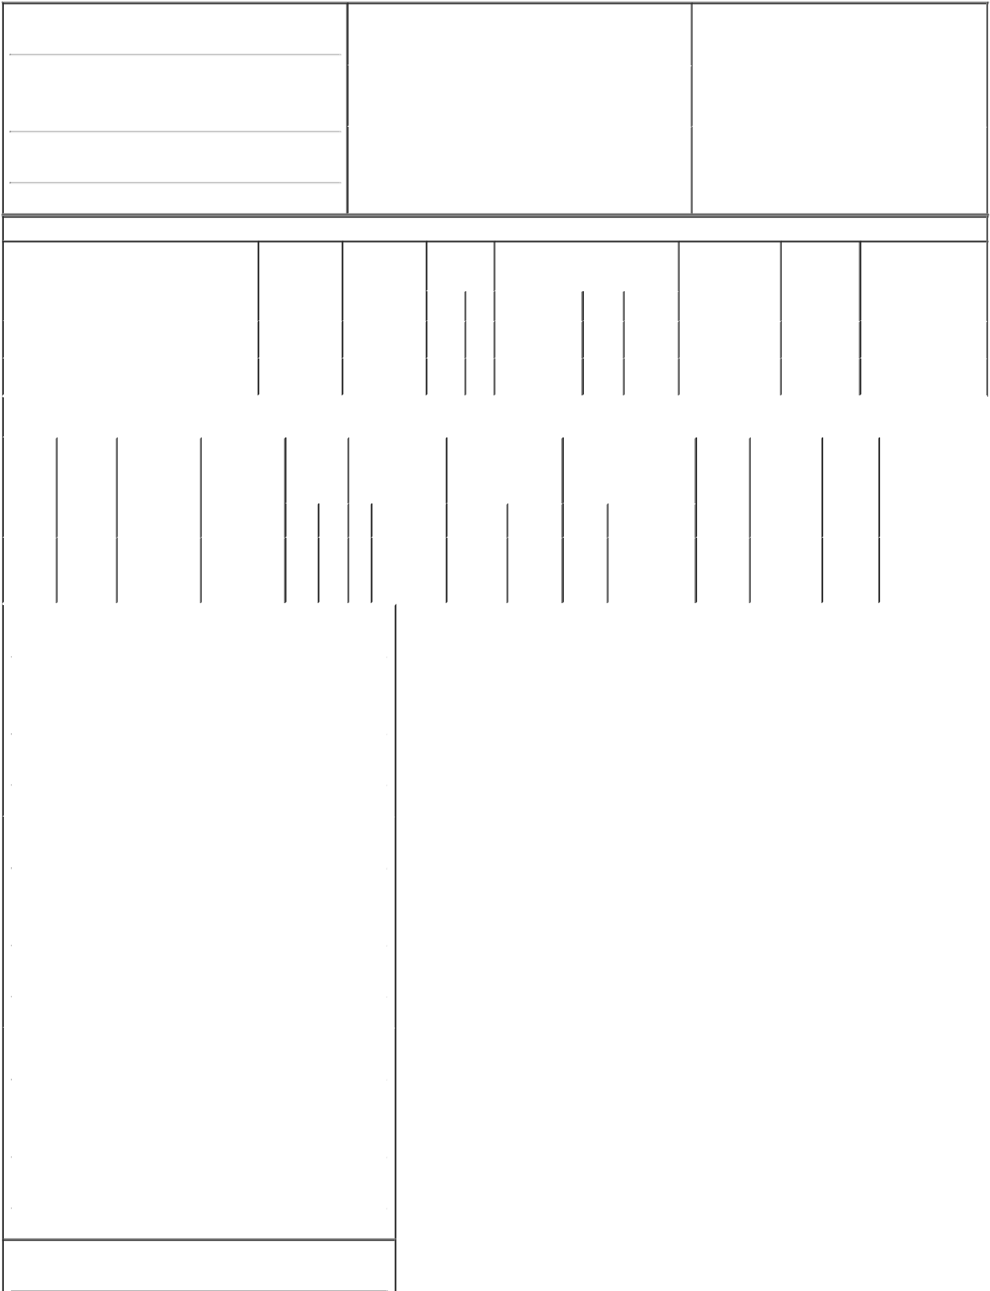

1. Name and Address of Reporting Person*
TSG6 Management L.L.C.

(Last) (First) (Middle)

C/O TSG CONSUMER PARTNERS, LLC 600 MONTGOMERY STREET, SUITE 2900

(Street)
SAN FRANCISCO CA | 94111

2. |  | Issuer Name and Ticker or Trading Symbol |  | 5. Relationship of Reporting Person(s) to Issuer
Planet Fitness, Inc. [ PLNT ] |  |  |  | (Check all applicable)
 |  |  |  |  | Director | X | 10% Owner
 |  |  |  |  | Officer (give title |  | Other (specify
3. |  | Date of Earliest Transaction (Month/Day/Year) |  |  | below) |  | below)
05/10/2017
4. |  | If Amendment, Date of Original Filed (Month/Day/Year) |  | 6. Individual or Joint/Group Filing (Check Applicable Line)
 |  |  |  |  | Form filed by One Reporting Person
 |  |  |  | X | Form filed by More than One Reporting Person

(City) (State) (Zip)

Table I - Non-Derivative Securities Acquired, Disposed of, or Beneficially Owned

1. Title of Security (Instr. 3) | 2. Transaction | 2A. Deemed | 3. |  | 4. Securities Acquired (A) or Disposed |  |  | 5. Amount of | 6. Ownership | 7. Nature of Indirect
 | Date | Execution Date, | Transaction |  | Of (D) (Instr. 3, 4 and 5) |  |  | Securities | Form: Direct (D) | Beneficial Ownership
 | (Month/Day/Year) | if any | Code (Instr. |  |  |  |  | Beneficially Owned | or Indirect (I) | (Instr. 4)
 |  | (Month/Day/Year) | 8) |  |  |  |  | Following Reported | (Instr. 4)
 |  |  |  |  |  |  |  | Transaction(s) (Instr.
 |  |  | Code | V | Amount | (A) or | Price | 3 and 4)
 |  |  |  |  |  | (D)

Class A common stock |  |  |  |  |  |  |  | 05/10/2017 |  |  |  | _{C}(1)(2) |  | 10,869,819⁽¹⁾⁽²⁾ |  | A | $0.00 |  | 16,085,510⁽¹⁾⁽²⁾ |  |  | I | _{See footnotes}(1)(2)(3)(4)
 |  |  |  |  |  |  |  |  |  |  |  |  |  |  |  |  |  |  |  |  |  |  | (5)(6)(7)
Class A common stock |  |  |  |  |  |  |  | 05/10/2017 |  |  |  | _{S}(3) |  | 16,085,510⁽³⁾ |  | D | $20.28 |  | 0 |  |  | I | See footnotes⁽¹⁾⁽²⁾⁽³⁾⁽⁴⁾
 |  |  |  |  |  |  |  |  |  |  |  |  |  |  |  |  |  |  |  |  |  |  | (5)(6)(7)
 |  |  |  |  |  |  |  | Table II - Derivative Securities Acquired, Disposed of, or Beneficially Owned
 |  |  |  |  |  |  |  |  | (e.g., puts, calls, warrants, options, convertible securities)
1. Title of |  |  | 2. | 3. Transaction |  |  |  | 3A. Deemed | 4. | 5. Number of |  |  | 6. Date Exercisable and |  | 7. Title and Amount of |  |  |  |  | 8. Price of | 9. Number of | 10. | 11. Nature of Indirect
Derivative |  |  | Conversion | Date |  |  |  | Execution Date, | Transaction | Derivative |  |  | Expiration Date |  | Securities Underlying |  |  |  |  | Derivative | derivative | Ownership Beneficial Ownership
Security |  |  | or Exercise | (Month/Day/Year) |  |  |  | if any | Code (Instr. | Securities Acquired |  |  | (Month/Day/Year) |  | Derivative Security (Instr. 3 |  |  |  |  | Security | Securities | Form: | (Instr. 4)
(Instr. 3) |  |  | Price of |  |  |  |  | (Month/Day/Year) | 8) | (A) or Disposed of |  |  |  |  | and 4) |  |  |  |  | (Instr. 5) | Beneficially | Direct (D)
 |  |  | Derivative |  |  |  |  |  |  | (D) (Instr. 3, 4 and 5) |  |  |  |  |  |  |  |  |  |  | Owned | or Indirect
 |  |  | Security |  |  |  |  |  |  |  |  |  |  |  |  |  |  |  |  |  | Following | (I) (Instr. 4)
 |  |  |  |  |  |  |  |  |  |  |  |  |  |  |  |  |  |  |  |  | Reported
 |  |  |  |  |  |  |  |  |  |  |  |  | Date | Expiration |  |  | Amount or |  |  |  | Transaction(s)
 |  |  |  |  |  |  |  |  | Code V | (A) (D) |  |  | Exercisable Date |  | Title |  | Number of Shares |  |  |  | (Instr. 4)
Holding
Units and |  |  | (4) | 05/10/2017 |  |  |  |  | C | 10,869,819⁽¹⁾⁽²⁾ |  |  | (4) | (4) | Class A |  | 10,869,819 | (1)(2) | $0.00 |  | ₀(1)(2) | I | _{See footnotes}(1)(2)(3)(4)(5)
Class B |  |  |  |  |  |  |  |  |  |  |  |  |  |  | common |  |  |  |  |  |  |  | (6)(7)
common |  |  |  |  |  |  |  |  |  |  |  |  |  |  | stock
stock
1. Name and Address of Reporting Person*
 | TSG6 Management L.L.C.
 | (Last) |  |  | (First) |  |  |  | (Middle)
 | C/O TSG CONSUMER PARTNERS, LLC
 | 600 MONTGOMERY STREET, SUITE 2900
(Street)
 | SAN FRANCISCO |  |  | CA |  |  |  | 94111
 | (City) |  |  | (State) |  |  |  | (Zip)
1. Name and Address of Reporting Person*
 | TSG6 AIV II-A L.P.
 | (Last) |  |  | (First) |  |  |  | (Middle)
 | C/O TSG CONSUMER PARTNERS, LLC
 | 600 MONTGOMERY STREET, SUITE 2900
(Street)
 | SAN FRANCISCO |  |  | CA |  |  |  | 94111
 | (City) |  |  | (State) |  |  |  | (Zip)
1. Name and Address of Reporting Person*
 | TSG6 PF Co-Investors A L.P.
 | (Last) |  |  | (First) |  |  |  | (Middle)
 | C/O TSG CONSUMER PARTNERS, LLC
 | 600 MONTGOMERY STREET, SUITE 2900
(Street)
 | SAN FRANCISCO |  |  | CA |  |  |  | 94111
 | (City) |  |  | (State) |  |  |  | (Zip)

1. Name and Address of Reporting Person*

TSG6 AIV II L.P.

 | (Last) |  | (First) |  |  | (Middle)
 | C/O TSG CONSUMER PARTNERS, LLC
 | 600 MONTGOMERY STREET, SUITE 2900
(Street)
 | SAN FRANCISCO |  | CA |  |  | 94111
 | (City) |  | (State) |  |  | (Zip)
1. Name and Address of Reporting Person*
 | TSG PF Investment LLC
 | (Last) |  | (First) |  |  | (Middle)
 | C/O TSG CONSUMER PARTNERS, LLC
 | 600 MONTGOMERY STREET, SUITE 2900
(Street)
 | SAN FRANCISCO |  | CA |  |  | 94111
 | (City) |  | (State) |  |  | (Zip)
1. Name and Address of Reporting Person*
 | TSG PF Investment II L.L.C.
 | (Last) |  | (First) |  |  | (Middle)
 | C/O TSG CONSUMER PARTNERS, LLC
 | 600 MONTGOMERY STREET, SUITE 2900
(Street)
 | SAN FRANCISCO |  | CA |  |  | 94111
 | (City) |  | (State) |  |  | (Zip)
Explanation of Responses:

- On May 10, 2017, (i) TSG PF Investment LLC ("Investment") exchanged 9,370,304 Common Units of Pla-Fit Holdings, LLC ("Holding Units") and 9,370,304 shares of Class B common stock of Planet Fitness, Inc. (the "Company") for 9,370,304 shares of Class A common stock of the Company, and substantially simultaneously sold all 9,370,304 shares of Class A common stock of the Company to the underwriter in the Company's secondary offering, which closed on May 10, 2017 (the "Offering"), and (ii) TSG PF Investment II LLC ("Investment II") exchanged 1,499,515 Holding Units and 1,499,515 shares of Class B common stock of the Company for 1,499,515 shares of Class A common stock of the Company, and substantially simultaneously sold all 1,499,515 shares of Class A common stock of the Company to the underwriter in the Offering.

- (Continued from Footnote 1) Following such sales, neither Investment nor Investment II holds any Holding Units or shares of Class B common stock of the Company.

- On May 10, 2017, (i) TSG6 AIV II-A L.P. ("AIV II-A") sold 2,471,391 shares of Class A common stock of the Company to the underwriter in the Offering and (ii) TSG6 PF Co-Investors A L.P. ("Co-Investors A") sold 2,744,300 shares of Class A common stock of the Company to the underwriter in the Offering. Following such sales, neither AIV II-A nor Co-Investors A holds any shares of Class A common stock of the Company.
- Pursuant to the terms of the Exchange Agreement dated as of August 5, 2015, as amended, by and among the Company, Pla-Fit Holdings, LLC and the holders from time to time of Holding Units and shares of Class B common stock of the Company, Investment and Investment II may each exchange all or a portion of its Holding Units (along with an equal number of its shares of Class B common stock of the Company) for shares of Class A common stock of the Company on a one-to-one basis. The Holding Units do not expire and holders thereof are not required to pay an exercise price in connection with exchanges. The Class B common stock provides the holder with one vote on all matters submitted to a vote of the Company's stockholders but does not entitle the holder to any of the economic rights associated with shares of the Company's Class A common stock.

- TSG6 Management L.L.C. is the general partner of each of AIV II-A, Co-Investors A and TSG6 AIV II L.P., which is the managing member of Investment and Investment II, and therefore may be deemed to share voting and dispositive power with respect to the securities reported herein.

- The Reporting Persons disclaim beneficial ownership of the securities reported herein except to the extent of any pecuniary interest therein.

- The Reporting Persons are jointly filing this Form 4 pursuant to Rule 16a-3(j) under the Exchange Act.

Remarks:

R. Wallace Wertsch is signing on behalf of the Reporting Persons pursuant to Powers of Attorney dated July 29, 2015, which were previously filed with the Securities and Exchange Commission.

/s/ R. Wallace Wertsch |  | 05/12/2017
** Signature of Reporting Person |  | Date

Reminder: Report on a separate line for each class of securities beneficially owned directly or indirectly.

* If the form is filed by more than one reporting person, see Instruction 4 (b)(v).

- Intentional misstatements or omissions of facts constitute Federal Criminal Violations See 18 U.S.C. 1001 and 15 U.S.C. 78ff(a). Note: File three copies of this Form, one of which must be manually signed. If space is insufficient, see Instruction 6 for procedure.
Persons who respond to the collection of information contained in this form are not required to respond unless the form displays a currently valid OMB Number.

