SEC Form 4

FORM 4

Check this box if no longer subject to Section 16. Form 4 or Form 5 obligations may continue. See Instruction 1(b).

UNITED STATES SECURITIES AND EXCHANGE COMMISSION
Washington, D.C. 20549
 |  | OMB APPROVAL
STATEMENT OF CHANGES IN BENEFICIAL OWNERSHIP
 |  | OMB Number: | 3235-0287
 |  | Estimated average burden
Filed pursuant to Section 16(a) of the Securities Exchange Act of 1934 |  | hours per response: | 0.5
or Section 30(h) of the Investment Company Act of 1940
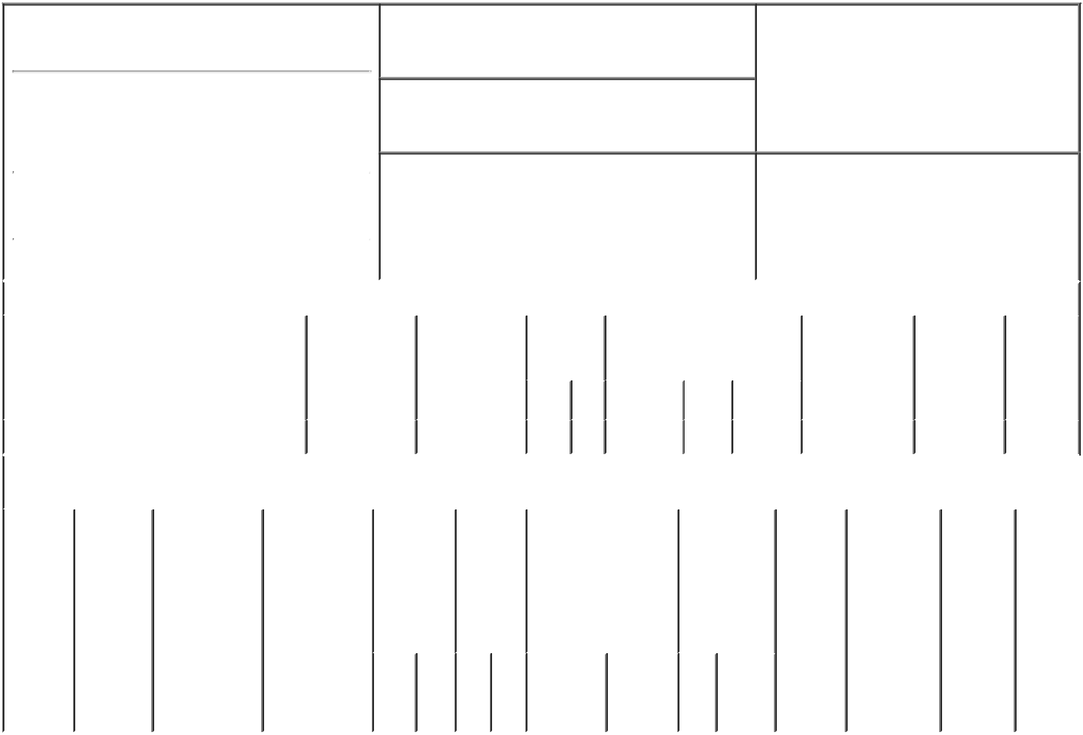

1. Name and Address of Reporting Person*
Mayerle Stephanie E

(Last) (First) (Middle)

1000 ABERNATHY ROAD NE BUILDING 400, SUITE 1700

2. Issuer Name and Ticker or Trading Symbol

Veritiv Corp [ VRTV ]

3. Date of Earliest Transaction (Month/Day/Year)

01/01/2023

- Relationship of Reporting Person(s) to Issuer (Check all applicable)

 | Director | 10% Owner
X | Officer (give title | Other (specify
 | below) | below)
 | SVP Sales

 |  |  |  |  |  |  |  | 4. If Amendment, Date of Original Filed (Month/Day/Year) |  |  |  |  |  | 6. Individual or Joint/Group Filing (Check Applicable
 | (Street) |  |  |  |  |  |  |  |  |  |  |  |  | Line)
 |  |  |  |  |  |  |  |  |  |  |  |  |  |  |  | X Form filed by One Reporting Person
 |  | ATLANTA |  | GA |  | 30328-3091
 |  |  |  |  |  |  |  |  |  |  |  |  |  |  |  |  | Form filed by More than One Reporting
 |  |  |  |  |  |  |  |  |  |  |  |  |  |  |  |  | Person
 |  | (City) |  | (State) |  | (Zip)
 |  |  |  |  | Table I - Non-Derivative Securities Acquired, Disposed of, or Beneficially Owned
 | 1. Title of Security (Instr. 3) |  |  |  |  | 2. Transaction |  |  | 2A. Deemed |  | 3. | 4. Securities Acquired (A) or |  |  |  |  | 5. Amount of |  | 6. Ownership | 7. Nature
 |  |  |  |  |  | Date |  |  | Execution Date, |  | Transaction | Disposed Of (D) (Instr. 3, 4 and |  |  |  |  | Securities |  | Form: Direct | of Indirect
 |  |  |  |  |  | (Month/Day/Year) |  |  | if any |  | Code (Instr. | 5) |  |  |  |  | Beneficially |  | (D) or Indirect | Beneficial
 |  |  |  |  |  |  |  |  | (Month/Day/Year) |  | 8) |  |  |  |  |  | Owned Following |  | (I) (Instr. 4) | Ownership
 |  |  |  |  |  |  |  |  |  |  |  |  |  |  |  |  | Reported |  |  | (Instr. 4)
 |  |  |  |  |  |  |  |  |  |  | Code V | Amount | (A) or | Price |  |  | Transaction(s)
 |  |  |  |  |  |  |  |  |  |  |  |  | (D) |  |  |  | (Instr. 3 and 4)
 | Common Stock |  |  |  |  | 01/01/2023 |  |  |  |  | F | 62 | D | $121.71 |  |  | 10,402 |  | D
 |  |  |  |  |  | Table II - Derivative Securities Acquired, Disposed of, or Beneficially Owned
 |  |  |  |  |  | (e.g., puts, calls, warrants, options, convertible securities)
 | 1. Title of |  | 2. |  | 3. Transaction | 3A. Deemed | 4. |  |  | 5. Number | 6. Date Exercisable and |  | 7. Title and |  |  | 8. Price of |  | 9. Number of 10. |  | 11. Nature
 | Derivative |  | Conversion |  | Date | Execution Date, |  | Transaction |  | of | Expiration Date |  | Amount of |  |  | Derivative |  | derivative | Ownership | of Indirect
 | Security |  | or Exercise |  | (Month/Day/Year) if any |  |  | Code (Instr. |  | Derivative | (Month/Day/Year) |  | Securities |  |  | Security |  | Securities | Form: | Beneficial
 | (Instr. 3) |  | Price of |  |  | (Month/Day/Year) | 8) |  |  | Securities |  |  | Underlying |  |  | (Instr. 5) |  | Beneficially | Direct (D) | Ownership
 |  |  | Derivative |  |  |  |  |  |  | Acquired |  |  | Derivative |  |  |  |  | Owned | or Indirect | (Instr. 4)
 |  |  | Security |  |  |  |  |  |  | (A) or |  |  | Security (Instr. |  |  |  |  | Following | (I) (Instr. 4)
 |  |  |  |  |  |  |  |  |  | Disposed |  |  | 3 and 4) |  |  |  |  | Reported
 |  |  |  |  |  |  |  |  |  | of (D) |  |  |  |  |  |  |  | Transaction(s)
 |  |  |  |  |  |  |  |  |  | (Instr. 3, 4 |  |  |  |  |  |  |  | (Instr. 4)
 |  |  |  |  |  |  |  |  |  | and 5)
 |  |  |  |  |  |  |  |  |  |  |  |  |  | Amount
 |  |  |  |  |  |  |  |  |  |  |  |  |  | or
 |  |  |  |  |  |  |  |  |  |  |  |  |  | Number
 |  |  |  |  |  |  |  |  |  |  | Date | Expiration |  | of
 |  |  |  |  |  |  |  | Code | V | (A) (D) | Exercisable | Date | Title | Shares

Explanation of Responses:

Remarks:

Power of Attorney attached as Exhibit 24.1

/s/ Susan B. Salyer, Attorney-

in-Fact for Stephanie E. 01/04/2023
Mayerle

** Signature of Reporting Person Date

Reminder: Report on a separate line for each class of securities beneficially owned directly or indirectly.

* If the form is filed by more than one reporting person, see Instruction 4 (b)(v).

- Intentional misstatements or omissions of facts constitute Federal Criminal Violations See 18 U.S.C. 1001 and 15 U.S.C. 78ff(a). Note: File three copies of this Form, one of which must be manually signed. If space is insufficient, see Instruction 6 for procedure.
Persons who respond to the collection of information contained in this form are not required to respond unless the form displays a currently valid OMB Number.

EXHIBIT 24.1

POWER OF ATTORNEY

KNOW ALL MEN BY THESE PRESENTS, that the undersigned constitutes and appoints Susan B. Salyer, Dean Adelman and Stephen J. Smith, and each of them, my true and lawful attorneys-in-fact and agents, with full power of substitution and resubstitution, to do any and all acts and things and execute, in the name of the undersigned, any and all instruments which said attorneys-in-fact and agents may deem necessary or advisable in order to enable Veritiv Corporation, a Delaware corporation (the "Company") to assist the undersigned in satisfying his or her obligations under Section 16 of the Securities Exchange Act and rules and regulations promulgated thereunder, including filing with the Securities and Exchange Commission of an application on Form ID, and filing with the Securities and Exchange Commission of Forms 3, 4 and/or 5 under Section 16, including specifically but without limitation, power and authority to sign the name of the undersigned to such documents, and any amendments and supplements thereto, and to file the same with all exhibits thereto and other documents in connection therewith, with the Securities and Exchange Commission, granting unto said attorneys-in-fact and agents, and each of them, full power and authority to do and to perform each and every act and thing requisite or necessary to be done in and about the premises, as fully and to all intents and purposes as the undersigned might or could do in person, hereby ratifying and confirming all that said attorneys-in-fact and agents, and any of them, or their substitutes, may lawfully do or cause to be done by virtue hereof.

This Power of Attorney shall remain in full force and effect until the

undersigned is no longer required to file Forms 3, 4 and 5 with respect to the undersigned's holdings of and transactions in securities issued by the Company, unless earlier revoked by the undersigned in a signed writing delivered to the foregoing attorneys-in-fact.

/s/ Stephanie E. Mayerle

October 4, 2022

