SEC Form 4

FORM 4

Check this box if no longer subject to Section 16. Form 4 or Form 5 obligations may continue. See Instruction 1(b).

UNITED STATES SECURITIES AND EXCHANGE COMMISSION
Washington, D.C. 20549
 |  | OMB APPROVAL
STATEMENT OF CHANGES IN BENEFICIAL OWNERSHIP
 |  | OMB Number: | 3235-0287
 |  | Estimated average burden
Filed pursuant to Section 16(a) of the Securities Exchange Act of 1934 |  | hours per response: | 0.5
or Section 30(h) of the Investment Company Act of 1940
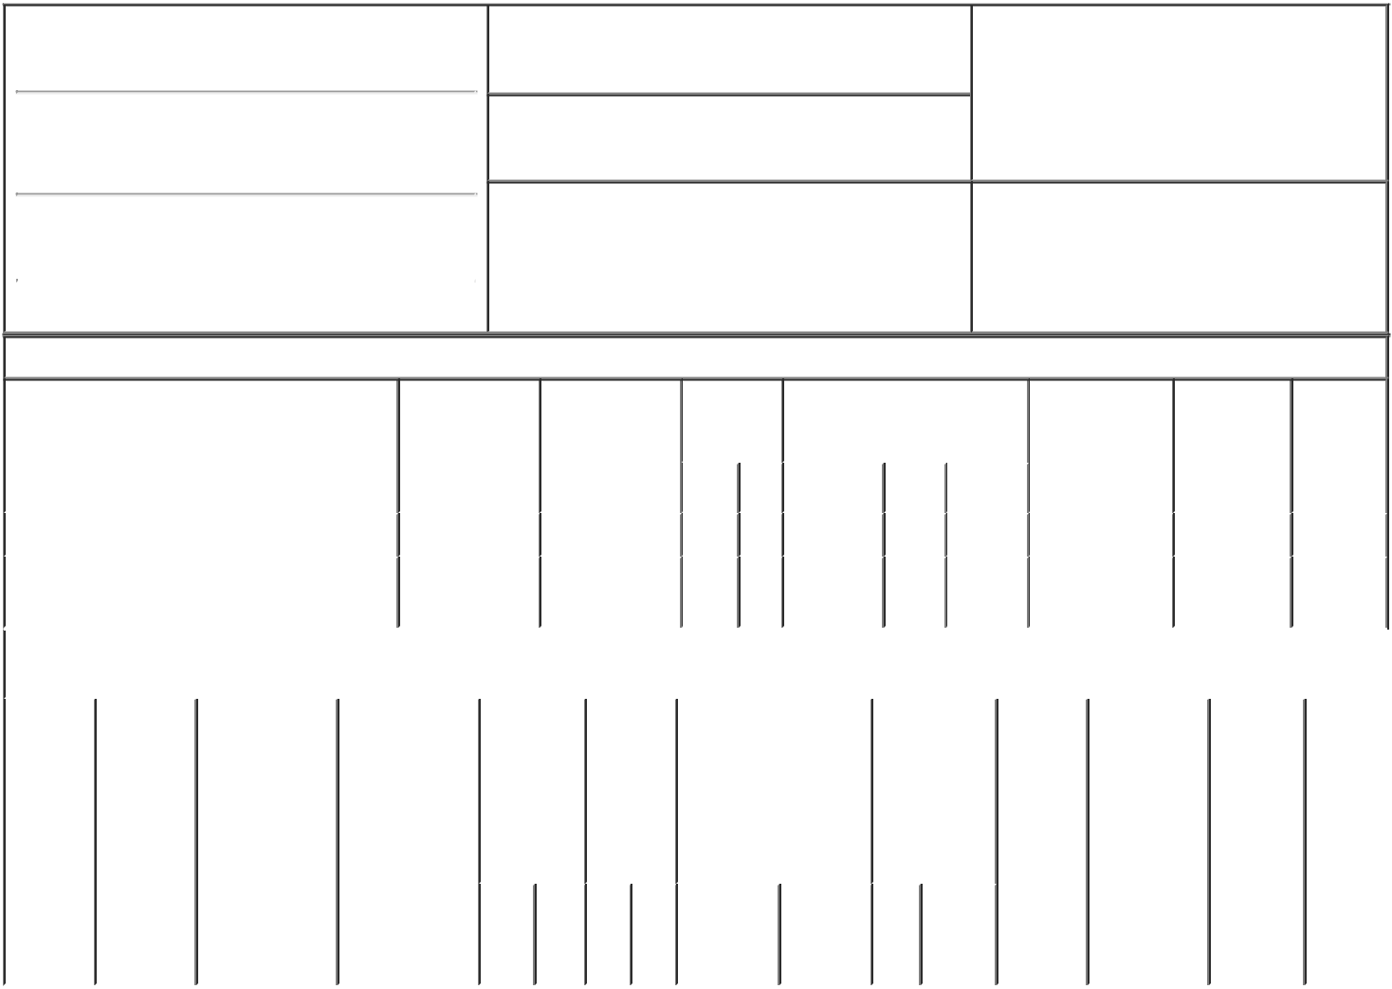

1. Name and Address of Reporting Person*
Raketich Kevin A

(Last) (First) (Middle)

1835 DUEBER AVE. SW

2. Issuer Name and Ticker or Trading Symbol

TimkenSteel Corp [ TMST ]

3. Date of Earliest Transaction (Month/Day/Year)

02/14/2023

- Relationship of Reporting Person(s) to Issuer (Check all applicable)

 | Director | 10% Owner
X | Officer (give title | Other (specify
 | below) | below)

EVP, Chief Commercial Officer

(Street)
 | CANTON | OH | 44706
 | (City) | (State) | (Zip)

4. If Amendment, Date of Original Filed (Month/Day/Year) 6. Individual or Joint/Group Filing (Check Applicable

Line)

X Form filed by One Reporting Person

Form filed by More than One Reporting

Person

Table I - Non-Derivative Securities Acquired, Disposed of, or Beneficially Owned

 | 1. Title of Security (Instr. 3) |  |  | 2. Transaction |  | 2A. Deemed |  | 3. | 4. Securities Acquired (A) or |  |  |  |  |  | 5. Amount of |  | 6. Ownership | 7. Nature
 |  |  |  | Date |  | Execution Date, |  | Transaction | Disposed Of (D) (Instr. 3, 4 and |  |  |  |  |  | Securities |  | Form: Direct | of Indirect
 |  |  |  | (Month/Day/Year) |  | if any |  | Code (Instr. | 5) |  |  |  |  |  | Beneficially |  | (D) or Indirect | Beneficial
 |  |  |  |  |  | (Month/Day/Year) |  | 8) |  |  |  |  |  |  | Owned Following |  | (I) (Instr. 4) | Ownership
 |  |  |  |  |  |  |  |  |  |  |  |  |  |  | Reported |  |  | (Instr. 4)
 |  |  |  |  |  |  |  | Code V | Amount | (A) or |  | Price |  |  | Transaction(s)
 |  |  |  |  |  |  |  |  |  | (D) |  |  |  |  | (Instr. 3 and 4)
 | Common Shares |  |  | 02/14/2023 |  |  |  | F | 3,624 | D |  | $19.54 |  |  | 80,255 |  | D
 | Common Shares |  |  |  |  |  |  |  |  |  |  |  |  |  | 1,846 |  | I | By 401k
 |  |  |  |  |  |  |  |  |  |  |  |  |  |  |  |  |  | Plan
 |  |  | Table II - Derivative Securities Acquired, Disposed of, or Beneficially Owned
 |  |  |  | (e.g., puts, calls, warrants, options, convertible securities)
 | 1. Title of | 2. | 3. Transaction | 3A. Deemed | 4. |  | 5. Number | 6. Date Exercisable and |  | 7. Title and |  |  |  | 8. Price of |  | 9. Number of 10. |  | 11. Nature
 | Derivative | Conversion | Date | Execution Date, | Transaction |  | of | Expiration Date |  | Amount of |  |  |  | Derivative |  | derivative | Ownership | of Indirect
 | Security | or Exercise | (Month/Day/Year) | if any | Code (Instr. |  | Derivative | (Month/Day/Year) |  | Securities |  |  |  | Security |  | Securities | Form: | Beneficial
 | (Instr. 3) | Price of |  | (Month/Day/Year) | 8) |  | Securities |  |  | Underlying |  |  |  | (Instr. 5) |  | Beneficially | Direct (D) | Ownership
 |  | Derivative |  |  |  |  | Acquired |  |  | Derivative |  |  |  |  |  | Owned | or Indirect | (Instr. 4)
 |  | Security |  |  |  |  | (A) or |  |  | Security (Instr. |  |  |  |  |  | Following | (I) (Instr. 4)
 |  |  |  |  |  |  | Disposed |  |  | 3 and 4) |  |  |  |  |  | Reported
 |  |  |  |  |  |  | of (D) |  |  |  |  |  |  |  |  | Transaction(s)
 |  |  |  |  |  |  | (Instr. 3, 4 |  |  |  |  |  |  |  |  | (Instr. 4)
 |  |  |  |  |  |  | and 5)
 |  |  |  |  |  |  |  |  |  |  | Amount
 |  |  |  |  |  |  |  |  |  |  | or
 |  |  |  |  |  |  |  |  |  |  | Number
 |  |  |  |  |  |  |  | Date | Expiration |  | of
 |  |  |  |  | Code | V | (A) (D) | Exercisable | Date | Title | Shares

Explanation of Responses:

Remarks:

/s/ Kristine C. Syrvalin, as

Attorney-in-Fact

** Signature of Reporting Person

02/15/2023

Date

Reminder: Report on a separate line for each class of securities beneficially owned directly or indirectly.

* If the form is filed by more than one reporting person, see Instruction 4 (b)(v).

- Intentional misstatements or omissions of facts constitute Federal Criminal Violations See 18 U.S.C. 1001 and 15 U.S.C. 78ff(a). Note: File three copies of this Form, one of which must be manually signed. If space is insufficient, see Instruction 6 for procedure.

Persons who respond to the collection of information contained in this form are not required to respond unless the form displays a currently valid OMB Number.

POWER OF ATTORNEY

I, Kevin A. Raketich, Executive Vice President of TimkenSteel Corporation, hereby constitute and appoint Kristine C. Syrvalin, Kristopher R. Westbrooks and Nicholas A. Yacobozzi, each of them, my true and lawful attorney or attorneys-in-fact, with full power of substitution and re-substitution, for me and in my name, place and stead, to sign on my behalf any Forms 3, 4, 5 or 144 required pursuant to the Securities Act of 1933 or the Securities Exchange Act of 1934, and to sign any and all amendments to such Forms 3, 4, 5 or 144, and to file the same with the Securities and Exchange Commission, granting unto said attorney or attorneys-in-fact, and each of them, full power and authority to do and perform each and every act and thing whatsoever that any of said attorney or attorneys-in-fact or any of them or their substitutes, may deem necessary or desirable, in his/her or their sole discretion, with any such act or thing being hereby ratified and approved in all respects without any further act or deed whatsoever.

Executed this 5th day of May, 2021 by the undersigned.

/s/ Kevin A. Raketich

Kevin A. Raketich

