SEC Form 3
FORM 3 | UNITED STATES SECURITIES AND EXCHANGE
 | COMMISSION
 |  |  | OMB APPROVAL
 | Washington, D.C. 20549
 |  |  | OMB Number: | 3235-
 | INITIAL STATEMENT OF BENEFICIAL OWNERSHIP OF |  |  | 0104
 |  |  | Estimated average burden
 | SECURITIES |  |  | 0.5
hours per
response:

Filed pursuant to Section 16(a) of the Securities Exchange Act of 1934
or Section 30(h) of the Investment Company Act of 1940
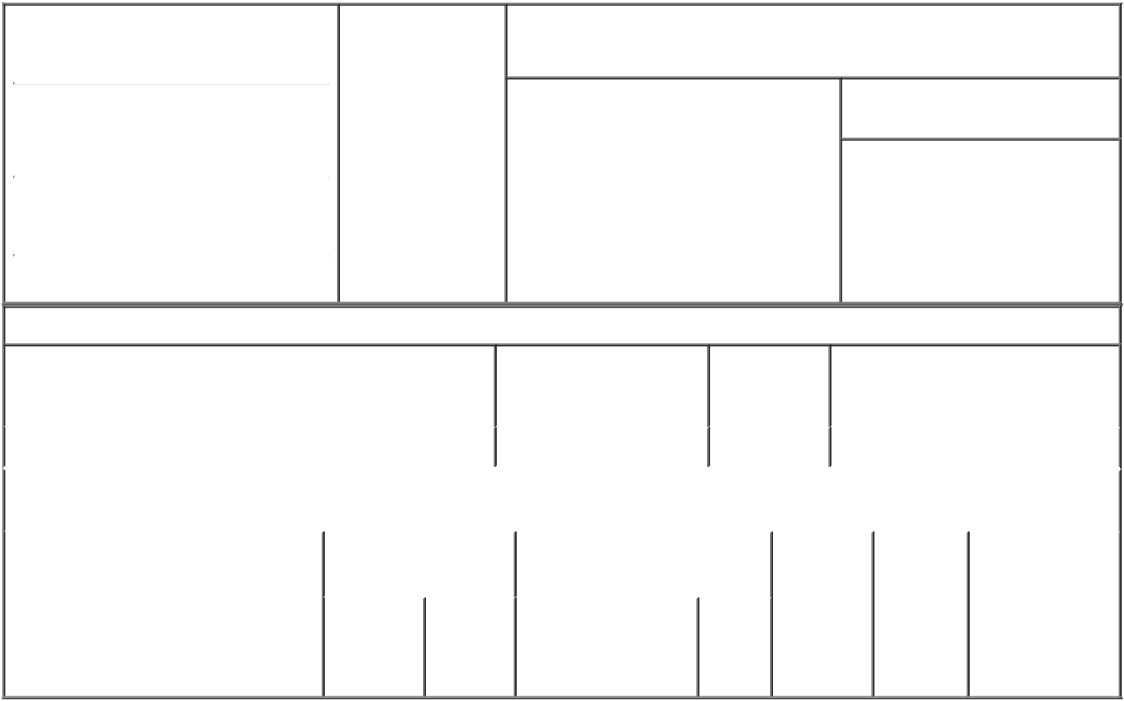

1. Name and Address of Reporting Person |  |  | * | 2. Date of Event
 |  |  |  | Requiring Statement
 | Garcia Ken V
 |  |  |  | (Month/Day/Year)
 |  |  |  | 08/12/2021

3. Issuer Name and Ticker or Trading Symbol

TimkenSteel Corp [ TMST ]

(Last) | (First) | (Middle)
1835 DUEBER AVE. SW
(Street)
CANTON | OH | 44706
(City) | (State) | (Zip)

- Relationship of Reporting Person(s) to Issuer
(Check all applicable)
X Director 10% Owner

Officer (give Other (specify
title below) below)

- If Amendment, Date of Original Filed (Month/Day/Year)

- Individual or Joint/Group Filing (Check Applicable Line)

- Form filed by One Reporting Person

Form filed by More than One Reporting Person

Table I - Non-Derivative Securities Beneficially Owned

1. Title of Security (Instr. 4) | 2. Amount of Securities | 3. Ownership | 4. Nature of Indirect Beneficial
 | Beneficially Owned (Instr. | Form: Direct | Ownership (Instr. 5)
 | 4) | (D) or Indirect
 |  | (I) (Instr. 5)

 | Common Shares |  |  |  | 0 | D
 |  |  | Table II - Derivative Securities Beneficially Owned
 |  | (e.g., puts, calls, warrants, options, convertible securities)
 | 1. Title of Derivative Security (Instr. 4) |  | 2. Date Exercisable and |  | 3. Title and Amount of Securities |  |  | 4. | 5. | 6. Nature of
 |  |  | Expiration Date |  | Underlying Derivative Security |  |  | Conversion | Ownership | Indirect Beneficial
 |  |  | (Month/Day/Year) |  | (Instr. 4) |  |  | or Exercise | Form: | Ownership (Instr.
 |  |  |  |  |  |  |  | Price of | Direct (D) | 5)
 |  |  |  |  |  | Amount
 |  |  |  |  |  |  |  | Derivative | or Indirect
 |  |  |  |  |  | or |  | Security | (I) (Instr. 5)
 |  |  |  |  |  | Number
 |  |  | Date | Expiration |  | of
 |  |  | Exercisable | Date | Title | Shares

Explanation of Responses:

Remarks:

 | /s/ Kristine C. Syrvalin, as |  |  | 08/12/2021
 | Attorney-in-Fact
 | ** Signature of Reporting |  |  | Date
 | Person
Reminder: Report on a separate line for each class of securities beneficially owned directly or indirectly.
* If the form is filed by more than one reporting person, see Instruction 5 (b)(v).

- Intentional misstatements or omissions of facts constitute Federal Criminal Violations See 18 U.S.C. 1001 and 15 U.S.C. 78ff(a). Note: File three copies of this Form, one of which must be manually signed. If space is insufficient, see Instruction 6 for procedure.
Persons who respond to the collection of information contained in this form are not required to respond unless the form displays a currently valid OMB Number.

POWER OF ATTORNEY

I, Ken V. Garcia, a director of TimkenSteel Corporation, hereby constitute and appoint Kristine C. Syrvalin, Kristopher R. Westbrooks and Nicholas A. Yacobozzi, each of them, my true and lawful attorney or attorneys-in-fact, with full power of substitution and re-substitution, for me and in my name, place and stead, to sign on my behalf any Forms 3, 4, 5 or 144 required pursuant to the Securities Act of 1933 or the Securities Exchange Act of 1934, and to sign any and all amendments to such Forms 3, 4, 5 or 144, and to file the same with the Securities and Exchange Commission, granting unto said attorney or attorneys-in-fact, and each of them, full power and authority to do and perform each and every act and thing whatsoever that any of said attorney or attorneys-in-fact or any of them or their substitutes, may deem necessary or desirable with regard to the foregoing, in his/her or their sole discretion, with any such act or thing being hereby ratified and approved in all respects without any further act or deed whatsoever.

Executed this 29th day of July, 2021 by the undersigned.

/s/ Ken V. Garcia

Ken V. Garcia

