SEC Form 4

FORM 4

Check this box if no longer subject to Section 16. Form 4 or Form 5 obligations may continue. See Instruction 1(b).

UNITED STATES SECURITIES AND EXCHANGE COMMISSION
Washington, D.C. 20549
 |  | OMB APPROVAL
STATEMENT OF CHANGES IN BENEFICIAL OWNERSHIP
 |  | OMB Number: | 3235-0287
 |  | Estimated average burden
Filed pursuant to Section 16(a) of the Securities Exchange Act of 1934 |  | hours per response: | 0.5
or Section 30(h) of the Investment Company Act of 1940
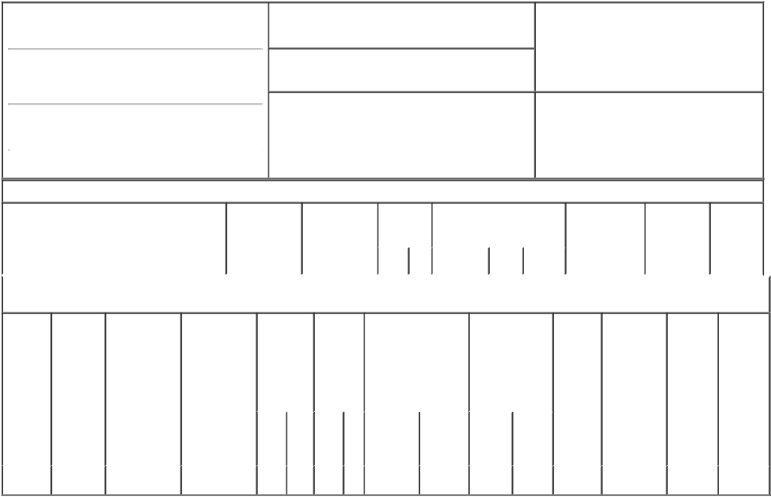

1. Name and Address of Reporting Person*
Carrabba Joseph A

(Last) (First) (Middle)

1835 DUEBER AVE., S.W.

2. Issuer Name and Ticker or Trading Symbol

TimkenSteel Corp [ TMST ]

3. Date of Earliest Transaction (Month/Day/Year)

06/29/2018

- Relationship of Reporting Person(s) to Issuer (Check all applicable)
X Director 10% Owner

Officer (give title Other (specify
below) below)

(Street)
 | CANTON | OH | 44706-2789
 | (City) | (State) | (Zip)

4. If Amendment, Date of Original Filed (Month/Day/Year) 6. Individual or Joint/Group Filing (Check Applicable
Line)
X Form filed by One Reporting Person

Form filed by More than One Reporting
Person

Table I - Non-Derivative Securities Acquired, Disposed of, or Beneficially Owned

 | 1. Title of Security (Instr. 3) | 2. Transaction | 2A. Deemed | 3. | 4. Securities Acquired (A) or |  |  | 5. Amount of | 6. Ownership | 7. Nature
 |  | Date | Execution Date, | Transaction | Disposed Of (D) (Instr. 3, 4 and |  |  | Securities | Form: Direct | of Indirect
 |  | (Month/Day/Year) | if any | Code (Instr. | 5) |  |  | Beneficially | (D) or Indirect | Beneficial
 |  |  | (Month/Day/Year) | 8) |  |  |  | Owned Following | (I) (Instr. 4) | Ownership
 |  |  |  |  |  |  |  | Reported |  | (Instr. 4)
 |  |  |  | Code V | Amount | (A) or | Price | Transaction(s)
 |  |  |  |  |  | (D) |  | (Instr. 3 and 4)

Table II - Derivative Securities Acquired, Disposed of, or Beneficially Owned

(e.g., puts, calls, warrants, options, convertible securities)

1. Title of | 2. | 3. Transaction | 3A. Deemed | 4. | 5. Number |  | 6. Date Exercisable and |  | 7. Title and |  | 8. Price of | 9. Number of | 10. | 11. Nature
Derivative | Conversion | Date | Execution Date, | Transaction | of |  | Expiration Date |  | Amount of |  | Derivative | derivative | Ownership | of Indirect
Security | or Exercise | (Month/Day/Year) | if any | Code (Instr. | Derivative |  | (Month/Day/Year) |  | Securities |  | Security | Securities | Form: | Beneficial
(Instr. 3) | Price of |  | (Month/Day/Year) | 8) | Securities |  |  |  | Underlying |  | (Instr. 5) | Beneficially | Direct (D) | Ownership
 | Derivative |  |  |  | Acquired |  |  |  | Derivative Security |  |  | Owned | or Indirect | (Instr. 4)
 | Security |  |  |  | (A) or |  |  |  | (Instr. 3 and 4) |  |  | Following | (I) (Instr. 4)
 |  |  |  |  | Disposed |  |  |  |  |  |  | Reported
 |  |  |  |  | of (D) |  |  |  |  |  |  | Transaction(s)
 |  |  |  |  | (Instr. 3, 4 |  |  |  |  |  |  | (Instr. 4)
 |  |  |  |  | and 5)
 |  |  |  |  |  |  |  |  |  | Amount
 |  |  |  |  |  |  |  |  |  | or
 |  |  |  |  |  |  |  |  |  | Number
 |  |  |  |  |  |  | Date | Expiration |  | of
 |  |  |  | Code V | (A) | (D) | Exercisable | Date | Title | Shares
Phantom | (1) | 06/29/2018 |  | A | 1,223 |  | (2) | (2) | Common | 1,223 | $16.35 | 5,430 | D
Shares |  |  |  |  |  |  |  |  | Shares

Explanation of Responses:

- Each phantom share is the equivalent of one Issuer common share.

- Phantom shares are payable in cash and/or common shares upon termination of the Reporting Person's service on the Board of Directors, as elected by the Reporting Person at the time he elected to defer compensation under the TimkenSteel Corporation Director Deferred Compensation Plan.

Remarks:

/s/ Frank A. DiPiero, as |  |  | 07/02/2018
Attorney-in-Fact
** Signature of Reporting Person |  |  | Date

Reminder: Report on a separate line for each class of securities beneficially owned directly or indirectly.

* If the form is filed by more than one reporting person, see Instruction 4 (b)(v).

- Intentional misstatements or omissions of facts constitute Federal Criminal Violations See 18 U.S.C. 1001 and 15 U.S.C. 78ff(a). Note: File three copies of this Form, one of which must be manually signed. If space is insufficient, see Instruction 6 for procedure.
Persons who respond to the collection of information contained in this form are not required to respond unless the form displays a currently valid OMB Number.

