SEC Form 4

FORM 4

Check this box if no longer subject to Section 16. Form 4 or Form 5 obligations may continue. See Instruction 1(b).

UNITED STATES SECURITIES AND EXCHANGE COMMISSION
Washington, D.C. 20549
 |  | OMB APPROVAL
STATEMENT OF CHANGES IN BENEFICIAL OWNERSHIP
 |  | OMB Number: | 3235-0287
 |  | Estimated average burden
Filed pursuant to Section 16(a) of the Securities Exchange Act of 1934 |  | hours per response: | 0.5
or Section 30(h) of the Investment Company Act of 1940
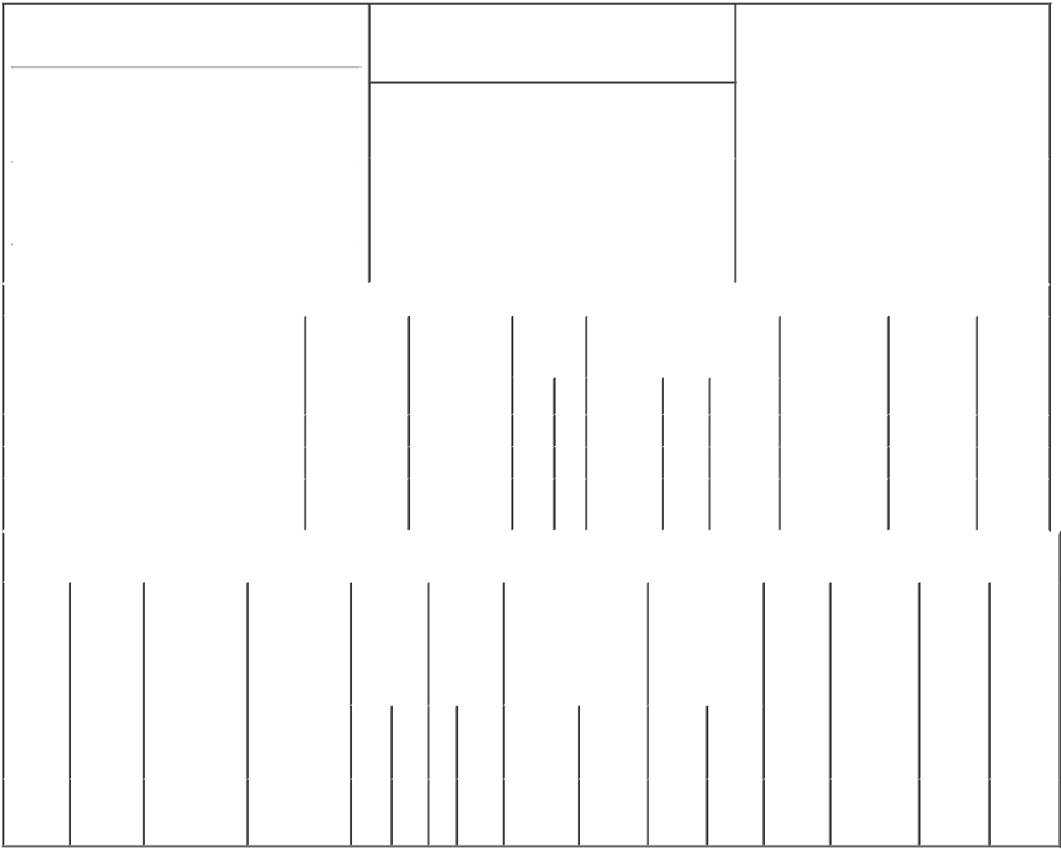

1. Name and Address of Reporting Person*
BAUER DOUGLAS F.

(Last) (First) (Middle)

C/O TRI POINTE HOMES, INC.

940 SOUTHWOOD BLVD, SUITE 200

2. Issuer Name and Ticker or Trading Symbol

Tri Pointe Homes, Inc. [ TPH ]

3. Date of Earliest Transaction (Month/Day/Year)

08/12/2021

- Relationship of Reporting Person(s) to Issuer (Check all applicable)

X | Director | 10% Owner
X | Officer (give title | Other (specify
 | below) | below)

Chief Executive Officer

 |  |  |  |  |  |  |  |  | 4. If Amendment, Date of Original Filed (Month/Day/Year) |  |  |  |  |  |  | 6. Individual or Joint/Group Filing (Check Applicable
 | (Street)
 |  |  |  |  |  |  |  |  |  |  |  |  |  |  |  | Line)
 |  | INCLINE
 |  |  |  | NV |  | 89451 |  |  |  |  |  |  |  |  |  | X Form filed by One Reporting Person
 |  | VILLAGE |  |  |  |  |  |  |  |  |  |  |  |  |  |  |  |  | Form filed by More than One Reporting
 |  |  |  |  |  |  |  |  |  |  |  |  |  |  |  |  |  |  | Person
 |  | (City) |  | (State) |  | (Zip)
 |  |  |  |  | Table I - Non-Derivative Securities Acquired, Disposed of, or Beneficially Owned
 | 1. Title of Security (Instr. 3) |  |  |  |  | 2. Transaction |  |  |  | 2A. Deemed |  | 3. |  | 4. Securities Acquired (A) or |  |  |  |  | 5. Amount of |  | 6. Ownership |  | 7. Nature
 |  |  |  |  |  | Date |  |  |  | Execution Date, |  |  | Transaction | Disposed Of (D) (Instr. 3, 4 and 5) |  |  |  |  | Securities |  | Form: Direct |  | of Indirect
 |  |  |  |  |  | (Month/Day/Year) |  |  |  | if any |  |  | Code (Instr. |  |  |  |  |  | Beneficially |  | (D) or Indirect |  | Beneficial
 |  |  |  |  |  |  |  |  |  | (Month/Day/Year) |  | 8) |  |  |  |  |  |  | Owned Following |  | (I) (Instr. 4) |  | Ownership
 |  |  |  |  |  |  |  |  |  |  |  |  |  |  |  |  |  |  | Reported |  |  |  | (Instr. 4)
 |  |  |  |  |  |  |  |  |  |  |  |  | Code V | Amount | (A) or | Price |  |  | Transaction(s)
 |  |  |  |  |  |  |  |  |  |  |  |  |  |  | (D) |  |  |  | (Instr. 3 and 4)
 | Common Stock |  |  |  |  | 08/12/2021 |  |  |  |  |  |  | M | 10,843 | A | $17 |  |  | 149,426 |  |  | D
 | Common Stock |  |  |  |  | 08/12/2021 |  |  |  |  |  |  | S | 10,843 | D | $24.51⁽¹⁾ |  |  | 138,583 |  |  | D
 | Common Stock |  |  |  |  |  |  |  |  |  |  |  |  |  |  |  |  |  | 779,136 |  |  | I | See
 |  |  |  |  |  |  |  |  |  |  |  |  |  |  |  |  |  |  |  |  |  |  | Note⁽²⁾
 |  |  |  |  |  | Table II - Derivative Securities Acquired, Disposed of, or Beneficially Owned
 |  |  |  |  |  | (e.g., puts, calls, warrants, options, convertible securities)
 | 1. Title of |  | 2. |  | 3. Transaction | 3A. Deemed | 4. |  |  |  | 5. Number | 6. Date Exercisable and |  |  | 7. Title and Amount |  |  | 8. Price of |  | 9. Number of |  | 10. | 11. Nature
 | Derivative |  | Conversion |  | Date | Execution Date, | Transaction |  |  |  | of | Expiration Date |  |  | of Securities |  |  | Derivative |  | derivative |  | Ownership | of Indirect
 | Security |  | or Exercise |  | (Month/Day/Year) | if any | Code (Instr. |  |  |  | Derivative | (Month/Day/Year) |  |  | Underlying |  |  | Security |  | Securities |  | Form: | Beneficial
 | (Instr. 3) |  | Price of |  |  | (Month/Day/Year) | 8) |  |  |  | Securities |  |  |  | Derivative Security |  |  | (Instr. 5) |  | Beneficially |  | Direct (D) | Ownership
 |  |  | Derivative |  |  |  |  |  |  |  | Acquired |  |  |  | (Instr. 3 and 4) |  |  |  |  | Owned |  | or Indirect | (Instr. 4)
 |  |  | Security |  |  |  |  |  |  |  | (A) or |  |  |  |  |  |  |  |  | Following |  | (I) (Instr. 4)
 |  |  |  |  |  |  |  |  |  |  | Disposed |  |  |  |  |  |  |  |  | Reported
 |  |  |  |  |  |  |  |  |  |  | of (D) (Instr. |  |  |  |  |  |  |  |  | Transaction(s)
 |  |  |  |  |  |  |  |  |  |  | 3, 4 and 5) |  |  |  |  |  |  |  |  | (Instr. 4)
 |  |  |  |  |  |  |  |  |  |  |  |  |  |  |  | Amount
 |  |  |  |  |  |  |  |  |  |  |  |  |  |  |  | or
 |  |  |  |  |  |  |  |  |  |  |  |  |  |  |  | Number
 |  |  |  |  |  |  |  |  |  |  |  | Date |  | Expiration |  | of
 |  |  |  |  |  |  | Code V |  |  |  | (A) (D) | Exercisable |  | Date | Title | Shares
 | Stock
 | Option |  | $17 |  | 08/12/2021 |  |  | M |  |  | 10,843 | (3) |  | 01/30/2023 | Common | 10,843 |  |  | $0 | 83,224 |  | D
 | (Right to |  |  |  |  |  |  |  |  |  |  |  |  |  | Stock
Buy)

Explanation of Responses:

- The sales price is a weighted average price. The shares were sold in multiple transactions ranging from $24.50 to $24.59, inclusive. The reporting person undertakes to provide Tri Pointe Homes, Inc. or the staff of the Securities and Exchange Commission, upon request, full information regarding the number of shares sold at each separate price within the range.

- By The Bauer Revocable Trust.

- On January 30, 2013, Mr. Bauer was granted an option to purchase a total of 94,067 shares of common stock, which vested in three equal installments on January 30, 2014, 2015 and 2016.

Remarks:
/s/ Glenn J. Keeler, attorney-in- _{08/16/2021}
fact

** Signature of Reporting Person Date

Reminder: Report on a separate line for each class of securities beneficially owned directly or indirectly.

* If the form is filed by more than one reporting person, see Instruction 4 (b)(v).

- Intentional misstatements or omissions of facts constitute Federal Criminal Violations See 18 U.S.C. 1001 and 15 U.S.C. 78ff(a). Note: File three copies of this Form, one of which must be manually signed. If space is insufficient, see Instruction 6 for procedure.
Persons who respond to the collection of information contained in this form are not required to respond unless the form displays a currently valid OMB Number.

