SEC Form 4

FORM 4

Check this box if no longer subject to Section 16. Form 4 or Form 5 obligations may continue. See Instruction 1(b).

UNITED STATES SECURITIES AND EXCHANGE COMMISSION
Washington, D.C. 20549
 |  | OMB APPROVAL
STATEMENT OF CHANGES IN BENEFICIAL OWNERSHIP
 |  | OMB Number: | 3235-0287
 |  | Estimated average burden
Filed pursuant to Section 16(a) of the Securities Exchange Act of 1934 |  | hours per response: | 0.5
or Section 30(h) of the Investment Company Act of 1940
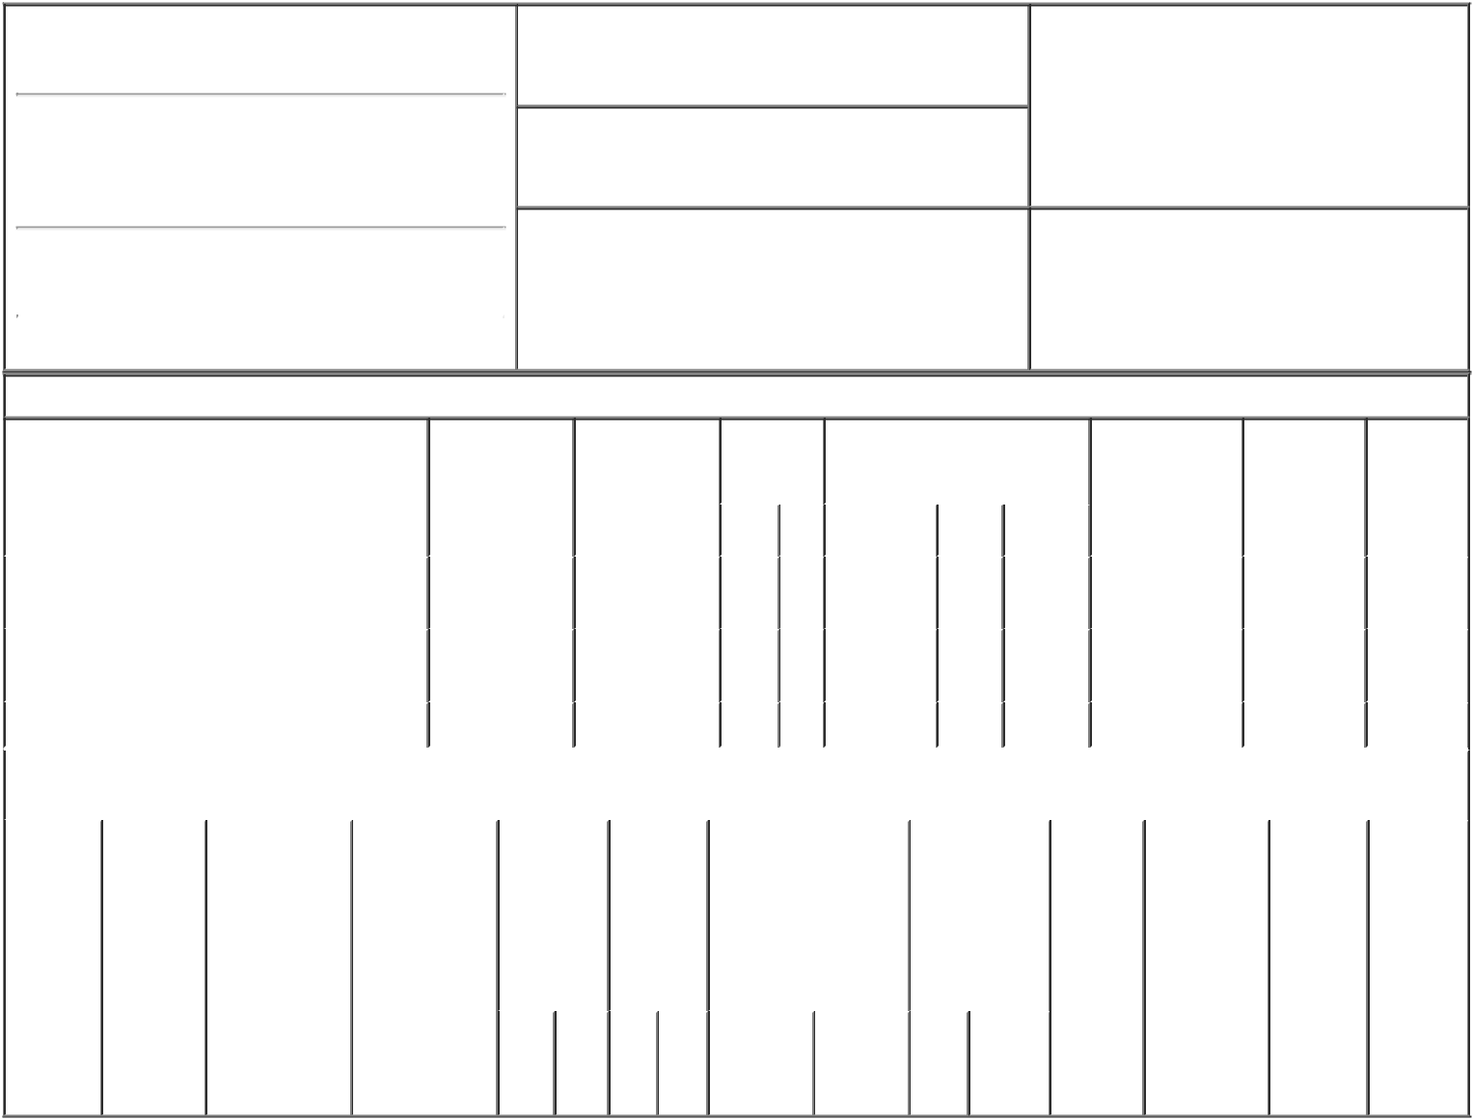

1. Name and Address of Reporting Person*
BAUER DOUGLAS F.

(Last) (First) (Middle)

C/O TRI POINTE GROUP, INC.

19540 JAMBOREE ROAD, SUITE 300

2. Issuer Name and Ticker or Trading Symbol

TRI Pointe Group, Inc. [ TPH ]

3. Date of Earliest Transaction (Month/Day/Year)

02/15/2018

- Relationship of Reporting Person(s) to Issuer (Check all applicable)

X | Director | 10% Owner
X | Officer (give title | Other (specify
 | below) | below)

Chief Executive Officer

(Street)
 | IRVINE | CA | 92612
 | (City) | (State) | (Zip)

4. If Amendment, Date of Original Filed (Month/Day/Year) 6. Individual or Joint/Group Filing (Check Applicable
Line)
X Form filed by One Reporting Person

Form filed by More than One Reporting
Person

Table I - Non-Derivative Securities Acquired, Disposed of, or Beneficially Owned

 | 1. Title of Security (Instr. 3) |  |  | 2. Transaction |  | 2A. Deemed |  | 3. |  | 4. Securities Acquired (A) or |  |  |  |  |  | 5. Amount of |  | 6. Ownership | 7. Nature
 |  |  |  | Date |  | Execution Date, |  |  | Transaction | Disposed Of (D) (Instr. 3, 4 and 5) |  |  |  |  |  | Securities |  | Form: Direct | of Indirect
 |  |  |  | (Month/Day/Year) |  | if any |  |  | Code (Instr. |  |  |  |  |  |  | Beneficially |  | (D) or Indirect | Beneficial
 |  |  |  |  |  | (Month/Day/Year) |  | 8) |  |  |  |  |  |  |  | Owned Following |  | (I) (Instr. 4) | Ownership
 |  |  |  |  |  |  |  |  |  |  |  |  |  |  |  | Reported |  |  | (Instr. 4)
 |  |  |  |  |  |  |  |  | Code V | Amount | (A) or |  | Price |  |  | Transaction(s)
 |  |  |  |  |  |  |  |  |  |  | (D) |  |  |  |  | (Instr. 3 and 4)
 | Common Stock |  |  | 02/15/2018 |  |  |  |  | A | 76,115⁽¹⁾ |  | A | $0 |  |  | 883,219 |  | I | See
 |  |  |  |  |  |  |  |  |  |  |  |  |  |  |  |  |  |  | Note⁽²⁾
 | Common Stock |  |  | 02/15/2018 |  |  |  |  | F | 29,083⁽³⁾ |  | D | $17.35 |  |  | 854,136 |  | I | See
 |  |  |  |  |  |  |  |  |  |  |  |  |  |  |  |  |  |  | Note⁽²⁾
 | Common Stock |  |  |  |  |  |  |  |  |  |  |  |  |  |  | 152,045⁽⁴⁾ |  | D
 |  |  | Table II - Derivative Securities Acquired, Disposed of, or Beneficially Owned
 |  |  |  | (e.g., puts, calls, warrants, options, convertible securities)
 | 1. Title of | 2. | 3. Transaction | 3A. Deemed | 4. |  | 5. Number | 6. Date Exercisable and |  |  | 7. Title and |  |  |  | 8. Price of |  | 9. Number of | 10. | 11. Nature
 | Derivative | Conversion | Date | Execution Date, | Transaction |  | of | Expiration Date |  |  | Amount of |  |  |  | Derivative |  | derivative | Ownership | of Indirect
 | Security | or Exercise | (Month/Day/Year) | if any | Code (Instr. |  | Derivative | (Month/Day/Year) |  |  | Securities |  |  |  | Security |  | Securities | Form: | Beneficial
 | (Instr. 3) | Price of |  | (Month/Day/Year) | 8) |  | Securities |  |  |  | Underlying |  |  |  | (Instr. 5) |  | Beneficially | Direct (D) | Ownership
 |  | Derivative |  |  |  |  | Acquired |  |  |  | Derivative |  |  |  |  |  | Owned | or Indirect | (Instr. 4)
 |  | Security |  |  |  |  | (A) or |  |  |  | Security (Instr. 3 |  |  |  |  |  | Following | (I) (Instr. 4)
 |  |  |  |  |  |  | Disposed |  |  |  | and 4) |  |  |  |  |  | Reported
 |  |  |  |  |  |  | of (D) |  |  |  |  |  |  |  |  |  | Transaction(s)
 |  |  |  |  |  |  | (Instr. 3, 4 |  |  |  |  |  |  |  |  |  | (Instr. 4)
 |  |  |  |  |  |  | and 5)
 |  |  |  |  |  |  |  |  |  |  |  | Amount
 |  |  |  |  |  |  |  |  |  |  |  | or
 |  |  |  |  |  |  |  |  |  |  |  | Number
 |  |  |  |  |  |  |  | Date |  | Expiration |  | of
 |  |  |  |  | Code V |  | (A) (D) | Exercisable |  | Date | Title | Shares

Explanation of Responses:

- Represents shares of common stock issued pursuant to the vesting of performance-based restricted stock units granted on March 9, 2015 that were eligible to vest based on attainment of certain earnings per share performance goals (the "RSU Awards"). The Compensation Committee of the issuer's board of directors determined that, based on the issuer's performance over the performance period, 76,115 RSU Awards would vest and be settled into an equal number of shares of common stock, in accordance with the terms of the RSU Awards.

- By The Bauer Revocable Trust.

- Withholding of shares incident to vesting of the RSU Awards.

- 137,268 performance-based restricted stock units granted to the reporting person on March 9, 2015, and previously reported in Table I of Form 4 on March 11, 2015, were forfeited on February 15, 2018 for no value.

Remarks:
/s/ Glenn J. Keeler, attorney-in- _{02/20/2018}
fact

** Signature of Reporting Person Date

Reminder: Report on a separate line for each class of securities beneficially owned directly or indirectly.

* If the form is filed by more than one reporting person, see Instruction 4 (b)(v).

- Intentional misstatements or omissions of facts constitute Federal Criminal Violations See 18 U.S.C. 1001 and 15 U.S.C. 78ff(a). Note: File three copies of this Form, one of which must be manually signed. If space is insufficient, see Instruction 6 for procedure.
Persons who respond to the collection of information contained in this form are not required to respond unless the form displays a currently valid OMB Number.

