SEC Form 4

FORM 4

Check this box if no longer subject to Section 16. Form 4 or Form 5 obligations may continue. See Instruction 1(b).

UNITED STATES SECURITIES AND EXCHANGE COMMISSION
Washington, D.C. 20549
 |  | OMB APPROVAL
STATEMENT OF CHANGES IN BENEFICIAL OWNERSHIP
 |  | OMB Number: | 3235-0287
 |  | Estimated average burden
Filed pursuant to Section 16(a) of the Securities Exchange Act of 1934 |  | hours per response: | 0.5
or Section 30(h) of the Investment Company Act of 1940
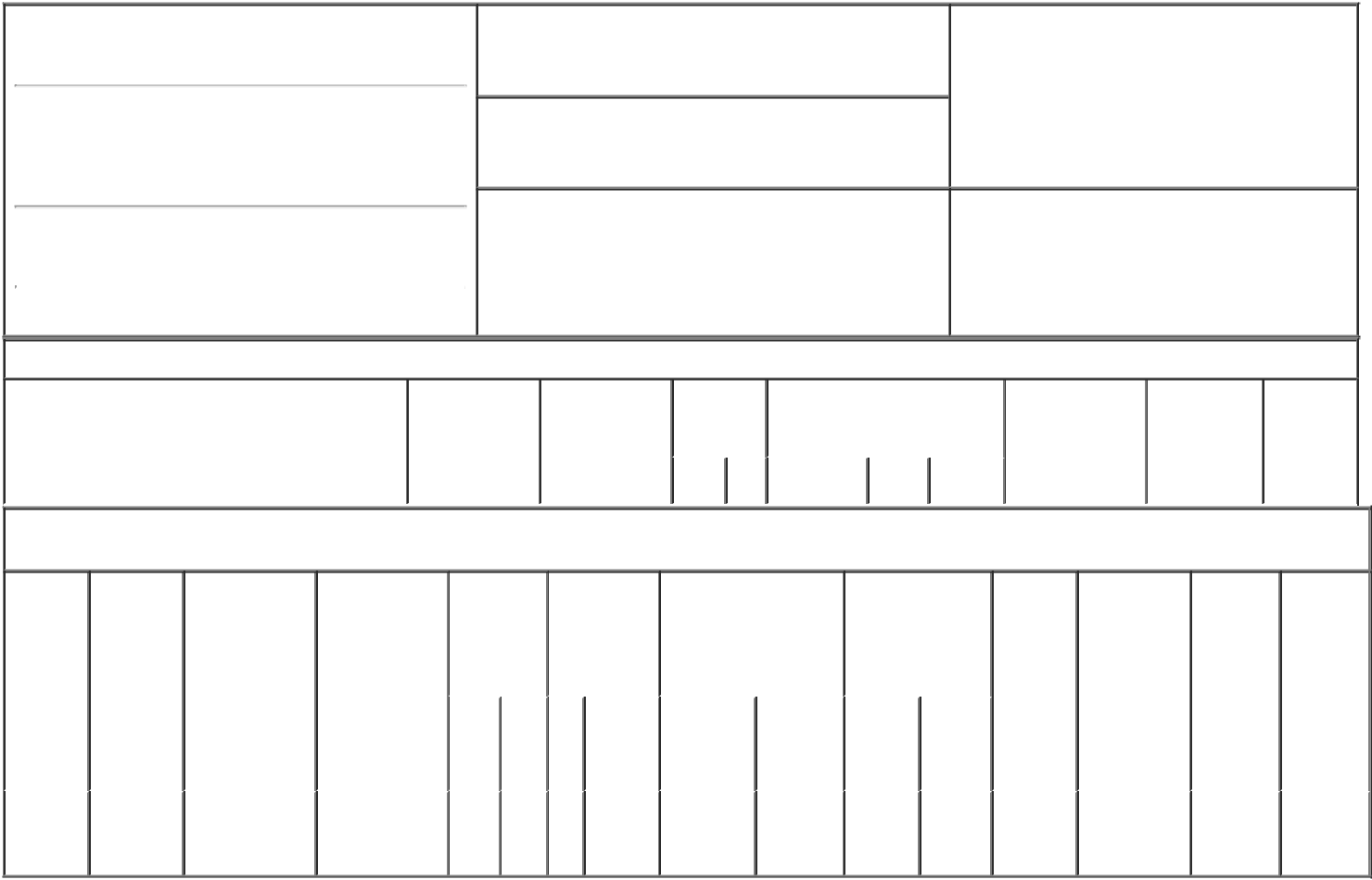

1. Name and Address of Reporting Person*
Wagner Paul A.

(Last) (First) (Middle)

C/O FORTE BIOSCIENCES, INC. 3060 PEGASUS PARK DR., BLDG 6

2. Issuer Name and Ticker or Trading Symbol

Forte Biosciences, Inc. [ FBRX ]

3. Date of Earliest Transaction (Month/Day/Year)

05/12/2022

- Relationship of Reporting Person(s) to Issuer (Check all applicable)

X | Director | 10% Owner
X | Officer (give title | Other (specify
 | below) | below)

See Remarks

(Street)
 | DALLAS | TX | 75247
 | (City) | (State) | (Zip)

4. If Amendment, Date of Original Filed (Month/Day/Year) 6. Individual or Joint/Group Filing (Check Applicable
Line)
X Form filed by One Reporting Person

Form filed by More than One Reporting
Person

Table I - Non-Derivative Securities Acquired, Disposed of, or Beneficially Owned

1. Title of Security (Instr. 3) | 2. Transaction | 2A. Deemed | 3. | 4. Securities Acquired (A) or |  |  | 5. Amount of | 6. Ownership | 7. Nature of
 | Date | Execution Date, | Transaction | Disposed Of (D) (Instr. 3, 4 and |  |  | Securities | Form: Direct | Indirect
 | (Month/Day/Year) | if any | Code (Instr. | 5) |  |  | Beneficially | (D) or Indirect | Beneficial
 |  | (Month/Day/Year) | 8) |  |  |  | Owned Following | (I) (Instr. 4) | Ownership
 |  |  |  |  |  |  | Reported |  | (Instr. 4)
 |  |  | Code V | Amount | (A) or | Price | Transaction(s)
 |  |  |  |  | (D) |  | (Instr. 3 and 4)

Table II - Derivative Securities Acquired, Disposed of, or Beneficially Owned

(e.g., puts, calls, warrants, options, convertible securities)

1. Title of | 2. | 3. Transaction | 3A. Deemed | 4. | 5. Number of | 6. Date Exercisable and |  | 7. Title and Amount |  | 8. Price of | 9. Number of | 10. | 11. Nature
Derivative | Conversion | Date | Execution Date, | Transaction | Derivative | Expiration Date |  | of Securities |  | Derivative | derivative | Ownership | of Indirect
Security | or Exercise | (Month/Day/Year) | if any | Code (Instr. | Securities | (Month/Day/Year) |  | Underlying |  | Security | Securities | Form: | Beneficial
(Instr. 3) | Price of |  | (Month/Day/Year) | 8) | Acquired (A) |  |  | Derivative Security |  | (Instr. 5) | Beneficially | Direct (D) | Ownership
 | Derivative |  |  |  | or Disposed |  |  | (Instr. 3 and 4) |  |  | Owned | or Indirect | (Instr. 4)
 | Security |  |  |  | of (D) (Instr. 3, |  |  |  |  |  | Following | (I) (Instr. 4)
 |  |  |  |  | 4 and 5) |  |  |  |  |  | Reported
 |  |  |  |  |  |  |  |  |  |  | Transaction(s)
 |  |  |  |  |  |  |  |  | Amount |  | (Instr. 4)
 |  |  |  |  |  |  |  |  | or
 |  |  |  |  |  |  |  |  | Number
 |  |  |  |  |  | Date | Expiration |  | of
 |  |  |  | Code V | (A) (D) | Exercisable | Date | Title | Shares
Stock
Option | $39.66 | 05/12/2022 |  | D | 40,000⁽¹⁾ | (2) | 04/09/2031 | Common | 40,000 | $0.00 | 135,000 | D
(right to |  |  |  |  |  |  |  | Stock
buy)

Explanation of Responses:

- 40,000 of the shares subject to this option were canceled by mutual agreement of the Reporting Person and the Issuer.

- Subject to the Reporting Person's Continuous Service (as defined in the Issuer's 2017 Equity Incentive Plan) through each applicable vesting date, twenty five percent (25%) of the shares subject to the option shall vest on the one year anniversary of the Vesting Commencement Date and one forty-eighth (1/48th) of the total shares subject to the option shall vest every month thereafter such that all shares shall be fully vested on the four year anniversary of the Vesting Commencement Date. "Vesting Commencement Date" shall mean April 9, 2021.

Remarks:

CEO, President, Secretary and Chair of the Board

/s/ Paul A. Wagner, Ph.D |  | 05/16/2022
** Signature of Reporting Person |  | Date

Reminder: Report on a separate line for each class of securities beneficially owned directly or indirectly.

* If the form is filed by more than one reporting person, see Instruction 4 (b)(v).

- Intentional misstatements or omissions of facts constitute Federal Criminal Violations See 18 U.S.C. 1001 and 15 U.S.C. 78ff(a). Note: File three copies of this Form, one of which must be manually signed. If space is insufficient, see Instruction 6 for procedure.
Persons who respond to the collection of information contained in this form are not required to respond unless the form displays a currently valid OMB Number.

