SEC Form 4

FORM 4

Check this box if no longer subject to Section 16. Form 4 or Form 5 obligations may continue. See Instruction 1(b).

UNITED STATES SECURITIES AND EXCHANGE COMMISSION
Washington, D.C. 20549
 |  | OMB APPROVAL
STATEMENT OF CHANGES IN BENEFICIAL OWNERSHIP
 |  | OMB Number: | 3235-0287
 |  | Estimated average burden
Filed pursuant to Section 16(a) of the Securities Exchange Act of 1934 |  | hours per response: | 0.5
or Section 30(h) of the Investment Company Act of 1940
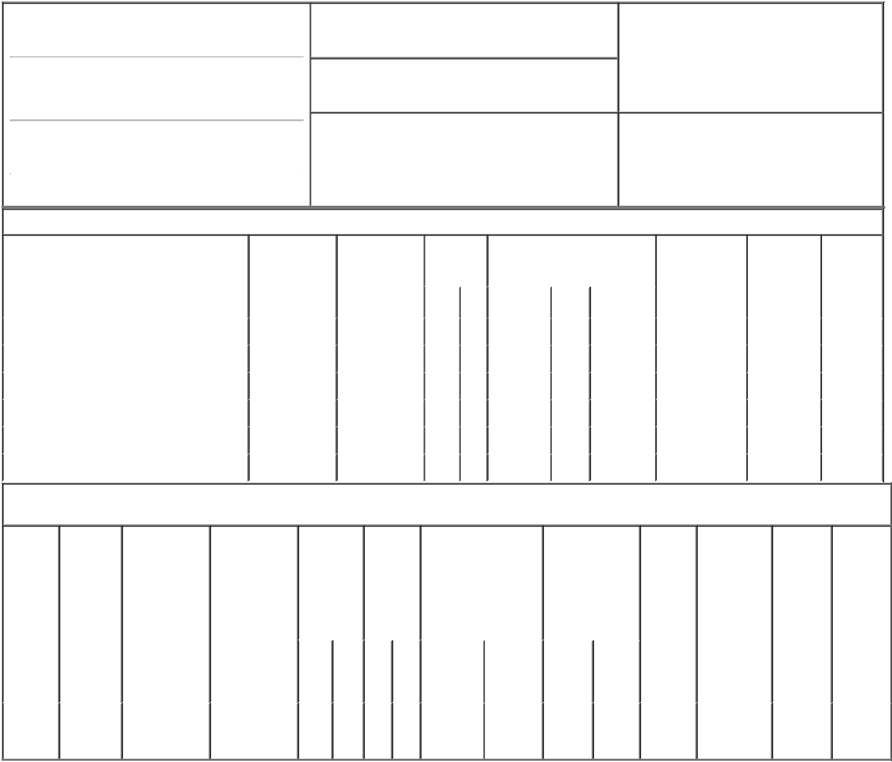

1. Name and Address of Reporting Person*
Roberts Johanna

(Last) (First) (Middle)

ONE PENUMBRA PLACE

2. Issuer Name and Ticker or Trading Symbol

Penumbra Inc [ PEN ]

3. Date of Earliest Transaction (Month/Day/Year)

03/01/2023

- Relationship of Reporting Person(s) to Issuer (Check all applicable)
 | Director | 10% Owner
X | Officer (give title | Other (specify
 | below) | below)

EVP, Gen. Counsel & Secretary

(Street)
 | ALAMEDA | CA | 94502
 | (City) | (State) | (Zip)

4. If Amendment, Date of Original Filed (Month/Day/Year) 6. Individual or Joint/Group Filing (Check Applicable

Line)
X Form filed by One Reporting Person

Form filed by More than One Reporting

Person

Table I - Non-Derivative Securities Acquired, Disposed of, or Beneficially Owned

 | 1. Title of Security (Instr. 3) | 2. Transaction | 2A. Deemed | 3. | 4. Securities Acquired (A) or |  |  | 5. Amount of | 6. Ownership | 7. Nature
 |  | Date | Execution Date, | Transaction | Disposed Of (D) (Instr. 3, 4 and 5) |  |  | Securities | Form: Direct | of Indirect
 |  | (Month/Day/Year) | if any | Code (Instr. |  |  |  | Beneficially | (D) or Indirect | Beneficial
 |  |  | (Month/Day/Year) | 8) |  |  |  | Owned Following | (I) (Instr. 4) | Ownership
 |  |  |  |  |  |  |  | Reported |  | (Instr. 4)
 |  |  |  | Code V | Amount | (A) or | Price | Transaction(s)
 |  |  |  |  |  | (D) |  | (Instr. 3 and 4)
 | Common Stock | 03/01/2023 |  | M | 600 | A | $22.04 | 70,560⁽¹⁾ | D
 | Common Stock | 03/01/2023 |  | _{S}(2) | 37 | D | $256.22⁽³⁾ | 70,523⁽¹⁾ | D
 | Common Stock | 03/01/2023 |  | _{S}(2) | 98 | D | $257.41⁽⁴⁾ | 70,425⁽¹⁾ | D
 | Common Stock | 03/01/2023 |  | _{S}(2) | 132 | D | $258.22⁽⁵⁾ | 70,293⁽¹⁾ | D
 | Common Stock | 03/01/2023 |  | _{S}(2) | 277 | D | $259.31⁽⁶⁾ | 70,016⁽¹⁾ | D
 | Common Stock | 03/01/2023 |  | _{S}(2) | 56 | D | $259.88⁽⁷⁾ | 69,960⁽¹⁾ | D

Table II - Derivative Securities Acquired, Disposed of, or Beneficially Owned

(e.g., puts, calls, warrants, options, convertible securities)

1. Title of | 2. | 3. Transaction | 3A. Deemed | 4. | 5. Number | 6. Date Exercisable and |  | 7. Title and |  | 8. Price of | 9. Number of | 10. | 11. Nature
Derivative | Conversion | Date | Execution Date, | Transaction | of | Expiration Date |  | Amount of |  | Derivative | derivative | Ownership | of Indirect
Security | or Exercise | (Month/Day/Year) | if any | Code (Instr. | Derivative | (Month/Day/Year) |  | Securities |  | Security | Securities | Form: | Beneficial
(Instr. 3) | Price of |  | (Month/Day/Year) | 8) | Securities |  |  | Underlying |  | (Instr. 5) | Beneficially | Direct (D) | Ownership
 | Derivative |  |  |  | Acquired |  |  | Derivative Security |  |  | Owned | or Indirect | (Instr. 4)
 | Security |  |  |  | (A) or |  |  | (Instr. 3 and 4) |  |  | Following | (I) (Instr. 4)
 |  |  |  |  | Disposed |  |  |  |  |  | Reported
 |  |  |  |  | of (D) |  |  |  |  |  | Transaction(s)
 |  |  |  |  | (Instr. 3, 4 |  |  |  |  |  | (Instr. 4)
 |  |  |  |  | and 5)
 |  |  |  |  |  |  |  |  | Amount
 |  |  |  |  |  |  |  |  | or
 |  |  |  |  |  |  |  |  | Number
 |  |  |  |  |  | Date | Expiration |  | of
 |  |  |  | Code V | (A) (D) | Exercisable | Date | Title | Shares
Stock
Option | $22.04 | 03/01/2023 |  | M | 600 | (8) | 08/11/2025 | Common | 600 | $0 | 8,850 | D
(right to |  |  |  |  |  |  |  | Stock
buy)

Explanation of Responses:

- A portion of these shares is subject to vesting.

- The sales were effected pursuant to the Reporting Person's Rule 10b5-1 trading plan.

- This transaction was executed in multiple trades at prices ranging from $255.84 to $256.73. The price reported above reflects the weighted average sale price. The Reporting Person hereby undertakes to provide to the SEC staff, the Issuer or a security holder of the Issuer, upon request, full information regarding the number of shares and prices at which the transaction was effected.

- This transaction was executed in multiple trades at prices ranging from $256.94 to $257.72. The price reported above reflects the weighted average sale price. The Reporting Person hereby undertakes to provide to the SEC staff, the Issuer or a security holder of the Issuer, upon request, full information regarding the number of shares and prices at which the transaction was effected.

- This transaction was executed in multiple trades at prices ranging from $257.84 to $258.77. The price reported above reflects the weighted average sale price. The Reporting Person hereby undertakes to provide to the SEC staff, the Issuer or a security holder of the Issuer, upon request, full information regarding the number of shares and prices at which the transaction was effected.

- This transaction was executed in multiple trades at prices ranging from $258.84 to $259.73. The price reported above reflects the weighted average sale price. The Reporting Person hereby undertakes to provide to the SEC staff, the Issuer or a security holder of the Issuer, upon request, full information regarding the number of shares and prices at which the transaction was effected.

- This transaction was executed in multiple trades at prices ranging from $259.85 to $260.02. The price reported above reflects the weighted average sale price. The Reporting Person hereby undertakes to provide to the SEC staff, the Issuer or a security holder of the Issuer, upon request, full information regarding the number of shares and prices at which the transaction was effected.

- All shares are vested and exercisable.

Remarks:

/s/ Johanna Roberts |  | 03/03/2023
** Signature of Reporting Person |  | Date

Reminder: Report on a separate line for each class of securities beneficially owned directly or indirectly.

* If the form is filed by more than one reporting person, see Instruction 4 (b)(v).

- Intentional misstatements or omissions of facts constitute Federal Criminal Violations See 18 U.S.C. 1001 and 15 U.S.C. 78ff(a). Note: File three copies of this Form, one of which must be manually signed. If space is insufficient, see Instruction 6 for procedure.
Persons who respond to the collection of information contained in this form are not required to respond unless the form displays a currently valid OMB Number.

