SEC Form 4

FORM 4

Check this box if no longer subject to Section 16. Form 4 or Form 5 obligations may continue. See Instruction 1(b).

UNITED STATES SECURITIES AND EXCHANGE COMMISSION
Washington, D.C. 20549
 |  | OMB APPROVAL
STATEMENT OF CHANGES IN BENEFICIAL OWNERSHIP
 |  | OMB Number: | 3235-0287
 |  | Estimated average burden
Filed pursuant to Section 16(a) of the Securities Exchange Act of 1934 |  | hours per response: | 0.5
or Section 30(h) of the Investment Company Act of 1940
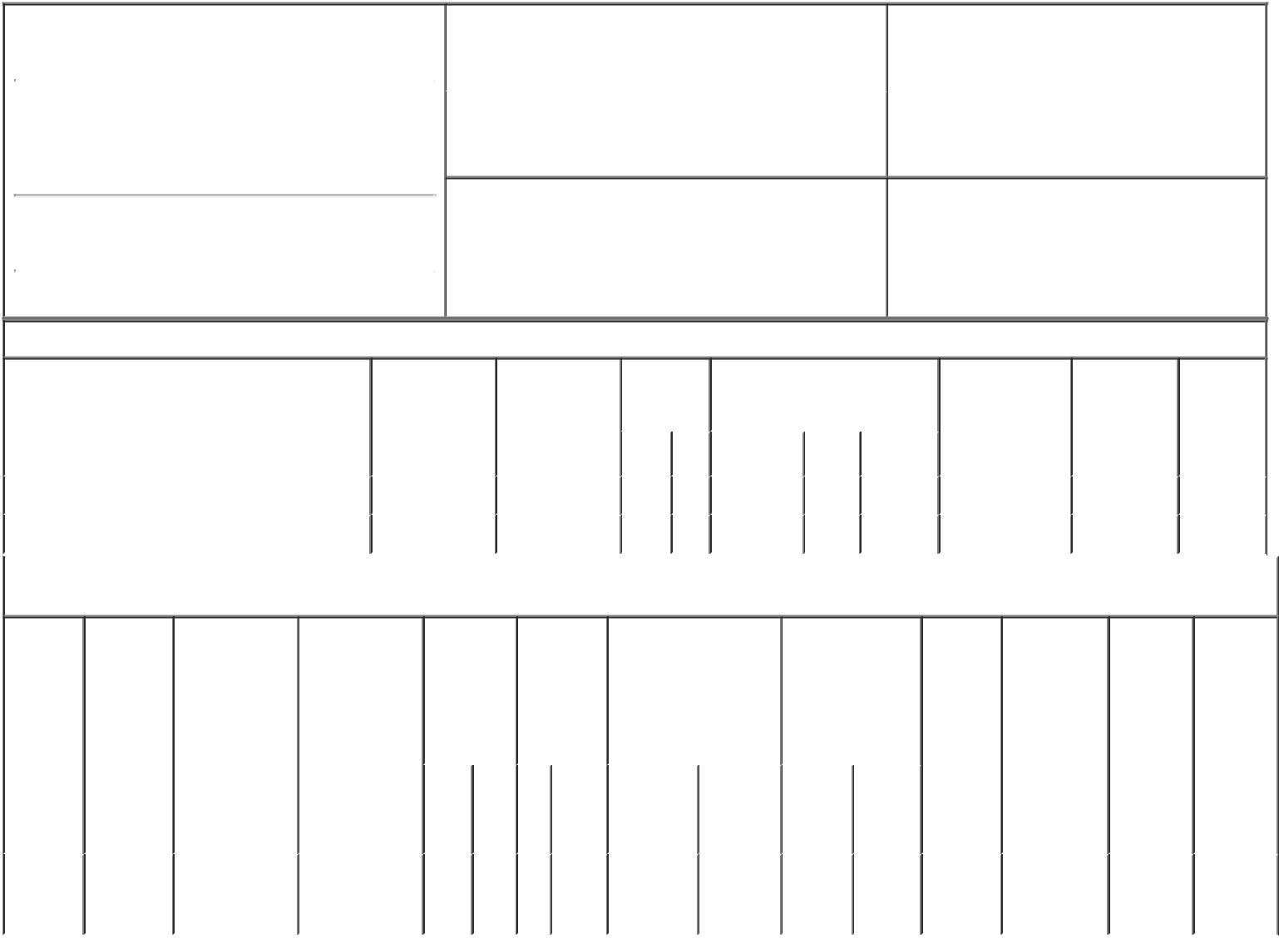

1. Name and Address of Reporting Person* |  |  |  |  |  | 2. Issuer Name and Ticker or Trading Symbol
 | FRAIZER MICHAEL D |  |  |  |  | GENWORTH FINANCIAL INC [ GNW ]
 | (Last) | (First) |  | (Middle) |  | 3. Date of Earliest Transaction (Month/Day/Year)
 | C/O GENWORTH FINANCIAL, INC. |  |  |  | 05/13/2005

6620 WEST BROAD STREET

- Relationship of Reporting Person(s) to Issuer (Check all applicable)

X | Director | 10% Owner
X | Officer (give title | Other (specify
 | below) | below)

Chairman, President & CEO

(Street)
 | RICHMOND | VA | 23230
 | (City) | (State) | (Zip)

4. If Amendment, Date of Original Filed (Month/Day/Year) 6. Individual or Joint/Group Filing (Check Applicable
Line)
X Form filed by One Reporting Person

Form filed by More than One Reporting
Person

Table I - Non-Derivative Securities Acquired, Disposed of, or Beneficially Owned

 | 1. Title of Security (Instr. 3) | 2. Transaction | 2A. Deemed | 3. | 4. Securities Acquired (A) or |  |  | 5. Amount of | 6. Ownership | 7. Nature
 |  | Date | Execution Date, | Transaction | Disposed Of (D) (Instr. 3, 4 and 5) |  |  | Securities | Form: Direct | of Indirect
 |  | (Month/Day/Year) | if any | Code (Instr. |  |  |  | Beneficially | (D) or Indirect | Beneficial
 |  |  | (Month/Day/Year) | 8) |  |  |  | Owned Following | (I) (Instr. 4) | Ownership
 |  |  |  |  |  |  |  | Reported |  | (Instr. 4)
 |  |  |  | Code V | Amount | (A) or | Price | Transaction(s)
 |  |  |  |  |  | (D) |  | (Instr. 3 and 4)
 | Class A Common Stock | 05/13/2005 |  | M | 59,041 | A | $9.4104 | 199,747 | D
 | Class A Common Stock | 05/13/2005 |  | F | 16,278 | D | $27.145 | 183,469 | D

Table II - Derivative Securities Acquired, Disposed of, or Beneficially Owned

(e.g., puts, calls, warrants, options, convertible securities)

 | 1. Title of | 2. | 3. Transaction | 3A. Deemed | 4. | 5. Number | 6. Date Exercisable and |  |  | 7. Title and Amount |  |  | 8. Price of |  | 9. Number of |  |  | 10. | 11. Nature
 | Derivative | Conversion | Date | Execution Date, | Transaction | of | Expiration Date |  |  | of Securities |  |  | Derivative |  | derivative |  |  | Ownership | of Indirect
 | Security | or Exercise | (Month/Day/Year) | if any | Code (Instr. | Derivative | (Month/Day/Year) |  |  | Underlying |  |  | Security |  | Securities |  |  | Form: | Beneficial
 | (Instr. 3) | Price of |  | (Month/Day/Year) | 8) | Securities |  |  |  | Derivative Security |  |  | (Instr. 5) |  | Beneficially |  |  | Direct (D) | Ownership
 |  | Derivative |  |  |  | Acquired |  |  |  | (Instr. 3 and 4) |  |  |  |  | Owned |  |  | or Indirect | (Instr. 4)
 |  | Security |  |  |  | (A) or |  |  |  |  |  |  |  |  | Following |  |  | (I) (Instr. 4)
 |  |  |  |  |  | Disposed |  |  |  |  |  |  |  |  | Reported
 |  |  |  |  |  | of (D) (Instr. |  |  |  |  |  |  |  |  | Transaction(s)
 |  |  |  |  |  | 3, 4 and 5) |  |  |  |  |  |  |  |  | (Instr. 4)
 |  |  |  |  |  |  |  |  |  |  | Amount
 |  |  |  |  |  |  |  |  |  |  | or
 |  |  |  |  |  |  |  |  |  |  | Number
 |  |  |  |  |  |  | Date | Expiration |  |  | of
 |  |  |  |  | Code V | (A) (D) | Exercisable | Date |  | Title | Shares
 | Stock |  |  |  |  |  |  |  |  | Class A
 | Option |  |  |  |  |  | (1) |  |  |  | 59,041 |  | (2)
 |  | $9.4104 | 05/13/2005 |  | M | 59,041 |  | 09/13/2006 |  | Common |  |  |  |  | 70,000 |  |  | D
 | (right to
 |  |  |  |  |  |  |  |  |  | Stock
 | buy)
 | Explanation of Responses:
 | 1. Immediately
 | 2. Not applicable
 |  |  |  |  |  |  |  |  | /s/ Richard J. Oelhafen Jr., |  |  |  |  |  | 05/17/2005
 |  |  |  |  |  |  |  |  | Attorney-in-Fact
 |  |  |  |  |  |  |  |  | ** Signature of Reporting Person |  |  |  |  |  |  | Date

Reminder: Report on a separate line for each class of securities beneficially owned directly or indirectly.

* If the form is filed by more than one reporting person, see Instruction 4 (b)(v).

- Intentional misstatements or omissions of facts constitute Federal Criminal Violations See 18 U.S.C. 1001 and 15 U.S.C. 78ff(a). Note: File three copies of this Form, one of which must be manually signed. If space is insufficient, see Instruction 6 for procedure.
Persons who respond to the collection of information contained in this form are not required to respond unless the form displays a currently valid OMB Number.

