SEC Form 3
FORM 3 | UNITED STATES SECURITIES AND EXCHANGE COMMISSION
 | Washington, D.C. 20549
 |  |  | OMB APPROVAL
 | INITIAL STATEMENT OF BENEFICIAL OWNERSHIP OF
 |  |  | OMB Number: | 3235-0104
 | SECURITIES |  | Estimated average burden
 |  |  | hours per response: | 0.5

Filed pursuant to Section 16(a) of the Securities Exchange Act of 1934
or Section 30(h) of the Investment Company Act of 1940
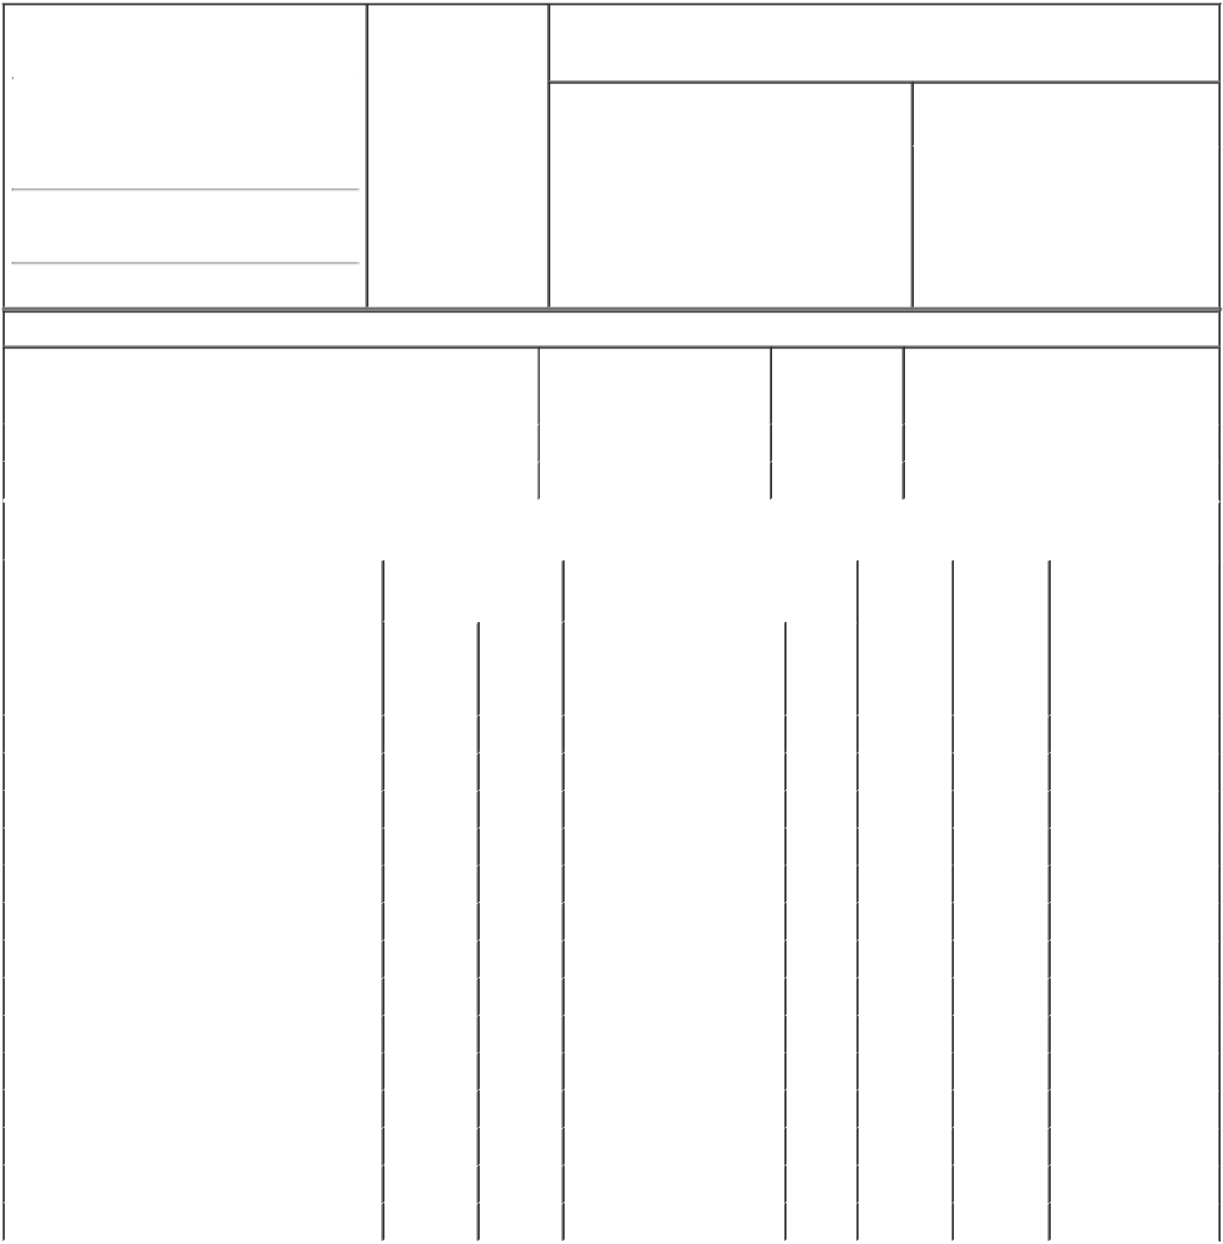

1. Name and Address of Reporting Person* |  |  |  | 2. Date of Event
 |  | Bobitz Ward E. |  | Requiring Statement
 |  |  |  | (Month/Day/Year)
 |  |  |  | 01/26/2015

(Last) (First) (Middle)

C/O GENWORTH FINANCIAL, INC.

6620 WEST BROAD STREET

(Street)
RICHMOND VA | 23230

3. Issuer Name and Ticker or Trading Symbol

GENWORTH FINANCIAL INC [ GNW ]

4. Relationship of Reporting Person(s) to Issuer |  |  | 5. | If Amendment, Date of Original Filed
(Check all applicable) |  |  | (Month/Day/Year)
 | Director | 10% Owner
X | Officer (give title | Other (specify
 |  |  | 6. | Individual or Joint/Group Filing (Check
 | below) | below)
 |  |  | Applicable Line)
 | EVP and General Counsel
 |  |  |  | X Form filed by One Reporting Person

Form filed by More than One
Reporting Person

(City) (State) (Zip)

Table I - Non-Derivative Securities Beneficially Owned

1. Title of Security (Instr. 4) | 2. Amount of Securities | 3. Ownership | 4. Nature of Indirect Beneficial Ownership
 | Beneficially Owned (Instr. 4) | Form: Direct (D) | (Instr. 5)
 |  | or Indirect (I)
 |  | (Instr. 5)

 | Class A Common Stock |  |  |  | 8,771 | D
 | Class A Common Stock |  |  |  | 163.63 | I | By 401(k)
 |  |  | Table II - Derivative Securities Beneficially Owned
 |  | (e.g., puts, calls, warrants, options, convertible securities)
 | 1. Title of Derivative Security (Instr. 4) |  | 2. Date Exercisable and |  | 3. Title and Amount of Securities |  | 4. | 5. | 6. Nature of Indirect
 |  |  | Expiration Date |  | Underlying Derivative Security (Instr. 4) |  | Conversion | Ownership | Beneficial Ownership
 |  |  | (Month/Day/Year) |  |  |  | or Exercise | Form: | (Instr. 5)
 |  |  |  |  |  |  | Price of | Direct (D)
 |  |  |  |  |  | Amount
 |  |  |  |  |  |  | Derivative | or Indirect
 |  |  |  |  |  | or | Security | (I) (Instr. 5)
 |  |  |  |  |  | Number
 |  |  | Date | Expiration |  | of
 |  |  | Exercisable | Date | Title | Shares
 | Restricted Stock Units (RSUs) | (1) |  | (1) | Class A Common Stock | 5,662 | (2) | D
 | Restricted Stock Units (RSUs) | (3) |  | (3) | Class A Common Stock | 5,400 | (2) | D
 | Restricted Stock Units (RSUs) | (4) |  | (4) | Class A Common Stock | 733 | (2) | D
 | Restricted Stock Units (RSUs) | (5) |  | (5) | Class A Common Stock | 1,700 | (2) | D
 | Stock Settled SARs | (6) |  | 02/15/2023 | Class A Common Stock | 17,000 | 9.06 | D
 | Stock Settled SARs | (7) |  | 02/20/2024 | Class A Common Stock | 21,000 | 15.23 | D
 | Stock Settled SARs | (8) |  | 02/09/2021 | Class A Common Stock | 13,200 | 12.75 | D
 | Stock Settled SARs | (9) |  | 02/14/2022 | Class A Common Stock | 15,300 | 8.88 | D
 | Stock Options (right to buy) | 02/12/2012 |  | 02/12/2019 | Class A Common Stock | 23,500 | 2.46 | D
 | Stock Options (right to buy) | 08/19/2012 |  | 07/20/2015 | Class A Common Stock | 2,400 | 7.8 | D
 | Stock Options (right to buy) | 08/19/2012 |  | 08/09/2016 | Class A Common Stock | 2,100 | 7.8 | D
 | Stock Options (right to buy) | 08/19/2012 |  | 07/31/2017 | Class A Common Stock | 3,200 | 7.8 | D
 | Stock Options (right to buy) | 08/19/2013 |  | 02/13/2018 | Class A Common Stock | 4,200 | 7.8 | D
 | Stock Options (right to buy) | 02/10/2014 |  | 02/10/2020 | Class A Common Stock | 22,000 | 14.18 | D
 | Explanation of Responses:

- Vests and converts to Class A Common Stock in equal annual installments on each of 2/15/2015, 2/15/2016 and 2/15/2017.

- Restricted Stock Units settle in Class A Common Stock on a 1:1 basis.

- Vests and converts to Class A Common Stock in equal annual installments on each of 2/20/2015, 2/20/2016, 2/20/2017 and 2/20/2018.

- Vests and converts to Class A Common Stock on 2/9/2015.

- Vests and converts to Class A Common Stock in equal annual installments on each of 2/14/2015 and 2/14/2016.

- Vested one-fourth on 2/15/2014. Remaining award vests in equal annual installments on each of 2/15/2015, 2/15/2016 and 2/15/2017. The vested and unexercised portion of the SARs, if any, shall be automatically exercised if the closing price of the issuer's common stock equals or exceeds a specified "maximum share value" equal to $75.

- Vests in equal annual installments on each of 2/20/2015, 2/20/2016, 2/20/2017, and 2/20/18. The vested and unexercised portion of the SARs, if any, shall be automatically exercised if the closing price of the issuer's common stock equals or exceeds a specified "maximum share value" equal to $75.

- Vested one-fourth on 2/9/2012, 2/9/2013 and 2/9/2014. Remaining award vests on 2/9/2015. The vested and unexercised portion of the SARs, if any, shall be automatically exercised if the closing price of the issuer's common stock equals or exceeds a specified "maximum share value" equal to $75.

- Vested one-fourth on 2/14/2013 and 2/14/2014. Remaining award vests in equal annual installments on 2/14/2015 and 2/14/2016. The vested and unexercised portion of the SARs, if any, shall be automatically exercised if the closing price of the issuer's common stock equals or exceeds a specified "maximum share value" equal to $75.

Remarks:
/s/ Christine A. Ness, by power _{02/03/2015}
of attorney

** Signature of Reporting Person Date

Reminder: Report on a separate line for each class of securities beneficially owned directly or indirectly.

* If the form is filed by more than one reporting person, see Instruction 5 (b)(v).

- Intentional misstatements or omissions of facts constitute Federal Criminal Violations See 18 U.S.C. 1001 and 15 U.S.C. 78ff(a). Note: File three copies of this Form, one of which must be manually signed. If space is insufficient, see Instruction 6 for procedure.
Persons who respond to the collection of information contained in this form are not required to respond unless the form displays a currently valid OMB Number.

SECTION 16
POWER OF ATTORNEY

Know all by these presents, that the undersigned hereby constitutes and appoints each of Michael J. McCullough and Christine A. Ness, signing singly, the undersigned's true and lawful attorney-in-fact to:

- execute for and on behalf of the undersigned, in the undersigned's capacity as an officer and/or director of Genworth Financial, Inc. (the "Company"), Forms 3, 4, and 5 in accordance with Section 16(a) of the Securities Exchange Act of 1934 and the rules thereunder;

- do and perform any and all acts for and on behalf of the undersigned which may be necessary or desirable to complete and execute any such Form 3, 4, or 5
and timely file such form with the Securities and Exchange Commission and any stock exchange or similar authority; and

- take any other action of any type whatsoever in connection with the foregoing which, in the opinion of such attorney-in-fact, may be of benefit to, in the best interest of, or legally required by, the undersigned, it being understood that the documents executed by such attorney-in-fact on behalf of the undersigned pursuant to this Power of Attorney shall be in such form and shall contain such terms and conditions as such attorney-in-fact may approve in such attorney-in-fact's discretion.

The undersigned hereby grants to each such attorney-in-fact full power and authority to do and perform any and every act and thing whatsoever requisite, necessary, or proper to be done in the exercise of any of the rights and powers herein granted, as fully to all intents and purposes as the undersigned might or could do if personally present, with full power of substitution or revocation, hereby ratifying and confirming all that such attorney-in-fact, or such attorney-in-fact's substitute or substitutes, shall lawfully do or cause to be done by virtue of this power of attorney and the rights and powers herein granted. The undersigned acknowledges that the foregoing attorneys-in-fact, in serving in such capacity at the request of the undersigned, are not assuming,

nor is the Company assuming, any of the undersigned's responsibilities to comply with Section 16 of the Securities Exchange Act of 1934.

This Power of Attorney shall remain in full force and effect until the undersigned is no longer required to file Forms 3, 4, and 5 with respect to the undersigned's holdings of and transactions in securities issued by the Company, unless earlier revoked without notice for an individual attorney-in-fact upon that person's termination of employment with the Company and any affiliate thereof or by the undersigned in a signed writing delivered to the Company. In affixing his or her signature to this Power of Attorney, the undersigned hereby revokes any and all previously executed Powers of Attorney for the same or similar purposes.

IN WITNESS WHEREOF, the undersigned has caused this Power of Attorney to be executed as of this 27th day of January, 2015.

/s/ Ward E. Bobitz
Ward E. Bobitz

