SEC Form 4

FORM 4

Check this box if no longer subject to Section 16. Form 4 or Form 5 obligations may continue. See Instruction 1(b).

UNITED STATES SECURITIES AND EXCHANGE COMMISSION
Washington, D.C. 20549
 |  | OMB APPROVAL
STATEMENT OF CHANGES IN BENEFICIAL OWNERSHIP
 |  | OMB Number: | 3235-0287
 |  | Estimated average burden
Filed pursuant to Section 16(a) of the Securities Exchange Act of 1934 |  | hours per response: | 0.5
or Section 30(h) of the Investment Company Act of 1940
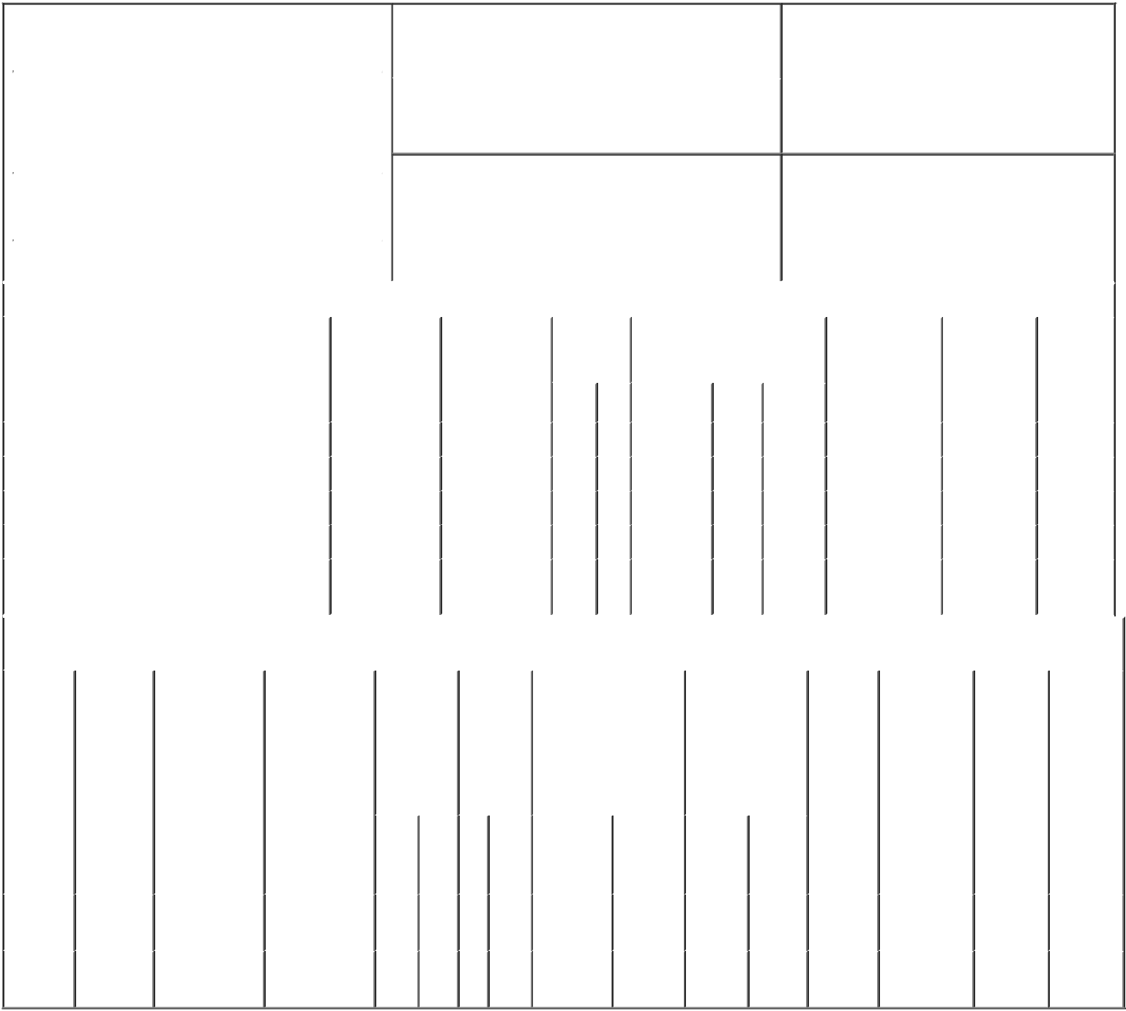

1. Name and Address of Reporting Person* |  |  |  |  |  |  | 2. Issuer Name and Ticker or Trading Symbol
 | Bobitz Ward E. |  |  |  |  |  | GENWORTH FINANCIAL INC [ GNW ]
 | (Last) | (First) |  | (Middle) |  |  | 3. Date of Earliest Transaction (Month/Day/Year)
 | C/O GENWORTH FINANCIAL, INC. |  |  |  | 02/14/2015

6620 WEST BROAD STREET

- Relationship of Reporting Person(s) to Issuer (Check all applicable)

 | Director | 10% Owner
X | Officer (give title | Other (specify
 | below) | below)

EVP and General Counsel

 |  |  |  |  |  |  |  | 4. If Amendment, Date of Original Filed (Month/Day/Year) |  |  |  |  |  |  | 6. Individual or Joint/Group Filing (Check Applicable
 | (Street) |  |  |  |  |  |  |  |  |  |  |  |  |  | Line)
 |  |  |  |  |  |  |  |  |  |  |  |  |  |  |  | X Form filed by One Reporting Person
 |  | RICHMOND |  | VA |  | 23230
 |  |  |  |  |  |  |  |  |  |  |  |  |  |  |  |  |  | Form filed by More than One Reporting
 |  |  |  |  |  |  |  |  |  |  |  |  |  |  |  |  |  | Person
 |  | (City) |  | (State) |  | (Zip)
 |  |  |  |  | Table I - Non-Derivative Securities Acquired, Disposed of, or Beneficially Owned
 | 1. Title of Security (Instr. 3) |  |  |  |  | 2. Transaction |  |  | 2A. Deemed | 3. |  |  | 4. Securities Acquired (A) or |  |  |  |  | 5. Amount of |  | 6. Ownership |  | 7. Nature
 |  |  |  |  |  | Date |  |  | Execution Date, |  | Transaction |  | Disposed Of (D) (Instr. 3, 4 and |  |  |  |  | Securities |  | Form: Direct |  | of Indirect
 |  |  |  |  |  | (Month/Day/Year) |  |  | if any |  | Code (Instr. |  | 5) |  |  |  |  | Beneficially |  | (D) or Indirect |  | Beneficial
 |  |  |  |  |  |  |  |  | (Month/Day/Year) 8) |  |  |  |  |  |  |  |  | Owned Following |  | (I) (Instr. 4) |  | Ownership
 |  |  |  |  |  |  |  |  |  |  |  |  |  |  |  |  |  | Reported |  |  |  | (Instr. 4)
 |  |  |  |  |  |  |  |  |  |  | Code V |  | Amount | (A) or | Price |  |  | Transaction(s)
 |  |  |  |  |  |  |  |  |  |  |  |  |  | (D) |  |  |  | (Instr. 3 and 4)
 | Class A Common Stock |  |  |  |  | 02/14/2015 |  |  |  |  | M |  | 850 | A | (1) |  | 10,072 |  |  |  | D
 | Class A Common Stock |  |  |  |  | 02/14/2015 |  |  |  |  | F |  | 327⁽²⁾ | D | $8.59 |  | 9,745 |  |  |  | D
 | Class A Common Stock |  |  |  |  | 02/15/2015 |  |  |  |  | M |  | 1,888 | A | (1) |  | 11,633 |  |  |  | D
 | Class A Common Stock |  |  |  |  | 02/15/2015 |  |  |  |  | F |  | ₇₂₅(3) | D | $8.59 |  | 10,908 |  |  |  | D
 | Class A Common Stock |  |  |  |  |  |  |  |  |  |  |  |  |  |  |  | 162.7474 |  |  |  | I | by
 |  |  |  |  |  |  |  |  |  |  |  |  |  |  |  |  |  |  |  |  |  | 401(k)
 |  |  |  |  | Table II - Derivative Securities Acquired, Disposed of, or Beneficially Owned
 |  |  |  |  |  | (e.g., puts, calls, warrants, options, convertible securities)
 | 1. Title of |  | 2. |  | 3. Transaction | 3A. Deemed | 4. |  | 5. Number | 6. Date Exercisable and |  |  |  | 7. Title and |  |  | 8. Price of |  | 9. Number of |  | 10. | 11. Nature
 | Derivative |  | Conversion |  | Date | Execution Date, | Transaction of |  |  | Expiration Date |  |  |  | Amount of |  |  | Derivative |  | derivative |  | Ownership | of Indirect
 | Security |  | or Exercise |  | (Month/Day/Year) | if any | Code (Instr. |  | Derivative | (Month/Day/Year) |  |  |  | Securities |  |  | Security |  | Securities |  | Form: | Beneficial
 | (Instr. 3) |  | Price of |  |  | (Month/Day/Year) | 8) |  | Securities |  |  |  |  | Underlying |  |  | (Instr. 5) |  | Beneficially |  | Direct (D) | Ownership
 |  |  | Derivative |  |  |  |  |  | Acquired |  |  |  |  | Derivative Security |  |  |  |  | Owned |  | or Indirect | (Instr. 4)
 |  |  | Security |  |  |  |  |  | (A) or |  |  |  |  | (Instr. 3 and 4) |  |  |  |  | Following |  | (I) (Instr. 4)
 |  |  |  |  |  |  |  |  | Disposed |  |  |  |  |  |  |  |  |  | Reported
 |  |  |  |  |  |  |  |  | of (D) |  |  |  |  |  |  |  |  |  | Transaction(s)
 |  |  |  |  |  |  |  |  | (Instr. 3, 4 |  |  |  |  |  |  |  |  |  | (Instr. 4)
 |  |  |  |  |  |  |  |  | and 5)
 |  |  |  |  |  |  |  |  |  |  |  |  |  |  | Amount
 |  |  |  |  |  |  |  |  |  |  |  |  |  |  | or
 |  |  |  |  |  |  |  |  |  |  |  |  |  |  | Number
 |  |  |  |  |  |  |  |  |  | Date |  | Expiration |  |  | of
 |  |  |  |  |  |  | Code V |  | (A) (D) | Exercisable |  | Date |  | Title | Shares
 | Restricted |  | (1) |  |  |  |  |  |  | (4) |  |  | (4) | Class A | 850
 | Stock |  |  |  | 02/14/2015 |  |  | M | 850 |  |  |  |  | Common |  |  | $0.00 |  | 850 |  | D
 | Units |  |  |  |  |  |  |  |  |  |  |  |  | Stock
 | Restricted |  | (1) |  |  |  |  |  |  | (5) |  |  | (5) | Class A | 1,888
 | Stock |  |  |  | 02/15/2015 |  |  | M | 1,888 |  |  |  |  | Common |  |  | $0.00 |  | 3,774 |  | D
 | Units |  |  |  |  |  |  |  |  |  |  |  |  | Stock

Explanation of Responses:

- Restricted Stock Units settle in Class A Common Stock on a 1:1 basis.

- The Company withheld shares of common stock to satisfy the tax withholding obligation for the Reporting Person's Restricted Stock Units that vested on February 14, 2015.

- The Company withheld shares of common stock to satisfy the tax withholding obligation for the Reporting Person's Restricted Stock Units that vested on February 15, 2015.

- Restricted Stock Units vested and converted to Class A Common Stock on 02/14/2015.

- Restricted Stock Units vested and converted to Class A Common Stock on 02/15/2015.

Remarks:
/s/ Christine A. Ness, by power _{02/18/2015}
of attorney

** Signature of Reporting Person Date

Reminder: Report on a separate line for each class of securities beneficially owned directly or indirectly.

* If the form is filed by more than one reporting person, see Instruction 4 (b)(v).

- Intentional misstatements or omissions of facts constitute Federal Criminal Violations See 18 U.S.C. 1001 and 15 U.S.C. 78ff(a). Note: File three copies of this Form, one of which must be manually signed. If space is insufficient, see Instruction 6 for procedure.
Persons who respond to the collection of information contained in this form are not required to respond unless the form displays a currently valid OMB Number.

