SEC Form 4

FORM 4

Check this box if no longer subject to Section 16. Form 4 or Form 5 obligations may continue. See Instruction 1(b).

UNITED STATES SECURITIES AND EXCHANGE COMMISSION
Washington, D.C. 20549
 |  | OMB APPROVAL
STATEMENT OF CHANGES IN BENEFICIAL OWNERSHIP
 |  | OMB Number: | 3235-0287
 |  | Estimated average burden
Filed pursuant to Section 16(a) of the Securities Exchange Act of 1934 |  | hours per response: | 0.5
or Section 30(h) of the Investment Company Act of 1940
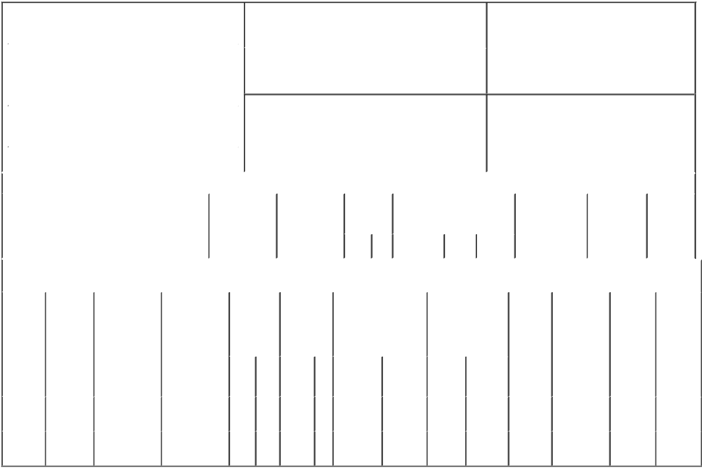

1. Name and Address of Reporting Person* |  |  |  |  |  | 2. Issuer Name and Ticker or Trading Symbol
 | Schneider Kevin Douglas |  |  |  |  | GENWORTH FINANCIAL INC [ GNW ]
 | (Last) | (First) |  | (Middle) |  | 3. Date of Earliest Transaction (Month/Day/Year)
 | C/O GENWORTH FINANCIAL, INC. |  |  |  | 02/20/2015

6620 WEST BROAD STREET

- Relationship of Reporting Person(s) to Issuer (Check all applicable)

 | Director | 10% Owner
X | Officer (give title | Other (specify
 | below) | below)

EVP - Genworth

 |  |  |  |  |  |  |  | 4. If Amendment, Date of Original Filed (Month/Day/Year) |  |  |  |  |  |  | 6. Individual or Joint/Group Filing (Check Applicable
 | (Street) |  |  |  |  |  |  |  |  |  |  |  |  |  | Line)
 |  |  |  |  |  |  |  |  |  |  |  |  |  |  | X Form filed by One Reporting Person
 |  | RICHMOND |  | VA |  | 23230
 |  |  |  |  |  |  |  |  |  |  |  |  |  |  |  |  |  | Form filed by More than One Reporting
 |  |  |  |  |  |  |  |  |  |  |  |  |  |  |  |  |  | Person
 |  | (City) |  | (State) |  | (Zip)
 |  |  |  |  | Table I - Non-Derivative Securities Acquired, Disposed of, or Beneficially Owned
 | 1. Title of Security (Instr. 3) |  |  |  |  | 2. Transaction |  |  | 2A. Deemed |  | 3. |  | 4. Securities Acquired (A) or |  |  |  |  | 5. Amount of |  | 6. Ownership |  | 7. Nature of
 |  |  |  |  |  | Date |  |  | Execution Date, |  |  | Transaction Disposed Of (D) (Instr. 3, 4 and 5) |  |  |  |  |  | Securities |  | Form: Direct |  | Indirect
 |  |  |  |  |  | (Month/Day/Year) |  |  | if any |  |  | Code (Instr. |  |  |  |  |  | Beneficially |  | (D) or Indirect |  | Beneficial
 |  |  |  |  |  |  |  |  | (Month/Day/Year) 8) |  |  |  |  |  |  |  |  | Owned Following |  | (I) (Instr. 4) |  | Ownership
 |  |  |  |  |  |  |  |  |  |  |  |  |  |  |  |  |  | Reported |  |  |  | (Instr. 4)
 |  |  |  |  |  |  |  |  |  |  |  | Code V | Amount | (A) or | Price |  |  | Transaction(s)
 |  |  |  |  |  |  |  |  |  |  |  |  |  | (D) |  |  |  | (Instr. 3 and 4)
 |  |  |  |  |  | Table II - Derivative Securities Acquired, Disposed of, or Beneficially Owned
 |  |  |  |  |  | (e.g., puts, calls, warrants, options, convertible securities)
 | 1. Title of |  | 2. |  | 3. Transaction | 3A. Deemed | 4. |  | 5. Number of |  | 6. Date Exercisable and |  |  | 7. Title and Amount |  |  | 8. Price of |  | 9. Number of |  | 10. | 11. Nature
 | Derivative |  | Conversion |  | Date | Execution Date, | Transaction |  | Derivative |  | Expiration Date |  |  | of Securities |  |  | Derivative |  | derivative |  | Ownership of Indirect
 | Security |  | or Exercise |  | (Month/Day/Year) | if any | Code (Instr. |  | Securities |  | (Month/Day/Year) |  |  | Underlying |  |  | Security |  | Securities |  | Form: | Beneficial
 | (Instr. 3) |  | Price of |  |  | (Month/Day/Year) | 8) |  | Acquired (A) |  |  |  |  | Derivative Security |  |  | (Instr. 5) |  | Beneficially |  | Direct (D) | Ownership
 |  |  | Derivative |  |  |  |  |  | or Disposed |  |  |  |  | (Instr. 3 and 4) |  |  |  |  | Owned |  | or Indirect | (Instr. 4)
 |  |  | Security |  |  |  |  |  | of (D) (Instr. |  |  |  |  |  |  |  |  |  | Following |  | (I) (Instr. 4)
 |  |  |  |  |  |  |  |  | 3, 4 and 5) |  |  |  |  |  |  |  |  |  | Reported
 |  |  |  |  |  |  |  |  |  |  |  |  |  |  |  |  |  |  | Transaction(s)
 |  |  |  |  |  |  |  |  |  |  |  |  |  |  | Amount |  |  |  | (Instr. 4)
 |  |  |  |  |  |  |  |  |  |  |  |  |  |  | or
 |  |  |  |  |  |  |  |  |  |  | Date |  | Expiration |  | Number
 |  |  |  |  |  |  | Code V |  | (A) | (D) | Exercisable |  | Date | Title | of Shares
 | Stock |  |  |  |  |  |  |  |  |  | (1) |  |  | Class A | 265,000
 | Settled |  | $7.99 |  | 02/20/2015 |  |  | A | 265,000 |  |  |  | 02/20/2025 | Common |  |  | $0.00 |  | 265,000 |  | D
 | SARs |  |  |  |  |  |  |  |  |  |  |  |  | Stock
 | Restricted |  | (2) |  |  |  |  |  |  |  | (3) |  | (3) | Class A | 80,000
 | Stock |  |  |  | 02/20/2015 |  |  | A | 80,000 |  |  |  |  | Common |  |  | $0.00 |  | 80,000 |  | D
 | Units |  |  |  |  |  |  |  |  |  |  |  |  | Stock

Explanation of Responses:

- The SARs vest in three equal annual installments beginning on February 20, 2016. The vested and unexercised portion of the SARs, if any, shall be automatically exercised if the closing price of the issuer's common stock equals or exceeds a specified "maximum share value" equal to $75.

- Restricted Stock Units settle in Class A Common Stock on a 1:1 basis.

- Restricted Stock Units vest and convert to Class A Common Stock in three equal annual installments beginning on February 20, 2016.

Remarks:

/s/ Christine A. Ness, by power

of attorney

** Signature of Reporting Person

02/24/2015

Date

Reminder: Report on a separate line for each class of securities beneficially owned directly or indirectly.

* If the form is filed by more than one reporting person, see Instruction 4 (b)(v).

- Intentional misstatements or omissions of facts constitute Federal Criminal Violations See 18 U.S.C. 1001 and 15 U.S.C. 78ff(a). Note: File three copies of this Form, one of which must be manually signed. If space is insufficient, see Instruction 6 for procedure.

Persons who respond to the collection of information contained in this form are not required to respond unless the form displays a currently valid OMB Number.

