SEC Form 4

FORM 4

Check this box if no longer subject to Section 16. Form 4 or Form 5 obligations may continue. See Instruction 1(b).

UNITED STATES SECURITIES AND EXCHANGE COMMISSION
Washington, D.C. 20549
 |  | OMB APPROVAL
STATEMENT OF CHANGES IN BENEFICIAL OWNERSHIP
 |  | OMB Number: | 3235-0287
 |  | Estimated average burden
Filed pursuant to Section 16(a) of the Securities Exchange Act of 1934 |  | hours per response: | 0.5
or Section 30(h) of the Investment Company Act of 1940
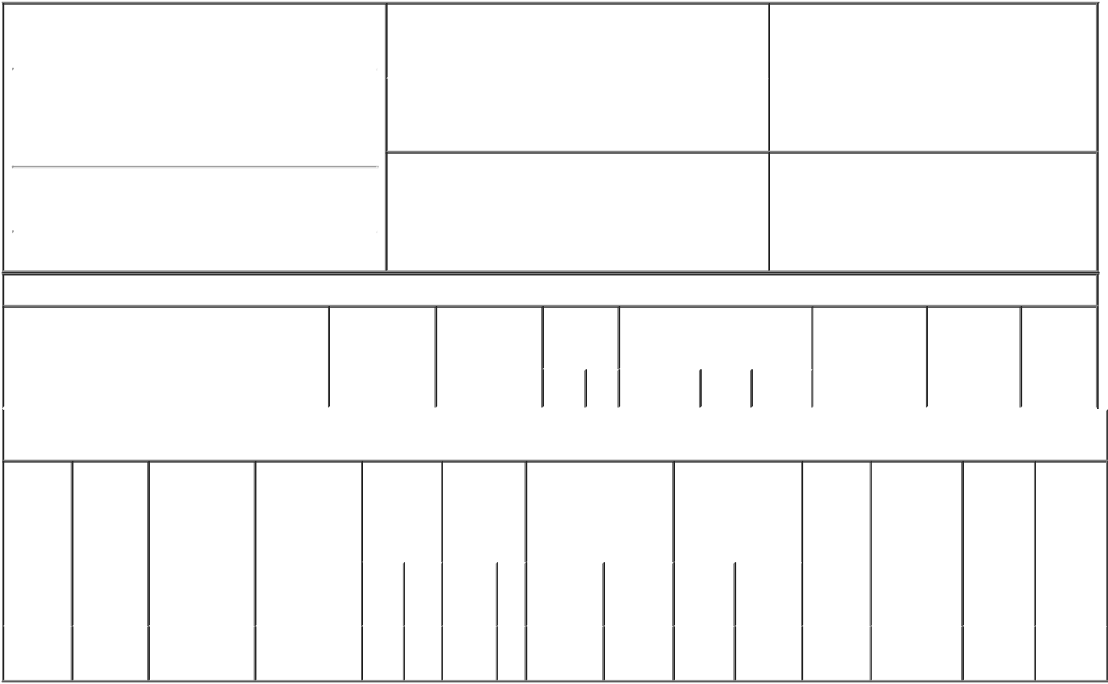

1. Name and Address of Reporting Person* |  |  |  |  |  |  | 2. Issuer Name and Ticker or Trading Symbol
 | McInerney Thomas J |  |  |  |  |  | GENWORTH FINANCIAL INC [ GNW ]
 | (Last) | (First) |  | (Middle) |  |  | 3. Date of Earliest Transaction (Month/Day/Year)
 | C/O GENWORTH FINANCIAL, INC. |  |  |  | 03/15/2017

6620 WEST BROAD STREET

- Relationship of Reporting Person(s) to Issuer (Check all applicable)

X | Director | 10% Owner
X | Officer (give title | Other (specify
 | below) | below)

President and CEO; Director

(Street)
 | RICHMOND | VA | 23230
 | (City) | (State) | (Zip)

4. If Amendment, Date of Original Filed (Month/Day/Year) 6. Individual or Joint/Group Filing (Check Applicable
Line)
X Form filed by One Reporting Person

Form filed by More than One Reporting
Person

Table I - Non-Derivative Securities Acquired, Disposed of, or Beneficially Owned

 | 1. Title of Security (Instr. 3) | 2. Transaction | 2A. Deemed | 3. | 4. Securities Acquired (A) or |  |  | 5. Amount of | 6. Ownership | 7. Nature of
 |  | Date | Execution Date, | Transaction | Disposed Of (D) (Instr. 3, 4 and 5) |  |  | Securities | Form: Direct | Indirect
 |  | (Month/Day/Year) | if any | Code (Instr. |  |  |  | Beneficially | (D) or Indirect | Beneficial
 |  |  | (Month/Day/Year) | 8) |  |  |  | Owned Following | (I) (Instr. 4) | Ownership
 |  |  |  |  |  |  |  | Reported |  | (Instr. 4)
 |  |  |  | Code V | Amount | (A) or | Price | Transaction(s)
 |  |  |  |  |  | (D) |  | (Instr. 3 and 4)

Table II - Derivative Securities Acquired, Disposed of, or Beneficially Owned

(e.g., puts, calls, warrants, options, convertible securities)

1. Title of | 2. | 3. Transaction | 3A. Deemed | 4. | 5. Number of |  | 6. Date Exercisable and |  | 7. Title and Amount |  | 8. Price of | 9. Number of | 10. | 11. Nature
Derivative | Conversion | Date | Execution Date, | Transaction | Derivative |  | Expiration Date |  | of Securities |  | Derivative | derivative | Ownership | of Indirect
Security | or Exercise | (Month/Day/Year) | if any | Code (Instr. | Securities |  | (Month/Day/Year) |  | Underlying |  | Security | Securities | Form: | Beneficial
(Instr. 3) | Price of |  | (Month/Day/Year) | 8) | Acquired (A) |  |  |  | Derivative Security |  | (Instr. 5) | Beneficially | Direct (D) | Ownership
 | Derivative |  |  |  | or Disposed |  |  |  | (Instr. 3 and 4) |  |  | Owned | or Indirect | (Instr. 4)
 | Security |  |  |  | of (D) (Instr. |  |  |  |  |  |  | Following | (I) (Instr. 4)
 |  |  |  |  | 3, 4 and 5) |  |  |  |  |  |  | Reported
 |  |  |  |  |  |  |  |  |  |  |  | Transaction(s)
 |  |  |  |  |  |  |  |  |  | Amount |  | (Instr. 4)
 |  |  |  |  |  |  |  |  |  | or
 |  |  |  |  |  |  | Date | Expiration |  | Number
 |  |  |  | Code V | (A) | (D) | Exercisable | Date | Title | of Shares
Restricted | (1) |  |  |  |  |  | (2) | (2) | Class A | 554,000
Stock |  | 03/15/2017 |  | A | 554,000 |  |  |  | Common |  | $0.00 | 554,000 | D
Units |  |  |  |  |  |  |  |  | Stock

Explanation of Responses:

- Restricted Stock Units settle in Class A Common Stock on a 1:1 basis.

- Restricted Stock Units vest and convert to Class A Common Stock in three equal annual installments beginning on March 15, 2018.

Remarks:

/s/ David F. Kurzawa, by power

of attorney

** Signature of Reporting Person

03/17/2017

Date

Reminder: Report on a separate line for each class of securities beneficially owned directly or indirectly.

* If the form is filed by more than one reporting person, see Instruction 4 (b)(v).

- Intentional misstatements or omissions of facts constitute Federal Criminal Violations See 18 U.S.C. 1001 and 15 U.S.C. 78ff(a). Note: File three copies of this Form, one of which must be manually signed. If space is insufficient, see Instruction 6 for procedure.
Persons who respond to the collection of information contained in this form are not required to respond unless the form displays a currently valid OMB Number.

