UNITED STATES

SECURITIES AND EXCHANGE COMMISSION

Washington, D.C. 20549

FORM 8-K

CURRENT REPORT

Pursuant to Section 13 or 15(d) of the Securities Exchange Act of 1934

Date of Report (Date of earliest event reported)

May 23, 2019

NELNET, INC.

(Exact name of registrant as specified in its charter)

Nebraska |  | 001-31924 |  | 84-0748903
(State or other jurisdiction of incorporation) |  | (Commission File Number) |  |  |  | (I.R.S. Employer Identification No.)
121 South 13th Street, Suite 100
Lincoln, Nebraska |  |  |  | 68508
(Address of principal executive offices) |  |  |  |  |  | (Zip Code)

Registrant's telephone number, including area code (402) 458-2370

Check the appropriate box below if the Form 8-K filing is intended to simultaneously satisfy the filing obligation of the registrant under any of the following provisions:

- ] Written communications pursuant to Rule 425 under the Securities Act (17 CFR 230.425)

- ] Soliciting material pursuant to Rule 14a-12 under the Exchange Act (17 CFR 240.14a-12)

- ] Pre-commencement communications pursuant to Rule 14d-2(b) under the Exchange Act (17 CFR 240.14d-2(b))

- ] Pre-commencement communications pursuant to Rule 13e-4(c) under the Exchange Act (17 CFR 240.13e-4(c))

Securities registered pursuant to Section 12(b) of the Act:

Title of each class | Trading Symbol | Name of each exchange on which registered
Class A Common Stock, Par Value $0.01 per Share | NNI | New York Stock Exchange

Indicate by check mark whether the registrant is an emerging growth company as defined in Rule 405 of the Securities Act of 1933 (§230.405 of this chapter) or Rule 12b-2 of the Securities Exchange Act of 1934 (§240.12b-2 of this chapter).
Emerging growth company [ ]

If an emerging growth company, indicate by check mark if the registrant has elected not to use the extended transition period for complying with any new or revised financial

accounting standards provided pursuant to Section 13(a) of the Exchange Act. [ ]

Item 5.02 Departure of Directors or Certain Officers; Election of Directors; Appointment of Certain Officers; Compensatory Arrangements of Certain Officers.

At the 2019 annual meeting of shareholders of Nelnet, Inc. (the "Company") held on May 23, 2019 (the "Annual Meeting"), the shareholder voting results of which are reported below under Item 5.07 of this report, the Company's shareholders approved a new Executive Officers Incentive Compensation Plan. The new Executive Officers Incentive Compensation Plan was previously approved by the Company's Board of Directors, subject to shareholder approval.

In summary, the new Executive Officers Incentive Compensation Plan is intended to provide the Company's executive officers with opportunities to earn performance-based compensation that aligns their interests with the interests of shareholders, based on certain performance criteria and goals that may be established by the Compensation Committee of the Board of Directors. The new Executive Officers Incentive Compensation Plan plan replaces the previous shareholder-approved Executive Officers Incentive Compensation Plan, which expired pursuant to its terms on January 1, 2019 and was designed so that compensation under that plan could qualify for the previous "performance based compensation" exemption from the limits on tax deductibility imposed by Section 162(m) of the Internal Revenue Code, which exemption was repealed under the Tax Cuts and Jobs Act which became effective on January 1, 2018. The new Executive Officers Incentive Compensation Plan is similar to the previous plan, except that it removes certain references and specific requirements applicable to the previous "performance based compensation" framework under Section 162(m), and thus is more flexible than the previous plan. The new Executive Officers Incentive Compensation Plan is effective as of January 1, 2019 and is administered by the Compensation Committee, which will select those executive officers who will be eligible for incentive compensation awards, determine the performance criteria and goals to which awards will be subject, and determine the payability of awards upon the attainment of performance goals.

Additional information about the new Executive Officers Incentive Compensation Plan can be found in the Company's definitive proxy statement for the Annual Meeting, as filed with the Securities and Exchange Commission on April 12, 2019. The foregoing summary is qualified in its entirety by reference to the complete text of the new Executive Officers Incentive Compensation Plan, a copy of which is filed with this report as Exhibit 10.1.

Item 5.03 Amendments to Articles of Incorporation or Bylaws; Change in Fiscal Year.

As reported below under Item 5.07 of this report, at the Company's Annual Meeting, the Company's shareholders approved an amendment to the Company’s articles of incorporation (the “Articles of Incorporation”). As a result, on May 23, 2019, the Company filed Articles of Amendment to Third Amended and Restated Articles of Incorporation (the “Articles of Amendment”) with the Nebraska Secretary of State, pursuant to which the approved amendment (the “Amendment”) to the first paragraph of Section 4.6 of the Articles of Incorporation to modify the restrictions for trusts which may hold Class B common stock (“Class B Shares”), with ten votes per share, without conversion into Class A common stock (“Class A Shares”), with one vote per share, became effective.

In summary, the Amendment made changes to the description of eligible trust beneficiaries, in part utilizing a uniform law “qualified beneficiary” term, in order to simplify and clarify the requirements for beneficiaries of trusts to which transfers of Class B Shares may be made without automatic conversion of such Class B Shares into Class A Shares, and thereby facilitate the use of customary estate planning trusts by holders of Class B Shares who do not intend for such shares to be converted, without inordinate time required of the Company in reviewing such trusts to determine the proper classification of such shares upon transfer to such trusts under the prior provisions of the Articles of Incorporation. The Company’s definitive proxy statement for the Annual Meeting as filed with the Securities and Exchange Commission on April 12, 2019 included under the description of the Amendment a marked version of the first paragraph of Section 4.6 of the Articles of Incorporation to show the Amendment in strikethrough and underlined text.

The above description of the Amendment is qualified in its entirety by reference to the complete text of the amended provisions contained in the Articles of Amendment, a copy of which is filed with this report as Exhibit 3.1.

Item 5.07 Submission of Matters to a Vote of Security Holders.

The Company held its 2019 annual meeting of shareholders on May 23, 2019. At the meeting, the following proposals were submitted to a vote of our shareholders, with the voting results indicated below:

Proposal 1: Election of Directors. Our shareholders elected the following three Class II directors to hold office until the 2022 annual meeting of shareholders and until their successors have been duly elected or appointed.

 | For |  | Against |  | Abstain |  | Broker Non-Votes
James P. Abel | 136,998,796 |  | 349,068 |  | 11,020 |  | 2,651,245
William R. Cintani | 136,132,442 |  | 1,215,422 |  | 11,020 |  | 2,651,245
Kimberly K. Rath | 132,216,790 |  | 5,130,983 |  | 11,111 |  | 2,651,245

Proposal 2: Ratification of the appointment of KPMG LLP. Our shareholders ratified the appointment of KPMG LLP as our independent registered public accounting firm for the year ending December 31, 2019.

For |  | Against |  | Abstain |  | Broker Non-Votes
139,649,373 |  | 351,421 |  | 9,335 |  | —

Proposal 3: Advisory vote on executive compensation. Our shareholders approved, by an advisory vote, the compensation of our named executive officers as disclosed in the proxy statement for the annual meeting.

For |  | Against |  | Abstain |  | Broker Non-Votes
137,166,320 |  | 84,888 |  | 107,676 |  | 2,651,245

Proposal 4: Approval of a new Executive Officers Incentive Compensation Plan. Our shareholders approved a new Executive Officers Incentive Compensation Plan.

For |  | Against |  | Abstain |  | Broker Non-Votes
132,360,269 |  | 4,889,088 |  | 109,527 |  | 2,651,245

Proposal 5: Approval of an amendment to the Articles of Incorporation. Our shareholders approved an amendment to the Company's Articles of Incorporation to modify the restrictions for trusts which may hold Class B common stock, with ten votes per share, without conversion into Class A common stock, with one vote per share.

For |  | Against |  | Abstain |  | Broker Non-Votes
128,018,029 |  | 9,286,403 |  | 54,452 |  | 2,651,245

Item 9.01 Financial Statements and Exhibits.

(d) Exhibits.

The following exhibits are filed as part of this report:

Exhibit No. |  |  | Description
3.1 |  |  | Articles of Amendment to Third Amended and Restated Articles of Incorporation of Nelnet, Inc.
10.1 |  |  | Nelnet, Inc. Executive Officers Incentive Compensation Plan, effective as of January 1, 2019

SIGNATURES

Pursuant to the requirements of the Securities Exchange Act of 1934, the registrant has duly caused this report to be signed on its behalf by the undersigned hereunto duly authorized.

Dated: May 23, 2019

NELNET, INC.

By: /s/ JAMES D. KRUGER

Name: James D. Kruger
Title: Chief Financial Officer

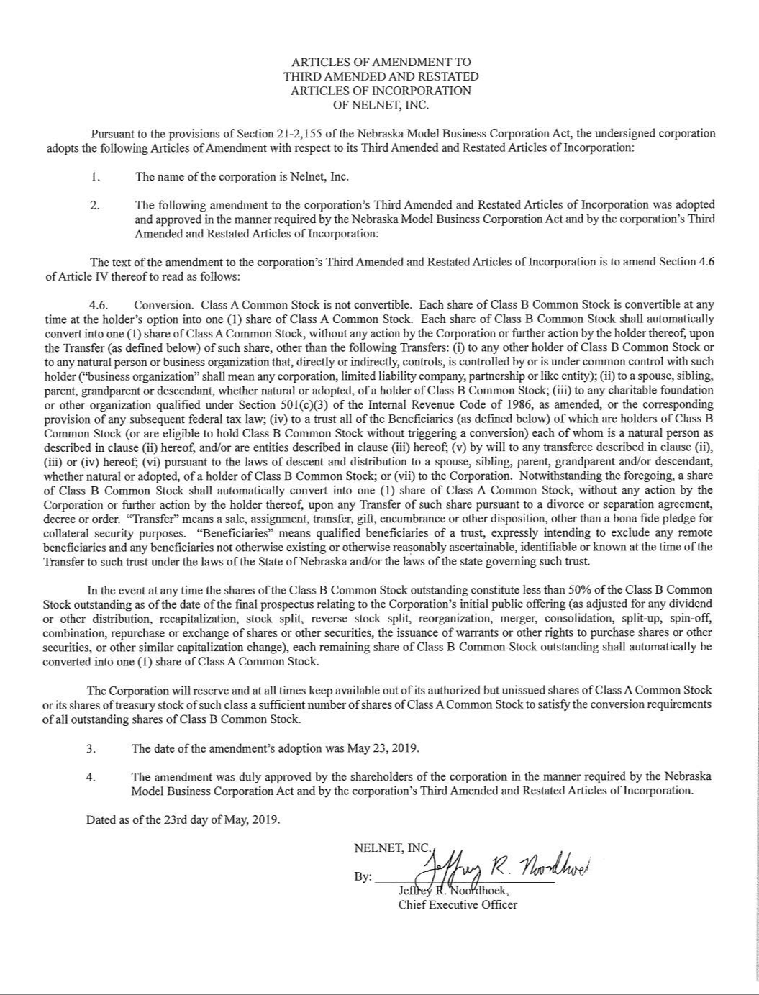

NELNET, INC.

EXECUTIVE OFFICERS INCENTIVE COMPENSATION PLAN

(Effective as of January 1, 2019)

- Purpose.

The purpose of the Nelnet, Inc. Executive Officers Incentive Compensation Plan is to advance the interests of Nelnet, Inc. and its shareholders by strengthening its ability to attract, retain, and motivate executive officers of Nelnet, Inc. upon whose judgment, initiative, and efforts ensure the continued success, growth and development of Nelnet, Inc. The intent is to provide them with opportunities to earn performance-based incentive compensation that aligns their interests with the interests of the shareholders, including the achievement of long-term strategic business objectives.

- Definitions.

For purposes of the Plan, the following terms shall be defined as set forth below:

- “Award” means the amount of incentive compensation in the form of a Performance-Based Award for a Performance Period that the Committee has determined is payable to a Participant in accordance with the Plan.

- “Beneficiary” means the person, persons, trust or trusts which have been designated by a Participant in his or her most recent written beneficiary designation filed with the Company to receive the benefits specified under this Plan upon the death of the Participant, or, if there is no designated Beneficiary or surviving designated Beneficiary, then the person, persons, trust or trusts entitled by will or the laws of descent and distribution to receive such benefits.

- “Board” means the Board of Directors of the Company.

- “Code” means the Internal Revenue Code of 1986, as amended from time to time. References to any provision of the Code shall be deemed to include successor provisions thereto and regulations thereunder.

- “Committee” means the Compensation Committee of the Board (or a subcommittee thereof to which authority under this Plan may be delegated by the Compensation Committee of the Board pursuant to Section 3 of this Plan).

- “Company” means Nelnet, Inc., a corporation organized under the laws of Nebraska, or any successor corporation.

- “Executive Officer” means an “executive officer” of the Company within the meaning of Rule 3b-7 under the Securities Exchange Act of 1934, as amended, including the Executive Chairman of the Board.

- “Participant” means an Executive Officer who has been selected by the Committee to participate in the Plan for a particular Performance Period and be eligible to receive an Award for that Performance Period.

- “Performance-Based Award” means an Award as described under Section 4 of the Plan.

- “Performance Period” means a calendar year or such other period established by the Committee in its sole discretion.

- “Plan” means this Nelnet, Inc. Executive Officers Incentive Compensation Plan.

- Administration. The Plan shall be administered by the Compensation Committee of the Board, provided that such Committee may from time to time delegate all or any part of its authority under this Plan to a subcommittee thereof and, to the extent of any such delegation, references in this Plan to the Committee shall be deemed to be references to such subcommittee. For each Performance Period, the Committee shall select those Executive Officers who will participate in the Plan and be eligible for an Award under the Plan for that Performance Period. The Committee shall have the authority to adopt, alter, and repeal such administrative rules, guidelines, and practices governing the Plan as it shall deem advisable, and to interpret the terms and provisions of the Plan. All determinations made by the Committee with respect to the Plan and Awards thereunder shall be final and binding on all persons, including the Company and all Executive Officers selected by the Committee to participate in the Plan.

1

4. Performance-Based Awards.

- The Committee may, from time to time, establish performance criteria with respect to Awards which Participants may be eligible to receive with respect to a Performance Period, and performance goals may be based on one or more of the following criteria:

  - Levels of earnings per share; net income; income before income taxes; net interest income; earnings per share or net income excluding derivative market value and other adjustments as the Committee deems appropriate in the Committee’s sole discretion; revenues from fee-based businesses (including measures related to the diversification of revenues from fee-based businesses and increases in revenues through both organic growth and acquisitions); federally insured student loan assets; private education loan assets; consumer loan assets; and total assets;

  - Return on equity (including return on tangible equity); return on assets or net assets; return on capital (including return on total capital or return on invested capital); return on investments; and ratio of equity to total assets;

  - Student loan servicing and other education finance or service customer measures (including loan servicing volume and service rating levels under contracts with the U.S. Department of Education);
  - Success or progress made in efforts to obtain new contracts with the U.S. Department of Education, as well as other loan servicing business;

  - Cash flow measures (including cash flows from operating activities, cash flow return on investment, assets, equity, or capital, and generation of long-term cash flows (including net cash flows from the Company’s securitized loan portfolios));

  - Market share;

  - Customer satisfaction levels, and employee engagement, productivity, retention, and satisfaction measures;

  - Operating performance and efficiency targets and ratios, as well as productivity targets and ratios;

  - Levels of, or increases or decreases in, operating margins, operating expenses, and/or nonoperating expenses;

  - Business segment, division or unit profitability and other performance measures (including growth in customer base, revenues, earnings before interest, taxes, depreciation and amortization, and segment profitability, as well as management of operating expense levels);

  - Acquisitions, dispositions, projects, or other specific events or transactions (including specific events or transactions intended to enhance the long-term strategic positioning of

the Company);

  - Performance of investments;

  - Regulatory compliance measures; or

  - Any other criteria as determined by the Committee in its sole discretion.

Any criteria may be used to measure the performance of the Company as a whole and/or any one or more operating segments, divisions, business units, and/or subsidiaries of the Company or any combination thereof, as the Committee may deem appropriate.

- The Committee shall determine whether, with respect to a Performance Period, the applicable performance goals have been met with respect to a particular Participant and, if they have, to ascertain the amount of the applicable Performance-Based Award. The Committee may provide that any evaluation of attainment of a performance goal may include or exclude any extraordinary items.

- Payment of Awards. The Award of each Participant for a Performance Period shall be paid after the determination of the payability of such Award is made by the Committee, and in any event the timing of the payment of an Award shall comply in all respects with the provisions of Section 409A of the Code. If a Participant dies after the end of a calendar year but before

2

receiving payment of any Award earned with respect to such year or any period within such year, the amount of such Award shall be paid to a designated Beneficiary, or, if no Beneficiary has been designated, to the Participant’s estate, as soon as practicable after the payability of such Award has been determined, and in any event in compliance with Section 409A of the Code.

- Maximum Annual Per-Participant Award Limit. In no event shall the amount paid under the Plan to a Participant with respect to any calendar year exceed 150% of that Participant’s base salary for that year.

- Form of Award. The Committee, at their discretion, can determine if the Award is to be paid in cash, stock, or a combination thereof, or provide the option for the Participant to elect to receive their Award in cash, stock, or a combination thereof.

- Nontransferability. No Award or rights under this Plan may be transferred or assigned other than by will or by the laws of descent and distribution.

- Amendments and Termination. The Board may terminate the Plan at any time and may amend it from time to time; provided, however, that no termination or amendment of the Plan shall adversely affect the rights of a Participant or a Beneficiary to a previously earned Award.

- General Provisions.

- Nothing set forth in this Plan shall prevent the Board from adopting other or additional compensation arrangements. Neither the adoption of this Plan or any Award hereunder shall confer upon an Executive Officer any right to continued employment.

- No member of the Board or the Committee, nor any officer or employee of the Company acting on behalf of the Board or the Committee, shall be personally liable for any action, determination, or interpretation taken or made with respect to the Plan, and all members of the Board or the Committee and all officers or employees of the Company acting on their behalf shall, to the extent permitted by law, be fully indemnified and protected by the Company in respect of any such action, determination, or interpretation.

- Governing Law. The validity, construction, and effect of this Plan, and any rules and regulations relating to this Plan, shall be determined in accordance with the laws of the State of Nebraska, without giving effect to principles of conflict of laws thereof.

- Effective Date; Term of Plan. The Plan shall be effective as of January 1, 2019, subject to approval of the Plan by the Company’s shareholders at the Company’s 2019 annual meeting of shareholders. If such shareholder approval is obtained and the Plan becomes effective, the Plan shall expire on January 1, 2024, which is five years after the effective date of the Plan.

- Titles and Headings. The titles and headings of the Sections in the Plan are for convenience of reference only. In the event of any conflict, the text of the Plan, rather than such titles or headings, shall control.

3

