SEC Form 4

FORM 4

Check this box if no longer subject to Section 16. Form 4 or Form 5 obligations may continue. See Instruction 1(b).

UNITED STATES SECURITIES AND EXCHANGE COMMISSION
Washington, D.C. 20549
 |  | OMB APPROVAL
STATEMENT OF CHANGES IN BENEFICIAL OWNERSHIP
 |  | OMB Number: | 3235-0287
 |  | Estimated average burden
Filed pursuant to Section 16(a) of the Securities Exchange Act of 1934 |  | hours per response: | 0.5
or Section 30(h) of the Investment Company Act of 1940
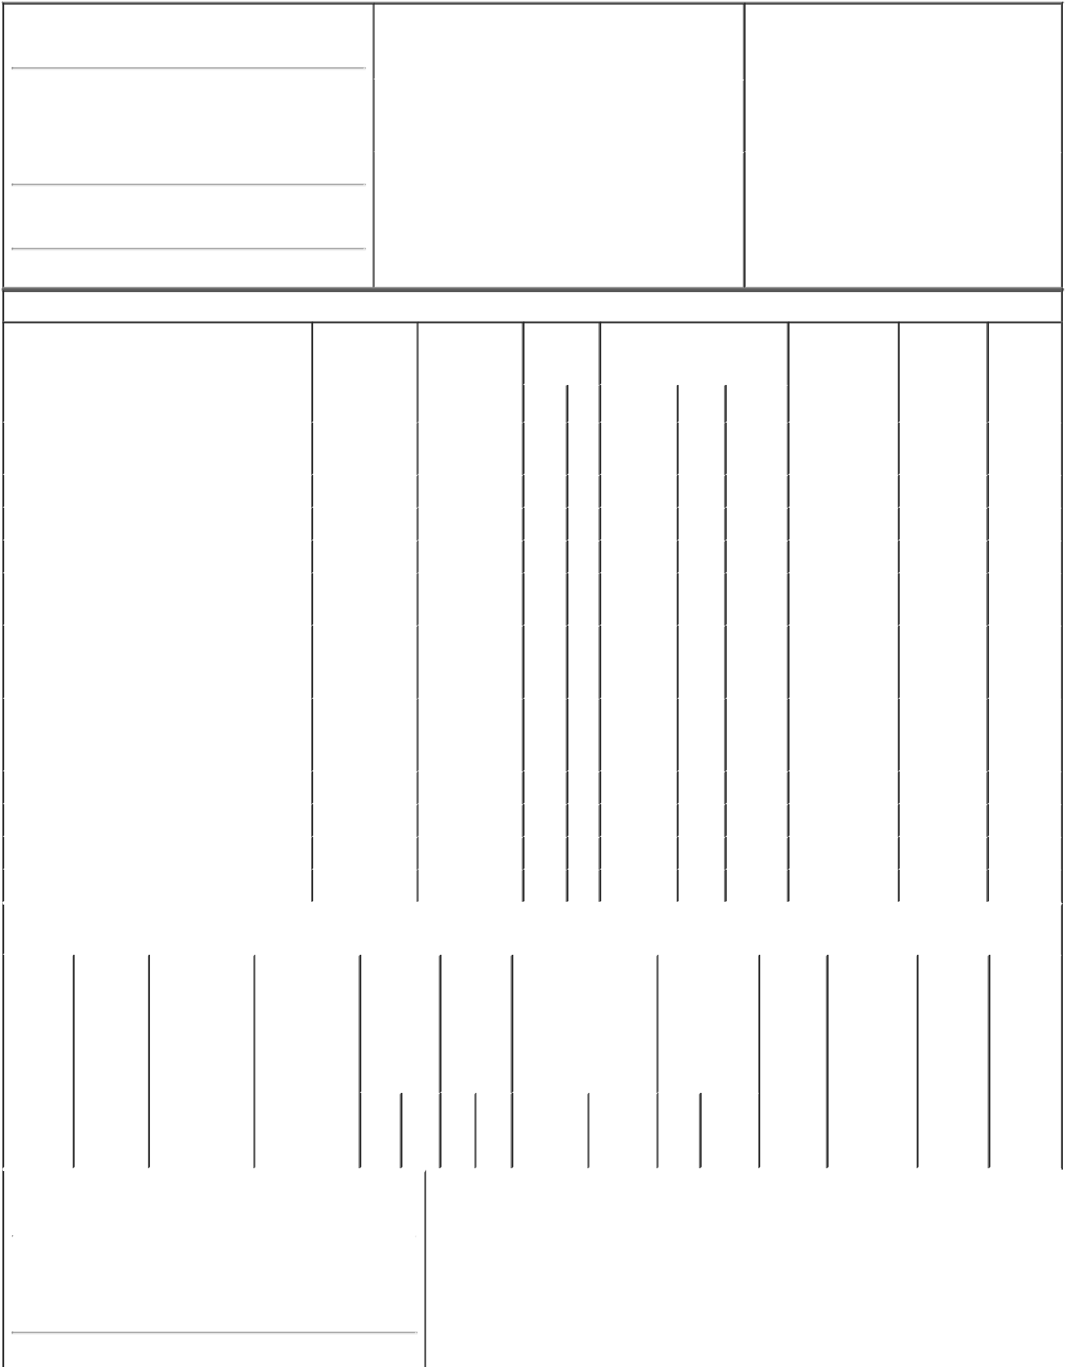

1. Name and Address of Reporting Person*
MUHLEISEN ANGIE

(Last) (First) (Middle)

C/O FARMERS & MERCHANTS INVESTMENT INC.

6801 SOUTH 27TH STREET

(Street)

LINCOLN NE 68512

2. |  | Issuer Name and Ticker or Trading Symbol |  | 5. | Relationship of Reporting Person(s) to Issuer
 | NELNET INC [ NNI ] |  |  | (Check all applicable)
 |  |  |  |  | Director | X 10% Owner
 |  |  |  |  | Officer (give title | Other (specify
3. |  | Date of Earliest Transaction (Month/Day/Year) |  |  | below) | below)
04/17/2019
4. |  | If Amendment, Date of Original Filed (Month/Day/Year) |  | 6. | Individual or Joint/Group Filing (Check Applicable
Line)

 | Form filed by One Reporting Person
X | Form filed by More than One Reporting
 | Person

(City) (State) (Zip)

Table I - Non-Derivative Securities Acquired, Disposed of, or Beneficially Owned

 | 1. Title of Security (Instr. 3) |  |  |  |  | 2. Transaction |  | 2A. Deemed |  |  |  | 3. |  | 4. Securities Acquired (A) or |  |  |  |  | 5. Amount of |  | 6. Ownership | 7. Nature
 |  |  |  |  |  | Date |  | Execution Date, |  |  |  |  | Transaction | Disposed Of (D) (Instr. 3, 4 and |  |  |  |  | Securities |  | Form: Direct | of Indirect
 |  |  |  |  |  | (Month/Day/Year) |  | if any |  |  |  |  | Code (Instr. | 5) |  |  |  |  | Beneficially |  | (D) or Indirect | Beneficial
 |  |  |  |  |  |  |  | (Month/Day/Year) |  |  |  | 8) |  |  |  |  |  |  | Owned Following |  | (I) (Instr. 4) | Ownership
 |  |  |  |  |  |  |  |  |  |  |  |  |  |  |  |  |  |  | Reported |  |  | (Instr. 4)
 |  |  |  |  |  |  |  |  |  |  |  |  | Code V | Amount | (A) or | Price |  |  | Transaction(s)
 |  |  |  |  |  |  |  |  |  |  |  |  |  |  | (D) |  |  |  | (Instr. 3 and 4)
 | Class A Common Stock |  |  |  |  | 04/17/2019 |  |  |  |  |  |  | _{S}(1)(2) | 1,000 | D | $57.93 |  |  | 682,538 |  | I | By adult
 |  |  |  |  |  |  |  |  |  |  |  |  |  |  |  |  |  |  |  |  |  | son
 | Class A Common Stock |  |  |  |  |  |  |  |  |  |  |  |  |  |  |  |  |  | 2,448,362⁽³⁾ |  | D
 | Class A Common Stock |  |  |  |  |  |  |  |  |  |  |  |  |  |  |  |  |  | 616,639⁽⁴⁾ |  | D
 | Class A Common Stock |  |  |  |  |  |  |  |  |  |  |  |  |  |  |  |  |  | 52,344⁽⁵⁾ |  | D
 | Class A Common Stock |  |  |  |  |  |  |  |  |  |  |  |  |  |  |  |  |  | 692,885 |  | I | By adult
 |  |  |  |  |  |  |  |  |  |  |  |  |  |  |  |  |  |  |  |  |  | daughter
 |  |  |  |  |  |  |  |  |  |  |  |  |  |  |  |  |  |  |  |  |  | By
 | Class A Common Stock |  |  |  |  |  |  |  |  |  |  |  |  |  |  |  |  |  | 175,000⁽⁶⁾ |  | I | Dynasty
 |  |  |  |  |  |  |  |  |  |  |  |  |  |  |  |  |  |  |  |  |  | Trust
 |  |  |  |  |  |  |  |  |  |  |  |  |  |  |  |  |  |  |  |  |  | By
 | Class A Common Stock |  |  |  |  |  |  |  |  |  |  |  |  |  |  |  |  |  | 175,000⁽⁷⁾ |  | I | Dynasty
 |  |  |  |  |  |  |  |  |  |  |  |  |  |  |  |  |  |  |  |  |  | Trust
 | Class A Common Stock |  |  |  |  |  |  |  |  |  |  |  |  |  |  |  |  |  | 88,070⁽⁸⁾ |  | I | By trust
 | Class A Common Stock |  |  |  |  |  |  |  |  |  |  |  |  |  |  |  |  |  | 88,070⁽⁹⁾ |  | I | By trust
 | Class A Common Stock |  |  |  |  |  |  |  |  |  |  |  |  |  |  |  |  |  | 88,020⁽¹⁰⁾ |  | I | By trust
 | Class A Common Stock |  |  |  |  |  |  |  |  |  |  |  |  |  |  |  |  |  | 88,010⁽¹¹⁾ |  | I | By trust
 |  |  |  |  | Table II - Derivative Securities Acquired, Disposed of, or Beneficially Owned
 |  |  |  |  |  | (e.g., puts, calls, warrants, options, convertible securities)
 | 1. Title of |  | 2. | 3. Transaction |  | 3A. Deemed | 4. |  |  |  | 5. Number | 6. Date Exercisable and |  |  | 7. Title and |  |  | 8. Price of |  | 9. Number of | 10. | 11. Nature
 | Derivative |  | Conversion | Date |  | Execution Date, | Transaction |  |  |  | of | Expiration Date |  |  | Amount of |  |  | Derivative |  | derivative | Ownership | of Indirect
 | Security |  | or Exercise | (Month/Day/Year) |  | if any | Code (Instr. |  |  |  | Derivative | (Month/Day/Year) |  |  | Securities |  |  | Security |  | Securities | Form: | Beneficial
 | (Instr. 3) |  | Price of |  |  | (Month/Day/Year) | 8) |  |  |  | Securities |  |  |  | Underlying |  |  | (Instr. 5) |  | Beneficially | Direct (D) | Ownership
 |  |  | Derivative |  |  |  |  |  |  |  | Acquired |  |  |  | Derivative |  |  |  |  | Owned | or Indirect | (Instr. 4)
 |  |  | Security |  |  |  |  |  |  |  | (A) or |  |  |  | Security (Instr. 3 |  |  |  |  | Following | (I) (Instr. 4)
 |  |  |  |  |  |  |  |  |  |  | Disposed |  |  |  | and 4) |  |  |  |  | Reported
 |  |  |  |  |  |  |  |  |  |  | of (D) |  |  |  |  |  |  |  |  | Transaction(s)
 |  |  |  |  |  |  |  |  |  |  | (Instr. 3, 4 |  |  |  |  |  |  |  |  | (Instr. 4)
 |  |  |  |  |  |  |  |  |  |  | and 5)
 |  |  |  |  |  |  |  |  |  |  |  |  |  |  | Amount
 |  |  |  |  |  |  |  |  |  |  |  |  |  |  | or
 |  |  |  |  |  |  |  |  |  |  |  |  |  |  | Number
 |  |  |  |  |  |  |  |  |  |  |  | Date |  | Expiration | of
 |  |  |  |  |  |  | Code V |  |  |  | (A) (D) | Exercisable |  | Date | Title Shares
 | 1. Name and Address of Reporting Person*
 |  | MUHLEISEN ANGIE
 |  | (Last) |  | (First) |  | (Middle)

C/O FARMERS & MERCHANTS INVESTMENT INC.

6801 SOUTH 27TH STREET

(Street)

 | LINCOLN | NE |  | 68512
 | (City) | (State) |  | (Zip)
1. Name and Address of Reporting Person*
 | Muhleisen Dan D
 | (Last) | (First) |  | (Middle)
 | 6321 DOECREEK CIRCLE
(Street)
 | LINCOLN | NE |  | 68516
 | (City) | (State) |  | (Zip)

Explanation of Responses:

- These shares were sold by the reporting persons' adult son pursuant to a Rule 10b5-1 Plan (the "Plan") entered into by the son on May 11, 2018, which provides for sales of shares of the issuer's Class A Common Stock, subject to limit price provisions and an expiration date. To the extent any future sales occur pursuant to the Plan, such sales will be publicly disclosed in Form 4 filings with the Securities and Exchange Commission.

- Rule 10b5-1, promulgated under the Securities Exchange Act of 1934, allows significant shareholders of a company and their family members who are not in possession of material non-public information to establish pre-arranged plans to buy or sell a specified number of shares of such company's stock. Once a plan is established, the significant shareholder or family member does not retain or exercise any discretion over sales of stock under the plan and the pre-planned trades may be executed at later dates as set forth in the plan, without regard to any subsequent material non-public information related to the company that the significant shareholder or family member may receive.

- These shares are held by Dan D. Muhleisen, who is the spouse of Angela L. Muhleisen.

- These shares are held by Angela L. Muhleisen.

- These shares are held jointly by Angela L. Muhleisen and Dan D. Muhleisen.

- Shares held by a Dynasty Trust, of which the adult daughter of the reporting persons is the initial beneficiary. The reporting persons continue to report beneficial ownership of all the shares held by the trust, but disclaim beneficial ownership of the shares held by the trust except to the extent of each such reporting person's pecuniary interest therein.

- Shares held by a Dynasty Trust, of which the adult son of the reporting persons is the initial beneficiary. The reporting persons continue to report beneficial ownership of all the shares held by the trust, but disclaim beneficial ownership of the shares held by the trust except to the extent of each such reporting person's pecuniary interest therein.

- Shares held by the Alicia L. Muhleisen Irrevocable Trust dated 8/29/2003, of which the adult daughter of the reporting persons is the beneficiary. The reporting persons continue to report beneficial ownership of all the shares held by the trust, but disclaim beneficial ownership of the shares held by the trust except to the extent of each such reporting person's pecuniary interest therein.
- Shares held by the D. Muhleisen Post-Annuity Irrevocable Trust dated 8/29/2003, of which the adult daughter of the reporting persons is the beneficiary. The reporting persons continue to report beneficial ownership of all the shares held by the trust, but disclaim beneficial ownership of the shares held by the trust except to the extent of each such reporting person's pecuniary interest therein.
- Shares held by the A. Muhleisen Post-Annuity Irrevocable Trust dated 8/29/2003, of which the adult son of the reporting persons is the beneficiary. The reporting persons continue to report beneficial ownership of all the shares held by the trust, but disclaim beneficial ownership of the shares held by the trust except to the extent of each such reporting person's pecuniary interest therein.
- Shares held by the Jason D. Muhleisen Irrevocable Trust dated 8/29/2003, of which the adult son of the reporting persons is the beneficiary. The reporting persons continue to report beneficial ownership of all the shares held by the trust, but disclaim beneficial ownership of the shares held by the trust except to the extent of each such reporting person's pecuniary interest therein.

/s/ Audra Hoffschneider,
Attorney-in-Fact for Angela L. 04/17/2019
Muhleisen

/s/ Audra Hoffschneider,
Attorney-in-Fact for Dan D. 04/17/2019
Muhleisen

** Signature of Reporting Person Date

Reminder: Report on a separate line for each class of securities beneficially owned directly or indirectly.

* If the form is filed by more than one reporting person, see Instruction 4 (b)(v).

- Intentional misstatements or omissions of facts constitute Federal Criminal Violations See 18 U.S.C. 1001 and 15 U.S.C. 78ff(a). Note: File three copies of this Form, one of which must be manually signed. If space is insufficient, see Instruction 6 for procedure.
Persons who respond to the collection of information contained in this form are not required to respond unless the form displays a currently valid OMB Number.

