SEC Form 4

FORM 4

Check this box if no longer subject to Section 16. Form 4 or Form 5 obligations may continue. See Instruction 1(b).

UNITED STATES SECURITIES AND EXCHANGE COMMISSION
Washington, D.C. 20549
 |  | OMB APPROVAL
STATEMENT OF CHANGES IN BENEFICIAL OWNERSHIP
 |  | OMB Number: | 3235-0287
 |  | Estimated average burden
Filed pursuant to Section 16(a) of the Securities Exchange Act of 1934 |  | hours per response: | 0.5
or Section 30(h) of the Investment Company Act of 1940
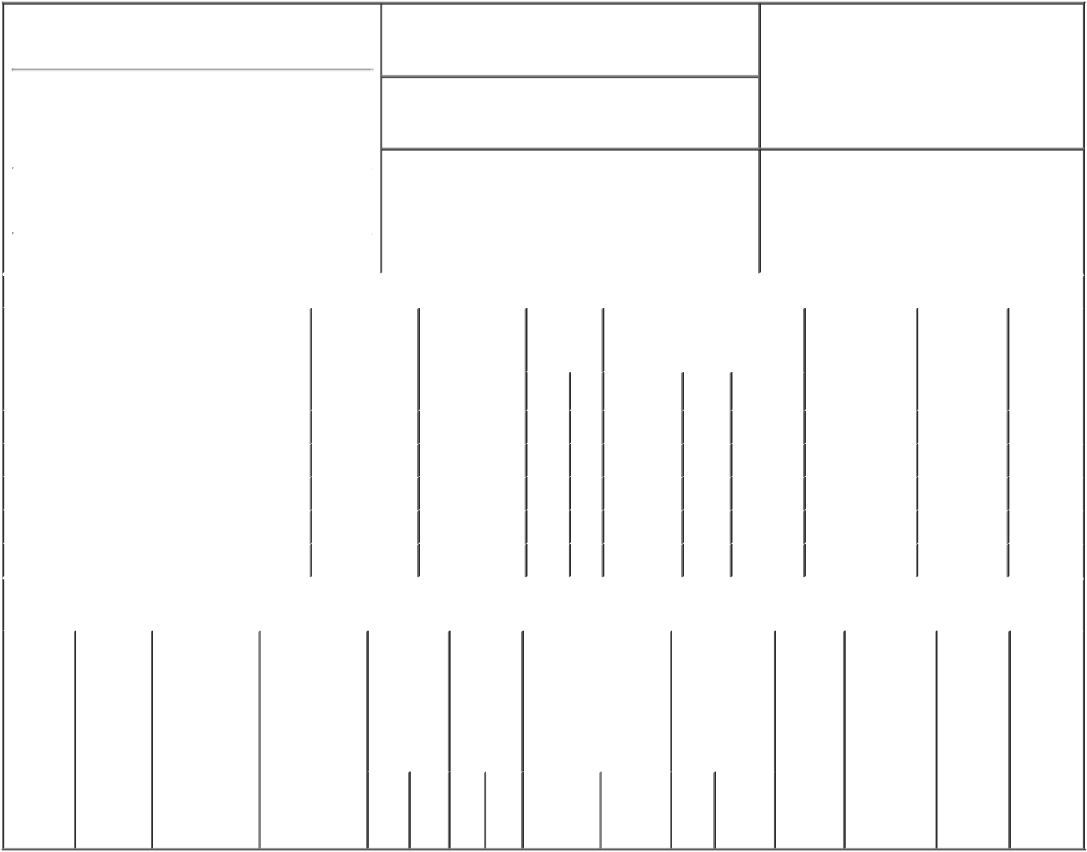

1. Name and Address of Reporting Person*
Munn William J

(Last) (First) (Middle)

3015 SOUTH PARKER ROAD SUITE 400

2. Issuer Name and Ticker or Trading Symbol

NELNET INC [ NNI ]

3. Date of Earliest Transaction (Month/Day/Year)

03/10/2019

- Relationship of Reporting Person(s) to Issuer (Check all applicable)

 | Director | 10% Owner
X | Officer (give title | Other (specify
 | below) | below)

Secy/Chief Legal Off/Gen Coun

 |  |  |  |  |  |  |  | 4. If Amendment, Date of Original Filed (Month/Day/Year) |  |  |  |  |  | 6. Individual or Joint/Group Filing (Check Applicable
 | (Street) |  |  |  |  |  |  |  |  |  |  |  |  | Line)
 |  |  |  |  |  |  |  |  |  |  |  |  |  |  | X Form filed by One Reporting Person
 |  | AURORA |  | CO |  | 80014
 |  |  |  |  |  |  |  |  |  |  |  |  |  |  |  | Form filed by More than One Reporting
 |  |  |  |  |  |  |  |  |  |  |  |  |  |  |  | Person
 |  | (City) |  | (State) |  | (Zip)
 |  |  |  |  | Table I - Non-Derivative Securities Acquired, Disposed of, or Beneficially Owned
 | 1. Title of Security (Instr. 3) |  |  |  |  | 2. Transaction |  |  | 2A. Deemed |  | 3. | 4. Securities Acquired (A) or |  |  |  | 5. Amount of |  | 6. Ownership | 7. Nature
 |  |  |  |  |  | Date |  |  | Execution Date, |  | Transaction | Disposed Of (D) (Instr. 3, 4 and 5) |  |  |  | Securities |  | Form: Direct | of Indirect
 |  |  |  |  |  | (Month/Day/Year) |  |  | if any |  | Code (Instr. |  |  |  |  | Beneficially |  | (D) or Indirect | Beneficial
 |  |  |  |  |  |  |  |  | (Month/Day/Year) |  | 8) |  |  |  |  | Owned Following |  | (I) (Instr. 4) | Ownership
 |  |  |  |  |  |  |  |  |  |  |  |  |  |  |  | Reported |  |  | (Instr. 4)
 |  |  |  |  |  |  |  |  |  |  | Code V | Amount | (A) or | Price |  | Transaction(s)
 |  |  |  |  |  |  |  |  |  |  |  |  | (D) |  |  | (Instr. 3 and 4)
 | Class A Common Stock |  |  |  |  | 03/10/2019 |  |  |  |  | F | 154⁽¹⁾ | D | $54.29⁽²⁾ |  | 25,407⁽³⁾ |  | D
 | Class A Common Stock |  |  |  |  | 03/10/2019 |  |  |  |  | F | 122⁽¹⁾ | D | $54.29⁽²⁾ |  | 25,285⁽³⁾ |  | D
 | Class A Common Stock |  |  |  |  | 03/10/2019 |  |  |  |  | F | 138⁽¹⁾ | D | $54.29⁽²⁾ |  | 25,147⁽³⁾ |  | D
 | Class A Common Stock |  |  |  |  | 03/10/2019 |  |  |  |  | F | ₁₂₉(1) | D | $54.29⁽²⁾ |  | 25,018⁽³⁾ |  | D
 | Class A Common Stock |  |  |  |  | 03/10/2019 |  |  |  |  | F | ₁₀₇(1) | D | $54.29⁽²⁾ |  | 24,911⁽³⁾ |  | D
 |  |  |  |  | Table II - Derivative Securities Acquired, Disposed of, or Beneficially Owned
 |  |  |  |  |  | (e.g., puts, calls, warrants, options, convertible securities)
 | 1. Title of |  | 2. |  | 3. Transaction | 3A. Deemed |  | 4. |  | 5. Number | 6. Date Exercisable and |  | 7. Title and |  | 8. Price of |  | 9. Number of | 10. | 11. Nature
 | Derivative |  | Conversion |  | Date | Execution Date, |  | Transaction |  | of | Expiration Date |  | Amount of |  | Derivative |  | derivative | Ownership | of Indirect
 | Security |  | or Exercise |  | (Month/Day/Year) | if any |  | Code (Instr. |  | Derivative | (Month/Day/Year) |  | Securities |  | Security |  | Securities | Form: | Beneficial
 | (Instr. 3) |  | Price of |  |  | (Month/Day/Year) |  | 8) |  | Securities |  |  | Underlying |  | (Instr. 5) |  | Beneficially | Direct (D) | Ownership
 |  |  | Derivative |  |  |  |  |  |  | Acquired |  |  | Derivative |  |  |  | Owned | or Indirect | (Instr. 4)
 |  |  | Security |  |  |  |  |  |  | (A) or |  |  | Security (Instr. 3 |  |  |  | Following | (I) (Instr. 4)
 |  |  |  |  |  |  |  |  |  | Disposed |  |  | and 4) |  |  |  | Reported
 |  |  |  |  |  |  |  |  |  | of (D) |  |  |  |  |  |  | Transaction(s)
 |  |  |  |  |  |  |  |  |  | (Instr. 3, 4 |  |  |  |  |  |  | (Instr. 4)
 |  |  |  |  |  |  |  |  |  | and 5)
 |  |  |  |  |  |  |  |  |  |  |  |  | Amount
 |  |  |  |  |  |  |  |  |  |  |  |  | or
 |  |  |  |  |  |  |  |  |  |  |  |  | Number
 |  |  |  |  |  |  |  |  |  |  | Date | Expiration | of
 |  |  |  |  |  |  |  | Code | V | (A) (D) | Exercisable | Date | Title Shares

Explanation of Responses:

- These shares were tax-withheld by the issuer to satisfy the reporting person's tax obligation resulting from the vesting of a previously reported grant of shares pursuant to Rule 16b-3(d).

- Per share value assigned by the issuer to the tax withholding shares under the tax withholding arrangement, and based on the market closing price of the shares as of March 11, 2019.

- Includes 500 shares held jointly with spouse.

/s/ Audra Hoffschneider,
Attorney-in-Fact for William J. 03/12/2019
Munn

** Signature of Reporting Person Date

Reminder: Report on a separate line for each class of securities beneficially owned directly or indirectly.

* If the form is filed by more than one reporting person, see Instruction 4 (b)(v).

- Intentional misstatements or omissions of facts constitute Federal Criminal Violations See 18 U.S.C. 1001 and 15 U.S.C. 78ff(a). Note: File three copies of this Form, one of which must be manually signed. If space is insufficient, see Instruction 6 for procedure.
Persons who respond to the collection of information contained in this form are not required to respond unless the form displays a currently valid OMB Number.

