SEC Form 4

FORM 4

Check this box if no longer subject to Section 16. Form 4 or Form 5 obligations may continue. See Instruction 1(b).

UNITED STATES SECURITIES AND EXCHANGE COMMISSION
Washington, D.C. 20549
 |  | OMB APPROVAL
STATEMENT OF CHANGES IN BENEFICIAL OWNERSHIP
 |  | OMB Number: | 3235-0287
 |  | Estimated average burden
Filed pursuant to Section 16(a) of the Securities Exchange Act of 1934 |  | hours per response: | 0.5
or Section 30(h) of the Investment Company Act of 1940
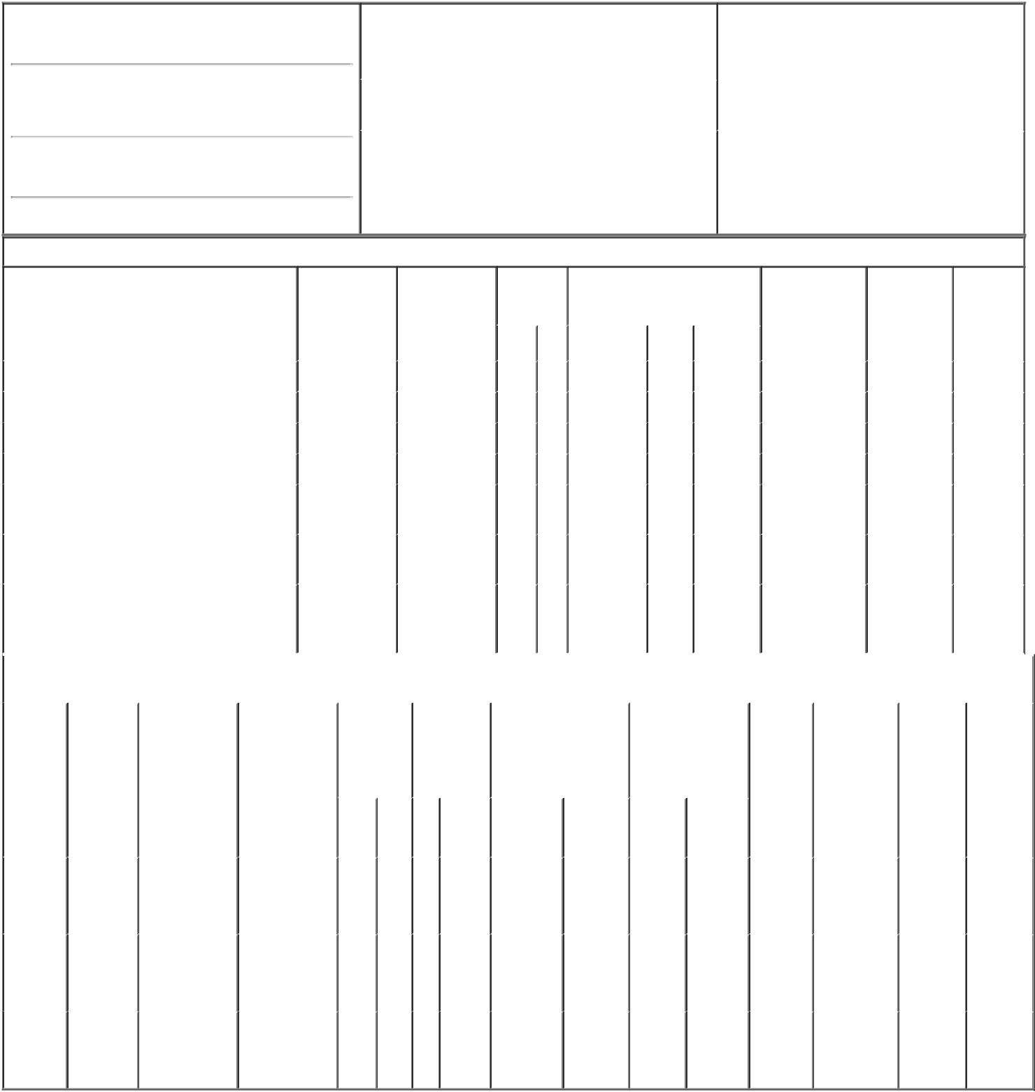

1. Name and Address of Reporting Person*
Houston Daniel Joseph

(Last) | (First) | (Middle)
711 HIGH STREET
(Street)
DES MOINES | IA | 50392
(City) | (State) | (Zip)

2. Issuer Name and Ticker or Trading Symbol |  |  | 5. Relationship of Reporting Person(s) to Issuer
PRINCIPAL FINANCIAL GROUP INC [ |  |  | (Check all applicable)
 |  |  | X | Director | 10% Owner
 | PFG ]
 |  |  | X | Officer (give title | Other (specify
 |  |  |  | below) | below)
3. Date of Earliest Transaction (Month/Day/Year)
 |  |  |  | Chairman, President & CEO
12/09/2022
4. If Amendment, Date of Original Filed (Month/Day/Year) |  |  | 6. Individual or Joint/Group Filing (Check Applicable
Line)
X Form filed by One Reporting Person

Form filed by More than One Reporting

Person

Table I - Non-Derivative Securities Acquired, Disposed of, or Beneficially Owned

 | 1. Title of Security (Instr. 3) |  |  | 2. Transaction |  | 2A. Deemed | 3. | 4. Securities Acquired (A) or |  |  |  |  |  | 5. Amount of |  | 6. Ownership |  | 7. Nature of
 |  |  |  | Date |  | Execution Date, | Transaction | Disposed Of (D) (Instr. 3, 4 and 5) |  |  |  |  |  | Securities |  | Form: Direct |  | Indirect
 |  |  |  | (Month/Day/Year) |  | if any | Code (Instr. |  |  |  |  |  |  | Beneficially |  | (D) or Indirect |  | Beneficial
 |  |  |  |  |  | (Month/Day/Year) | 8) |  |  |  |  |  |  | Owned Following |  | (I) (Instr. 4) |  | Ownership
 |  |  |  |  |  |  |  |  |  |  |  |  |  | Reported |  |  |  | (Instr. 4)
 |  |  |  |  |  |  | Code V | Amount |  | (A) or | Price |  |  | Transaction(s)
 |  |  |  |  |  |  |  |  |  | (D) |  |  |  | (Instr. 3 and 4)
 | Common Stock |  |  | 12/09/2022 |  |  | A | 1,890 |  | A | $53.09 |  | 116,551 |  |  |  | D
 | Common Stock |  |  | 12/09/2022 |  |  | A | 267,980 |  | A | $51.73 |  | 384,531 |  |  |  | D
 | Common Stock |  |  | 12/09/2022 |  |  | D | 211,580⁽¹⁾ |  | D | $88.44⁽²⁾ |  | 172,951 |  |  |  | D
 | Common Stock |  |  | 12/09/2022 |  |  | D | 58,290⁽¹⁾ |  | D | $89.21⁽³⁾ |  | 114,661 |  |  |  | D
 | Common Stock |  |  |  |  |  |  |  |  |  |  |  | 45,823 |  |  |  | I | By
 |  |  |  |  |  |  |  |  |  |  |  |  |  |  |  |  |  | Trust⁽⁴⁾
 | Common Stock |  |  |  |  |  |  |  |  |  |  |  | 125,000 |  |  |  | I | By
 |  |  |  |  |  |  |  |  |  |  |  |  |  |  |  |  |  | Trust⁽⁵⁾
 |  |  |  |  |  |  |  |  |  |  |  |  |  |  |  |  |  | By
 | Common Stock |  |  |  |  |  |  |  |  |  |  |  | 3,745 |  |  |  | I | 401(k)
 |  |  |  |  |  |  |  |  |  |  |  |  |  |  |  |  |  | Plan
 |  |  |  | Table II - Derivative Securities Acquired, Disposed of, or Beneficially Owned
 |  |  |  | (e.g., puts, calls, warrants, options, convertible securities)
 | 1. Title of | 2. | 3. Transaction | 3A. Deemed | 4. | 5. Number of | 6. Date Exercisable and |  | 7. Title and Amount |  |  |  | 8. Price of |  | 9. Number of |  | 10. | 11. Nature
 | Derivative | Conversion | Date | Execution Date, | Transaction Derivative |  | Expiration Date |  | of Securities |  |  |  | Derivative |  | derivative |  | Ownership of Indirect
 | Security | or Exercise | (Month/Day/Year) | if any | Code (Instr. | Securities | (Month/Day/Year) |  | Underlying |  |  |  | Security |  | Securities |  | Form: | Beneficial
 | (Instr. 3) | Price of |  | (Month/Day/Year) | 8) | Acquired (A) |  |  | Derivative Security |  |  |  | (Instr. 5) |  | Beneficially |  | Direct (D) | Ownership
 |  | Derivative |  |  |  | or Disposed |  |  | (Instr. 3 and 4) |  |  |  |  |  | Owned |  | or Indirect | (Instr. 4)
 |  | Security |  |  |  | of (D) (Instr. |  |  |  |  |  |  |  |  | Following |  | (I) (Instr. 4)
 |  |  |  |  |  | 3, 4 and 5) |  |  |  |  |  |  |  |  | Reported
 |  |  |  |  |  |  |  |  |  |  |  |  |  |  | Transaction(s)
 |  |  |  |  |  |  |  |  |  |  | Amount |  |  |  | (Instr. 4)
 |  |  |  |  |  |  |  |  |  |  | or
 |  |  |  |  |  |  | Date | Expiration |  |  | Number
 |  |  |  |  | Code V | (A) (D) | Exercisable | Date | Title |  | of Shares
 | Employee
 | Stock |  |  |  |  |  |  |  | Common |  | 1,890
 | Option | $53.09 | 12/09/2022 |  | M | 1,890 | 02/25/2022 | 02/25/2029 |  |  |  |  | $53.09 |  | 0 |  | D
 |  |  |  |  |  |  |  |  |  | Stock
 | (Right to
 | Buy)
 | Employee
 | Stock |  |  |  |  |  |  |  | Common |  | 133,990
 | Option | $51.73 | 12/09/2022 |  | M | 133,990 | 02/24/2021 | 02/24/2030 |  |  |  |  | $51.73 |  | 0 |  | D
 | (Right to |  |  |  |  |  |  |  |  | Stock
 | Buy)
 | Employee
 | Stock |  |  |  |  |  |  |  | Common |  | 133,990
 | Option | $51.73 | 12/09/2022 |  | M | 133,990 | 02/24/2022 | 02/24/2030 |  |  |  |  | $51.73 |  | 0 |  | D
 | (Right to |  |  |  |  |  |  |  |  | Stock
Buy)

Explanation of Responses:

- Pursuant to a Rule 10b5-1 trading plan adopted by the reporting person on November 8, 2022.

- The price reported in Column 4 is a weighted average price. These shares were sold in multiple transactions at prices ranging from $87.95 to $88.94, inclusive. The reporting person undertakes to provide Principal Financial Group, Inc., any security holder of Principal Financial Group, Inc., or the staff of the Securities Exchange Commission, upon request, full information regarding the number of shares sold at each separate price within the ranges set forth in this footnote.

- The price reported in Column 4 is a weighted average price. These shares were sold in multiple transactions at prices ranging from $88.95 to $89.65, inclusive. The reporting person undertakes to provide Principal Financial Group, Inc., any security holder of Principal Financial Group, Inc., or the staff of the Securities Exchange Commission, upon request, full information regarding the number of shares sold at each separate price within the ranges set forth in this footnote.

- Joan M. Houston 2021 Trust.

- Daniel J. Houston 2019 DGT Exempt Trust.

Clint Woods |  | 12/13/2022
** Signature of Reporting Person |  | Date

Reminder: Report on a separate line for each class of securities beneficially owned directly or indirectly.

* If the form is filed by more than one reporting person, see Instruction 4 (b)(v).

- Intentional misstatements or omissions of facts constitute Federal Criminal Violations See 18 U.S.C. 1001 and 15 U.S.C. 78ff(a). Note: File three copies of this Form, one of which must be manually signed. If space is insufficient, see Instruction 6 for procedure.
Persons who respond to the collection of information contained in this form are not required to respond unless the form displays a currently valid OMB Number.

