##### 

Free Writing Prospectus dated June 13, 2007  
Filed pursuant to Rule 163  
Registration Statement Nos. 333-129763 and 333-129763-01

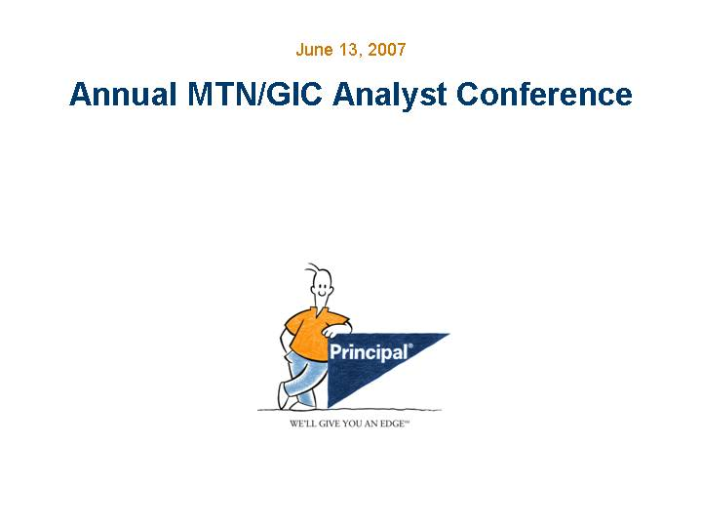

|  |
| --- |
| Annual MTN/GIC Analyst Conference June 13, 2007 |

##### 

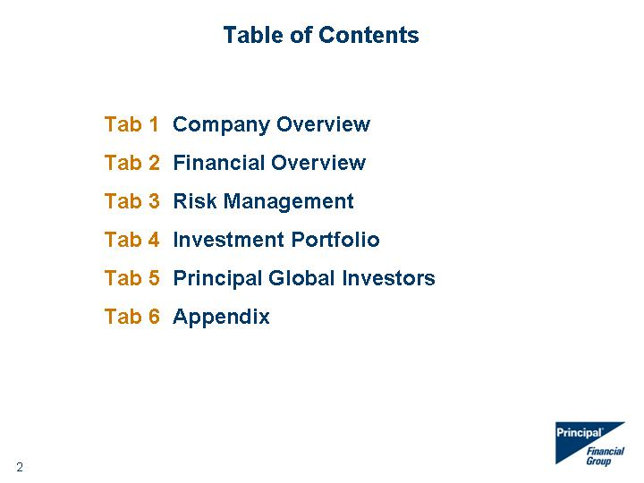

|  |
| --- |
| Table of Contents Tab 1 Company Overview Tab 2 Financial Overview Tab 3 Risk Management Tab 4 Investment Portfolio Tab 5 Principal Global Investors Tab 6 Appendix |

##### 

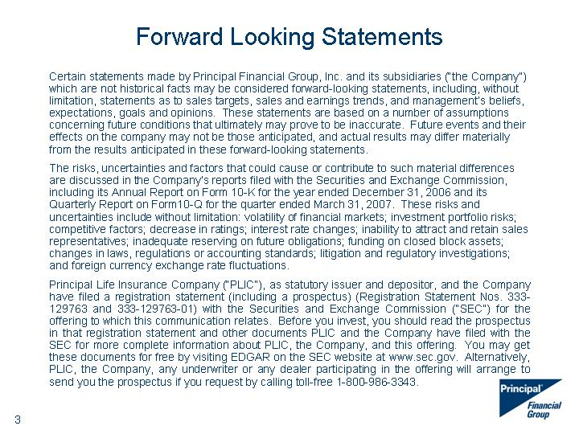

|  |
| --- |
| Forward Looking Statements Certain statements made by Principal Financial Group, Inc. and its subsidiaries ("the Company") which are not historical facts may be considered forward-looking statements, including, without limitation, statements as to sales targets, sales and earnings trends, and management's beliefs, expectations, goals and opinions. These statements are based on a number of assumptions concerning future conditions that ultimately may prove to be inaccurate. Future events and their effects on the company may not be those anticipated, and actual results may differ materially from the results anticipated in these forward-looking statements. The risks, uncertainties and factors that could cause or contribute to such material differences are discussed in the Company's reports filed with the Securities and Exchange Commission, including its Annual Report on Form 10-K for the year ended December 31, 2006 and its Quarterly Report on Form10-Q for the quarter ended March 31, 2007. These risks and uncertainties include without limitation: volatility of financial markets; investment portfolio risks; competitive factors; decrease in ratings; interest rate changes; inability to attract and retain sales representatives; inadequate reserving on future obligations; funding on closed block assets; changes in laws, regulations or accounting standards; litigation and regulatory investigations; and foreign currency exchange rate fluctuations. Principal Life Insurance Company ("PLIC"), as statutory issuer and depositor, and the Company have filed a registration statement (including a prospectus) (Registration Statement Nos. 333- 129763 and 333-129763-01) with the Securities and Exchange Commission ("SEC") for the offering to which this communication relates. Before you invest, you should read the prospectus in that registration statement and other documents PLIC and the Company have filed with the SEC for more complete information about PLIC, the Company, and this offering. You may get these documents for free by visiting EDGAR on the SEC website at www.sec.gov. Alternatively, PLIC, the Company, any underwriter or any dealer participating in the offering will arrange to send you the prospectus if you request by calling toll-free 1-800-986-3343. |

##### 

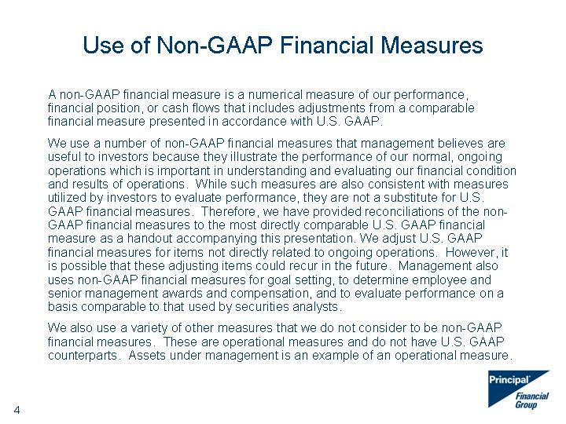

|  |
| --- |
| Use of Non-GAAP Financial Measures A non-GAAP financial measure is a numerical measure of our performance, financial position, or cash flows that includes adjustments from a comparable financial measure presented in accordance with U.S. GAAP. We use a number of non-GAAP financial measures that management believes are useful to investors because they illustrate the performance of our normal, ongoing operations which is important in understanding and evaluating our financial condition and results of operations. While such measures are also consistent with measures utilized by investors to evaluate performance, they are not a substitute for U.S. GAAP financial measures. Therefore, we have provided reconciliations of the non- GAAP financial measures to the most directly comparable U.S. GAAP financial measure as a handout accompanying this presentation. We adjust U.S. GAAP financial measures for items not directly related to ongoing operations. However, it is possible that these adjusting items could recur in the future. Management also uses non-GAAP financial measures for goal setting, to determine employee and senior management awards and compensation, and to evaluate performance on a basis comparable to that used by securities analysts. We also use a variety of other measures that we do not consider to be non-GAAP financial measures. These are operational measures and do not have U.S. GAAP counterparts. Assets under management is an example of an operational measure. |

##### 



|  |
| --- |
| Principal Financial Group Simplified Organizational Structure Simplified Organizational Structure Simplified Organizational Structure GICs, funding agreements and other products issued by Principal Life Insurance Company are obligations of Principal Life and are not obligations of Principal Financial Group, Inc., unless expressly guaranteed by Principal Financial Group, Inc. |

##### 

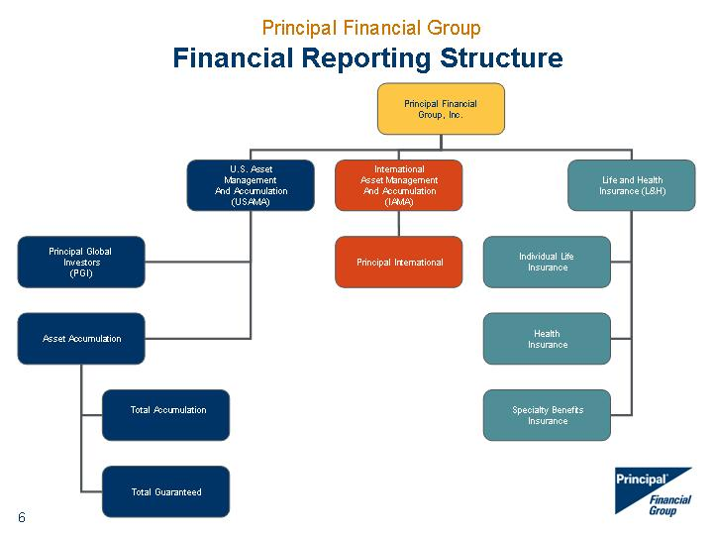

|  |
| --- |
| Principal Financial Group Financial Reporting Structure |

##### 



|  |
| --- |
| Company Overview |

##### 

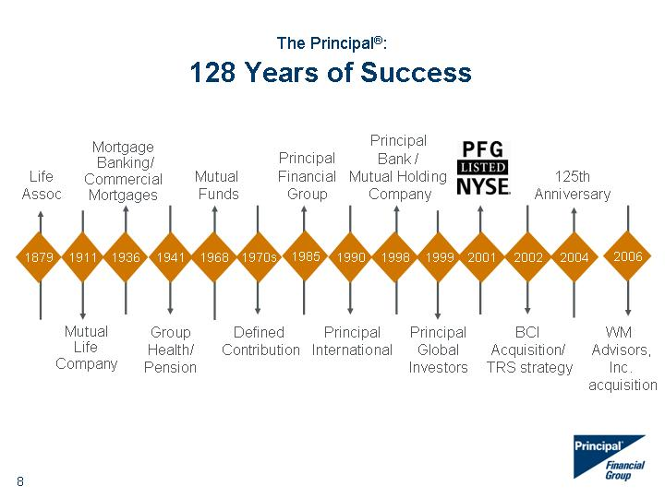

|  |
| --- |
| 1879 1911 1936 1941 1968 1990 1998 1999 2001 1970s 2002 2004 Life Assoc Mutual Life Company Mortgage Banking/ Commercial Mortgages Group Health/ Pension Mutual Funds Defined Contribution Principal International Principal Bank / Mutual Holding Company Principal Global Investors BCI Acquisition/ TRS strategy 125th Anniversary The Principal(r): 128 Years of Success 1985 WM Advisors, Inc. acquisition 2006 Principal Financial Group |

##### 

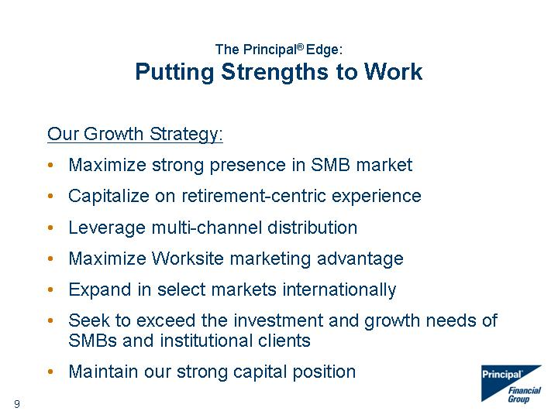

|  |
| --- |
| The Principal(r) Edge: Putting Strengths to Work Our Growth Strategy: Maximize strong presence in SMB market Capitalize on retirement-centric experience Leverage multi-channel distribution Maximize Worksite marketing advantage Expand in select markets internationally Seek to exceed the investment and growth needs of SMBs and institutional clients Maintain our strong capital position |

##### 

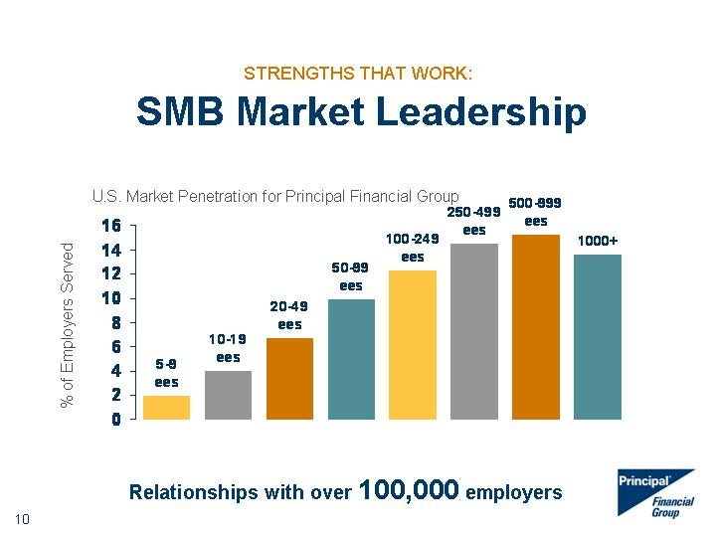

|  |
| --- |
| 1Q06 5-9 ees 1.94 10-19 ees 4 20-49 ees 6.71 50-99 ees 9.93 100-249 ees 12.25 250-499 ees 14.46 500-999 ees 15.25 1000+ 13.61 STRENGTHS THAT WORK: SMB Market Leadership Relationships with over 100,000 employers % of Employers Served |

##### 

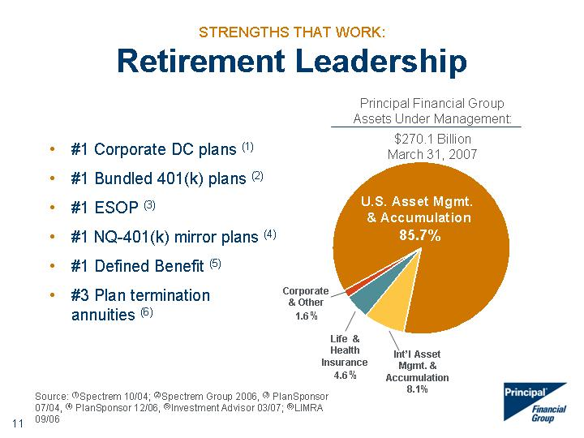

|  |
| --- |
| STRENGTHS THAT WORK: Retirement Leadership US Asset Int'l Asset Life & Health Mortgage Banking Corp. & Other 221.9 19.1 12.3 0 3.6 Principal Financial Group Assets Under Management: $270.1 Billion March 31, 2007 U.S. Asset Mgmt. & Accumulation 85.7% Corporate & Other 1.6% Life & Health Insurance 4.6% Int'l Asset Mgmt. & Accumulation 8.1% #1 Corporate DC plans (1) #1 Bundled 401(k) plans (2) #1 ESOP (3) #1 NQ-401(k) mirror plans (4) #1 Defined Benefit (5) #3 Plan termination annuities (6) Source: (1)Spectrem 10/04; (2)Spectrem Group 2006, (3) PlanSponsor 07/04, (4) PlanSponsor 12/06, (5)Investment Advisor 03/07; (6)LIMRA 09/06 |

##### 

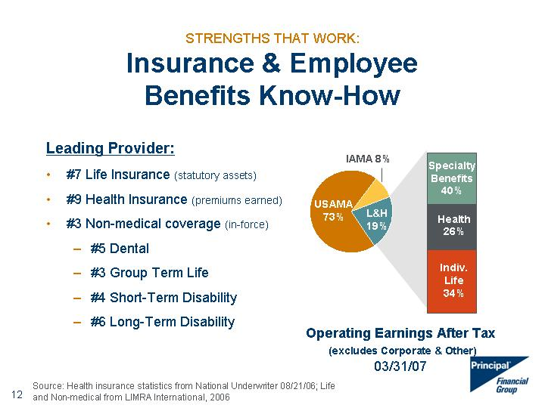

|  |
| --- |
| Health 26% Specialty Benefits 40% STRENGTHS THAT WORK: Insurance & Employee Benefits Know-How Leading Provider: #7 Life Insurance (statutory assets) #9 Health Insurance (premiums earned) #3 Non-medical coverage (in-force) #5 Dental #3 Group Term Life #4 Short-Term Disability #6 Long-Term Disability USAMA IAMA L&H 149.061386138614 19.3 45.5 Source: Health insurance statistics from National Underwriter 08/21/06; Life and Non-medical from LIMRA International, 2006 Operating Earnings After Tax (excludes Corporate & Other) 03/31/07 USAMA 73% L&H 19% IAMA 8% Indiv. Life 34% |

##### 

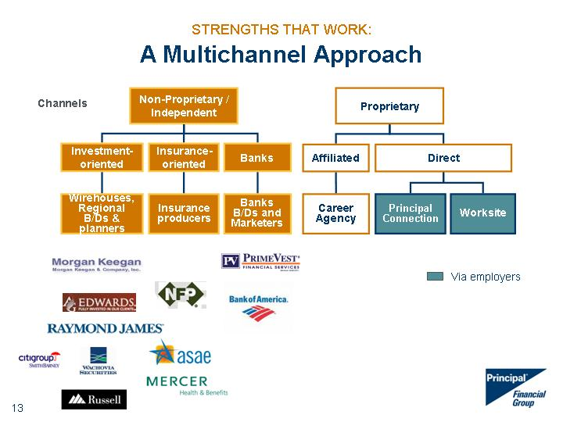

|  |
| --- |
| STRENGTHS THAT WORK: A Multichannel Approach Proprietary Career Agency Principal Connection Via employers Worksite Wirehouses, Regional B/Ds & planners Channels Insurance producers Non-Proprietary / Independent Banks B/Ds and Marketers Direct Affiliated Investment- oriented Insurance- oriented Banks |

##### 

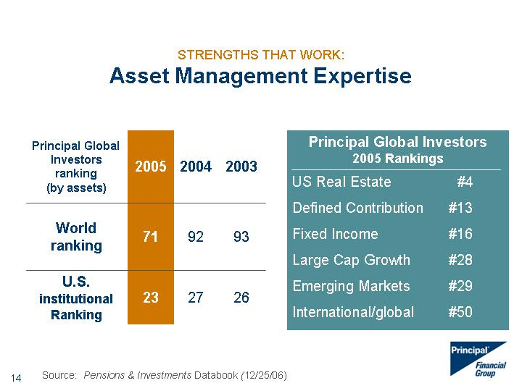

|  |
| --- |
| STRENGTHS THAT WORK: Asset Management Expertise Principal Global Investors ranking (by assets) 2005 2004 2003 World ranking 71 92 93 U.S. institutional Ranking 23 27 26 Principal Global Investors 2005 Rankings US Real Estate #4 Defined Contribution #13 Fixed Income #16 Large Cap Growth #28 Emerging Markets #29 International/global #50 Source: Pensions & Investments Databook (12/25/06) |

##### 

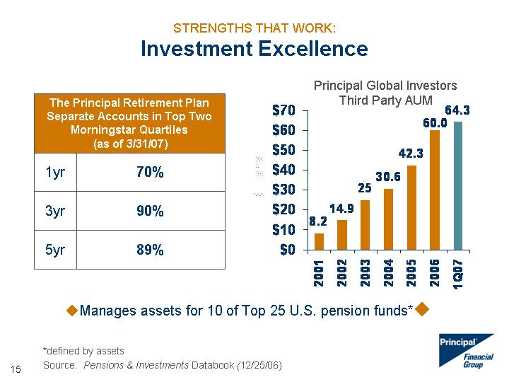

|  |
| --- |
| STRENGTHS THAT WORK: Investment Excellence The Principal Retirement Plan Separate Accounts in Top Two Morningstar Quartiles (as of 3/31/07) The Principal Retirement Plan Separate Accounts in Top Two Morningstar Quartiles (as of 3/31/07) 1yr 70% 3yr 90% 5yr 89% 2001 2002 2003 2004 2005 2006 1Q07 East 8.2 14.9 25 30.6 42.3 60 64.3 Principal Global Investors Third Party AUM ?Manages assets for 10 of Top 25 U.S. pension funds*? *defined by assets Source: Pensions & Investments Databook (12/25/06) |

##### 

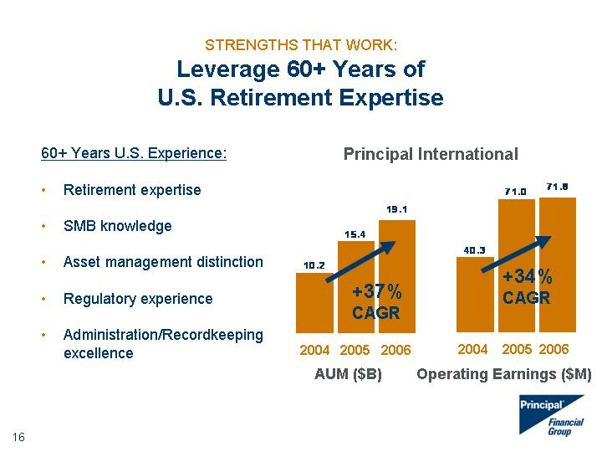

|  |
| --- |
| STRENGTHS THAT WORK: Leverage 60+ Years of U.S. Retirement Expertise 60+ Years U.S. Experience: Retirement expertise SMB knowledge Asset management distinction Regulatory experience Administration/Recordkeeping excellence +37% CAGR +34% CAGR 2004 2005 2006 2004 2005 2006 AUM ($B) Operating Earnings ($M) Principal International |

##### 

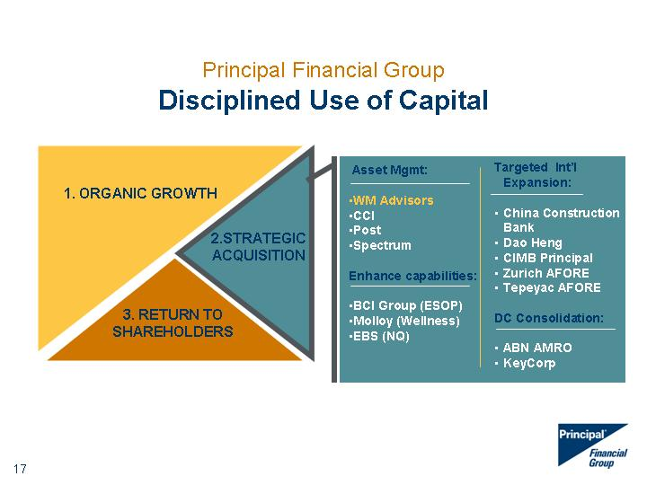

|  |
| --- |
| Principal Financial Group Disciplined Use of Capital 1. ORGANIC GROWTH 2.STRATEGIC ACQUISITION 3. RETURN TO SHAREHOLDERS |

##### 

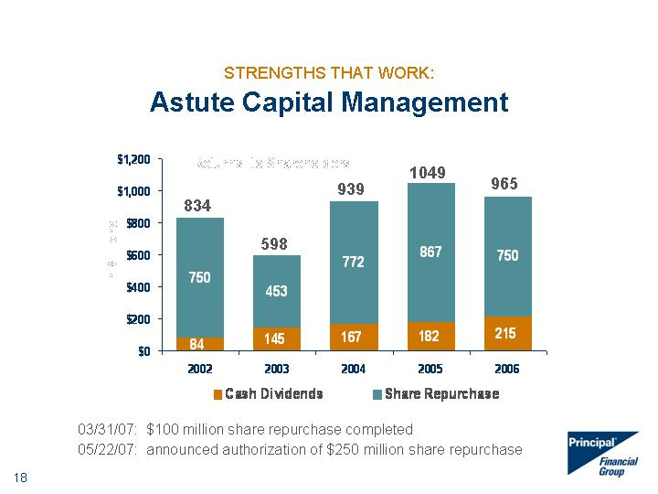

|  |
| --- |
| STRENGTHS THAT WORK: Astute Capital Management Cash Dividends Share Repurchase 2002 84 750 2003 145 453 2004 167 772 2005 182 867 2006 215 750 834 598 939 1049 965 03/31/07: $100 million share repurchase completed 05/22/07: announced authorization of $250 million share repurchase |

##### 

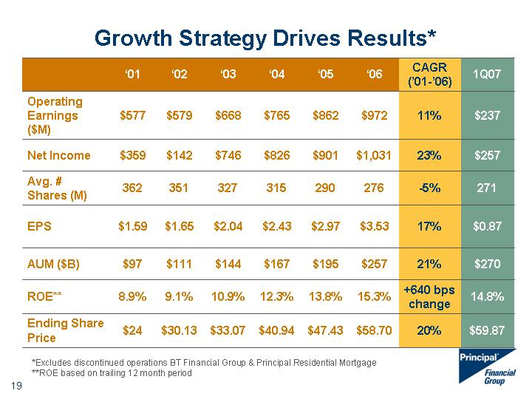

|  |
| --- |
| Growth Strategy Drives Results* '01 '02 '03 '04 '05 '06 CAGR ('01-'06) 1Q07 Operating Earnings ($M) $577 $579 $668 $765 $862 $972 11% $237 Net Income $359 $142 $746 $826 $901 $1,031 23% $257 Avg. # Shares (M) 362 351 327 315 290 276 -5% 271 EPS $1.59 $1.65 $2.04 $2.43 $2.97 $3.53 17% $0.87 AUM ($B) $97 $111 $144 $167 $195 $257 21% $270 ROE** 8.9% 9.1% 10.9% 12.3% 13.8% 15.3% +640 bps change 14.8% Ending Share Price $24 $30.13 $33.07 $40.94 $47.43 $58.70 20% $59.87 *Excludes discontinued operations BT Financial Group & Principal Residential Mortgage **ROE based on trailing 12 month period |

##### 

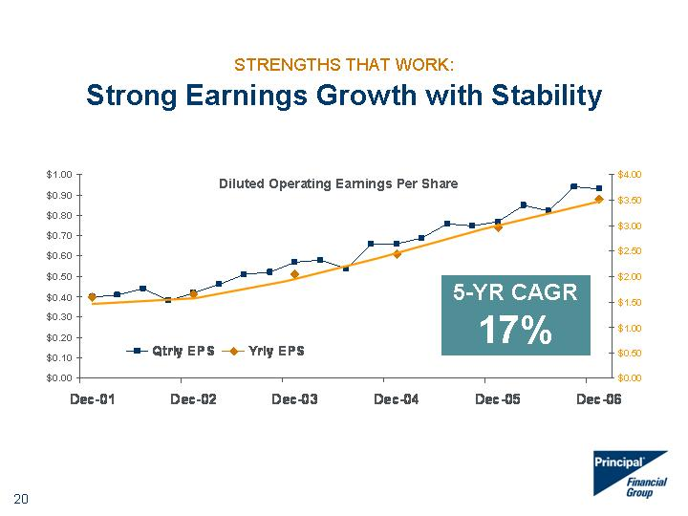

|  |
| --- |
| STRENGTHS THAT WORK: Strong Earnings Growth with Stability 12/31/2001 3/31/2002 6/30/2002 9/30/2002 12/31/2002 3/31/2003 6/30/2003 9/30/2003 12/31/2003 3/31/2004 6/30/2004 9/30/2004 12/31/2004 3/31/2005 6/30/2005 9/30/2005 12/31/2005 3/31/2006 6/30/2006 9/30/2006 12/31/2006 Qtrly EPS 0.4 0.41 0.44 0.38 0.42 0.46 0.51 0.52 0.57 0.58 0.54 0.66 0.66 0.69 0.76 0.75 0.77 0.85 0.82 0.94 0.93 0.87 Yrly EPS 1.59 1.65 2.04 2.43 2.97 3.53 5-YR CAGR 17% Diluted Operating Earnings Per Share |

##### 

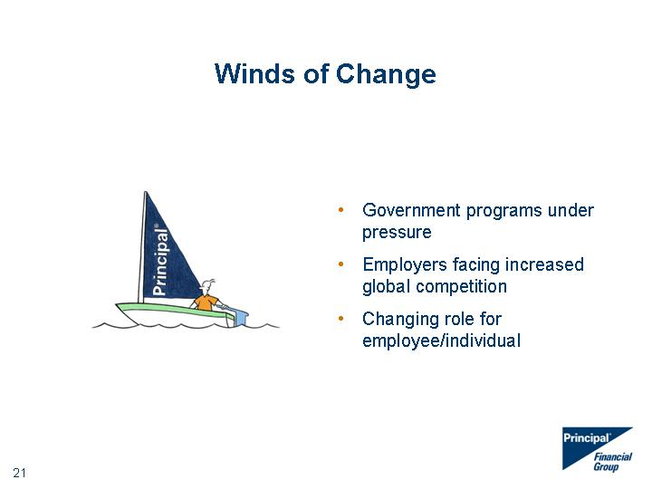

|  |
| --- |
| Winds of Change Winds of Change Government programs under pressure Employers facing increased global competition Changing role for employee/individual |

##### 

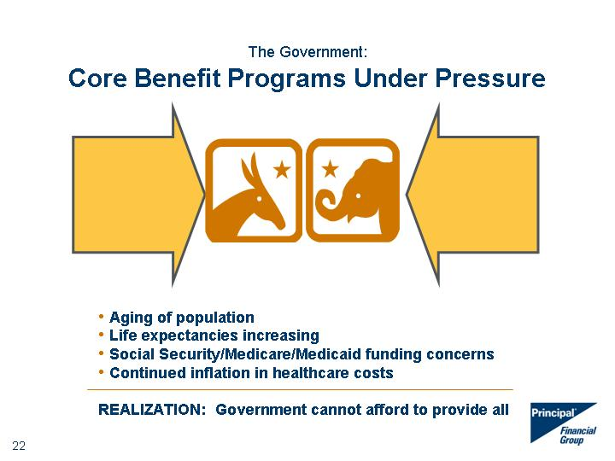

|  |
| --- |
| Aging of population Life expectancies increasing Social Security/Medicare/Medicaid funding concerns Continued inflation in healthcare costs REALIZATION: Government cannot afford to provide all The Government: Core Benefit Programs Under Pressure |

##### 

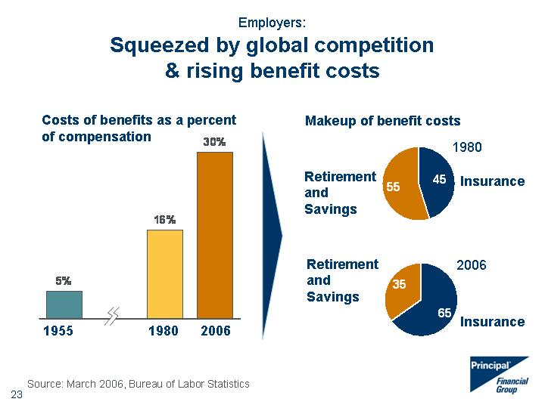

|  |
| --- |
| Employers: Squeezed by global competition & rising benefit costs Costs of benefits as a percent of compensation 1955 1980 2006 Source: March 2006, Bureau of Labor Statistics Makeup of benefit costs Insurance Retirement and Savings Insurance Retirement and Savings 1980 2006 |

##### 

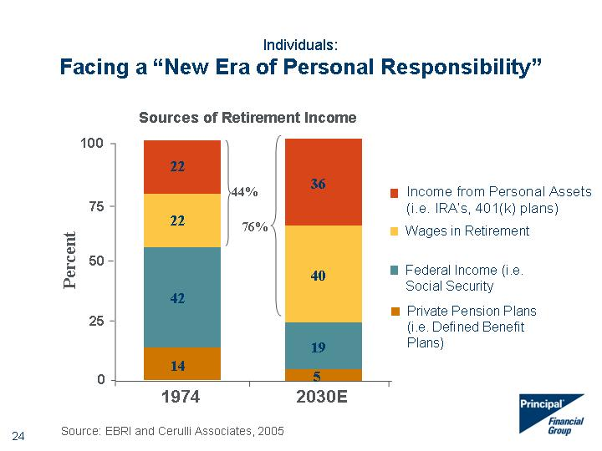

|  |
| --- |
| 5 42 19 22 40 14 22 36 0 25 50 75 100 1974 2030E Percent Income from Personal Assets (i.e. IRA's, 401(k) plans) Wages in Retirement Federal Income (i.e. Social Security Private Pension Plans (i.e. Defined Benefit Plans) Source: EBRI and Cerulli Associates, 2005 44% 76% Individuals: Facing a "New Era of Personal Responsibility" Sources of Retirement Income |

##### 

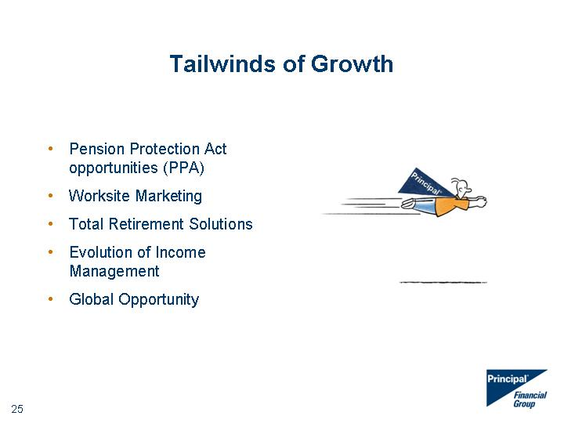

|  |
| --- |
| Tailwinds of Growth Pension Protection Act opportunities (PPA) Worksite Marketing Total Retirement Solutions Evolution of Income Management Global Opportunity |

##### 

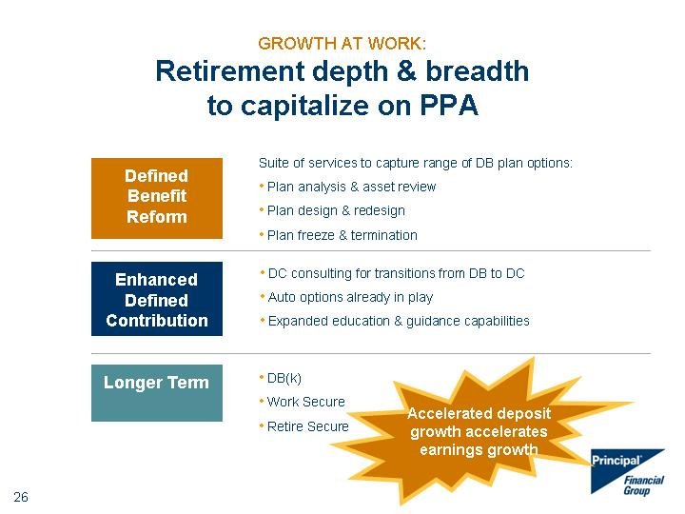

|  |
| --- |
| Suite of services to capture range of DB plan options: Plan analysis & asset review Plan design & redesign Plan freeze & termination DC consulting for transitions from DB to DC Auto options already in play Expanded education & guidance capabilities DB(k) Work Secure Retire Secure Defined Benefit Reform Enhanced Defined Contribution Longer Term GROWTH AT WORK: Retirement depth & breadth to capitalize on PPA Accelerated deposit growth accelerates earnings growth |

##### 

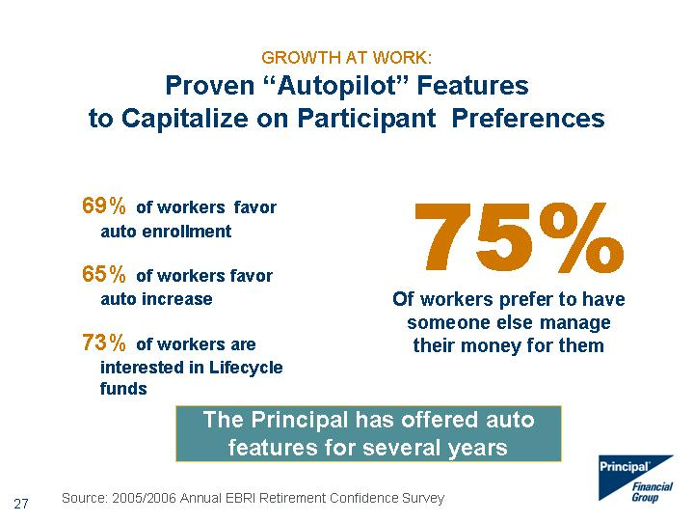

|  |
| --- |
| GROWTH AT WORK: Proven "Autopilot" Features to Capitalize on Participant Preferences 69% of workers favor auto enrollment 65% of workers favor auto increase 73% of workers are interested in Lifecycle funds 75% Of workers prefer to have someone else manage their money for them Source: 2005/2006 Annual EBRI Retirement Confidence Survey The Principal has offered auto features for several years |

##### 

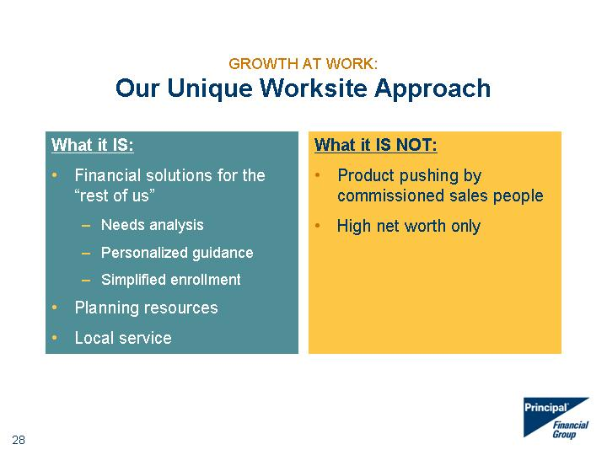

|  |
| --- |
| GROWTH AT WORK: Our Unique Worksite Approach What it IS: Financial solutions for the "rest of us" Needs analysis Personalized guidance Simplified enrollment Planning resources Local service What it IS NOT: Product pushing by commissioned sales people High net worth only |

##### 

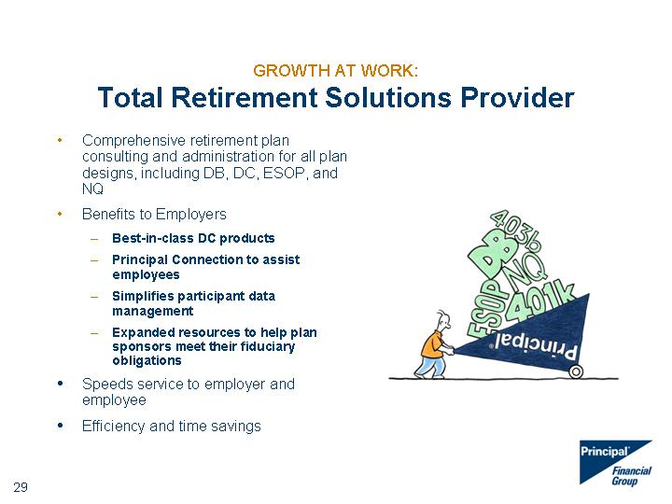

|  |
| --- |
| GROWTH AT WORK: Total Retirement Solutions Provider Comprehensive retirement plan consulting and administration for all plan designs, including DB, DC, ESOP, and NQ Benefits to Employers Best-in-class DC products Principal Connection to assist employees Simplifies participant data management Expanded resources to help plan sponsors meet their fiduciary obligations Speeds service to employer and employee Efficiency and time savings Efficiency and time savings Efficiency and time savings Efficiency and time savings Efficiency and time savings Efficiency and time savings Efficiency and time savings Efficiency and time savings Efficiency and time savings Efficiency and time savings Efficiency and time savings Efficiency and time savings Efficiency and time savings Efficiency and time savings Efficiency and time savings Efficiency and time savings Efficiency and time savings |

##### 



|  |
| --- |
| GROWTH AT WORK: Evolution of Income Management What people WANT/NEED: Simple Customization Advice Liquidity Portability Our Approach Auto features Needs-based Easy-to-use Education & guidance Flexibility Our Strategy: Manage each phase separately to maximize both accumulation and payout Source: Internal Studies and Research |

##### 

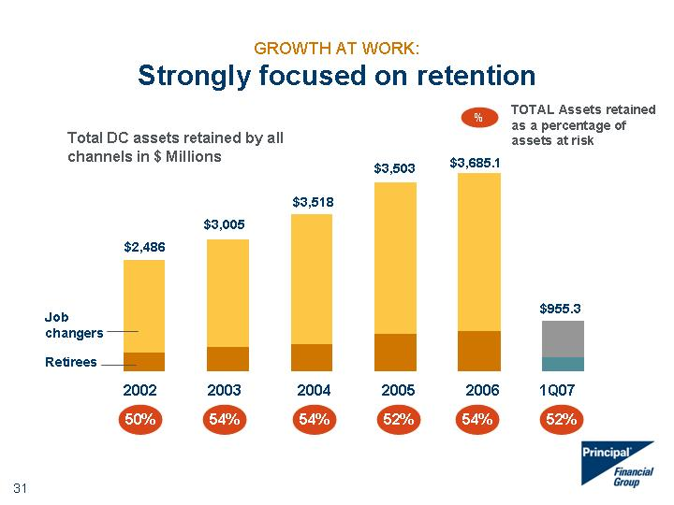

|  |
| --- |
| 2003 2004 Total DC assets retained by all channels in $ Millions Retirees Job Changers 2002 374 1701 2003 469 2001 2004 527 2400 2005 726.6 2776.6 2006 763.3 2921.8 2007 297.3 658 % TOTAL Assets retained as a percentage of assets at risk $2,486 $3,005 $3,518 Job changers Retirees GROWTH AT WORK: Strongly focused on retention $3,503 2005 2006 54% 54% 52% 54% $3,685.1 $955.3 2002 52% 50% 1Q07 |

##### 

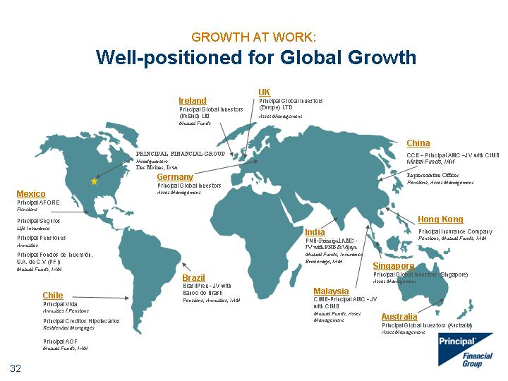

|  |
| --- |
| PRINCIPAL FINANCIAL GROUP Headquarters Des Moines, Iowa Mexico Principal AFORE Pensions Principal Seguros Life Insurance Principal Pensiones Annuities Principal Fondos de Inversion, S.A. de C.V (PFI) Mutual Funds, IAM Chile Principal Vida Annuities / Pensions Principal Creditos Hipotecarios Residential Mortgages Principal AGF Mutual Funds, IAM Brazil BrasilPrev - JV with Banco do Brasil Pensions, Annuities, IAM India PNB-Principal AMC - JV with PNB &Vijaya Mutual Funds, Insurance Brokerage, IAM Malaysia CIMB-Principal AMC - JV with CIMB Mutual Funds, Asset Management Hong Kong Principal Insurance Company Pensions, Mutual Funds, IAM China CCB - Principal AMC -JV with CIMB Mutual Funds, IAM Representative Offices Pensions, Asset Management GROWTH AT WORK: Well-positioned for Global Growth Germany Principal Global Investors Asset Management Ireland Principal Global Investors (Ireland) Ltd Mutual Funds UK Principal Global Investors (Europe) LTD Asset Management Australia Principal Global Investors (Australia) Asset Management Singapore Principal Global Investors (Singapore) Asset Management |

##### 

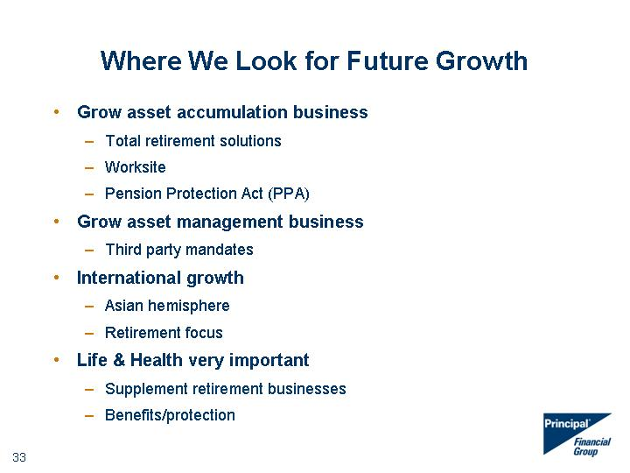

|  |
| --- |
| Where We Look for Future Growth Grow asset accumulation business Total retirement solutions Worksite Pension Protection Act (PPA) Grow asset management business Third party mandates International growth Asian hemisphere Retirement focus Life & Health very important Supplement retirement businesses Benefits/protection |

##### 

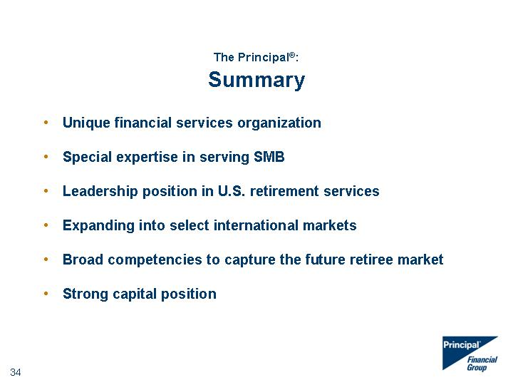

|  |
| --- |
| The Principal(r): Summary Unique financial services organization Special expertise in serving SMB Leadership position in U.S. retirement services Expanding into select international markets Broad competencies to capture the future retiree market Strong capital position |

##### 

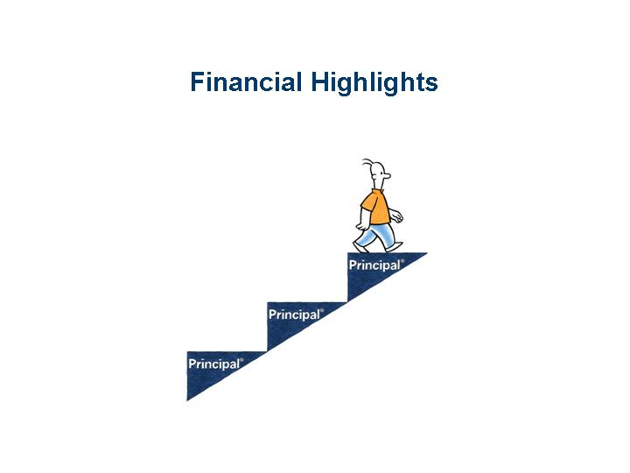

|  |
| --- |
| Financial Highlights |

##### 

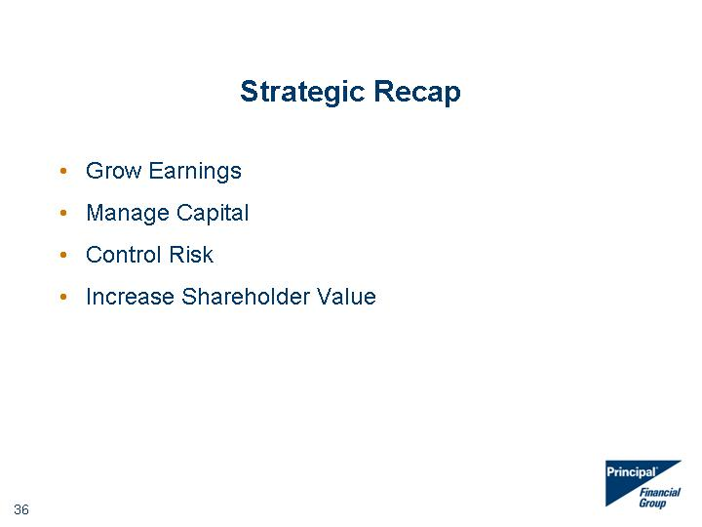

|  |
| --- |
| Strategic Recap Grow Earnings Manage Capital Control Risk Increase Shareholder Value |

##### 

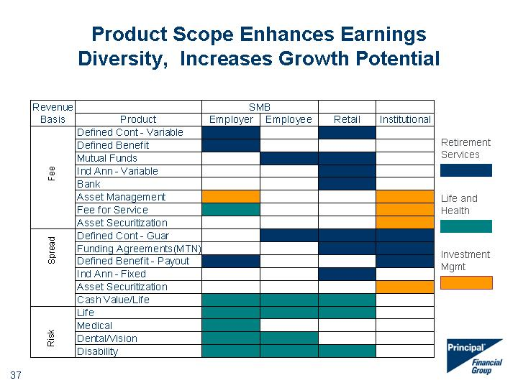

|  |
| --- |
| Product Scope Enhances Earnings Diversity, Increases Growth Potential Retirement Services Life and Health Investment Mgmt |

##### 

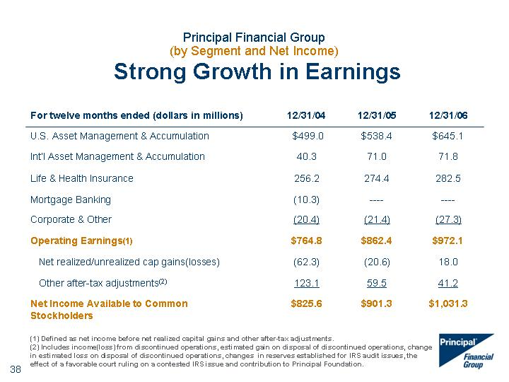

|  |
| --- |
| Principal Financial Group (by Segment and Net Income) Strong Growth in Earnings For twelve months ended (dollars in millions) 12/31/04 12/31/05 12/31/06 U.S. Asset Management & Accumulation $499.0 $538.4 $645.1 Int'l Asset Management & Accumulation 40.3 71.0 71.8 Life & Health Insurance 256.2 274.4 282.5 Mortgage Banking (10.3) ---- ---- Corporate & Other (20.4) (21.4) (27.3) Operating Earnings(1) $764.8 $862.4 $972.1 Net realized/unrealized cap gains(losses) (62.3) (20.6) 18.0 Other after-tax adjustments(2) 123.1 59.5 41.2 Net Income Available to Common Stockholders $825.6 $901.3 $1,031.3 (1) Defined as net income before net realized capital gains and other after-tax adjustments. (2) Includes income(loss) from discontinued operations, estimated gain on disposal of discontinued operations, change in estimated loss on disposal of discontinued operations, changes in reserves established for IRS audit issues, the effect of a favorable court ruling on a contested IRS issue and contribution to Principal Foundation. |

##### 

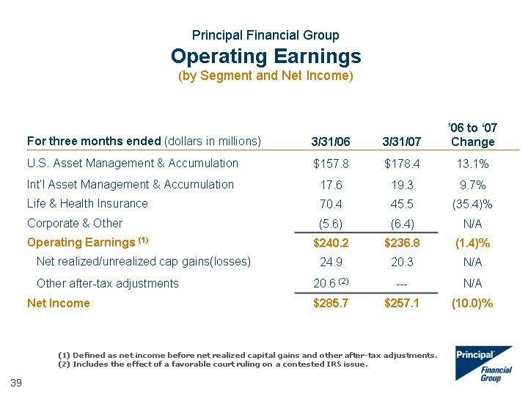

|  |
| --- |
| Principal Financial Group Operating Earnings (by Segment and Net Income) For three months ended (dollars in millions) 3/31/06 3/31/07 '06 to '07 Change U.S. Asset Management & Accumulation $157.8 $178.4 13.1% Int'l Asset Management & Accumulation 17.6 19.3 9.7% Life & Health Insurance 70.4 45.5 (35.4)% Corporate & Other (5.6) (6.4) N/A Operating Earnings (1) $240.2 $236.8 (1.4)% Net realized/unrealized cap gains(losses) 24.9 20.3 N/A Other after-tax adjustments 20.6 (2) --- N/A Net Income $285.7 $257.1 (10.0)% (1) Defined as net income before net realized capital gains and other after-tax adjustments. (2) Includes the effect of a favorable court ruling on a contested IRS issue. |

##### 

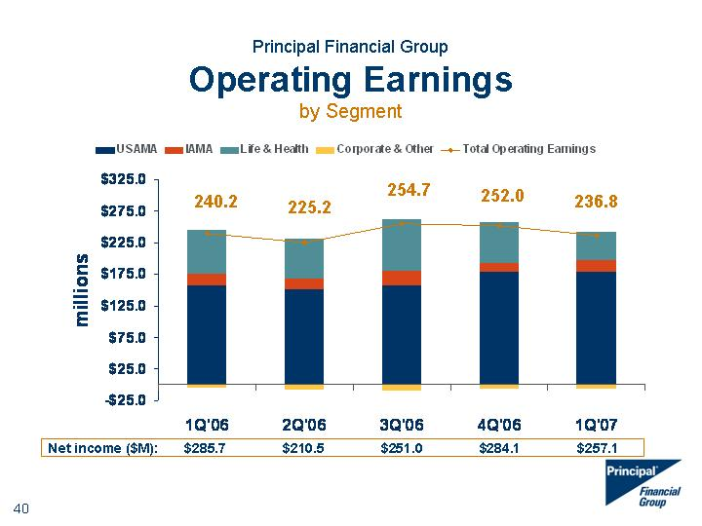

|  |
| --- |
| Principal Financial Group Operating Earnings by Segment 4Q02 1Q'03 2Q'03 3Q'03 4Q'03 1Q'04 2Q'04 3Q'04 4Q'04 1Q'05 2Q'05 3Q'05 4Q'05 1Q'06 2Q'06 3Q'06 4Q'06 1Q'07 USAMA 83.7 97.5 105.7 107.9 114.1 119.5 121.7 123.5 134.3 138.6 130.5 133.3 136 157.8 151.2 157.4 178.7 178.4 Total Operating Earnings 177.9 210.5 165.8 167.3 183.1 186.5 173.4 205.2 199.7 209.2 221 214.3 217.9 240.2 225.2 254.7 252 236.8 IAMA 9.4 6.6 11.9 7.8 8.2 8.6 9.3 10.9 11.5 9.5 19.1 19.7 22.7 17.6 16.1 23.2 14.9 19.3 Life & Health 61.4 59.1 62.9 52.8 66.4 74.8 56.9 71.6 52.9 69.5 76.3 65.4 63.2 70.4 65.2 82 64.9 45.5 Mortgage Banking 29.1 52.3 -4.5 -5 -4.7 -4.9 -5.4 0 0 0 0 0 Corporate & Other -5.7 -5 -10.4 3.8 -0.9 -11.5 -9.1 -0.8 1 -8.4 -4.9 -4.1 -4 -5.6 -7.3 -7.9 -6.5 -6.4 Net Income 285.7 210.5 251 284.1 257.1 252.0 225.2 240.2 254.7 236.8 Net income ($M): $285.7 $210.5 $251.0 $284.1 $257.1 |

##### 

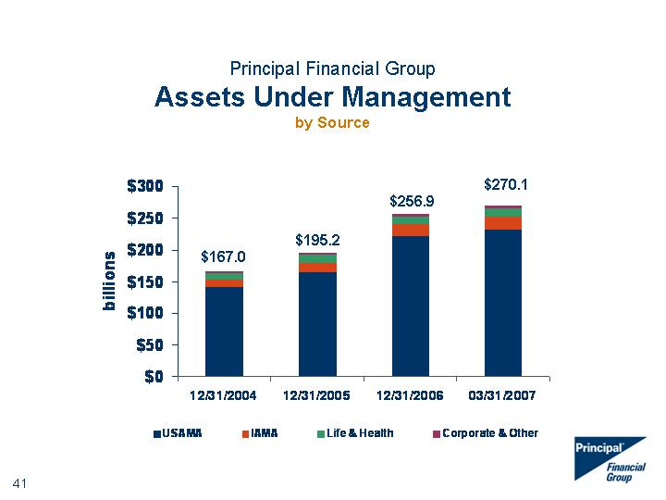

|  |
| --- |
| Principal Financial Group Assets Under Management by Source 6/22/1905 12/31/2001 Dec 31 '02 Dec 31 '03 12/31/2004 12/31/2005 12/31/2006 3/31/2007 USAMA 78.1 82.2 92.3 120.8 142.1 164.3 221.9 231.5 IAMA 28.4 25.3 4.4 7.5 10.2 15.4 19.1 22 Life & Health 9.3 9.6 10.3 10.9 11.7 12.3 12.3 12.4 Mortgage Banking 0.2 0.5 0.6 2.3 0 Corporate & Other 1.5 2.6 3.5 3.4 3 3.2 3.6 4.2 $256.9 $195.2 $167.0 $270.1 |

##### 



|  |
| --- |
| Principal Financial Group Total Capital 6/22/1905 12/31/2001 Dec 31 '02 Dec 31 '03 12/31/2004 12/31/2005 12/31/2006 3/31/2007 Common GAAP Equity 78.1 82.2 92.3 120.8 6231 6271 6472 231.5 Preferred Equity 28.4 25.3 4.4 7.5 542 542 22 Balance Sheet Debt 9.3 9.6 10.3 10.9 1125 1374 1638 12.4 Other Debt Adjustments 0.2 0.5 0.6 2.3 141 322 Corporate & Other 1.5 2.6 3.5 3.4 3 3.2 3.6 4.2 $8,327 $7,356 $8,974 |

##### 

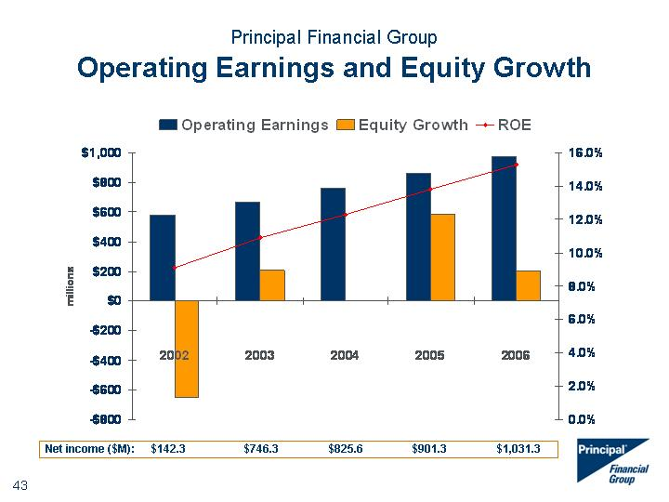

|  |
| --- |
| Principal Financial Group Operating Earnings and Equity Growth 4Q02 1Q'03 2Q'03 3Q'03 4Q'03 1Q'04 2Q'04 3Q'04 4Q'04 1Q'05 2Q'05 3Q'05 2002 2003 2004 2005 2006 Operating Earnings 83.7 97.5 105.7 107.9 114.1 119.5 121.7 123.5 134.3 138.6 130.5 133.3 579.3 667.7 764.8 862.4 972.1 ROE 177.9 210.5 165.8 167.3 183.1 186.5 173.4 205.2 199.7 209.2 221 214.3 0.091 0.109 0.123 0.138 0.153 Equity Growth 9.4 6.6 11.9 7.8 8.2 8.6 9.3 10.9 11.5 9.5 19.1 19.7 -651.4 206.9 2.7 581.4 201.5 Life & Health 61.4 59.1 62.9 52.8 66.4 74.8 56.9 71.6 52.9 69.5 76.3 65.4 63.2 70.4 65.2 82 64.9 Mortgage Banking 29.1 52.3 -4.5 -5 -4.7 -4.9 -5.4 0 0 0 0 0 Corporate & Other -5.7 -5 -10.4 3.8 -0.9 -11.5 -9.1 -0.8 1 -8.4 -4.9 -4.1 -4 -5.6 -7.3 -7.9 -6.5 Net income ($M): $142.3 $746.3 $825.6 $901.3 $1,031.3 |

##### 

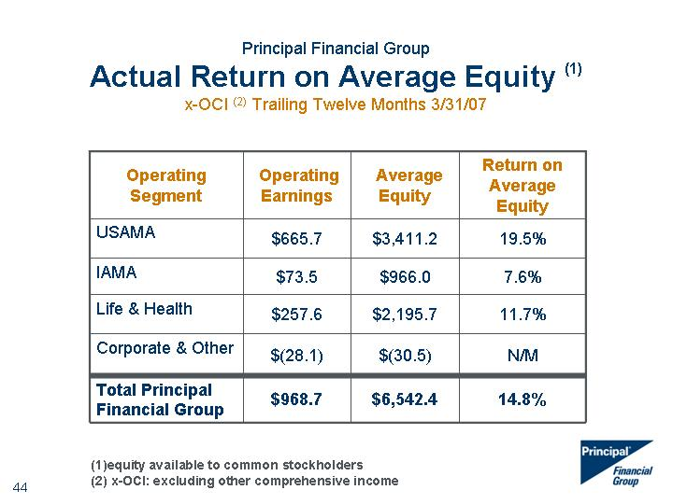

|  |
| --- |
| Principal Financial Group Actual Return on Average Equity (1) x-OCI (2) Trailing Twelve Months 3/31/07 (1)equity available to common stockholders (2) x-OCI: excluding other comprehensive income Operating Segment Operating Earnings Average Equity Return on Average Equity USAMA $665.7 $3,411.2 19.5% IAMA $73.5 $966.0 7.6% Life & Health $257.6 $2,195.7 11.7% Corporate & Other $(28.1) $(30.5) N/M Total Principal Financial Group $968.7 $6,542.4 14.8% |

##### 

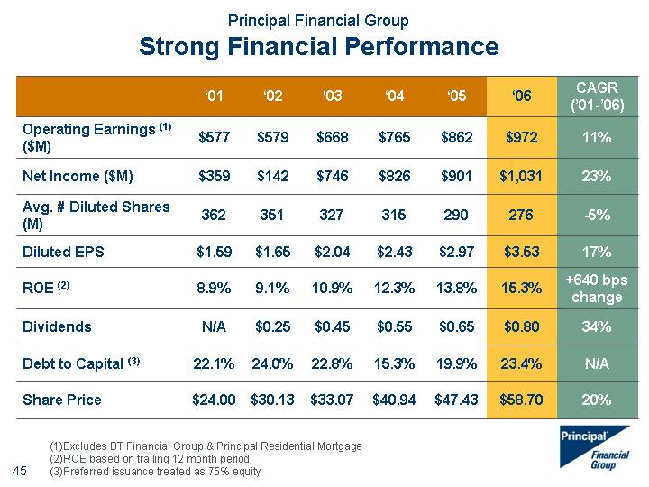

|  |
| --- |
| Principal Financial Group Strong Financial Performance '01 '02 '03 '04 '05 '06 CAGR ('01-'06) Operating Earnings (1) ($M) $577 $579 $668 $765 $862 $972 11% Net Income ($M) $359 $142 $746 $826 $901 $1,031 23% Avg. # Diluted Shares (M) 362 351 327 315 290 276 -5% Diluted EPS $1.59 $1.65 $2.04 $2.43 $2.97 $3.53 17% ROE (2) 8.9% 9.1% 10.9% 12.3% 13.8% 15.3% +640 bps change Dividends N/A $0.25 $0.45 $0.55 $0.65 $0.80 34% Debt to Capital (3) 22.1% 24.0% 22.8% 15.3% 19.9% 23.4% N/A Share Price $24.00 $30.13 $33.07 $40.94 $47.43 $58.70 20% (1)Excludes BT Financial Group & Principal Residential Mortgage (2)ROE based on trailing 12 month period (3)Preferred issuance treated as 75% equity |

##### 

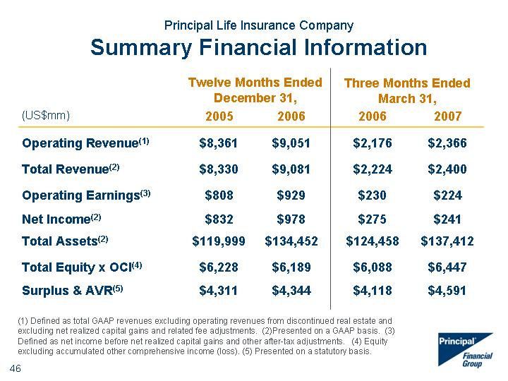

|  |
| --- |
| Principal Life Insurance Company Summary Financial Information (1) Defined as total GAAP revenues excluding operating revenues from discontinued real estate and excluding net realized capital gains and related fee adjustments. (2)Presented on a GAAP basis. (3) Defined as net income before net realized capital gains and other after-tax adjustments. (4) Equity excluding accumulated other comprehensive income (loss). (5) Presented on a statutory basis. (US$mm) 2005 2006 2006 2007 Operating Revenue(1) $8,361 $9,051 $2,176 $2,366 Total Revenue(2) $8,330 $9,081 $2,224 $2,400 Operating Earnings(3) $808 $929 $230 $224 Net Income(2) $832 $978 $275 $241 Total Assets(2) $119,999 $134,452 $124,458 $137,412 Total Equity x OCI(4) $6,228 $6,189 $6,088 $6,447 Surplus & AVR(5) $4,311 $4,344 $4,118 $4,591 Twelve Months Ended December 31, Three Months Ended March 31, |

##### 

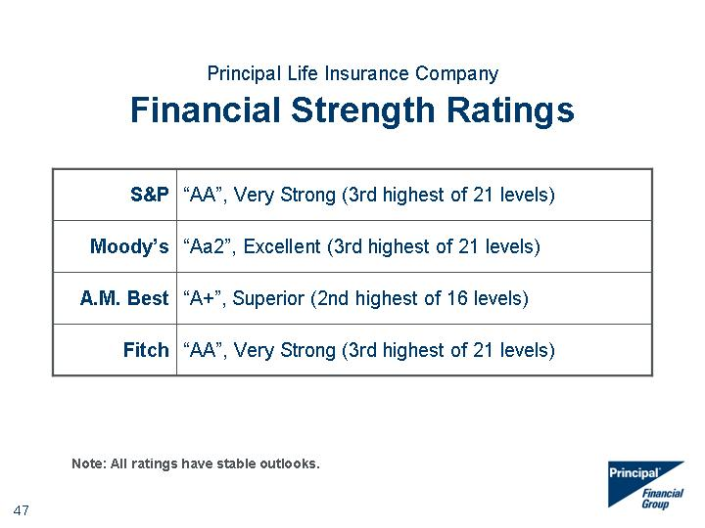

|  |
| --- |
| Principal Life Insurance Company Financial Strength Ratings S&P "AA", Very Strong (3rd highest of 21 levels) Moody's "Aa2", Excellent (3rd highest of 21 levels) A.M. Best "A+", Superior (2nd highest of 16 levels) Fitch "AA", Very Strong (3rd highest of 21 levels) Note: All ratings have stable outlooks. |

##### 

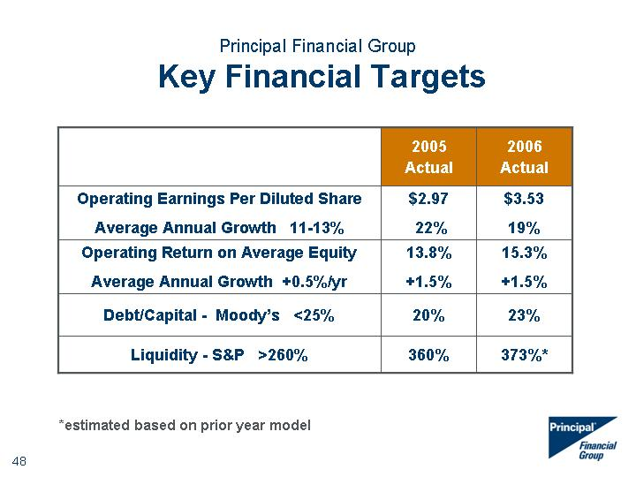

|  |
| --- |
| Principal Financial Group Key Financial Targets 2005 Actual 2006 Actual Operating Earnings Per Diluted Share Average Annual Growth 11-13% $2.97 22% $3.53 19% Operating Return on Average Equity Average Annual Growth +0.5%/yr 13.8% +1.5% 15.3% +1.5% Debt/Capital - Moody's <25% 20% 23% Liquidity - S&P >260% 360% 373%* *estimated based on prior year model |

##### 

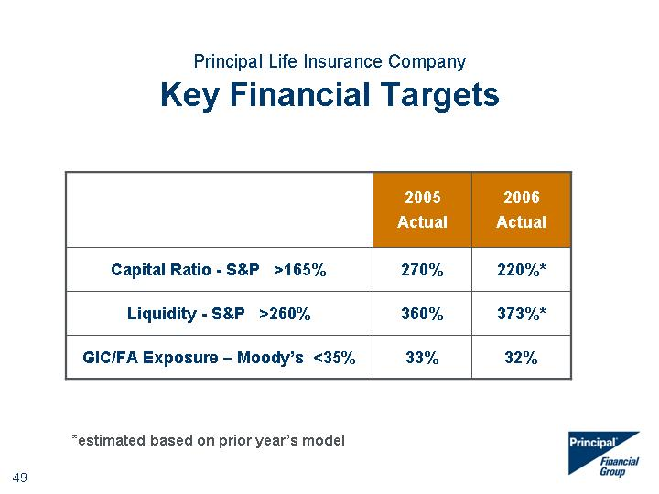

|  |
| --- |
| Principal Life Insurance Company Key Financial Targets 2005 Actual 2006 Actual Capital Ratio - S&P >165% 270% 220%* Liquidity - S&P >260% 360% 373%* GIC/FA Exposure - Moody's <35% 33% 32% *estimated based on prior year's model |

##### 



|  |
| --- |
| Risk Management at The Principal(r) |

##### 

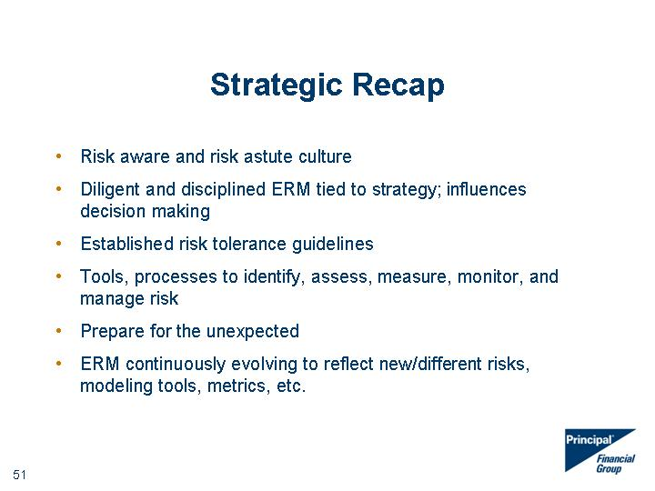

|  |
| --- |
| Strategic Recap Risk aware and risk astute culture Diligent and disciplined ERM tied to strategy; influences decision making Established risk tolerance guidelines Tools, processes to identify, assess, measure, monitor, and manage risk Prepare for the unexpected ERM continuously evolving to reflect new/different risks, modeling tools, metrics, etc. |

##### 

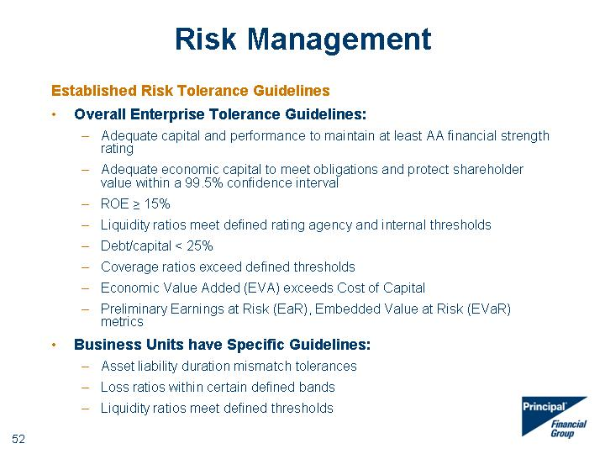

|  |
| --- |
| Established Risk Tolerance Guidelines Overall Enterprise Tolerance Guidelines: Adequate capital and performance to maintain at least AA financial strength rating Adequate economic capital to meet obligations and protect shareholder value within a 99.5% confidence interval ROE ^ 15% Liquidity ratios meet defined rating agency and internal thresholds Debt/capital < 25% Coverage ratios exceed defined thresholds Economic Value Added (EVA) exceeds Cost of Capital Preliminary Earnings at Risk (EaR), Embedded Value at Risk (EVaR) metrics Business Units have Specific Guidelines: Asset liability duration mismatch tolerances Loss ratios within certain defined bands Liquidity ratios meet defined thresholds Risk Management |

##### 

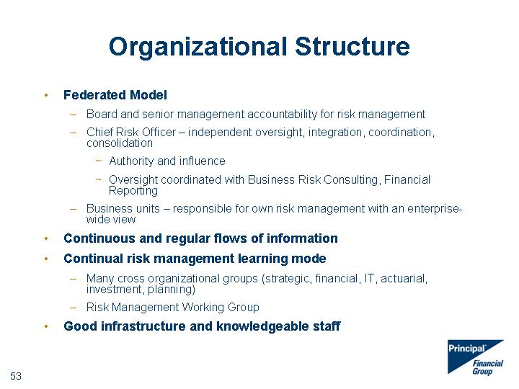

|  |
| --- |
| Organizational Structure Federated Model Board and senior management accountability for risk management Chief Risk Officer - independent oversight, integration, coordination, consolidation Authority and influence Oversight coordinated with Business Risk Consulting, Financial Reporting Business units - responsible for own risk management with an enterprise- wide view Continuous and regular flows of information Continual risk management learning mode Many cross organizational groups (strategic, financial, IT, actuarial, investment, planning) Risk Management Working Group Good infrastructure and knowledgeable staff |

##### 

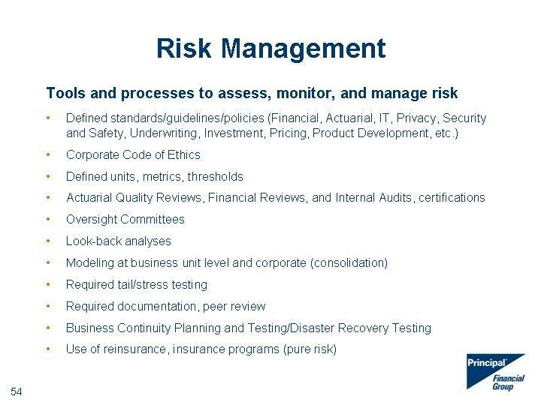

|  |
| --- |
| Risk Management Tools and processes to assess, monitor, and manage risk Defined standards/guidelines/policies (Financial, Actuarial, IT, Privacy, Security and Safety, Underwriting, Investment, Pricing, Product Development, etc.) Corporate Code of Ethics Defined units, metrics, thresholds Actuarial Quality Reviews, Financial Reviews, and Internal Audits, certifications Oversight Committees Look-back analyses Modeling at business unit level and corporate (consolidation) Required tail/stress testing Required documentation, peer review Business Continuity Planning and Testing/Disaster Recovery Testing Use of reinsurance, insurance programs (pure risk) |

##### 

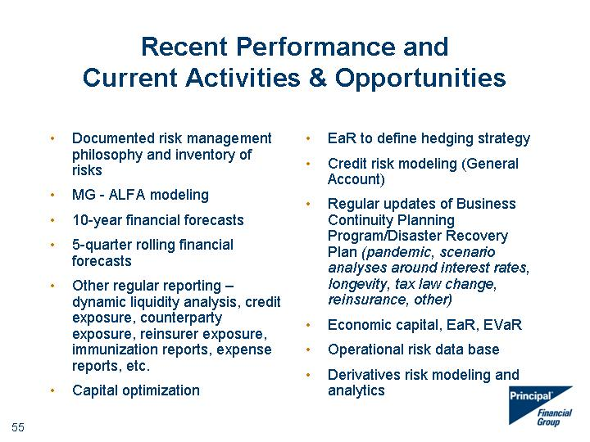

|  |
| --- |
| Recent Performance and Current Activities & Opportunities Documented risk management philosophy and inventory of risks MG - ALFA modeling 10-year financial forecasts 5-quarter rolling financial forecasts Other regular reporting - dynamic liquidity analysis, credit exposure, counterparty exposure, reinsurer exposure, immunization reports, expense reports, etc. Capital optimization EaR to define hedging strategy Credit risk modeling (General Account) Regular updates of Business Continuity Planning Program/Disaster Recovery Plan (pandemic, scenario analyses around interest rates, longevity, tax law change, reinsurance, other) Economic capital, EaR, EVaR Operational risk data base Derivatives risk modeling and analytics |

##### 

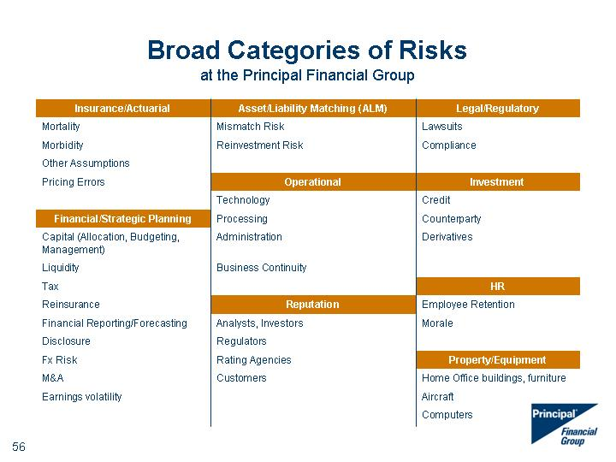

|  |
| --- |
| Broad Categories of Risks at the Principal Financial Group Insurance/Actuarial Asset/Liability Matching (ALM) Legal/Regulatory Mortality Mismatch Risk Lawsuits Morbidity Reinvestment Risk Compliance Other Assumptions Pricing Errors Operational Investment Technology Credit Financial/Strategic Planning Processing Counterparty Capital (Allocation, Budgeting, Management) Administration Derivatives Liquidity Business Continuity Tax HR Reinsurance Reputation Employee Retention Financial Reporting/Forecasting Analysts, Investors Morale Disclosure Regulators Fx Risk Rating Agencies Property/Equipment M&A Customers Home Office buildings, furniture Earnings volatility Aircraft Computers |

##### 

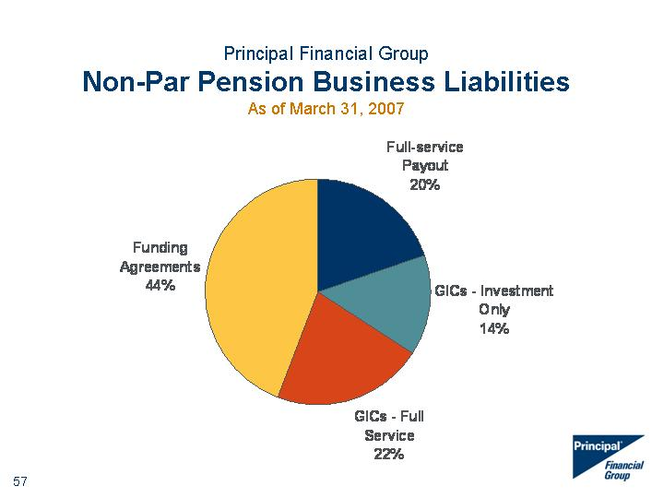

|  |
| --- |
| Full Service Payout GICs - Full Service GICs - Investment Only Funding Agreements East 6240.5 6787.4 5663.7 11580.6 West 30.6 38.6 34.6 31.6 North 45.9 46.9 45 43.9 Full-service Payout GICs - Investment Only GICs - Full Service Funding Agreements 2005 6450.3 5821 7282 12115.7 2006 6611 4751.55 7255.859 14685.668 North 45.9 46.9 45 43.9 Principal Financial Group Non-Par Pension Business Liabilities As of March 31, 2007 |

##### 

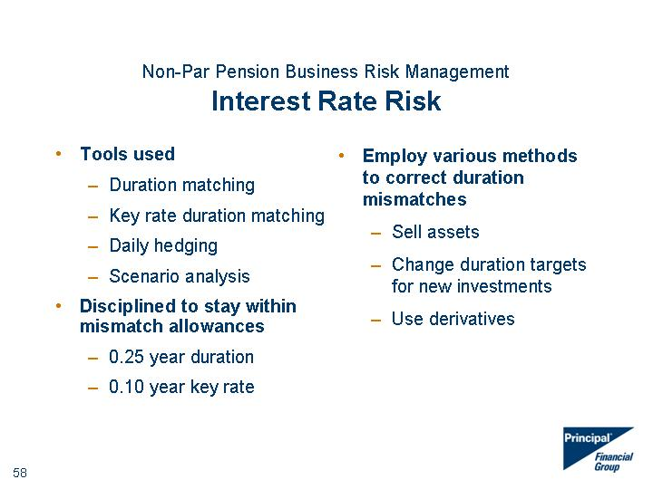

|  |
| --- |
| Non-Par Pension Business Risk Management Interest Rate Risk Tools used Duration matching Key rate duration matching Daily hedging Scenario analysis Disciplined to stay within mismatch allowances 0.25 year duration 0.10 year key rate Employ various methods to correct duration mismatches Sell assets Change duration targets for new investments Use derivatives |

##### 

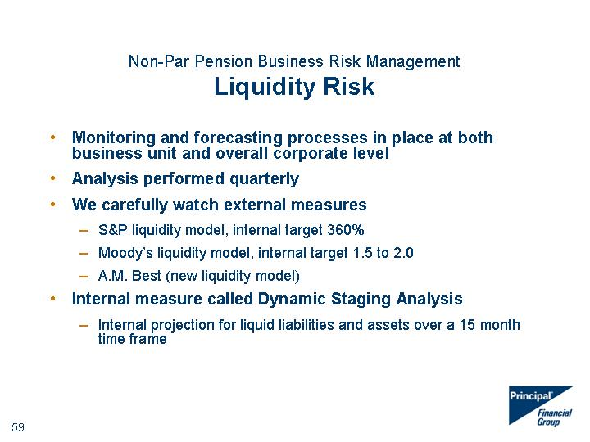

|  |
| --- |
| Non-Par Pension Business Risk Management Liquidity Risk Monitoring and forecasting processes in place at both business unit and overall corporate level Analysis performed quarterly We carefully watch external measures S&P liquidity model, internal target 360% Moody's liquidity model, internal target 1.5 to 2.0 A.M. Best (new liquidity model) Internal measure called Dynamic Staging Analysis Internal projection for liquid liabilities and assets over a 15 month time frame |

##### 

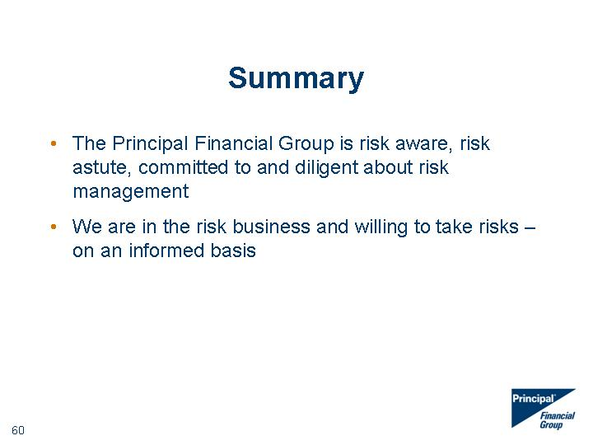

|  |
| --- |
| Summary The Principal Financial Group is risk aware, risk astute, committed to and diligent about risk management We are in the risk business and willing to take risks - on an informed basis |

##### 

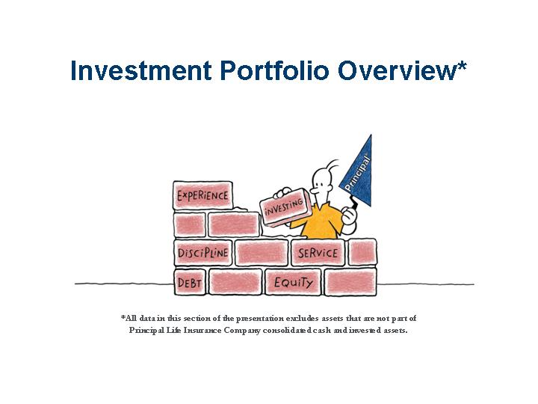

|  |
| --- |
| Investment Portfolio Overview* *All data in this section of the presentation excludes assets that are not part of Principal Life Insurance Company consolidated cash and invested assets. |

##### 

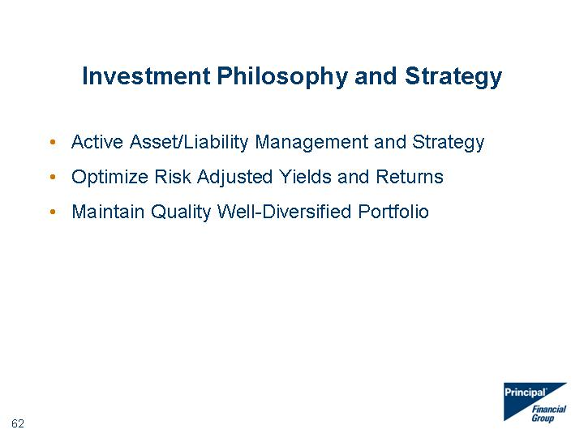

|  |
| --- |
| Investment Philosophy and Strategy Active Asset/Liability Management and Strategy Optimize Risk Adjusted Yields and Returns Maintain Quality Well-Diversified Portfolio |

##### 

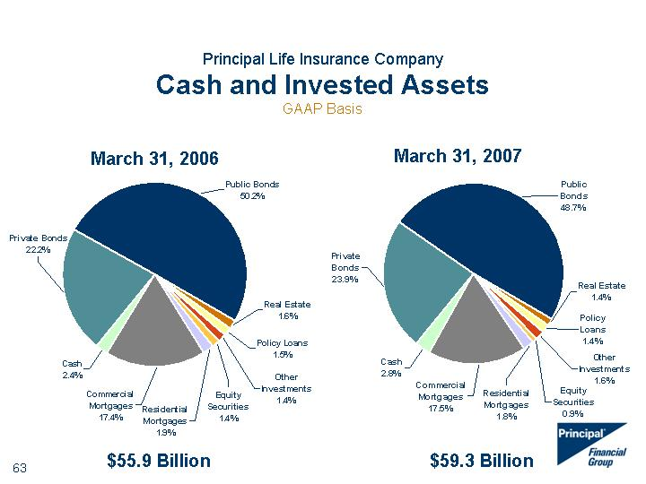

|  |
| --- |
| Principal Life Insurance Company Cash and Invested Assets GAAP Basis 3/31/2006 Real Estate 1.6 Policy Loans 1.5 Other Investments 1.4 Equity Securities 1.4 Residential Mortgages 1.9 Commercial Mortgages 17.4 Cash 2.4 Private Bonds 22.2 Public Bonds 50.2 3/31/2007 Real Estate 1.4 Policy Loans 1.4 Other Investments 1.6 Equity Securities 0.9 Residential Mortgages 1.8 Commercial Mortgages 17.5 Cash 2.8 Private Bonds 23.9 Public Bonds 48.7 March 31, 2007 March 31, 2006 $55.9 Billion $59.3 Billion |

##### 

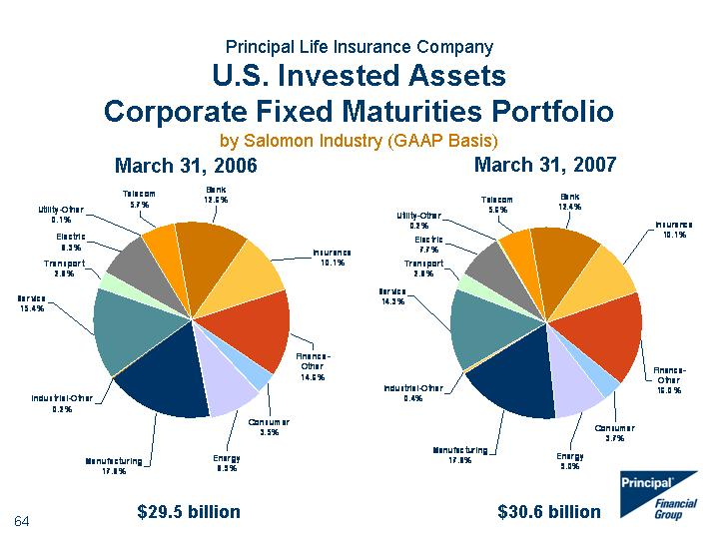

|  |
| --- |
| Principal Life Insurance Company U.S. Invested Assets Corporate Fixed Maturities Portfolio by Salomon Industry (GAAP Basis) 3/31/2006 Bank 12.6 Insurance 10.1 Finance-Other 14.6 Consumer 3.5 Energy 8.9 Manufacturing 17.8 Industrial-Other 0.2 Service 15.4 Transport 2.8 Electric 8.3 Utility-Other 0.1 Telecom 5.7 3/31/2007 Bank 12.4 Insurance 10.1 Finance-Other 16 Consumer 3.7 Energy 9 Manufacturing 17.8 Industrial-Other 0.4 Service 14.3 Transport 2.8 Electric 7.7 Utility-Other 0.2 Telecom 5.6 March 31, 2007 March 31, 2006 $29.5 billion $30.6 billion |

##### 

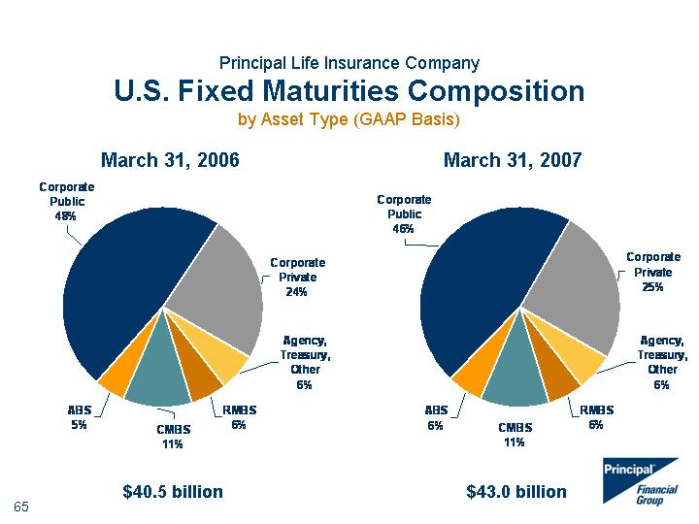

|  |
| --- |
| Principal Life Insurance Company U.S. Fixed Maturities Composition by Asset Type (GAAP Basis) 3/31/2006 Agency, Treasury, Other 6 RMBS 6 CMBS 11 ABS 5 Corporate Public 48 Corporate Private 24 3/31/2007 Agency, Treasury, Other 6 RMBS 6 CMBS 11 ABS 6 Corporate Public 46 Corporate Private 25 March 31, 2007 March 31, 2006 $40.5 billion $43.0 billion |

##### 

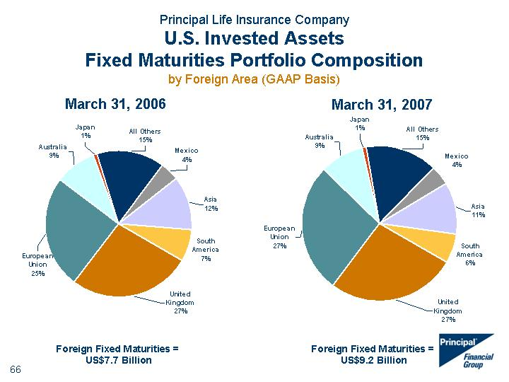

|  |
| --- |
| Principal Life Insurance Company U.S. Invested Assets Fixed Maturities Portfolio Composition by Foreign Area (GAAP Basis) 3/31/2006 United Kingdom 27 European Union 25 Australia 9 Japan 1 All Others 15 Mexico 4 Asia 12 South America 7 3/31/2007 United Kingdom 27 European Union 27 Australia 9 Japan 1 All Others 15 Mexico 4 Asia 11 South America 6 March 31, 2007 Foreign Fixed Maturities = US$7.7 Billion March 31, 2006 Foreign Fixed Maturities = US$9.2 Billion |

##### 

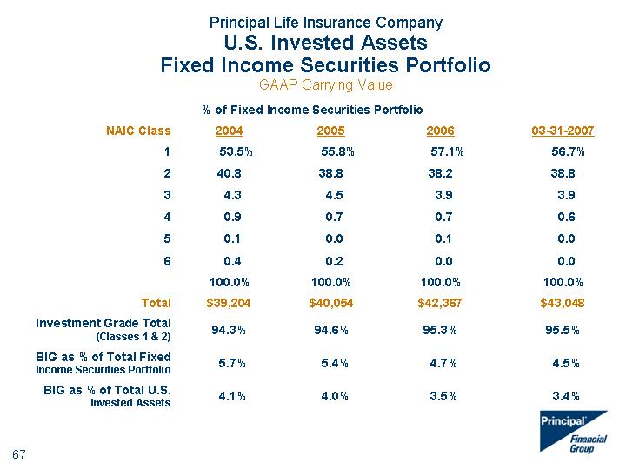

|  |
| --- |
| Principal Life Insurance Company U.S. Invested Assets Fixed Income Securities Portfolio GAAP Carrying Value % of Fixed Income Securities Portfolio % of Fixed Income Securities Portfolio % of Fixed Income Securities Portfolio % of Fixed Income Securities Portfolio % of Fixed Income Securities Portfolio NAIC Class 2004 2005 2006 03-31-2007 1 2 3 4 5 6 53.5% 40.8 4.3 0.9 0.1 0.4 55.8% 38.8 4.5 0.7 0.0 0.2 57.1% 38.2 3.9 0.7 0.1 0.0 56.7% 38.8 3.9 0.6 0.0 0.0 100.0% 100.0% 100.0% 100.0% Total $39,204 $40,054 $42,367 $43,048 Investment Grade Total (Classes 1 & 2) 94.3% 94.6% 95.3% 95.5% BIG as % of Total Fixed Income Securities Portfolio 5.7% 5.4% 4.7% 4.5% BIG as % of Total U.S. Invested Assets 4.1% 4.0% 3.5% 3.4% |

##### 

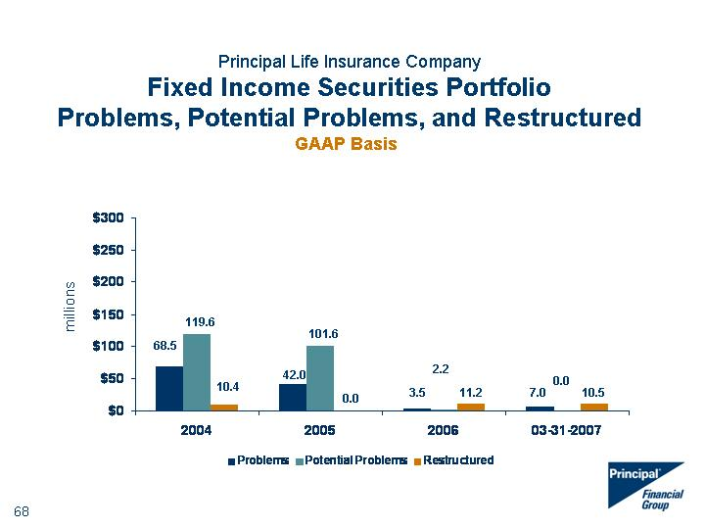

|  |
| --- |
| Principal Life Insurance Company Fixed Income Securities Portfolio Problems, Potential Problems, and Restructured 2004 2005 2006 3/31/2007 Problems 68.5 42 3.5 7 Potential Problems 119.6 101.6 2.2 0 Restructured 10.4 0 11.2 10.5 68.5 119.6 101.6 0.0 10.4 GAAP Basis 42.0 3.5 2.2 11.2 7.0 0.0 10.5 |

##### 

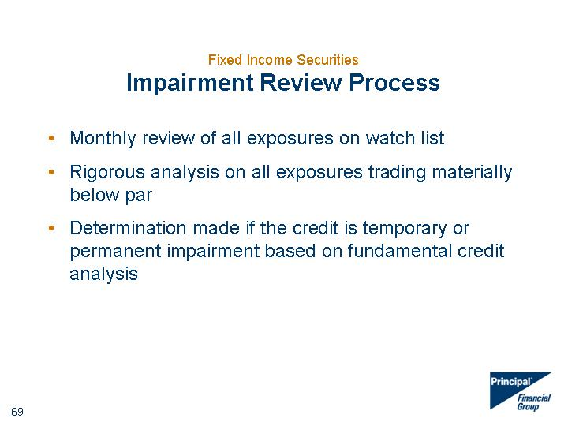

|  |
| --- |
| Fixed Income Securities Impairment Review Process Monthly review of all exposures on watch list Rigorous analysis on all exposures trading materially below par Determination made if the credit is temporary or permanent impairment based on fundamental credit analysis |

##### 

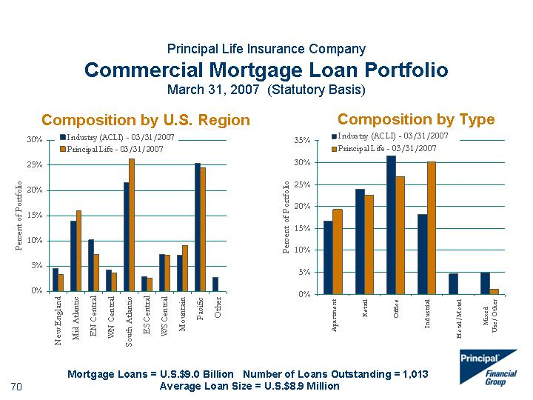

|  |
| --- |
| Composition by U.S. Region Composition by Type Principal Life Insurance Company Commercial Mortgage Loan Portfolio March 31, 2007 (Statutory Basis) Mortgage Loans = U.S.$9.0 Billion Number of Loans Outstanding = 1,013 Average Loan Size = U.S.$8.9 Million Industry (ACLI) - 03/31/2007 Principal Life - 03/31/2007 New England 0.045 0.033 Mid Atlantic 0.139 0.159 EN Central 0.102 0.073 WN Central 0.042 0.037 South Atlantic 0.215 0.263 ES Central 0.029 0.027 WS Central 0.074 0.072 Mountain 0.072 0.091 Pacific 0.254 0.245 Other 0.028 0 Industry (ACLI) - 03/31/2007 Principal Life - 03/31/2007 Apartment 0.167 0.193 Retail 0.24 0.226 Office 0.316 0.268 Industrial 0.182 0.301 Hotel/Motel 0.046 0 Mixed Use/Other 0.049 0.012 |

##### 

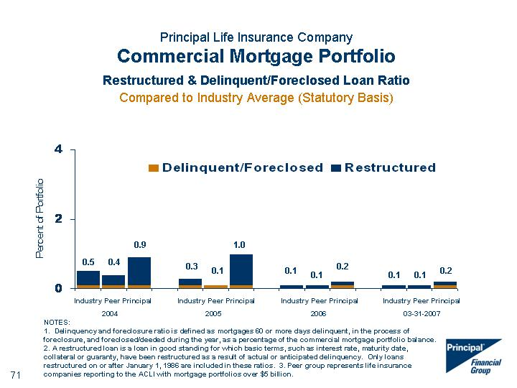

|  |
| --- |
| NOTES: 1. Delinquency and foreclosure ratio is defined as mortgages 60 or more days delinquent, in the process of foreclosure, and foreclosed/deeded during the year, as a percentage of the commercial mortgage portfolio balance. 2. A restructured loan is a loan in good standing for which basic terms, such as interest rate, maturity date, collateral or guaranty, have been restructured as a result of actual or anticipated delinquency. Only loans restructured on or after January 1, 1986 are included in these ratios. 3. Peer group represents life insurance companies reporting to the ACLI with mortgage portfolios over $5 billion. Principal Life Insurance Company Commercial Mortgage Portfolio Restructured & Delinquent/Foreclosed Loan Ratio Compared to Industry Average (Statutory Basis) Delinquent/Foreclosed Restructured Industry 0.1 0.4 Peer 2004 0.1 0.3 Principal 0.1 0.8 Industry 0.1 0.2 Peer 2005 0.1 0 Principal 0.1 0.9 Industry 0 0.1 Peer 2006 0 0.1 Principal 0.1 0.1 Industry 0 0.1 Peer 03-31-2007 0 0.1 Principal 0.1 0.1 0.1 0.1 1.0 0.3 0.9 0.4 0.5 0.2 0.1 Industry Peer Principal 2004 Industry Peer Principal 2006 Industry Peer Principal 2005 0.2 0.1 0.1 Industry Peer Principal 03-31-2007 |

##### 

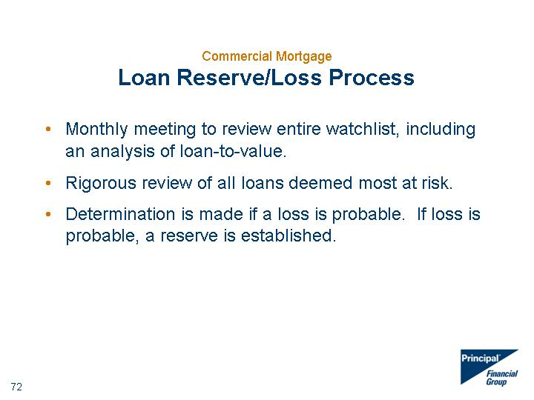

|  |
| --- |
| Commercial Mortgage Loan Reserve/Loss Process Monthly meeting to review entire watchlist, including an analysis of loan-to-value. Rigorous review of all loans deemed most at risk. Determination is made if a loss is probable. If loss is probable, a reserve is established. |

##### 

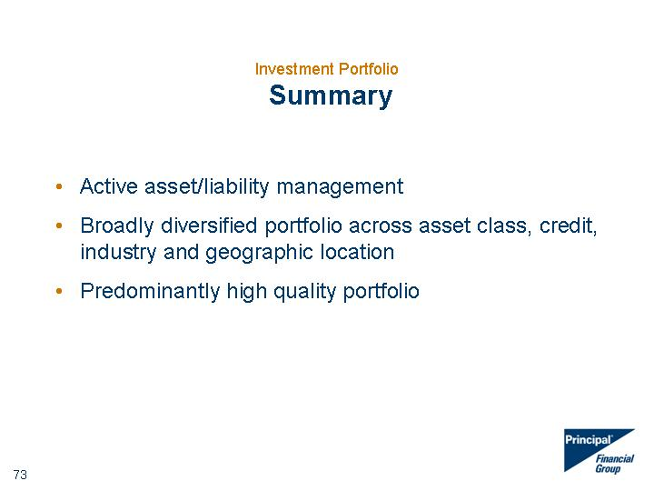

|  |
| --- |
| Investment Portfolio Summary Active asset/liability management Broadly diversified portfolio across asset class, credit, industry and geographic location Predominantly high quality portfolio |

##### 

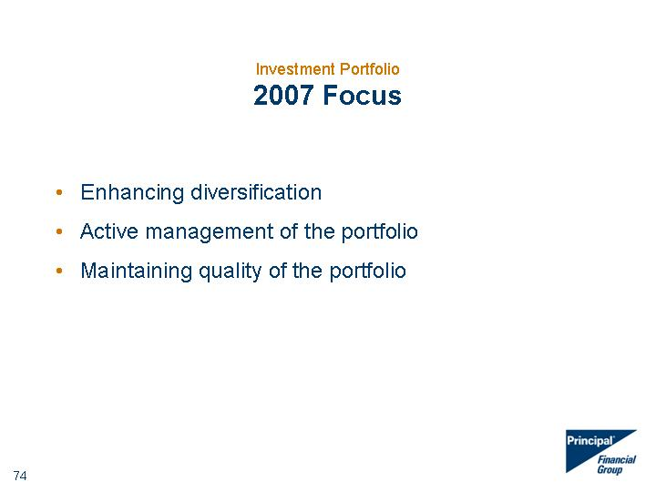

|  |
| --- |
| Investment Portfolio 2007 Focus Enhancing diversification Active management of the portfolio Maintaining quality of the portfolio |

##### 

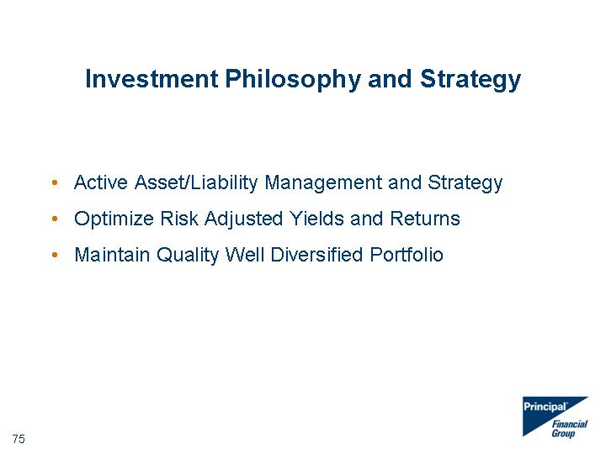

|  |
| --- |
| Investment Philosophy and Strategy Active Asset/Liability Management and Strategy Optimize Risk Adjusted Yields and Returns Maintain Quality Well Diversified Portfolio |

##### 



|  |
| --- |
| Principal Global Investors |

##### 

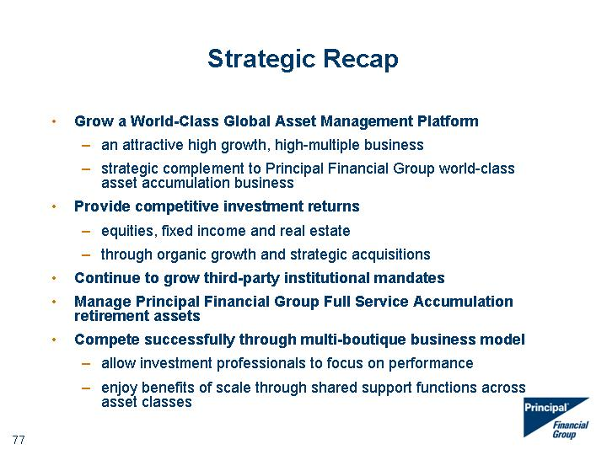

|  |
| --- |
| Strategic Recap Grow a World-Class Global Asset Management Platform an attractive high growth, high-multiple business strategic complement to Principal Financial Group world-class asset accumulation business Provide competitive investment returns equities, fixed income and real estate through organic growth and strategic acquisitions Continue to grow third-party institutional mandates Manage Principal Financial Group Full Service Accumulation retirement assets Compete successfully through multi-boutique business model allow investment professionals to focus on performance enjoy benefits of scale through shared support functions across asset classes |

##### 

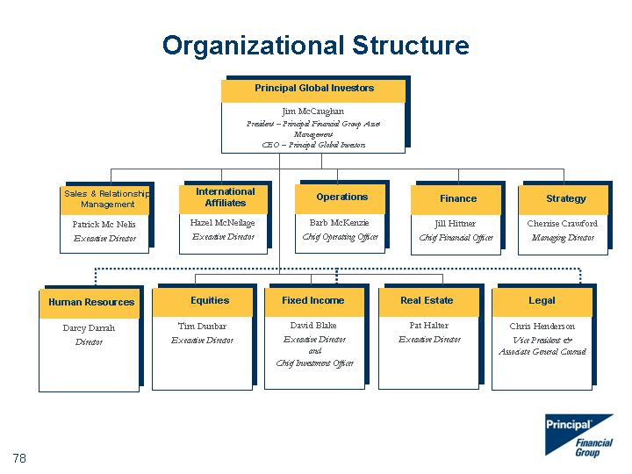

|  |
| --- |
| Pat Halter Executive Director Real Estate Hazel McNeilage Executive Director International Affiliates Patrick Mc Nelis Executive Director Sales & Relationship Management Barb McKenzie Chief Operating Officer Operations Jill Hittner Chief Financial Officer Finance Tim Dunbar Executive Director Equities David Blake Executive Director and Chief Investment Officer Fixed Income Cherrise Crawford Managing Director Strategy Principal Global Investors Jim McCaughan President - Principal Financial Group Asset Management CEO - Principal Global Investors Principal Global Investors Darcy Darrah Director Human Resources Chris Henderson Vice President & Associate General Counsel Legal Organizational Structure |

##### 

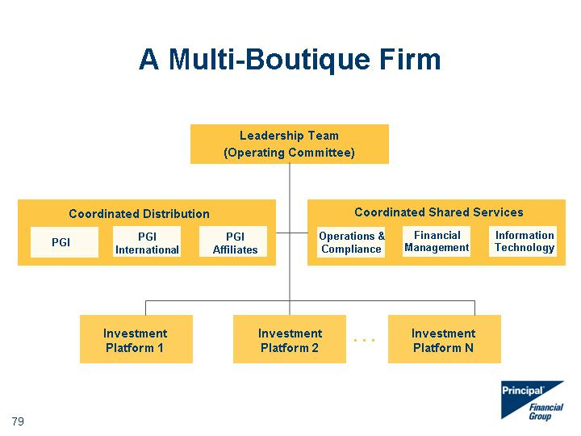

|  |
| --- |
| A Multi-Boutique Firm Leadership Team (Operating Committee) Coordinated Shared Services Investment Platform 1 Investment Platform 2 Investment Platform N Operations & Compliance Financial Management Information Technology Coordinated Distribution PGI PGI International PGI Affiliates .... |

##### 



|  |
| --- |
| Principal Global Investors* A diversified global asset management organization $213.6 billion in assets under management as of 3/31/07 Broad range of capabilities, tailored to client objectives Global reach and clarity of purpose *Principal Global Investors represents the asset management operations of the Principal Financial Group. Please refer to slide titled "Asset Management Affiliates" for more details. **Cash and accrued income Assets Under Management As of March, 31 2007 $ in Billions Fixed Income Equity Real Estate Other** By Asset Class 110.9 60.9 39.6 2.2 |

##### 

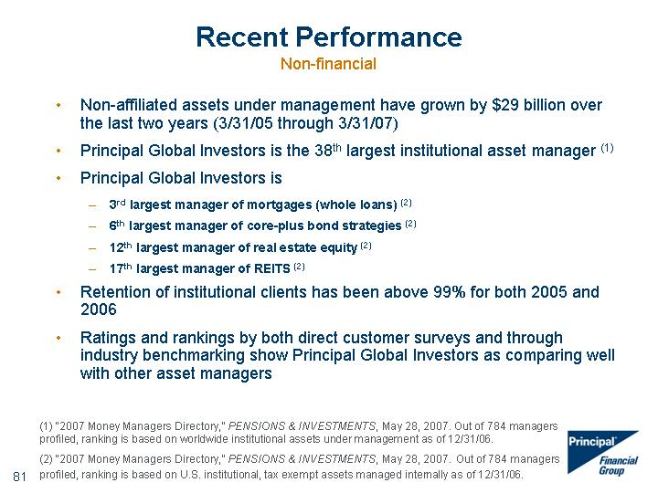

|  |
| --- |
| Recent Performance Non-financial Non-affiliated assets under management have grown by $29 billion over the last two years (3/31/05 through 3/31/07) Principal Global Investors is the 38th largest institutional asset manager (1) Principal Global Investors is 3rd largest manager of mortgages (whole loans) (2) 6th largest manager of core-plus bond strategies (2) 12th largest manager of real estate equity (2) 17th largest manager of REITS (2) Retention of institutional clients has been above 99% for both 2005 and 2006 Ratings and rankings by both direct customer surveys and through industry benchmarking show Principal Global Investors as comparing well with other asset managers (1) "2007 Money Managers Directory," PENSIONS & INVESTMENTS, May 28, 2007. Out of 784 managers profiled, ranking is based on worldwide institutional assets under management as of 12/31/06. (2) "2007 Money Managers Directory," PENSIONS & INVESTMENTS, May 28, 2007. Out of 784 managers profiled, ranking is based on U.S. institutional, tax exempt assets managed internally as of 12/31/06. .. |

##### 

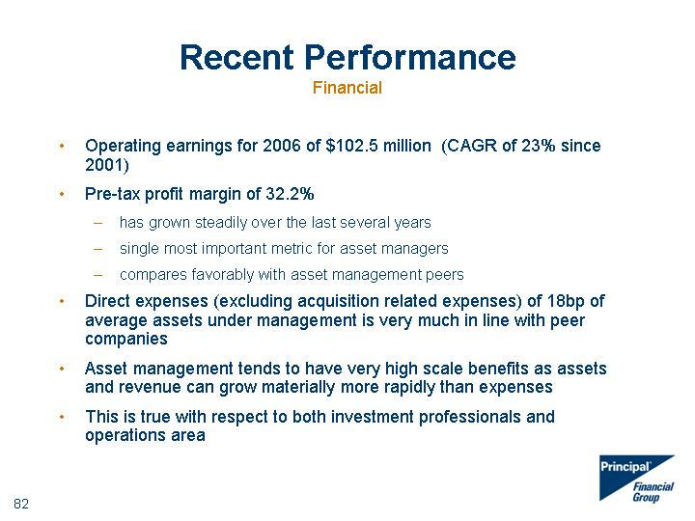

|  |
| --- |
| Recent Performance Financial Operating earnings for 2006 of $102.5 million (CAGR of 23% since 2001) Pre-tax profit margin of 32.2% has grown steadily over the last several years single most important metric for asset managers compares favorably with asset management peers Direct expenses (excluding acquisition related expenses) of 18bp of average assets under management is very much in line with peer companies Asset management tends to have very high scale benefits as assets and revenue can grow materially more rapidly than expenses This is true with respect to both investment professionals and operations area |

##### 

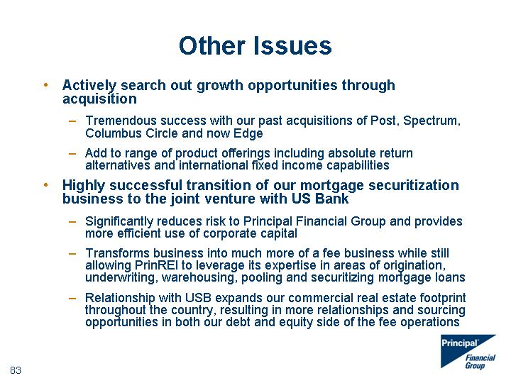

|  |
| --- |
| Other Issues Actively search out growth opportunities through acquisition Tremendous success with our past acquisitions of Post, Spectrum, Columbus Circle and now Edge Add to range of product offerings including absolute return alternatives and international fixed income capabilities Highly successful transition of our mortgage securitization business to the joint venture with US Bank Significantly reduces risk to Principal Financial Group and provides more efficient use of corporate capital Transforms business into much more of a fee business while still allowing PrinREI to leverage its expertise in areas of origination, underwriting, warehousing, pooling and securitizing mortgage loans Relationship with USB expands our commercial real estate footprint throughout the country, resulting in more relationships and sourcing opportunities in both our debt and equity side of the fee operations |

##### 

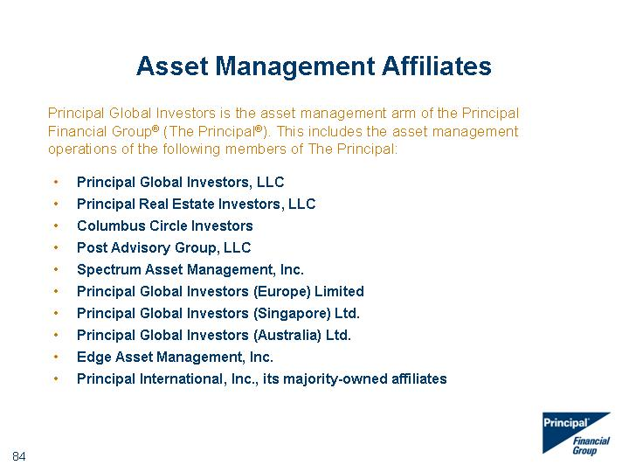

|  |
| --- |
| Principal Global Investors is the asset management arm of the Principal Financial Group(r) (The Principal(r)). This includes the asset management operations of the following members of The Principal: Asset Management Affiliates Asset Management Affiliates Principal Global Investors, LLC Principal Real Estate Investors, LLC Columbus Circle Investors Post Advisory Group, LLC Spectrum Asset Management, Inc. Principal Global Investors (Europe) Limited Principal Global Investors (Singapore) Ltd. Principal Global Investors (Australia) Ltd. Edge Asset Management, Inc. Principal International, Inc., its majority-owned affiliates |

##### 



|  |
| --- |
| Thank you |

##### 

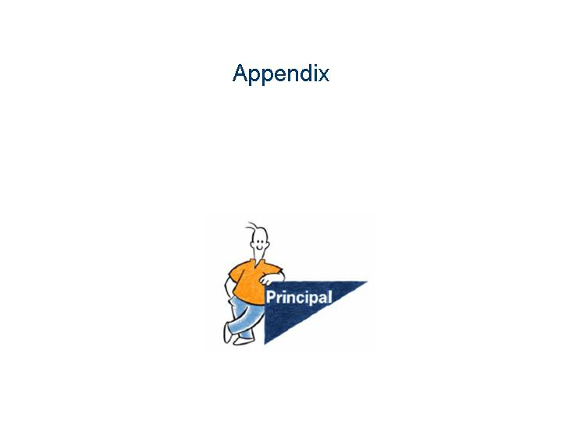

|  |
| --- |
| Appendix |

##### 

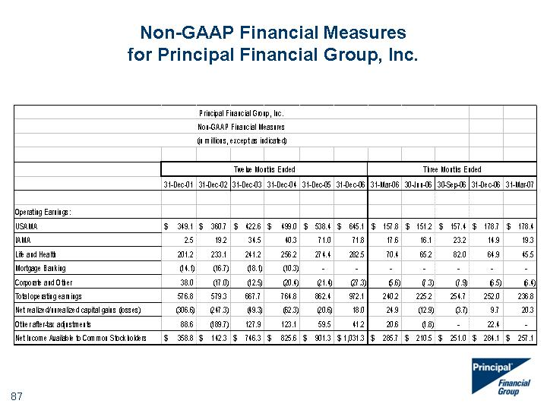

|  |
| --- |
| Non-GAAP Financial Measures for Principal Financial Group, Inc. |

##### 

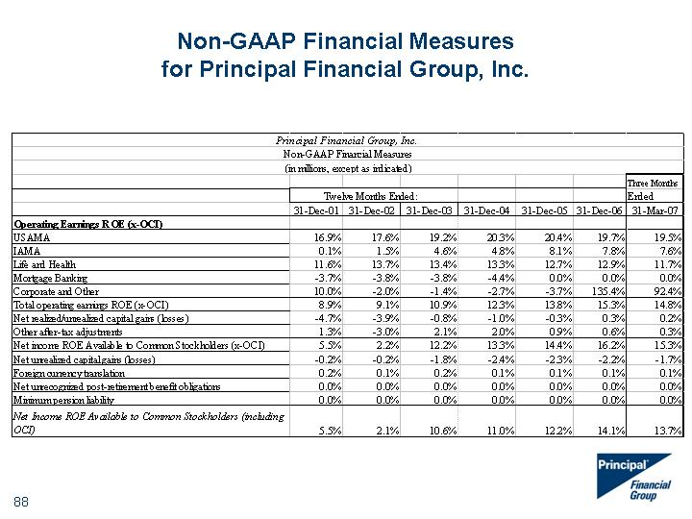

|  |
| --- |
| Non-GAAP Financial Measures for Principal Financial Group, Inc. |

##### 

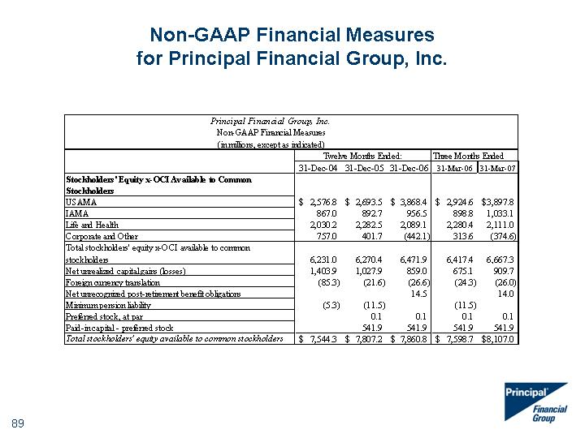

|  |
| --- |
| Non-GAAP Financial Measures for Principal Financial Group, Inc. |

##### 

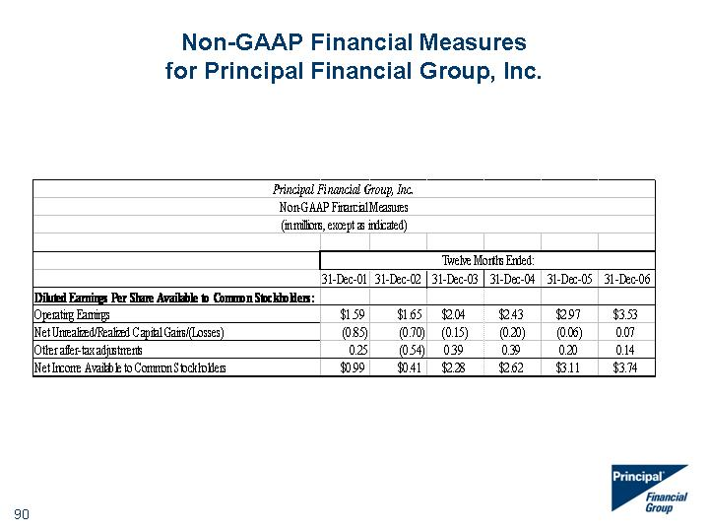

|  |
| --- |
| Non-GAAP Financial Measures for Principal Financial Group, Inc. |

##### 

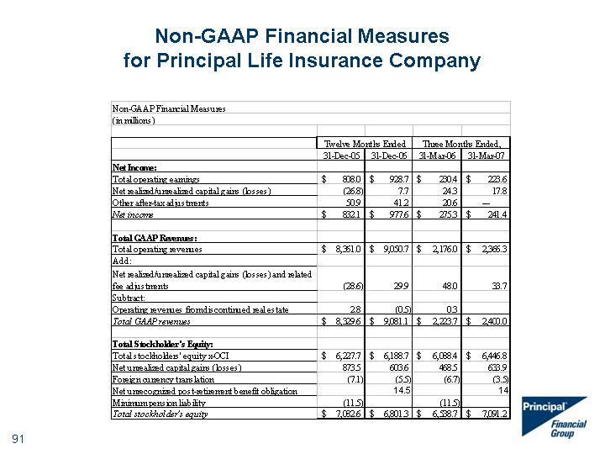

|  |
| --- |
| Non-GAAP Financial Measures for Principal Life Insurance Company |