|  |  |  |  |  |  |  |  |  |  |  |  |  |  |  |  |  |  |  |  |  |  |  |  |  |  |  |  |  |  |  |  |  |  |
| --- | --- | --- | --- | --- | --- | --- | --- | --- | --- | --- | --- | --- | --- | --- | --- | --- | --- | --- | --- | --- | --- | --- | --- | --- | --- | --- | --- | --- | --- | --- | --- | --- | --- |
| SEC Form 5 | | | |  |  |  |  |  |  |  |  |  |  |  |  |  |  |  |  |  |  |  |  |  |  |  |  |  |  |  |  |  |  |
|  |  |  | **FORM 5** | | | **UNITED STATES SECURITIES AND EXCHANGE COMMISSION** | | | | | | | | | | | | | | | | | | | |  |  |  |  |  |  |  |  |
|  |  |  |  |  |  |  |  |  |  | Washington, D.C. 20549 | | | |  |  |  |  |  |  |  |  |  |  |  |  |  |  |  |  |  |  |  |  |
|  |  | Check this box if no longer subject to | | | |  |  |  |  |  |  |  |  |  |  |  |  |  |  |  |  | OMB APPROVAL | | | | |  |  |  |
|  |  |  |  |  |  |  |  |  |  |  |  |  |  |  |  |  |  |  |  |  |  |  |  |  |
|  |  | Section 16. Form 4 or Form 5 | | | | **ANNUAL STATEMENT OF CHANGES IN BENEFICIAL** | | | | | | | | | | | | | | | | |  |  |  |  |  |  |  |  |  |  |  |
|  |  | OMB Number: | | |  | 3235-0362 |  |  |  |  |
|  |  | obligations may continue. *See* | | | |  |  |  |  |  |  |  |
|  |  |  |  |  |  |  |  |  |  |  |  |  |  |  |  |  |  |  |  |  |  |  |  |  |  |  |  |  |  |
|  |  | Instruction 1(b). | |  |  |  |  |  |  |  | **OWNERSHIP** | | |  |  |  |  |  |  |  |  |  |  |  | Estimated average burden | | | | | |  |  |  |
|  |  | Form 3 Holdings Reported. | | | |  |  |  |  |  |  |  |  |  |  |  |  |  |  |  |  | hours per response: | | |  | 1.0 |  |  |  |  |
|  |  | Filed pursuant to Section 16(a) of the Securities Exchange Act of 1934 | | | | | | | | | | | | |  |  |  |  |  |  |  |  |  |  |  |  |  |  |  |
|  |  |  |  |  |  |  |  |  |  |  |  |  |  |  |
|  |  | Form 4 Transactions Reported. | | | |  |  |  |  |  |  |  |  |  |  |  |  |  |  |  |
|  |  |  |  |  | or Section 30(h) of the Investment Company Act of 1940 | | | | | | | |  |  |  |  |  |  |  |  |  |  |  |  |  |  |  |  |  |
|  |  |  |  |  |  |  |  |  |  |  |  |  |  |  |  |  |  |  |  |  |  |  |  |  |  |
|  |  |  | | |  | |  |  |  | | | | |  |  |  |  |  |  | |  | | | | | | | | | |  |  |  |
|  | 1. Name and Address of Reporting Person* | | | | | |  |  | 2. Issuer Name **and** Ticker or Trading Symbol | | | | |  |  |  |  |  | 5. Relationship of Reporting Person(s) to Issuer | | | | | | | | | | | |  |  |  |
|  |  | [ZIMPLEMAN LARRY D](http://www.sec.gov/cgi-bin/browse-edgar?action=getcompany&CIK=0001166875) | | | |  |  |  | [PRINCIPAL FINANCIAL GROUP INC](http://www.sec.gov/cgi-bin/browse-edgar?action=getcompany&CIK=0001126328) [ | | | | | | | | | | (Check all applicable) | | | | | | |  |  |  |  |  |  |  |  |
|  |  |  |  |  |  |  |  |  |  |  |  |  |  |  |  |  |  |  |  |  |  |  |
|  |  |  |  |  |  |  |  |  |  |  |  |  |  |  |  | X | | Director | | | |  | 10% Owner | | | |  |  |  |
|  |  |  |  |  | PFG ] |  |  |  |  |  |  |  |  |  |  |  |  |  |  |
|  |  |  |  |  |  |  |  |  |  |  |  |  |  |  |  |  |  |  |  |  |  |  |
|  |  |  |  |  |  |  |  |  |  |  |  |  |  |  |  |  |  |  |  |  |  |  |  |  |  |
|  |  |  |  |  |  |  |  |  |  |  |  |  |  |  |  |  |  |  |  | X | | Officer (give title | | | |  | Other (specify | | | |  |  |  |
|  |  |  |  |  |  |  |  |  |  |  |  |  |  |  |  |  |  |  |  |  |  |  |  |
|  |  | (Last) | (First) | | | (Middle) |  |  |  |  |  |  |  |  |  |  |  |  |  | below) | | | |  | below) | |  |  |  |  |  |
|  |  |  |  | 3. Statement for Issuer's Fiscal Year Ended (Month/Day/Year) | | | | | | | | | |  |  |  |  |  |  |  |  |  |
|  |  |  |  |  |  |  |  |  |  |  |  |  | President & COO | | | | |  |  |  |  |  |  |
|  |  | 711 HIGH STREET | |  |  |  | 12/31/2006 | | | |  |  |  |  |  |  |  |  |  |  |  |  |  |  |  |  |  |  |
|  |  |  |  |  |  |  |  |  |  |  |  |  |  |  |  |  |  |  |  |  |  |  |  |  |  |  |  |
|  |  |  |  |  |  |  |  |  |  | | | | | | | |  |  |  | |  | | | | | | | | | |  |  |  |
|  |  |  |  |  |  |  |  |  | 4. If Amendment, Date of Original Filed (Month/Day/Year) | | | | | | | |  |  | 6. Individual or Joint/Group Filing (Check Applicable | | | | | | | | | | | |  |  |  |
|  | (Street) | |  |  |  |  |  |  |  |  |  |  |  |
|  |  |  |  |  |  |  |  |  |  |  |  |  |  |  |  |  | Line) | | |  |  |  |  |  |  |  |  |  |  |  |  |
|  |  | DES MOINES IA | |  |  | 50392 |  |  |  |  |  |  |  |  |  |  |  |  |  | X Form filed by One Reporting Person | | | | | | | | | | |  |  |  |
|  |  |  |  |  |  |  |  |  |  |  |  |  |  |  |  |  |  |  |  |  |  | Form filed by More than One Reporting | | | | | | | | |  |  |  |
|  |  |  |  |  |  |  |  |  |  |  |  |  |  |  |  |  |  |  |  |  |  |  |  |  |
|  |  | (City) | (State) | | | (Zip) |  |  |  |  |  |  |  |  |  |  |  |  |  |  |  | Person | | | |  |  |  |  |  |  |  |  |
|  |  |  |  |  |  |  |  |  |  |  |  |  |  |  |  |  |  |  |  |  |  |  |  |  |  |  |  |  |
|  |  |  |  |  |  | | |  |  | | | | | | | | |  | | |  | | | | |  |  |  |  |  |  |  |  |
|  |  |  |  | **Table I - Non-Derivative Securities Acquired, Disposed of, or Beneficially Owned** | | | | | | | | | | | | | | | | | | | | | |  |  |  |  |  |  |  |  |
|  |  |  | |  |  |  |  | |  |  |  |  |  | | | | | | |  |  |  | | | |  |  |  | | |  |  |  |
|  | **1. Title of Security (Instr. 3)** | | |  |  | **2. Transaction** | **2A. Deemed** | | |  | **3.** |  | **4. Securities Acquired (A) or Disposed** | | | | | | |  |  | **5. Amount of** | | | | **6.** |  | **7. Nature of** | | |  |  |  |
|  |  |  |  |  |  | **Date** | **Execution Date,** | | | | **Transaction** | | **Of (D) (Instr. 3, 4 and 5)** | | |  |  |  |  |  |  | **Securities** | | | | **Ownership** | | **Indirect** | | |  |  |  |
|  |  |  |  |  |  | **(Month/Day/Year)** | **if any** | | |  | **Code (Instr.** | |  |  |  |  |  |  |  |  |  | **Beneficially** | | | | **Form: Direct** | | **Beneficial** | | |  |  |  |
|  |  |  |  |  |  |  | **(Month/Day/Year)** | | | | **8)** |  |  |  |  |  |  |  |  |  |  | **Owned at end of** | | | | **(D) or** | | **Ownership** | | |  |  |  |
|  |  |  |  |  |  |  |  |  |  |  |  |  |  |  |  |  |  |  |  |
|  |  |  |  |  |  |  |  |  |  |  |  |  |  | **(A) or** | |  |  |  |  |  |  | **Issuer's Fiscal** | | | | **Indirect (I)** | | **(Instr. 4)** | | |  |  |  |
|  |  |  |  |  |  |  |  |  |  |  |  |  | **Amount** | **Price** | | |  |  |  | **Year (Instr. 3 and** | | | | **(Instr. 4)** | |  |  |  |  |  |  |
|  |  |  |  |  |  |  |  |  |  |  |  |  | **(D)** | |  |  |  |  |  |  |  |  |  |
|  |  |  |  |  |  |  |  |  |  |  |  |  |  |  |  |  |  |  |  | **4)** |  |  |  |  |  |  |  |  |  |  |  |
|  |  |  |  |  |  |  |  |  |  |  |  |  |  |  |  |  |  |  |  |  |  |  |  |  |  |  |  |  |  |  |  |  |
|  |  |  | |  |  |  |  |  |  |  |  |  |  |  |  |  |  | |  |  |  |  | | | |  |  |  |  |  |  |  |  |
|  | Common Stock | | |  |  | 01/29/2004 |  |  |  |  | J(1) |  | 103 |  | A |  | $0(2) | |  |  |  | 26,662(3) | | | |  | D |  |  |  |  |  |  |
|  | Common Stock | | |  |  | 12/17/2004 |  |  |  |  | P(4) |  | 24 |  | A |  | $39.86 | | |  |  | 26,686(3) | | | |  | D |  |  |  |  |  |  |
|  | Common Stock | | |  |  | 12/16/2005 |  |  |  |  | P(4) |  | 25 |  | A |  | $49.72 | | |  |  | 26,711(3) | | |  |  | D |  |  |  |  |  |  |
|  |  |  |  |  |  | **Table II - Derivative Securities Acquired, Disposed of, or Beneficially Owned** | | | | | | | | | | | | | | | | |  |  |  |  |  |  |  |  |  |  |  |
|  |  |  |  |  |  | **(e.g., puts, calls, warrants, options, convertible securities)** | | | | | | | | | | | | | |  |  |  |  |  |  |  |  |  |  |  |  |  |  |
|  |  |  |  |  |  |  |  | |  |  | |  | |  |  | | | |  |  | | |  | | | |  |  |  | |  |  |  |
|  | **1. Title of** | | **2.** | **3. Transaction** | | **3A. Deemed** | **4.** | |  | **5. Number** | | **6. Date Exercisable and** | |  | **7. Title and** | | | |  | **8. Price of** | | | **9. Number of** | | | | **10.** |  | **11. Nature** | |  |  |  |
|  | **Derivative** | | **Conversion** | **Date** | | **Execution Date,** | **Transaction** | | | **of** |  | **Expiration Date** | |  | **Amount of** | | | |  | **Derivative** | | | **derivative** | | |  | **Ownership** | | **of Indirect** | |  |  |  |
|  | **Security** | | **or Exercise** | **(Month/Day/Year) if any** | | | **Code (Instr.** | | | **Derivative** | | **(Month/Day/Year)** | |  | **Securities** | | | |  | **Security** | | | **Securities** | | |  | **Form:** |  | **Beneficial** | |  |  |  |
|  | **(Instr. 3)** | | **Price of** |  |  | **(Month/Day/Year)** | **8)** | |  | **Securities** | |  |  |  | **Underlying** | | | |  | **(Instr. 5)** | | | **Beneficially** | | | | **Direct (D)** |  | **Ownership** | |  |  |  |
|  |  |  | **Derivative** |  |  |  |  |  |  | **Acquired** | |  |  |  | **Derivative** | | | |  |  |  |  | **Owned** | | |  | **or Indirect** | | **(Instr. 4)** | |  |  |  |
|  |  |  | **Security** |  |  |  |  |  |  | **(A) or** |  |  |  |  | **Security (Instr. 3** | | | | |  |  |  | **Following** | | |  | **(I) (Instr. 4)** | |  |  |  |  |  |
|  |  |  |  |  |  |  |  |  |  | **Disposed** | |  |  |  | **and 4)** |  |  |  |  |  |  |  | **Reported** | | |  |  |  |  |  |  |  |  |
|  |  |  |  |  |  |  |  |  |  | **of (D)** |  |  |  |  |  |  |  |  |  |  |  |  | **Transaction(s)** | | | |  |  |  |  |  |  |  |
|  |  |  |  |  |  |  |  |  |  | **(Instr. 3, 4** | |  |  |  |  |  |  |  |  |  |  |  | **(Instr. 4)** | | |  |  |  |  |  |  |  |  |
|  |  |  |  |  |  |  |  |  |  | **and 5)** | |  |  |  |  |  |  |  |  |  |  |  |  |  |  |  |  |  |  |  |  |  |  |
|  |  |  |  |  |  |  |  |  |  |  |  |  |  |  |  |  |  | | |  |  |  |  |  |  |  |  |  |  |  |  |  |  |
|  |  |  |  |  |  |  |  |  |  |  |  |  |  |  |  |  | **Amount** | | |  |  |  |  |  |  |  |  |  |  |  |  |  |  |
|  |  |  |  |  |  |  |  |  |  |  |  |  |  |  |  |  | **or** | |  |  |  |  |  |  |  |  |  |  |  |  |  |  |  |
|  |  |  |  |  |  |  |  |  |  |  |  |  |  |  |  |  | **Number** | | |  |  |  |  |  |  |  |  |  |  |  |  |  |  |
|  |  |  |  |  |  |  |  |  |  |  |  | **Date** | **Expiration** | |  |  | **of** | |  |  |  |  |  |  |  |  |  |  |  |  |  |  |  |
|  |  |  |  |  |  |  |  |  |  | **(A)** | **(D)** | **Exercisable Date** | |  | **Title** |  | **Shares** | |  |  |  |  |  |  |  |  |  |  |  |  |  |  |  |

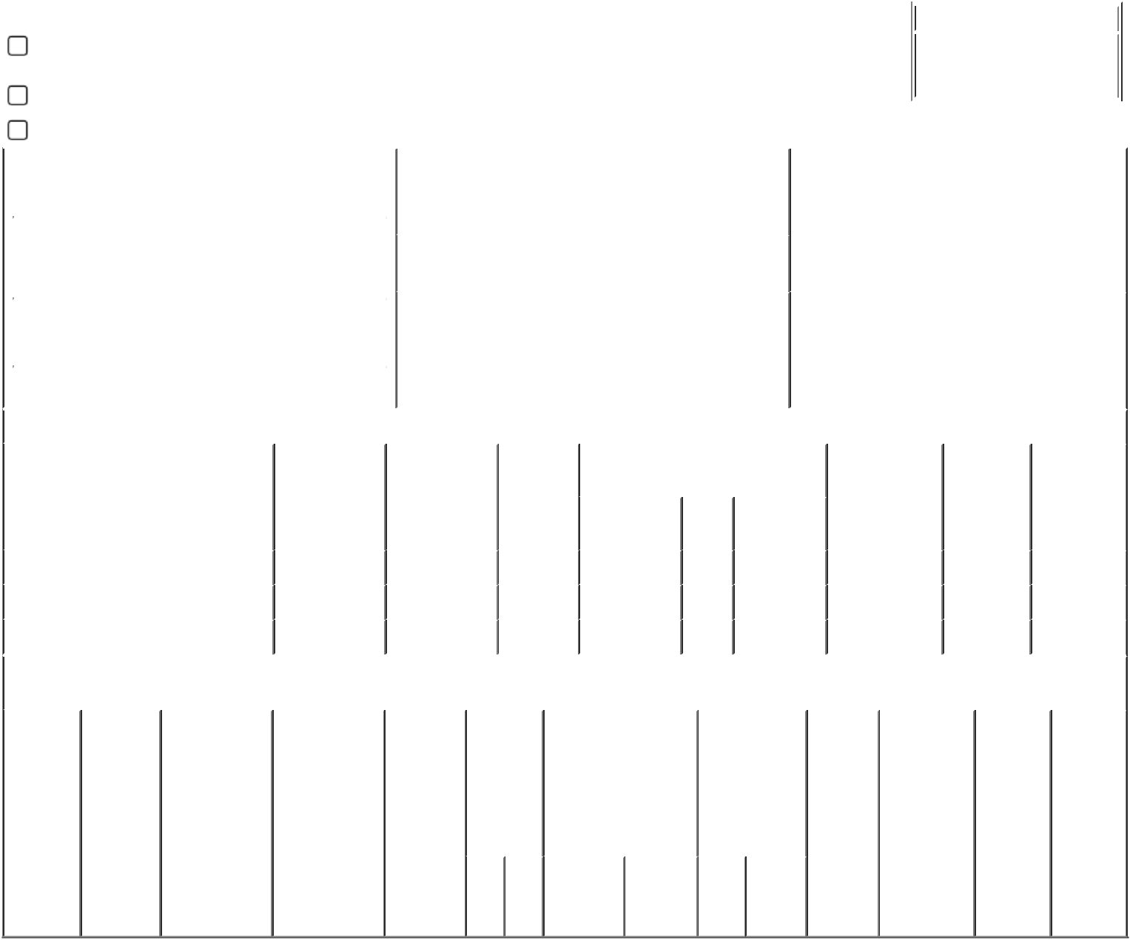

**Explanation of Responses:**

1. Delinquent report of acquisition of shares received by the reporting person's spouse as demutualization compensation (See footnote 2) and transferred to a joint account.
2. Shares were acquired in the demutualization of Principal Mutual Holding Company as compensation in exchange for the extinguishment of a membership interest in Principal Mutual Holding Company. The demutualization was effective October 26, 2001. Principal Financial Group, Inc. closed its initial public offering at $18.50 per share on that date. It distributed shares to former holders of membership interests on December 10, 2001.
3. Includes 2,680 shares acquired pursuant to the Principal Financial Group, Inc. Employee Stock Purchase Plan.
4. Reinvestment of dividends on shares acquired as demutualization compensation by the reporting person and such person's spouse.

**Remarks:**

|  |  |  |  |
| --- | --- | --- | --- |
| Joyce N. Hoffman |  | 02/14/2007 | |
|  |  |  |  |
| ** Signature of Reporting Person | | Date | |

Reminder: Report on a separate line for each class of securities beneficially owned directly or indirectly.

* If the form is filed by more than one reporting person, *see* Instruction 4 (b)(v).

* Intentional misstatements or omissions of facts constitute Federal Criminal Violations *See* 18 U.S.C. 1001 and 15 U.S.C. 78ff(a). Note: File three copies of this Form, one of which must be manually signed. If space is insufficient, *see* Instruction 6 for procedure.

**Persons who respond to the collection of information contained in this form are not required to respond unless the form displays a currently valid OMB Number.**