SEC Form 4

FORM 4

Check this box if no longer subject to Section 16. Form 4 or Form 5 obligations may continue. See Instruction 1(b).

UNITED STATES SECURITIES AND EXCHANGE COMMISSION
Washington, D.C. 20549
 |  | OMB APPROVAL
STATEMENT OF CHANGES IN BENEFICIAL OWNERSHIP
 |  | OMB Number: | 3235-0287
 |  | Estimated average burden
Filed pursuant to Section 16(a) of the Securities Exchange Act of 1934 |  | hours per response: | 0.5
or Section 30(h) of the Investment Company Act of 1940
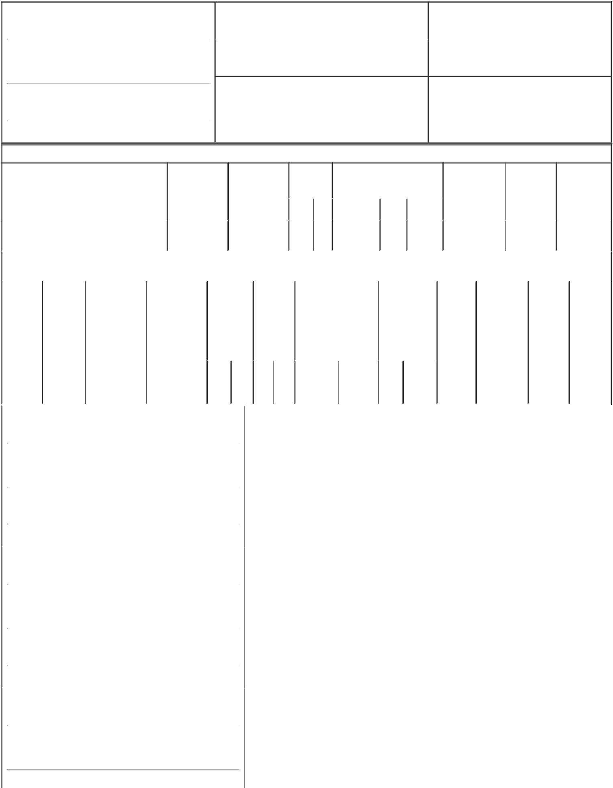

1. Name and Address of Reporting Person* |  |  |  |  | 2. |  |  | Issuer Name and Ticker or Trading Symbol
 | PRINCIPAL FINANCIAL GROUP INC |  |  |  |  |  | HEALTHEXTRAS INC [ HLEX ]
 | (Last) | (First) | (Middle) |  | 3. |  |  | Date of Earliest Transaction (Month/Day/Year)
 |  |  |  |  | 02/01/2007
711 HIGH STREET

- Relationship of Reporting Person(s) to Issuer (Check all applicable)

Director X 10% Owner

Officer (give title Other (specify
below) below)

(Street)
 | DES MOINES | IA | 50392
 | (City) | (State) | (Zip)

4. If Amendment, Date of Original Filed (Month/Day/Year) 6. Individual or Joint/Group Filing (Check Applicable Line)

 | Form filed by One Reporting Person
X | Form filed by More than One Reporting
 | Person

Table I - Non-Derivative Securities Acquired, Disposed of, or Beneficially Owned

 | 1. Title of Security (Instr. 3) |  |  |  | 2. Transaction |  |  |  |  | 2A. Deemed |  |  |  |  |  | 3. | 4. Securities Acquired (A) or |  |  |  |  | 5. Amount of |  | 6. Ownership |  | 7. Nature of
 |  |  |  |  | Date |  |  |  |  | Execution Date, |  |  |  |  |  | Transaction | Disposed Of (D) (Instr. 3, 4 and 5) |  |  |  |  | Securities |  | Form: Direct |  | Indirect
 |  |  |  |  | (Month/Day/Year) |  |  |  |  | if any |  |  |  |  |  | Code (Instr. |  |  |  |  |  | Beneficially |  | (D) or Indirect |  | Beneficial
 |  |  |  |  |  |  |  |  |  | (Month/Day/Year) |  |  |  |  |  | 8) |  |  |  |  |  | Owned Following |  | (I) (Instr. 4) |  | Ownership
 |  |  |  |  |  |  |  |  |  |  |  |  |  |  |  |  |  |  |  |  |  | Reported |  |  |  | (Instr. 4)
 |  |  |  |  |  |  |  |  |  |  |  |  |  |  |  | Code V | Amount | (A) or | Price |  |  | Transaction(s)
 |  |  |  |  |  |  |  |  |  |  |  |  |  |  |  |  |  | (D) |  |  |  | (Instr. 3 and 4)
 | Common Stock |  |  |  | 02/01/2007 |  |  |  |  |  |  |  |  |  |  | S | 1,250,000 | D | $25.48 |  | 5,227,500 |  |  |  | I | By
 |  |  |  |  |  |  |  |  |  |  |  |  |  |  |  |  |  |  |  |  |  |  |  |  |  | Subsidiary⁽¹⁾
 |  |  |  | Table II - Derivative Securities Acquired, Disposed of, or Beneficially Owned
 |  |  |  |  | (e.g., puts, calls, warrants, options, convertible securities)
 | 1. Title of |  | 2. | 3. Transaction | 3A. Deemed |  |  | 4. |  |  |  |  |  | 5. Number |  | 6. Date Exercisable and |  | 7. Title and |  |  | 8. Price of |  | 9. Number of |  | 10. |  | 11. Nature
 | Derivative |  | Conversion | Date | Execution Date, |  |  | Transaction |  |  |  |  |  | of |  | Expiration Date |  | Amount of |  |  | Derivative |  | derivative |  | Ownership |  | of Indirect
 | Security |  | or Exercise | (Month/Day/Year) | if any |  |  | Code (Instr. |  |  |  |  |  | Derivative |  | (Month/Day/Year) |  | Securities |  |  | Security |  | Securities |  | Form: |  | Beneficial
 | (Instr. 3) |  | Price of |  | (Month/Day/Year) |  |  | 8) |  |  |  |  |  | Securities |  |  |  | Underlying |  |  | (Instr. 5) |  | Beneficially |  | Direct (D) |  | Ownership
 |  |  | Derivative |  |  |  |  |  |  |  |  |  |  | Acquired |  |  |  | Derivative |  |  |  |  | Owned |  | or Indirect |  | (Instr. 4)
 |  |  | Security |  |  |  |  |  |  |  |  |  |  | (A) or |  |  |  | Security (Instr. 3 |  |  |  |  | Following |  | (I) (Instr. 4)
 |  |  |  |  |  |  |  |  |  |  |  |  |  | Disposed |  |  |  | and 4) |  |  |  |  | Reported
 |  |  |  |  |  |  |  |  |  |  |  |  |  | of (D) |  |  |  |  |  |  |  |  | Transaction(s)
 |  |  |  |  |  |  |  |  |  |  |  |  |  | (Instr. 3, 4 |  |  |  |  |  |  |  |  | (Instr. 4)
 |  |  |  |  |  |  |  |  |  |  |  |  |  | and 5)
 |  |  |  |  |  |  |  |  |  |  |  |  |  |  |  |  |  |  | Amount
 |  |  |  |  |  |  |  |  |  |  |  |  |  |  |  |  |  |  | or
 |  |  |  |  |  |  |  |  |  |  |  |  |  |  |  |  |  |  | Number
 |  |  |  |  |  |  |  |  |  |  |  |  |  |  |  | Date | Expiration |  | of
 |  |  |  |  |  |  |  | Code |  | V |  |  |  | (A) (D) |  | Exercisable | Date | Title | Shares
 | 1. Name and Address of Reporting Person*
 |  | PRINCIPAL FINANCIAL GROUP INC
 |  | (Last) |  | (First) | (Middle)
 |  | 711 HIGH STREET
 | (Street)
 |  | DES MOINES |  | IA | 50392
 |  | (City) |  | (State) | (Zip)
 | 1. Name and Address of Reporting Person*
 |  | PRINCIPAL FINANCIAL SERVICES INC
 |  | (Last) |  | (First) | (Middle)
 |  | 711 HIGH STREET
 | (Street)
 |  | DES MOINES |  | IA | 50392
 |  | (City) |  | (State) | (Zip)
 | 1. Name and Address of Reporting Person*
 |  | PRINCIPAL LIFE INSURANCE CO
 |  | (Last) |  | (First) | (Middle)

711 HIGH STREET

(Street)

 | DES MOINES | IA |  | 50392
 | (City) | (State) |  | (Zip)
1. Name and Address of Reporting Person*
 | PRINCIPAL HOLDING CO
 | (Last) | (First) |  | (Middle)
 | 711 HIGH STREET
(Street)
 | DES MOINES | IA |  | 50392
 | (City) | (State) |  | (Zip)

Explanation of Responses:

- 4,427,500 of these shares are owned directly by Principal Holding Company, a wholly-owned subsidiary of Principal Life Insurance Company, a wholly-owned subsidiary of Principal Financial Services, Inc., a wholly-owned subsidiary of Principal Financial Group, Inc. The remaining 800,000 shares were contributed by Principal Holding Company to Final Sequel Newco, LLC, a Delaware limited liability company of which Principal Holding Company is a 50 percent owner. Principal Life Insurance Company, Principal Financial Services, Inc. and Principal Financial Group, Inc. are indirect beneficial owners of the reported securities.

Remarks:

Joyce N. Hoffman, Senior Vice

President and Corporate
Secretary, Principal Financial

Group

** Signature of Reporting Person

Reminder: Report on a separate line for each class of securities beneficially owned directly or indirectly.

* If the form is filed by more than one reporting person, see Instruction 4 (b)(v).

- Intentional misstatements or omissions of facts constitute Federal Criminal Violations See 18 U.S.C. 1001 and 15 U.S.C. 78ff(a). Note: File three copies of this Form, one of which must be manually signed. If space is insufficient, see Instruction 6 for procedure.

02/05/2007

Date

Persons who respond to the collection of information contained in this form are not required to respond unless the form displays a currently valid OMB Number.

 |  |  | EXHIBIT 99
FORM 4 JOINT FILER INFORMATION
Name: | Principal Financial Services, Inc.
Address: | 711 High Street
 | Des Moines, Iowa |  | 50392
Designated Filer: | Principal Financial Group, Inc.
Issuer and Ticker Symbol: | HealthExtras, Inc. (HLEX)
Date of Event Requiring Statement: | 2/5/2007
Signature: | By: | /S/ JOYCE N. HOFFMAN
 |  | ----------------------------
 |  | Senior Vice President and
 |  | Corporate Secretary
Name: | Principal Life Insurance Company.
Address: | 711 High Street
 | Des Moines, Iowa |  | 50392
Designated Filer: | Principal Financial Group, Inc.
Issuer and Ticker Symbol: | HealthExtras, Inc. (HLEX)
Date of Event Requiring Statement: | 2/5/2007
Signature: | By: | /S/ JOYCE N. HOFFMAN
 |  | ----------------------------
 |  | Senior Vice President and
 |  | Corporate Secretary
Name: | Principal Holding Company
Address: | 711 High Street
 | Des Moines, Iowa |  | 50392
Designated Filer: | Principal Financial Group, Inc.
Issuer and Ticker Symbol: | HealthExtras, Inc. (HLEX)
Date of Event Requiring Statement: | 2/5/2007
Signature: | By: | /S/ JOYCE N. HOFFMAN
 |  | ----------------------------
 |  | Senior Vice President and
 |  | Corporate Secretary

