SEC Form 4

FORM 4

Check this box if no longer subject to Section 16. Form 4 or Form 5 obligations may continue. See Instruction 1(b).

UNITED STATES SECURITIES AND EXCHANGE COMMISSION
Washington, D.C. 20549
 |  | OMB APPROVAL
STATEMENT OF CHANGES IN BENEFICIAL OWNERSHIP
 |  | OMB Number: | 3235-0287
 |  | Estimated average burden
Filed pursuant to Section 16(a) of the Securities Exchange Act of 1934 |  | hours per response: | 0.5
or Section 30(h) of the Investment Company Act of 1940
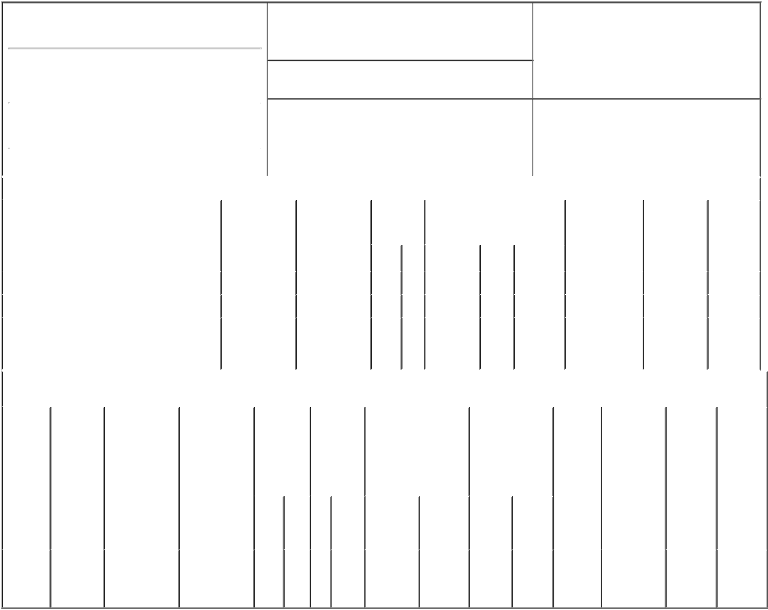

1. Name and Address of Reporting Person*
Houston Daniel Joseph

(Last) (First) (Middle)

711 HIGH STREET

2. Issuer Name and Ticker or Trading Symbol

PRINCIPAL FINANCIAL GROUP INC [

PFG ]

3. Date of Earliest Transaction (Month/Day/Year)

12/07/2016

- Relationship of Reporting Person(s) to Issuer (Check all applicable)

X | Director | 10% Owner
X | Officer (give title | Other (specify
 | below) | below)

Chairman, President & CEO

 |  |  |  |  |  |  | 4. If Amendment, Date of Original Filed (Month/Day/Year) |  |  |  |  |  |  | 6. Individual or Joint/Group Filing (Check Applicable
 | (Street)
 |  |  |  |  |  |  |  |  |  |  |  |  |  | Line)
 |  | DES MOINES IA |  |  | 50392 |  |  |  |  |  |  |  |  | X Form filed by One Reporting Person
 |  |  |  |  |  |  |  |  |  |  |  |  |  |  |  |  | Form filed by More than One Reporting
 |  | (City) | (State) |  | (Zip) |  |  |  |  |  |  |  |  |  |  |  | Person
 |  |  |  | Table I - Non-Derivative Securities Acquired, Disposed of, or Beneficially Owned
 | 1. Title of Security (Instr. 3) |  |  |  | 2. Transaction |  |  | 2A. Deemed |  | 3. |  | 4. Securities Acquired (A) or |  |  |  |  | 5. Amount of |  | 6. Ownership |  | 7. Nature
 |  |  |  |  | Date |  |  | Execution Date, |  |  | Transaction | Disposed Of (D) (Instr. 3, 4 and 5) |  |  |  |  | Securities |  | Form: Direct |  | of Indirect
 |  |  |  |  | (Month/Day/Year) |  |  | if any |  |  | Code (Instr. |  |  |  |  |  | Beneficially |  | (D) or Indirect |  | Beneficial
 |  |  |  |  |  |  |  | (Month/Day/Year) |  | 8) |  |  |  |  |  |  | Owned Following |  | (I) (Instr. 4) |  | Ownership
 |  |  |  |  |  |  |  |  |  |  |  |  |  |  |  |  | Reported |  |  |  | (Instr. 4)
 |  |  |  |  |  |  |  |  |  |  | Code V | Amount | (A) or | Price |  |  | Transaction(s)
 |  |  |  |  |  |  |  |  |  |  |  |  | (D) |  |  |  | (Instr. 3 and 4)
 | Common Stock |  |  |  | 12/07/2016 |  |  |  |  |  | _{M}(1) | 72,350 | A | $22.21 |  |  | 222,192⁽²⁾ |  |  | D
 | Common Stock |  |  |  | 12/07/2016 |  |  |  |  |  | _{S}(1) | 72,350 | D | $60.02⁽³⁾ |  |  | 149,842⁽²⁾ |  |  | D
 |  |  |  |  |  |  |  |  |  |  |  |  |  |  |  |  |  |  |  |  | By
 | Common Stock |  |  |  |  |  |  |  |  |  |  |  |  |  |  |  | 2,970 |  |  | I | 401(k)
 |  |  |  |  |  |  |  |  |  |  |  |  |  |  |  |  |  |  |  |  | Plan
 |  |  |  |  | Table II - Derivative Securities Acquired, Disposed of, or Beneficially Owned
 |  |  |  |  | (e.g., puts, calls, warrants, options, convertible securities)
 | 1. Title of |  | 2. | 3. Transaction | 3A. Deemed | 4. |  |  | 5. Number | 6. Date Exercisable and |  |  | 7. Title and Amount |  |  | 8. Price of |  | 9. Number of |  | 10. | 11. Nature
 | Derivative |  | Conversion | Date | Execution Date, | Transaction |  |  | of | Expiration Date |  |  | of Securities |  |  | Derivative |  | derivative |  | Ownership | of Indirect
 | Security |  | or Exercise | (Month/Day/Year) | if any | Code (Instr. |  |  | Derivative | (Month/Day/Year) |  |  | Underlying |  |  | Security |  | Securities |  | Form: | Beneficial
 | (Instr. 3) |  | Price of |  | (Month/Day/Year) | 8) |  |  | Securities |  |  |  | Derivative Security |  |  | (Instr. 5) |  | Beneficially |  | Direct (D) | Ownership
 |  |  | Derivative |  |  |  |  |  | Acquired |  |  |  | (Instr. 3 and 4) |  |  |  |  | Owned |  | or Indirect | (Instr. 4)
 |  |  | Security |  |  |  |  |  | (A) or |  |  |  |  |  |  |  |  | Following |  | (I) (Instr. 4)
 |  |  |  |  |  |  |  |  | Disposed |  |  |  |  |  |  |  |  | Reported
 |  |  |  |  |  |  |  |  | of (D) (Instr. |  |  |  |  |  |  |  |  | Transaction(s)
 |  |  |  |  |  |  |  |  | 3, 4 and 5) |  |  |  |  |  |  |  |  | (Instr. 4)
 |  |  |  |  |  |  |  |  |  |  |  |  |  | Amount
 |  |  |  |  |  |  |  |  |  |  |  |  |  | or
 |  |  |  |  |  |  |  |  |  |  |  |  |  | Number
 |  |  |  |  |  |  |  |  |  | Date |  | Expiration |  | of
 |  |  |  |  |  | Code V |  |  | (A) (D) | Exercisable |  | Date | Title | Shares
 | Employee
 | Stock |  |  |  |  | _{M}(1) |  |  |  |  |  |  | Common | 72,350
 | Option |  | $22.21 | 12/07/2016 |  |  |  |  | 72,350 | 02/23/2013 |  | 02/23/2020 |  |  |  |  | $0 | 0 |  | D
 | (Right to |  |  |  |  |  |  |  |  |  |  |  | Stock
Buy)

Explanation of Responses:

- Pursuant to a Rule 10b5-1 trading plan adopted by the reporting person on May 10, 2016.

- Includes 2,748 shares acquired pursuant to the Principal Financial Group, Inc. Employee Stock Purchase Plan.

- The price reported in Column 4 is a weighted average price. These shares were sold in multiple transactions at prices ranging from $60.00 - 60.14, inclusive. The reporting person undertakes to provide to Principal Financial Group, Inc., any security holder of Principal Financial Group, Inc., or the staff of the Securities and Exchange Commission, upon request, full information regarding the number of shares sold at each separate price within the ranges set forth in this footnote.

Remarks:

Patrick A. Kirchner, by Power |  |  | 12/09/2016
of Attorney
** Signature of Reporting Person |  |  | Date

Reminder: Report on a separate line for each class of securities beneficially owned directly or indirectly.

* If the form is filed by more than one reporting person, see Instruction 4 (b)(v).

- Intentional misstatements or omissions of facts constitute Federal Criminal Violations See 18 U.S.C. 1001 and 15 U.S.C. 78ff(a). Note: File three copies of this Form, one of which must be manually signed. If space is insufficient, see Instruction 6 for procedure.
Persons who respond to the collection of information contained in this form are not required to respond unless the form displays a currently valid OMB Number.

