SEC Form 4

FORM 4

Check this box if no longer subject to Section 16. Form 4 or Form 5 obligations may continue. See Instruction 1(b).

UNITED STATES SECURITIES AND EXCHANGE COMMISSION
Washington, D.C. 20549
 |  | OMB APPROVAL
STATEMENT OF CHANGES IN BENEFICIAL OWNERSHIP
 |  | OMB Number: | 3235-0287
 |  | Estimated average burden
Filed pursuant to Section 16(a) of the Securities Exchange Act of 1934 |  | hours per response: | 0.5
or Section 30(h) of the Investment Company Act of 1940
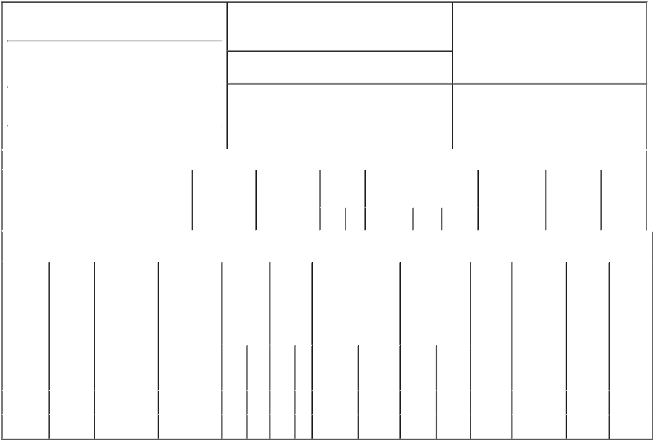

1. Name and Address of Reporting Person*
ZIMPLEMAN LARRY D

(Last) (First) (Middle)

711 HIGH STREET

2. Issuer Name and Ticker or Trading Symbol

PRINCIPAL FINANCIAL GROUP INC [
PFG ]

3. Date of Earliest Transaction (Month/Day/Year)

09/25/2015

- Relationship of Reporting Person(s) to Issuer (Check all applicable)

X | Director | 10% Owner
X | Officer (give title | Other (specify
 | below) | below)
 | Chairman

 |  |  |  |  |  | 4. If Amendment, Date of Original Filed (Month/Day/Year) |  |  |  |  |  |  |  | 6. Individual or Joint/Group Filing (Check Applicable
 | (Street)
 |  |  |  |  |  |  |  |  |  |  |  |  |  | Line)
 |  | DES MOINES IA |  |  | 50392 |  |  |  |  |  |  |  |  | X Form filed by One Reporting Person
 |  |  |  |  |  |  |  |  |  |  |  |  |  |  |  |  | Form filed by More than One Reporting
 |  | (City) | (State) |  | (Zip) |  |  |  |  |  |  |  |  |  |  |  | Person
 |  |  |  | Table I - Non-Derivative Securities Acquired, Disposed of, or Beneficially Owned
 | 1. Title of Security (Instr. 3) |  |  |  | 2. Transaction |  | 2A. Deemed |  |  | 3. |  | 4. Securities Acquired (A) or |  |  |  |  | 5. Amount of |  | 6. Ownership |  | 7. Nature of
 |  |  |  |  | Date |  | Execution Date, |  |  |  | Transaction | Disposed Of (D) (Instr. 3, 4 and |  |  |  |  | Securities |  | Form: Direct |  | Indirect
 |  |  |  |  | (Month/Day/Year) |  | if any |  |  |  | Code (Instr. | 5) |  |  |  |  | Beneficially |  | (D) or Indirect |  | Beneficial
 |  |  |  |  |  |  | (Month/Day/Year) |  |  | 8) |  |  |  |  |  |  | Owned Following |  | (I) (Instr. 4) |  | Ownership
 |  |  |  |  |  |  |  |  |  |  |  |  |  |  |  |  | Reported |  |  |  | (Instr. 4)
 |  |  |  |  |  |  |  |  |  |  | Code V | Amount | (A) or | Price |  |  | Transaction(s)
 |  |  |  |  |  |  |  |  |  |  |  |  | (D) |  |  |  | (Instr. 3 and 4)
 |  |  |  |  | Table II - Derivative Securities Acquired, Disposed of, or Beneficially Owned
 |  |  |  |  | (e.g., puts, calls, warrants, options, convertible securities)
 | 1. Title of |  | 2. | 3. Transaction | 3A. Deemed | 4. |  | 5. Number |  | 6. Date Exercisable and |  |  | 7. Title and |  |  | 8. Price of |  | 9. Number of |  | 10. | 11. Nature
 | Derivative |  | Conversion | Date | Execution Date, | Transaction |  | of |  | Expiration Date |  |  | Amount of |  |  | Derivative |  | derivative |  | Ownership of Indirect
 | Security |  | or Exercise | (Month/Day/Year) if any |  | Code (Instr. |  | Derivative |  | (Month/Day/Year) |  |  | Securities |  |  | Security |  | Securities |  | Form: | Beneficial
 | (Instr. 3) |  | Price of |  | (Month/Day/Year) | 8) |  | Securities |  |  |  |  | Underlying |  |  | (Instr. 5) |  | Beneficially |  | Direct (D) | Ownership
 |  |  | Derivative |  |  |  |  | Acquired |  |  |  |  | Derivative Security |  |  |  |  | Owned |  | or Indirect | (Instr. 4)
 |  |  | Security |  |  |  |  | (A) or |  |  |  |  | (Instr. 3 and 4) |  |  |  |  | Following |  | (I) (Instr. 4)
 |  |  |  |  |  |  |  | Disposed |  |  |  |  |  |  |  |  |  | Reported
 |  |  |  |  |  |  |  | of (D) |  |  |  |  |  |  |  |  |  | Transaction(s)
 |  |  |  |  |  |  |  | (Instr. 3, 4 |  |  |  |  |  |  |  |  |  | (Instr. 4)
 |  |  |  |  |  |  |  | and 5)
 |  |  |  |  |  |  |  |  |  |  |  |  |  | Amount
 |  |  |  |  |  |  |  |  |  |  |  |  |  | or
 |  |  |  |  |  |  |  |  |  |  |  |  |  | Number
 |  |  |  |  |  |  |  |  |  | Date |  | Expiration |  | of
 |  |  |  |  |  | Code V |  | (A) | (D) | Exercisable |  | Date | Title | Shares
 | Performance |  | (1) | 09/25/2015 |  | A |  | 66 |  | (2) |  | (2) | Common | 66 |  | (2) |  | 8,417 |  | D
 | Units |  |  |  |  |  |  |  |  |  |  |  | Stock
 | Phantom |  | (1) | 09/25/2015 |  | A |  | 102.3 |  | (3) |  | (3) | Common | 102.3 |  | $48.05 |  | 13,036.7 |  | D
 | Stock Units |  |  |  |  |  |  |  |  |  |  |  | Stock

Explanation of Responses:

- The units convert to common stock on a one-for-one basis.

- The reported performance units were acquired pursuant to the Principal Financial Group Long-Term Performance Plan. Units under the Plan will be settled in cash or stock within a five-year period from the date of vesting.

- Acquired pursuant to the Principal Financial Group, Inc. Select Savings Excess Plan and may be transferred at any time into another investment alternative under that plan. Interests under the plan will be settled upon the reporting person's retirement or other termination of service.

Remarks:

Patrick A. Kirchner, by Power |  |  | 09/29/2015
of Attorney
** Signature of Reporting Person |  |  | Date

Reminder: Report on a separate line for each class of securities beneficially owned directly or indirectly.

* If the form is filed by more than one reporting person, see Instruction 4 (b)(v).

- Intentional misstatements or omissions of facts constitute Federal Criminal Violations See 18 U.S.C. 1001 and 15 U.S.C. 78ff(a). Note: File three copies of this Form, one of which must be manually signed. If space is insufficient, see Instruction 6 for procedure.

Persons who respond to the collection of information contained in this form are not required to respond unless the form displays a currently valid OMB Number.

