SEC Form 4

FORM 4

Check this box if no longer subject to Section 16. Form 4 or Form 5 obligations may continue. See Instruction 1(b).

UNITED STATES SECURITIES AND EXCHANGE COMMISSION
Washington, D.C. 20549
 |  | OMB APPROVAL
STATEMENT OF CHANGES IN BENEFICIAL OWNERSHIP
 |  | OMB Number: | 3235-0287
 |  | Estimated average burden
Filed pursuant to Section 16(a) of the Securities Exchange Act of 1934 |  | hours per response: | 0.5
or Section 30(h) of the Investment Company Act of 1940
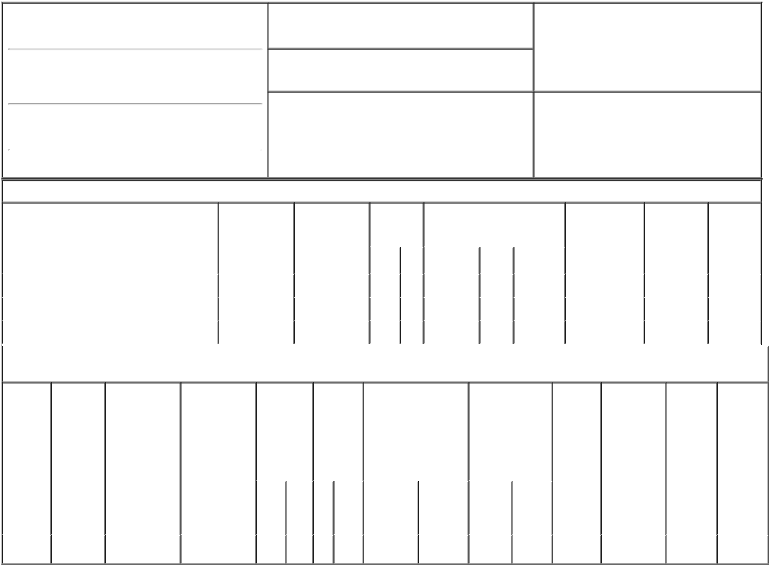

1. Name and Address of Reporting Person*
BAILEY PAMELA G

(Last) (First) (Middle)

10000 WEHRLE DRIVE

2. Issuer Name and Ticker or Trading Symbol

Integer Holdings Corp [ ITGR ]

3. Date of Earliest Transaction (Month/Day/Year)

11/20/2018

- Relationship of Reporting Person(s) to Issuer (Check all applicable)
X Director 10% Owner

Officer (give title Other (specify
below) below)

(Street)
 | CLARENCE | NY | 14031
 | (City) | (State) | (Zip)

4. If Amendment, Date of Original Filed (Month/Day/Year) 6. Individual or Joint/Group Filing (Check Applicable
Line)
X Form filed by One Reporting Person

Form filed by More than One Reporting
Person

Table I - Non-Derivative Securities Acquired, Disposed of, or Beneficially Owned

 | 1. Title of Security (Instr. 3) | 2. Transaction | 2A. Deemed | 3. | 4. Securities Acquired (A) or |  |  | 5. Amount of | 6. Ownership | 7. Nature
 |  | Date | Execution Date, | Transaction | Disposed Of (D) (Instr. 3, 4 and 5) |  |  | Securities | Form: Direct | of Indirect
 |  | (Month/Day/Year) | if any | Code (Instr. |  |  |  | Beneficially | (D) or Indirect | Beneficial
 |  |  | (Month/Day/Year) | 8) |  |  |  | Owned Following | (I) (Instr. 4) | Ownership
 |  |  |  |  |  |  |  | Reported |  | (Instr. 4)
 |  |  |  | Code V | Amount | (A) or | Price | Transaction(s)
 |  |  |  |  |  | (D) |  | (Instr. 3 and 4)
 | Common Stock | 11/20/2018 |  | M | 5,767 | A | $24.75 | 53,562 | D
 | Common Stock | 11/20/2018 |  | S | 4,760 | D | $83.04⁽¹⁾ | 48,802 | D
 | Common Stock | 11/20/2018 |  | S | 1,007 | D | $83.7⁽²⁾ | 47,795 | D

Table II - Derivative Securities Acquired, Disposed of, or Beneficially Owned

(e.g., puts, calls, warrants, options, convertible securities)

1. Title of | 2. | 3. Transaction | 3A. Deemed | 4. | 5. Number | 6. Date Exercisable and |  | 7. Title and |  | 8. Price of | 9. Number of | 10. | 11. Nature
Derivative | Conversion | Date | Execution Date, | Transaction | of | Expiration Date |  | Amount of |  | Derivative | derivative | Ownership | of Indirect
Security | or Exercise | (Month/Day/Year) | if any | Code (Instr. | Derivative | (Month/Day/Year) |  | Securities |  | Security | Securities | Form: | Beneficial
(Instr. 3) | Price of |  | (Month/Day/Year) | 8) | Securities |  |  | Underlying |  | (Instr. 5) | Beneficially | Direct (D) | Ownership
 | Derivative |  |  |  | Acquired |  |  | Derivative Security |  |  | Owned | or Indirect | (Instr. 4)
 | Security |  |  |  | (A) or |  |  | (Instr. 3 and 4) |  |  | Following | (I) (Instr. 4)
 |  |  |  |  | Disposed |  |  |  |  |  | Reported
 |  |  |  |  | of (D) |  |  |  |  |  | Transaction(s)
 |  |  |  |  | (Instr. 3, 4 |  |  |  |  |  | (Instr. 4)
 |  |  |  |  | and 5)
 |  |  |  |  |  |  |  |  | Amount
 |  |  |  |  |  |  |  |  | or
 |  |  |  |  |  |  |  |  | Number
 |  |  |  |  |  | Date | Expiration |  | of
 |  |  |  | Code V | (A) (D) | Exercisable | Date | Title | Shares
Stock | $24.75 | 11/20/2018 |  | M | 5,767 | 01/01/2010 | 01/05/2019 | Common | 5,767 | $0.00 | 0 | D
Option

Explanation of Responses:

- The price reported in Column 4 is a weighted average price. These shares were sold in multiple transactions at multiple prices ranging from $82.55 to $83.51, inclusive. The reporting person undertakes to provide to Integer Holdings Corp, any security holder of Integer Holdings Corp, or the staff of the Securities and Exchange Commission, upon request, full information regarding the number of shares sold at each separate price within the ranges set forth in footnote (1) and (2) to this Form 4.

- The price reported in Column 4 is a weighted average price. These shares were sold in multiple transactions at multiple prices ranging from $83.55 to $84.07, inclusive.

Remarks:

/s/ Mark Zawodzinski as
attorney-in-fact for Pamela G. 11/20/2018
Bailey.

** Signature of Reporting Person Date

Reminder: Report on a separate line for each class of securities beneficially owned directly or indirectly.

* If the form is filed by more than one reporting person, see Instruction 4 (b)(v).

- Intentional misstatements or omissions of facts constitute Federal Criminal Violations See 18 U.S.C. 1001 and 15 U.S.C. 78ff(a). Note: File three copies of this Form, one of which must be manually signed. If space is insufficient, see Instruction 6 for procedure.
Persons who respond to the collection of information contained in this form are not required to respond unless the form displays a currently valid OMB Number.

