SEC Form 4

FORM 4

Check this box if no longer subject to Section 16. Form 4 or Form 5 obligations may continue. See Instruction 1(b).

UNITED STATES SECURITIES AND EXCHANGE COMMISSION
Washington, D.C. 20549
 |  | OMB APPROVAL
STATEMENT OF CHANGES IN BENEFICIAL OWNERSHIP
 |  | OMB Number: | 3235-0287
 |  | Estimated average burden
Filed pursuant to Section 16(a) of the Securities Exchange Act of 1934 |  | hours per response: | 0.5
or Section 30(h) of the Investment Company Act of 1940
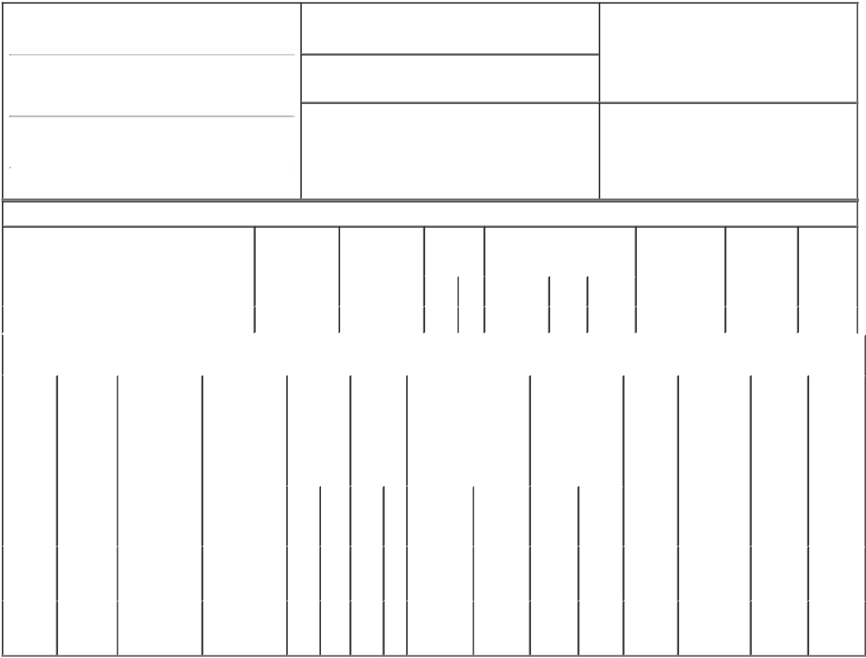

1. Name and Address of Reporting Person*
Hinrichs James F.

(Last) (First) (Middle)

10000 WEHRLE DRIVE

2. Issuer Name and Ticker or Trading Symbol

Integer Holdings Corp [ ITGR ]

3. Date of Earliest Transaction (Month/Day/Year)

02/12/2018

- Relationship of Reporting Person(s) to Issuer (Check all applicable)
X Director 10% Owner

Officer (give title Other (specify
below) below)

(Street)
 | CLARENCE | NY | 14031
 | (City) | (State) | (Zip)

4. If Amendment, Date of Original Filed (Month/Day/Year) 6. Individual or Joint/Group Filing (Check Applicable
Line)
X Form filed by One Reporting Person

Form filed by More than One Reporting
Person

Table I - Non-Derivative Securities Acquired, Disposed of, or Beneficially Owned

 | 1. Title of Security (Instr. 3) |  |  | 2. Transaction |  | 2A. Deemed |  |  | 3. |  | 4. Securities Acquired (A) or |  |  |  |  |  | 5. Amount of |  | 6. Ownership |  | 7. Nature
 |  |  |  | Date |  | Execution Date, |  |  | Transaction |  | Disposed Of (D) (Instr. 3, 4 and |  |  |  |  |  | Securities |  | Form: Direct |  | of Indirect
 |  |  |  | (Month/Day/Year) |  | if any |  |  | Code (Instr. |  | 5) |  |  |  |  |  | Beneficially |  | (D) or Indirect |  | Beneficial
 |  |  |  |  |  | (Month/Day/Year) |  |  | 8) |  |  |  |  |  |  |  | Owned Following |  | (I) (Instr. 4) |  | Ownership
 |  |  |  |  |  |  |  |  |  |  |  |  |  |  |  |  | Reported |  |  |  | (Instr. 4)
 |  |  |  |  |  |  |  |  | Code V |  | Amount |  | (A) or | Price |  |  | Transaction(s)
 |  |  |  |  |  |  |  |  |  |  |  |  | (D) |  |  |  | (Instr. 3 and 4)
 | Common Stock |  |  | 02/12/2018 |  |  |  |  | A |  | 1,925⁽¹⁾ |  | A | $0.00 |  | 1,925 |  |  |  | D
 |  |  |  | Table II - Derivative Securities Acquired, Disposed of, or Beneficially Owned
 |  |  |  | (e.g., puts, calls, warrants, options, convertible securities)
 | 1. Title of | 2. | 3. Transaction | 3A. Deemed | 4. | 5. Number |  | 6. Date Exercisable and |  |  |  | 7. Title and |  |  |  | 8. Price of |  | 9. Number of |  | 10. | 11. Nature
 | Derivative | Conversion | Date | Execution Date, | Transaction | of |  | Expiration Date |  |  |  | Amount of |  |  |  | Derivative |  | derivative |  | Ownership | of Indirect
 | Security | or Exercise | (Month/Day/Year) | if any | Code (Instr. | Derivative |  | (Month/Day/Year) |  |  |  | Securities |  |  |  | Security |  | Securities |  | Form: | Beneficial
 | (Instr. 3) | Price of |  | (Month/Day/Year) | 8) | Securities |  |  |  |  |  | Underlying |  |  |  | (Instr. 5) |  | Beneficially |  | Direct (D) | Ownership
 |  | Derivative |  |  |  | Acquired |  |  |  |  |  | Derivative Security |  |  |  |  |  | Owned |  | or Indirect | (Instr. 4)
 |  | Security |  |  |  | (A) or |  |  |  |  |  | (Instr. 3 and 4) |  |  |  |  |  | Following |  | (I) (Instr. 4)
 |  |  |  |  |  | Disposed |  |  |  |  |  |  |  |  |  |  |  | Reported
 |  |  |  |  |  | of (D) |  |  |  |  |  |  |  |  |  |  |  | Transaction(s)
 |  |  |  |  |  | (Instr. 3, 4 |  |  |  |  |  |  |  |  |  |  |  | (Instr. 4)
 |  |  |  |  |  | and 5)
 |  |  |  |  |  |  |  |  |  |  |  |  |  | Amount
 |  |  |  |  |  |  |  |  |  |  |  |  |  | or
 |  |  |  |  |  |  |  |  |  |  |  |  |  | Number
 |  |  |  |  |  |  |  | Date |  | Expiration |  |  |  | of
 |  |  |  |  | Code V | (A) | (D) | Exercisable |  | Date |  | Title |  | Shares
 | Non-
 | Qualified | $44.6 | 02/12/2018 |  | A | 1,955 |  | 02/12/2018⁽²⁾ |  | 02/12/2028 |  | Common |  | 1,955 |  | $0.00 |  | 1,955 |  | D
 | Stock
 | Options
 | Non-
 | Qualified | $44.6 | 02/12/2018 |  | A | 7,648 |  | 02/12/2018⁽³⁾ |  | 02/12/2028 |  | Common |  | 7,648 |  | $0.00 |  | 7,648 |  | D
 | Stock
Options

Explanation of Responses:

- Grant of restricted stock of which 350 shares vest immediately and the remaining shares will vest in three equal installments on April 2, 2018, July 2, 2018 and October 1, 2018.

- Grant of non-qualified stock options of which 355 options vest immediately and the remaining options will vest in three equal installments on April 2, 2018, July 2, 2018 and October 1, 2018.

- Grant of non-qualified stock options that vest in three equal annual installments on the last day of each fiscal year beginning in fiscal year 2018.

Remarks:

/s/ Mark Zawodzinski as

attorney-in-fact for James F. 02/14/2018
Hinrichs.

** Signature of Reporting Person Date

Reminder: Report on a separate line for each class of securities beneficially owned directly or indirectly.

* If the form is filed by more than one reporting person, see Instruction 4 (b)(v).

- Intentional misstatements or omissions of facts constitute Federal Criminal Violations See 18 U.S.C. 1001 and 15 U.S.C. 78ff(a). Note: File three copies of this Form, one of which must be manually signed. If space is insufficient, see Instruction 6 for procedure.
Persons who respond to the collection of information contained in this form are not required to respond unless the form displays a currently valid OMB Number.

