SEC Form 4

FORM 4

Check this box if no longer subject to Section 16. Form 4 or Form 5 obligations may continue. See Instruction 1(b).

UNITED STATES SECURITIES AND EXCHANGE COMMISSION
Washington, D.C. 20549
 |  | OMB APPROVAL
STATEMENT OF CHANGES IN BENEFICIAL OWNERSHIP
 |  | OMB Number: | 3235-0287
 |  | Estimated average burden
Filed pursuant to Section 16(a) of the Securities Exchange Act of 1934 |  | hours per response: | 0.5
or Section 30(h) of the Investment Company Act of 1940
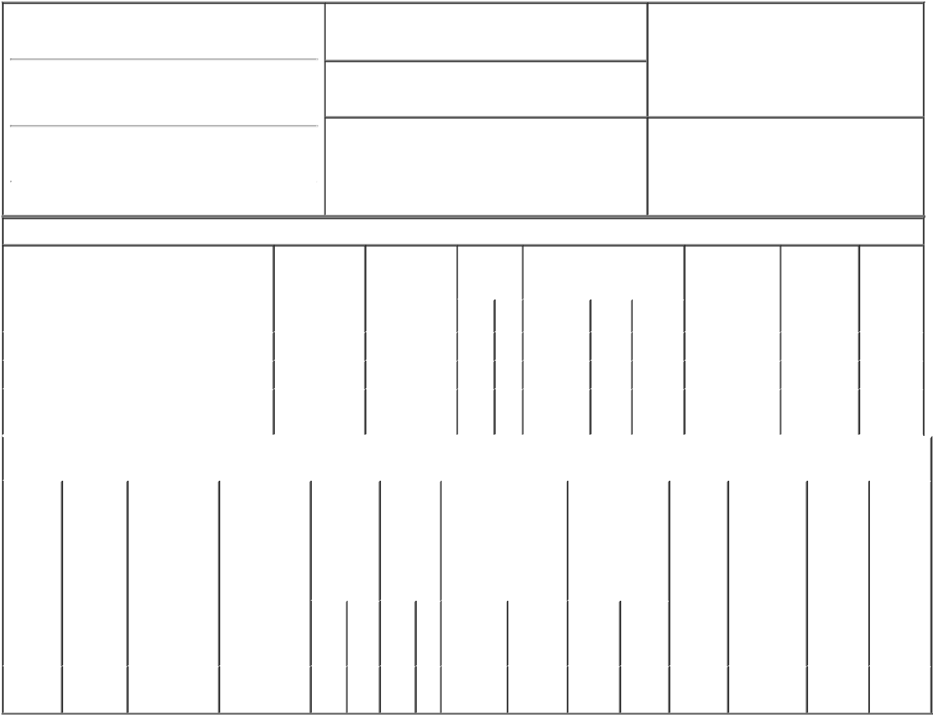

1. Name and Address of Reporting Person*
McEvoy Timothy G

(Last) (First) (Middle)

10000 WEHRLE DRIVE

2. Issuer Name and Ticker or Trading Symbol

Integer Holdings Corp [ ITGR ]

3. Date of Earliest Transaction (Month/Day/Year)

03/09/2018

- Relationship of Reporting Person(s) to Issuer (Check all applicable)

 | Director | 10% Owner
X | Officer (give title | Other (specify
 | below) | below)

Sr. VP, Gen. Counsel & Sec.

(Street)
 | CLARENCE | NY | 14031
 | (City) | (State) | (Zip)

4. If Amendment, Date of Original Filed (Month/Day/Year) 6. Individual or Joint/Group Filing (Check Applicable
Line)
X Form filed by One Reporting Person

Form filed by More than One Reporting
Person

Table I - Non-Derivative Securities Acquired, Disposed of, or Beneficially Owned

 | 1. Title of Security (Instr. 3) |  |  | 2. Transaction |  | 2A. Deemed |  | 3. |  |  | 4. Securities Acquired (A) or |  |  |  |  | 5. Amount of |  | 6. Ownership |  | 7. Nature
 |  |  |  | Date |  | Execution Date, |  |  | Transaction |  | Disposed Of (D) (Instr. 3, 4 and |  |  |  |  | Securities |  | Form: Direct |  | of Indirect
 |  |  |  | (Month/Day/Year) |  | if any |  |  | Code (Instr. |  | 5) |  |  |  |  | Beneficially |  | (D) or Indirect |  | Beneficial
 |  |  |  |  |  | (Month/Day/Year) 8) |  |  |  |  |  |  |  |  |  | Owned Following |  | (I) (Instr. 4) |  | Ownership
 |  |  |  |  |  |  |  |  |  |  |  |  |  |  |  | Reported |  |  |  | (Instr. 4)
 |  |  |  |  |  |  |  |  | Code V |  | Amount | (A) or | Price |  |  | Transaction(s)
 |  |  |  |  |  |  |  |  |  |  |  | (D) |  |  |  | (Instr. 3 and 4)
 | Common Stock |  |  | 03/09/2018 |  |  |  |  | _{A}(1) |  | 4,511 | A | $0.00 |  | 34,353 |  |  |  | D
 | Common Stock |  |  | 03/09/2018 |  |  |  |  | F |  | 1,522 | D | $53.8 |  | 32,831 |  |  |  | D
 | Common Stock |  |  |  |  |  |  |  |  |  |  |  |  |  | 2,108 |  |  |  | I | By
 |  |  |  |  |  |  |  |  |  |  |  |  |  |  |  |  |  |  |  | 401(k)
 |  |  | Table II - Derivative Securities Acquired, Disposed of, or Beneficially Owned
 |  |  |  | (e.g., puts, calls, warrants, options, convertible securities)
 | 1. Title of | 2. | 3. Transaction | 3A. Deemed | 4. | 5. Number |  | 6. Date Exercisable and |  |  |  | 7. Title and |  |  | 8. Price of |  | 9. Number of |  | 10. | 11. Nature
 | Derivative | Conversion | Date | Execution Date, | Transaction of |  |  | Expiration Date |  |  |  | Amount of |  |  | Derivative |  | derivative |  | Ownership | of Indirect
 | Security | or Exercise | (Month/Day/Year) | if any | Code (Instr. | Derivative |  | (Month/Day/Year) |  |  |  | Securities |  |  | Security |  | Securities |  | Form: | Beneficial
 | (Instr. 3) | Price of |  | (Month/Day/Year) | 8) | Securities |  |  |  |  |  | Underlying |  |  | (Instr. 5) |  | Beneficially |  | Direct (D) | Ownership
 |  | Derivative |  |  |  | Acquired |  |  |  |  |  | Derivative Security |  |  |  |  | Owned |  | or Indirect | (Instr. 4)
 |  | Security |  |  |  | (A) or |  |  |  |  |  | (Instr. 3 and 4) |  |  |  |  | Following |  | (I) (Instr. 4)
 |  |  |  |  |  | Disposed |  |  |  |  |  |  |  |  |  |  | Reported
 |  |  |  |  |  | of (D) |  |  |  |  |  |  |  |  |  |  | Transaction(s)
 |  |  |  |  |  | (Instr. 3, 4 |  |  |  |  |  |  |  |  |  |  | (Instr. 4)
 |  |  |  |  |  | and 5)
 |  |  |  |  |  |  |  |  |  |  |  |  | Amount
 |  |  |  |  |  |  |  |  |  |  |  |  | or
 |  |  |  |  |  |  |  |  |  |  |  |  | Number
 |  |  |  |  |  |  |  | Date |  | Expiration |  |  | of
 |  |  |  |  | Code V | (A) | (D) | Exercisable |  | Date |  | Title | Shares
 | Restricted |  |  |  | _{A}(2) |  |  | (2) |  |  | (2) |  | 3,565
 | Stock | $0.00 | 03/09/2018 |  |  | 3,565 |  |  |  |  |  | Common |  |  | $0.00 |  | 3,565 |  | D
Units

Explanation of Responses:

- Represent the portion of a performance-based restricted stock unit ("PRSU") award made on February 6, 2017 that was determined to be earned based on performance for the period ending December 29, 2017. The established performance and service conditions were determined to have been met as of March 9, 2018.

- Represent the portion of a PRSU award made on February 6, 2017 that was determined to be earned based on performance for the period ending December 29, 2017. The established performance conditions were determined to have been met as of March 9, 2018. The PRSUs are scheduled to vest in two approximately equal installments on December 28, 2018 and January 3, 2020, provided the reporting person is employed by the Issuer on the vesting date.

Remarks:

/s/ Mark Zawodzinski as
attorney-in-fact for Timothy G. 03/13/2018
McEvoy.

** Signature of Reporting Person Date

Reminder: Report on a separate line for each class of securities beneficially owned directly or indirectly.

* If the form is filed by more than one reporting person, see Instruction 4 (b)(v).

- Intentional misstatements or omissions of facts constitute Federal Criminal Violations See 18 U.S.C. 1001 and 15 U.S.C. 78ff(a). Note: File three copies of this Form, one of which must be manually signed. If space is insufficient, see Instruction 6 for procedure.
Persons who respond to the collection of information contained in this form are not required to respond unless the form displays a currently valid OMB Number.

