|  |  |  |  |  |  |  |  |  |  |  |  |  |  |  |  |  |  |  |  |  |  |  |  |  |  |  |  |  |  |  |  |  |  |  |  |  |  |  |
| --- | --- | --- | --- | --- | --- | --- | --- | --- | --- | --- | --- | --- | --- | --- | --- | --- | --- | --- | --- | --- | --- | --- | --- | --- | --- | --- | --- | --- | --- | --- | --- | --- | --- | --- | --- | --- | --- | --- |
| SEC Form 5 | | | | |  |  |  |  |  |  |  |  |  |  |  |  |  |  |  |  |  |  |  |  |  |  |  |  |  |  |  |  |  |  |  |  |  |  |
|  |  |  |  | **FORM 5** | | | | **UNITED STATES SECURITIES AND EXCHANGE COMMISSION** | | | | | | | | | | | | | | | | | | | | | |  |  |  |  |  |  |  |  |  |
|  |  |  |  |  |  |  |  |  |  |  |  |  | Washington, D.C. 20549 | | |  |  |  |  |  |  |  |  |  |  |  |  |  |  |  |  |  |  |  |  |  |  |  |
|  |  |  | Check this box if no longer subject | | | | |  |  |  |  |  |  |  |  |  |  |  |  |  |  |  |  |  |  | OMB APPROVAL | | | | | | | | |  |
|  |  |  |  |  |  |  |  |  |  |  |  |  |  |  |  |  |  |  |  |  |  |  |  |  |
|  |  |  | to Section 16. Form 4 or Form 5 | | | | | **ANNUAL STATEMENT OF CHANGES IN BENEFICIAL** | | | | | | | | | | | | | | | | | | |  |  |  |  |  |  |  |  |  |  |  |  |
|  |  | OMB Number: | | | 3235-0362 | |  |  |  |  |  |
|  |  |  | obligations may continue. *See* | | | | |  |  |  |  |  |  |  |
|  |  |  |  |  |  |  |  |  |  |  |  |  |  |  |  |  |  |  |  |  |  |  |  |  |  |  |  |  |  |  |  |  |  |
|  |  |  | Instruction 1(b). | |  |  |  |  |  |  |  |  | **OWNERSHIP** | | |  |  |  |  |  |  |  |  |  |  |  |  |  | Estimated average burden | | | |  |  |  |  |  |  |
|  |  |  | Form 3 Holdings Reported. | | | | |  |  |  |  |  |  |  |  |  |  |  |  |  |  |  |  |  |  | hours per response: | | |  | 1.0 |  |  |  |  |  |
|  |  |  | Filed pursuant to Section 16(a) of the Securities Exchange Act of 1934 | | | | | | | | | | | | | | | |  |  |  |  |  |  |  |  |  |  |  |  |  |  |  |
|  |  |  |  |  |  |  |  |  |  |  |  |  |  |  |
|  |  |  | Form 4 Transactions Reported. | | | | |  |  |  |  |  |  |  |  |  |  |  |  |  |  |  |
|  |  |  |  |  |  | or Section 30(h) of the Investment Company Act of 1940 | | | | | | | | | |  |  |  |  |  |  |  |  |  |  |  |  |  |  |  |  |  |  |
|  |  |  |  |  |  |  |  |  |  |  |  |  |  |  |  |  |  |  |  |  |  |  |  |  |  |  |  |  |
|  |  |  |  | | | |  | |  |  |  | | | | |  |  |  |  |  |  |  |  | |  | | | | | | | | | | |  | |  |
|  | 1. Name and Address of Reporting Person* | | | | | | | |  |  | 2. Issuer Name **and** Ticker or Trading Symbol | | | | |  |  |  |  |  |  | 5. Relationship of Reporting Person(s) to Issuer | | | | | | | | | | | | | | | |  |
|  |  |  | [Miller Jeffrey Douglas](http://www.sec.gov/cgi-bin/browse-edgar?action=getcompany&CIK=0001394121) | | | |  |  |  |  | [HIGHWOODS PROPERTIES, INC.](http://www.sec.gov/cgi-bin/browse-edgar?action=getcompany&CIK=0000921082) [ HIW (Check all applicable) | | | | | | | | | | | | | | | | | | |  |  |  |  |  |  |  |  |  |
|  |  |  |  |  |  | | ] |  |  |  |  |  |  |  |  |  |  |  |  |  |  | Director | | | |  | 10% Owner | | | | | | |  |
|  |  |  | | | |  |  |  |  |  |  |  |  |  |  |  |  |  |  |  |  |  |
|  |  |  |  |  |  |  |  |  |  |  |  |  |  |  |  |  |  |  |  |  | X | | Officer (give title | | | |  | Other (specify | | | | | | |  |
|  |  |  |  |  |  |  |  |  |  |  |  |  |  |  |  |  |  |  |  |  |  |  |  |  |  |
|  |  |  |  |  |  |  |  |  |  |  |  |  |  |  |  |  |  |  |  |  |  |  |  | below) | | | |  | below) | |  |  |  |  |  |  |
|  |  | (Last) | |  | (First) | | | (Middle) |  |  | 3. Statement for Issuer's Fiscal Year Ended (Month/Day/Year) | | | | | | | | | | | | |  |  |  |  |  |  |  |  |  |
|  |  |  |  |  |  |  | EVP, General Counsel & Sec. | | | | | | |  |  |  |  |  |  |
|  |  |  |  |  |  |  |  |  |  |  |  |  |  |  |  |  |  |  |
|  |  | 150 FAYETTEVILLE STREET, SUITE 1400 | | | | | | | 12/31/2022 | | | |  |  |  |  |  |  |  |  |  |  |  |  |  |  |  |  |  |  |  |
|  |  |  |  |  |  |  |  |  |  |  |  |  |  |  |  |  |  |  |  |  |  |  |  |  |  |  |  |
|  |  |  |  |  |  |  |  |  |  |  |  | | | | | | | |  | |  |  |  | |  | | | | | | | | | | |  | |  |
|  |  |  |  |  |  |  |  |  |  |  | 4. If Amendment, Date of Original Filed (Month/Day/Year) | | | | | | | | | |  | 6. Individual or Joint/Group Filing (Check Applicable | | | | | | | | | | | | | | | |  |
|  |  |  |  |  |  |  |  |  |  |
|  | (Street) | | |  |  |  |  |  |  |  |  |  |  |  |  |  |  |  |  |  |  | Line) | | | |  |  |  |  |  |  |  |  |  |  |  |  |  |
|  |  | RALEIGH | | | NC |  |  | 27601 |  |  |  |  |  |  |  |  |  |  |  |  |  |  |  | X Form filed by One Reporting Person | | | | | | | | | | | | | |  |
|  |  |  |  |  |  |  |  |  |  |  |  |  |  |  |  |  |  |  |  |  |  |  |  |  |  | Form filed by More than One Reporting | | | | | | | | | | | |  |
|  |  | (City) | |  | (State) | | | (Zip) |  |  |  |  |  |  |  |  |  |  |  |  |  |  |  |  |  | Person | | | |  |  |  |  |  |  |  |  |  |
|  |  |  |  |  |  |  |  |  |  |  |  |  |  |  |  |  |  |  |  |  |  |  |  |  |  |  |  |  |  |  |  |  |
|  |  |  |  |  |  |  |  | | |  |  | | | | | | | |  | | |  |  | |  | | | | |  |  |  |  |  |  |  |  |  |
|  |  |  |  |  |  |  | **Table I - Non-Derivative Securities Acquired, Disposed of, or Beneficially Owned** | | | | | | | | | | | | | | | | | | | | | | |  |  |  |  |  |  |  |  |  |
|  |  | |  | | | |  |  |  | |  |  |  |  |  | | | |  | | | |  |  |  |  | | | |  |  |  | | | |  | |  |
|  | **1. Title of Security (Instr. 3)** | | | | | | | **2. Transaction** | **2A. Deemed** | | |  | **3.** |  | **4. Securities Acquired (A) or Disposed** | | | | | | | | |  |  | **5. Amount of** | | | | **6.** |  | **7. Nature of** | | | | | |  |
|  |  |  |  |  |  |  |  | **Date** | **Execution Date,** | | | | **Transaction** | | **Of (D) (Instr. 3, 4 and 5)** | | | | |  |  |  |  |  |  | **Securities** | | | | **Ownership** | | **Indirect** | | | | | |  |
|  |  |  |  |  |  |  |  | **(Month/Day/Year)** | **if any** | | |  | **Code (Instr.** | |  |  |  |  |  |  |  |  |  |  |  | **Beneficially** | | | | **Form: Direct** | | **Beneficial** | | | | | |  |
|  |  |  |  |  |  |  |  |  | **(Month/Day/Year)** | | | | **8)** |  |  |  |  |  |  |  |  |  |  |  |  | **Owned at end of** | | | | **(D) or** | | **Ownership** | | | | | |  |
|  |  |  |  |  |  |  |  |  |  |  |  |  |  |  |  |  |  |  |  |  |  |
|  |  |  |  |  |  |  |  |  |  |  |  |  |  |  |  | **(A) or** | | | |  |  |  |  |  |  | **Issuer's Fiscal** | | | | **Indirect (I)** | | **(Instr. 4)** | | | | | |  |
|  |  |  |  |  |  |  |  |  |  |  |  |  |  |  | **Amount** | **Price** | | | |  |  | **Year (Instr. 3 and** | | | | **(Instr. 4)** | |  |  |  |  |  |  |  |
|  |  |  |  |  |  |  |  |  |  |  |  |  |  |  | **(D)** | |  |  |  |  |  |  |  |  |  |  |  |
|  |  |  |  |  |  |  |  |  |  |  |  |  |  |  |  |  |  |  |  |  |  |  |  | **4)** |  |  |  |  |  |  |  |  |  |  |  |  |
|  |  |  |  |  |  |  |  |  |  |  |  |  |  |  |  |  |  |  |  |  |  |  |  |  |  |  |  |  |  |  |  |  |  |  |  |  |  |
|  |  | |  | |  |  |  |  |  | |  | |  |  |  |  |  | |  |  |  | |  |  |  |  | | | |  |  |  |  |  |  |  |  |  |
|  | Common Stock | | | |  |  |  | 03/28/2022 | 03/28/2022 | | | | G |  | 600 |  | D | | |  | $0.00 | |  |  |  | 116,212(1) | | | |  | D |  |  |  |  |  |  |  |
|  |  |  |  |  |  |  |  | **Table II - Derivative Securities Acquired, Disposed of, or Beneficially Owned** | | | | | | | | | | | | | | | | | | | | | |  |  |  |  |  |  |  |  |  |
|  |  |  |  |  |  |  |  | **(e.g., puts, calls, warrants, options, convertible securities)** | | | | | | | | | | | | | | | | | |  |  |  |  |  |  |  |  |  |  |  |  |  |
|  |  | |  |  |  |  |  |  |  | |  |  | |  | | |  |  |  | | | |  |  | | |  | | | |  |  |  | | | | |  |
|  | **1. Title of** | | | **2.** |  | **3. Transaction** | | **3A. Deemed** | **4.** | | | **5. Number** | | **6. Date Exercisable and** | | |  | **7. Title and** | | | | | | **8. Price of** | | | **9. Number of** | | | | **10.** |  | **11. Nature** | | | | |  |
|  | **Derivative** | | | **Conversion** | | **Date** | | **Execution Date,** |  | **Transaction** | | **of** |  | **Expiration Date** | |  |  | **Amount of** | | | | | | **Derivative** | | | **derivative** | | |  | **Ownership** | | **of Indirect** | | | | |  |
|  | **Security** | | | **or Exercise** | | **(Month/Day/Year) if any** | | |  | **Code (Instr.** | | **Derivative** | | **(Month/Day/Year)** | |  |  | **Securities** | | | | | | **Security** | | | **Securities** | | |  | **Form:** |  | **Beneficial** | | | | |  |
|  | **(Instr. 3)** | | | **Price of** |  |  |  | **(Month/Day/Year)** | **8)** | | | **Securities** | |  |  |  |  | **Underlying** | | | | | | **(Instr. 5)** | | | **Beneficially** | | | | **Direct (D)** | | **Ownership** | | | | |  |
|  |  |  |  | **Derivative** | |  |  |  |  |  |  | **Acquired** | |  |  |  |  | **Derivative** | | | | | |  |  |  | **Owned** | | |  | **or Indirect** | | **(Instr. 4)** | | | | |  |
|  |  |  |  | **Security** |  |  |  |  |  |  |  | **(A) or** | |  |  |  |  | **Security (Instr.** | | | | | |  |  |  | **Following** | | |  | **(I) (Instr. 4)** | |  |  |  |  |  |  |
|  |  |  |  |  |  |  |  |  |  |  |  | **Disposed** | |  |  |  |  | **3 and 4)** | | | | | |  |  |  | **Reported** | | |  |  |  |  |  |  |  |  |  |
|  |  |  |  |  |  |  |  |  |  |  |  | **of (D)** | |  |  |  |  |  |  |  |  |  |  |  |  |  | **Transaction(s)** | | | |  |  |  |  |  |  |  |  |
|  |  |  |  |  |  |  |  |  |  |  |  | **(Instr. 3, 4** | |  |  |  |  |  |  |  |  |  |  |  |  |  | **(Instr. 4)** | | |  |  |  |  |  |  |  |  |  |
|  |  |  |  |  |  |  |  |  |  |  |  | **and 5)** | |  |  |  |  |  |  |  |  |  |  |  |  |  |  |  |  |  |  |  |  |  |  |  |  |  |
|  |  |  |  |  |  |  |  |  |  |  |  |  |  |  |  |  |  |  |  |  |  | |  |  |  |  |  |  |  |  |  |  |  |  |  |  |  |  |
|  |  |  |  |  |  |  |  |  |  |  |  |  |  |  |  |  |  |  |  |  | **Amount** | | |  |  |  |  |  |  |  |  |  |  |  |  |  |  |  |
|  |  |  |  |  |  |  |  |  |  |  |  |  |  |  |  |  |  |  |  |  | **or** | | |  |  |  |  |  |  |  |  |  |  |  |  |  |  |  |
|  |  |  |  |  |  |  |  |  |  |  |  |  |  |  |  |  |  |  |  |  | **Number** | | |  |  |  |  |  |  |  |  |  |  |  |  |  |  |  |
|  |  |  |  |  |  |  |  |  |  |  |  |  |  | **Date** | **Expiration** | |  |  |  |  | **of** | | |  |  |  |  |  |  |  |  |  |  |  |  |  |  |  |
|  |  |  |  |  |  |  |  |  |  |  |  | **(A)** | **(D)** | **Exercisable Date** | |  |  | **Title** | |  | **Shares** | | |  |  |  |  |  |  |  |  |  |  |  |  |  |  |  |
|  |  |  |  |  |  |  |  |  |  |  |  |  |  |  |  |  |  |  |  |  |  |  |  |  |  |  |  |  |  |  |  |  |  |  |  |  |  |  |

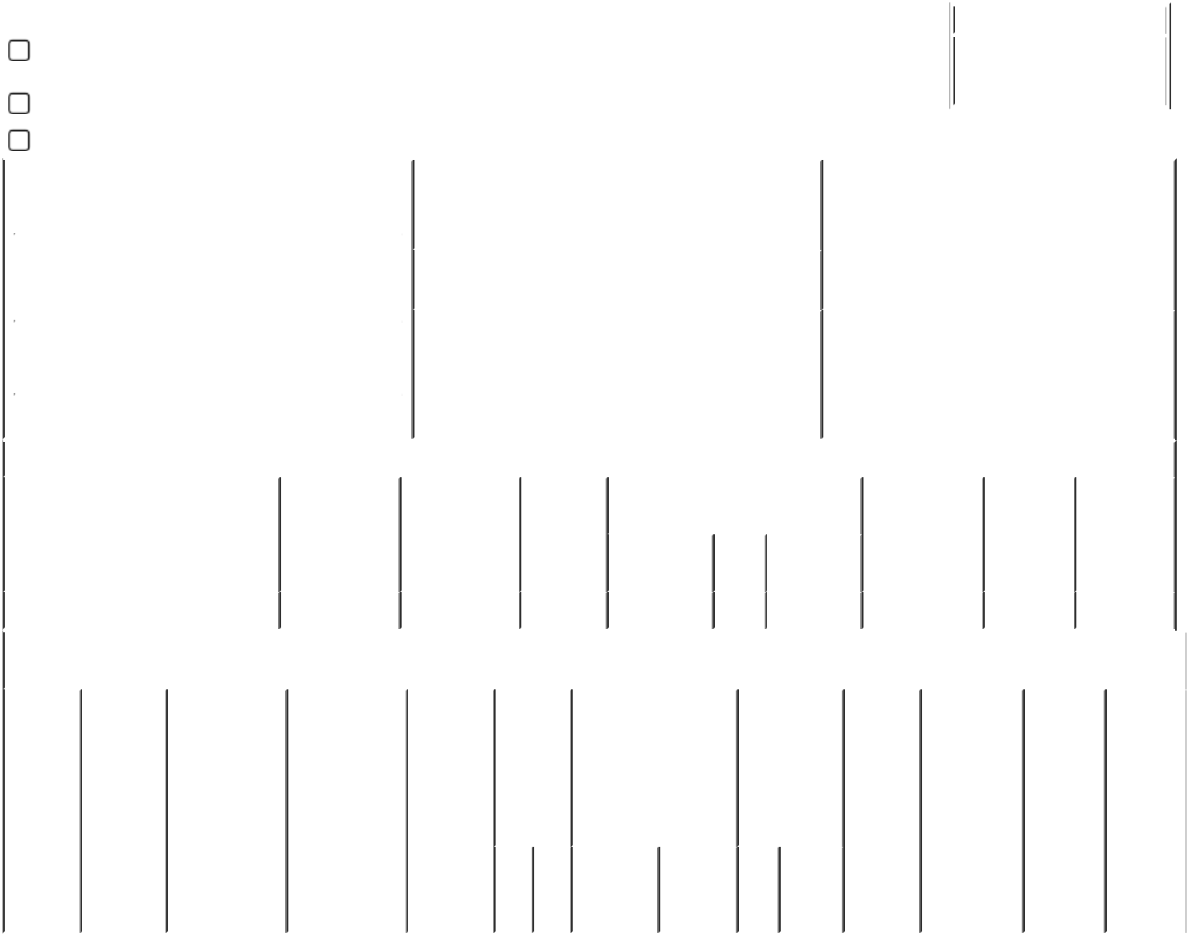

**Explanation of Responses:**

1. Includes 330 shares acquired through employee stock purchase plan.

**Remarks:**

|  |  |  |
| --- | --- | --- |
| /s/Jeffrey D. Miller | | 02/09/2023 |
|  |  |  |
| ** Signature of Reporting Person | | Date |

Reminder: Report on a separate line for each class of securities beneficially owned directly or indirectly.

* If the form is filed by more than one reporting person, *see* Instruction 4 (b)(v).

* Intentional misstatements or omissions of facts constitute Federal Criminal Violations *See* 18 U.S.C. 1001 and 15 U.S.C. 78ff(a). Note: File three copies of this Form, one of which must be manually signed. If space is insufficient, *see* Instruction 6 for procedure.

**Persons who respond to the collection of information contained in this form are not required to respond unless the form displays a currently valid OMB Number.**