SEC Form 4

FORM 4

Check this box if no longer subject to Section 16. Form 4 or Form 5 obligations may continue. See Instruction 1(b).

UNITED STATES SECURITIES AND EXCHANGE COMMISSION
Washington, D.C. 20549
 |  | OMB APPROVAL
STATEMENT OF CHANGES IN BENEFICIAL OWNERSHIP
 |  | OMB Number: | 3235-0287
 |  | Estimated average burden
Filed pursuant to Section 16(a) of the Securities Exchange Act of 1934 |  | hours per response: | 0.5
or Section 30(h) of the Investment Company Act of 1940
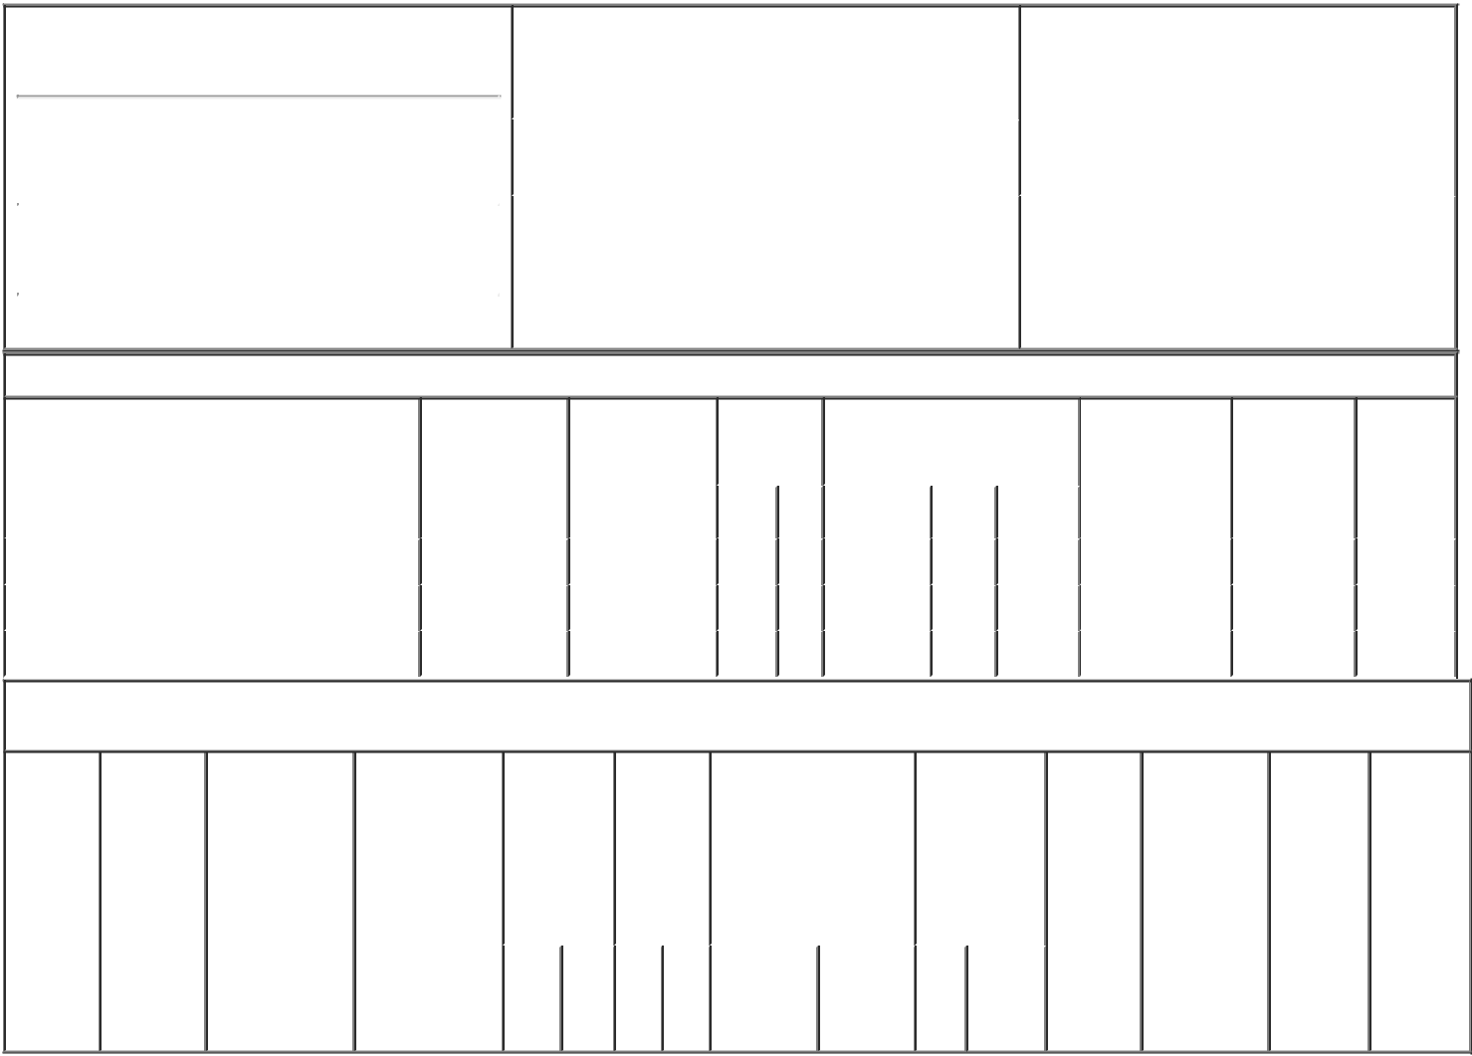

1. Name and Address of Reporting Person*
Klinck Theodore J

 | (Last) | (First) | (Middle)
 | 3100 SMOKETREE COURT, SUITE 600
(Street)
 | RALEIGH | NC | 27604
 | (City) | (State) | (Zip)

2. |  | Issuer Name and Ticker or Trading Symbol |  | 5. Relationship of Reporting Person(s) to Issuer
 | HIGHWOODS PROPERTIES, INC. [ HIW |  |  | (Check all applicable)
 | ] |  |  | X | Director | 10% Owner
 |  |  |  | X | Officer (give title | Other (specify
 |  |  |  |  | below) | below)
3. |  | Date of Earliest Transaction (Month/Day/Year)
 |  |  |  |  | President and CEO
03/01/2022
4. |  | If Amendment, Date of Original Filed (Month/Day/Year) |  | 6. Individual or Joint/Group Filing (Check Applicable
Line)
X Form filed by One Reporting Person

Form filed by More than One Reporting
Person

Table I - Non-Derivative Securities Acquired, Disposed of, or Beneficially Owned

 | 1. Title of Security (Instr. 3) | 2. Transaction | 2A. Deemed | 3. | 4. Securities Acquired (A) or |  |  | 5. Amount of | 6. Ownership | 7. Nature
 |  | Date | Execution Date, | Transaction | Disposed Of (D) (Instr. 3, 4 and |  |  | Securities | Form: Direct | of Indirect
 |  | (Month/Day/Year) | if any | Code (Instr. | 5) |  |  | Beneficially | (D) or Indirect | Beneficial
 |  |  | (Month/Day/Year) | 8) |  |  |  | Owned Following | (I) (Instr. 4) | Ownership
 |  |  |  |  |  |  |  | Reported |  | (Instr. 4)
 |  |  |  | Code V | Amount | (A) or | Price | Transaction(s)
 |  |  |  |  |  | (D) |  | (Instr. 3 and 4)
 | Common Stock⁽¹⁾ | 03/01/2022 | 03/01/2022 | A | 60,816 | A | $0.00 | 255,955 | D
 | Common Stock⁽²⁾ | 03/01/2022 | 03/01/2022 | F | 11,460 | D | $0.00 | 244,495 | D
 | Common Stock⁽³⁾ | 03/01/2022 | 03/01/2022 | D | 3,050 | D | $0.00 | 241,445 | D

Table II - Derivative Securities Acquired, Disposed of, or Beneficially Owned

(e.g., puts, calls, warrants, options, convertible securities)

1. Title of | 2. | 3. Transaction | 3A. Deemed | 4. | 5. Number | 6. Date Exercisable and |  | 7. Title and | 8. Price of | 9. Number of | 10. | 11. Nature
Derivative | Conversion | Date | Execution Date, | Transaction | of | Expiration Date |  | Amount of | Derivative | derivative | Ownership | of Indirect
Security | or Exercise | (Month/Day/Year) | if any | Code (Instr. | Derivative | (Month/Day/Year) |  | Securities | Security | Securities | Form: | Beneficial
(Instr. 3) | Price of |  | (Month/Day/Year) | 8) | Securities |  |  | Underlying | (Instr. 5) | Beneficially | Direct (D) | Ownership
 | Derivative |  |  |  | Acquired |  |  | Derivative |  | Owned | or Indirect | (Instr. 4)
 | Security |  |  |  | (A) or |  |  | Security (Instr. |  | Following | (I) (Instr. 4)
 |  |  |  |  | Disposed |  |  | 3 and 4) |  | Reported
 |  |  |  |  | of (D) |  |  |  |  | Transaction(s)
 |  |  |  |  | (Instr. 3, 4 |  |  |  |  | (Instr. 4)
 |  |  |  |  | and 5)
 |  |  |  |  |  |  |  | Amount
 |  |  |  |  |  |  |  | or
 |  |  |  |  |  |  |  | Number
 |  |  |  |  |  | Date | Expiration | of
 |  |  |  | Code V | (A) (D) | Exercisable | Date | Title Shares

Explanation of Responses:

- Consists of time-based restricted stock granted by the Company that vests ratably over four years on March 1st of each year after the grant date and total return-based restricted stock granted by the Company that vests at the end of the applicable measurement period to the extent actual performance exceeds certain levels of performance.

- In accordance with the terms of the initial restricted stock award and in connection with the vesting of the award, the reporting person tendered a portion of the restricted stock award to the issuer in satisfaction of tax liabilities.

- Represents the number of total return-based shares of restricted stock forfeited because the Company achieved less than target levels of performance relative to predetermined goals.

Remarks:

/s/Jeffrey D. Miller Attorney |  |  |  | 03/02/2022
in fact for Theodore J. Klinck
** Signature of Reporting Person |  |  | Date

Reminder: Report on a separate line for each class of securities beneficially owned directly or indirectly.

* If the form is filed by more than one reporting person, see Instruction 4 (b)(v).

- Intentional misstatements or omissions of facts constitute Federal Criminal Violations See 18 U.S.C. 1001 and 15 U.S.C. 78ff(a). Note: File three copies of this Form, one of which must be manually signed. If space is insufficient, see Instruction 6 for procedure.
Persons who respond to the collection of information contained in this form are not required to respond unless the form displays a currently valid OMB Number.

