SEC Form 5
 |  | FORM 5 |  |  | UNITED STATES SECURITIES AND EXCHANGE COMMISSION
 |  |  |  |  |  |  |  |  |  | Washington, D.C. 20549
 |  | Check this box if no longer subject to |  |  |  |  |  |  |  |  |  |  |  |  | OMB APPROVAL
 |  | Section 16. Form 4 or Form 5 |  |  |  | ANNUAL STATEMENT OF CHANGES IN BENEFICIAL
 |  |  |  |  |  |  |  |  |  |  |  |  |  |  | OMB Number: | 3235-0362
 |  | obligations may continue. See
 |  | Instruction 1(b). |  |  |  |  |  |  |  | OWNERSHIP |  |  |  |  | Estimated average burden
 |  | Form 3 Holdings Reported. |  |  |  |  |  |  |  |  |  |  |  |  | hours per response: |  | 1.0
 |  |  |  |  |  |  | Filed pursuant to Section 16(a) of the Securities Exchange Act of 1934
 |  | Form 4 Transactions Reported.
 |  |  |  |  |  |  |  |  |  | or Section 30(h) of the Investment Company Act of 1940
 | 1. Name and Address of Reporting Person* |  |  |  |  |  |  |  |  | 2. Issuer Name and Ticker or Trading Symbol |  | 5. Relationship of Reporting Person(s) to Issuer
 |  | Miller Jeffrey Douglas |  |  |  |  |  |  |  | HIGHWOODS PROPERTIES INC [ HIW ] |  | (Check all applicable)
 |  |  |  |  |  |  |  |  |  |  |  |  | Director |  |  | 10% Owner
 |  |  |  |  |  |  |  |  |  |  |  | X | Officer (give title |  |  | Other (specify
 |  | (Last) | (First) |  | (Middle) |  |  |  |  | 3. Statement for Issuer's Fiscal Year Ended (Month/Day/Year) |  |  | below) |  |  | below)
 |  |  |  |  |  |  | 12/31/2018 |  |  |  |  |  | EVP, General Counsel & Sec.
 |  | 3100 SMOKETREE COURT, SUITE 600
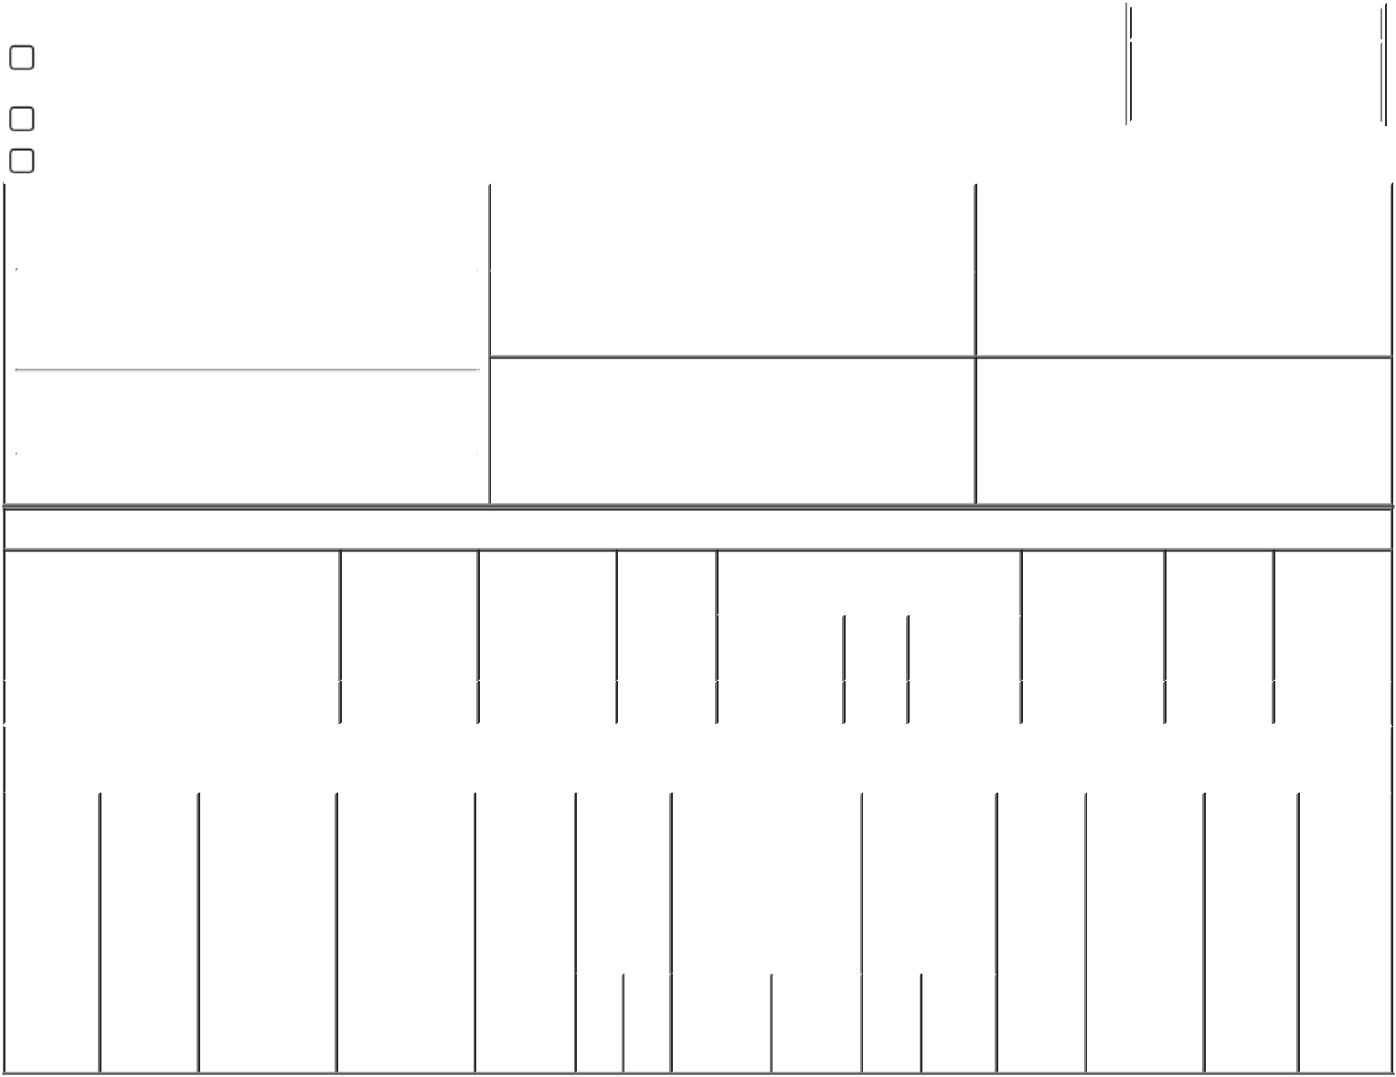

(Street)
 | RALEIGH | NC | 27604
 | (City) | (State) | (Zip)

4. If Amendment, Date of Original Filed (Month/Day/Year) 6. Individual or Joint/Group Filing (Check Applicable

Line)
X Form filed by One Reporting Person

Form filed by More than One Reporting

Person

Table I - Non-Derivative Securities Acquired, Disposed of, or Beneficially Owned

 | 1. Title of Security (Instr. 3) |  |  | 2. Transaction | 2A. Deemed |  | 3. |  | 4. Securities Acquired (A) or Disposed |  |  |  | 5. Amount of |  | 6. |  | 7. Nature of
 |  |  |  | Date | Execution Date, |  | Transaction |  | Of (D) (Instr. 3, 4 and 5) |  |  |  | Securities |  | Ownership |  | Indirect
 |  |  |  | (Month/Day/Year) | if any |  | Code (Instr. |  |  |  |  |  | Beneficially |  | Form: Direct |  | Beneficial
 |  |  |  |  | (Month/Day/Year) |  | 8) |  |  |  |  |  | Owned at end of |  | (D) or |  | Ownership
 |  |  |  |  |  |  |  |  |  | (A) or |  |  | Issuer's Fiscal |  | Indirect (I) |  | (Instr. 4)
 |  |  |  |  |  |  |  |  | Amount |  | Price |  | Year (Instr. 3 and |  | (Instr. 4)
 |  |  |  |  |  |  |  |  |  | (D)
 |  |  |  |  |  |  |  |  |  |  |  | 4)
 | Common Stock |  |  | 05/02/2018 | 05/02/2018 |  | G |  | 125 | D | $0.00 | 79,752⁽¹⁾ |  |  |  | D
 |  |  | Table II - Derivative Securities Acquired, Disposed of, or Beneficially Owned
 |  |  |  | (e.g., puts, calls, warrants, options, convertible securities)
 | 1. Title of | 2. | 3. Transaction | 3A. Deemed | 4. | 5. Number |  | 6. Date Exercisable and |  | 7. Title and |  | 8. Price of |  | 9. Number of |  | 10. |  | 11. Nature
 | Derivative | Conversion | Date | Execution Date, | Transaction | of |  | Expiration Date |  | Amount of |  | Derivative |  | derivative |  | Ownership |  | of Indirect
 | Security | or Exercise | (Month/Day/Year) | if any | Code (Instr. | Derivative |  | (Month/Day/Year) |  | Securities |  | Security |  | Securities |  | Form: |  | Beneficial
 | (Instr. 3) | Price of |  | (Month/Day/Year) | 8) | Securities |  |  |  | Underlying |  | (Instr. 5) |  | Beneficially |  | Direct (D) |  | Ownership
 |  | Derivative |  |  |  | Acquired |  |  |  | Derivative |  |  |  | Owned |  | or Indirect |  | (Instr. 4)
 |  | Security |  |  |  | (A) or |  |  |  | Security (Instr. 3 |  |  |  | Following |  | (I) (Instr. 4)
 |  |  |  |  |  | Disposed |  |  |  | and 4) |  |  |  | Reported
 |  |  |  |  |  | of (D) |  |  |  |  |  |  |  | Transaction(s)
 |  |  |  |  |  | (Instr. 3, 4 |  |  |  |  |  |  |  | (Instr. 4)
 |  |  |  |  |  | and 5)
 |  |  |  |  |  |  |  |  |  |  | Amount
 |  |  |  |  |  |  |  |  |  |  | or
 |  |  |  |  |  |  |  | Date | Expiration |  | Number
 |  |  |  |  |  | (A) | (D) |  |  | Title | of
 |  |  |  |  |  |  |  | Exercisable Date |  |  | Shares

Explanation of Responses:

1. Includes 115 shares acquired in 2018 through the issuer's employee stock purchase plan.

Remarks:

/s/Jeffrey D. Miller |  | 02/08/2019
** Signature of Reporting Person |  | Date

Reminder: Report on a separate line for each class of securities beneficially owned directly or indirectly.

* If the form is filed by more than one reporting person, see Instruction 4 (b)(v).

- Intentional misstatements or omissions of facts constitute Federal Criminal Violations See 18 U.S.C. 1001 and 15 U.S.C. 78ff(a). Note: File three copies of this Form, one of which must be manually signed. If space is insufficient, see Instruction 6 for procedure.
Persons who respond to the collection of information contained in this form are not required to respond unless the form displays a currently valid OMB Number.

