UNITED STATES
SECURITIES AND EXCHANGE COMMISSION
WASHINGTON, DC 20549

SCHEDULE 14A

Proxy Statement Pursuant to Section 14(a) of the
Securities Exchange Act of 1934

Filed by the Registrant [X]

Filed by a Party other than the Registrant [ ]

Check the appropriate box:

[ ] Preliminary Proxy Statement
[ ] Confidential, for Use of the Commission Only (as permitted by Rule 14a-6(e)(2))
[ ] Definitive Proxy Statement
[X] Definitive Additional Materials
[ ] Soliciting Material Pursuant to Section 240.14a-12

HIGHWOODS PROPERTIES, INC.
(Name of Registrant as Specified in its Charter)

Payment of Filing Fee (Check the appropriate box):

[X] No fee required.

[ ] Fee computed on table below per Exchange Act Rules 14a-6(i)(4) and 0-11.

(1) | Title of each class of securities to which transaction applies:

(2) | Aggregate number of securities to which transaction applies:

(3) | Per unit price or other underlying value of transaction computed pursuant to Exchange Act Rule 0-11 (set forth the amount on which the filing fee is calculated and state how it was determined):

(4) | Proposed maximum aggregate value of transaction:

(5) | Total fee paid:

[ ] Fee paid previously with preliminary materials.

[ ] | Check box if any part of the fee is offset as provided by Exchange Act Rule 0-11(a)(2) and identify the filing for which the offsetting fee was paid previously. Identify the previous filing by registration statement number, or the form or schedule and the date of its filing.

(1) | Amount Previously Paid:

(2) | Form, Schedule or Registration Statement No.:

(3) | Filing Party:

(4) | Date Filed:

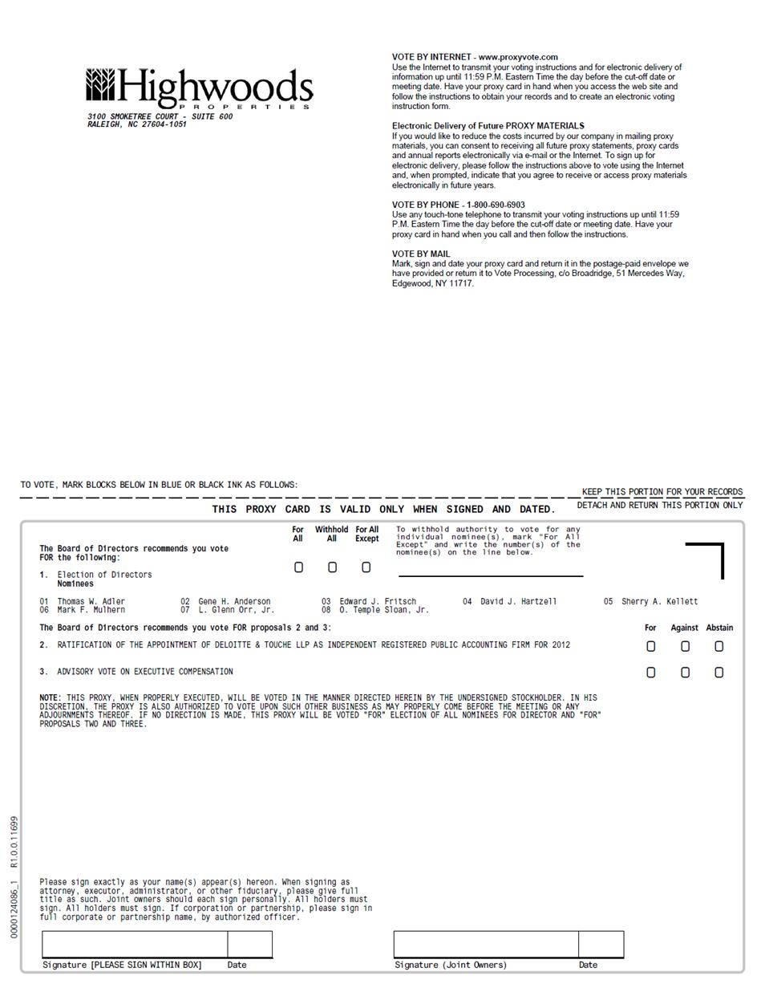

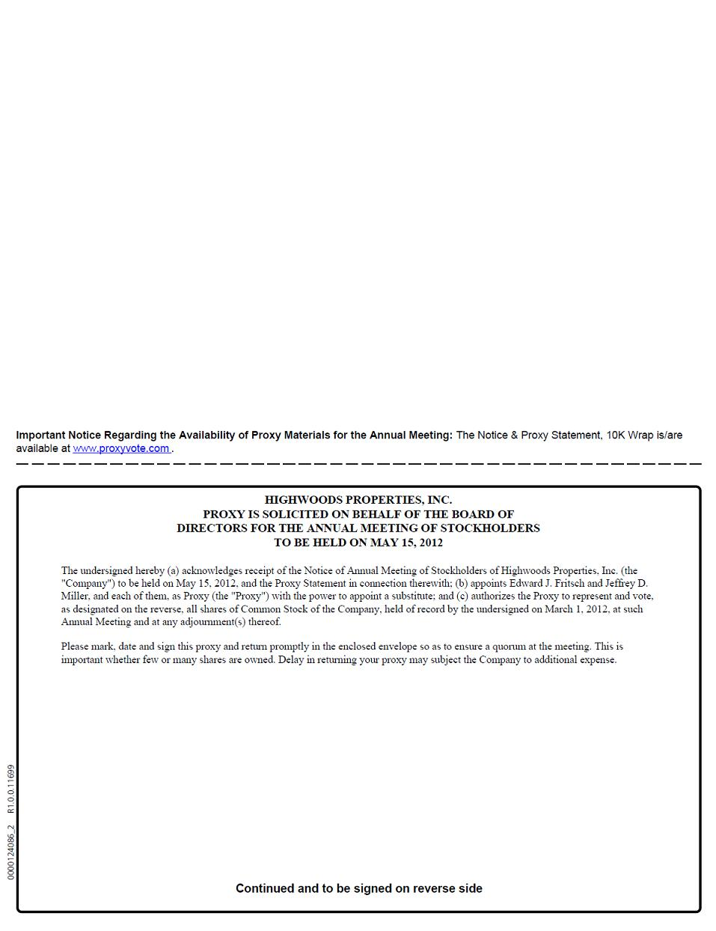

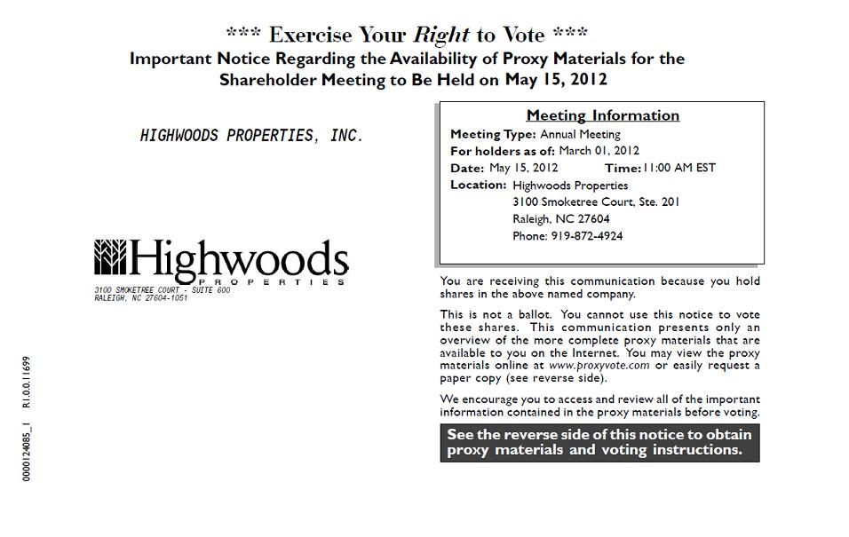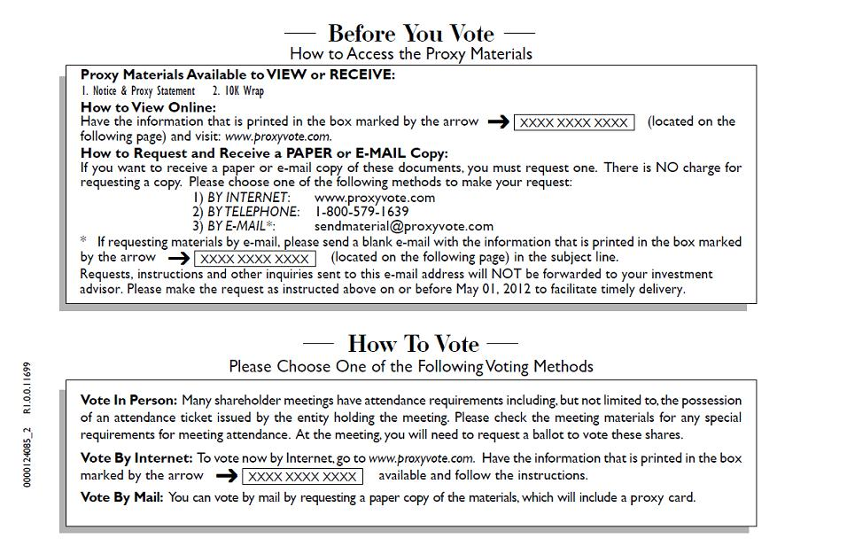

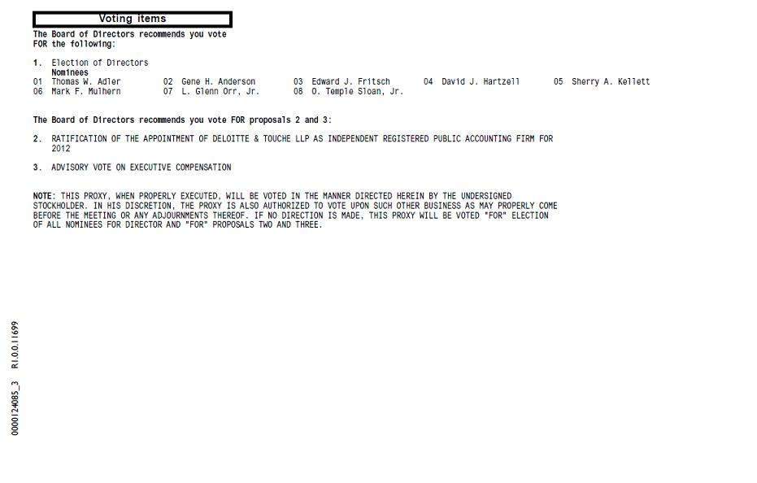

EXPLANATORY NOTE

The information set forth below was included under “Part II, Item 5. Other Events” in the Company's Quarterly Report on Form 10-Q for the three months ended March 31, 2012, previously filed with the SEC.

Stock Ownership Guidelines

Our compensation and governance committee has established the following stock ownership guidelines:

Position | Multiple (in dollars)
Chief Executive Officer | 6x Base Salary
Other Executive Officers | 5x Base Salary
Divisional Vice Presidents and Other Officers | 2x Base Salary
Directors | 3x Base Annual Retainer

Our directors and officers may not directly or indirectly engage in any transactions pursuant to which shares of common stock or units of limited partnership interest in Highwoods Realty Limited Partnership, our operating partnership, are held in margin accounts or otherwise pledged to secure personal loans or lines of credit or similar forms of indebtedness without the prior consent of the compensation and governance committee. None of our officers or directors has pledged shares of common stock as collateral, except that Mr. Anderson pledged 400,000 operating partnership units and 65,000 shares of common stock to secure a personal line of credit prior to adoption of this policy in 2009.

Compensation of Executive Officers

Annual Non-Equity Incentive Program. In 2011, all of our officers, including Named Executive Officers, participated in our annual non-equity incentive program pursuant to which they were eligible to earn cash payments (which were paid in March 2012) based on a percentage of their annual base salary in effect for December 2011. Under this component of our executive compensation program, officers are eligible to earn additional cash compensation to the extent specific performance-based metrics are achieved during the most recently completed year. The position held by each officer has a target annual incentive percentage. For 2011, the target annual incentive percentage was 130% for Mr. Fritsch, 95% for Mr. Harris, 90% for Mr. Stevens and 75% for Mr. Miller. In addition to considering the pay practices of our peer group in determining each officer's annual incentive percentage, the committee also considers the individual officer's ability to influence our overall performance. The more senior the position within the company, the greater the portion of compensation that varies with performance.

The amount an officer may earn under the annual non-equity incentive compensation program is the product of the target annual incentive percentage times an “actual performance factor,” which can range from zero to 200%. The actual performance factor depends upon the relationship between actual performance in specific areas at each of our divisions and predetermined goals. For Messrs. Fritsch, Harris, Stevens and Miller, who served as corporate executives during 2011, the actual performance factor was based on the goals and criteria applied to our performance as a whole. Participants in our annual non-equity incentive program receive quarterly statements throughout the year that illustrate our forecasted and re-forecasted performance, which we believe is an important tool in keeping our employees focused on achieving our strategic and operating goals.

The components and weighting of each year's metrics, which are set by the compensation and governance committee prior to or near the beginning of each year as part of our budgeting and strategic planning process, are intended to closely match our company's overall operating and financial goals and provide our officers with direct “line of sight” to focus their individual and collective efforts on the achievement of the metrics.

The performance criteria, which are equally weighted, are the following:

• | per share funds from operations (“FFO”) excluding any unusual charges or credits that may occur;

• | net operating income (on a division-by-division basis) excluding any unusual charges or credits that may occur and including a capital charge/credit applied with respect to any investment activity; and

• | average occupancy (on a division-by-division basis).

The compensation and governance committee sets threshold, target and maximum levels with respect to each of the factors. The following table sets forth information about the performance-based metrics under our annual non-equity incentive program, including our actual performance, for 2011:

Factor | Actual 2011  Performance | Threshold (50%) | Target (100%) | Maximum (200%)
Per Share FFO | $2.58 | $2.44 | $2.52 | $2.62
Net Operating Income | 0.8% Growth | 0.5% Growth | 3.0% Growth | 7.0% Growth
Average Occupancy | 89.2% | 87% | 91.5% | 94%

If the threshold level is not satisfied with respect to a particular factor, the actual performance factor would be zero with respect to that factor. If performance exceeds the threshold level but does not satisfy the target level, the actual performance factor would range on a sliding scale between 50% and 100% with respect to that factor. If performance is between the target level and the maximum level, the actual performance factor would range on a sliding scale between 100% and 200% with respect to that factor. The performance factor used to determine the amount an executive could earn in 2011 under the annual non-equity incentive program was the average of the three factors. Notwithstanding the formulas described above, our compensation and governance committee has retained the discretion and flexibility to increase or decrease the actual performance factor with respect to any particular year and/or any particular officer to more appropriately reflect, in the committee's sole judgment, actual performance, market conditions, unanticipated circumstances and other factors. The compensation and governance committee did not exercise its right to modify the actual performance factor for any of the Named Executive Officers in 2011. For corporate executives in 2011, the performance factors under the non-equity incentive program were 165.3% for the Per Share FFO factor, 56.8% for the Net Operating Income factor and 74.4% for the Average Occupancy factor, which resulted in an overall actual performance factor of 98.8%. For additional information regarding our actual 2011 performance, see our 2011 Annual Report on Form 10-K.

The following table sets forth information about the performance-based metrics under our annual non-equity incentive program for 2012:

Factor | Threshold (50%) | Target (100%) | Maximum (200%)
Per Share FFO* | $2.61 | $2.66 | $2.77
Net Operating Income | 0.5% Growth | 2.0% Growth | 5.0% Growth
Average Occupancy | 87% | 90.5% | 93%
__________
* | To the extent the dilutive effects of dispositions and equity issuances are more or less than $0.10 per share, such differences will be excluded.

While the target and maximum levels for the Net Operating Income and Average Occupancy factors are slightly lower in 2012 than in 2011, the threshold, target and maximum levels for the Per Share FFO factor are higher in 2012 than 2011. As a result, the probable overall actual performance factor for corporate executives under the 2012 program is expected to be similar to the 98.8% overall actual performance factor for 2011.

Equity Incentive Compensation-Time-Based Restricted Stock. The compensation and governance committee believes that the issuance of time-based restricted stock is an important retention tool and serves to deter our officers from seeking other employment opportunities. Time-based restricted stock vests ratably on an annual basis over a four-year term. If an officer leaves our employ at any time before the fourth anniversary of the date of grant, unvested shares will be forfeited upon termination of employment except in the event of death, disability or as otherwise provided under our retirement plan. If an officer dies, unvested shares of time-based restricted stock will automatically vest. If an officer becomes disabled, unvested shares of time-based restricted stock will become non-forfeitable and continue to vest according to the terms of their original grants. Except as set for th in the next sentence, dividends received on time-based restricted stock are non-forfeitable and are paid at the same rate and on the same date as on shares of our common stock. Commencing in 2012 with respect to shares of time-based restricted stock issued to our chief executive officer and subject to any delay in payment that would result in adverse tax consequences under Section 409A of the Internal Revenue Code, dividends will accumulate and be payable only if and to the extent the shares vest.

Equity Incentive Compensation-Total Return-Based Restricted Stock. The compensation and governance committee believes the issuance of total return-based restricted stock is an important retention tool that incentivizes our officers to concentrate their efforts on generating and sustaining long-term stockholder value. One of our principal goals is to provide our stockholders with attractive risk-adjusted returns on their investment through the consistent payment of quarterly dividends and stock price appreciation. Total return is defined as the sum of stock price appreciation plus reinvested dividends over the stock value at the

beginning of the applicable period.

Each year, the committee sets minimum, target and maximum payout levels based on the probable expected total return of our common stock over three years using an analysis of all historical three-year total return periods since our company's initial public offering in 1994. Each year, the three-year total return performance for the minimum payout level is determined such that the probability of achievement based on historical three-year total return performance is generally 60%. (In other words, there is a 40% chance that the minimum level will not be achieved and the shares will be forfeited, except as otherwise described below.) The three-year total return performance for the maximum level is determined such that the probability of achievement based on historical three-year total return performance is generally 10%.

Under this probability achievement formula, shares of total return-based restricted stock will generally vest only to the extent our absolute total return for the applicable three-year period is at least 22% with respect to shares issued in 2011 and at least 17% with respect to shares issued in 2012. Accordingly, if our absolute total return does not at least meet the minimum threshold, all of the total return-based restricted stock will be forfeited at the end of the period, except as otherwise described below. The percentage of total return-based restricted stock that vests will range between 50% and 100% to the extent our absolute total return ranges between 22% and 44% with respect to shares issued in 2011 and 17% and 36% with respect to shares issued in 2012. All of the total-return based restricted stock will vest and we will issue an amount of additional shares up to 150% of the original total return-based restricted stock award to the extent our absolute total return ranges between 44% and 88% with respect to shares issued in 2011 and 36% and 81% with respect to shares issued in 2012. These additional shares, if any, would be fully vested when issued. Notwithstanding the foregoing, if our total return is not at least 22% with respect to shares issued in 2011 and 17% for shares issued in 2012 but our total return index exceeds 100% of the peer group total return index, then 50% of the total return-based restricted stock will vest at the end of the applicable period.

If an officer leaves our employ at any time before the end of the three-year cycle, all of the total return-based restricted stock will be forfeited except in the event of death, disability or as otherwise provided under our retirement plan. If an officer dies or becomes disabled, a pro rata portion of the total return-based restricted stock would become non-forfeitable and continue to vest according to the terms of their original grants.

Except as set forth in the next sentence, dividends received on restricted stock are non-forfeitable and are paid at the same rate and on the same date as on shares of our common stock. Commencing in 2012 with respect to shares of total return-based restricted stock issued to our chief executive officer and subject to any delay in payment that would result in adverse tax consequences under Section 409A of the Internal Revenue Code, dividends will accumulate and be payable only if and to the extent the shares vest.

Employee Benefits and Perquisites. Each officer receives the same company-wide benefits as are generally available to all other salaried employees, such as short- and long-term disability insurance, basic life insurance and eligibility for supplemental health and life insurance, access to flexible health care reimbursement accounts and 401(k) matching. Officers participate in the same company-wide health insurance program, except that we pay an officer's family premium. Additionally, officers are entitled to receive additional annual perquisites not widely available to all salaried employees, typically items such as a vehicle allowance and reimbursement for personal financial consulting services and the costs of a physical exam not otherwise covered by our health insurance. We also reimbursed Mr. Fritsch on a tax grossed-up basis for supplemental life insurance coverage during 2011. This benefit ended in 2011.

