SEC Form 4

FORM 4

Check this box if no longer subject to Section 16. Form 4 or Form 5 obligations may continue. See Instruction 1(b).

UNITED STATES SECURITIES AND EXCHANGE COMMISSION
Washington, D.C. 20549
 |  | OMB APPROVAL
STATEMENT OF CHANGES IN BENEFICIAL OWNERSHIP
 |  | OMB Number: | 3235-0287
 |  | Estimated average burden
Filed pursuant to Section 16(a) of the Securities Exchange Act of 1934 |  | hours per response: | 0.5
or Section 30(h) of the Investment Company Act of 1940
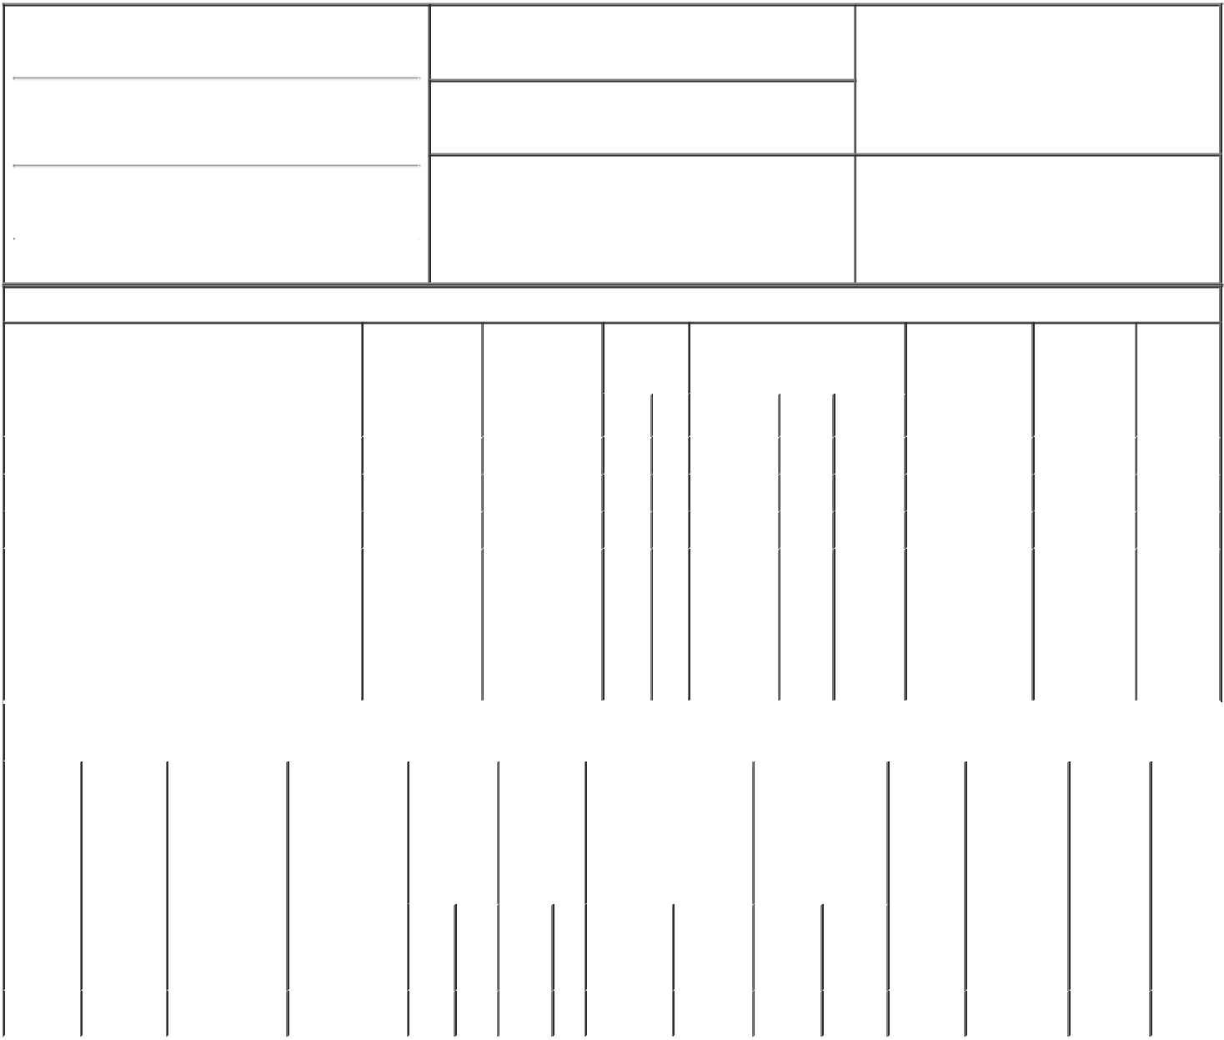

1. Name and Address of Reporting Person*
LINDE DEREK P

(Last) (First) (Middle)

7000 E. 1ST AVENUE

2. Issuer Name and Ticker or Trading Symbol

VIAD CORP [ VVI ]

3. Date of Earliest Transaction (Month/Day/Year)

02/23/2022

- Relationship of Reporting Person(s) to Issuer (Check all applicable)

 | Director | 10% Owner
X | Officer (give title | Other (specify
 | below) | below)

General Counsel & Corp Secy

(Street)
 | SCOTTSDALE | AZ | 85251
 | (City) | (State) | (Zip)

4. If Amendment, Date of Original Filed (Month/Day/Year) 6. Individual or Joint/Group Filing (Check Applicable
Line)
X Form filed by One Reporting Person

Form filed by More than One Reporting
Person

Table I - Non-Derivative Securities Acquired, Disposed of, or Beneficially Owned

 | 1. Title of Security (Instr. 3) |  |  | 2. Transaction |  | 2A. Deemed |  | 3. |  |  | 4. Securities Acquired (A) or |  |  |  |  |  | 5. Amount of |  | 6. Ownership |  | 7. Nature
 |  |  |  | Date |  | Execution Date, |  |  | Transaction |  | Disposed Of (D) (Instr. 3, 4 and |  |  |  |  |  | Securities |  | Form: Direct |  | of Indirect
 |  |  |  | (Month/Day/Year) |  | if any |  |  | Code (Instr. |  | 5) |  |  |  |  |  | Beneficially |  | (D) or Indirect |  | Beneficial
 |  |  |  |  |  | (Month/Day/Year) 8) |  |  |  |  |  |  |  |  |  |  | Owned Following |  | (I) (Instr. 4) |  | Ownership
 |  |  |  |  |  |  |  |  |  |  |  |  |  |  |  |  | Reported |  |  |  | (Instr. 4)
 |  |  |  |  |  |  |  |  | Code V |  | Amount |  | (A) or | Price |  |  | Transaction(s)
 |  |  |  |  |  |  |  |  |  |  |  |  | (D) |  |  |  | (Instr. 3 and 4)
 | Common Stock |  |  | 02/23/2022 |  |  |  |  | A |  | 5,742⁽¹⁾ |  | A | $0.00 |  |  | 15,834 |  |  | D
 | Common Stock |  |  | 02/23/2022 |  |  |  |  | F |  | 483⁽²⁾ |  | D | $34.81 |  |  | 15,351 |  |  | D
 | Common Stock |  |  |  |  |  |  |  |  |  |  |  |  |  |  |  | 775.4882⁽³⁾ |  |  | I | by 401K
 |  |  |  |  |  |  |  |  |  |  |  |  |  |  |  |  |  |  |  |  | Derek
 |  |  |  |  |  |  |  |  |  |  |  |  |  |  |  |  |  |  |  |  | and
 | Common Stock |  |  |  |  |  |  |  |  |  |  |  |  |  |  |  | 2,274 |  |  | I | Laura
 |  |  |  |  |  |  |  |  |  |  |  |  |  |  |  |  |  |  |  |  | Linde
 |  |  |  |  |  |  |  |  |  |  |  |  |  |  |  |  |  |  |  |  | Family
 |  |  |  |  |  |  |  |  |  |  |  |  |  |  |  |  |  |  |  |  | Trust
 |  |  |  | Table II - Derivative Securities Acquired, Disposed of, or Beneficially Owned
 |  |  |  | (e.g., puts, calls, warrants, options, convertible securities)
 | 1. Title of | 2. | 3. Transaction | 3A. Deemed | 4. | 5. Number |  | 6. Date Exercisable and |  |  |  | 7. Title and Amount |  |  |  | 8. Price of |  | 9. Number of |  | 10. | 11. Nature
 | Derivative | Conversion | Date | Execution Date, | Transaction | of |  | Expiration Date |  |  |  | of Securities |  |  |  | Derivative |  | derivative |  | Ownership | of Indirect
 | Security | or Exercise | (Month/Day/Year) | if any | Code (Instr. | Derivative |  | (Month/Day/Year) |  |  |  | Underlying |  |  |  | Security |  | Securities |  | Form: | Beneficial
 | (Instr. 3) | Price of |  | (Month/Day/Year) | 8) | Securities |  |  |  |  |  | Derivative Security |  |  |  | (Instr. 5) |  | Beneficially |  | Direct (D) | Ownership
 |  | Derivative |  |  |  | Acquired |  |  |  |  |  | (Instr. 3 and 4) |  |  |  |  |  | Owned |  | or Indirect | (Instr. 4)
 |  | Security |  |  |  | (A) or |  |  |  |  |  |  |  |  |  |  |  | Following |  | (I) (Instr. 4)
 |  |  |  |  |  | Disposed |  |  |  |  |  |  |  |  |  |  |  | Reported
 |  |  |  |  |  | of (D) (Instr. |  |  |  |  |  |  |  |  |  |  |  | Transaction(s)
 |  |  |  |  |  | 3, 4 and 5) |  |  |  |  |  |  |  |  |  |  |  | (Instr. 4)
 |  |  |  |  |  |  |  |  |  |  |  |  |  | Amount
 |  |  |  |  |  |  |  |  |  |  |  |  |  | or
 |  |  |  |  |  |  |  |  |  |  |  |  |  | Number
 |  |  |  |  |  |  |  | Date |  | Expiration |  |  |  | of
 |  |  |  |  | Code V | (A) | (D) | Exercisable |  | Date |  | Title |  | Shares
 | Stock | $33.96 | 02/23/2022 |  | A | 27,576 |  | (4) |  | 02/23/2029 |  | Common |  | 27,576 |  |  | $0.00 | 104,184 |  | D
 | Option

Explanation of Responses:

- Restricted Stock Units ("RSUs") granted on February 23, 2022, pursuant to the 2017 Viad Corp Omnibus Incentive Plan, and will vest in three equal tranches on each of February 23, 2023, February 23, 2024, and February 23, 2025, and are payable in shares of VVI common stock on a one-for-one basis upon vesting.

- Shares were surrendered for taxes in connection with vesting of RSUs granted February 23, 2021, based on the prior day closing stock price.

- Between May 2021 and February 2022, the reporting person acquired 173.4782 shares of VVI common stock under the Viad Corp 401(k) plan.

- The option vests and becomes exercisable in three equal tranches on each of February 23, 2023, February 23, 2024, and February 23, 2025.

Remarks:

/s/ Jonathan A. Massimino as |  |  | 02/25/2022
Attorney-in-Fact
** Signature of Reporting Person |  |  | Date

Reminder: Report on a separate line for each class of securities beneficially owned directly or indirectly.

* If the form is filed by more than one reporting person, see Instruction 4 (b)(v).

- Intentional misstatements or omissions of facts constitute Federal Criminal Violations See 18 U.S.C. 1001 and 15 U.S.C. 78ff(a). Note: File three copies of this Form, one of which must be manually signed. If space is insufficient, see Instruction 6 for procedure.
Persons who respond to the collection of information contained in this form are not required to respond unless the form displays a currently valid OMB Number.

