SEC Form 4

FORM 4

Check this box if no longer subject to Section 16. Form 4 or Form 5 obligations may continue. See Instruction 1(b).

UNITED STATES SECURITIES AND EXCHANGE COMMISSION
Washington, D.C. 20549
 |  | OMB APPROVAL
STATEMENT OF CHANGES IN BENEFICIAL OWNERSHIP
 |  | OMB Number: | 3235-0287
 |  | Estimated average burden
Filed pursuant to Section 16(a) of the Securities Exchange Act of 1934 |  | hours per response: | 0.5
or Section 30(h) of the Investment Company Act of 1940
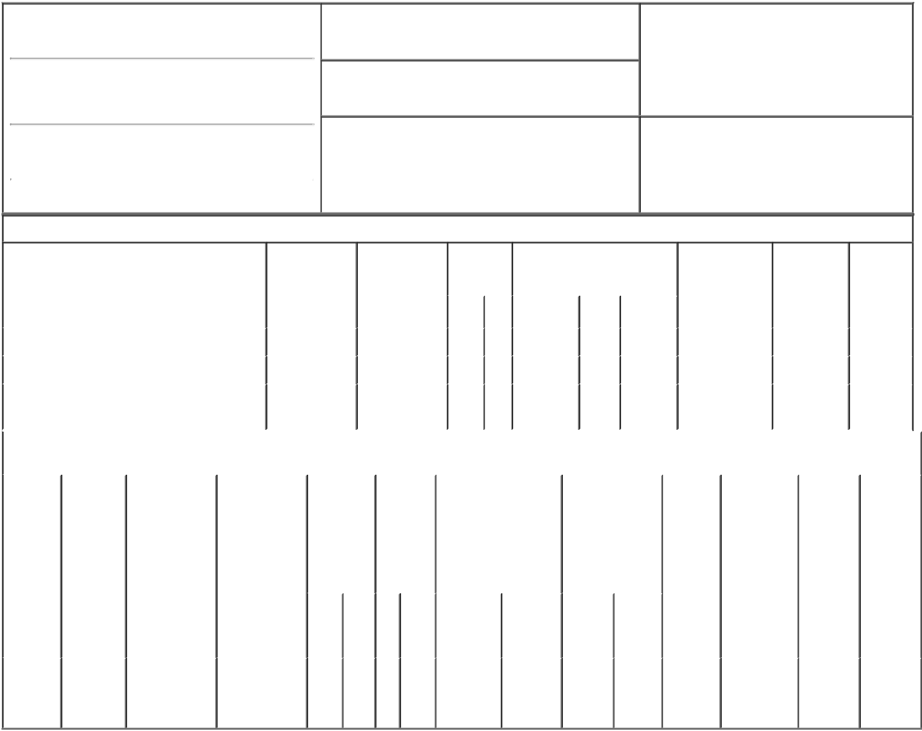

1. Name and Address of Reporting Person*
Kuczynski Thomas M

(Last) (First) (Middle)

1850 N. CENTRAL AVE., SUITE 1900

2. Issuer Name and Ticker or Trading Symbol

VIAD CORP [ VVI ]

3. Date of Earliest Transaction (Month/Day/Year)

05/04/2015

- Relationship of Reporting Person(s) to Issuer (Check all applicable)

 | Director | 10% Owner
X | Officer (give title | Other (specify
 | below) | below)

Chief Corp Dev & Strat Officer

(Street)
 | PHOENIX | AZ | 85004-4565
 | (City) | (State) | (Zip)

4. If Amendment, Date of Original Filed (Month/Day/Year) 6. Individual or Joint/Group Filing (Check Applicable
Line)
X Form filed by One Reporting Person

Form filed by More than One Reporting
Person

Table I - Non-Derivative Securities Acquired, Disposed of, or Beneficially Owned

 | 1. Title of Security (Instr. 3) |  |  | 2. Transaction |  | 2A. Deemed |  | 3. |  | 4. Securities Acquired (A) or |  |  |  | 5. Amount of |  | 6. Ownership |  | 7. Nature
 |  |  |  | Date |  | Execution Date, |  |  | Transaction Disposed Of (D) (Instr. 3, 4 and 5) |  |  |  |  | Securities |  | Form: Direct |  | of Indirect
 |  |  |  | (Month/Day/Year) |  | if any |  |  | Code (Instr. |  |  |  |  | Beneficially |  | (D) or Indirect |  | Beneficial
 |  |  |  |  |  | (Month/Day/Year) 8) |  |  |  |  |  |  |  | Owned Following |  | (I) (Instr. 4) |  | Ownership
 |  |  |  |  |  |  |  |  |  |  |  |  |  | Reported |  |  |  | (Instr. 4)
 |  |  |  |  |  |  |  |  | Code V | Amount | (A) or | Price |  | Transaction(s)
 |  |  |  |  |  |  |  |  |  |  | (D) |  |  | (Instr. 3 and 4)
 | Common Stock |  |  | 05/04/2015 |  |  |  |  | M | 7,148 | A | $16.619 |  | 30,297 |  |  | D
 | Common Stock |  |  | 05/04/2015 |  |  |  |  | S | 7,148 | D | $26.734 |  | 23,149 |  |  | D
 | Common Stock |  |  |  |  |  |  |  |  |  |  |  |  | 3,359.0047 |  |  | I | by 401K
 |  |  |  |  |  |  |  |  |  |  |  |  |  |  |  |  |  | Plan
 |  |  | Table II - Derivative Securities Acquired, Disposed of, or Beneficially Owned
 |  |  |  | (e.g., puts, calls, warrants, options, convertible securities)
 | 1. Title of | 2. | 3. Transaction | 3A. Deemed | 4. |  | 5. Number | 6. Date Exercisable and |  |  | 7. Title and |  | 8. Price of |  | 9. Number of |  | 10. | 11. Nature
 | Derivative | Conversion | Date | Execution Date, | Transaction |  | of | Expiration Date |  |  | Amount of |  | Derivative |  | derivative |  | Ownership | of Indirect
 | Security | or Exercise | (Month/Day/Year) | if any | Code (Instr. |  | Derivative | (Month/Day/Year) |  |  | Securities |  | Security |  | Securities |  | Form: | Beneficial
 | (Instr. 3) | Price of |  | (Month/Day/Year) | 8) |  | Securities |  |  |  | Underlying |  | (Instr. 5) |  | Beneficially |  | Direct (D) | Ownership
 |  | Derivative |  |  |  |  | Acquired |  |  |  | Derivative Security |  |  |  | Owned |  | or Indirect | (Instr. 4)
 |  | Security |  |  |  |  | (A) or |  |  |  | (Instr. 3 and 4) |  |  |  | Following |  | (I) (Instr. 4)
 |  |  |  |  |  |  | Disposed |  |  |  |  |  |  |  | Reported
 |  |  |  |  |  |  | of (D) |  |  |  |  |  |  |  | Transaction(s)
 |  |  |  |  |  |  | (Instr. 3, 4 |  |  |  |  |  |  |  | (Instr. 4)
 |  |  |  |  |  |  | and 5)
 |  |  |  |  |  |  |  |  |  |  |  | Amount
 |  |  |  |  |  |  |  |  |  |  |  | or
 |  |  |  |  |  |  |  |  |  |  |  | Number
 |  |  |  |  |  |  |  | Date |  | Expiration |  | of
 |  |  |  |  | Code V |  | (A) (D) | Exercisable |  | Date | Title | Shares
 | Incentive
 | Stock | $16.619⁽¹⁾ |  |  |  |  |  | (2) |  |  | Common | 7,148 |  |  | 10,902⁽¹⁾
 | Option |  | 05/04/2015 |  | M |  | 7,148 |  |  | 02/24/2020 |  |  |  | $0.0 |  |  | D
 |  |  |  |  |  |  |  |  |  |  | Stock
 | (right to
buy)

Explanation of Responses:

- Pursuant to the mandatory provisions of the 2007 Viad Corp Omnibus Incentive Plan and the reporting person's stock option agreements executed thereunder, the Viad Corp Human Resources Committee approved equitable adjustments to the reporting person's option awards as a result of special dividends paid on November 14, 2013 and February 14, 2014. Under the equitable adjustments, the number of securities underlying the reporting person's outstanding options was increased and the option exercise price for such options was decreased.

- The 10-year option vested in 3 equal annual installments beginning on February 24, 2011, which was the first anniversary of the grant date.

By: Deborah J. DePaoli For: |  |  | 05/06/2015
Thomas M. Kuczynski
** Signature of Reporting Person |  |  | Date

Reminder: Report on a separate line for each class of securities beneficially owned directly or indirectly.

* If the form is filed by more than one reporting person, see Instruction 4 (b)(v).

- Intentional misstatements or omissions of facts constitute Federal Criminal Violations See 18 U.S.C. 1001 and 15 U.S.C. 78ff(a). Note: File three copies of this Form, one of which must be manually signed. If space is insufficient, see Instruction 6 for procedure.
Persons who respond to the collection of information contained in this form are not required to respond unless the form displays a currently valid OMB Number.

