SEC Form 4

FORM 4

Check this box if no longer subject to Section 16. Form 4 or Form 5 obligations may continue. See Instruction 1(b).

UNITED STATES SECURITIES AND EXCHANGE COMMISSION
Washington, D.C. 20549
 |  | OMB APPROVAL
STATEMENT OF CHANGES IN BENEFICIAL OWNERSHIP
 |  | OMB Number: | 3235-0287
 |  | Estimated average burden
Filed pursuant to Section 16(a) of the Securities Exchange Act of 1934 |  | hours per response: | 0.5
or Section 30(h) of the Investment Company Act of 1940
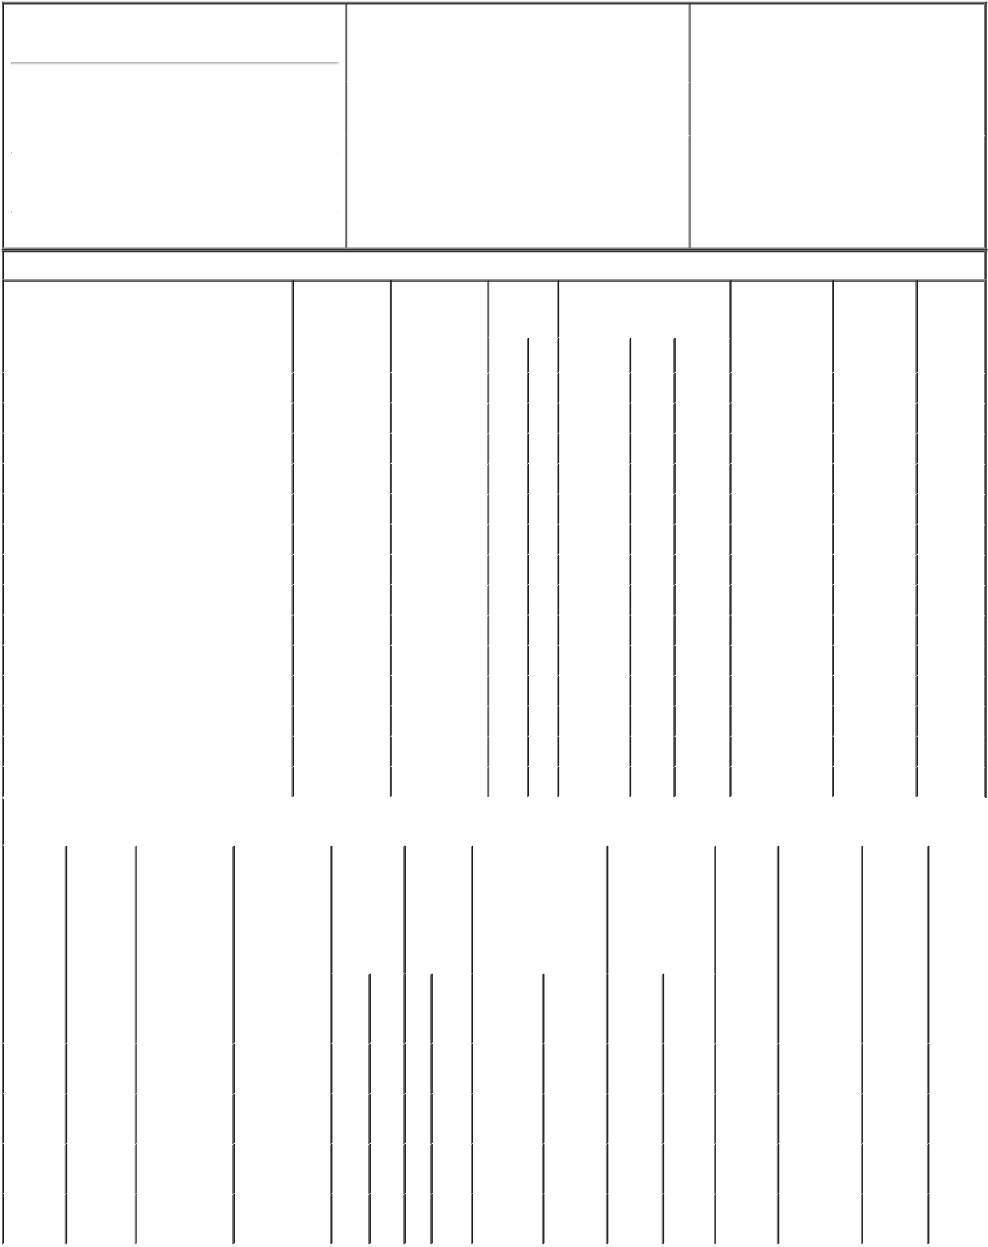

1. Name and Address of Reporting Person*
Blankenship Elizabeth A

 | (Last) | (First) | (Middle)
 | 400 NORTH FIFTH STREET
 | MAIL STATION 8602
(Street)
 | PHOENIX | AZ | 85004
 | (City) | (State) | (Zip)

2. |  | Issuer Name and Ticker or Trading Symbol |  | 5. Relationship of Reporting Person(s) to Issuer
 | PINNACLE WEST CAPITAL CORP [ PNW |  |  | (Check all applicable)
 | ] |  |  |  | Director | 10% Owner
 |  |  |  | X | Officer (give title | Other (specify
 |  |  |  |  | below) | below)
3. |  | Date of Earliest Transaction (Month/Day/Year) |  |  | VP, Controller and CAO
02/17/2023
4. |  | If Amendment, Date of Original Filed (Month/Day/Year) |  | 6. Individual or Joint/Group Filing (Check Applicable
Line)
X Form filed by One Reporting Person

Form filed by More than One Reporting

Person

Table I - Non-Derivative Securities Acquired, Disposed of, or Beneficially Owned

 | 1. Title of Security (Instr. 3) |  |  | 2. Transaction |  | 2A. Deemed | 3. |  |  | 4. Securities Acquired (A) or |  |  |  |  | 5. Amount of |  | 6. Ownership |  | 7. Nature
 |  |  |  | Date |  | Execution Date, |  | Transaction |  | Disposed Of (D) (Instr. 3, 4 and |  |  |  |  | Securities |  | Form: Direct |  | of Indirect
 |  |  |  | (Month/Day/Year) |  | if any |  | Code (Instr. |  | 5) |  |  |  |  | Beneficially |  | (D) or Indirect |  | Beneficial
 |  |  |  |  |  | (Month/Day/Year) 8) |  |  |  |  |  |  |  |  | Owned Following |  | (I) (Instr. 4) |  | Ownership
 |  |  |  |  |  |  |  |  |  |  |  |  |  |  | Reported |  |  |  | (Instr. 4)
 |  |  |  |  |  |  |  | Code V |  | Amount | (A) or | Price |  |  | Transaction(s)
 |  |  |  |  |  |  |  |  |  |  | (D) |  |  |  | (Instr. 3 and 4)
 | Common Stock |  |  | 02/17/2023 |  |  |  | M |  | ₅₆(1) | A | (1) |  | 2,385 |  |  |  | D
 | Common Stock |  |  | 02/17/2023 |  |  |  | D |  | 56 | D | $75.1 |  | 2,329 |  |  |  | D
 | Common Stock |  |  | 02/17/2023 |  |  |  | M |  | ₈₆(1) | A | (1) |  | 2,415 |  |  |  | D
 | Common Stock |  |  | 02/17/2023 |  |  |  | D |  | 86 | D | $75.1 |  | 2,329 |  |  |  | D
 | Common Stock |  |  | 02/17/2023 |  |  |  | M |  | ₈₆(1) | A | (1) |  | 2,415 |  |  |  | D
 | Common Stock |  |  | 02/17/2023 |  |  |  | _{F}(2) |  | 28 | D | $75.1 |  | 2,387 |  |  |  | D
 | Common Stock |  |  | 02/17/2023 |  |  |  | M |  | ₃₂₉(1) | A | (1) |  | 2,716 |  |  |  | D
 | Common Stock |  |  | 02/17/2023 |  |  |  | _{F}(2) |  | 106 | D | $75.1 |  | 2,610 |  |  |  | D
 | Common Stock |  |  | 02/17/2023 |  |  |  | M |  | ₄₂₉(3) | A | (3) |  | 3,039 |  |  |  | D
 | Common Stock |  |  | 02/17/2023 |  |  |  | _{D}(4) |  | 20 | D | $75.1 |  | 3,019 |  |  |  | D
 | Common Stock |  |  | 02/17/2023 |  |  |  | _{F}(2) |  | 132 | D | $75.1 |  | 2,887 |  |  |  | D
 | Common Stock |  |  | 02/17/2023 |  |  |  | A |  | ₄₃(5) | A | (5) |  | 2,930 |  |  |  | D
 | Common Stock |  |  | 02/17/2023 |  |  |  | _{F}(2) |  | 14 | D | $75.1 |  | 2,916 |  |  |  | D
 | Common Stock |  |  |  |  |  |  |  |  |  |  |  |  |  |  | 55 |  | I | by 401K
 |  |  | Table II - Derivative Securities Acquired, Disposed of, or Beneficially Owned
 |  |  |  | (e.g., puts, calls, warrants, options, convertible securities)
 | 1. Title of | 2. | 3. Transaction | 3A. Deemed | 4. | 5. Number | 6. Date Exercisable and |  |  |  | 7. Title and |  |  | 8. Price of |  | 9. Number of |  | 10. | 11. Nature
 | Derivative | Conversion | Date | Execution Date, | Transaction | of | Expiration Date |  |  |  | Amount of |  |  | Derivative |  | derivative |  | Ownership | of Indirect
 | Security | or Exercise | (Month/Day/Year) | if any | Code (Instr. | Derivative | (Month/Day/Year) |  |  |  | Securities |  |  | Security |  | Securities |  | Form: | Beneficial
 | (Instr. 3) | Price of |  | (Month/Day/Year) | 8) | Securities |  |  |  |  | Underlying |  |  | (Instr. 5) |  | Beneficially |  | Direct (D) | Ownership
 |  | Derivative |  |  |  | Acquired |  |  |  |  | Derivative Security |  |  |  |  | Owned |  | or Indirect | (Instr. 4)
 |  | Security |  |  |  | (A) or |  |  |  |  | (Instr. 3 and 4) |  |  |  |  | Following |  | (I) (Instr. 4)
 |  |  |  |  |  | Disposed |  |  |  |  |  |  |  |  |  | Reported
 |  |  |  |  |  | of (D) |  |  |  |  |  |  |  |  |  | Transaction(s)
 |  |  |  |  |  | (Instr. 3, 4 |  |  |  |  |  |  |  |  |  | (Instr. 4)
 |  |  |  |  |  | and 5)
 |  |  |  |  |  |  |  |  |  |  |  | Amount
 |  |  |  |  |  |  |  |  |  |  |  | or
 |  |  |  |  |  |  |  |  |  |  |  | Number
 |  |  |  |  |  |  | Date |  | Expiration |  |  | of
 |  |  |  |  | Code V | (A) (D) | Exercisable |  | Date |  | Title | Shares
 | Restricted | (1) |  |  |  |  | (6) |  |  | (6) | Common | 56 |  | (1)
 | Stock |  | 02/17/2023 |  | M | 56 |  |  |  |  |  |  |  |  |  | 0 |  | D
 |  |  |  |  |  |  |  |  |  |  | Stock
 | Units
 | Restricted | (1) |  |  |  |  | (7) |  |  | (7) | Common | 172 |  | (1)
 | Stock |  | 02/17/2023 |  | M | 172 |  |  |  |  |  |  |  |  |  | 172 |  | D
 |  |  |  |  |  |  |  |  |  |  | Stock
 | Units
 | Restricted | (1) |  |  |  |  | (8) |  |  | (8) | Common | 329 |  | (1)
 | Stock |  | 02/17/2023 |  | M | 329 |  |  |  |  |  |  |  |  |  | 658 |  | D
 |  |  |  |  |  |  |  |  |  |  | Stock
 | Units
 | Restricted | (3) |  |  |  | ₄₂₉(9) | (10) |  |  | (10) | Common | 429 |  | (3) |  | 1,286⁽¹¹⁾
 | Stock |  | 02/17/2023 |  | M |  |  |  |  |  |  |  |  |  |  |  |  | D
 |  |  |  |  |  |  |  |  |  |  | Stock
 | Units

Explanation of Responses:

- Each Restricted Stock Unit represents a contingent right to receive the economic equivalent of one share of the Company's common stock. The Restricted Stock Units will be settled, at the reporting person's election, in 100% shares of common stock, 50% in common stock and 50% in cash, or 100% in cash.

- Shares retained by the Company for the purpose of meeting tax withholding requirements. The recipient retained all other shares.

- Each Restricted Stock Unit represents a contingent right to receive the economic equivalent of one share of the Company's common stock. The Restricted Stock Units will be settled either in 100% shares of

common stock or 100% in cash with respect to Restricted Stock Units received in connection with the settlement of dividend equivalent rights.

- Represents the cash settlement of Restricted Stock Units received in connection with the settlement of dividend equivalent rights.

- Represents shares of common stock received by the individual in settlement of dividend rights granted in connection with the 2020 and 2021 Restricted Stock Unit grants.

- The Restricted Stock Units award was granted and was effective in February 2019, and vests in four equal, annual installments beginning on February 20, 2020.

- The Restricted Stock Units award was granted and was effective in February 2020, and vests in four equal, annual installments beginning on February 20, 2021.

- The Restricted Stock Units award was granted and was effective in February 2021, and vests in four equal, annual installments beginning on February 20, 2022.

- The number of derivative securities in Column 5 includes 20 vested Restricted Stock Units received in connection with the settlement of dividend equivalent rights. Dividend equivalent rights accrue with respect to these Restricted Stock Units when and as cash dividends are paid on the Company's common stock.

- The Restricted Stock Units award was granted and was effective in February 2022, and vests in four equal, annual installments beginning on February 20, 2023.

- Includes 59 Restricted Stock Units received in connection with the settlement of dividend equivalent rights.

Remarks:

/s/ Diane Wood, Attorney-in- |  |  | 02/21/2023
Fact
** Signature of Reporting Person |  |  | Date

Reminder: Report on a separate line for each class of securities beneficially owned directly or indirectly.

* If the form is filed by more than one reporting person, see Instruction 4 (b)(v).

- Intentional misstatements or omissions of facts constitute Federal Criminal Violations See 18 U.S.C. 1001 and 15 U.S.C. 78ff(a). Note: File three copies of this Form, one of which must be manually signed. If space is insufficient, see Instruction 6 for procedure.
Persons who respond to the collection of information contained in this form are not required to respond unless the form displays a currently valid OMB Number.

