Table of Contents

UNITED STATES

SECURITIES AND EXCHANGE COMMISSION
Washington, D.C. 20549

SCHEDULE 14A

Proxy Statement Pursuant to Section 14(a) of the

Securities Exchange Act of 1934 (Amendment No. )

☑ Filed by the Registrant ☐ Filed by a party other than the Registrant

CHECK THE APPROPRIATE BOX:

- Preliminary Proxy Statement

- Confidential, for Use of the Commission Only (as permitted by Rule 14a-6(e)(2)) ☑ Definitive Proxy Statement

- Definitive Additional Materials

- Soliciting Material under §240.14a-12
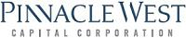

Pinnacle West Capital Corporation

(Name of Registrant as Specified In Its Charter)

(Name of Person(s) Filing Proxy Statement, if other than the Registrant)

PAYMENT OF FILING FEE (CHECK ALL BOXES THAT APPLY):

- No fee required

- Fee paid previously with preliminary materials

- Fee computed on table in exhibit required by Item 25(b) per Exchange Act Rules 14a-6(i)(1) and 0-11

Table of Contents
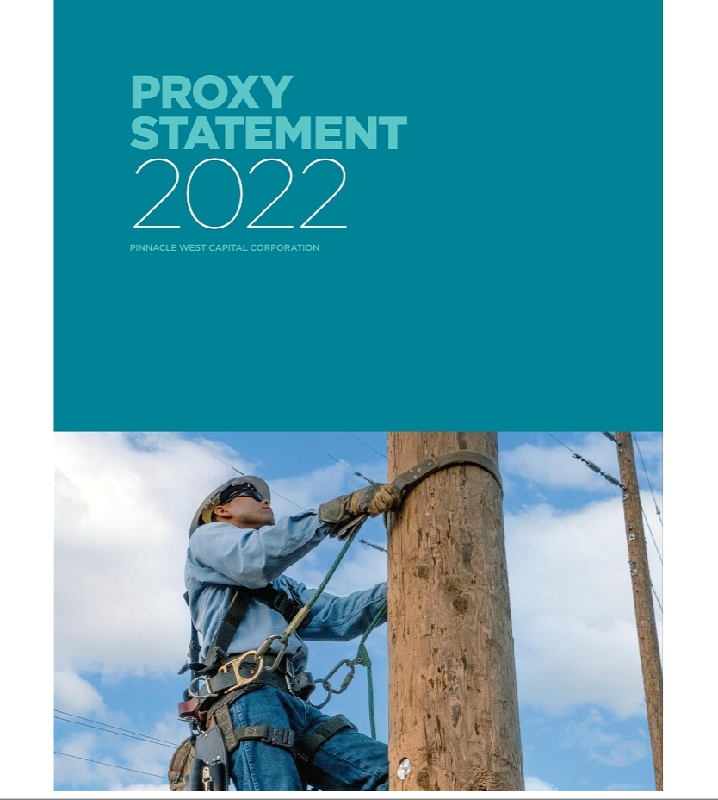

Table of Contents
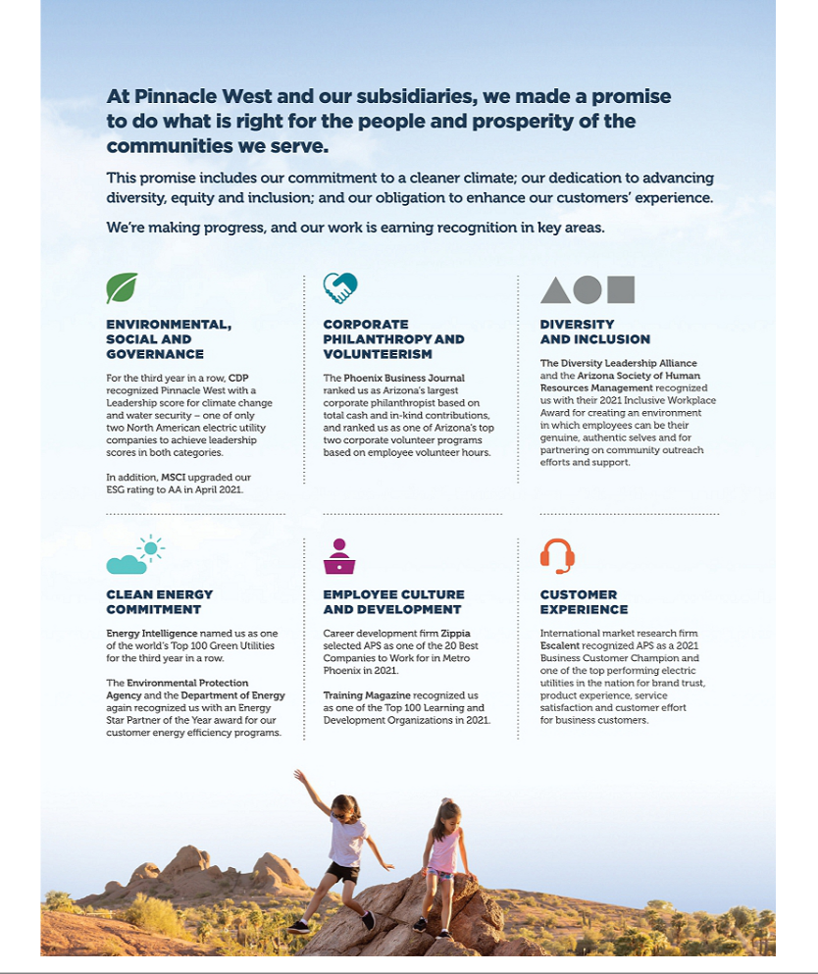

Table of Contents

About Pinnacle West

Who We Are

We are Pinnacle West Capital Corporation (“Pinnacle West,” “PNW” or the “Company”). We are an investor-owned electric utility holding company based in Phoenix, Arizona with consolidated assets of about $22 billion. For over 130 years, Pinnacle West, through our affiliates, has provided energy and energy-related products to people and businesses throughout Arizona. Our success enables us to reinvest in our home state’s growth and give back to our communities, enhancing Arizona’s continued economic and cultural vitality.

Pinnacle West derives essentially all of our revenues and

earnings from our principal subsidiary, Arizona Public
Service Company (“APS”). APS is a wholly-owned, vertically-
integrated electric utility that provides either retail or
wholesale electric service to most of the State of Arizona.
APS is also the operator and co-owner of the Palo Verde
Generating Station – a primary source of electricity for the
Southwest and the largest nuclear power plant in the United

States.

APS is Arizona’s largest and longest-serving electric

company that generates safe, affordable and reliable

electricity for approximately 1.3 million retail and

residential customers in 11 of Arizona’s 15 counties.

Table of Contents

A Message from Our Chairman, President and CEO

“As we move forward into 2022, rest assured our leaders have a well-thought-out strategy to continue to deliver on our Clean Energy Commitment, improve our customer experience, focus on the development of our workforce and create long-term value for shareholders.”

JEFFREY B. GULDNER

Chairman of the Board, President
and Chief Executive Officer

To our Shareholders:

On behalf of our Board of Directors, management and employees, I invite you to participate in our 2022 Annual Meeting of Shareholders. The meeting will be held at 1:30 p.m. (EDT), Wednesday, May 18, 2022. Details regarding how to attend the meeting and the business to be conducted are in the accompanying Notice of Annual Meeting and Proxy Statement.

Reflections on 2021

Last year presented a number of successes and opportunities as well as challenges and setbacks. Several of those are detailed in my letter in the 2021 Annual Report. A few highlights I would like to mention here include our Pinnacle West earnings of $618.7 million, or $5.47 per share, which surpassed our 2020 results of $550.6 million or $4.87 per share. We also progressed on our Clean Energy Commitment, procuring nearly 1,400 megawatts of additional clean energy and storage since our announcement in 2020 and we will begin to transition our Four Corners Power Plant to seasonal operations in 2023. We also acknowledge that the outcome of our 2019 rate case was a disappointment. We hope that we can find a better path forward with the Arizona Corporation Commission, one that will benefit our customers, our community, and our investors.

In reflecting on 2021, I want to take this opportunity to thank our investment community, who recognized that, notwithstanding the outcome of our 2019 rate case, our Company remains a solid, long-term investment. I also want to thank our employees, who worked day in and day out to make sure we kept the lights on and the power flowing to our customers and communities.

The APS Promise and the 10-Year Strategic Plan

We introduced the APS Promise in 2020 and our 10-Year Strategic Plan (the “Plan”) in 2021. The APS Promise sets forth our purpose, our vision and our mission:

- Purpose: As Arizona stewards, we do what is right for the people and prosperity of our state.

- Vision: Create a sustainable energy future for Arizona.

- Mission: Serve our customers with clean, reliable and affordable energy.

You can read more about the APS Promise on page 35 of this Proxy Statement.

The Plan outlines how we will deliver on the APS Promise. You can read more about the Plan on page 36 of this Proxy Statement. We will use the Plan to ensure employees and stakeholders are aware of and aligned to the Company’s long-range strategic objectives, to identify strategies and goals that guide resources and efforts to address our long-term issues, and guide business planning to develop measurable actions to achieve our vision. In 2021 the progress we made against the long-term strategic pillars

ii

Table of Contents

outlined in the Plan included strengthening APS’s already diverse energy mix by increasing its investments in carbon-free resources and initiating an APS organization-wide customer experience strategy council designed to further drive a customer-oriented culture and improve customer satisfaction. You can read more about our advances in renewable energy and our customer satisfaction in our 2021 Annual Report.

I see 2022 as full of opportunities. Arizona’s economy is growing rapidly, which translates into steady customer growth. Arizona’s economy is also diversifying. As we move forward in 2022, rest assured our leaders have a well-thought-out strategy to continue to deliver on our Clean Energy Commitment, improve our customer experience, focus on the development of our workforce and create long-term value for shareholders.

Environmental, Social and Governance (“ESG”)

In 2021, APS remained focused on ESG trends. APS has adopted strong governance structures to effectively evaluate ESG issues impacting the Company. We continued to be focused on our Clean Energy Commitment and are evaluating ways to achieve the commitment through the promotion of supportive policies, economic advancement in our communities, innovative technologies in our industry, and collaboration with our stakeholders. In addition, we established a Social Issues Committee Framework to provide a process for considering emergent social issues.

You can read more about our advancements in ESG in the Proxy Statement Summary that begins on page 3 of the Proxy Statement. However, I want to highlight three awards we received in 2021. First, APS was honored by the Environmental Protection Agency with the ENERGY

STAR® Partner of the Year Award for excellence in customer programs. Second, Pinnacle West was recognized by the global environmental non-profit CDP for leadership in corporate sustainability with an A- score for climate change and protecting water security. Pinnacle West is only one of two North American electric utility companies to achieve leadership scores in these areas. Last, APS received the 2021 Inclusive Workplace Award, a joint accolade from the Diversity Leadership Alliance and the Arizona Society of Human Resources Management. The award recognizes an Arizona corporation or organization that leads by example, creating an inclusive

A Message from Our Chairman, President and CEO

environment where employees can be their genuine, authentic selves and partnering on community outreach efforts and support.

Congratulations to our employees for great work that has been recognized by these awards.

Board of Directors

Our Board of Directors plays a vital role in establishing our corporate strategy. Their varied knowledge, experience and skills bring crucial insights to developing near- and long-term goals and, ultimately, overseeing our progress in building a more sustainable energy future and creating customer and shareholder value. I want to thank the Board of Directors for their outstanding support in 2021.

One of our outstanding Directors, Denis Cortese, will retire from the Board as of the 2022 Annual Meeting. We thank Denis for his many years of service. His deep knowledge of Arizona and valued counsel on important issues facing our Company will be missed.

In February of 2022 we added Gonzalo de la Melena, Jr. to the Board. Gonzalo is the Founder and CEO of Emerging Airport Ventures, LLC and the former President and CEO of the Arizona Hispanic Chamber of Commerce. Gonzalo is an Arizona resident, which will assist us in our continuing focus on our customers. He brings a unique combination of big and small business, civic association and entrepreneurial experience to the Board. I look forward to working with Gonzalo.

Finally, your vote is important to us. Whether or not you plan to participate in the Annual Meeting, we encourage you to vote promptly. You may vote on the internet; by telephone; or by completing, signing, dating and returning a proxy card or voting instruction form.

Thank you for your investment and continued support of Pinnacle West. Sincerely,
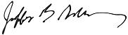

JEFFREY B. GULDNER

Chairman of the Board, President

and Chief Executive Officer

2022 Proxy Statement iii

Table of Contents

A Message from Our Lead Director

“Your Board is committed to our customers, our community, our employees, and continuing to make our stock an attractive long-term investment for our investors.”

KATHRYN L. MUNRO

Lead Director

Dear Fellow Shareholders,

On behalf of the Board, I thank you for your investment in Pinnacle West. As we approach our 2022 Annual Meeting of Shareholders, I take this opportunity to provide you an update on how your Board is approaching and addressing key areas of shareholder value, board tenure, board diversity and our attention to environmental, social and governance issues.

Stock Price Performance

We acknowledge the outcome of our 2019 rate case had a negative impact on our stock price. We strongly disagree with the decision of the Arizona Corporation Commission, and are pursuing our options for relief from parts of that decision. We are also looking closely at our future strategy. However, that decision did not change our commitment to our customers, our community, our employees and our investors. Notwithstanding the impact to the Company resulting from the decision, the Board decided it was necessary to protect the dividend for our investors. Although our growth in the dividend was less than in prior years, our dividend still has one of the highest dividend yields in the U.S. investor-owned electric utility sector. Your Board is committed to continuing to make our stock an attractive long-term investment.

Board Tenure

The Board understands our investors’ concerns regarding long-tenured directors. We believe we have developed a robust plan to refresh the Board and its leadership significantly over the next several years. In 2016 we adopted our Director Retirement Policy. As we began to implement that policy, we looked at the turn-over timeline for our directors and revised the policy in 2020

to make sure we are providing for an orderly transition that captures the experience and knowledge of our longer-serving directors while adding new skills and fresh ideas. Since we adopted the retirement policy, 50% of our Board has been refreshed. This year Denis Cortese will retire from the Board. Under the current retirement policy, Bruce Nordstrom, Dale Klein, Richard Fox and I are scheduled to retire from the Board in the next three years. More information about our retirement policy is located on page 25 of the Proxy Statement.

Denis Cortese

It is with mixed emotions that I say good-bye to our trusted advisor and friend, Denis Cortese. Denis has brought thought provoking and insightful analyses to the myriad of issues that have come before the Board. His counsel has been wise and he has been a phenomenal asset to the Board of Directors and the Company. Denis has been an outstanding member of the Board and has served the Company and the Board with respect and integrity.

Gonzalo de la Melena, Jr.

I am happy to announce that we added Gonzalo de la Melena, Jr. to the Board in February of 2022. Gonzalo has more than 20 years of management experience.

iv

Table of Contents

A Message from Our Lead Director

He began his career in “back of the house” restaurant operations before joining consumer products companies Coca-Cola and The Dial Corporation, where he conducted business in more than 30 countries before the age of 30. He is now the Founder and CEO of Emerging Airport Ventures, LLC. Gonzalo currently serves on the National Board of Directors for Airport Minority Advisory Council, and the Board of Directors for Gainey Business Bank (de novo), Education Forward Arizona and Greater Phoenix Leadership. He brings added diversity to the Board as a member of the Hispanic community. His diverse skill set includes finance/capital allocation, investment experience, business strategy, and as an Arizona resident, customer perspectives. The Board welcomes Gonzalo and we look forward to his participation and insights.

Board Diversity

The Board continues to focus on adding diverse candidates. We require our outside director search firm to make diversity a focal point of all our searches. The Corporate Governance and Public Responsibility Committee is responsible for identifying and recommending to the Board individuals qualified to become directors. The Board believes that its membership should be composed of a combination of knowledge, skills, and experience in the following areas, among others: finance and accounting; business operations and strategy; large organizational leadership; energy and utility industry; public policy and regulatory compliance; and risk oversight and risk management. The Board also believes that diversity, utilizing a broad meaning that includes race, gender, background, ethnicity, accomplishments, and other traits, is an important consideration in selecting candidates. Out of our eleven nominees, three are women and two are racially or ethnically diverse. Our Directors’ diverse skills and expertise are shown in the chart on page 18 of this Proxy Statement.

Environmental, Social and Governance (“ESG”)

The Board also focused on environmental, social and corporate governance matters. To demonstrate the heightened attention on ESG, the Board previously changed the name of the Corporate Governance Committee to the Corporate Governance and Public Responsibility Committee and specifically added to the Charter the responsibility to review significant ESG trends that may impact the Company; ensure the oversight of relevant ESG issues by the Board and its committees;

and make recommendations to the Board, as appropriate. At the Committee’s meeting in October, the Committee engaged with management in a detailed discussion about the Company’s sustainability history, evolving ESG trends, and the Company’s ESG strategy and alignment.

We amended the Charter of the Human Resources Committee to include a requirement to periodically review and assess the Company’s strategies and policies related to human capital management, such as diversity, inclusion, pay equity, corporate culture, talent development and retention. In February of 2022, the Human Resources Committee revised the metrics for our performance share grants and added a new clean megawatt installed metric. You can read more about the new metrics on page 76 of this Proxy Statement.

Board Engagement

Our independent Board members are expected to be active, engaged and contributing members. Our discussions are focused on oversight of Pinnacle West’s business strategy. We are excited about the progress of our Clean Energy Commitment and our plan to deliver 100% clean, carbon-free energy to our customers by 2050, with a near-term 2030 target of 65% clean energy, with 45% of our portfolio coming from renewable energy. The Company continued to make progress on its Clean Energy Commitment in 2021, as noted in Jeff’s letter.

In 2021, we held a combined total of 39 Board and Board committee meetings. Directors have focused on strategy, regulatory matters, ESG and our shareholder engagement program. Although we were forced to hold most of our 2021 meetings virtually due to COVID, that did not reduce or hinder our level of engagement.

On behalf of the Board, I thank our shareholders for their time and feedback. I am pleased to provide this window into the Board’s activities in 2021 and express our commitment to running our business for long-term value creation for you, our shareholders. We appreciate your support at our 2022 Annual Meeting.

Sincerely,
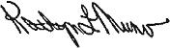

KATHRYN L. MUNRO

Lead Director

2022 Proxy Statement v

Table of Contents

Table of Contents

A Message from Our Chairman, President | ii | Proposal 3: Ratification of The | 99
and CEO |  | Appointment of Deloitte & Touche LLP
A Message from Our Lead Director | iv | as the Independent Accountant for the
 |  | Company
Notice of the 2022 Annual Meeting of | 1
 |  | The Independent Accountant | 99
Shareholders
 |  | Pre-Approval Policies | 100
Proxy Statement Summary | 3
 |  | Audit Fees | 101
The Value We Create | 3
 |  | Report of the Audit Committee | 101
Financial Highlights | 5
 |  | Stock Matters | 103
Customer Highlights | 6
 |  | Ownership of Pinnacle West Stock | 103
Employee Highlights | 8
 |  | Section 16(a) Beneficial Ownership Reporting | 104
Environmental Highlights | 12
 |  | Compliance
Community Highlights | 14
 |  | Shareholder Proposal | 105
Governance Highlights | 15
 |  | Proposal 4: Shareholder Proposal | 105
Board Highlights | 16
 |  | Seeking to Reduce Ownership
Compensation Highlights | 19 | Threshold to Call Special Shareholder
Information About Our Board and | 21 | Meetings
Corporate Governance |  | General Information | 108
Director Nomination Process | 21 | Time, Date and Place | 108
Board Effectiveness | 24 | Notice of Internet Availability | 109
Board and Committee Structure | 28 | Record Date; Shareholders Entitled to Vote | 109
Board Oversight and Engagement | 35 | Voting | 109
Director Nominees for the 2022 Annual | 44 | Quorum | 110
Meeting |  | Vote Required | 110
Proposal 1: Election of Directors | 44
 |  | Board Recommendations | 111
Director Nominees | 46 | Delivery of Annual Reports and Proxy | 111
Director Independence | 52 | Statements to a Shared Address and
 |  | Obtaining a Copy
Director Compensation | 53
 |  | Shareholder Proposals for the 2023 Annual | 112
Executive Compensation | 55
 |  | Meeting
Proposal 2: Advisory Vote on | 55
 |  | Proxy Solicitation | 112
Executive Compensation
 |  | Other Matters | 113
Human Resources Committee Report | 56
 |  | Related Party Transactions | 113
Compensation Discussion and Analysis | 56
 |  | Human Resources Committee Interlocks and | 114
(“CD&A”)
 |  | Insider Participation
Executive Compensation Tables | 81
 |  | Helpful Resources | 115
Pay Ratio | 98
Audit Matters | 99

INDEX OF FREQUENTLY
REQUESTED INFORMATION

 | Auditor Fees | 101
 | Beneficial Ownership Table | 103
 | Board Evaluations | 26
 | Board Leadership | 28
 | CEO Pay Ratio | 98
 | Clawback Policies | 78
 | Code of Ethics | 38
 | Company Culture | 35
 | Compensation Consultant | 63
 | Corp. Gov. Guidelines | 31
 | Director Attendance | 35
 | Director Independence | 52
 | Director Biographies | 46
 | Director Skills Matrix | 18
 | Director Tenure | 17
 | ESG Framework | 37
 | Financial Performance | 5
 | Human Capital Management | 37
 | Lead Director Duties | 28
 | Management Succession | 41
 | Named Executive Officers (“NEOs”) for
 | 2021 | 56
 | Peer Group | 65
 | Perks | 77
 | Related Party Transactions | 113
 | Risk Oversight | 38
 | Stock Ownership Guidelines | 78
 | Strategic Framework | 36
 | Succession Planning | 41

vi

Table of Contents

Notice of the 2022 Annual Meeting of Shareholders

DATE AND TIME

Wednesday, May 18, 2022 at 1:30 p.m. Eastern Daylight Time

LOCATION

Online at www. virtualshareholdermeeting. com/PNW

WHO CAN VOTE

All shareholders of record at the close of business on March 10, 2022 are entitled to notice of and to vote at the Annual Meeting

ADVANCE VOTING METHODS

INTERNET

www.proxyvote.com

TELEPHONE

1-800-690-6903

MAIL

Mark, sign, date, and mail your proxy card or voting instruction form (a postage-paid envelope is provided for mailing in the United States)

VOTING ITEMS

- To elect eleven directors to serve until the 2023 Annual Meeting of Shareholders

FOR each director nominee

- To hold an advisory vote to approve executive compensation

FOR

- To ratify the appointment of our independent accountant for the year ending December 31, 2022
FOR

- A shareholder proposal asking the Company to amend its governing documents to reduce the ownership threshold to 10% to call special shareholder meetings, if properly presented at the meeting.
AGAINST

Your vote is important. Whether you plan to participate in the Annual Meeting or not, please promptly vote by telephone, over the Internet, by proxy card, or by voting instruction form.

By order of the Board of Directors,

DIANE WOOD

Corporate Secretary
April 5, 2022

The Proxy Statement and form of proxy are first being made available to shareholders on or about April 5, 2022.

EXECUTIVE OFFICES ADDRESS:

PINNACLE WEST CAPITAL CORPORATION
Post Office Box 53999

Phoenix, Arizona 85072-3999

2022 Proxy Statement | 1

Table of Contents

Notice of the 2022 Annual Meeting of Shareholders

Proxy Voting Roadmap

Proposal 1 – Election of Directors

The Board of Directors and the Corporate Governance and Public Responsibility Committee believe that the eleven nominees possess the skills and experience necessary to serve on the Board and have concluded that each nominee is qualified to serve as director.

To know more about this proposal, see page 44.

The Board of Directors unanimously recommends a vote FOR the election of the nominated slate of directors.

Proposal 2 – Advisory Vote on Executive Compensation

The Company has designed its executive compensation program to align executives’ interests with those of our shareholders, make executives accountable for business and individual performance by putting pay at risk, and attract, retain and reward the executive talent required to achieve our corporate objectives and to increase long-term shareholder value. We believe that our compensation policies and practices promote a pay-at-risk philosophy and, as such, are aligned with the interests of our shareholders.

To know more about this proposal, see page 55.

The Board of Directors unanimously recommends a vote FOR the approval of the Company’s executive compensation.

Proposal 3 – Ratification of The Appointment of Deloitte & Touche LLP (“D&T”) as the Independent Accountant for the Company

The Audit Committee has discussed the qualifications and performance of D&T and believes that the continued retention of D&T to serve as the Company’s independent accountant is in the best interest of the Company and its shareholders.

To know more about this proposal, see page 99.

The Board of Directors unanimously recommends a vote FOR ratification of the appointment of Deloitte & Touche as the Company’s independent accountant for the year ending December 31, 2022.

Proposal 4 – A Shareholder Proposal

A shareholder proposal asking the Company to amend its governing documents to reduce the ownership threshold to 10% to call a special shareholder meeting, if properly presented at the 2022 Annual Meeting of Shareholders.

To know more about this proposal, see page 105.

The Board of Directors unanimously recommends a vote AGAINST this proposal.

2

Table of Contents

Proxy Statement Summary

The Value We Create

The APS Promise

Our Purpose

As Arizona stewards, we do what is right for the people and prosperity of our state.

Our Vision

Create a sustainable energy future for Arizona.

Our Mission

Serve our customers with clean, reliable and affordable energy.

Our Principles

The culture and behaviors that will enable us to fulfill our purpose, vision and mission.

Design for Tomorrow

See the Way Forward
Innovate with Courage

Value Learning

Empower Each Other

Embrace Diverse Perspectives
Challenge Respectfully

Unite as One Team

Succeed Together

Create Clarity
Anchor in Safety

Deliver for the Community

Our Strategy

How we will execute our mission to achieve our vision.

Long-term issues and priority areas of focus

for our business over the next ten years:

- focus on customer experience and community stewardship;
- support an evolving workforce;

- decarbonize and manage generation resources;

- achieve a constructive regulatory environment; and

- ensure long-term financial health.

Strategies and Goals

Actions and targets that guide resources and efforts to address our long-term issues.

Business Plan

Defines how each business unit executes our strategy.

Tiered Metrics

Provides a clear look at what the Company is trying to accomplish by measuring what matters.

Performance Management

Recognizes and rewards the individual contributions to priority work.

2022 Proxy Statement | 3

Table of Contents

Proxy Statement Summary

The Value We Create for Our Stakeholders

Financial

Creating long-term value for our shareholders is dependent upon having the right strategy to drive our operational performance. We recognize the links between strong customer satisfaction, a constructive regulatory environment and financial health and stability. To support future value creation for our shareholders, we are committed to enhancing our customer focus and improving our regulatory relationships. In addition, our strong customer growth and clean energy investments distinguish our future potential to build shareholder value.

Page 5

Customers

Customers are at the core of what we do every day at APS, and we are committed to providing options that make it easier for them to do business with us. We continually work to find new and better ways to meet our customers’ needs. Recognizing that creating customer value is inextricably linked to increasing shareholder value, our focus remains on our customers and achieving an industry-leading customer experience.

Page 6

Employees

Our more than 5,800 dedicated employees strengthen our Company with their skills, experience and diverse perspectives. We recognize that the next generation of employees has its own unique career expectations, and our business is evolving to accommodate the changing workforce. We are taking steps to support the changing needs, skills and priorities of our employees. We also continue to develop new strategies to attract and retain our highly skilled employees, and ensure they remain engaged during this time of change.

Page 8

Environment

APS is committed to its role as a leader in environmental and sustainability stewardship by establishing sound environmental policies, managing environmental risks, implementing world-class environmental management systems and driving the adoption of sustainable concepts. Anchored by our Clean Energy Commitment to provide 100% clean, carbon-free electricity by 2050, our sustainability initiatives also include ensuring adequate water security, waste management, and land use and biodiversity.

Page 12

Communities

In addition to powering Arizona, we empower communities across Arizona through programs and partnerships dedicated to improving the lives of Arizonans. Our multifaceted approach to community engagement is grounded in our commitment to community development. We not only invest in the communities where we do business but also focus on building meaningful relationships, which help us manage our social, economic and environmental impact.

Page 14

4

Table of Contents
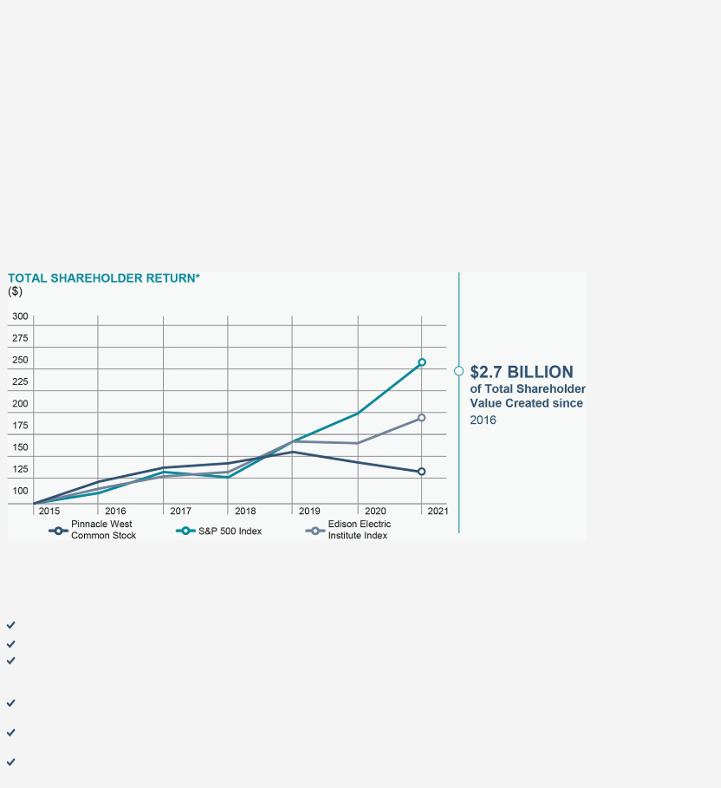

Proxy Statement Summary

Financial Highlights

Shareholder Value

Our management team is committed to increasing shareholder value as one of our top priorities. One area where we underperformed compared to our historical track record was in total shareholder return, which combines stock price performance with dividends paid, at -7.8% for the year. Arizona Corporation Commission (“ACC”)-driven discussions and increased regulatory uncertainty leading up to a disappointing outcome in our 2019 rate case impacted total shareholder return. We are taking actions coming out of the 2019 rate case, including announcing that we plan to file another rate case in 2022 and plan to defer any equity issuances until after the next rate case. In addition, we anticipate further clarity around the regulatory environment in Arizona and look forward to the ability to have more detailed discussions regarding the execution of our clean energy commitment and growth profile. We are committed to cultivating robust communication and collaboration with the ACC and other stakeholders to find constructive solutions that support our customers while maintaining the financial health of our Company. We believe we have the right strategy and team in place to meet our near-term goals and deliver long-term shareholder value.

- Value of $100 invested as of December 31, 2015, with dividends reinvested.

2021 Financial and Operating Highlights

PNW increased its dividend for the 10th consecutive year.
Maintained solid credit ratings from all three rating agencies despite a challenging rate case outcome.

In 2021, APS continued to drive our customer affordability initiative to identify opportunities to streamline our business processes, which resulted in the Company identifying approximately $30 million in annual incremental cost saving opportunities starting in 2022 through LEAN principles.

Maintained reliable energy delivery to customers through the largest regional natural gas freeze-off event in recent history, loss of a pipeline due to explosion, and severe transmission limitations due to wildfire.
Non-nuclear generation units performed exceptionally well during the crucial summer run, with a summertime equivalent availability factor of 94.4%. This was our second highest performance percentage in the last 10 years, only second to 2020, which was 95.3%.

APS continued successful operation of Palo Verde Generating Station (“PVGS”), a nuclear energy facility that is the largest clean-air generator in the United States.

2022 Proxy Statement | 5

Table of Contents

Proxy Statement Summary

Customer Highlights

Recognizing that creating customer value is inextricably linked to increasing shareholder value, our focus remains on our customers and achieving an industry-leading customer experience. This multi-year objective includes incrementally improving our scores in the J.D. Power Electric Utility Residential Study Overall Customer Satisfaction Index (“J.D. Power Residential Customer Satisfaction Rating”). We made progress on that front in 2021. Our fourth-quarter overall customer satisfaction score in the J.D. Power Residential Customer Satisfaction Rating advanced to the third-quartile, and we made year-over-year improvements in several key areas important to customers, including power quality and reliability, billing and payment, and phone customer care. We also were named a 2021 Business Customer Champion by international market research firm Escalent. They recognized us as one of the top performing electric utilities in the nation for brand trust, product experience, service satisfaction and customer effort score for business customers.

Customer Care Center

Our customers can contact us anytime – day or night – through our 24/7 Customer Care Center. In 2021, our call center performance improved, with associates answering about 76% of more than one million calls in 30 seconds or less. We also experienced growth of 53% in online transactions and engagements through digital customer platforms. Through our website and app, customers completed 26 million-plus transactions and engagements in 2021. Accordingly, customers collectively rate our app with over 4 stars on both Apple and Google app stores.

Customer Advisory Board

Formed in 2020 and made up of a cross-section of customers and stakeholders, this group met several times in 2021 to inform us of customer needs, wants and perspectives. Their direct feedback facilitated improved analysis, education and communication to customers about rate plan options, rate names and related communications. Additionally, the Customer Advisory Board helped shape on-going redesign and enhancements to APS’s monthly bill based on customer feedback, research and industry best practices.

Customer Experience Strategy Council

In 2021, we initiated an organization-wide customer experience strategy council designed to further drive a customer-oriented culture and improve J.D. Power Residential Customer Satisfaction Rating performance. Through this and other on-going customer-centric initiatives, we:

- Embraced increased empathy and knowledge training for care center associates;

- Adopted more flexible payment arrangements for customers;

- Simplified our financial assistance process for customers and community partner agencies by significantly increasing the number of customer and financial support provided to them;

- Implemented numerous customer web-based enhancements, including streamlined navigation and Spanish language transaction capabilities on aps.com; an enhanced online power outage center; and enrollment of more than 1 million customers for outage email and text notifications;

- Refined our communications and outreach strategy; and

- Launched a broad-reaching ad campaign focused on energy efficiency and financial assistance programs.

6

Table of Contents

Proxy Statement Summary

Limited Income Offerings

We have assistance programs that provide discounts to qualified limited-income customers as well as programs to help customers to stay on top of their bills:

- Crisis Bill Assistance. Qualified customers experiencing an unplanned major expense or an unexpected reduction in income can receive up to $800 a year to cover current or past due APS bills through the Crisis Bill Assistance program.

- Energy Support. Funded at $48 million in 2021, our energy support program gives qualified limited-income customers a 25% discount on their bill each month.

- Project Share. This program encourages our customers and employees to make tax-deductible contributions through their monthly electric bills and employee paychecks, respectively. In addition, we match employee contributions dollar-for-dollar. All contributions are then administered by the Salvation Army to assist limited-income customers in paying their utility bills.

- Safety Net and Guest Role. These programs allow customers to designate a friend or relative as a Safety Net partner or Guest to receive a copy of their monthly energy bill as a reminder when payment is due and to be notified if the account becomes past-due. Guest roles also have access to account information with options to make payments and compare service plans.

2022 Proxy Statement | 7

Table of Contents

Proxy Statement Summary

Employee Highlights

Our more than 5,800 dedicated employees strengthen our Company with their skills, experience and diverse perspectives. Human capital measures and objectives that the Company focuses on in managing its business include the safety of its employees, diversity and inclusion, succession planning, hiring and retention of talent, compensation and benefits and employee engagement.

Focused on Our People

The Company seeks to attract the best employees, to retain those employees and to create a safe, inclusive and productive work environment for all employees. We believe the strength, talent, and commitment of our employees are significant contributors to our Company’s success.

Talent Strategy

- Internship Programs: 69 virtual summer internships in 2021, 68% of whom were diverse based on race, ethnicity, or gender

- Top 100 Internship Program award received from WayUp, for the second consecutive year in 2021

- Apprentice Programs: 127 apprentices in the programs, 38 of whom were hired for the programs in 2021

- Incoming Engineer Programs: New Engineers in Operations Program (Fossil); Legacy Engineer Program (PVGS); Rotational Engineer Program (Transmission and Distribution)

- Enhanced applicant experience and relationship management through the implementation of SuccessFactors applicant tracking system

- Strong commitment to our communities: Our Company values and encourages active engagement by our employees in the community, which is attractive to new employees

Retention

- Robust employee engagement, including 10 Employee Network Groups (see page 11 of this Proxy Statement)

- Average employee tenure of 12.77 years due to strong talent strategy

- Total turnover for 2021 was 9.8% (4.1% of which were related to retirements)

- Annual and focused quarterly pulse surveys allow us to gather employee feedback, identify opportunities for improvement and compare our performance to other companies

- The surveys allow us to track our Employee Experience Index and take meaningful action in response to survey results

- Actions taken in response to the surveys include enterprise-wide initiatives focused on improving communication between employees and management, removing obstacles that prevent job success, providing opportunities for employees to have more access to leadership, and improved meeting efficiency

8

Table of Contents

Proxy Statement Summary

Development and Succession Planning

- Graduated 84 employees from our leadership academies in 2021

- 68% of officers, including our CEO, were promoted from leadership positions within the Company⁽¹⁾

- 60% of officer positions have “ready-now” replacements identified⁽¹⁾

- Our Learning and Development organization was recognized as a top training organization, earning an APEX Award from Training Magazine

- Launched a wide variety of on-demand training programs for all leaders, who collectively completed over 12,000 development modules

- Officers and other select Company leaders attended Catalytic Leadership in Culture Transformation session

- As of March 1, 2022.

Diversity, Equity, and Inclusion (“DEI”)

At APS, we believe that belonging matters. When we feel seen, heard, and valued, we can more effectively unite behind our APS Promise. You can find more information on the APS Promise on page 35 of this Proxy Statement. We create this sense of belonging through our commitment to inclusion.

Inclusion at APS involves taking deliberate action to embrace the unique perspectives of each employee. True inclusion brings greater appreciation for our diversity. This allows us to equitably leverage our powerful workforce so we can succeed together to bring our APS Promise to life.

Employee diversity:⁽¹⁾

- 33% are ethnically or racially diverse

- 25% are female

- 16% are veterans

New hires in 2021:

- 44% were ethnically or racially diverse

- 37% were female

- 10% were veterans

40% of all officers are female⁽¹⁾

In 2021 we launched our DEI Strategy, which covers eleven focus areas. Key activities in 2021 included:

- A four-part inclusive leadership education series for all officers and HR team members covering topics such as cultural competence, unconscious bias, and allyship.

- Launching a company-wide inclusion calendar to increase visibility to recognize and celebrate multiple cultures.

APS was honored with the 2021 Inclusive Workplace Award, a joint accolade from the Diversity Leadership Alliance and the Arizona Society of Human Resources Management.

- As of December 31, 2021.

2022 Proxy Statement | 9

Table of Contents

Proxy Statement Summary

Our DEI Strategy: Key Areas of Focus

Alignment & Accountability

DEI Education and Dialogue — Create experiential learning to ensure alignment around relevant concepts across the organization

DEI Governance and Influence — Build governance structure to ensure alignment and accountability

DEI Analytics — Extract data-driven insights to shape our DEI approach and monitor progress through meaningful measures

Policies & Practices — Assess and revise internal policies and practices to ensure equity

Workforce Evolution

Talent Acquisition — Analyze and evolve current recruiting and selection processes to improve external diverse hiring

Talent Development, Performance

- Succession — Assess existing talent processes to ensure equity and improve diverse representation among leadership

Workforce Development — Explore our current activities and create clarity and ownership for developing talent pipelines to create a diverse workforce for the future

Leveraging Connections

Employee Network Groups — Evolve our ENGs to increasingly serve as business resources over time

Employee Communication & Events — Visibly demonstrate our commitment to diversity, expose employees to different cultures and perspectives and recognize key occasions

Internal Partnerships — Partner with key internal stakeholder groups to ensure an integrated and aligned approach

External Partnerships & Recognition — Partner with external organizations to benchmark, innovate, and be recognized for our DEI efforts

In 2021, we developed and implemented a multi-faceted DEI Strategy, focusing on eleven critical areas.

10

Table of Contents
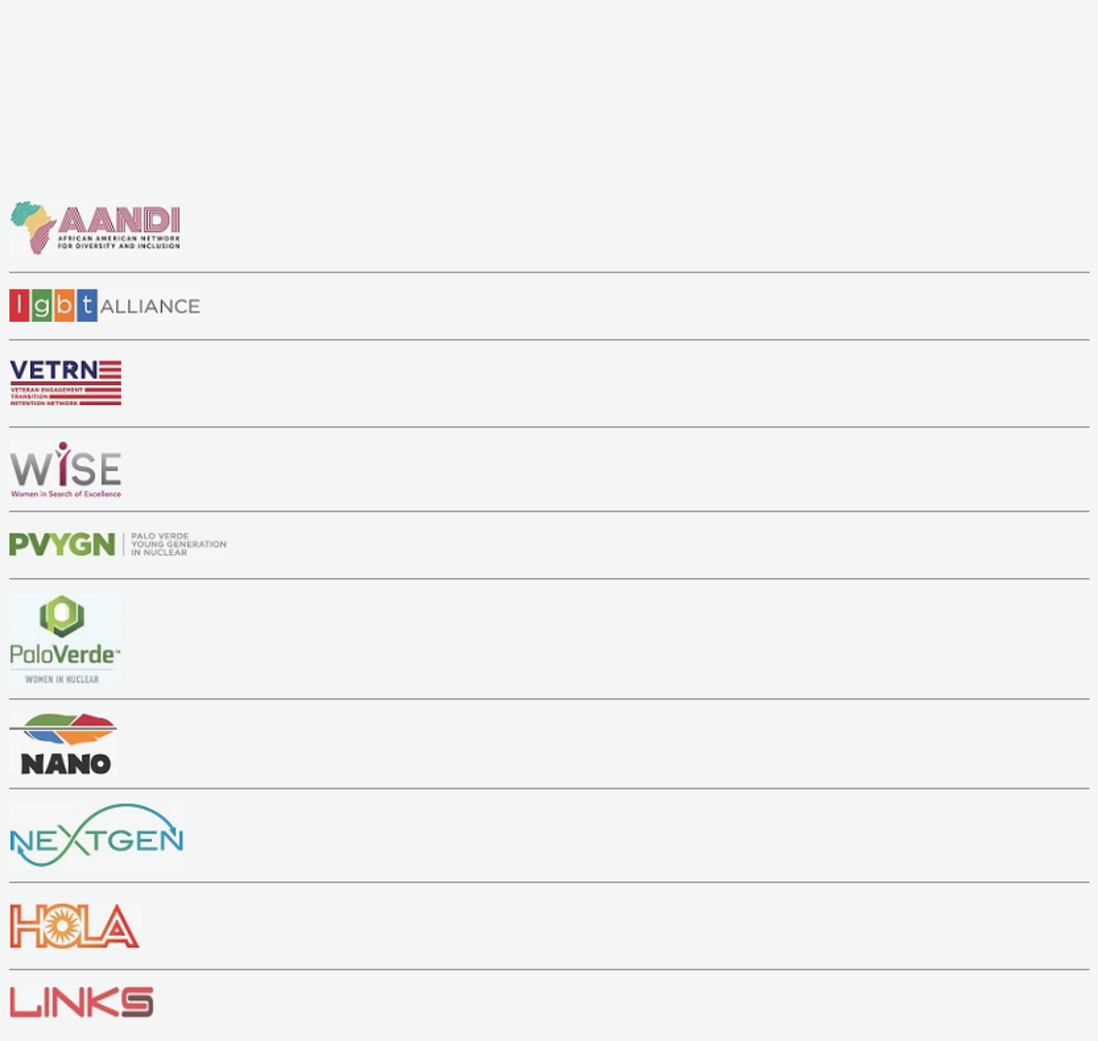

Proxy Statement Summary

Employee Network Groups

To encourage employees to challenge themselves, develop additional skills and advance within their chosen fields, the Company supports 10 employee networks that enable employees to connect with one another and promote career development:

The African American Network for Diversity and Inclusion’s mission is to create a collaborative and highly engaged network of African-American employees that promote the interests of AANDI, its strategic initiatives and the values of APS.

The Lesbian, Gay, Bisexual & Transgender Alliance’s mission is to empower inclusion through community, support, and education.

The Veteran Engagement, Transition & Retention Network’s mission is to develop opportunities benefiting our honored Arizona veterans. We strive to promote their service to our country, leadership skills, and the achievements of veterans in the organization.

Women in Search of Excellence’s mission is to build a community at APS to further develop women as they achieve their personal and professional excellence.

Palo Verde Young Generation in Nuclear’s mission is to unite young professionals for the purpose of strengthening its community by focusing on the success of nuclear technology.

Palo Verde Women in Nuclear’s mission is to promote an environment in which all employees are able to succeed while working to encourage public awareness about nuclear energy.

The Native American Network Organization’s mission is to attract and develop Native American talent by providing professional development opportunities, assisting in recruiting and retention, and encouraging community development.

Next Gen’s mission is to unite professionals new to the utility industry by providing professional development opportunities, enhance recruitment and retention, and organize community outreach programs.

The Hispanic Organization for Leadership and Advancement promotes a culture of inclusiveness and community stewardship across APS, as well as develops high-performing leaders in pursuit of operational excellence and continuous self-improvement.

Links’ mission is to connect experienced employees with opportunities for development, networking, and engagement.

2022 Proxy Statement | 11

Table of Contents
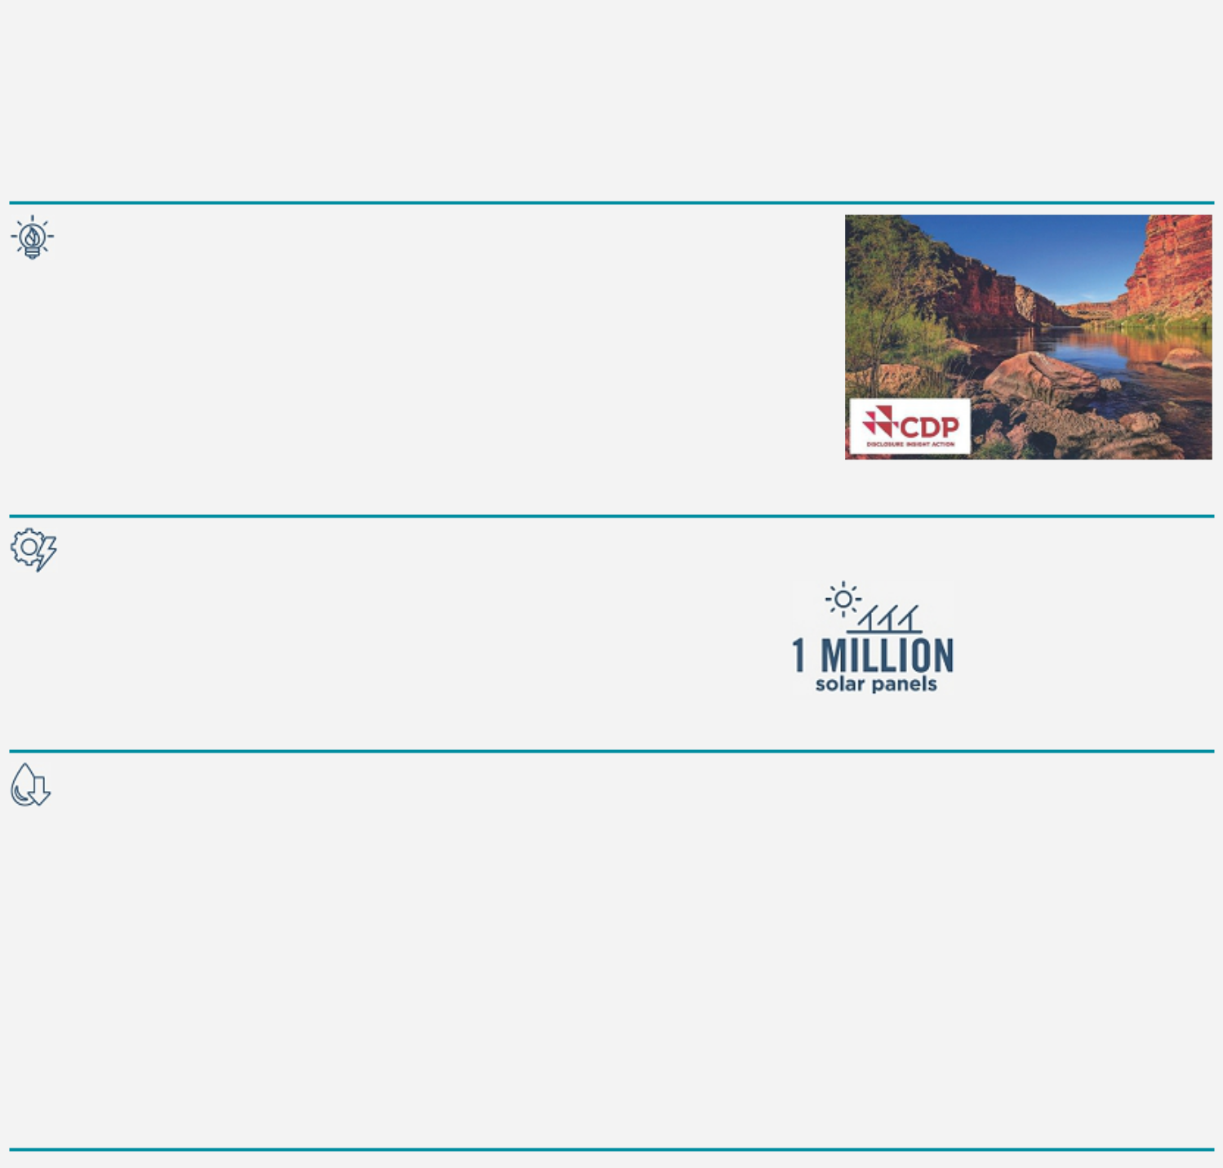

Proxy Statement Summary

Environmental Highlights

Through our Clean Energy Commitment we are dedicated to providing clean, reliable and affordable electricity in order to achieve a sustainable future for our Company and our customers.

Recognition

- Pinnacle West is only one of two North American electric utility companies to achieve leadership scores in both climate change and water security in 2021 by global environmental non-profit CDP. This is the third year in a row that we are receiving leadership scores in both areas.

- Pinnacle West moved up to a “AA” rating from Morgan Stanley Capital International (“MSCI”) (as of April 27, 2021).

- On the list of Top 100 Green Utilities from Energy Intelligence for the third year in a row.

Energy Innovation

APS is in the midst of one of the greatest periods of change in our Company’s 130-plus year history.

- 2,300 MW of renewable capacity today

- Plan to add at least 3,000 MW of additional clean energy technologies, including solar and storage, by 2025

Our 10 grid-scale solar plants are powered by more than

1 million solar panels

Reducing Water Consumption

Operating in the water-constrained Southwest desert, APS is challenged to maximize our use of water resources:

- 33% reduction⁽¹⁾ in groundwater use in 2021

- 73% of water consumed by APS power plants in 2021 came from treated effluent water

Projected Conservation of Non-Renewable Water Supplies:

2025 |  | 2035
50% | 79% | 80% | 95%
groundwater reduction⁽¹⁾ | use of treated effluent water | groundwater reduction⁽¹⁾ | use of treated effluent water
- Based on 2014 usage baseline.

12

Table of Contents
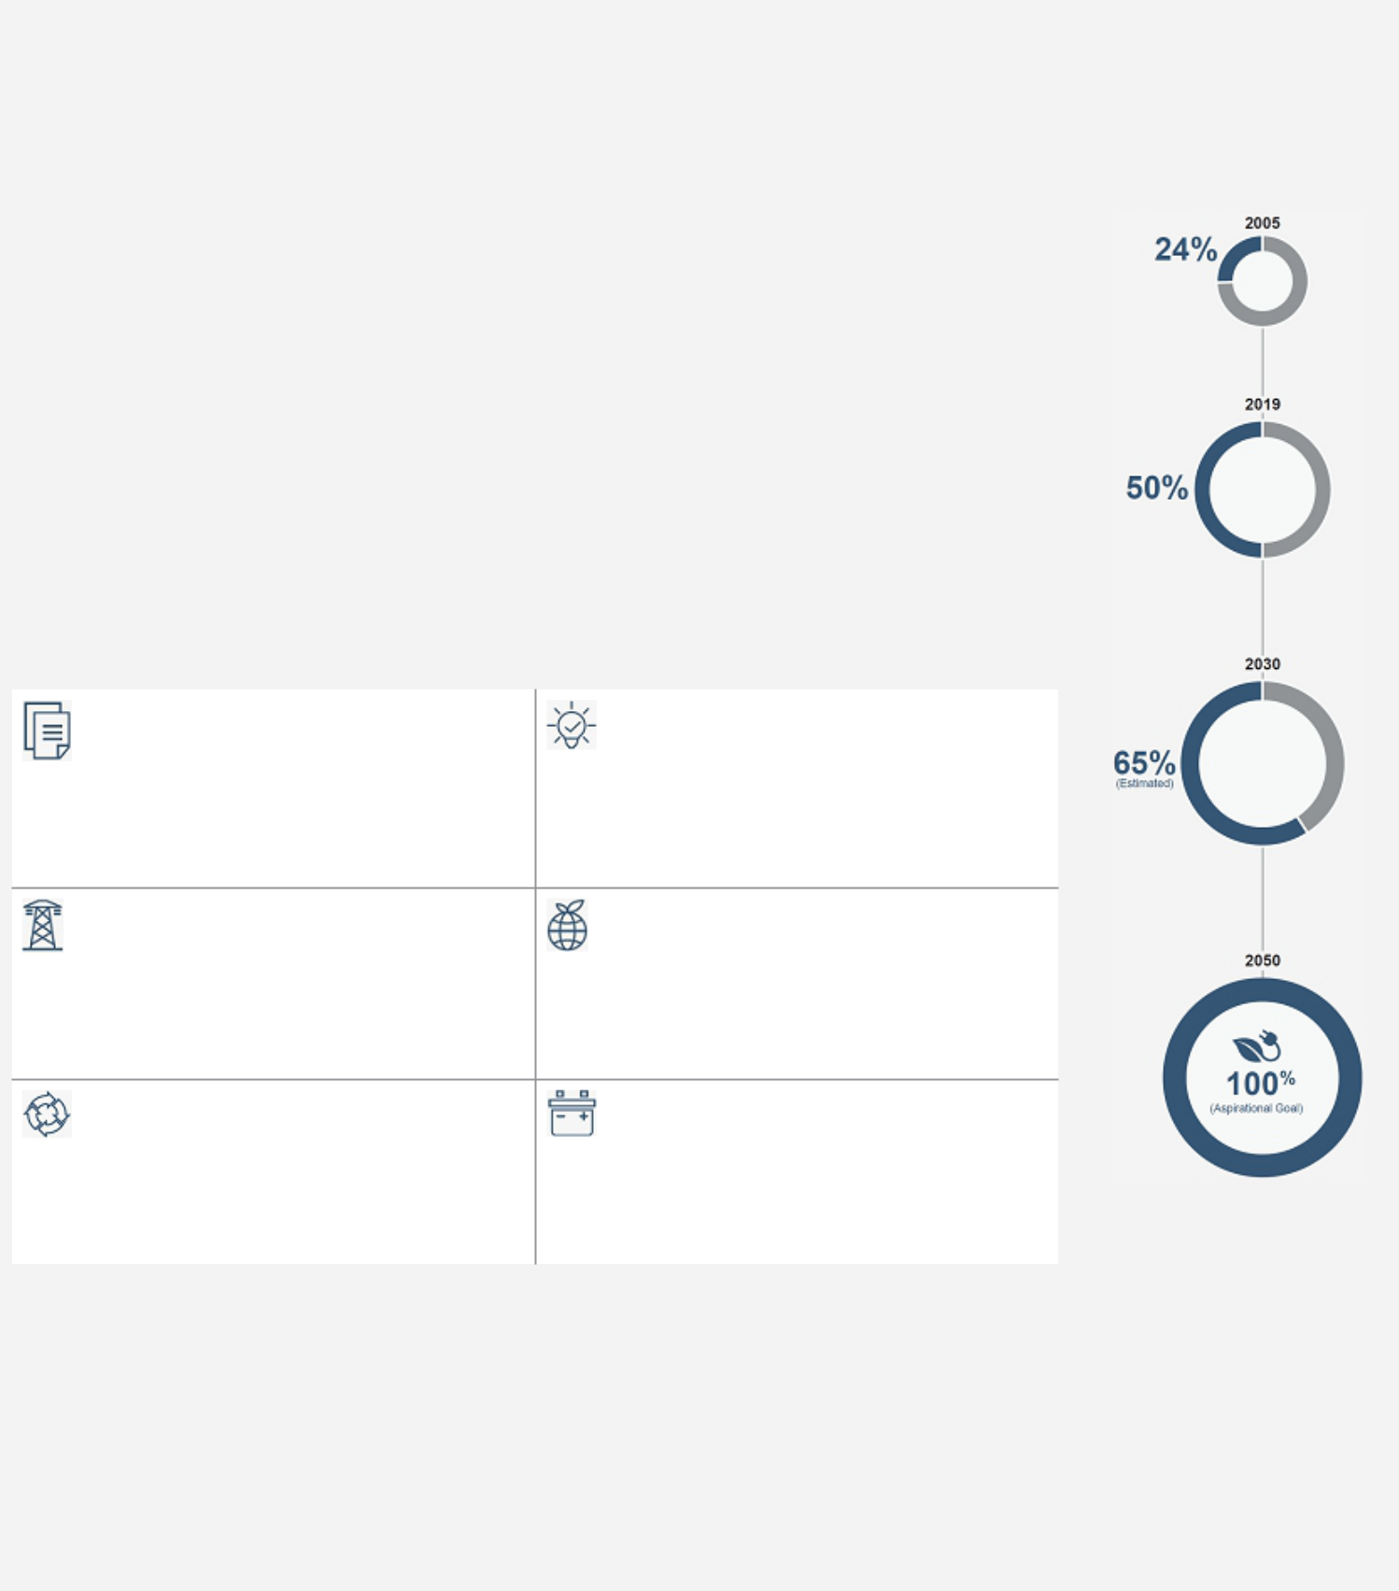

Proxy Statement Summary

APS Clean Energy Commitment

Our Commitment: 100% Clean Energy by 2050 Clean Energy Pathway

We’ve set a bold, three-part goal to provide a clean energy future for our customers:

- A 2050 goal to provide 100% clean, carbon-free electricity

- A 2030 target of achieving a resource mix that is 65% clean energy, with 45% of the generation portfolio coming from renewable energy

- A commitment to end APS’s use of coal-fired generation by 2031

A Clean Economic Future

- Our clean energy plan will be guided by sound science and focused on achieving environmental and economic gains—all while maintaining affordable, reliable service for our customers

- Collaboration with customers, regulators and other stakeholders is key to our plan’s ultimate success. We look forward to working alongside those who believe in this vision to move forward together to keep Arizona clean, beautiful and thriving

Pathways to 100% Clean

POLICY DECISIONS | ELECTRIFICATION
 | Electrification will drive a cleaner environment and
Support policy decisions that leverage market-
 | more energy-efficient operations throughout the
based technology and innovation to attract
 | economy
investment in Arizona

EXISTING POWER SOURCES | MODERNIZATION OF THE ELECTRIC GRID
Near-term use of natural gas until technological | Continue to advance infrastructure that is
advances are available to maintain reliable | responsive and resilient while providing
service at reasonable prices | customers more choice and control

EVOLVING MARKET-BASED SOLUTIONS |  |  | ENERGY STORAGE SOLUTIONS
Participation in the Energy Imbalance Market |  |  | Storage creates opportunities to take advantage
provides access to clean energy resources while |  |  | of midday solar generation and better respond to
saving customers money |  |  | peak demand
NEXT |  | Steady progress on our commitment:
STEPS IN
ACTION |  | ● Plans to transition the Four Corners Power Plant to seasonal operations beginning in 2023, which will result in up to
 |  | 25% reduction in annual CO2 emissions at the plant.
 |  | ● Since 2020, we’ve procured nearly 1,400 MWs of additional clean energy and storage – all of which will be in service
 |  | no later than 2024.
 |  | ● Deployed more than 57,000 residential thermostats with a capability of shedding more than 80 MWs of energy.
 |  | ● You can learn more about our Clean Energy Commitment at aps.com/cleanenergy.

2022 Proxy Statement 13

Table of Contents

Proxy Statement Summary

Community Highlights

Our multifaceted approach to community engagement is grounded in our commitment to community development. We not only invest in the communities where we do business but also focus on building meaningful relationships, which help us manage our social, economic and environmental impact.

We use a variety of communication channels to develop dialogue in our communities, such as open houses, community summits, business forums and other special events. These enable us to gather feedback from participants, inform them about issues that affect their communities and APS, and identify issues and opportunities for action. We also develop strategic partnerships in areas such as diversity, inclusion and workforce development to advance social and economic goals.

Coal Communities Transition

The transition away from coal-fired power plants toward a clean energy future will pose unique economic challenges for the communities around these plants. We worked collaboratively with community leaders and stakeholders to propose a comprehensive Coal Communities Transition Plan. The proposed framework provides substantial financial and economic development support to build new economic opportunities and addresses a transition strategy for plant employees. We are committed to continuing our long-running partnership with the Navajo Nation in other areas as well, including expanding electrification and developing tribal renewable projects. Our proposed plan supports the Navajo Nation, where the Four Corners Power Plant is located, the communities surrounding the Cholla Power Plant and the Hopi Tribe, which is impacted by closure of the Navajo Generating Station. The ACC approved a portion of the plan in the 2019 rate case decision, and continues to discuss possible further action in a separate docket.

Community Engagement

At APS, we initiate and maintain relationships with stakeholders to understand our communities’ needs and identify opportunities to build healthy, sustainable communities. Our community engagement teams collaborate with representatives from a wide range of community and government entities – including state, county, municipal and tribal governments; military bases; school districts; nonprofits; business organizations; and public interest groups. The relationships are one important way we collect, record and address feedback so that we work together to address concerns. In addition, the ACC has a grievance process for our customers.

Philanthropy and Volunteerism

We are actively involved in the communities we serve. We partner with nonprofit organizations and community groups across the state to build a stronger, healthier Arizona. Our efforts include financial support, board service and volunteer assistance.

We donated more than $12.9 million to worthwhile causes in 2021. This includes our corporate giving program, which funds organizations that contribute to the vitality of Arizona, with a focus on arts and culture, civic and economic development, education and employment, and human services.

Giving back to our communities is an integral part of the APS culture, and our employees donate their time and talents to a wide range of charitable organizations and civic initiatives. In 2021, our employees volunteered an estimated 91,000 hours of time, both in-person and virtually, to causes important to them.

Our employees sit on the boards of more than 400 Arizona community organizations, nonprofit organizations, and industry groups. Employee engagement of this kind not only assists those nonprofits but also produces valuable human-capital development, as volunteerism increases loyalty, performance and job satisfaction while providing employees with professional development opportunities.

Other accomplishments for 2021 include:

- Employees pledged $2 million to the 2021 Community Service Fund campaign (United Way) and the Company matched those pledges for a total of $4 million donated.

- For the fourth consecutive year, we supported Arizona teachers through our Supply My Class awards program, in which 500 Arizona K-12 teachers from 266 schools received $500 each to purchase much-needed classroom supplies.

- In partnership with key nonprofit partners, we launched a heat relief strategy aimed at expanding assistance to vulnerable individuals during Arizona’s hot summer months, including:

  - In partnership with the Foundation for Senior Living, we provided 30 APS vulnerable customers with emergency air conditioning repair or replacement through the APS Healthy Homes AC Pilot Program.

  - In partnership with St. Vincent de Paul, we provided rent and utility assistance to 72 households and 503 individuals.

14

Table of Contents
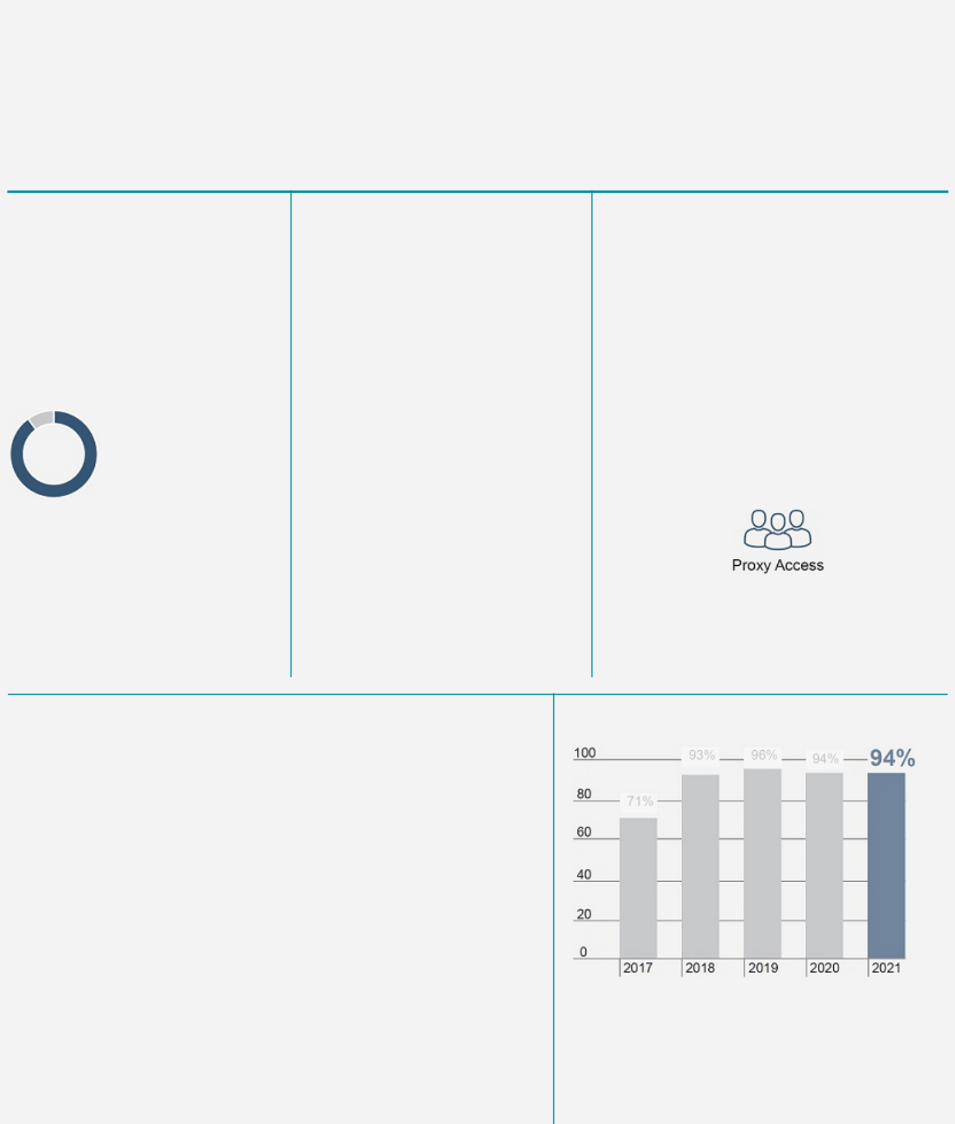

Proxy Statement Summary

Governance Highlights

Our strong corporate governance practices demonstrate the Board’s commitment to enabling an effective structure to support the successful execution of our strategic priorities.

Board Independence

- Independent Lead Director role with clearly defined and robust responsibilities

- Ten of our eleven Director nominees are independent and the members of all of the Board committees are independent

10/11

independent

director nominees

Board Oversight

- Defined oversight of environmental, social, and governance practices by the Corporate Governance and Public Responsibility Committee

- Robust management succession planning

- Focused Board oversight of strategy and risk

- Thorough CEO performance oversight process

Board Performance

- Annual Board, committee and individual Director evaluations and discussions with the Lead Director

- Director skills and experience necessary to provide oversight of our strategy and operations

- Robust Board refreshment, with director retirement policy

Shareholder Rights

- Reduced threshold to call a special meeting to 15%

- Annual elections of all Directors with cumulative voting

- No poison pill plan or similar anti-takeover provision in place

- No supermajority provisions in our Articles of Incorporation or Bylaws

- Proxy access rights allowing up to 20 shareholders owning 3% of our outstanding stock for at least 3 years to nominate up to 25% of the Board

3% | 3 years | 20 shareholders

Compensation Governance

- Shareholder feedback informs compensation program design

- Substantial proportion of target compensation is at risk (83% for the CEO and 70% for other NEOs)

- Performance shares are 100% tied to relative performance (50% on relative TSR and 50% on relative operational metrics and beginning with the grants in 2022, we have changed the metrics and added a clean megawatt installed metric) and require 90th percentile performance for maximum payouts

- No excise tax gross-up provisions in new or materially amended Change of Control Agreements with our NEOs

- Anti-hedging policy for all Directors, officers and all employees and anti-pledging policy for all Directors and officers

- Stock ownership guidelines for all NEOs (all NEOs are in compliance with the stock ownership guidelines)

- Clawback policy for our current or former executive officers covering short- and long-term incentive awards

While we have historically had strong support for our program, after a disappointing say-on-pay vote result in 2017, significant changes were made in direct response to our shareholder outreach and feedback provided to the Board, resulting in strong support for our compensation program since 2017.

2022 Proxy Statement 15

Table of Contents
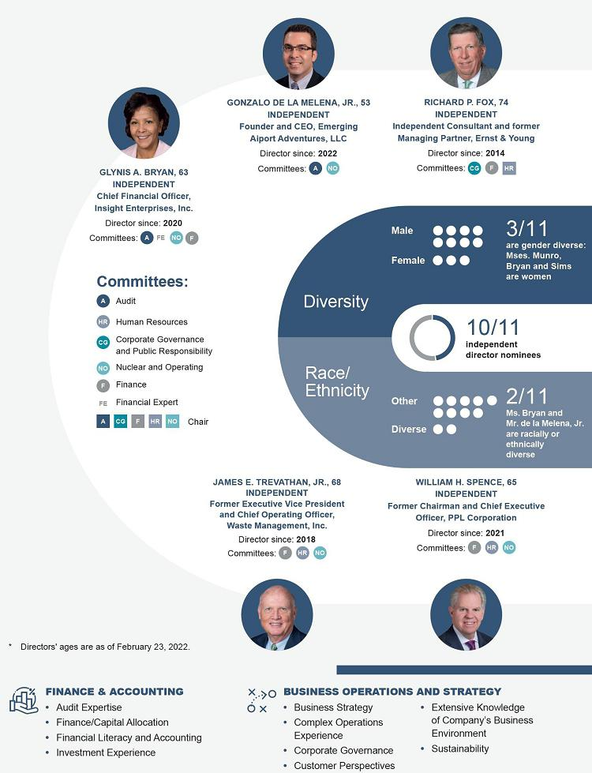

Proxy Statement Summary

Board

Highlights

16

Table of Contents
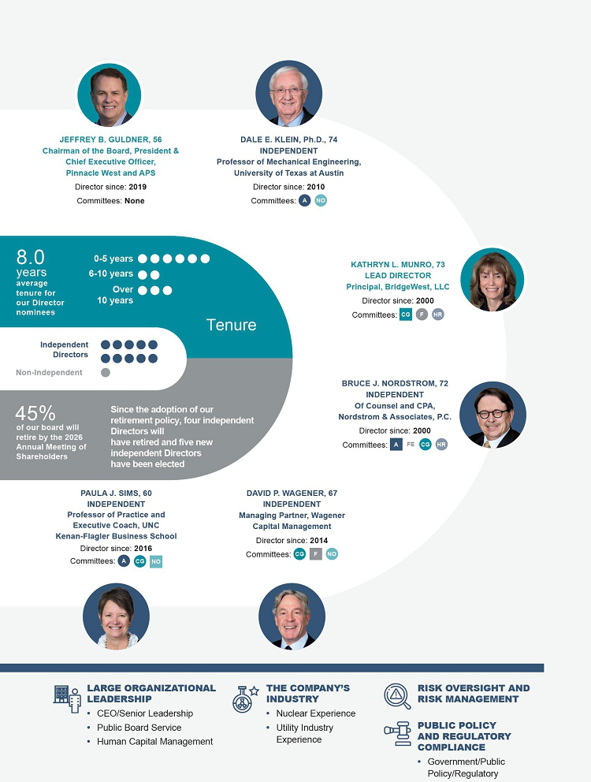

Proxy Statement Summary

2022 Proxy Statement 17

Table of Contents

Proxy Statement Summary
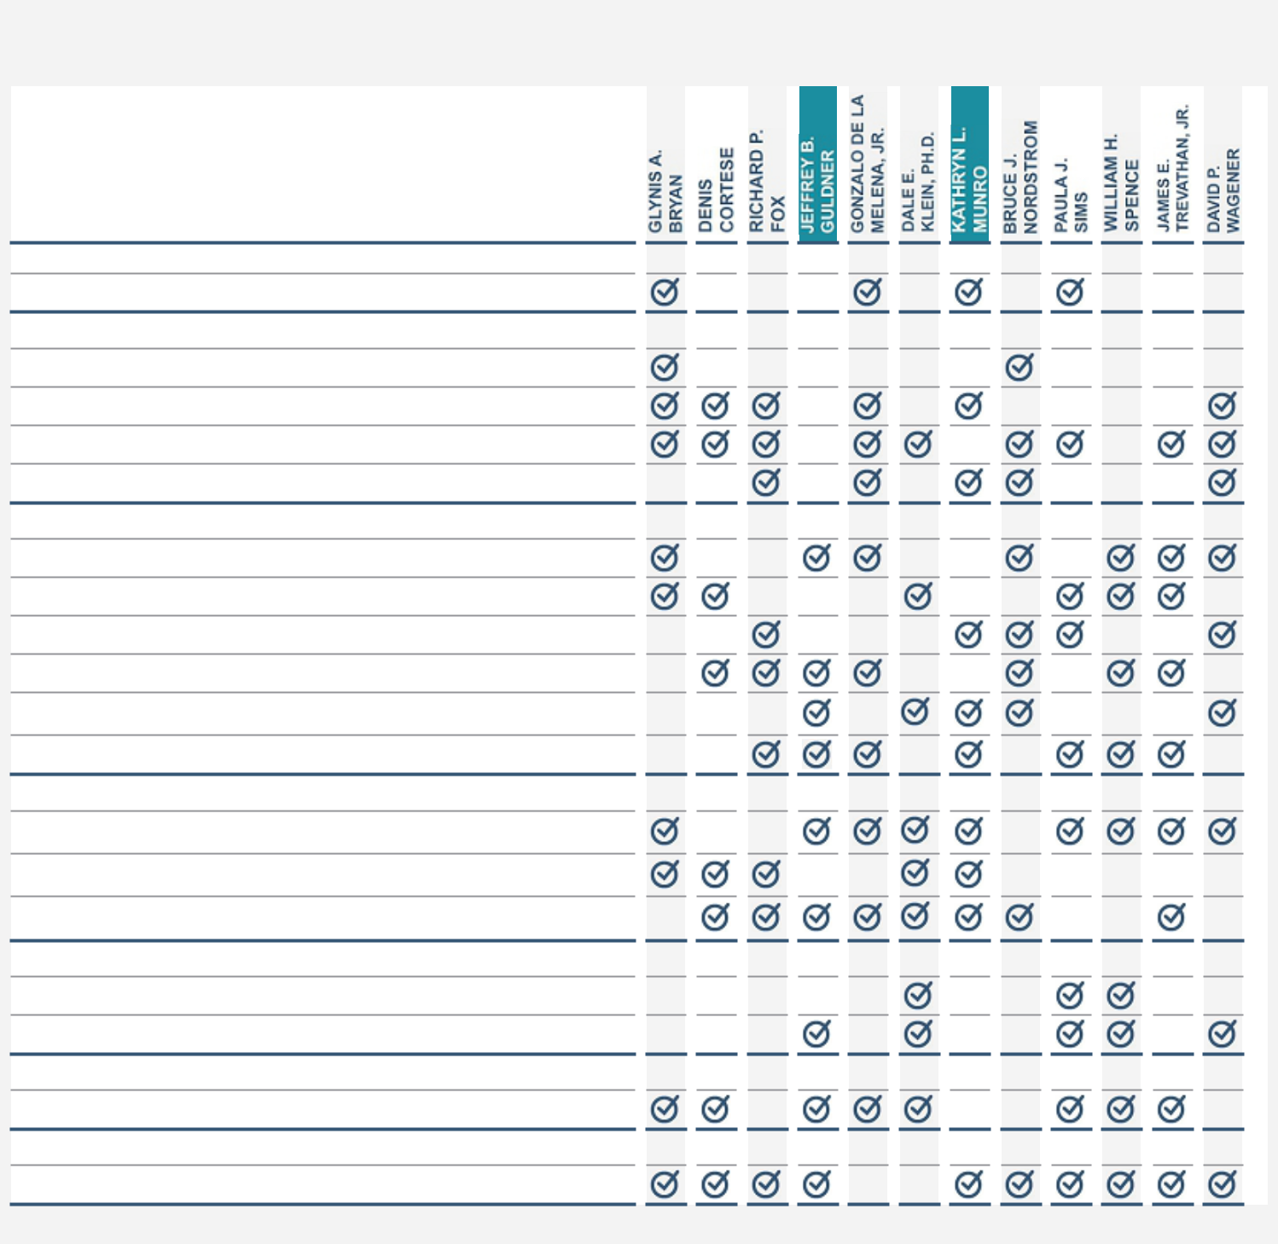

DIRECTORS’ KEY SKILLS AND EXPERIENCE

DIVERSITY

Gender or Ethnicity

FINANCE & ACCOUNTING

Audit Expertise

Finance/Capital Allocation

Financial Literacy and Accounting

Investment Experience

BUSINESS OPERATIONS AND STRATEGY

Business Strategy

Complex Operations Experience

Corporate Governance

Customer Perspectives

Extensive Knowledge of Company’s Business Environment Sustainability

LARGE ORGANIZATIONAL LEADERSHIP CEO/Senior Leadership

Public Board Service

Human Capital Management

THE COMPANY’S INDUSTRY

Nuclear Experience

Utility Industry Experience

PUBLIC POLICY AND REGULATORY COMPLIANCE

Government/Public Policy/Regulatory

RISK OVERSIGHT AND RISK MANAGEMENT

Risk Oversight and Risk Management

Board Leadership

18

Table of Contents
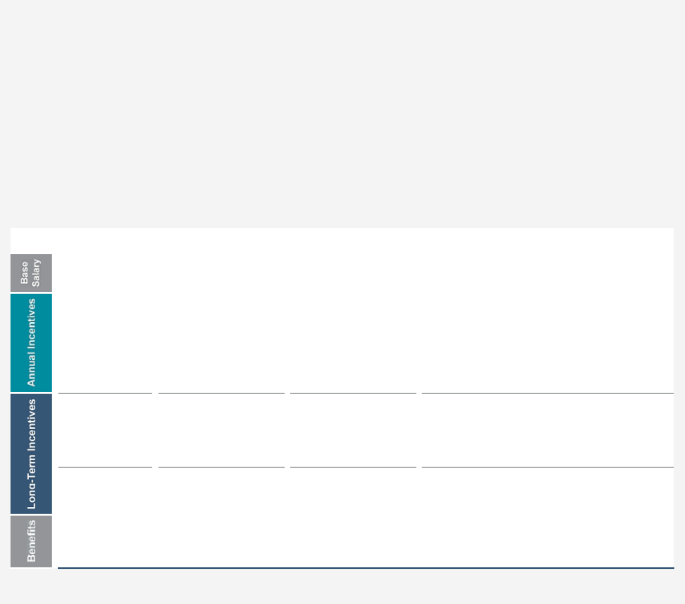

Proxy Statement Summary

Compensation Highlights

Our compensation program is designed to be transparent with a clear emphasis on putting pay at risk and retaining key executives. Our executive compensation philosophy centers on the core objectives of maintaining alignment with shareholder interests and retaining key management.

Pay at Risk

The Company believes that a significant portion of each NEO’s total compensation opportunity should reflect both upside potential and downside risk. We place a strong emphasis on performance-based, shareholder-aligned incentive compensation.

For 2021, the Company’s core executive compensation program for our NEOs consisted of the following key components⁽¹⁾:

 |  | Measurement
Pay Element |  | Period | Performance Link |  | Description
Cash |  | Salary is based on experience, performance and responsibilities and is benchmarked to a peer group and market
 |  | survey data to align with competitive levels.
 |  |  | Earnings |  | Universal measure of business financial performance;
 |  |  | CEO: 50.0% |  | encourages achievement of bottom-line earnings growth
Cash |  | 1 year | Other NEOs: 50.0% |  | goals.

Business Unit | Pre-established operational business unit performance
 | goals that include safety, customer experience and
Performance 50.0%
 | operational quality and efficiency metrics.

 |  | Relative TSR
Performance |  | 50%
 | 3 years
 |  | Relative Operational
Shares 70%
Performance

50%

Relative measures incentivize sustained shareholder value creation and strong performance on operational benchmarks.

Restricted | Vest ratably over |  | Encourages retention; value dependent upon share
Stock Units |  | Stock Price | price appreciation and four-year vesting to encourage
 | 4 years
30% |  |  | retention.

We provide benefits, including pension and deferred compensation programs, change of control agreements and limited perquisites, that are designed to attract and retain our executive talent.

- For additional details on our executive compensation program for our NEOs, see page 61 of this Proxy Statement.

2022 Proxy Statement | 19

Table of Contents
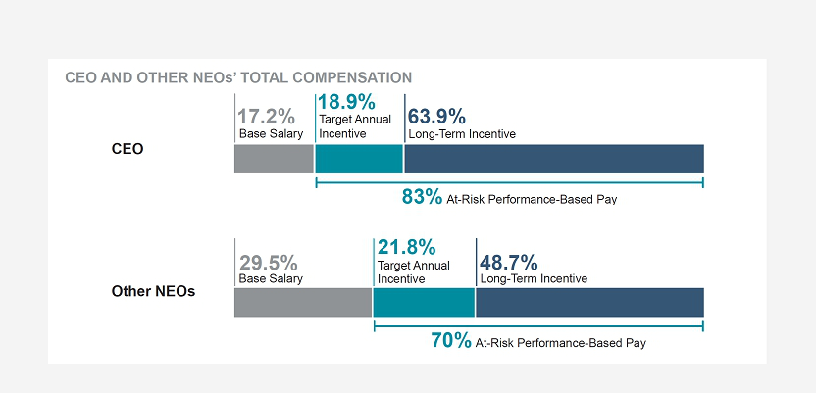

Proxy Statement Summary

20

Table of Contents

Information About Our Board and Corporate Governance

Director Nomination Process

Director Qualifications

The Bylaws and the Corporate Governance Guidelines contain Board membership criteria that apply to nominees recommended for a position on the Board. Under the Bylaws, a director must be a shareholder of the Company. The Corporate Governance and Public Responsibility Committee is responsible for identifying and recommending to the Board individuals qualified to become directors. The Board believes that its membership should be composed of a combination of knowledge, skills, and experience in the areas discussed below.

SKILLS AND EXPERIENCE POSSESSED BY OUR BOARD AS A GROUP

FINANCE AND ACCOUNTING

As a publicly traded company subject to the rules of the Securities and Exchange Commission (“SEC”) and the New York Stock Exchange (“NYSE”), and because we operate in a complex financial environment and are regulated by multiple regulators, we require strong financial, accounting and capital allocation skills and experience.
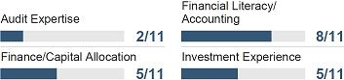

BUSINESS OPERATIONS AND STRATEGY

As a large organization with complex operations, our Board must have a comprehensive combination of skills and experience in business operations and strategy in order to guide the development of our near- and long-term operational and strategic goals, and making sure they are sustainable, which requires knowledge about the Company, our business environment and our customers’ perspectives.

LARGE ORGANIZATIONAL LEADERSHIP

Leadership experience in a large organization, at both the management and director level, provides directors with the ability to effectively oversee management in setting, implementing and evaluating the Company’s strategic objectives for long-term sustainability as well as providing invaluable experience in developing, implementing and maintaining the policies and practices for managing an effective workforce.
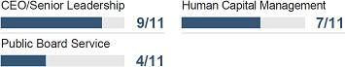

THE COMPANY’S INDUSTRY

Possessing an understanding of both the utility industry and the nuclear industry is important to understanding the challenges we face as we develop and implement our business strategy.

PUBLIC POLICY AND REGULATORY COMPLIANCE
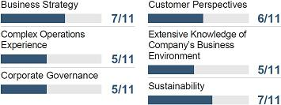

Operating in the heavily regulated utility industry, we are directly affected by public policy and the actions of various federal, state and local governmental agencies.

RISK OVERSIGHT AND RISK MANAGEMENT

Operations in our industry require the development of policies and

procedures that allow for the oversight of and effectively manage risk.

2022 Proxy Statement | 21

Table of Contents

Information About Our Board and Corporate Governance

The Board believes that diversity, utilizing a broad meaning that includes race, gender, background, ethnicity, accomplishments, and other traits, is an important consideration in selecting candidates. We require our outside director search firm to make diversity a focal point of any of our searches, with an emphasis on women candidates. Additionally, each director should possess the following core characteristics:

High Standards | We look for individuals that set high standards and expectations for themselves and others and the
 | accomplishment of those standards and expectations.
Informed Judgment | Directors should be thoughtful in their deliberations. We look for individuals who demonstrate intelligence, wisdom
 | and thoughtfulness in decision-making. Their decision-making process should include a willingness to thoroughly
 | discuss issues, ask questions, express reservations and voice dissent.
Integrity and Accountability | Directors should act with integrity. We look for individuals who have integrity and strength of character in their
 | personal and professional dealings. Our Directors should be prepared to be, and are, held accountable for their
 | decisions.
Time and Effort | Directors should spend the necessary time to properly discharge their responsibilities as directors, including
 | reviewing written materials provided to the Board or committee in advance of Board or committee meetings.
 | Directors are expected to be present at all Board meetings, the Annual Meeting of Shareholders, and meetings of
 | committees on which they serve. We also expect our Directors to make themselves accessible to management
 | upon request.
Other Commitments | We expect our Directors to monitor their other commitments to ensure that these other commitments do not
 | impact their service to our Company. Directors may not serve on more than three other boards of public
 | companies in addition to the Pinnacle West Board without the prior approval of the Corporate Governance and
 | Public Responsibility Committee. A director may not serve as a member of the Audit Committee if he or she
 | serves on the audit committees of more than three public companies (including the Company) unless the Board
 | determines that such simultaneous service would not impair the ability of such member to effectively serve on the
 | Company’s Audit Committee.
Stock Ownership | We expect our Directors to have investments in the Company’s stock that align with our shareholders. Our
 | Directors are expected to comply with our Director Stock Ownership Policy.
22

Table of Contents

Information About Our Board and Corporate Governance

Selection of Nominees for the Board

The Corporate Governance and Public Responsibility Committee uses a variety of methods to identify and evaluate nominees for a director position:

Board Size |  | The Corporate Governance and Public Responsibility Committee regularly assesses the appropriate size of the
 |  | Board, including whether any vacancies on the Board are expected due to retirement or otherwise.
Board Knowledge, Skills, Expertise |  | The Corporate Governance and Public Responsibility Committee considers whether the Board reflects the
and Diversity |  | appropriate balance of knowledge, skills, expertise, and diversity required for the Board as a whole. Diversity is a
 |  | focal point of the Corporate Governance and Public Responsibility Committee’s deliberations. The Board believes
 |  | that diversity, utilizing a broad meaning that includes race, gender, background, ethnicity, accomplishments, and
 |  | other traits, is an important consideration in selecting candidates.
Sourcing Candidates |  | Candidates may be considered at any point during the year and come to the attention of the Corporate
 |  | Governance and Public Responsibility Committee through current Board members, professional search firms or
 |  | shareholders. The Corporate Governance and Public Responsibility Committee evaluates all nominees from
 |  | these sources against the same criteria.

Other than Mr. de la Melena, Jr., all Directors were elected at the 2021 Annual Meeting of Shareholders. In recruiting Mr. de la Melena, Jr., the Corporate Governance and Public Responsibility Committee retained the search firm of Spencer Stuart to help identify director prospects, perform candidate outreach, assist in reference and background checks, and provide related services. Candidates who passed the initial screening were then interviewed by members of the Corporate Governance and Public Responsibility Committee, Mr. Guldner and Ms. Munro, followed by the full Board. The Corporate Governance and Public Responsibility Committee recommended Mr. de la Melena, Jr. for Board membership, and he was added to the Board in February 2022.

Shareholder Recommendation of Board Candidates for the 2023 Annual Meeting

Shareholder nominations for a director to the Board must be received by the Corporate Secretary at the address set forth below by

November 18, 2022 (“Shareholder Nomination”):

Corporate Secretary

Pinnacle West Capital Corporation
400 North Fifth Street, Mail Station 8602

Phoenix, Arizona 85004

Proxy Access

In February 2017, our Board amended the Bylaws to provide, among other things, that under certain circumstances a shareholder or group of shareholders may include director candidates that they have nominated in our annual meeting proxy statement — “proxy access”. Under these provisions, a shareholder or group of up to 20 shareholders seeking to include director nominees in our annual meeting proxy statement must own 3% or more of our outstanding common stock continuously for at least the previous three years. Generally, the number of qualifying shareholder-nominated candidates the Company will include in its annual meeting proxy materials will be limited to the greater of 25% of the Board or two candidates. Based on the current Board size of 12 directors, the maximum number of proxy access candidates we would be required to include in our proxy materials is three.

2022 Proxy Statement | 23

Table of Contents

Information About Our Board and Corporate Governance

Nominees submitted under the proxy access provisions that are later withdrawn or are included in the proxy materials as Board-nominated candidates will be counted in determining whether the 25% maximum has been reached. If the number of shareholder-nominated candidates exceeds 25%, each nominating shareholder or group of shareholders may select one nominee for inclusion in our proxy materials until the maximum number is met. The order of selection would be determined by the amount (largest to smallest) of shares of our common stock held by each nominating shareholder or group of shareholders. Requests to include shareholder-nominated candidates under proxy access must be received by our Corporate Secretary at the address set forth above not earlier than the close of business on November 6, 2022 nor later than the close of business on December 6, 2022. The number of qualifying shareholder-nominated candidates the Company will include in its proxy materials under proxy access will be reduced on a one-for-one basis in the event the Company receives a Shareholder Nomination, but at least one qualifying shareholder-nominated proxy access nominee will be included in the proxy materials.

In all cases, shareholders and nominees must also comply with the applicable rules of the SEC and the applicable sections of our Bylaws relating to qualifications of nominees and nominating shareholders and disclosure requirements.

Board Effectiveness

Board Refreshment Planning

Our Board has developed a robust plan to refresh the Board and its leadership significantly over the next several years. The plan is designed to continue to provide for a well-qualified, diverse and highly independent Board, with the requisite experience and skills to provide effective oversight. This plan includes the identification of the current key skills and experience possessed by our members. A matrix of current key skills and experience possessed by our Board is on page 18. The identification of these skills and experiences, combined with a comprehensive Board evaluation process, provide visibility into the skills and experience leaving our Board in the future and allows for the identification of additional skills, experience or expertise needed to facilitate the Company’s long-term strategy. This information is taken into account when identifying director nominees during the recruitment process.

Board refreshment is overseen by the Corporate Governance and Public Responsibility Committee, which regularly assesses whether the composition of the Board reflects the knowledge, skills, expertise, and diversity appropriate to serve the needs of the Company.

24

Table of Contents

Information About Our Board and Corporate Governance

Director Retirement Policy

Our Board first adopted a Director Retirement Policy in 2016 that was based on a person’s age at the time of election. In February 2020, we reevaluated that policy. The policy as drafted could result in long tenure solely by virtue of the person’s age when he or she joined the Board. As such, we amended the policy to add a 12-year term limit in addition to an age limit. The revised policy provides that a non-employee Director will not be eligible to be nominated for election or re-election as a member of the Board if, as of the commencement of the term for which they are nominated, such Director will have (i) completed 12 years of service from the date of first election to the Board or (ii) attained 75 years of age. We also added a provision that will allow the Board, if it determines that it is in the best interest of the Company to do so, to extend such term limit to up to 15 years for a particular nominee, so long as the average tenure of the overall Board is less than 10 years. We believe this combination of both a term and age limit creates the most robust and effective policy.

We were also concerned about the rate of retirements under the age-only policy in light of the Company having a newly appointed CEO. Under the age-only policy, we would have experienced multiple years with more than one member scheduled to retire. We believe that it is in the best interests of the Company to better stagger these retirements while Mr. Guldner gets more experience in the CEO role. As such, we created a transition period that slowed the immediate turn-over rate, but provided a bridge to the final policy. Through and until the 2024 Annual Meeting of Shareholders, a non-employee Director shall be eligible for nomination for election or re-election as a member of the Board unless, as of the commencement of the term for which they are nominated, such Director will have completed 12 years of service from the date first elected to the Board and the individual has attained 75 years of age. During the transition period and under the final policy, the policies will apply regardless of the source of the nomination or whether the nomination was made at a meeting of the Board of Directors, at an Annual Meeting or otherwise.

Directors added or retired since the adoption of our Director Retirement Policy:

2016 ● Paula J. Sims added

2018 ● Roy A. Herberger, Jr. retired

2018 ● James E. Trevathan, Jr. added

2020 ● Glynis A. Bryan added

2020 ● Michael L. Gallagher retired

2021 ● William H. Spence added

2021 ● Humberto S. Lopez retired

February 2022 ● Gonzalo A. de la Melena, Jr.

added

May 2022 ● Denis A. Cortese scheduled retirement

50% of our Board has been refreshed

Since the adoption of our Director Retirement Policy, five independent Directors have been added and four members of the Board will have retired as of May 18, 2022. Under our current policy, over 45% of our current Board will retire by the 2026 Annual Meeting of Shareholders.

Our average tenure decreased from 12.2 years as of May 2016 to 8.0 years as of May 2022.

2022 Proxy Statement | 25

Table of Contents

Information About Our Board and Corporate Governance

Board Evaluations

OUR BOARD EVALUATION PROCESS

1 | Board Evaluation | Topics covered include, among others:
 | Each Director completes a comprehensive evaluation of Board and | ● Board composition and effectiveness
 | committee performance | ● Competency and accountability
 | Reviewed on a one-year stand-alone basis and three-year basis to identify
 |  | ● Deliberations and administration
 | year-over-year trends
 |  | ● Committee effectiveness
 |  | ● Specific skills, experience and expertise recommended by
 |  | Directors to be added or enhanced
2 | Director Self-Evaluation | Topics covered include, among others:
 | Each Director evaluates different areas of his or her performance as a | ● Independence
 | Director | ● Knowledge and expertise
 |  | ● Judgment and skills
 |  | ● Participation and contribution to collective decision-making
3 | One-on-One Discussions | Topics covered include, among others:
 | Conducted by Lead Director, who initially reviews the assessment results, in | ● The Board, its functions and membership
 | a formal annual call | ● Board and committee structure
 | The Lead Director is prepared to have hard conversations, if necessary, to
 |  | ● Processes for effective communication and feedback
 | keep the Board, and each individual Director, functioning at a high level
 |  | ● Director’s plan with respect to continuing Board service
 |  | ● Any other topic the individual Director desires to discuss
4 | Evaluation Results | The results of the evaluations and calls are presented to the
 |  | Corporate Governance and Public Responsibility Committee and full
 |  | Board each February
5 | Feedback Incorporated | Based on the evaluation results, changes in practices or procedures
are considered and implemented as needed

Each year, the Corporate Governance and Public Responsibility Committee reviews the Board and Director Self-Evaluations as well as the evaluation process to determine whether any changes to the evaluations or the process is necessary. This annual review is also shared with, and recommendations are solicited from, the full Board. This process provides the Board the ability to assess the overall functioning of the Board as a whole, and identify any skills, experience or expertise needed to continue to provide effective oversight of the Company’s long-term strategy. This process also allows the Board to identify any areas of concern, both with respect to the Board overall and with respect to individual performance. As performance issues are identified, they are addressed by the Lead Director and the Chairman as needed.

26

Table of Contents

Information About Our Board and Corporate Governance

Director Onboarding

Upon election to the Board, all new directors attend a director orientation program tailored to each director based on their past individual experience. After Mr. Spence was elected to the Board, he received detailed information and materials about our Company, business and operations. He attended a virtual orientation that took place over several days and included meetings with management from multiple business units, and presentations on topics of significance to the Company and our industry. A similar orientation is planned for Mr. de la Melena, Jr.

Director Education

Directors are provided with continuing education opportunities both within the Company and externally. In addition to the Company-hosted educational opportunities provided, directors are invited to attend Palo Verde Off-Site Safety Review Committee meetings that typically occur three times per year and directors are encouraged to attend a variety of industry and public board-related symposia and conferences throughout the year, many of which were virtual in 2021. Additionally, directors are permitted to participate in other educational opportunities relevant to the Company and submit such record of attendance for credit in our program.

Director Resignation Policies

We employ a plurality voting standard with a director resignation policy because we believe a majority voting policy is inconsistent with cumulative voting, which is mandated by the Arizona Constitution.

With respect to the election of directors, the Company’s Bylaws provide that in an uncontested election, a director nominee who receives a greater number of votes cast “withheld” for his or her election than “for” such election will promptly tender his or her resignation to the Corporate Governance and Public Responsibility Committee. The Corporate Governance and Public Responsibility Committee is required to evaluate the resignation, taking into account the best interests of the Company and its shareholders, and will recommend to the Board whether to accept or reject the resignation.

Under the Company’s Corporate Governance Guidelines, upon a substantial change in a director’s primary business position from the position the director held when originally elected to the Board, a director is required to apprise the Corporate Governance and Public Responsibility Committee and to offer his or her resignation for consideration to the Corporate Governance and Public Responsibility Committee. The Corporate Governance and Public Responsibility Committee will recommend to the Board the action, if any, to be taken with respect to the tendered resignation.

2022 Proxy Statement | 27

Table of Contents

Information About Our Board and Corporate Governance

Board and Committee Structure

The Board’s Leadership Structure

Lead Director

Kathryn L. Munro serves as the Company’s Lead Director and chairs the Corporate Governance and Public Responsibility Committee. As a former chief executive with significant Board and Chair and Lead Director experience, Ms. Munro has the competency and capability to fulfil the duties of Lead Director. As Lead Director, Ms. Munro is poised to guide the Board during these transformative times. Ms. Munro is an independent director and vigorously carries out the duties of the Lead Director. Ms. Munro makes sure the Directors are focused, are encouraged to offer different points of view, and maintain their independence from management.

The Lead Director performs the following duties and responsibilities as set forth in our Corporate Governance Guidelines:

- Serves as a liaison between the Chairman of the Board (the “Chairman”) and the independent Directors;

- Advises the Chairman as to an appropriate schedule of Board meetings, reviews and provides the Chairman with input regarding agendas for the Board meetings and, as appropriate or as requested, reviews and provides the Chairman with input regarding information sent to the Board;

- Presides at all meetings at which the Chairman is not present, including executive sessions of the independent Directors (which are regularly scheduled as part of each Board meeting) and calls meetings of the independent Directors when necessary and appropriate;

- Oversees the Board and Board committee self-assessment process;

- Is available for appropriate consultation and direct communication with the Company’s shareholders and other interested parties; and

- Performs such other duties as the Board may from time-to-time delegate.

These duties and responsibilities do not, however, fully capture Ms. Munro’s active role in serving as our Lead Director. For example, Ms. Munro has regular discussions with the CEO, other members of the senior management team and members of the Board between Board meetings on a variety of topics, and she serves as a liaison between the CEO and the independent Directors. Ms. Munro focuses the Board on key issues facing our Company and on topics of interest to the Board. She takes the lead on director recruitment and has a formal annual call with each non-employee Director to discuss the Board, its functions, its membership, the individual’s plan with respect to his or her continuing Board service, and any other topic the individual desires to discuss with our Lead Director. Her leadership fosters a Board culture of open discussion and deliberation to support sound decision-making. She also encourages communication between management and the Board to facilitate productive working relationships.

28

Table of Contents

Information About Our Board and Corporate Governance

Chairman and CEO Positions

Upon promoting Jeff Guldner to the position of CEO, the Board also chose to elect him as Chairman of the Board. The Board believes that the Company is in a better position to implement its near- and long-term strategies if the Chairman is also the person directly responsible for the operations executing those strategies. The Board further believes that separating the roles of the CEO and Chairman and appointing an independent Board Chairman at this time would create an additional level of unneeded hierarchy that would only duplicate the activities already being vigorously carried out by our Lead Director.

The independent Directors believe that Mr. Guldner, with his extensive knowledge of the challenges facing the Company and our industry and his open leadership style, will be a highly effective conduit between the Board and management and that Mr. Guldner provides the vision and leadership to execute on the Company’s strategy and create shareholder value without the need for an independent chair. The Board also convenes regularly scheduled executive sessions of the independent directors in order to ensure the independent directors can speak candidly and openly without the presence of management.

Board Committees

The Board has the following standing committees: Audit; Corporate Governance and Public Responsibility; Finance; Human Resources; and Nuclear and Operating. All of the charters of the Board’s committees are publicly available on the Company’s website (www.pinnaclewest.com). All of our committees conduct a formal review of their charters every other year and as often as any committee member deems necessary. In the years in which a formal review is not conducted, the Board has tasked management with reviewing the charters and recommending any changes management deems necessary or reflective of good corporate governance. The charters are also changed as needed to comply with any corresponding changes to any applicable rule or regulation.

All of our committees are comprised of independent Directors who meet the independence requirements of the NYSE rules, SEC rules, and the Company’s Director Independence Standards, including any specific committee independence requirements. The duties and responsibilities of our committees are as follows:

2022 Proxy Statement | 29

Table of Contents

Information About Our Board and Corporate Governance

AUDIT COMMITTEE
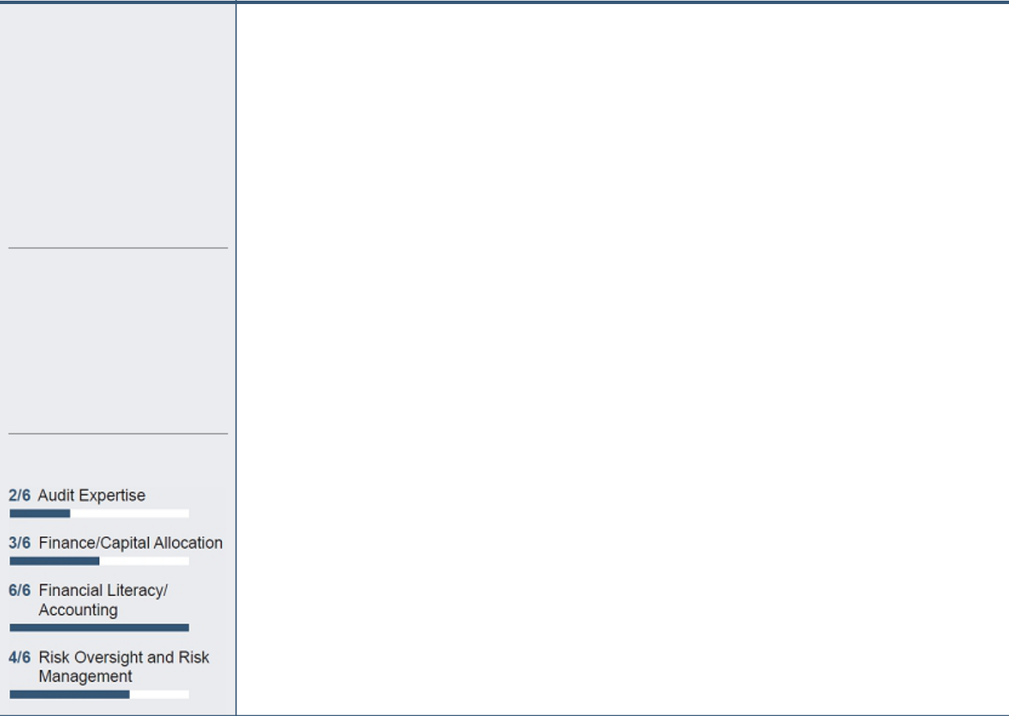

“The Audit Committee’s oversight of the Company’s audit function is critical and the Audit Committee members are committed to working with management to ensure effective risk and financial management.”

-Bruce Nordstrom

2021 MEETINGS: 6

COMMITTEE MEMBERS:

Bruce J. Nordstrom, Chair

Glynis A. Bryan
Denis A. Cortese
Gonzalo A. de la Melena, Jr.
Dale E. Klein
Paula J. Sims

KEY MEMBER SKILLS

RESPONSIBILITIES:

- Oversees the integrity of the Company’s financial statements and internal controls;

- Appoints the independent accountants and is responsible for their qualifications, independence, performance (including resolution of disagreements between the independent accountants and management regarding financial reporting), and compensation;

- Monitors the Company’s compliance with legal and regulatory requirements;

- Reviews the annual audited financial statements or quarterly financial statements, as applicable, and the “Management’s Discussion and Analysis of Financial Condition and Results of Operations” contained therein;

- Discusses with management and the independent accountants significant financial reporting issues and judgments made in connection with the preparation of the Company’s financial statements;

- Reviews the Company’s draft earnings press releases, as well as financial information and earnings guidance provided to analysts and rating agencies;

- Discusses guidelines and policies to govern the process by which risk assessment and risk management is undertaken across the Company and discusses the Company’s major financial risk exposures and the steps management has taken to monitor and control such exposures; and

- Reviews management’s monitoring of the Company’s compliance with the Company’s Code of Ethical Conduct.

The Board has determined that each member of the Audit Committee meets the NYSE experience requirements and that Mr. Nordstrom, the Chair of the Audit Committee, and Ms. Bryan are “audit committee financial experts” under applicable SEC rules. None of the members of our Audit Committee currently serve on more than three public company audit committees.

30

Table of Contents

Information About Our Board and Corporate Governance

CORPORATE GOVERNANCE AND PUBLIC RESPONSIBILITY COMMITTEE
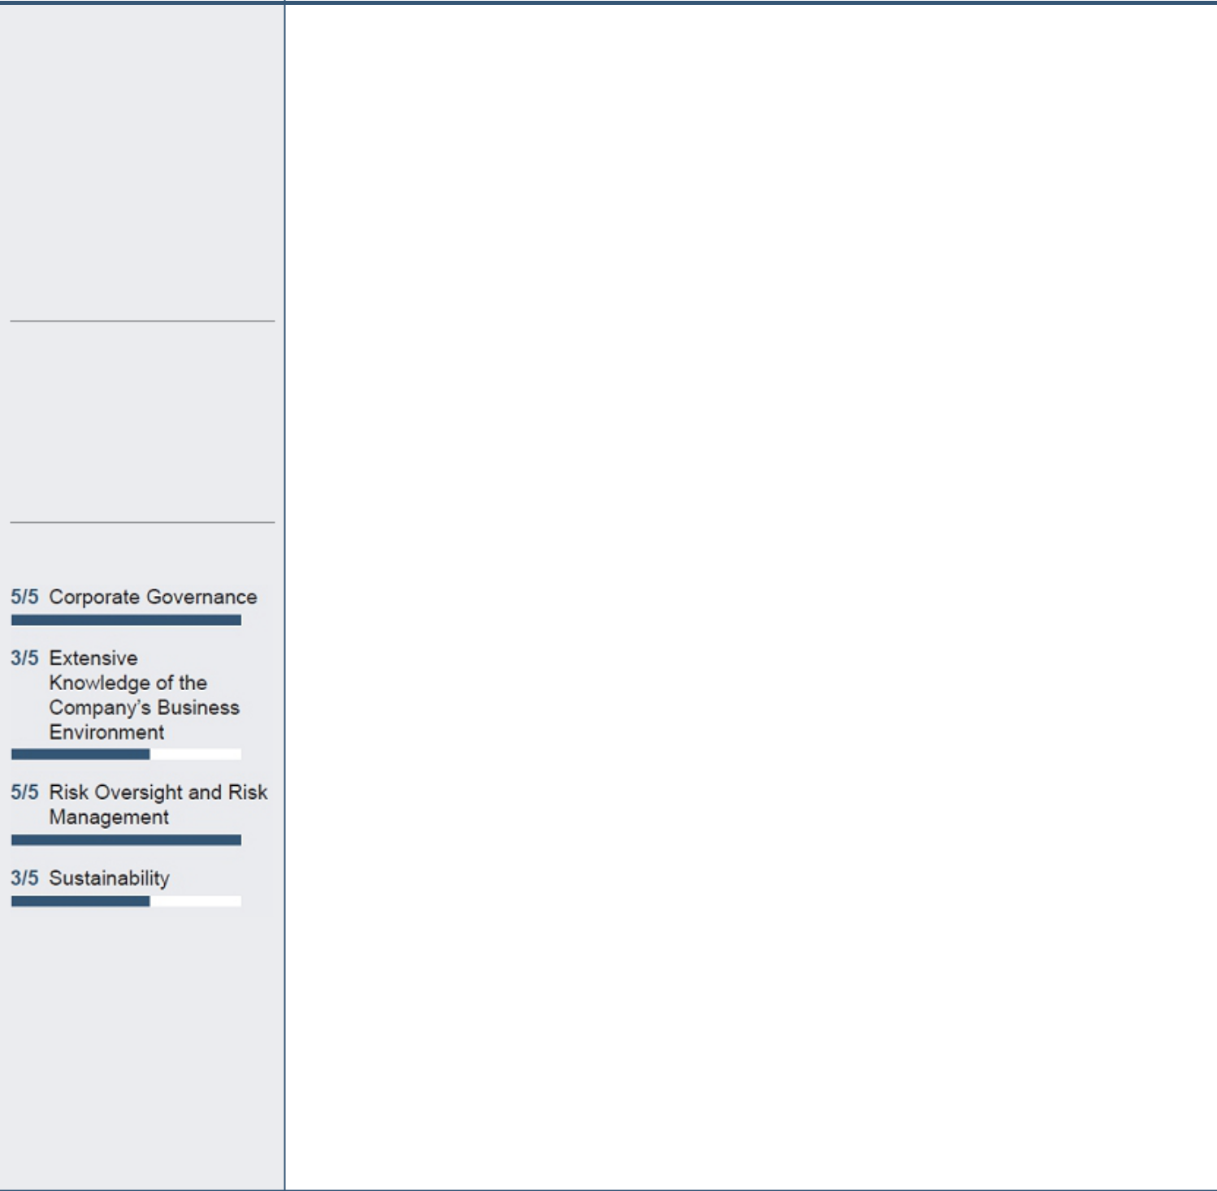

“The Committee focused on the composition of the Board in 2021 and the traits and skills that we considered important in adding a new director, targeting in particular diversity and an Arizona presence.”

-Kathy Munro

2021 MEETINGS: 4

COMMITTEE MEMBERS:

Kathryn L. Munro, Chair

Richard P. Fox Bruce J. Nordstrom Paula J. Sims David P. Wagener

KEY MEMBER SKILLS

RESPONSIBILITIES:

- Reviews and assesses the Corporate Governance Guidelines;

- Develops and recommends to the Board criteria for selecting new directors;

- Identifies and evaluates individuals qualified to become members of the Board, consistent with the criteria for selecting new directors;

- Recommends director nominees to the Board;

- Recommends to the Board who should serve on each of the Board’s committees;

- Reviews significant ESG trends that may impact the Company, ensuring the oversight of relevant ESG issues by the Board and its committees, and makes recommendations to the Board as appropriate;

- Reviews the Company’s public and social responsibility policies, strategy, and practices and periodically review them with the Board;

- Reviews the results of the Annual Meeting shareholder votes;

- Reviews and makes recommendations to the Board regarding the selection of the CEO and CEO and senior management succession planning;

- Reviews the Company’s Code of Ethical Conduct for compliance with applicable law;

- Recommends a process for responding to communications to the Board by shareholders and other interested parties;

- Reviews the independence of members of the Board and approves or ratifies certain types of related-party transactions;

- Reviews and makes recommendations to the Board regarding shareholder proposals requested for inclusion in the Company’s proxy materials;

- Reviews and makes recommendations regarding proxy material disclosures related to the Company’s corporate governance policies and practices;

- Periodically reviews principal risks relating to the Company’s corporate governance policies and practices or other matters addressed by the Corporate Governance and Public Responsibility Committee;

- Oversees the Board and committee self-assessments on at least an annual basis; and

- Reviews and assesses the Company’s Political Participation Policy, and then reviews the Company’s policies and practices with respect to governmental affairs strategy and political activities in accordance with the Company’s Political Participation Policy.

The Corporate Governance and Public Responsibility Committee periodically reviews and recommends to the Board amendments to the Corporate Governance Guidelines and the Political Participation Policy. The Corporate Governance Guidelines and the Political Participation Policy are available on the Company’s website (www.pinnaclewest.com).

2022 Proxy Statement | 31

Table of Contents

Information About Our Board and Corporate Governance

FINANCE COMMITTEE
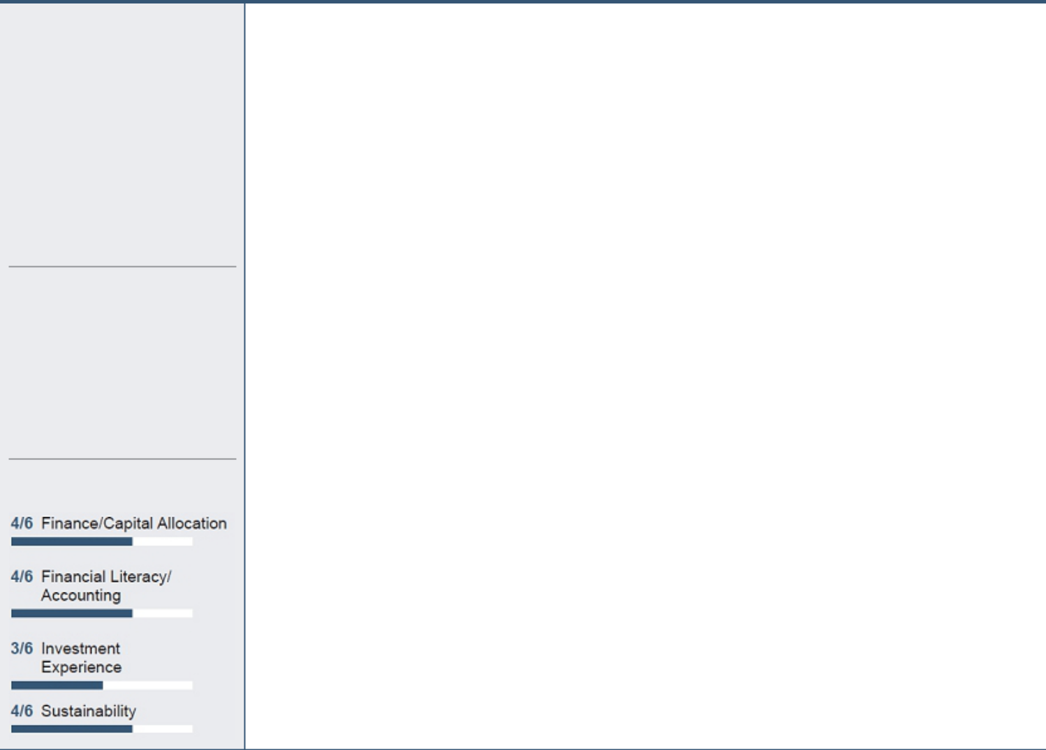

“The Finance Committee is focused on the long-term financial health of the Company by providing oversight of the Company’s financial performance, financing and capital strategy, and dividend policies and actions.”

-David Wagener

2021 MEETINGS: 5

COMMITTEE MEMBERS:

David P. Wagener, Chair

Glynis A. Bryan Richard P. Fox Kathryn L. Munro William H. Spence James E. Trevathan, Jr.

KEY MEMBER SKILLS

RESPONSIBILITIES:

- Reviews the historical and projected financial performance of the Company and its subsidiaries;

- Reviews the Company’s financial condition, including sources of liquidity, cash flows and levels of indebtedness;

- Reviews and recommends approval of corporate short-term investment and borrowing policies;

- Reviews the Company’s financing plan and recommends to the Board approval of the issuance of long-term debt, capital and/or financing leases or other arrangements incorporating the effective intent or purpose of providing any form of financing, common equity and preferred securities, and the establishment of credit facilities;

- Reviews the Company’s use of guarantees and other forms of credit support;

- Reviews and monitors the Company’s dividend policies and proposed dividend actions;

- Establishes and selects the members of the Company’s Investment Management Committee to oversee the investment programs of the Company’s trusts and benefit plans;

- Reviews and discusses with management the Company’s process for allocating and managing capital;

- Reviews and recommends approval of the Company’s annual capital budget;

- Reviews the Company’s annual operations and maintenance budget and monitors throughout the year how the Company’s actual spend tracks to the budget;

- Reviews the Company’s insurance programs; and

- Periodically reviews principal risks relating to the Company’s policies and practices concerning budgeting, financing credit exposures, or other matters addressed by the Finance Committee.

32

Table of Contents

Information About Our Board and Corporate Governance

HUMAN RESOURCES COMMITTEE
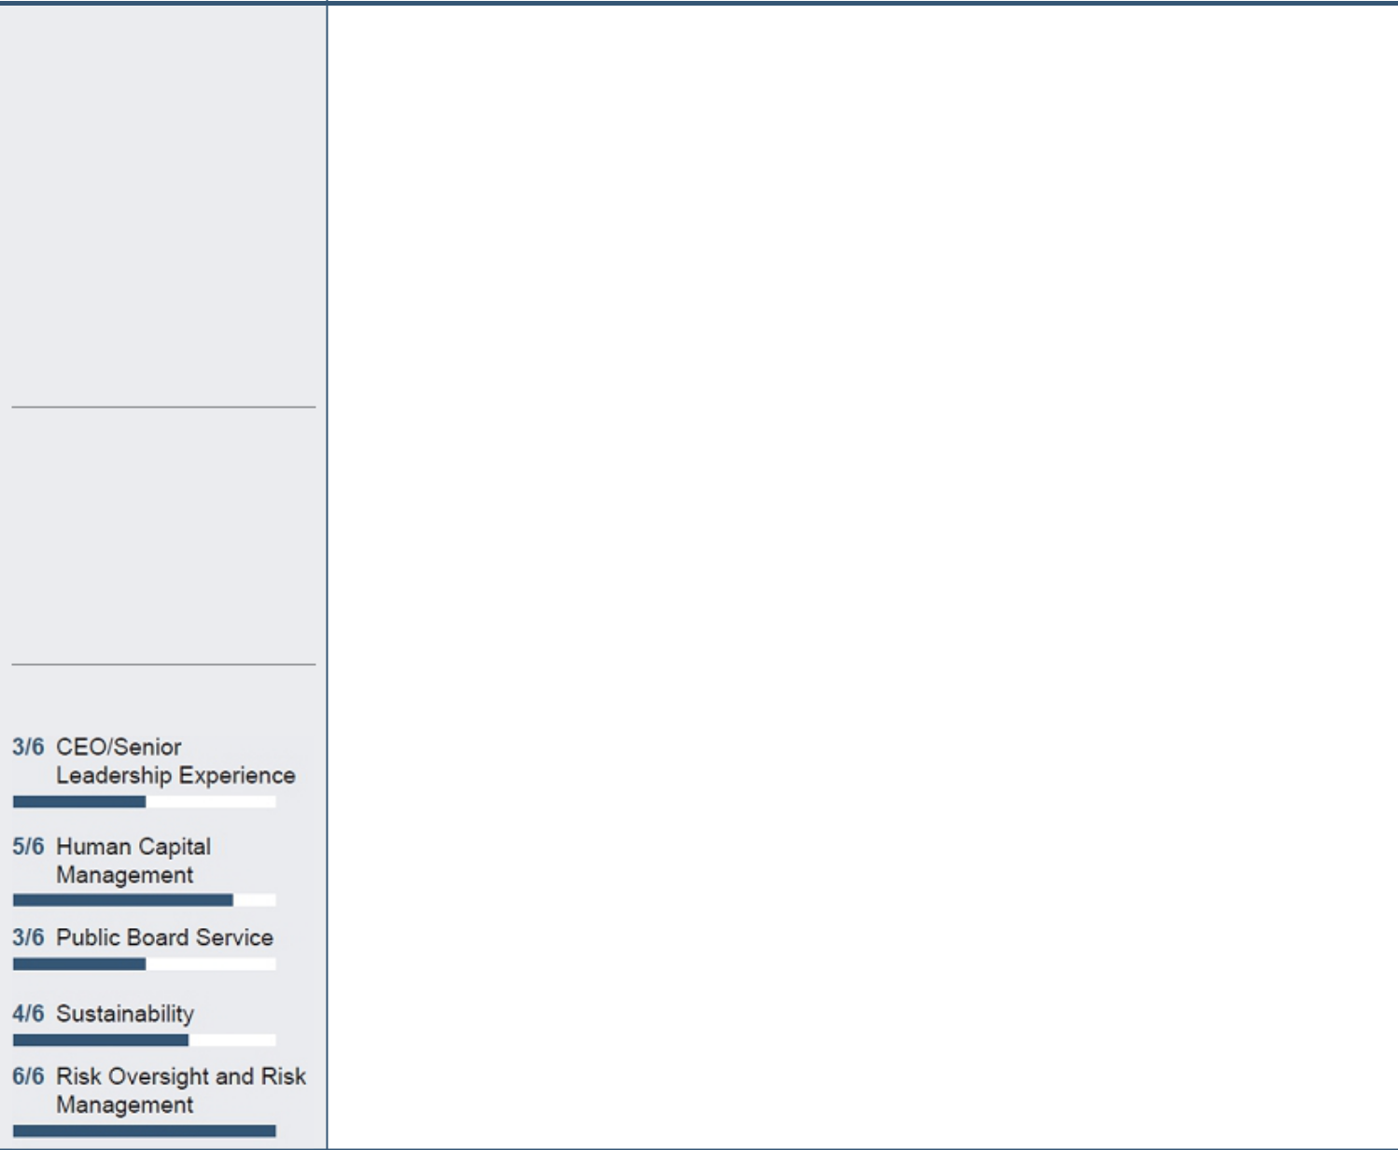

“The Committee focused on executive compensation and our workforce, specifically addressing issues such as safety, the impact of the continuation of the pandemic, workforce recruitment, development and retention, and diversity and inclusion.”

-Rick Fox

2021 MEETINGS: 7

COMMITTEE MEMBERS:

Richard P. Fox, Chair

Denis A. Cortese Kathryn L. Munro Bruce J. Nordstrom William H. Spence James E. Trevathan, Jr.

KEY MEMBER SKILLS

RESPONSIBILITIES:

- Reviews management’s programs for the attraction, retention, succession, motivation and development of the Company’s human resources needed to achieve corporate objectives;

- Establishes the Company’s executive compensation philosophy;

- Reviews and assesses the Company’s strategies and policies related to human capital management, including those with respect to matters such as diversity, inclusion, pay equity, corporate culture, talent development and retention;

- Recommends to the Board persons for election as officers;

- Annually reviews the goals and performance of the officers of the Company and APS;

- Approves corporate goals and objectives relevant to the compensation of the CEO, assesses the CEO’s performance in light of these goals and objectives, and sets the CEO’s compensation based on this assessment;

- Makes recommendations to the Board with respect to non-CEO executive compensation and director compensation;

- Acts as the “Committee” under the Company’s long-term incentive plans;

- Reviews and discusses with management the Compensation Discussion and Analysis on executive compensation set forth in our proxy statements;

- Reviews the number, type, and design of the Company’s pension, health, welfare and benefit plans;

- Periodically reviews principal risks relating to the Company’s compensation and human resources policies and practices or other matters addressed by the Human Resources Committee; and

- Periodically reviews the Company’s compensation policies and practices applicable to executive and non-executive employees to identify and assess potential material risks arising from the policies and practices.

Under the Human Resources Committee’s charter, the Human Resources Committee may delegate authority to subcommittees, but did not do so in 2021. Additional information on the processes and procedures of the Human Resources Committee is provided under the heading “Compensation Discussion and Analysis (“CD&A”)”.

2022 Proxy Statement | 33

Table of Contents

Information About Our Board and Corporate Governance

NUCLEAR AND OPERATING COMMITTEE
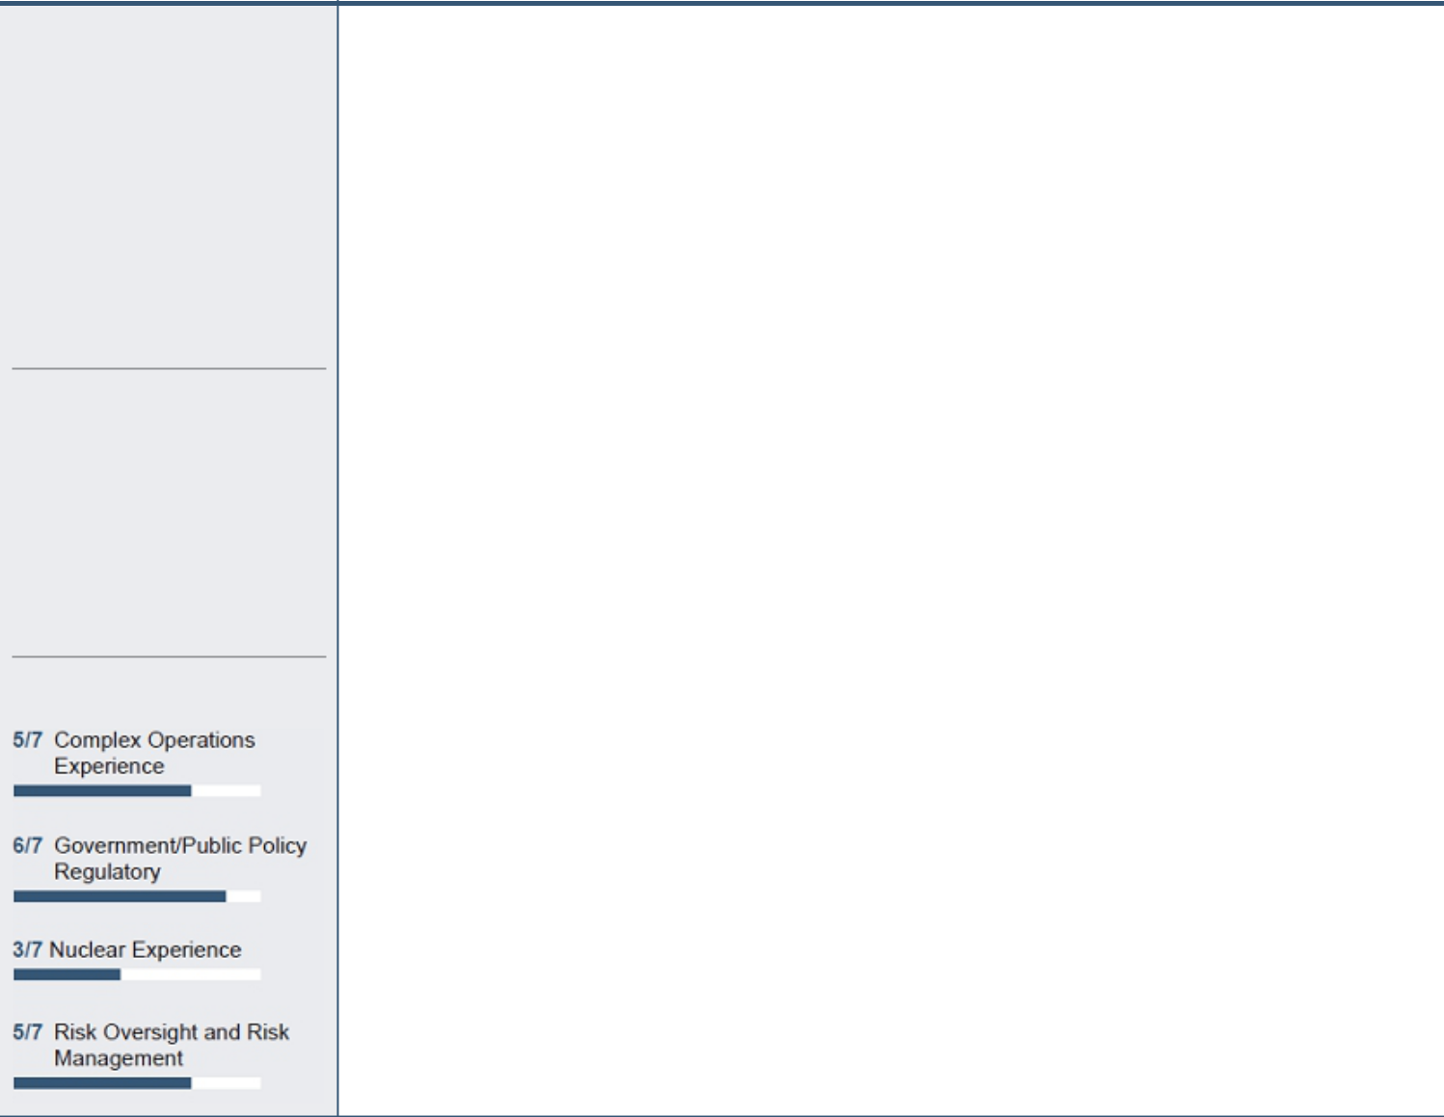

“The Committee focused on operational areas and topics critical to our business, including enterprise safety, customer service, energy storage, resource adequacy and cybersecurity.”

-Paula Sims

2021 MEETINGS: 4

COMMITTEE MEMBERS:

Paula J. Sims, Chair

Glynis A. Bryan
Gonzalo A. de la Melena, Jr. Dale E. Klein

William H. Spence James E. Trevathan, Jr. David P. Wagener

KEY MEMBER SKILLS

RESPONSIBILITIES:

- Receives regular reports from management and monitors the overall performance of Palo Verde Generating Station;

- Reviews the results of major PVGS inspections and evaluations by external oversight groups, such as the Institute of Nuclear Power Operations (“INPO”) and the Nuclear Regulatory Commission (“NRC”);

- Monitors overall performance of the principal non-nuclear business functions of the Company and APS, including fossil energy generation, energy transmission and delivery, customer service, fuel supply and transportation, safety, legal compliance, and any significant incidents or events;

- Reviews regular reports from management concerning the environmental, health and safety (“EH&S”) policies and practices of the Company, and monitors compliance by the Company with such policies and applicable laws and regulations;

- Reviews APS’s planning for generation resources additions and significant expansions of its bulk transmission system;

- Periodically reviews principal risks related to the Company’s nuclear, fossil generation, transmission and distribution, EH&S operations, or other matters addressed by the Nuclear and Operating Committee;

- Receives reports on the Company’s sustainability initiatives and strategy;

- Provides oversight of security policies, programs and controls for protection of cyber and physical assets; and

- Receives regular reports from the Off-Site Safety Review Committee (“OSRC”). The OSRC provides independent assessments of the safe and reliable operations of PVGS. The OSRC is comprised of nonemployee individuals with senior management experience in the nuclear industry and the Palo Verde Director of Nuclear Assurance.

34

Table of Contents

Information About Our Board and Corporate Governance

Board Meetings and Attendance

In 2021, our Board held thirteen meetings and all of our Directors attended at least 95% of the Board meetings and any meetings of Board committees on which he or she served. Each Director is expected to participate in the Annual Meeting. All Board members attended the 2021 Annual Meeting.

Board Oversight and Engagement

Company Culture

In 2020, the Company launched the APS Promise anchoring our commitment to our customers, community, and each other. The Promise explains why we’re here (our purpose), what we’re here to do (our vision and mission) and the principles and behaviors that will empower us to achieve our strategic goals. It represents the opportunity to build on our cultural strengths and develop new behaviors that will enable our future success.

APS PROMISE

The APS Promise

Our Purpose |  | Our Vision |  | Our Mission
As Arizona stewards, we do what is right |  | Create a sustainable energy future for Arizona. |  | Serve our customers with clean, reliable and
for the people and prosperity of our state. |  |  |  | affordable energy.
 |  |  | Our Principles
Design For Tomorrow |  | Empower Each Other |  | Succeed Together
● | See the way forward | ● | Embrace diverse perspectives | ● Create clarity
● | Innovate with courage | ● | Challenge respectfully | ● Anchor in safety
● | Value learning | ● | Unite as one team | ● Deliver for the community

2022 Proxy Statement | 35

Table of Contents

Information About Our Board and Corporate Governance

Strategic Framework

Anchored by the APS Promise, in January 2021, we introduced our ten-year strategic plan. The plan identifies five long-term strategic issues that are priority focus areas for the business to address over the next ten years. Our strategic plan keeps our eye on the future even as we navigate the dynamic present:

Focus on customer experience and community stewardship

Critical to our success is our ability to deliver value to our customers and build quality relationships with our stakeholders. We have an opportunity to improve the customer experience and strengthen our community stewardship by increasing our customer focus, investing in the community in new ways and building on our emerging ESG objectives.

Support an evolving workforce

As our industry experiences social and economic change, employees continue to be the key differentiators of our success. We must plan and prepare to employ the workforce of the future in order to achieve long-term success. The creation of the APS Promise and a focus on cultural principles will allow us to drive innovation and create a sense of belonging for our employees.

Decarbonize and manage generation resources

National sentiment toward environmental and climate issues increasingly challenges our use of fossil resources and accelerates the transition to renewable and clean energy sources. APS must thoughtfully navigate these transitions to optimize our existing generation fleet, integrate customer-sited resources and strategically invest in the clean energy fleet needed to meet our Clean Energy Commitment.

Achieve a constructive regulatory environment

As a regulated utility, our business outcomes are shaped by regulatory outcomes at the federal, state and local level. This requires us to work from a strong foundation of trust and accountability, and to focus our engagements with the customer top of mind. We must continue to build from a long history of productive relationships and engagement to achieve our long-term objectives.

Ensure long-term financial health

We must keep rates affordable while meeting investor growth expectations and reliability goals. Investments that encourage an economically vital Arizona support our financial health and provide opportunities for new and diversified revenue streams, which will prove essential to our long-term success.

Our Board reviews the development of the strategic business plan and oversees the implementation of that strategy, receiving regular reports from management on progress and any changes throughout the year. The Board, through the Human Resources Committee, is also involved in setting the annual performance metrics, which are aligned with the strategic plan and designed to incentivize achievement of the strategic goals.

36

Table of Contents

Information About Our Board and Corporate Governance

Environmental, Social and Governance (“ESG”)

To demonstrate the heightened attention on ESG and focus on ESG trends that may impact the Company, the Board previously changed the name of the Corporate Governance Committee to the Corporate Governance and Public Responsibility Committee and amended its charter to focus ESG oversight within the responsibilities of a single committee. The Corporate Governance and Public Responsibility Committee has the responsibility to review significant ESG trends that may impact the Company, ensure the oversight of relevant ESG issues by the Board and its committees, and make recommendations to the Board, as appropriate. The full Board also dedicates a significant amount of time to ESG matters. As an electric utility, environmental matters are at the forefront of our discussions on operations, strategy and risk. The Nuclear and Operating Committee has primary responsibility over environmental and sustainability matters, though the Board also receives reports on matters of environmental importance. Another key focus of the Board is the adoption and maintenance of good governance practices, which is a primary responsibility of the Corporate Governance and Public Responsibility Committee. Our social impact, within the Company, in our community and with our customers, has also been a key focus of the Board, with certain aspects being overseen by Corporate Governance and Public Responsibility and Human Resources Committees.

APS has been integrating ESG practices into its core work for almost 30 years. As a business strategy, we seek to establish shared value – addressing societal and environmental challenges in a way that also delivers business value. We believe that the best way to solve these challenges is to work collaboratively to create a sustainable energy future for Arizona. In 2020, in support of our Clean Energy Commitment and the growing role of ESG in our organization, we formed a new Sustainability department at APS that is dedicated to integrating environmental, social and governance best practices into the everyday work of APS. Its fundamental purpose is to drive our performance and enhance our reputation as a responsible corporate citizen. The department reports to the Vice President of Sustainability, who reports directly to our Senior Vice President of Public Policy.

An ESG Executive Council was previously established to guide the Company’s development of a common, cross-functional ESG vision, ensuring alignment and integration with the corporate strategic framework. The Council also has oversight of ESG reporting and implementation and is responsible for measuring and reporting on the actions taken to reach our Clean Energy Commitment. In 2021, the Company established a Social Issues Committee Framework. The goal of the framework is to provide a process for considering emergent social issues, and for determining whether or how best to engage on these important issues.

Human Capital Management

Human capital measures and objectives that the Company focuses on in managing its business include the safety of its employees, diversity and inclusion, succession planning, hiring and retention of talent, compensation and benefits and employee engagement. In 2021, the Human Resources Committee had oversight of the Company’s strategies and policies related to human capital management, including those with respect to matters such as diversity, inclusion, and talent development and retention. The Human Resources Committee is also tasked with oversight of the Company’s workforce, including establishing the Company’s executive compensation philosophy and reviewing the Company’s plans and programs for the attraction, retention, succession, motivation, and development of the human resources needed to achieve corporate objectives. The Human Resources Committee also reviews the Company’s pension, health, welfare and benefit plans and is responsible for the oversight of risks relating to or arising out of the Company’s compensation and human resources policies and practices. The full Board also receives reports on issues relating to human capital. The Board generally has multiple opportunities each year to interact directly with employees, including during our annual Board meeting at the Palo Verde Generating Station, during an annual dinner with select employees, and at employee-driven presentations to the Board. While many of these opportunities were not available in 2021 due to the COVID-19 pandemic, the Board is committed to resuming them once it is safe to do so.

2022 Proxy Statement | 37

Table of Contents

Information About Our Board and Corporate Governance

Codes of Ethics

To ensure the highest levels of business ethics, the Board has adopted the Code of Ethics and Business Practices, which applies to all employees, officers and directors, and the Code of Ethics for Financial Executives, both of which are described below:

Code of Ethical Conduct (“Code of Ethics”)

Employees, directors and officers receive access to the Code of Ethics when they join the Company or APS, as well as annual updates. The Code of Ethics helps ensure that employees, directors and officers of the Company and APS act with integrity and avoid any real or perceived violation of the Company’s policies and applicable laws and regulations. The Company provides annual online training covering the principles in the Code of Ethics. This training includes extensive discussion of the Company’s principles, an explanation of Company ethical standards, application of ethical standards in typical workplace scenarios, information on reporting concerns, assessment questions to measure understanding, and an agreement to abide by the Code of Ethics. All active employees of the Company, APS and our subsidiaries and all of our Directors complete the training.

Code of Ethics for Financial Executives

The Company has adopted a Code of Ethics for Financial Executives, which is designed to promote honest and ethical conduct and compliance with applicable laws and regulations, particularly as related to the maintenance of financial records, the preparation of financial statements, and proper public disclosure. “Financial Executive” means the Company’s CEO; Chief Administrative Officer; Chief Financial Officer; Chief Accounting Officer; Controller; Treasurer; Vice President, Financial Planning; and General Counsel; and the APS President and Chief Operating Officer; and other persons designated from time to time as a Financial Executive subject to the Code of Ethics for Financial Executives by the Chair of the Audit Committee.

Both codes are available on the Company’s website (www.pinnaclewest.com).

The Board’s Role in Risk Oversight

Top risks discussed by the Board and its committees in 2021 included:
● | Clean Energy Strategy and Execution | ● Arizona Utility Regulation
● Customer Trust |  | ● Employee Safety
● | Workforce Recruitment, Development and Retention | ● | Catastrophic Fire Event
 |  | ● | Cybersecurity and Data Privacy

The Board believes it is important to look at the list fresh each year as part of a diligent risk review.

38

Table of Contents

Information About Our Board and Corporate Governance

Responsibilities

Responsibility for the management of the Company’s risks rests with the Company’s senior management team. The Board’s oversight of the Company’s risk management function is designed to provide assurance that the Company’s risk management processes are well adapted to and consistent with the Company’s business and strategy and are functioning as intended.
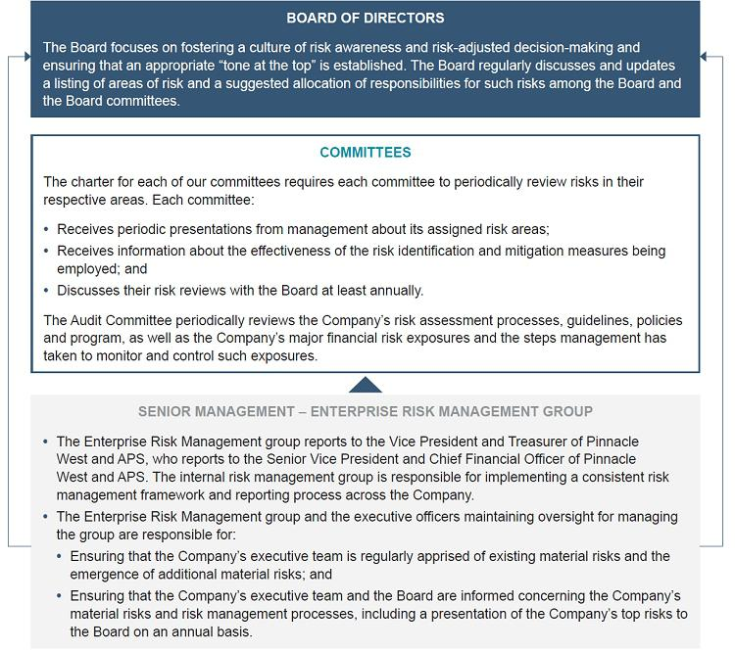

2022 Proxy Statement | 39

Table of Contents

Information About Our Board and Corporate Governance

Highlights of Certain Risks

Two risks monitored by the Board and its committees in 2021 were as follows:

Clean Energy Strategy and Execution

Implementation of the Company’s long-term Clean Energy Commitment vision is one of the most pressing issues facing the Company due to fossil fuel plant retirements, replacing those fossil units with evolving clean technologies, and managing a myriad of financial and regulatory considerations. Successful implementation requires enterprise-wide commitment to battery storage, renewables and hydrogen initiative, plus both short- and long-term coordination and support from several stakeholders including the ACC, federal regulators, and communities dependent on fossil fuel generation. Additionally, the Palo Verde Generating Station is a critical component of the Company’s Clean Energy Commitment due to its long-term ability to deliver clean energy. Initiatives and efforts in place to mitigate the risks of implementing the Company’s long-term Clean Energy Commitment:

- Updated Tier 1 Metric for carbon intensity;

- Focused clean energy strategy messaging in communications and disclosure documents; and

- Consistent outreach and dialog with stakeholders, including the ACC.

Responsibility for oversight of this risk was allocated to the full Board of Directors.

Workforce Recruitment, Development and Retention

The Company is increasingly challenged to compete for top talent in a workforce where its competitors are no longer simply other utilities, creating a risk of losing the Company’s most talented and vital workers and/or an inability to attract the top talent needed for the future growth of the Company. Relatedly, the Company must work to expand and update the digital skills of its existing workforce to meet with a changing workplace needs. In addition, the Company must continue to further promote and sustain a vital level of diversity and inclusion across the enterprise. Main components of the mitigation strategy include:

- Strategic workforce planning strategy;

- Internship programs; and

- Workplace of the Future Initiative.

Responsibility for oversight of this risk was allocated to the Human Resources Committee.

40

Table of Contents

Information About Our Board and Corporate Governance

Management Succession

Executive succession planning and senior management development continue to be specific areas of focus for the Corporate Governance and Public Responsibility and Human Resources Committees. Our deliberate and thoughtful succession plan was implemented largely in 2019 and 2020, resulting in the election of Jeffrey B. Guldner as Chairman of the Board, President and CEO of the Company and Chairman of the Board and CEO of APS. The Board also elected Maria L. Lacal as Executive Vice President and Chief Nuclear Officer, PVGS of APS, and Theodore N. Geisler as Senior Vice President and Chief Financial Officer of the Company and APS. In 2021, Mr. Guldner was promoted to President of APS, Jacob Tetlow was promoted to Executive Vice President, Operations of APS, and Robert E. Smith was promoted to Executive Vice President, General Counsel and Chief Development Officer of Pinnacle West and APS.

Given our need for specialized experience, we maintain strong management succession planning practices and are focused on developing and retaining talent within our Company. Our Board’s focus on attracting, developing and retaining highly skilled and experienced executives is a core consideration in structuring our executive compensation programs.

The implementation of our succession plan is the result of the Corporate Governance and Public Responsibility and Human Resources Committees engaging with management in thorough analysis and thoughtful discussions, including the development and evaluation of current and potential senior leaders.

Our Board places a high priority on senior management development and succession planning. While the Corporate Governance and Public Responsibility Committee has principal responsibility for overseeing CEO and other senior management succession planning, the Human Resources Committee and full Board are actively involved in reviewing our senior management succession plans, which are designed to provide for smooth and thoughtful leadership transitions in the future.

Employee, Officer and Director Hedging

Directors, officers, and employees of the Company may not engage in any speculative trading, hedging, or derivative security transaction (including the purchase of any financial instrument such as a prepaid variable forward contract, equity swap, collar, short-sales, or exchange fund) that involves or references Company securities, whether granted to the employee or Director as part of the compensation program or otherwise held by the employee or Director. In addition, Directors and officers may not pledge, margin or otherwise grant an economic interest in any shares of Company stock.

2022 Proxy Statement | 41

Table of Contents

Information About Our Board and Corporate Governance

Shareholder Engagement

We have an established shareholder engagement program to maintain a dialogue with our shareholders throughout the year. Each year we strive to respond to shareholder questions in a timely manner, conduct extensive proactive outreach to investors, and evaluate the information we provide to investors in an effort to continuously improve our engagement.

Shareholder Outreach Board Access

In 2021, we contacted the holders of approximately 60% of the shares outstanding.

Our Board is focused on shareholder feedback. Our Lead Director and other members of the Board, depending on the topic to be discussed, have participated in shareholder discussions, providing shareholders with direct access to the Board.

Matters Discussed in our Fall 2021 Outreach

● | Our strategy | ● | Board refreshment | ● | Customer experience
● | Our performance | ● | Our people | ● | Diversity, equity and inclusion
● Our Clean Energy Commitment |  | ● | Executive compensation

We Listen to our Shareholders

What our shareholders think is important to us and we want to ensure we have the opportunity to engage directly with our shareholders. We seek to maintain a transparent and productive dialogue with our shareholders. Each year we take feedback from our shareholders, ESG rating agencies and organizations, and other stakeholders to ensure our strategy and focus align with the interests of our shareholders and community.

Board Responsiveness

In response to feedback we’ve received, we improved shareholder rights by decreasing the number of shares required to call a special meeting of shareholders from 25% to 15%, refined our executive compensation program to further align pay-for-performance – as detailed in the CD&A – and we announced our bold aspiration to serve customers with 100% clean, carbon-free energy by 2050. In addition, we set an interim target to achieve 65% clean, carbon-free energy and 45% renewables by 2030. We also revised our performance share metrics to add a new clean megawatts installed metric.

42

Table of Contents

Information About Our Board and Corporate Governance

ANNUAL ENGAGEMENT CYCLE
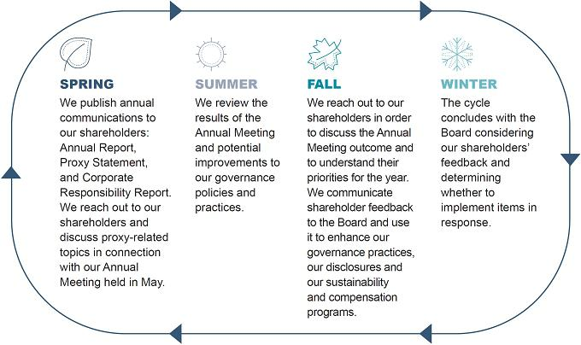

Communicating with the Board

Shareholders and other parties interested in communicating with the Board, the independent Directors or with the Lead Director may do so by writing to the Corporate Secretary, Pinnacle West Capital Corporation, 400 North Fifth Street, Mail Station 8602, Phoenix, Arizona 85004. The Corporate Secretary will transmit such communications, as appropriate, depending on the facts and circumstances outlined in the communications. In that regard, the Corporate Secretary has discretion to exclude communications that are unrelated to the duties and responsibilities of the Board, such as commercial advertisements or other forms of solicitations, service or billing matters and complaints related to individual employment-related actions.

2022 Proxy Statement | 43

Table of Contents

Director Nominees for the 2022 Annual Meeting

Proposal 1: Election of Directors

The Board of Directors unanimously recommends a vote FOR the election of the nominated slate of directors

The eleven nominees for election as directors are set forth below. All nominees will be elected for a one-year term that will expire at the 2023 Annual Meeting. The Directors’ ages are as of February 23, 2022. All of our Directors also serve as Directors of APS for no additional compensation.

DIRECTOR NOMINEES’ KEY SKILLS AND EXPERIENCE
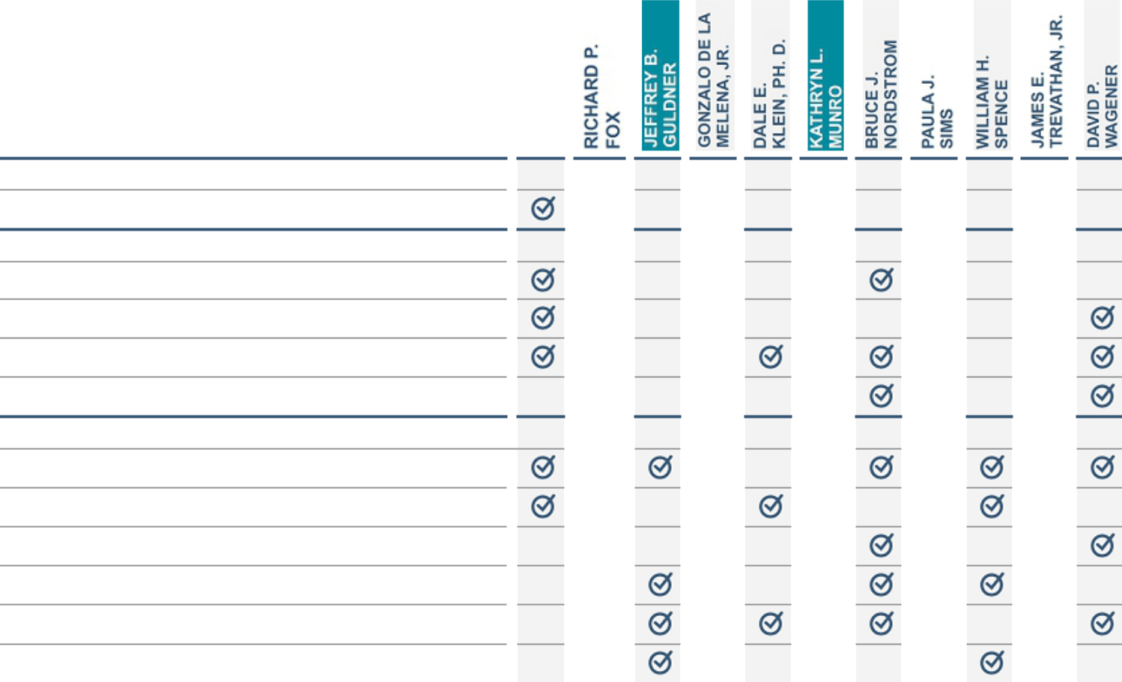

DIVERSITY

Gender or Ethnicity

FINANCE & ACCOUNTING

Audit Expertise

Finance/Capital Allocation

Financial Literacy and Accounting

Investment Experience

BUSINESS OPERATIONS AND STRATEGY

Business Strategy

Complex Operations Experience

Corporate Governance

Customer Perspectives

Extensive Knowledge of Company’s Business Environment

Sustainability

44

Table of Contents
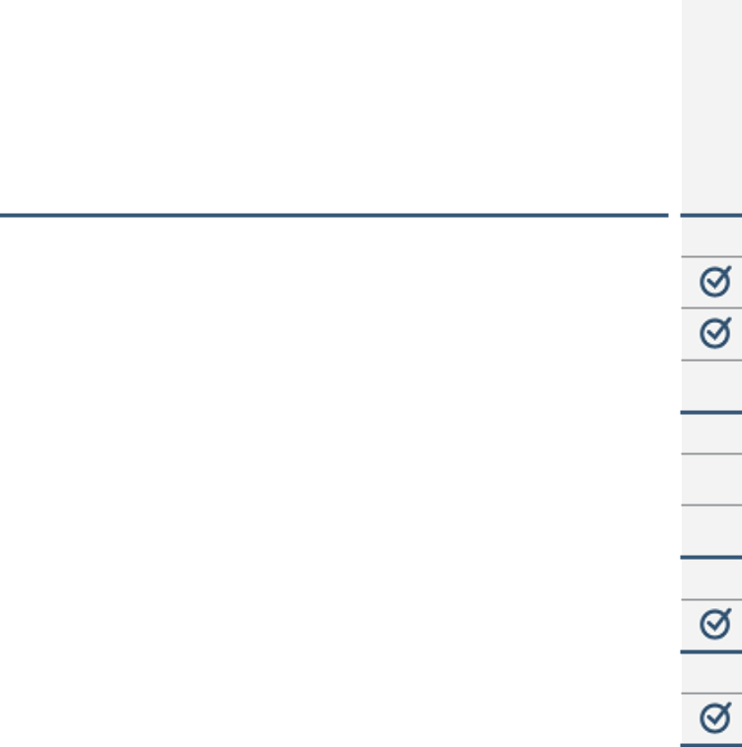

LARGE ORGANIZATIONAL LEADERSHIP CEO/Senior Leadership
Public Board Service

Human Capital Management

THE COMPANY’S INDUSTRY

Nuclear Experience

Utility Industry Experience

PUBLIC POLICY AND REGULATORY COMPLIANCE

Government/Public Policy/Regulatory

RISK OVERSIGHT AND RISK MANAGEMENT

Risk Oversight and Risk Management

- Board Leadership

Director Nominees for the 2022 Annual Meeting
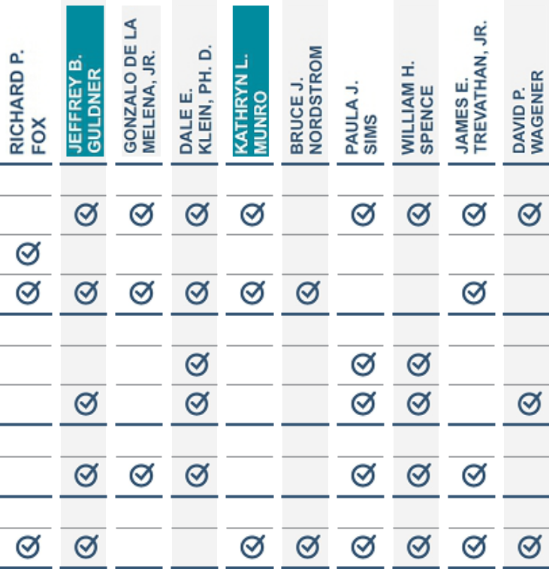

2022 Proxy Statement | 45

Table of Contents

Director Nominees for the 2022 Annual Meeting

Director Nominees

Glynis A. Bryan

Independent Director

Age: 63

Director since: 2020

Committees

- Audit

- Finance

- Nuclear and Operating

Gonzalo A. de la Melena, Jr.

Independent Director

Age: 53

Director since: 2022

Committees

- Audit

- Nuclear and Operating

BACKGROUND NOMINEE SKILLS AND EXPERIENCE

● Since 2007: Chief Financial Officer, Insight Enterprises, Inc. (computer As a long-tenured CFO and member of a public board

hardware, software, and technology solutions) of a large, multinational corporation, Ms. Bryan brings

● Ms. Bryan is also a director of Pentair plc the following key attributes to the Company:

QUALIFICATIONS ● Audit Expertise

As a Chief Financial Officer for more than 20 years, Ms. Bryan brings to the ● Finance/Capital Allocation

Board broad functional experience in financial planning and analysis, ● Financial Literacy/Accounting

treasury, capital markets and managing financial risk. In addition to her ● Business Strategy

executive leadership experience, she also has more than 15 years of public ● Complex Operations Experience

company board experience, serving on the Board of Pentair plc where she ● CEO/Senior Leadership

serves as the Chair of the Audit and Finance Committee and previously ● Public Board Service

served as the Chair of the Governance Committee. Ms. Bryan also brings ● Government/Public Policy/Regulatory

added diversity to the Board as a woman of color. ● Risk Oversight and Risk Management

BACKGROUND NOMINEE SKILLS AND EXPERIENCE

● Since 2012: Founder and CEO, Emerging Airport Ventures, LLC. (airport As the current CEO and Founder of Emerging Airport

concessions company) Ventures and as an Arizonan, and as the former CEO

● Mr. de la Melena served as the CEO of the Arizona Hispanic Chamber of of the Arizona Hispanic Chamber of Commerce, Mr.

Commerce from 2010 to 2020 De la Melena brings the following key attributes to the

● Mr. de la Melena currently serves on the Board of Directors of Gainey Company:

Business Bank (de novo), Education Forward Arizona and the Airport

Minority Advisory Council. ● Finance/Capital Allocation

● Financial Literacy and Accounting

QUALIFICATIONS ● Investment Experience

As the current Founder and CEO of Emerging Airport Ventures, Mr. de la ● Business Strategy

Melena brings a deep understanding of finance, investment experience and ● Customer Perspectives

CEO experience to the Board. As an Arizonan, Mr. de la Melena can provide ● Sustainability

valuable insight into our customers’ expectations, needs, and perspectives. ● CEO/Senior Leadership

As the former CEO of the Hispanic Chamber of Commerce, he brings ● Human Capital Management

extensive experience in economic development, which is a valuable attribute ● Government/Public Policy/Regulatory in light of Arizona’s fast growth and development. Mr. de la Melena also brings added diversity to the Board as a member of the Hispanic community.

46

Table of Contents

Richard P. Fox

Independent Director

Age: 74

Director since: 2014

Committees

- Corporate Governance and Public Responsibility
- Finance

- Human Resources (Chair)

Director Nominees for the 2022 Annual Meeting

BACKGROUND | NOMINEE SKILLS AND EXPERIENCE
● Since 2001: Consultant and independent board member for companies in | As a former Managing Partner of Ernst & Young, one
various industries | of the “Big Four” auditing firms with multinational
● Mr. Fox previously held executive, operational and financial positions at | operations, Mr. Fox brings the following key attributes
CyberSafe Corporation (“CyberSafe”), Wall Data, Incorporated (“Wall | to the Company:
Data”) and PACCAR Inc., and is a former Managing Partner of Ernst &
Young’s Seattle office | ● Finance/Capital Allocation
● Mr. Fox is a director of LiveRamp Holdings, Inc., but has informed the | ● Financial Literacy and Accounting
Board of Directors of LiveRamp Holdings, Inc. of his intention not to stand | ● Investment Experience
for re-election at the 2022 Liveramp Holdings, Inc. Annual Meeting, which | ● Corporate Governance
is scheduled for August 9, 2022 | ● Customer Perspectives
● Mr. Fox is also a director of FrontDoor, Inc. and Univar Solutions, Inc. | ● Sustainability
● Within the past five years, Mr. Fox has served as a director of | ● Public Board Service
ServiceMaster Global Holdings and Acxiom Corporation | ● Human Capital Management
QUALIFICATIONS | ● Risk Oversight and Risk Management
As a former Managing Partner of Ernst & Young, former Chief Financial
Officer of Wall Data, and President and Chief Operating Officer of CyberSafe,
Mr. Fox has a deep understanding of auditing, financial and accounting
matters. Mr. Fox has also served on the boards of several companies
throughout his career, including seven public companies, giving him extensive
insights into corporate governance, human capital management and
compensation, investment opportunities, risk oversight and risk management,
and the customer perspective. His extensive board experience, including
service on various audit, governance, human resources and finance
committees, including chairmanships, adds to the Board’s depth and
capabilities.
 | 2022 Proxy Statement | 47

Table of Contents

Director Nominees for the 2022 Annual Meeting

Jeffrey B. Guldner

Chairman of the Board, President and CEO of the Company and of APS

Age: 56

Director since: 2019

Dale E. Klein, Ph.D.

Independent Director

Age: 74

Director since: 2010

Committees

- Audit

- Nuclear and Operating

BACKGROUND | NOMINEE SKILLS AND EXPERIENCE
● Since August of 2021, Chairman of the Board, President and CEO of the | Mr. Guldner has comprehensive experience within the
Company and of APS | Company in many different areas of importance to the
● Since November 2019: Chairman of the Board, President and CEO of the | overall health of the Company, including the
Company and Chairman of the Board and CEO of APS | development of strategy with respect to rates and
● From December 2018 to January 2020: President of APS | regulation as well as our clean energy vision. Mr.
● From May 2017 to November 2019: Executive Vice President, Public | Guldner brings the following key attributes to the
Policy of the Company | Company:
● From May 2017 to December 2018: Executive Vice President, Public
Policy of APS | ● Business Strategy
● From May 2017 to August 2018: General Counsel of the Company and | ● Customer Perspective
APS | ● Extensive Knowledge of Company’s Business
● From 2014 to May 2017: Senior Vice President, Public Policy of APS | Environment
 | ● Sustainability
QUALIFICATIONS | ● CEO/Senior Leadership
Mr. Guldner joined the Company in 2004 and has held a number of | ● Human Capital Management
leadership and executive positions responsible for several different areas of | ● Utility Industry Experience
importance to the health and success of the Company, including public | ● Government/Public Policy/Regulatory
policy, legal, rates and regulation, government affairs and customer service. | ● Risk Oversight and Risk Management
Prior to joining APS, Mr. Guldner was a partner in the Phoenix office of
Snell & Wilmer LLP, where he practiced public utility, telecommunications and
energy law. Before practicing law, Mr. Guldner served as a surface warfare
officer in the United States Navy and was an assistant professor of naval
history at the University of Washington.
BACKGROUND | NOMINEE SKILLS AND EXPERIENCE
● Since January 2011: Associate Vice Chancellor for Research, The | As former Chairman of the NRC, the entity that
University of Texas System | formulates policies and regulations governing nuclear
● From July 2006 to May 2009: Chairman of the Nuclear Regulatory | reactor and materials safety, issues orders to
Commission (“NRC”), and thereafter continued as a Commissioner until | licensees, and adjudicates legal matters brought
March 2010 | before it, Dr. Klein brings the following key attributes to
● From November 2001 to July 2006: Assistant to the Secretary of Defense | the Company:
for Nuclear, Chemical and Biological Defense Program
● Since September 1977: Professor of Mechanical Engineering, University | ● Financial Literacy/Accounting
of Texas at Austin | ● Complex Operations Experience
● Dr. Klein is also a director of Southern Company | ● Extensive Knowledge of Company’s Business
 | Environment
QUALIFICATIONS | ● CEO/Senior Leadership
The NRC oversees nuclear power plant operations in the United States. As | ● Public Board Service
the former Chairman of the NRC, Dr. Klein brings expertise in all aspects of | ● Human Capital Management
nuclear energy regulation, operation, technology and safety. His broad | ● Nuclear Experience
national and international experience in all aspects of the nuclear utility | ● Utility Industry Experience
industry, nuclear energy, government and regulation brings value to the | ● Government/Public Policy/Regulatory
Board, particularly from the perspective of our operations at Palo Verde
Generating Station and business environment. His service with the NRC,
including his tenure as Chairman, gives him senior leadership experience in
operating large, complex organizations, financial literacy and human capital
management and compensation experience.

48

Table of Contents

Kathryn L. Munro

Independent Director

Age: 73

Director since: 2000

Lead Director

Committees

- Corporate Governance and Public Responsibility (Chair)
- Finance

- Human Resources

Bruce J. Nordstrom

Independent Director

Age: 72

Director since: 2000

Committees

- Audit (Chair)

- Corporate Governance and Public Responsibility
- Human Resources

Director Nominees for the 2022 Annual Meeting

BACKGROUND | NOMINEE SKILLS AND EXPERIENCE
● Since July 2003: Principal of BridgeWest, LLC (an investment company) | As a former CEO of BofA’s Southwest Banking Group,
● From February 1999 until July 2003: Chairman of BridgeWest, LLC | Ms. Munro brings a wealth of experience to the
● From 1996 to 2000: Chief Executive Officer of Bank of America’s (“BofA”) | Company, including the following key attributes:
Southwest Banking Group
● From 1994 to 1996: President of BofA Arizona. Prior to that, Ms. Munro | ● Finance/Capital Allocation
held a variety of senior positions during her 20-year career with BofA | ● Investment Experience
● Ms. Munro is Lead Director of Knight-Swift Transportation Holdings, Inc. | ● Corporate Governance
(“Knight-Swift”) | ● Extensive Knowledge of Company’s Business
● Within the past five years, Ms. Munro has served as a director of Premera | Environment
Blue Cross | ● Sustainability
 | ● CEO/Senior Leadership
QUALIFICATIONS | ● Public Board Service
As principal of an investment company, former Chief Executive Officer of | ● Human Capital Management
BofA’s Southwest Banking Group, and President of BofA Arizona, Ms. Munro | ● Risk Oversight and Risk Management
brings business and investment acumen, financial and capital allocation
experience, and leadership skills to the Company. Her extensive knowledge
of the Company’s business environment includes experience with the cycles
in Arizona’s economy, which assists a growing infrastructure company like
Pinnacle West in accessing capital and meeting its financing needs. Ms.
Munro is an experienced director, currently serving on the boards of Knight-
Swift and Premera Blue Cross, providing her experience in human capital
management and compensation, corporate governance, and risk oversight
and risk management.
BACKGROUND | NOMINEE SKILLS AND EXPERIENCE
● Since January 2021: Of Counsel to and certified public accountant, | As the former President of Nordstrom & Associates,
Nordstrom & Associates, P.C., in Flagstaff, Arizona | P.C. and a practicing CPA, Mr. Nordstrom brings the
● June 2019 to December 2020: Vice President of and certified public | following key attributes to the Company:
accountant, Nordstrom & Associates, P.C.
● From 1988 to June 2019: President of and certified public accountant at | ● Audit Expertise
Nordstrom & Associates, P.C. | ● Financial Literacy/Accounting
 | ● Investment Experience
QUALIFICATIONS | ● Business Strategy
As the former president of and current Of Counsel to an accounting firm, Mr. | ● Corporate Governance
Nordstrom has gained an extensive accounting, auditing and financial skill | ● Customer Perspectives
set, as well as experience in strategy development and the principles of risk | ● Extensive Knowledge of Company’s Business
oversight and risk management. His tenure with the Company in addition to | Environment
operating an Arizona-based business has provided him with extensive | ● Human Capital Management
knowledge of the Company’s business environment. Furthermore, as an | ● Risk Oversight and Risk Management
individual who built an accounting firm in Flagstaff, Arizona, Mr. Nordstrom
has obtained experience in human capital management and compensation
and corporate governance as well as a familiarity with the perspectives of
customers in the Northern Arizona service territory of APS.

2022 Proxy Statement | 49

Table of Contents

Director Nominees for the 2022 Annual Meeting

Paula J. Sims

Independent Director

Age: 60

Director since: 2016

Committees

- Audit

- Corporate Governance and Public Responsibility
- Nuclear and Operating (Chair)

William H. Spence

Independent Director

Age: 65

Director since: 2021

Committees

- Finance

- Human Resources

- Nuclear and Operating

BACKGROUND NOMINEE SKILLS AND EXPERIENCE

● Since May 2012: Professor of Practice and Executive Coach, University of Ms. Sims brings hands-on experience in electric utility

North Carolina Kenan-Flagler Business School operations, including generation, renewable energy,

● From July 2010 to June 2012: Senior Vice President of Corporate energy efficiency, fuels and energy trading, and

Development and Improvement, Progress Energy Inc. customer service, as well as an understanding of the

● From July 2007 to July 2010: Senior Vice President Power Operations, role of management and executive oversight, and

Progress Energy Inc. brings the following key attributes to the Company:

QUALIFICATIONS ● Financial Literacy and Accounting

Ms. Sims worked directly in the utility industry for more than 13 years. She ● Complex Operations Experience

brings extensive leadership experience to the Company in business and ● Corporate Governance

finance strategy, electric utility operations, nuclear strategy, and operating in ● Sustainability

a regulated environment. In her prior roles at Progress Energy, Ms. Sims was ● CEO/Senior Leadership

responsible for complex business operations and strategy, including new ● Nuclear Experience

generation, supply chain and information technology, as well as overall ● Utility Industry Experience

process and efficiency improvements. Her experience gives her extensive ● Government/Public Policy/Regulatory

insight into the operational, financial, regulatory, and risk-related matters that ● Risk Oversight and Risk Management are of ever-increasing significance to the Company.

BACKGROUND NOMINEE SKILLS AND EXPERIENCE

● Since March 2021: Former Chairman of the Board of PPL Corporation As a former CEO of an electric utility, Mr. Spence bring

(investor-owned electric utility) the following skills to the Board:

● From June 2020 to March 2021: Chairman of the Board, PPL Corporation

● From March 2012 to June 2020: Chairman of the Board, President and ● Business Strategy

Chief Executive Officer, PPL Corporation ● Complex Operations Experience

● Mr. Spence is also a director of the Williams Companies, Inc. ● Customer Perspectives

● Sustainability

QUALIFICATIONS ● CEO/Senior Leadership

As the former Chief Executive of an investor-owned electric utility company, ● Public Board Experience

Mr. Spence brings a broad range of operating experience in the energy ● Nuclear Experience

industry. He has extensive experience in strategy development and risk ● Government/Public Policy/Regulatory

management and has a comprehensive understanding of the issues facing ● Risk Oversight and Risk Management

an electric utility, including regulatory strategy and customer service. He also brings significant public board experience both from his role as Chairman of PPL Corporation and from his service as a director of the Williams Companies, Inc.

50

Table of Contents

James E.

Trevathan, Jr.
Independent Director

Age: 68

Director since: 2018

Committees

- Finance

- Human Resources

- Nuclear and Operating

David P. Wagener

Independent Director

Age: 67

Director since: 2014

Committees

- Corporate Governance and Public Responsibility
- Finance (Chair)

- Nuclear and Operating

Director Nominees for the 2022 Annual Meeting

BACKGROUND NOMINEE SKILLS AND EXPERIENCE

● From July 2012 to December 2018: Executive Vice President and Chief From his more than 35 years of operational and

Operating Officer, Waste Management, Inc. (“Waste Management”) (waste executive experience at Waste Management, Mr.

disposal and recycling solutions) Trevathan brings the following key attributes to the

● From June 2011 to July 2012: Executive Vice President of Growth, Company:

Innovation and Field Support, Waste Management, Inc.

● From July 2007 to June 2011: Senior Vice President – Southern Group, ● Financial Literacy and Accounting

Waste Management, Inc. ● Business Strategy

● Complex Operations Experience

QUALIFICATIONS ● Customer Perspectives

Mr. Trevathan brings to the Board more than 35 years of complex operational ● Sustainability experience, serving 15 years in an executive capacity, with a focus on safety, ● CEO/Senior Leadership environmental issues, customer service, disruptive technology, risk oversight ● Human Capital Management

and risk management, and community and regulatory affairs. Through his ● Government/Public Policy/Regulatory

experience at Waste Management, Mr. Trevathan has gained significant ● Risk Oversight and Risk Management

experience in the oversight and management of risk, human capital management, business strategy development as well as literacy in finance and accounting.

BACKGROUND NOMINEE SKILLS AND EXPERIENCE

● Since June 1995: Managing Partner, Wagener Capital Management As the Managing Partner of Wagener Capital

(investment and advisory firm serving utility and private equity companies) Management, Mr. Wagener is experienced at

● Mr. Wagener previously held executive positions at Salomon Brothers and analyzing business strategies, and brings the following

Goldman, Sachs & Co. key attributes to the Company:

QUALIFICATIONS ● Finance/Capital Allocation

Mr. Wagener brings to the Board over 40 years of experience in the ● Financial Literacy/Accounting

power/energy industry, project finance and investment banking experience, ● Investment Experience

and knowledge of utility regulation. Through his financial experience and ● Business Strategy

service on boards of public companies he has developed key experience in ● Corporate Governance

corporate governance, capital allocation, accounting, and risk oversight and ● Extensive Knowledge of Company’s Business

risk management. His participation brings value to the Company and the Environment

Board as we address structural and business strategy challenges facing the ● CEO/Senior Leadership

utility industry. ● Utility Industry Experience

● Risk Oversight and Risk Management

2022 Proxy Statement | 51

Table of Contents

Director Nominees for the 2022 Annual Meeting

Current Directors Not Standing for Reelection

Dr. Denis A. Cortese will retire from the Board effective at the Annual Meeting. The Board recognizes Dr. Cortese for his distinguished service throughout the years and thanks him for his tireless labor, devotion and service to the Company.

Director Independence

NYSE rules require companies whose securities are traded on the NYSE to have a majority of independent directors. These rules describe certain relationships that prevent a director from being independent and require a company’s board of directors to make director independence determinations in all other circumstances. The Company’s Board has also adopted Director Independence Standards to assist the Board in making independence determinations. These Director Independence Standards are available on the Company’s website (www.pinnaclewest.com).

In accordance with the NYSE rules and the Director Independence Standards, the Board undertakes an annual review to determine which of its Directors are independent. The review generally takes place in the first quarter of each year; however, Directors are required to notify the Company of any changes that occur throughout the year that may impact their independence.

Based on the Board’s review, the Board has determined that all of the Company’s Directors and Director nominees are independent, except Mr. Guldner due to his employment with the Company. Mr. Lopez was independent while he was a member of the Board.

11 of our 12

Directors are
independent

The Company has purchase, sale and other transactions and relationships in the normal course of business with companies with which certain Company Directors are associated but which the Board determined are not material to our Company, the Directors or the companies with which the Directors are associated. These transactions were reviewed and considered by the Board in determining the independence of Company Directors. In particular, the Board took into account the following transactions during fiscal year 2021:

- Ms. Bryan is an executive officer of Insight Enterprises, Inc. (“Insight”), which provides computer hardware and software products and information technology services to APS. The amounts paid to Insight represent less than 1% of the Company’s and Insight’s total annual revenues;

- Dr. Cortese is an employee of Arizona State University, which is considered a part of the reporting entity for the State of Arizona (the “State”) for financial reporting purposes. During fiscal year 2021, various transactions occurred between the State and the Company and its affiliates, such as the provision of electric service, the payment of various State fees, taxes, memberships, licenses, sponsorships and donations, and the payment by each party of utility-related costs. The amounts paid to and received from the State represent less than 2% of the State’s total annual revenues; and

- Mr. Fox serves as a director of Univar Solutions, Inc. (“Univar”), from which APS purchases chemicals that are used in the operation and maintenance of our power plants. The amounts paid to Univar represent less than 1.5% of the Company’s and Univar’s total annual revenues.

The Board believes that all of the transactions and relationships during fiscal year 2021 described above were on arm’s-length terms that were reasonable and competitive and that the Directors did not participate in or receive any direct personal benefit from these transactions.

52

Table of Contents

Director Nominees for the 2022 Annual Meeting

In addition, with respect to all of the Directors, the Board considered that many of the Directors and/or businesses of which they are officers, Directors, shareholders, or employees are located in APS’s service territory and purchase electricity from APS at regulated rates in the normal course of business. The Board considered these relationships in determining the Directors’ independence, but, because the rates and charges for electricity provided by APS are fixed by the ACC, and the Directors satisfied the other independence criteria specified in the NYSE rules and the Director Independence Standards, the Board determined that these relationships did not impact the independence of any Director. The Board also considered contributions to charitable and non-profit organizations where a Director also serves as a director of such charity or organization. However, since no Director is also an executive officer of such charitable or nonprofit organization, the Board determined that these payments did not impact the independence of any Director.

Director Compensation

Compensation of the directors for 2021 was as follows:

 |  |  |  |  |  | Change in Pension Value
 |  | Fees Earned or |  | Stock |  | and Nonqualified Deferred |  | All Other
 |  | Paid in Cash |  | Awards |  | Compensation Earnings |  | Compensation |  | Total
Name |  | ($) |  | ($)⁽¹⁾ |  | ($)⁽²⁾ |  | ($) |  | ($)
Glynis A. Bryan |  | 108,328 |  | 139,849 |  | 0 |  | 0 |  | 248,177
Denis A. Cortese, M.D. |  | 108,328 |  | 139,849 |  | 0 |  | 0 |  | 248,177
Richard P. Fox |  | 126,656 |  | 139,849 |  | 38,698 |  | 0 |  | 305,203
Jeffrey B. Guldner⁽³⁾ |  |  |  | 0 |  | 0 |  | 0 |  | 0
Dale E. Klein, Ph.D. |  | 108,328 |  | 139,849 |  | 0 |  | 0 |  | 248,177
Humberto S. Lopez⁽⁴⁾ |  | 40,615 |  | 0 |  | 321,196 |  | 25,000⁽⁶⁾ |  | 386,811
Kathryn L. Munro |  | 156,656 |  | 139,849 |  | 38,570 |  | 0 |  | 335,075
Bruce J. Nordstrom |  | 126,656 |  | 139,849 |  | 130,563 |  | 0 |  | 397,068
Paula J. Sims |  | 126,656 |  | 139,849 |  | 6,708 |  | 0 |  | 273,213
William H. Spence⁽⁵⁾ |  | 91,766 |  | 179,686 |  | 0 |  | 0 |  | 271,452
James E. Trevathan, Jr. |  | 108,328 |  | 139,849 |  | 14,824 |  | 0 |  | 263,001
David P. Wagener |  | 126,656 |  | 139,849 |  | 0 |  | 0 |  | 266,505

- In accordance with FASB ASC Topic 718, this amount reflects the aggregate grant date fair value of the stock awards. On May 19, 2021, all of the Directors at that time received a grant of either common stock or stock units (“SUs”), based on an election previously delivered to the Company. All Directors who received the grant on May 19, 2021 received common stock except for Messrs. Fox, Trevathan and Dr. Klein, and Mses. Bryan and Munro, who each received SUs. Under the terms of the SUs, M. Bryan, Mr. Trevathan and Dr. Klein will receive 100% of the SUs in stock and the remaining Directors who received SUs will receive 50% of the SUs in cash and 50% of the SUs in common stock, in all cases on the last business day of the month following the month in which they separate from service on the Board. The number of shares of common stock or SUs granted was 1,637, and the grant date fair value of each share of common stock or SU was $85.43, which was the closing stock price on May 19, 2021. In addition, on March 1, 2021, Mr. Spence received a pro-rata grant of common stock based on his service on the Board from February 2021 to May 2021 in the amount of 551 shares; and the shares have a grant date fair value of $72.30. As of December 31, 2021, the following Directors had the following outstanding RSU or SU awards: Ms. Bryan – 3,290; Mr. Fox — 8,927; Dr. Klein — 19,396; Ms. Munro — 17,351; Ms. Sims — 2,817; and Mr. Trevathan – 4,553.

- The Company does not have a pension plan for Directors. The amount in this column consists solely of the above-market portion of annual interest accrued under a deferred compensation plan pursuant to which Directors may defer all or a portion of their Board fees. See the discussion of the rates of interest applicable to the deferred compensation program under “Discussion of Nonqualified Deferred Compensation”.

- Mr. Guldner is an NEO and his compensation is set forth in the Summary Compensation Table. Only non-management directors are compensated for Board service.

- Mr. Lopez retired from the Board of Directors on May 19, 2021.

- Mr. Spence joined the Board of Directors on February 26, 2021.

- In 2018, Mr. Lopez and the H.S. Lopez Family Foundation, in partnership with the Gospel Rescue Mission, established the Center of Opportunity, a one-stop refuge for the homeless that provides holistic support for individuals as they journey out of homelessness into self-sufficiency. More than just a shelter, the Center of Opportunity provides short- and long-term care for the homeless, and provides a large number of services, including housing, food, job training, addiction counseling, medical and dental services, and much more. The Center of Opportunity provides valuable resources to help individuals journey out of homelessness. In December of 2021, in recognition of his service to the Pinnacle West Board of Directors, Pinnacle West made a contribution of $25,000 to the Gospel Rescue Mission, which is the managing partner for the Center of Opportunity.

2022 Proxy Statement | 53

Table of Contents

Director Nominees for the 2022 Annual Meeting

Discussion of Directors’ Compensation

The Human Resources Committee makes recommendations to the Board for compensation, equity participation, and other benefits for

Directors. The director compensation program consists of the following components:

Compensation Component

Annual Retainer
Audit Committee, Corporate Governance and Public Responsibility Committee, Human Resources Committee, Finance Committee, and Nuclear and Operating Committee Chairs Annual Retainers
Lead Director Annual Retainer
Annual Equity Grant

Amount

($)

110,000
20,000

30,000

Shares with a value of approximately $140,000 on the grant date

Directors had an option to either receive the stock grant on May 19, 2021 or defer the receipt until a later date. A director who elected to defer his or her receipt of stock received SUs in lieu of the stock grant. Those directors who elected to receive SUs were able to elect to receive payment for the SUs in either: (1) stock; (2) 50% in stock and 50% in cash; or (3) cash. The directors also elected whether to receive these payments either as of the last business day of the month following the month in which the director separates from service on the Board, or as of a date specified by the director, which date must be after December 31 of the year in which the grant was received. The SUs accrue dividend rights equal to the amount of dividends the director would have received if the director had directly owned one share of our common stock for each SU held, plus interest at the rate of 5% per annum, compounded quarterly. The manner of payment for the dividends and interest will be based on the director’s election for payment of the SUs.

Directors of Pinnacle West also serve on the APS Board of Directors for no additional compensation. The Company reimburses Board members for expenses associated with Board meetings and director education programs.

The 2012 Long-Term Incentive Plan, as amended (the “2012 Plan”), was amended in 2017 to add an overall limit to non-employee directors’ compensation. The value of equity grants (based on the grant date value) plus the aggregate amount of cash fees earned or paid is limited to $500,000 per calendar year.

A comparison against the compensation programs of a peer group is generally performed every two years, and a study was last performed and reviewed by the Human Resources Committee in December 2020. At that time, the Human Resources Committee recommended to the Board, and the Board approved, increasing the value of the annual retainer from $105,000 to $110,000, the annual equity grant from $120,000 to $140,000, and the committee chair retainers from $15,000 to $20,000. These changes went into effect in May 2021. The Consultant concluded that the new amounts were within the competitive range.

Director Stock Ownership Policy

The Company believes that directors should have a meaningful financial stake in the Company to align their personal financial interests with those of the Company’s shareholders.

In December 2019, the Board amended the Company’s stock ownership policy for non-management directors to increase the holding requirement. Each director is required to hold or control Company common stock, RSUs, or SUs with a value of at least five times the annual cash retainer fee paid to directors. Directors will have three years from the date of the adoption of the amendment to meet the new requirement; newly elected directors will have six years following the date they become a director to reach the required ownership level. The Corporate Governance and Public Responsibility Committee may grant exceptions to this policy for hardship or other special circumstances. Directors may not engage in any speculative trading, hedging, or derivative security transaction (including any financial instrument such as a prepaid variable forward contract, equity swap, collar, short-sales, or exchange fund) that involves or references Company securities. In addition, Directors may not pledge, margin or otherwise grant an economic interest in any shares of Company stock.

All of the Directors are in compliance with the Director Stock Ownership Policy.

54

Table of Contents

Executive Compensation

Proposal 2: Advisory Vote on Executive Compensation

The Board of Directors unanimously recommends a vote FOR the approval of the Company’s executive compensation

Section 14A of the Exchange Act requires U.S. public corporations to provide for an advisory (non-binding) vote on executive compensation. As discussed in more detail in our CD&A and the accompanying tables and narrative, the Company has designed its executive compensation program to align executives’ interests with those of our shareholders, make executives accountable for business and individual performance by putting pay at risk, and attract, retain and reward the executive talent required to achieve our corporate objectives and to increase long-term shareholder value. We believe that our compensation policies and practices promote a pay at risk philosophy and, as such, are aligned with the interests of our shareholders.

In deciding how to vote on this say-on-pay proposal, the Board points out the following factors, many of which are more fully discussed in the

CD&A:

- Our Human Resources Committee has designed the compensation packages for our NEOs to depend significantly on putting pay at risk by tying pay to the achievement of goals that the Human Resources Committee believes drive long-term shareholder value;

- Our pay practices are designed to encourage management to not take unacceptable risks;

- We engage in periodic structural reviews of our compensation programs and policies; and

- We believe that the Company’s executive compensation program is well suited to promote the Company’s objectives in both the short-and long-term.

The Board endorses the Company’s executive compensation program and recommends that the shareholders vote in favor of the following resolution:

RESOLVED, that the compensation paid to the Company’s Named Executive Officers as disclosed in this Proxy Statement in the CD&A, the compensation tables and the narrative discussion, is hereby approved.

Because your vote is advisory, it will not be binding upon the Human Resources Committee or the Board. However, we value our shareholders’ opinions, and we will consider the outcome of the vote when determining future executive compensation arrangements.

2022 Proxy Statement | 55

Table of Contents

Executive Compensation

Human Resources Committee Report

The Human Resources Committee submitted the following report:

The Human Resources Committee is composed of non-employee directors, each of whom is independent as defined by NYSE rules and the Company’s Director Independence Standards.

In accordance with SEC rules, the Human Resources Committee discussed and reviewed the Compensation Discussion and Analysis with management and, based on those discussions and review, the Human Resources Committee recommended to the Board that the Compensation Discussion and Analysis be included in this Proxy Statement.

HUMAN RESOURCES COMMITTEE CHAIR

HUMAN RESOURCES COMMITTEE MEMBERS

Richard P. Fox

Denis A. Cortese, M.D.
Kathryn L. Munro
Bruce J. Nordstrom
William H. Spence

James E. Trevathan, Jr.

Compensation Discussion and Analysis (“CD&A”)

Named Executive Officers

Our NEOs for 2021 were:

Jeffrey B. Guldner | Theodore N. Geisler | James R. Hatfield
Chairman of the Board, President and Chief | Senior Vice President and Chief Financial | Advisor to the Chief Executive Officer of
Executive Officer of PNW and APS | Officer of PNW and APS | PNW⁽¹⁾

Maria L. Lacal

Executive Vice President and Chief Nuclear

Officer of Palo Verde Generating Station,

APS

Robert E. Smith

Executive Vice President, General Counsel

and Chief Development Officer of PNW and

APS

- Mr. Hatfield retired on December 31, 2021.

56

Table of Contents

Executive Compensation

Pay for Performance Overview

Business Overview

Pinnacle West is an electric utility holding company based in Phoenix, Arizona, one of the fastest-growing metropolitan areas in the United States. Through our principal subsidiary, APS, we provide retail electricity service to approximately 1.3 million customers in 11 of Arizona’s 15 counties.

We have the full range of resources needed to satisfy customers’ expectations, support
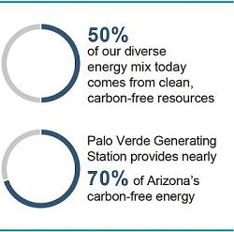
Arizona’s expanding economy and population, and deliver long-term value to shareholders:

- strong, experienced senior leadership;

- talented and resourceful employees who are the Company’s strength;

- a diverse, well-performing energy portfolio that will grow even cleaner with our new clean energy commitment; and

- an established track record of safe, reliable operations.

Clean energy plays a vital role in meeting our customers’ energy needs. By partnering with our customers, our shareholders and stakeholders and leveraging our existing assets, 50% of our diverse energy mix comes from clean, carbon-free resources. The Company has been on a trajectory of increasingly clean energy through solar power innovation, major investments in energy storage technology, carbon-free nuclear operations and advances in energy efficiency solutions while also reducing reliance on coal-generation. Now, we are accelerating and

solidifying that path with a goal to deliver 100% clean, carbon-free and affordable electricity to customers by 2050. We will rely on intelligent investments in renewable resources, continued modernization of the grid, the nuclear power produced at Palo Verde Generating Station, the nation’s largest carbon-free energy resource, and innovative partnerships to develop clean technologies like green hydrogen in order to sustain reliability and affordability on the pathway to the 100% goal.

While we share ownership of Palo Verde Generating Station, APS retains full day-to-day operational responsibility, including regulatory responsibility to the NRC. The complexity of running a nuclear plant of Palo Verde’s size requires a highly specialized and experienced management team. Given our need for specialized experience within our organization, we maintain strong succession planning practices and are focused on developing and retaining talent within our Company. Our Board’s focus on attracting, developing and retaining highly skilled and experienced executives is a core consideration in structuring our executive compensation programs.

2022 Proxy Statement | 57

Table of Contents

Executive Compensation

Building Shareholder Value Through our APS Promise and 10-Year Strategic Plan

As Arizona’s largest and longest-serving electric company, we’re proud of our heritage and performance. We also recognize the implications of new technologies and growing customer expectations, which are leading to changes at our Company and in our industry. Our strategy for building long-term value is driven by the APS Promise and our 10-Year Strategic Plan:

APS PROMISE |  | 10-YEAR STRATEGIC PLAN
● Do what is right for the people and prosperity of our state |  | ● Focus on Customer Experience and Stewardship
● Create a sustainable energy future in Arizona |  | ● Support an Evolving Workforce
● Serve our customers with clean, reliable and affordable energy |  | ● Decarbonize and Manage Generation Resources
 |  | ● Achieve a Constructive Regulatory Environment
 |  | ● Ensure Long-Term Financial Health

Delivering Results

Our management team has maintained a focus on our core business of operating and investing in a vertically-integrated electric utility. Under the leadership of the senior officer team, PVGS continues to be a top producer of clean energy in the U.S. We have, over the long term, provided gains in shareholder returns and maintained high credit ratings.

During 2021, our total shareholder value underperformed our historical track record. ACC-driven discussions and increased regulatory uncertainty leading up to a disappointing outcome in our 2019 rate case impacted shareholder confidence. Coming out of our 2019 rate case decision, we are taking actions including announcing that we will file another rate case in 2022 and deferring any Pinnacle West equity issuance until after the next rate case. In addition, we anticipate further clarity around the regulatory environment in Arizona and look forward to the ability to have more detailed discussions regarding the execution of our clean energy commitment and growth profile. We are committed to maintaining robust communication and collaboration with the ACC and other stakeholders to find constructive solutions that support our customers while maintaining the financial health of our Company. We believe we have the right strategy and team in place to meet our near-term goals and deliver long-term shareholder value.

Due to our total shareholder value underperforming, the portion of performance shares that were based on relative total shareholder return with the performance period beginning January 1, 2019 and ending December 31, 2021 did not pay out in February 2022.

Although our total shareholder value underperformed, we achieved the following accomplishments in 2021, among others:

● Pinnacle West increased its dividend for the 10th consecutive | ● Maintained reliable energy delivery to customers through the
year | largest regional natural gas freeze-off event in recent history,
● Maintained strong credit ratings from all three rating agencies | loss of a pipeline due to an explosion, and severe transmission
 | limitation due to wildfire
despite a challenging rate case outcome | ● Non-nuclear generation units performed exceptionally well
● In 2021, APS continued to drive our customer affordability
 | during the crucial summer run, with a summertime equivalent
initiative to identify opportunities to streamline its business | availability factor of 94.4%. This was our second highest
processes, which resulted in the Company identifying
 | performance percentage in the last 10 years, only second to
approximately $30 million in annual incremental cost saving
 | 2020 which was 95.3%
opportunities in 2022 through LEAN principles
 | ● APS continued successful operation of Palo Verde Generating
 | Station, a nuclear energy facility that is the largest clean-air
 | generator in the United States
58

Table of Contents

Executive Compensation

Our Philosophy and Objectives

Our executive compensation philosophy incorporates the following core principles and objectives:

ALIGNMENT WITH SHAREHOLDER INTERESTS

KEY MANAGEMENT RETENTION

We structure our annual cash and long-term equity incentive compensation to

We structure our program to provide compensation at

put pay at risk and reward business performance.

levels necessary to attract, engage and retain an

experienced management team.
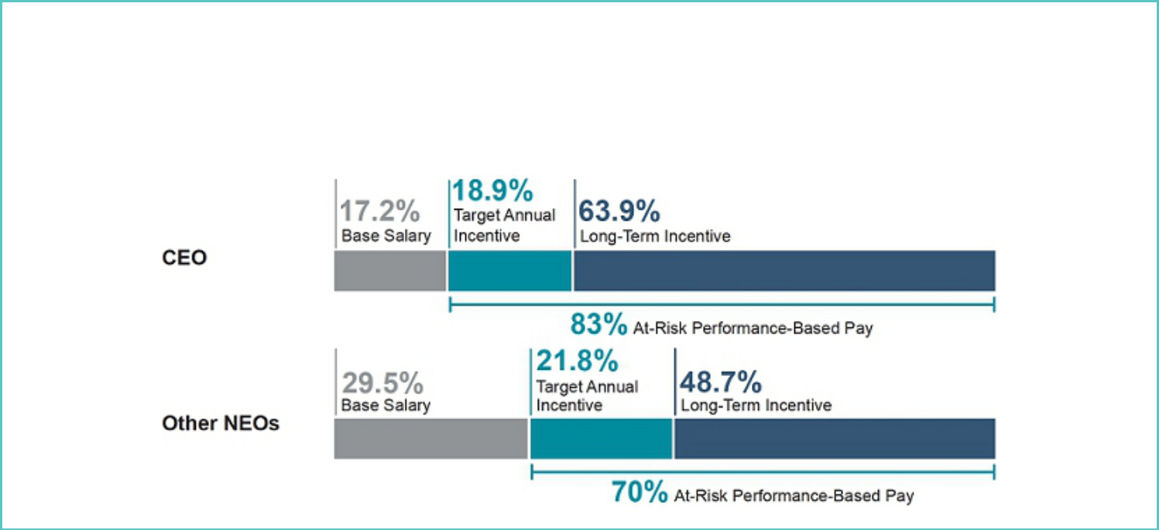

Pay at Risk

The Company believes that a significant portion of each NEO’s total compensation opportunity should reflect both upside potential and downside risk. We place a strong emphasis on performance-based, shareholder-aligned incentive compensation.

CEO AND OTHER NEOs’ TOTAL COMPENSATION

2022 Proxy Statement | 59

Table of Contents

Executive Compensation

Executive Compensation Enhancements

We are committed to actively engaging with our shareholders and to make changes to our compensation program to ensure that it represents our strong commitment to our pay-for-performance philosophy. Over the past several years, we have undertaken the following enhancements:

- Enhanced annual cash incentive plan with enterprise shared metrics focused on our strategic priorities and cultural transformation

- Ensure performance-based plan goals are set with appropriate levels of rigor

- Increased percentage of at-risk compensation

- Aligned 2021 Performance Share relative operational metrics to long-term initiatives

  - Added J.D. Power Residential Customer Satisfaction

  - Removed relative Coal Capacity Factor

- Looking ahead - 2022 equity grant changes made to enhance alignment to shareholder value and our Clean Energy Commitment

  - Earnings Per Share (“EPS”) performance and clean megawatts installed metrics added to 2022 Performance Share metrics

  - Modified Restricted Stock Units awards to only be paid in stock

Key 2021 Performance Metrics
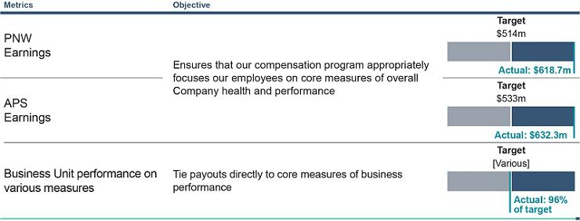

2021 Compensation Outcomes

The table below illustrates the total direct compensation (in millions) for each of our NEOs in 2021:

Jeffrey B. Theodore N. James R. Maria L. Robert E.

Guldner Geisler Hatfield Lacal Smith

Base Salary | $1.1 | $0.5 | $0.7 | $0.6 | $0.6
Annual Cash Incentive | $1.8 | $0.4 | $0.7 | $0.8 | $0.6
Long-Term Incentive | $4.1 | $1.1 | $1.3 | $0.8 | $0.8
Total Direct Compensation | $7.0 | $2.0 | $2.7 | $2.2 | $2.0

60

Table of Contents

Executive Compensation

2021 Compensation Plan

For 2021, the Company’s core executive compensation program for our NEOs consisted of the following key components:

Pay Element

Cash

Measurement Period Performance Link Description

Salary is based on experience, performance and responsibilities and is benchmarked to a peer group and market survey data to align with competitive levels.

Cash

Performance Shares

70%⁽³⁾

 |  | Earnings
 |  | CEO⁽¹⁾: 50.0%
1 year |  | Other NEOs: 50.0%
 |  | Business Unit
 |  | Performance⁽²⁾
 |  | 50.0%
 |  | Relative TSR
 |  | 50%
3 years |  | Relative Operational
 |  | Performance⁽⁴⁾
 |  | 50%

Universal measure of business financial performance; encourages achievement of bottom-line earnings growth goals.

Pre-established operational business unit performance goals that include safety, customer experience and operational quality and efficiency metrics.

Relative measures incentivize sustained shareholder value creation and strong performance on operational benchmarks.

Restricted Stock Units
30%⁽³⁾

Vest ratably over | Stock Price | Encourages retention; value dependent upon share price
4 years |  | appreciation and four-year vesting to encourage retention.

We provide benefits, including pension and deferred compensation programs, change of control agreements and limited perquisites, that are designed to attract and retain our executive talent.

- Mr. Guldner participated in the APS 2021 Annual Incentive Award Plan (the “APS Plan”). However, under the APS Plan, Mr. Guldner’s incentive opportunity tied to earnings was based on PNW earnings and not APS earnings. For additional details regarding Mr. Guldner’s incentive award for 2021, please refer to pages 69-70.

- Based on the following business units, as applicable: Corporate Resources (Information Technology), Corporate Resources (Resource Management), Corporate Resources (excluding Resource Management and Information Technology), Customer Experience, Generation (non-nuclear), Transmission and Distribution, and PVGS. For additional details regarding our goal-setting process and the specific business unit goals for 2021, please refer to pages 70-73.

- For our 2021 annual long-term equity awards, Mr. Guldner, Mr. Hatfield and Ms. Lacal were granted 70% performance shares and 30% Restricted Stock Units; Mr. Geisler and Mr. Smith were granted 60% performance shares and 40% Restricted Stock Units.

- Based on the following benchmarks: Customer reliability, customer-to-employee improvement ratio, Occupational Safety and Health Administration (“OSHA”) all incident injury rate, nuclear capacity factor, and J.D. Power Customer Satisfaction Rating, all of which are based on comparisons to companies selected by independent, objective data providers. For additional details regarding our goal-setting process and the specific relative long-term operational goals for 2021 performance share awards, please refer to pages 74-75.

Key 2021 Compensation Decisions

For fiscal year 2021, the Human Resources Committee (for purposes of the CD&A, the “Committee”), or the Board acting on the Committee’s recommendation, approved the following compensation for our NEOs:

2021 Base Salary Adjustments

For fiscal year 2021, the Committee did not increase Mr. Guldner’s salary and the Board, acting on the Committee’s recommendation, did not increase Messrs. Hatfield’s or Smith’s salary, recognizing that their base salaries were well positioned versus the market median for their roles. The Board, acting on the Committee’s recommendation, increased Mr. Geisler’s and Ms. Lacal’s base salary 12.5% and 3.4%, respectively.

2022 Proxy Statement | 61

Table of Contents

Executive Compensation

2021 Annual Incentive Award

The Board oversees the Company’s business strategy. The Company maintains a rigorous performance goal-setting process wherein targets are set based on our strategies and goals that address our long-term issues during our annual business planning process.

- The Committee annually reviews the earnings goal and business unit metrics to ensure alignment with the financial plan and business strategy, with target performance set at levels that are intended to be challenging without incentivizing inappropriate risk taking.

- The Company’s goal setting process is a multi-step process guided by our long-term objectives and strategic priorities, using a blend of business considerations, industry benchmark data, and opportunities to improve performance to ensure the appropriate level of rigor.

The 2021 annual incentive earnings and business unit components were set with these practices and philosophy as further described on pages 69-73 of this Proxy Statement.

2021 Long-Term Incentive Awards

Our long-term equity incentive compensation is intended to align the interests of executives and our shareholders and increase long-term shareholder value, while also offering an award opportunity that helps attract and retain qualified, experienced executives. The 2021 long-term annual incentive grants awarded to our NEOs were granted consistent with our executive compensation practices and philosophy as described on page 73 of this Proxy Statement.

Compensation Governance

Our executive compensation program is overseen by the Committee. Through ongoing shareholder engagement and regular assessment of our compensation governance practices, we seek to continue to improve our compensation governance:

Compensation Practices and Highlights

- Shareholder feedback informs compensation program design

- Short-term and long-term goals connect to the long-term objectives, our financial plan and strategic goals

- Substantial proportion of target compensation is at risk (83% for the CEO and 70% for other NEOs)

- 2021 Performance Shares removed coal capacity, added J.D. Power Customer Satisfaction Rating, and maintained relative performance

- Shareholder value alignment through performance share relative TSR performance – no payout received for performance period beginning January 1, 2019 and ending December 31, 2021

- Shareholder and Clean Energy Commitment alignment – EPS performance and clean megawatt installed metrics added to 2022 Performance Share grants and operational metrics removed

- No excise tax gross-up provisions in new or materially amended Change of Control Agreements (defined below) with our NEOs

- Anti-hedging policy for all Directors, officers and all employees and anti-pledging policy for all Directors and officers

- Stock ownership guidelines for all NEOs, other officers and non-employee directors (all NEOs, other officers and non-employee directors are in compliance with guidelines)

- Clawback policy for our current or former executive officers covering short- and long-term incentive awards

62

Table of Contents

Executive Compensation

Our Philosophy and Objectives

Our compensation program is designed to be transparent with a clear emphasis on putting pay at risk and retaining key executives. Our executive compensation philosophy incorporates the following core principles and objectives:

- Alignment with Shareholder Interests. We structure our annual cash and long-term equity incentive compensation to put pay at risk and reward business performance. Payouts under these plans are tied predominantly to the Company’s total return to shareholders, earnings, and the achievement of measurable and sustainable business and individual goals, so that executives’ interests are tied to the success of the Company and are aligned with those of our shareholders.

- Key Management Retention. We structure our program to provide compensation at levels necessary to attract, engage and retain an experienced management team who have the skill sets and industry experience to succeed in our complex operating and regulatory environment, including operating the Palo Verde Generating Station, and who can provide consistently strong operating and financial results.

Setting Executive Compensation

The Human Resources Committee

The Committee monitors executive officer compensation throughout the year and undertakes a thorough analysis of our executive officer compensation each fall. This review includes consideration of competitive positions relative to specified labor markets, the mix of compensation components, performance requirements, the portion of pay at risk and tied to performance, and individual performance evaluations. From December through February, the Committee considers and approves executive officer compensation, including salary and cash and non-cash incentives. The Committee makes all compensation decisions relating to our CEO’s compensation, makes awards under the 2021 Long-Term Incentive Plan (the “2021 LTIP”) and previously made awards under the 2012 Plan, and determines the awards under the 2021 Incentive Plans (defined below). The Committee recommends other executive officer compensation decisions, which are approved by the Board for Pinnacle West officers and the Board of Directors of APS for APS officers.

Role of Executive Officers in Determining Executive Compensation

Management works with the Committee in establishing the agenda for Committee meetings and in preparing meeting information. Management conducts evaluations and provides information on the performance of the executive officers for the Committee’s consideration and provides such other information as the Committee may request. Management also assists the Committee in recommending: salary levels; annual incentive plan structure and design, including earnings and business unit performance targets or other goals; long-term incentive plan structure and design, including award levels; and the type, structure, and amount of other awards. The executive officers are available to the Committee’s compensation consultant to provide information as requested by the consultant. At the request of the Chair of the Committee, the CEO or other officers may attend and participate in portions of the Committee’s meetings.

Role of Compensation Consultants

The Committee’s charter gives the Committee the sole authority to retain and terminate any consulting firm used by the Committee in evaluating non-employee director and officer compensation. The Committee engaged Frederic W. Cook & Co. to assist the Committee in its evaluation of 2021 compensation for our executive officers (the “Consultant”). The Consultant does not provide any other services to the Company or its affiliates. The Committee has assessed the independence of the Consultant and has concluded that the Consultant is an independent consultant to the Committee as determined under the NYSE rules. The Committee instructed the Consultant to prepare a competitive analysis of the compensation of the executive officers of the Company and of APS, and to make recommendations for changes to the existing compensation program, if warranted.

Pay Comparisons

In evaluating compensation for the NEOs, the Committee takes into account the analysis provided by the Consultant and its recommendations regarding the competitiveness and structure of compensation. The Committee considers the competitive market data presented by the Consultant as an important reference point to assure the Committee of the reasonableness of compensation levels and programs provided to executive management; however, actual compensation levels also take into account the individual executives and their responsibilities, skills, expertise, value added, as well as the competitive marketplace for executive talent.

2022 Proxy Statement | 63

Table of Contents

Executive Compensation

Consultant’s Report

The Consultant reviewed our executive compensation practices and considered the extent to which these practices support our executive compensation objectives and philosophy. As part of this study, the Consultant performed competitive pay comparisons for our executive officers based on three data sets:

PEER GROUP | GENERAL INDUSTRY DATA | INDUSTRY-SPECIFIC
(33%)⁽¹⁾ | (33%)⁽¹⁾ | DATA (33%)⁽¹⁾
 | Based on surveys published by Aon | From the Towers Watson Energy Services
2019/2020 compensation information as | Hewitt (reflecting an interpolation between | Industry Survey (reflecting an interpolation
disclosed in 2020 SEC filings for the peer | data for companies in the $2.5B-$5B | between companies in the $3B-$6B
group (as described below) | ⁺ revenue and $5B-$10B revenue brackets) | ⁺ revenue bracket and companies with
 | and Willis Towers Watson PLC (“Towers | revenues greater than $6B)
 | Watson”) (interpolating between data for
 | companies in the $3B-$6B revenue and
 | $6B-$10B revenue brackets)
- Reflects weightings used for Messrs. Guldner, Geisler, Hatfield and Smith. Weighting for Ms. Lacal is discussed below.

From these sources, the Consultant developed a consensus in which the competitive industry comparison for Messrs. Guldner, Geisler, Hatfield and Smith reflect a weighting of one-third peer group proxy statement data, one-third Energy Services Industry Survey, and one-third general industry surveys. Ms. Lacal did not have a general industry survey match, so the competitive industry comparisons reflect an average of the peer group proxy statement data and Energy Services Industry Survey data for her position. Compensation levels were updated to 2021 based on projected executive level market movement from major salary planning surveys selected by the Consultant.

Executive Compensation

In providing information to the Committee with respect to setting 2021 compensation, the Consultant reviewed the total compensation levels of the executive officers and presented its analysis in October 2020. At that time, the Consultant also reviewed the individual elements of compensation, including the design of annual incentives and long-term incentives.

In its analysis, the Consultant provided competitive findings for base salary, annual incentive, long-term equity incentives and target total direct compensation for the NEOs relative to the 25th, 50th and 75th percentile. The conclusions of the reports as to competitive pay comparisons of the NEOs for these compensation elements are as follows:

 |  | Target Annual Cash |  |  |  | Target Total
Name |  | (Salary + Target Annual Incentives) |  | Long-Term Incentives |  | Direct Compensation
Mr. Guldner |  | 50th percentile |  | 25th percentile |  | 25th percentile
Mr. Geisler |  | < 25th percentile |  | < 25th percentile |  | < 25th percentile
Mr. Hatfield |  | >75th percentile |  | 75th percentile |  | 75th percentile
Ms. Lacal |  | 50th percentile |  | 25th percentile |  | 50th percentile
Mr. Smith⁽¹⁾ |  | 75th percentile |  | 25th - 50th percentile |  | 50th percentile

- This information reflects Mr. Smith’s prior position as Senior Vice President and General Counsel of PNW and APS and does not reflect his promotion to Executive Vice President, General Counsel and Chief Development Officer in June of 2021.

Application of the Committee’s Judgment

The analysis in the Consultant’s report and its recommendations regarding the competitiveness and structure of compensation are factors that the Committee takes into account in its evaluation of compensation for the NEOs. The Committee considers the competitive market data presented by the Consultant as an important reference point to assure the Committee of the reasonableness of compensation levels and programs provided to executive management; however, actual compensation levels also take into account the individual executives and their responsibilities, skills, expertise, value added, as well as the competitive marketplace for executive talent.

Company, business unit, and individual officer performance, as well as compensation competitiveness, are the primary factors in determining the level of total direct compensation for the NEOs. While the Committee

64

Table of Contents

Executive Compensation

considers internal pay equity in making compensation decisions, we do not have a policy requiring any set levels of internal pay differentiation. Finally, the Committee evaluates other factors that it considers relevant, such as the financial condition of the Company and APS. The Company does not have a pre-established policy or target for allocation between cash and non-cash compensation or between short-term and long-term incentive compensation, although the Committee does allocate long-term awards between the two forms of equity grants.

Determining the Peer Group

The Peer Group (defined below) used as one input in our pay comparison process is reviewed annually for its continued appropriateness. The Committee takes into consideration the scope and complexity of the Company’s management responsibility and liability needs, including the following factors:

- Pinnacle West’s operating subsidiary APS operates the Palo Verde Generating Station, the largest nuclear power plant in the U.S., which has a $1 billion annual budget, employs one-third of APS employees, and is subject to comprehensive and complex nuclear and environmental regulation;

- The management scope of the Palo Verde Generating Station operations necessitates that the Company seeks talent from larger utilities, including those with significant nuclear operations and similar regulatory and business challenges; and

- APS has full operational control and legal responsibility for Palo Verde Generating Station, Four Corners Generating Station and Cholla Power Plant. This is an important factor because APS does not have 100% ownership of these stations and, therefore, our full operational responsibility is not accounted for in standard measures of Pinnacle West’s or APS’s size.

Given these factors, we make certain adjustments to our size measure to account for our operational responsibilities to allow for more appropriate comparability of Pinnacle West to potential peer companies. In determining the composition of the Peer Group, we adjust our revenues to reflect our control and responsibility for Palo Verde Generating Station, Four Corners Generating Station and Cholla Power Plant. The amount used for APS revenues is adjusted to take into account the revenues that are attributable to co-owned assets over which APS maintains full operational control and legal compliance responsibility. This adjustment resulted in an amount of $5.1 billion compared to its reported twelve months ended June 30, 2020 revenues of $3.5 billion.

Within the range of potential peers based on adjusted revenues, the Peer Group below is then determined based on additional factors including:

- Scope of management complexity

- Nuclear operations

- Top industry talent (related to management complexity)

- Regulated vs. non-regulated operations

- Complexities of a challenging regulatory environment

- CEO/senior management leadership

As a result of such review, the Committee approved the use of the same peer group that was used in setting 2020 executive compensation except, to better align revenue size, the Committee replaced Consolidated Edison, Inc. with Avangrid, Inc. and PNM Resources, Inc. The Peer Group is broadly similar to the Company in scope and complexity of operations (taking into account nuclear operations, regulatory

profile, and other quantitative and qualitative considerations) and positions the Company between the 25th percentile and median with respect to revenues (adjusted as explained above).

As outlined previously, peer proxy data is only one third of the compensation information that is referenced for our NEOs (except for Ms. Lacal, where peer proxy statement data is weighted at 50%). For setting 2021 compensation, the Peer Group consisted of the following predominantly rate-regulated utilities (the “Peer Group”):

PEER GROUP

Alliant Energy Corporation | Evergy, Inc. | PNM Resources, Inc.
Ameren Corporation | Eversource Energy | The Southern Company
Avangrid, Inc. | Hawaiian Electric Industries, Inc. | WEC Energy Group, Inc.
CMS Energy | NiSource Inc. | Xcel Energy, Inc.
DTE Energy Company | OGE Energy Corp.
Edison International | PPL Corporation

2022 Proxy Statement 65

Table of Contents

Executive Compensation

Risk Management and Assessment

The Committee reviewed a compensation risk assessment conducted independently by the Consultant. The assessment focused on the design and application of the Company’s executive compensation programs and whether such programs encourage excessive risk taking by executive officers. In addition, management advised the Committee that management has reviewed the overall compensation programs for the Company’s employees and has concluded that the programs are balanced and do not encourage imprudent risk-taking. Management advised the Committee that non-executive employee compensation programs generally consist of the compensation components contained in the executive compensation programs. Based on the outcome of the Consultant assessment and the information from management, the Committee believes that the Company’s compensation programs (i) do not motivate our executive officers or our non-executive employees to take excessive risks, (ii) are well designed to encourage behaviors aligned with the long-term interests of stockholders, and (iii) are not reasonably likely to have a material adverse effect on the Company.

Executive Compensation Components

Base Salary

Base salaries are set at competitive levels to attract and retain qualified, experienced executives. Salary levels are based on experience, performance and responsibilities, and benchmarked to the Peer Group and market survey data to align with competitive levels. The Committee reviews competitive salary information and individual salaries for executive officers on an annual basis. In considering individual salaries, the Committee reviews the scope of job responsibilities, individual contributions, business performance, retention concerns, and current compensation compared to market practices. In setting base salaries, the Committee also considers that base salary is used as the basis for calculating annual incentive awards.

In December 2020, the Committee, based on the considerations set forth above, set the base salaries for fiscal year 2021 at the following:

 |  | 2020 Base Salary |  | 2021 Base Salary
Name |  | ($) |  | ($)
Mr. Guldner |  | 1,100,000 |  | 1,100,000
Mr. Geisler |  | 400,000 |  | 450,000
Mr. Hatfield |  | 700,000 |  | 700,000
Ms. Lacal |  | 580,000 |  | 600,000
Mr. Smith |  | 610,000 |  | 610,000

Annual Cash Incentives

Our annual cash incentives are strongly performance-based and designed to both reward achievement of pre-determined annual performance objectives that are critical to our business operations and to attract and retain qualified, experienced executives. Performance for NEOs is measured based on relevant and objective earnings and business unit metrics.

- CEO. Mr. Guldner participates in the APS Incentive Plan, but the award opportunities are based 50% on the achievement of 2021 Pinnacle West earnings levels and 50% on the achievement of performance goals established for business units of APS in the functional areas of customer experience, transmission and distribution, generation (non-nuclear), corporate resources and the Palo Verde Generating Station.

- Other NEOs. Messrs. Geisler, Hatfield, and Smith participated in the APS Incentive Plan and Ms. Lacal participated in the APS 2021 Annual Incentive Award Plan for Palo Verde Employees (the “Palo Verde Incentive Plan”).

The APS Incentive Plan and the Palo Verde Incentive Plan are collectively referred to as the “2021 Incentive Plans”. In December 2020, the Committee approved the CEO portion of the APS Annual Incentive Plan and the Board, on the recommendation of the Committee, approved the 2021 Incentive Plans for all other officers.

66

Table of Contents

Executive Compensation

2021 Annual Incentive Plan Component Summary
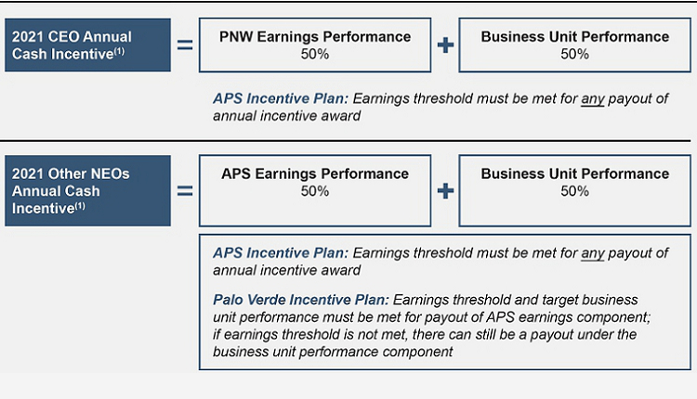

- Weightings are shown as a percentage of total incentive opportunity.

Individual awards under our annual cash incentive plans are based on the achievement of relevant and objective earnings and business unit goals, which tie payouts directly to core measures of business performance and key operational business unit results and ultimately serve to enhance shareholder value.

2021 Incentive Plan Opportunities

 |  | Threshold |  | Target |  | Maximum |  | 2021 Actual |  | 2021 Actual
NEO |  | (% of Salary) |  | (% of Salary) |  | (% of Salary) |  | (% of Salary) |  | ($)
Mr. Guldner |  | 27.50 |  | 110 |  | 220 |  | 162.7 |  | 1,790,074
Mr. Geisler |  | 17.50 |  | 70 |  | 140 |  | 99.5 |  | 447,757
Mr. Hatfield |  | 18.75 |  | 75 |  | 150 |  | 106.0 |  | 741,701
Ms. Lacal |  | 18.75 |  | 75 |  | 150 |  | 132.8 |  | 796,545
Mr. Smith⁽¹⁾ |  | 18.75 |  | 75 |  | 150 |  | 106.0 |  | 646,333

- As a result of his promotion to Executive Vice President, General Counsel and Chief Development Officer in June of 2021, Mr. Smith’s annual incentive target as a percent of salary was increased from 65% to 75%.

2022 Proxy Statement | 67

Table of Contents

Executive Compensation

2021 APS Incentive Plan Results

The metrics, weightings, and results for Messrs. Guldner, Geisler, Hatfield, and Smith under the APS Incentive Plan, and Ms. Lacal under the

Palo Verde Incentive Plan, are outlined below:

 |  |  | 50% Business Unit Performance
 | 50% | Corporate | Customer | Generation | Transmission/ | Palo | 2021
 | Earnings⁽¹⁾ | Resources | Experience | (non-nuclear) | Distribution | Verde | Total
NEO | (%) | (%) | (%) | (%) | % | (%) | %
Mr. Guldner | 200 | 83(2) | 90 | 102 | 51 | 154 | 96
Weighting | (50) | (10) | (10) | (10) | (10) | (10) | (50)
Mr. Geisler | 200 | 84(3) |  |  |  |  | 84
Weighting | (50) | (50) |  |  |  |  | (50)
Mr. Hatfield | 200 | 83(4) |  |  |  |  | 83
Weighting | (50) | (50) |  |  |  |  | (50)
Ms. Lacal | 200 |  |  |  |  | 154 | 154
Weighting | (50) |  |  |  |  | (50) | (50)
Mr. Smith | 200 | 83(5) |  |  |  |  | 83
Weighting | (50) | (50) |  |  |  |  | (50)

- Reflects PNW earnings for Mr. Guldner and APS earnings for all others.

- Reflects the average of all Corporate Resources business units.

- Reflects the following Corporate Resources business units and respective weightings: Finance/Accounting at 70% and Information Technology at 30%.

- Reflects the Finance/Accounting Corporate Resources business unit.

- Reflects the Legal Corporate Resources business unit.

68

Table of Contents

Executive Compensation

2021 Incentive Plan Target Setting Process, Rigor and Results

Earnings Component Target Setting Process

The earnings component targets consider that, as a regulated utility, we are generally unable to adjust our base retail rates outside of a rate case. As such, in years in which we do not expect a retail rate adjustment, changes in our revenues over the previous year would depend largely on factors beyond our control, such as customer growth, weather and customer usage patterns. The Committee sets earnings goals each year in support of the Company’s financial plan and growth objectives, while taking into consideration economic conditions and items that may have impacted the prior year’s actual results, such as:

- weather-related revenue

- state and federal regulatory or policy changes

- impact(s) of one-time or non-recurring items

The Committee reviews earnings adjustments throughout the year by considering:

- whether the item was included in the financial plan

- whether the item was an unanticipated event that occurred during the period (outside of management’s control)

- whether the item was unusual on non-recurring, including without limitation, ACC related impacts on earnings

Consistent with this methodology, for 2021, the Committee set threshold, target and maximum Pinnacle West and APS earnings goals at a decrease relative to 2020 actual incentive earnings in consideration of the following:

- inclusion of a projection of revenue and earnings impacts related to the anticipated but unknown actual impact of a decrease in base retail rates from our pending 2019 rate case decision

- the 2020 incentive earnings being favorably impacted by the hottest summer on record and an adjustment for a one-time expense

- a continued focus on effective cost controls and customer affordability

- a forecast of annual retail electricity sales growth to be in the range of 0.5% - 1.5% based on COVID recovery expectations of growth in commercial and industrial sales and a return to a more historical residential usage level as compared to 2020 impacts of COVID remote work and school policies

For 2021, we set the APS earnings target at $ 533 million, a decrease from 2020 actual incentive earnings of $587.7 million. Likewise, we set Pinnacle West’s 2021 earnings target at $514 million, compared to Pinnacle West’s 2020 actual incentive earnings of $569.5 million.

2021 PNW AND APS INCENTIVE PLAN RESULTS – EARNINGS

Actual earnings for Pinnacle West and APS for incentive plan purposes were 200% of target, at $618.7 million and $632.3 million, respectively, as shown on page 70. The 2021 earnings results were driven primarily by:

- commercial and industrial sales recovery to historical levels

- residential sales significantly higher than forecasted due to on-going COVID remote work and school policies
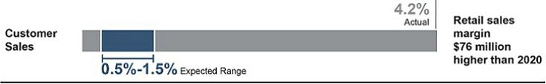

- 2021 incentive earning results would have been unchanged if no adjustments (as discussed above) were made during the 2021 Incentive Plans target setting process

2022 Proxy Statement | 69

Table of Contents

Executive Compensation

The earnings portion of the annual cash incentive for Mr. Guldner as CEO was determined based on Pinnacle West earnings weighted at 50% of the award. For all NEOs other than the CEO, the earnings portion of the annual cash incentive was determined based on APS earnings and weighted at 50% of the award. The APS Incentive Plan provides that if the threshold earnings number is not met, no incentive payment will be awarded, regardless of business unit performance.

The Palo Verde Incentive Plan provides that if the threshold earnings number is not met, the APS earnings portion of the incentive payment will not be awarded. In addition, under the Palo Verde Incentive Plan, PVGS’s overall business unit performance was required to achieve at least 100% of the target level for 2021 before Ms. Lacal could receive any payout under the APS earnings portion.
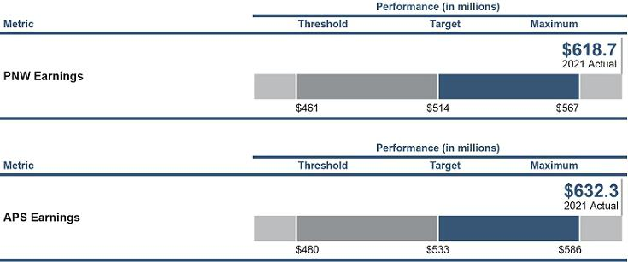

Under the terms of the 2021 Incentive Plans, the Committee may adjust plan targets or incentive results and may make other changes to the plan deemed necessary or appropriate due to unanticipated events that arise during the performance period or unusual or non-recurring adjustments on actual earnings that arise during the performance period, including without limitation, ACC rate-related impacts on earnings. The Committee did not make any adjustments to PNW and APS 2021 earnings.

Business Unit Component Target Setting Process

The Committee and the Board review and discuss the metrics and target recommendations to ensure appropriate rigor and alignment to business strategy and the financial plan.

The Company reviews enterprise shared and business unit specific metrics as part of the strategic business planning process to ensure alignment with the APS Promise, long-term issues and strategic priorities.

The goal-setting process considers objective measures to set achievement levels based on:

- industry benchmarks with the objective of delivering top quartile performance

- previous performance and opportunities to improve performance

- internal trends and external considerations

- goals to stretch and motivate performance improvement

Enterprise shared and specific business unit metrics are tied to the mission pillars of the APS Promise: Culture; Reliable; Customer Centric; Clean; and Affordable.

70

Table of Contents

Executive Compensation

For 2021, we revised several of our metrics to shared enterprise-wide metrics to align with our principles and execution of strategic priorities. The 2021 Incentive Plans business unit performance for the NEOs (excluding Ms. Lacal) was measured sixty percent on five shared enterprise metrics and the remaining forty percent on specific metrics aligned with the business unit(s) the officer supports.

- Mr. Guldner was evaluated against the shared enterprise metrics and an average of the five business specific areas

- Ms. Lacal was measured on PVGS business area metrics

2021 PNW and APS Incentive Plan Results – Business Unit Metrics

The 2021 average of all business unit metrics performance for 2021 was 96% of target compared to 130% of target in 2020. Performance includes adjustments for prudent business decisions, as described further below.

 |  |  | Business Unit Performance
 | Corporate | Customer | Generation | Transmission/ | Palo
 | Resources | Experience | (non-nuclear) | Distribution | Verde | Average
 | (%) | (%) | (%) | (%) | (%) | (%)
2021 Results⁽¹⁾ | 83 | 90 | 102 | 51 | 154 | 96
2020 Results⁽²⁾ | 123 | 117 | 152 | 100 | 157 | 130

- Results include adjustments made for prudent business decisions discussed below.

- Results include adjustments for prudent business decisions discussed on page 79 of the Company’s 2021 Proxy Statement.

As indicated above, NEOs are evaluated based on shared enterprise metrics and/or business area specific metrics that correlate to their responsibilities. The business unit component for each NEO was weighted at 50%, with multiple business area results averaged for applicable NEOs. The 2021 Incentive Plans allow the Committee to make adjustments for individual performance, and the Committee may exercise discretion under the 2021 Incentive Plans due to unanticipated events that might arise during the performance period. In 2021, the Committee adjusted two business metrics for management authorized increased prudent spend to offset and mitigate expense in future years due to the favorable impacts on earnings that were available primarily because of customer sales growth.

- These financial decisions increased the expenses for the shared enterprise operations and maintenance (“O&M”) for 2021 and the Committee approved an adjustment for PNW O&M.

- These financial decisions also increased capital spend for 2021 and the Committee approved an adjustment for PNW but capped the results to target achievement.

See “Business Unit Components Under the 2021 Incentive Plans” below for detailed goals and achievement levels for each business area.

2022 Proxy Statement | 71

Table of Contents

Executive Compensation

Business Unit Components Under the 2021 Incentive Plans

The following table summarizes the shared enterprise metrics and/or business area specific metrics used for each business unit, in addition to individual weightings, targets, and 2021 results. Under the components of the 2021 Incentive Plans, the range of potential achievement for each business unit metric was zero to 200% of the target level. Within that range, a target level of achievement provided for a 100% payout, a threshold level provided for a 50% of target payout and a maximum level provided for a 200% of target payout.

The percentage of target performance achieved reflects the comparison of our actual achievement of a particular measure for 2021 to the target established for that measure.

Business Unit Measures
and Weighting |  | Measure
Shared Enterprise Metrics (60%) (excluding PVGS)
Culture (15%) |  | Total Company Serious Injury and Fatality⁽¹⁾ (SIF)
 |  | (10%)
 |  | Total Company OSHA Recordable Incidents (5%)
Customer Centric (15%) |  | J.D. Power Electric Utility Residential Study Overall
 |  | Customer Satisfaction Index
Affordable (30%) |  | PNW O&M⁽²⁾ (15%)
 |  | PNW Capital⁽²⁾ (15%)
Corporate Resources (Information Technology)
Shared Enterprise Metrics (60%)
Reliable (40%) |  | Average of All Operations Groups⁽³⁾ Results (30%)
 |  | Mission Critical System Cumulative Availability (10%)
Corporate Resources (Resource Management)
Shared Enterprise Metrics (60%)
Culture (10%) |  | ERMG Violations (10%)
Reliable (30%) |  | Average of All Operations Groups⁽³⁾ Results (20%)
 |  | EIM Flex Ramping Value (10%)
Corporate Resources (excluding Information Technology and Resource Management)
Shared Enterprise Metrics (60%)
Reliable (40%) |  | Average of All Operations Groups⁽³⁾ Results (20%)
Customer Experience
Shared Enterprise Metrics (60%)
Customer Centric (40%) |  | Customer Care Service Level (20%)
 |  | Digital Engagement (20%)
Generation (non-nuclear)
Shared Enterprise Metrics (60%)
Reliable (20%) |  | G&O Start-Up Reliability (20%)
Customer Centric (20%) |  | Fleet Summertime Equivalent Availability Factor
 |  | (20%)
Transmission & Distribution

 |  |  |  |  | % of Target
 |  |  | Actual |  | Performance
Target |  |  | Results |  | Achieved
 |  |  |  |  | 26
 | N/A |  | 7 |  | 0
 | 27 |  | 40 |  | 0
 | Top half of 3rd |  | Top half of 4th |  | 0
Quartile |  |  | Quartile
 | $3M < Budget |  | $1.3M Under |  | 72
 | Budget +/- $5M |  | $5M Over |  | 100
 |  |  |  |  | 88
 |  |  |  |  | 26
 | 100% |  | 142% |  | 142
 | 99.9850% |  | 99.9978% |  | 200
 |  |  |  |  | 79
 |  |  |  |  | 26
 | 1 |  | 1 |  | 100
 | 100% |  | 142% |  | 142
 | 97.00% |  | 97.51% |  | 151
 |  |  |  |  | 83
 |  |  |  |  | 26
 | 100% |  | 142% |  | 142
 |  |  |  |  | 90
 |  |  |  |  | 26
 | 75.00% |  | 76.10% |  | 122
 | 100.0% |  | 184.9% |  | 200
 |  |  |  |  | 102
 |  |  |  |  | 26
 | 98.8% |  | 99.8% |  | 200
 | 92.8% |  | 94.4% |  | 180
 |  |  |  |  | 51

72

Table of Contents

 |  |  |  |  |  |  | Executive Compensation
Shared Enterprise Metrics (60%) |  |  |  |  |  |  |  |  | 26
Reliable (40%) | System Average Interruption Frequency Index |  |  | 0.86 |  | 0.89 |  |  | 63
 | (“SAIFI”) – All Weather (20%)
 |  | System Average Interruption Duration Index |  | 82.67 |  | 87.36 |  |  | 62
 | (“SAIDI”) (20%)
Palo Verde Generating Station⁽⁴⁾ |  |  |  |  |  |  |  |  | 154
Culture (40%) | Reactivity Management (7.5%) |  |  | 95 |  | 95 |  |  | 100
 |  | PVGS SIF⁽⁵⁾ – Employees and Contractors (20%) |  | N/A |  | 0 |  |  | 200
 |  | INPO Evaluation (5%) |  | N/A |  | Exemplary |  |  | 200
 |  | Voluntary Protection Permit (2.5%) |  | N/A |  | Certification |  |  | 200
 |  | Radiological Safety Focus Index (5%) |  | 93 |  | 98 |  |  | 171
Customer Centric (30%) |  | Site Capacity Factor (12.5%) |  | 92.00% |  | 91.71% |  |  | 86
 |  | Summer Reliability Capacity Factor (17.5%) |  | 98.70% |  | 98.65% |  |  | 95
Reliable (10%) |  | PI&R Performance Index⁽⁶⁾ (5%) |  | 5 G/W |  | 3 | Green |  | 113
 | Measured 3/31, 6/30, 9/30 and 12/31 |  | No Red |  |  | 4 | White
 |  | Operational Focus Indicator (2.5%) |  | 7 G/W |  | 8 | Green |  | 200
 | Measured 6/30 and 12/31⁽⁶⁾ |  | No Red |  |  | 0 | White
 |  | Plant Health Committee (PHC) Actions (2.5%) |  | 90 |  | 100 |  |  | 200
Affordable (20%) |  | O&M Budget (20%) |  | $2M < Budget |  | $14.6M Under |  |  | 200

- Measured quarterly; pays at maximum for each quarter with no recordable incidents; no payout if total SIFs for the year exceed 4 or in the event of an APS employee work-related fatality.

- Performance listed under the Actual Results column was adjusted; see page 71 for additional detail on this adjustment.

- Average includes: Transmission/Distribution, Customer Experience, Generation (non-nuclear) and PVGS.

- PVGS business unit performance goals must achieve at least 100% payout overall before payment of the APS performance component can occur.

- Measured quarterly; pays at maximum for each quarter with no recordable incidents; no payout if total SIFs for the year exceed 4, or in the event of a PVGS employee work-related fatality.

- Performance listed under the Actual Results column reflects 12/31/21 measurement.

Long-Term Incentives

Our long-term equity incentive compensation is intended to align the interests of executives and our shareholders and increase long-term shareholder value while also offering an award opportunity that helps attract and retain qualified, experienced executives. The Company currently uses two types of equity awards: performance shares and RSUs. For our CEO and Executive Vice Presidents, our annual long-term equity awards were granted 70% to performance-based measures and 30% to time-based vesting and for all other officers, 60% to performance-based measures and 40% to time-based vesting.

2021 Long-Term Equity Incentive Component Summary

 |  | % of Target
vehicle |  | Equity Pay Mix |  | Measurement Period |  | Performance Link
Performance Shares |  | ₇₀(1) |  | 3 years |  | Relative TSR (50%)
 |  |  |  |  |  | Relative Operational Performance (50%)
RSUs |  | ₃₀(1) |  | Vest ratably over 4 years |  | Stock Price

- For our 2021 annual long-term equity awards, all of our officers other than our CEO and our Executive Vice Presidents, were granted 60% Performance Shares and 40% RSUs.

2022 Proxy Statement | 73

Table of Contents

Executive Compensation

To determine the amount of performance share and RSU awards for the annual grants made in February of each year, the Committee first establishes a target compensation value for each officer that it wants to deliver through long-term equity award opportunities. The Committee considers various factors, including the retention value of the total compensation package, the long-term equity component in light of the competitive environment and individual performance. The Committee also considers target value taking into consideration the Company’s achievement of earnings targets and overall performance. Once the target value is established, the Committee determined the number of shares subject to the awards by reference to the then-current market value of the Company’s common stock and then allocated the 2021 awards 70% to performance shares and 30% to RSUs for the CEO and Executive Vice Presidents and 60% to performance shares and 40% to RSUs for all other officers.

The 2021 awards to the NEOs were as follows:

 |  | Performance Shares – 70% |  | RSUs – 30% |  | Grant Date Value
Name |  | (#) |  | (#) |  | _{($)}(1)
Mr. Guldner |  | 35,820 |  | 15,352 |  | $3,890,095
Mr. Geisler⁽²⁾ |  | 7,894 |  | 5,264 |  | $1,000,271
Mr. Hatfield |  | 11,050 |  | 4,736 |  | $1,200,052
Ms. Lacal |  | 7,368 |  | 3,160 |  | $800,339
Mr. Smith⁽²⁾ |  | 5,724 |  | 3,816 |  | $725,231

- For purposes of this table, Grant Date Value is equal to the total number of shares multiplied by the Company’s closing stock price on the date of grant ($76.02).

- Messrs. Geisler’s and Smith’s 2021 awards were 60% performance shares and 40% RSUs.

Performance Shares

2021 Performance Shares

We granted performance shares to our NEOs in February 2021 for a three-year performance period (the “2021 Performance Shares”) with two distinct elements — relative TSR and relative operational performance against five metrics.

Metrics

Relative TSR

Measures the Company’s TSR performance against:

- Edison Electric Institute Index (the “Index”)

Relative Operational Performance

Measures the Company’s average percentile ranking in:

- Customer reliability

- Customer-to-employee improvement ratio

- OSHA all incident injury rate

- Nuclear capacity factor

- J.D. Power Residential Customer Satisfaction Rating

Weighting

50%

50%

Rationale & Performance Link

Links pay to key measure generating shareholder value relative to others in the industry

Metrics are direct indicators of operational performance and provide a clear barometer of performance versus external benchmarks

The Committee grants each award recipient a specified number of performance shares, which is considered the “Base Grant.” Under each of the two performance elements, up to 100% of the Base Grant may be earned based on performance. The maximum award opportunity is 200% of the Base Grant, which reflects the sum of the maximum opportunities for performance against the two elements:

74

Table of Contents

Executive Compensation

TSR

TSR is the measure of a company’s stock price appreciation plus dividends during the three-year performance period. We believe using TSR strengthens the link between officer performance and shareholder return. We anticipate that the common stock payout, if any, related to this element will be made in February 2024. For our CEO and Executive Vice Presidents, the portion of the performance shares that are TSR based will vest at target only if the Company’s three-year relative TSR performance equals or exceeds the 55th percentile of the Index.

Relative Performance

Scale for Each Element
90th Percentile or Greater
75th Percentile
55th Percentile⁽¹⁾
25th Percentile
Less than 25th Percentile

Performance Share

Payout for Each Element

100% of the Base Grant

75% of the Base Grant

50% of the Base Grant

25% of the Base Grant

None

Total Maximum

Award Opportunity

200% of Base Grant

(Would require 90th percentile or greater performance for both relative TSR and operational performance metrics)

- For Messrs. Geisler’s and Smith’s 2021 Performance Shares, 50% of the Base Grant will pay out if the relative performance scale equals or exceeds the 50th percentile of the Index.

OPERATIONAL PERFORMANCE

The Company’s “average performance” with respect to the metrics listed below will be the average of the Company’s percentile ranking for each of these metrics during each of the three years of the performance period:

- The Company’s percentile ranking based on customer reliability results relative to other companies reported in the Edison Electric Institute (“EEI”) data;

- The Company’s ranking for a customer-to-employee improvement ratio, based on data provided by S&P Global Market Intelligence (“Market Intelligence”), an independent third-party data system, relative to other companies reported in the Market Intelligence data;

- The Company’s percentile ranking based on the OSHA rate (All Incident Injury Rate) relative to other companies reported in the EEI data;

- The Company’s percentile ranking based on nuclear capacity factor relative to other companies reported in the Market Intelligence data; and

- The Company’s percentile ranking based on the J.D. Power Residential Customer Satisfaction Rating relative to other large, investor-owned utility participating companies reported in the study.

Relative Performance

Scale for Each Element
90th Percentile or Greater
75th Percentile
55th Percentile⁽¹⁾
25th Percentile
Less than 25th Percentile

Performance Share

Payout for Each Element

100% of the Base Grant

75% of the Base Grant

50% of the Base Grant

25% of the Base Grant

None

Total Maximum

Award Opportunity

200% of Base Grant

(would require 90th percentile or greater performance for both relative TSR and operational performance metrics)

- For Messrs. Geisler’s and Smith’s 2021 Performance Shares, 50% of the Base Grant will pay out if the relative performance scale equals or exceeds the 50th Percentile of the Index.

The metrics selected are direct indicators of key business performance success. The metrics can be readily benchmarked and provide a clear barometer of top-tier performance excellence. We believe a focus on these performance metrics over a three-year period aligns long-term compensation with key operational goals, thereby enhancing overall Company performance.

We anticipate that the common stock payout, if any, related to this performance element will be made in October 2024.

2022 Proxy Statement | 75

Table of Contents

Executive Compensation

The recipient must remain employed with the Company throughout the performance period, unless the recipient meets any of the exceptions described under “Potential Payments upon Termination or Change of Control.” A recipient of performance shares will receive additional shares of common stock equal to the amount of dividends that the recipient would have received had the recipient directly owned the shares from the date of grant to the date of payment, plus interest on such dividends at the rate of 5% per annum, compounded quarterly, divided by the fair market value of one share of stock on the date of the stock payout. This common stock is paid out only if the related common stock payout is made. The 2021 Performance Shares are not included in calculating pension benefits.

The 2021 Performance Shares are included in the Summary Compensation Table in the column under “Stock Awards” and in the Grants of Plan-Based Awards table.

LOOKING AHEAD: 2022 PERFORMANCE SHARES

In 2022, we made substantial changes to our performance share metrics to enhance alignment to shareholder value and our strategic priority of ensuring long-term financial health and to execute on our Clean Energy Commitment. These changes went into effect beginning with the February 2022 grants to our NEOs. For the three-year performance period beginning January 1, 2022, there are three distinct elements — relative TSR, EPS performance and clean megawatts installed. The relative operational performance metrics in the prior 2021 Performance Shares were removed.

Metrics

Relative TSR

Measures the Company’s TSR performance against:

- Edison Electric Institute Index (the “Index”)

EPS Performance

Measures the Company’s actual EPS to our EPS target

Clean Megawatts Installed

Weighting |  | Rationale & Performance Link
40% |  | Links pay to key measure generating shareholder value
 |  | relative to others in the industry
40% |  | Links pay to key measure generating shareholder value
 |  | and financial targets
20% |  | Links pay to Clean Energy Commitment

Measures the Company’s actual clean megawatts installed to our clean

megawatts installed target

PAYOUTS OF 2018 PLAN AWARDS

In 2018, the Committee granted performance shares to the NEOs, based on relative TSR and relative operational performance. For the three-year period ended December 31, 2020, our TSR percentile was 5.8% compared to the companies in the Index. This was below the

25th percentile so the NEOs did not receive a payout for the TSR portion of these performance shares. For the same period, our average performance percentile with respect to the 2018 performance metrics was 66.5% compared to the companies included in the operational performance metrics. The actual payout to each NEO is identified in the Option Exercises and Stock Vested table.

RSUs

We granted RSUs to our NEOs in February 2021. RSUs vest in equal 25% installments over four years if the award recipient remains employed by the Company or one of its subsidiaries unless the recipient meets any of the exceptions described under “Potential Payments upon Termination or Change of Control”.

Each RSU represents the fair market value of one share of our common stock on the applicable vesting date, and the value rises and falls with the Company’s stock price.

The 2021 RSUs are payable at the election of the participant made shortly after the date of the initial grant, either 100% in stock, 50% in cash and 50% in stock, or 100% in cash, and will vest each February 20 in an amount equal to the number of RSUs vesting on such date multiplied by the closing price of a share of our common stock on that date.

The RSUs accrue dividend rights on the vested RSUs, equal to the amount of dividends that the participant would have received had the participant directly owned stock equal to the number of vested RSUs from the date of grant to the date of payment, plus interest at the rate of 5% per annum, compounded quarterly,

76

Table of Contents

Executive Compensation

with such amount paid either 100% in stock, 50% in cash and 50% in stock, or 100% in cash based on the participant’s election as discussed above.

The 2021 RSUs are included in the Summary Compensation Table in the column under “Stock Awards” and in the Grants of Plan-Based Awards table. RSUs granted in previous years that vested in 2021 are identified in the Option Exercises and Stock Vested table.

Benefits

Pension Programs

The NEOs participate in the Pinnacle West Capital Corporation Retirement Plan (the “Retirement Plan”) and the Supplemental Excess Benefit Retirement Plan (the “Supplemental Plan”). We describe these plans in more detail under “Discussion of Pension Benefits”. The Company believes that the pension programs are important recruitment and retention tools.

Deferred Compensation Program

The Company offers to its executive officers the ability, if the officer so chooses, to participate in a deferred compensation program. We describe our deferred compensation program in more detail under “Discussion of Nonqualified Deferred Compensation”. We offer our deferred compensation program because the Committee believes that it is standard market practice to permit officers to defer some portion of their cash compensation. However, we generally consider the value in the deferred compensation plan to be the participant’s own money and do not give this amount significant weight in making compensation decisions. Discretionary credit awards under the deferred compensation plan for Mr. Geisler and Ms. Lacal are discussed under the heading “Discussion of Nonqualified Deferred Compensation”.

Change of Control Agreements

The Company maintains Key Executive Employment and Severance Agreements (the “Change of Control Agreements”) for our officers, including the NEOs. Similar to our deferred compensation programs, Change of Control Agreements do not have a significant impact on compensation design. We discuss our Change of Control Agreements in more detail under “Potential Payments upon Termination or Change of Control.” Our Change of Control Agreements are “double trigger” agreements that provide severance benefits if, during a specified period following a change of control, the Company terminates an employee without “cause” or the employee terminates employment “for good reason.” We believe that the possibility of strategic transactions or unsolicited offers creates job uncertainty for executives, and that the Change of Control Agreements are effective tools to provide incentives for executives to stay with the Company in light of these uncertainties. In addition, we believe that if the agreements are appropriately structured, they do not deter takeovers or disadvantage shareholders. Each agreement is terminable on notice given six months prior to each anniversary of the agreement.

In May 2009, in connection with a review of its executive compensation practices, the Company determined that, on a going-forward basis, it would no longer provide excise tax gross-up payments in new and materially amended Change of Control Agreements with its NEOs, but provided for an exception that gave the Company the ability to include a limited excise tax gross-up provision in connection with recruiting a new executive to the Company. In 2018, the Committee removed this exception.

In addition to the Change of Control Agreements described above, under the terms of our 2012 Plan and 2021 LTIP awards are accelerated upon a change of control unless the Board chooses to override such provisions. In exercising its override authority, the Board must conclude, in good faith, that participants’ awards will remain outstanding, be assumed, or be exchanged for new awards pursuant to a change of control, and that there will be no material impairment to either the value of the awards or the opportunity for future appreciation in respect of the awards.

Perquisites

We have had a long-standing practice of providing only limited perquisites to our executive officers. We describe our perquisites paid to each of the NEOs in footnote 4 to the Summary Compensation Table on page 81.

2022 Proxy Statement | 77

Table of Contents

Executive Compensation

Other Considerations

Stock Ownership and Retention Guidelines

We believe that linking a significant portion of an officer’s current and potential future net worth to the Company’s success, as reflected in our stock price, helps to ensure that officers have a stake similar to that of our shareholders. Stock ownership guidelines also encourage the long-term management of the Company for the benefit of the shareholders.

The Company’s Guidelines are based on the officer’s position and his or her base salary. The ownership requirements are shown below in respect of the indicated officer position:

Officer

Chief Executive Officer

APS President and all Executive and Senior Vice Presidents

All other Vice Presidents and Officers

Multiple of Base Salary⁽¹⁾
5 times Base Salary

2 times Base Salary

1 times Base Salary

- Each officer is expected to meet his or her ownership requirement within five years following such officer’s election (the “Phase-in Period”). In the event of (1) a promotion or a change in the Guidelines that would cause the officer to move into a higher multiple level or (2) a base salary increase of more than 20% over the officer’s previous base salary, an officer will have an additional three years to meet his or her applicable ownership requirement. If the officer does not attain compliance with his or her ownership requirement by the end of the Phase-in Period, any subsequent grants of equity compensation to such officer will be payable solely in shares of stock until the ownership requirement is met. Under the Guidelines, the CEO may grant exceptions for hardship and other special circumstances. The types of ownership arrangements counted toward the Guidelines are: common stock, whether held individually, jointly, or in trust with or for the benefit of an immediate family member; shares issued upon the vesting of RSUs or the payout of performance shares; and unvested RSUs to the extent they will result in the issuance of common stock to the officer.

Officers may not sell or otherwise transfer (“Dispose”) any shares of Company stock received by them pursuant to any of the Company’s compensation or benefit programs (net of shares sold or surrendered to meet tax withholding or exercise requirements) until his or her ownership requirement has been met. All NEOs are in compliance with the Guidelines.

Prohibition on Hedging and Pledging

Directors, officers, and employees of the Company may not engage in any speculative trading, hedging, or derivative security transaction (including any financial instrument such as a prepaid variable forward contract, equity swap, collar, short-sales, or exchange fund) that involves or references Company securities. In addition, Directors and officers may not pledge, margin or otherwise grant an economic interest in any shares of Company stock.

Clawback Policy

Pinnacle West has a clawback policy that applies to specified current or former executive officers, including our NEOs. Under the policy, in the event of any material restatement of the consolidated financial statements of the Company and its subsidiaries within three years of the first public release or filing with the SEC, the Committee may, within 12 months after the material restatement, require forfeiture and/or return to the Company of all or a portion of the compensation vested, awarded or received under any bonus award, short-term incentive award, equity award (including any award of restricted stock, performance shares, phantom stock, deferred stock units or RSUs) or other award during the period subject to restatement and the 12-month period following the first public issuance or filing with the SEC of the financial statements that were restated, by any executive that the Committee determines has personally engaged in intentional misconduct that caused or partially caused the need for such restatement. Any forfeiture and/or return of compensation by an executive under the policy will be limited to the portion that the executive would not have received if the consolidated financial statements had been reported properly at the time of first public release or filing with the SEC. By accepting any award as to which this policy applies, each executive agrees to forfeit and/or return compensation to the Company as provided by the policy. The policy does not limit the ability of the Company to pursue forfeiture or reclaim payments under other legal rights.

78

Table of Contents

Executive Compensation

Taxation Considerations Regarding

Executive Compensation

Pursuant to Section 162(m) of the Internal Revenue Code (the “Code”), for federal income tax purposes, publicly traded corporations generally are not permitted to deduct annual compensation in excess of $1 million paid to any of certain top executives. The Committee and the Board may weigh the tax consequences of the total compensation program when setting the total compensation package for an officer. However, the Committee and the Board do not routinely apply the tax-deductibility rules to limit what they determine otherwise to be necessary and appropriate compensation awards or as a justification for awarding compensation below $1 million.

As a result of changes made by the 2017 Tax Cuts and Jobs Act, certain “performance-based” compensation, which was excludible from the scope of Section 162(m) under prior law, must now be included in determining the $1 million limitation unless it qualifies under a transition rule applicable to certain compensation arrangements in place as of November 2, 2017. In December 2020, the Internal Revenue Service released final regulations which provide additional guidance related to this transition rule. The Company continues to believe that performance-based awards granted to our executive officers, and in place as of November 2, 2017, are deductible under this transition rule. Further, the Committee reserves the right to modify compensation that was initially intended to be exempt from Section 162(m) if it determines that such modifications are consistent with the Company’s business needs.

2022 Proxy Statement | 79

Table of Contents

Executive Compensation

NEO Pay Summaries

The charts below illustrate the strong emphasis that we place on performance-based, shareholder-aligned incentive compensation:
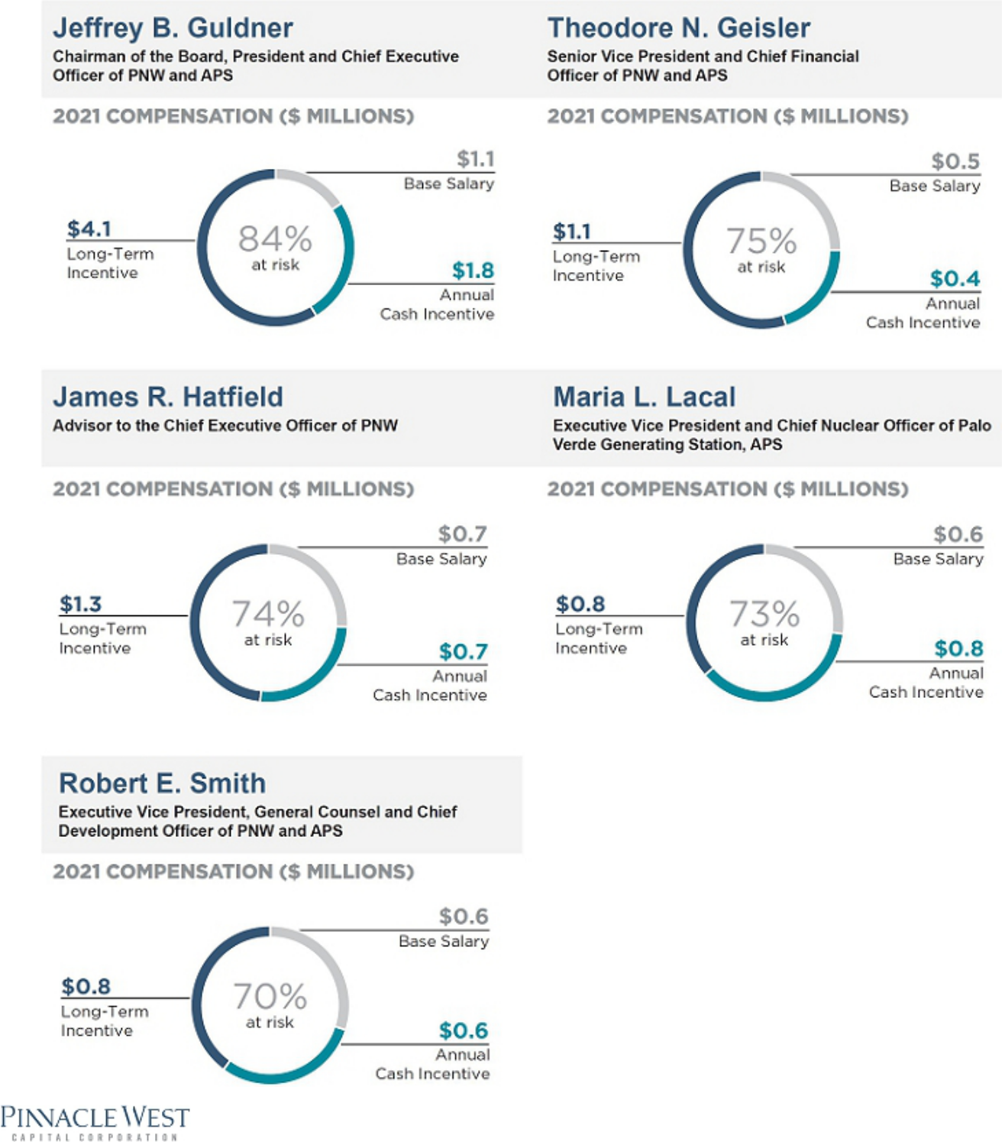

80

Table of Contents

Executive Compensation

Executive Compensation Tables

Summary Compensation Table

The following table provides information concerning the total compensation earned or paid to the Company’s NEOs:

 |  |  |  |  |  |  |  |  |  |  |  | Change in
 |  |  |  |  |  |  |  |  |  |  |  | Pension
 |  |  |  |  |  |  |  |  |  |  |  | Value and
 |  |  |  |  |  |  |  |  |  |  |  | Nonqualified
 |  |  |  |  |  |  |  |  |  | Non-Equity |  | Deferred
 |  |  |  |  |  |  |  | Stock |  | Incentive Plan |  | Compensation |  | All Other
Name and |  |  |  | Salary |  | Bonus |  | Awards |  | Compensation |  | Earnings |  | Compensation |  | Total
Principal Position |  | Year |  | ($) |  | ($) |  | ($)⁽¹⁾ |  | ($)⁽²⁾ |  | ($)⁽³⁾ |  | ($)⁽⁴⁾ |  | ($)
Jeffrey B. Guldner, |  | 2021 |  | 1,100,000 |  | 0 |  | 4,079,762 |  | 1,790,074 |  | 1,099,555 |  | 30,766 |  | 8,100,157
Chairman of the Board, President and Chief Executive
 |  | 2020 |  | 1,100,000 |  | 0 |  | 3,316,740 |  | 1,551,946 |  | 856,971 |  | 23,798 |  | 6,849,455
Officer of PNW and APS
 |  | 2019 |  | 777,644 |  | 0 |  | 1,821,229 |  | 716,247 |  | 551,217 |  | 26,711 |  | 3,893,048
Theodore N. Geisler, |  | 2021 |  | 450,000 |  | 0 |  | 1,051,582 |  | 447,757 |  | 93,957 |  | 28,489 |  | 2,071,785
Senior Vice President and Chief Financial Officer of PNW
 | 2020 |  |  | 380,109 |  | 0 |  | 512,791 |  | 318,840 |  | 78,194 |  | 23,388 |  | 1,313,322
and APS
James R. Hatfield,⁽⁵⁾ |  | 2021 |  | 700,000 |  | 0 |  | 1,258,562 |  | 741,701 |  | 782,368 |  | 785,962 |  | 4,268,593
Advisor to the Chief Executive Officer of PNW
 |  | 2020 |  | 700,000 |  | 0 |  | 1,224,562 |  | 699,090 |  | 835,020 |  | 23,210 |  | 3,481,882
 |  | 2019 |  | 686,000 |  | 0 |  | 1,012,038 |  | 534,128 |  | 814,347 |  | 27,718 |  | 3,074,231
Maria L. Lacal, |  | 2021 |  | 600,000 |  | 0 |  | 839,352 |  | 796,545 |  | 483,567 |  | 34,821 |  | 2,754,285
Executive Vice President, Chief Nuclear Officer Palo
 | 2020 |  |  | 570,710 |  | 0 |  | 714,708 |  | 563,394 |  | 479,883 |  | 23,210 |  | 2,351,905
Verde Generating Station, APS
Robert E. Smith,⁽⁶⁾ |  | 2021 |  | 610,000 |  | 0 |  | 762,436 |  | 646,333 |  | 229,176 |  | 26,800 |  | 2,274,745
Executive Vice President, General Counsel and Chief
 |  | 2020 |  | 610,000 |  | 0 |  | 717,454 |  | 528,812 |  | 194,742 |  | 115,813 |  | 2,166,821
Development Officer of PNW and APS
 |  | 2019 |  | 600,000 |  | 150,000 |  | 656,982 |  | 408,330 |  | 129,434 |  | 205,241 |  | 2,149,987

- The amounts in this column reflect the aggregate grant date fair value of performance shares and RSUs computed in accordance with FASB ASC Topic 718. For performance shares, 50% of the value reported is based on the probable outcome of the performance conditions as of the grant date using a Monte Carlo simulation model: ($86.61 for Messrs. Guldner and Hatfield, and Ms. Lacal; and $89.02 for Messrs. Geisler and Smith) and 50% is based on the closing price on the date of grant ($76.02). The amounts in the column are allocated between the various equity grants as follows:

 |  |  |  | Performance
 |  | RSUs |  | Shares
Name |  | ($) |  | ($)
Mr. Guldner |  | 1,167,059 |  | 2,912,703
Mr. Geisler |  | 400,169 |  | 651,413
Mr. Hatfield |  | 360,031 |  | 898,531
Mrs. Lacal |  | 240,223 |  | 599,129
Mr. Smith |  | 290,092 |  | 472,344

The aggregate grant date fair value of the performance shares granted in 2021 assuming the highest level of performance is achieved is as follows: Mr. Guldner — $5,825,406; Mr. Geisler — $1,302,826; Mr. Hatfield — $1,797,062; Ms. Lacal — $1,198,257; and Mr. Smith — $944,688. There were no forfeitures in 2021.

- These amounts represent the payments described under “Executive Compensation Components — Annual Cash Incentives” in the CD&A.

2022 Proxy Statement | 81

Table of Contents

Executive Compensation

- The amounts in this column for 2021 consist of: (i) the estimated aggregate change in the actuarial present value from December 31, 2020 to December 31, 2021 of each of
the NEO’s accumulated benefits payable under all defined benefit and actuarial pension plans (including supplemental plans and employment agreements) as follows: Mr. Guldner — $1,021,838; Mr. Geisler — $79,310; Mr. Hatfield — $760,633; Ms. Lacal — $401,148 and Mr. Smith — $202,572; and (ii) the above-market portion of interest accrued under the deferred compensation plan as follows: Mr. Guldner — $77,717; Mr. Geisler — $14,647; Mr. Hatfield — $21,735; Ms. Lacal — $82,419 and Mr. Smith — $26,604. The actuarial present value provided in this footnote is driven by certain assumptions, including the discount rate and the mortality assumption.

- The amounts in this column include the following amounts for each of the NEOs for 2021:

Mr. Guldner:

• | Company’s contribution under the 401(k) plan | 13,050
• | Perquisites and personal benefits consisting of a car allowance, executive physical and financial planning | 17,716
Mr. Geisler:
• | Company’s contribution under the 401(k) plan | 13,050
• | Perquisites and personal benefits consisting of a car allowance and executive physical | 15,439
Mr. Hatfield:
• | Company’s contribution under the 401(k) plan | 13,050
• | Perquisites and personal benefits consisting of a car allowance, executive physical and financial planning | 22,912
• | Separation payment | 750,000
Ms. Lacal:
• | Company’s contribution under the 401(k) plan | 13,050
• | Perquisites and personal benefits consisting of a car allowance and executive physical | 21,771
Mr. Smith:
• | Company’s contribution under the 401(k) plan | 13,050
• | Perquisites and personal benefits consisting of a car allowance and financial planning | 13,750

- Mr. Hatfield retired on December 31, 2021.

- Mr. Smith was promoted to Executive Vice President, General Counsel and Chief Development Officer of PNW and APS effective June 23, 2021.

82

Table of Contents

Executive Compensation

Grants of Plan-Based Awards

Name

Jeffrey B. Guldner

Theodore N. Geisler

James R. Hatfield

Maria L. Lacal

Robert E. Smith

 |  |  |  |  |  |  |  |  |  |  |  |  |  | All Other |  | Grant
 |  |  |  |  |  |  |  |  |  |  |  |  |  | Stock |  | Date
 |  |  |  |  |  |  |  |  |  |  |  |  |  | Awards: |  | Fair Value
 |  | Estimated Possible Payouts Under |  |  |  |  |  | Estimated Future Payouts Under |  |  |  |  |  | Number of |  | of Stock
 |  | Non-Equity Incentive Plan Awards⁽²⁾ |  |  |  |  |  | Equity Incentive Plan Awards |  |  |  |  |  | Shares of |  | and
 |  |  |  |  |  |  |  |  |  |  |  |  |  | Stock or |  | Option
Grant Date⁽¹⁾ |  | Threshold |  | Target |  | Maximum |  | Threshold |  | Target |  | Maximum |  | Units |  | Awards⁽³⁾
 |  | ($) |  | ($) |  | ($) |  | (#) |  | (#) |  | (#) |  | (#) |  | ($)
 |  | 6,050 |  | 1,210,000 |  | 2,420,000
02/16/2021⁽⁴⁾ |  |  |  |  |  |  |  | 17,910 |  | 35,820 |  | 71,640 |  |  |  | 2,912,703
(PS)
02/16/2021⁽⁵⁾ |  |  |  |  |  |  |  |  |  |  |  |  |  | 15,352 |  | 1,167,059
(RSU)
 |  | 1,575 |  | 315,000 |  | 630,000
02/16/2021⁽⁴⁾ |  |  |  |  |  |  |  | 3,946 |  | 7,894 |  | 15,788 |  |  |  | 651,413
(PS)
02/16/2021⁽⁵⁾ |  |  |  |  |  |  |  |  |  |  |  |  |  | 5,264 |  | 400,169
(RSU)
 |  | 2,625 |  | 525,000 |  | 1,050,000
02/16/2021⁽⁴⁾ |  |  |  |  |  |  |  | 5,524 |  | 11,050 |  | 22,100 |  |  |  | 898,531
(PS)
02/16/2021⁽⁵⁾ |  |  |  |  |  |  |  |  |  |  |  |  |  | 4,736 |  | 360,031
(RSU)
 |  | 2,250 |  | 450,000 |  | 900,000
02/16/2021⁽⁴⁾ |  |  |  |  |  |  |  | 3,684 |  | 7,368 |  | 14,736 |  |  |  | 599,129
(PS)
02/16/2021⁽⁵⁾ |  |  |  |  |  |  |  |  |  |  |  |  |  | 3,160 |  | 240,223
(RSU)
 |  | 2,288 |  | 457,500 |  | 915,000
02/16/2021⁽⁴⁾ |  |  |  |  |  |  |  | 2,862 |  | 5,724 |  | 11,448 |  |  |  | 472,344
(PS)
02/16/2021⁽⁵⁾ |  |  |  |  |  |  |  |  |  |  |  |  |  | 3,816 |  | 290,092
(RSU)

- In this column, the abbreviation “PS” means performance share awards and “RSU” means restricted stock unit awards.

- As required by SEC rules, the “Estimated Possible Payouts” represent the “threshold,” “target,” and “maximum” payouts the NEOs were eligible to receive under the 2021 Incentive Plans. The actual awards paid to the NEOs under the 2021 Incentive Plans are disclosed in the “Non-Equity Incentive Plan Compensation” column of the Summary Compensation Table. With respect to Messrs. Guldner, Geisler, Hatfield, and Smith, the minimum amount each officer would have been eligible to receive was calculated based on earnings achieving 1% and no achievement of the business unit performance metrics. The minimum amount Ms. Lacal would have been eligible to receive was calculated based on the business unit performance metrics achieving 1% and no achievement of the APS earnings goals under the Palo Verde Incentive Plan.

- The amounts in this column reflect the aggregate grant date fair value of performance shares and RSUs computed in accordance with FASB ASC Topic 718.

- This amount represents the 2021 Performance Shares described under “Executive Compensation Components — Long-Term Incentives — Performance Shares” in the CD&A. In accordance with FASB ASC Topic 718, 50% of the value is based on the probable outcome of the performance conditions as of the grant date using a Monte Carlo simulation model ($86.61 for Mr. Guldner, Mr. Hatfield, and Ms. Lacal; $89.02 for Messrs. Geisler and Smith), while the other 50% is based on the closing stock price on the date of grant ($76.02). There were no forfeitures in 2021.

- This amount represents the 2021 RSU awards described under “Executive Compensation Components — Long-Term Incentives — RSUs” in the CD&A. In accordance with FASB ASC Topic 718, we valued the RSUs using the number of RSUs awarded multiplied by the closing stock price on the date of the grant ($76.02). There were no forfeitures in 2021.

2022 Proxy Statement | 83

Table of Contents

Executive Compensation

Narrative Disclosure to Summary Compensation Table and Grants of Plan-Based Awards Table

See the CD&A for further information regarding the terms of awards reported in the Summary Compensation Table and the Grants of Plan-Based Awards table, and for discussions regarding the formulas or criteria to be applied in determining the amounts payable, vesting schedules, and the treatment of dividends.

The Company does not have formal employment agreements with its NEOs; however, we typically enter into offer letters with new executive officers. Deferred compensation credits granted to Mr. Geisler and Ms. Lacal are discussed under the heading “Discussion of Nonqualified Deferred Compensation” on page 91 and a Medical Retention Agreement entered into with Ms. Lacal is discussed under the heading “Potential Payments upon Termination or Change of Control” on pages 91-92.

Pinnacle West and Mr. Smith executed an offer letter dated July 19, 2018. Pursuant to the offer letter, Mr. Smith was awarded 1,232 performance shares to be released, only if the performance criteria were met in 2020; 2,464 performance shares to be released, only if the performance criteria were met in 2021; 1,232 RSUs that vested on February 20, 2019; 1,846 RSUs that vested on February 20, 2020; and 2,464 that vested on February 19, 2021. The offer letter also provided for participation in the Supplemental Executive Retirement Plan and the Deferred Compensation Plan; a Change-in-Control Agreement similar to those provided to other officers and standard executive relocation benefits.

Effective October 17, 2018, Pinnacle West and Mr. Smith entered into a Supplemental Agreement to his offer letter which provided that Mr.

Smith received an additional long-term stock base award grant in February 2019 with a grant date value of $100,000.

Effective August 30, 2021, in further alignment with its focus on costs, the Company eliminated the Chief Administrative Officer position. With the elimination of this position, Mr. Hatfield transitioned to the role of Advisor to the Chief Executive Officer. In connection with this transition, Mr. Hatfield and the Company entered into a Transition and Separation Agreement (“Transition and Separation Agreement”), and Mr. Hatfield separated from the Company effective December 31, 2021. Mr. Hatfield continued to receive his current annual base salary of $ 700,000 until his separation date and he was eligible to receive a 2021 incentive award under the APS Incentive Plan. In consideration of Mr. Hatfield remaining employed with the Company until December 31, 2021, the Company paid Mr. Hatfield a lump sum separation payment in the amount of $750,000.

84

Table of Contents

Executive Compensation

Outstanding Equity Awards at Fiscal Year-End

 |  |  |  |  |  | Stock Awards
 |  |  |  |  |  |  | Equity Incentive Plan |  | Equity Incentive Plan
 |  | Number of |  |  |  |  | Awards: Number of |  | Awards: Market or
 |  | Shares or |  | Market Value of |  |  | Unearned Shares, |  | Payout Value
 |  | Units of Stock |  | Shares or Units of |  |  | Units or Other Rights |  | of Unearned Shares,
 |  | That Have Not |  | Stock That Have |  |  | That Have Not |  | Units or Other Rights
 |  | Vested |  | Not Vested |  |  | Vested |  | That Have Not
Name |  | (#) |  | ($)⁽¹⁾ |  | (#) |  |  | Vested ($)⁽¹⁾
Jeffrey B. Guldner |  | 15,907⁽²⁾ |  | 1,122,875 |  | 37,114⁽⁶⁾ |  |  | 2,619,877
 |  | (RSUs) |  |  |  |  | (PS at target)
 |  | 7,185⁽³⁾ |  | 507,189 |  | 24,241⁽⁷⁾ |  |  | 1,711,172
 |  | (RSUs) |  |  |  |  | (PS at target)
 |  | 2,980⁽⁴⁾ |  | 210,358 |  | 15,745⁽⁸⁾ |  |  | 1,111,440
 |  | (RSUs) |  |  |  |  | (PS at target)
 |  | 681⁽⁵⁾ |  | 48,072
 |  | (RSUs)
Theodore N. Geisler |  | 5,454⁽²⁾ |  | 384,998 |  | 8,179⁽⁶⁾ |  |  | 577,355
 |  | (RSUs) |  |  |  |  | (PS at target)
 |  | 1,601⁽³⁾ |  | 113,015 |  | 3,198⁽⁷⁾ |  |  | 225,747
 |  | (RSUs) |  |  |  |  | (PS at target)
 |  | 440⁽⁴⁾ |  | 31,060 |  | 1,314⁽⁸⁾ |  |  | 92,755
 |  | (RSUs) |  |  |  |  | (PS at target)
 |  | 268⁽⁵⁾ |  | 18,918
 |  | (RSUs)
James R. Hatfield |  | 4,736⁽²⁾ |  | 334,314 |  | 11,449⁽⁶⁾ |  |  | 808,185
 |  | (RSUs) |  |  |  |  | (PS at target)
 |  | 2,652⁽³⁾ |  | 187,205 |  | 8,951⁽⁷⁾ |  |  | 631,851
 |  | (RSUs) |  |  |  |  | (PS at target)
 |  | 1,656⁽⁴⁾ |  | 116,897 |  | 8,749⁽⁸⁾ |  |  | 617,592
 |  | (RSUs) |  |  |  |  | (PS at target)
 |  | 972⁽⁵⁾ |  | 68,613
 |  | (RSUs)
Maria L. Lacal |  | 3,217⁽²⁾ |  | 227,088 |  | 7,634⁽⁶⁾ |  |  | 538,884
 |  | (RSUs) |  |  |  |  | (PS at target)
 |  | 1,635⁽³⁾ |  | 115,414 |  | 5,224⁽⁷⁾ |  |  | 368,762
 |  | (RSUs) |  |  |  |  | (PS at target)
 |  | 750⁽⁴⁾ |  | 52,943 |  | 2,250⁽⁸⁾ |  |  | 158,828
 |  | (RSUs) |  |  |  |  | (PS at target)
 |  | 459⁽⁵⁾ |  | 32,401
 |  | (RSUs)
Robert E. Smith⁽¹⁰⁾ |  | 3,885⁽²⁾ |  | 274,242 |  | 5,931⁽⁶⁾ |  |  | 418,669
 |  | (RSUs) |  |  |  |  | (PS at target)
 |  | 2,151⁽³⁾ |  | 151,839 |  | 4,476⁽⁷⁾ |  |  | 315,961
 |  | (RSUs) |  |  |  |  | (PS at target)
 |  | 1,627⁽⁴⁾ |  | 114,850 |  | 4,875⁽⁸⁾ |  |  | 344,126
 |  | (RSUs) |  |  |  |  | (PS at target)

- The amount in this column is calculated by multiplying the closing market price of our common stock at the end of 2021 ($70.59 per share as of December 31, 2021) by the number of RSUs, performance shares and corresponding dividend rights (and interest thereon) that will be paid in stock to the extent the underlying RSU’s and performance shares actually vest, listed for the specified officer.

- This amount represents the RSUs awarded in 2021 that are described, with their vesting and release schedule, under “Executive Compensation Components — Long-Term Incentives — RSUs” in the CD&A.

2022 Proxy Statement | 85

Table of Contents

Executive Compensation

- This amount represents (i) the remaining RSUs awarded in 2020 as follows: Mr. Guldner — 7,185; Mr. Geisler — 1,476; Mr. Hatfield — 2,652; Ms. Lacal — 1,548; and Mr.
Smith — 2,064; and (ii) accrued dividend rights (and interest thereon) that will be paid in stock to the extent the underlying RSU’s actually vest, as follows: Mr. Geisler — 125; Ms. Lacal — 87; and Mr. Smith — 87. The 2020 RSUs vest and are released in 25% increments beginning on February 20, 2021, so they will be fully vested on February 20, 2024.
- This amount represents (i) the remaining RSUs awarded in 2019 as follows: Mr. Guldner — 2,980; Mr. Geisler — 388; Mr. Hatfield —1,656; Ms. Lacal — 662; and Mr. Smith
— 1,436; and (ii) accrued dividend rights (and interest thereon) that will be paid in stock to the extent the underlying RSU’s actually vest, as follows: Mr. Geisler — 52; Ms. Lacal — 88; and Mr. Smith — 191. The 2019 RSUs vest and are released in 25% increments beginning on February 20, 2020, so they will be fully vested on February 20, 2023.
- This amount represents (i) the remaining RSUs awarded in 2018 as follows: Mr. Guldner — 681; Mr. Geisler — 227; Mr. Hatfield —972; and Ms. Lacal — 389; and (ii)
accrued dividend rights (and interest thereon) that will be paid in stock to the extent the underlying RSU’s actually vest, as follows: Mr. Geisler — 41; and Ms. Lacal — 70. The 2018 RSUs vest and are released in 25% increments beginning on February 20, 2019, so they were fully vested on February 18, 2022.

- This amount represents: (i) the 2021 Performance Shares — the SEC rules require us to assume a number of shares equal to the target (100% of Base Grant) payout level of these performance shares, although the actual number of shares awarded, if any, will not be determined until after the end of the performance period, which ends on December 31, 2023; and (ii) accrued dividend rights (and interest thereon) that will be paid in stock to the extent the underlying performance shares actually vest and are paid out, as follows: Mr. Guldner — 1,294; Mr. Geisler — 285; Mr. Hatfield — 399; Ms. Lacal — 266; and Mr. Smith — 207. The 2021 Performance Shares are described with their vesting schedule under “Executive Compensation Components — Long-Term Incentives — Performance Shares” in the CD&A.

- This amount represents: (i) the 2020 Performance Shares — the SEC rules require us to assume a number of shares equal to the target (100% of Base Grant) payout level of these performance shares, although the actual number of shares awarded, if any, will not be determined until after the end of the performance period, which ends on December 31, 2022; and (ii) accrued dividend rights (and interest thereon) that will be paid in stock to the extent the underlying performance shares actually vest and are paid out, as follows: Mr. Guldner — 1,893; Mr. Geisler — 250; Mr. Hatfield — 699; Ms. Lacal — 408; and Mr. Smith — 350. The 2020 Performance Shares are described with their vesting schedule under “Executive Compensation Components — Long-Term Incentives — Performance Shares” in the CD&A.

- This amount represents: (i) the 2019 performance shares — the SEC rules require us to assume a number of shares equal to the target (100% of the Base Grant) payout level of these performance shares, although the actual number of shares awarded, if any, will not be determined until after the end of the performance period, which ends on December 31, 2021; and (ii) accrued dividend rights (and interest thereon) that will be paid in stock to the extent the underlying performance shares actually vest and are paid out, as follows: Mr. Guldner — 1,845; Mr. Geisler — 154; Mr. Hatfield —1,025; Ms. Lacal — 264; and Mr. Smith — 571.

Option Exercises and Stock Vested

 |  | Stock Awards
 |  | Number of Shares |  | Value Realized
 |  | Acquired on Vesting |  | on Vesting
Name |  | (#)⁽¹⁾ |  | ($)⁽²⁾
Jeffrey B. Guldner |  | 10,436 |  | 731,906
Theodore N. Geisler |  | 2,164 |  | 151,442
James R. Hatfield |  | 11,457 |  | 782,239
Maria L. Lacal |  | 3,774 |  | 264,147
Robert E. Smith |  | 5,978 |  | 431,840

- The amount in this column consists of: (i) RSUs that were granted to NEOs in February 2020 that vested and were released in part on February 19, 2021 as follows: Mr. Guldner — 2,395; Mr. Geisler — 49; Mr. Hatfield —884; Ms. Lacal — 516; and Mr. Smith — 688; dividend rights (and interest thereon) payable in stock earned on RSUs granted in February 2020 and released in part on February 19, 2021 as follows: Mr. Geisler — 21; Ms. Lacal — 22; and Mr. Smith — 15 ; (ii) RSUs that were granted to NEOs in February 2019 that vested and were released in part on February 19, 2021 as follows: Mr. Guldner — 1,490; Mr. Geisler — 194; Mr. Hatfield — 828; Ms. Lacal — 331; and Mr. Smith — 718; dividend rights (and interest thereon) payable in stock earned on RSUs granted in February 2019 and released in part on February 19, 2021 as follows: Mr. Geisler — 17; Ms. Lacal — 28; and Mr. Smith — 62; (iii) RSUs that were granted to NEOs (except Mr. Smith) in February 2018, and Mr. Smith in October 2018, that vested and were released in part on February 19, 2021 as follows: Mr. Guldner — 681; Mr. Geisler — 227; Mr. Hatfield — 972; Ms. Lacal — 389; and Mr. Smith — 2,464; dividend rights (and interest thereon) payable in stock earned on RSUs granted in 2018 and released in part on February 19, 2021 as follows: Mr. Geisler — 29; Ms. Lacal — 50; and Mr. Smith — 132; (iv) RSUs that were granted to the NEOs (except Mr. Smith) in February 2017 that vested and were released in part on February 19, 2021 as follows: Mr. Guldner —627; Mr. Geisler —95; Mr. Hatfield — 1,129; and Ms. Lacal — 377; and dividend rights (and interest thereon) payable in stock earned on RSUs granted in February 2017 and released in part on February 19, 2021 as follows: Mr. Geisler — 16; Mr. Hatfield — 96; and Ms. Lacal — 64; (v) additional RSUs resulting from notional dividends on the one-time award of supplemental grants of RSUs that were granted in February 2011 for performance prior to 2011 and further described below (the “Supplemental RSUs”), that vested, but were not released, on the following dates in 2021:

86

Table of Contents

Executive Compensation

Name |  | March 1 |  | June 1 |  | September 1 |  | December 1
Jeffrey B. Guldner |  | 60 |  | 52 |  | 56 |  | 72
James R. Hatfield |  | 100 |  | 87 |  | 95 |  | 119
Maria L. Lacal |  | 40 |  | 35 |  | 37 |  | 48

(The Supplemental RSUs vested 50% on February 15, 2013, 25% on February 14, 2014, and 25% on February 13, 2015. The Supplemental RSUs are not released to the recipient until the recipient’s retirement, death, disability or separation of employment from the Company).

  - performance shares that were granted to the NEOs in February 2018 and Mr. Smith in October 2018, which were based on a performance period of January 1, 2018 to December 31, 2020, and which were released in 2021 when the Company had the information needed to determine whether, and to what extent, the applicable performance criteria were met, as follows: performance shares related to TSR did not meet performance criteria so there was no pay out of shares for this portion of the award; and performance shares related to the five operational performance metrics were released on November 4, 2021 as follows: Mr. Guldner — 4,221; Mr. Geisler — 905; Mr. Hatfield — 6,030; Ms. Lacal — 1,550; and Mr. Smith — 1,638; and dividend rights (and interest thereon) payable in stock on the performance shares released on November 4, 2021 as follows: Mr. Guldner — 782; Mr. Geisler — 168; Mr. Hatfield — 1,117; Ms. Lacal — 287; and Mr. Smith — 261.

- The values realized for the RSUs, Supplemental RSUs and the performance shares are calculated by multiplying the number of shares of stock or units released or vested by the market value of the common stock on the release or vesting date, which: (i) for the RSUs released on February 19, 2021 was $76.26; (ii) for the Supplemental RSUs vested on March 1, 2021 was $72.30; (iii) for the Supplemental RSUs vested on June 1, 2021 was $84.45; (iv) for the Supplemental RSUs vested on September 1, 2021 was $77.78; (v) for the Supplemental RSUs vested on December 1, 2021 was $64.06; and (vi) for the performance shares released on November 4, 2021 was $63.60.

Pension Benefits

The Pension Benefits table below includes estimates of the potential future pension benefits for each NEO based on the actuarial assumptions used for financial reporting purposes, such as the life expectancy of each NEO and their spouse and “discount rates.”

 |  |  |  |  |  | Present Value |  | Payments
 |  |  |  | Number of Years |  | of Accumulated |  | During Last
 |  |  |  | Credited Service |  | Benefits |  | Fiscal Year
Name |  | Plan Name |  | (#) |  | _{($)}(1) |  | ($)
Jeffrey B. Guldner⁽²⁾ |  | Retirement Plan |  | 17 |  | 372,251 |  | 0
 |  | Supplemental Plan |  | 17 |  | 3,984,751 |  | 0
Theodore N. Geisler⁽³⁾ |  | Retirement Plan |  | 12 |  | 151,696 |  | 0
 |  | Supplemental Plan |  | 12 |  | 142,961 |  | 0
James R. Hatfield⁽⁴⁾ |  | Retirement Plan |  | 14 |  | 351,400 |  | 0
 |  | Supplemental Plan |  | 14 |  | 6,076,427 |  | 0
Maria L. Lacal⁽⁵⁾ |  | Retirement Plan |  | 15 |  | 340,547 |  | 0
 |  | Supplemental Plan |  | 15 |  | 2,462,670 |  | 0
Robert E. Smith⁽⁶⁾ |  | Retirement Plan |  | 4 |  | 65,715 |  | 0
 |  | Supplemental Plan |  | 4 |  | 472,258 |  | 0

- See Note 8 of the Notes to Consolidated Financial Statements in the Pinnacle West/APS Annual Report on Form 10-K for the fiscal year ended December 31, 2021 for additional information about the assumptions used by the Company in calculating pension obligations.

- The amounts shown are the present values of Mr. Guldner’s accumulated benefits for the Retirement Plan to be paid as an annuity and lump sum and for the Supplemental Plan to be paid as a five-year certain payment (payable in 60 monthly installments).

- The amounts shown are the present values of Mr. Geisler’s accumulated benefits for the Retirement Plan to be paid as an annuity and lump sum and for the Supplemental Plan to be paid as an annuity.

- The amounts shown are the present values of Mr. Hatfield’s accumulated benefits for the Retirement Plan to be paid as an annuity and lump sum and for the Supplemental Plan to be paid as a five-year certain payment (payable in 60 monthly installments).

- The amounts shown are the present values of Ms. Lacal’s accumulated benefits for the Retirement Plan to be paid as an annuity and lump sum and for the Supplemental Plan to be paid as an annuity.

- The amounts shown are the present values of Mr. Smith’s accumulated benefits for the Retirement Plan to be paid as an annuity and lump sum and for the Supplemental Plan to be paid as a five-year certain payment (payable in 60 monthly installments).

2022 Proxy Statement | 87

Table of Contents

Executive Compensation

Discussion of Pension Benefits

Retirement Plan and Supplemental Plan

Retirement Plan Supplemental Plan

The Company’s Retirement Plan is a tax-qualified, noncontributory The Supplemental Plan provides additional retirement benefits for

retirement plan for salaried and hourly employees. key salaried employees but does not duplicate benefits provided

under the Retirement Plan.

The total benefit is calculated and then benefits payable under the Retirement Plan are paid from a tax-exempt trust and any remaining benefits due under the Supplemental Plan are paid from the general assets of the Company. Messrs. Guldner and Hatfield and Ms. Lacal currently qualify for early retirement, but not normal retirement, under the Retirement Plan and the Supplemental Plan. Messrs. Geisler and Smith do not currently qualify for early or normal retirement under either the Retirement Plan or the Supplemental Plan.

Account Balance

Formula Benefit

Retirement Plan Supplemental Plan

Description

Effective April 1, 2003, the Company changed the benefit accrual formula for both the Retirement Plan and the Supplemental Plan to a retirement account balance formula (the “Account Balance Formula”). Active participants were able to elect to either (1) continue to earn benefits calculated under a traditional formula, or (2) earn benefits calculated
- under the traditional formula for service through March 31, 2003, and (b) under the Account Balance Formula for service after that date. Messrs. Guldner’s, Geisler’s, Hatfield’s, and Smith’s and Ms. Lacal’s benefits are calculated under the Account Balance Formula.

How it works

Under the Account Balance Formula, a notional account is established for each eligible participant and benefits are generally payable at termination of employment. The Company credits monthly amounts (based on the participant’s current monthly compensation) to a participant’s account.

Under the Retirement Plan, Company credits are based on the following formula:

Age Plus Whole Years of

Service at End of Plan Year

Less than 40

40-49

50-59

60-69

70-79

80 and over

Percent of Monthly

Compensation

Contribution Rate

(%)

4

5

6

7

9

11

In addition, participants in the Retirement Plan on December 31, 2002 were eligible for up to 10 years of transition credits based on age and years of service (with the maximum transition credit equal to 2.75% of current monthly compensation).

88

Table of Contents

Executive Compensation

Under the Supplemental Plan, Company credits are based on the following formula:

Age at End of Plan Year

Less than 35

35-39

40-44

45-49

50-54

55 and over

Percent of Monthly

Compensation

Contribution Rate

(%)

12

14

16

20

24

28

Company credits under the Supplemental Plan stop at the end of the year in which a participant attains 25 years of service (the “25-Year Cap”).

For purposes of calculating the Account Balance Formula benefit under the Retirement Plan, compensation consists solely of base salary up to $290,000, including any employee contributions under the Company’s 401(k) plan, flexible benefits plan and qualified transportation arrangement under Section 132(f) of the Code. Amounts voluntarily deferred under other deferred compensation plans, bonuses, incentive pay and long-term equity awards are not taken into account under the Retirement Plan. The Supplemental Plan takes these amounts into account (with certain exceptions) plus base salary beyond the $290,000 limit.

Effective January 1, 2011, the Supplemental Plan was amended to reduce the Company credits for individuals who became participants on or after January 1, 2011 to the levels listed in the following table:

Age at End of Plan Year

Less than 35

35-39

40-44

45-49

50-54

55 and over

Percent of Monthly

Compensation

Contribution Rate

(%)

8

9

10

12

15

18

Individuals who became participants in the Supplemental Plan on or after January 1, 2011 are not entitled to receive a fully subsidized 50% joint and survivor annuity form of benefit, and the 25-Year Cap has been eliminated. Participants promoted to officer status on or after January 1, 2011 are not retroactively treated as officers for their entire period of employment. Messrs. Geisler and Smith became officers after January 1, 2011.

Participants typically begin accruing service when hired and are vested after completing three years of service. Under both the Retirement Plan and the Supplemental Plan, Account Balance Formula benefits are eligible to be paid in the form of a level annuity with or without survivorship or as a lump sum. All optional benefit forms available through the Retirement Plan are approximately actuarially equivalent. Under the Supplemental Plan, the 50% joint and survivor benefit is fully subsidized, and the other benefit forms are partially subsidized. The Supplemental Plan offers an additional five-year certain payment option (payable in 60 monthly installments).

2022 Proxy Statement | 89

Table of Contents

Executive Compensation

Nonqualified Deferred Compensation

 |  | Executive |  | Registrant |  | Aggregate |  |  |  | Aggregate
 |  | Contributions |  | Contributions |  | Earnings in |  | Aggregate |  | Balance at
 |  | in Last Fiscal |  | in Last Fiscal |  | Last Fiscal |  | Withdrawals/ |  | Last Fiscal
 |  | Year |  | Year |  | Year |  | Distributions |  | Year End
Name | ($)⁽¹⁾ |  |  | ($) |  | ($)⁽²⁾ |  | ($) |  | ($)
Jeffrey B. Guldner:
DCP⁽³⁾ |  | 132,597 |  | 0 |  | 111,499 |  | 0 |  | 1,593,168
Supplemental RSUs⁽⁴⁾ |  | 0 |  | 0 |  | 0 |  | 0 |  | 383,163
Theodore N. Geisler:
DCP⁽³⁾ |  | 22,461 |  | 0 |  | 4,440 |  | 0 |  | 73,611
Geisler DCP Discretionary Credits⁽⁵⁾ |  | 0 |  | 50,000 |  | 16,703 |  | 0 |  | 232,440
James R. Hatfield:
DCP⁽³⁾ |  | 35,000 |  | 0 |  | 31,376 |  | 0 |  | 454,224
Supplemental RSUs⁽⁴⁾ |  | 0 |  | 0 |  | 0 |  | 0 |  | 639,687
Maria L. Lacal:
DCP⁽³⁾ |  | 0 |  | 0 |  | 23,338 |  | 0 |  | 323,983
Lacal DCP Discretionary Credits⁽⁵⁾ |  | 0 |  | 0 |  | 93,357 |  | 0 |  | 1,296,039
Supplemental RSUs⁽⁴⁾ |  | 0 |  | 0 |  | 0 |  | 0 |  | 256,101
Robert E. Smith:
DCP⁽³⁾ |  | 325,406 |  | 0 |  | 40,475 |  | 0 |  | 648,841

- The amount of the executive contribution is solely from the voluntary deferral by the executive of the executive’s designated compensation and does not include any separate Company contribution. These deferred amounts are included in the “Salary” and “Non-Equity Incentive Plan Compensation” columns in the Summary Compensation Table.

- A portion of the amounts reported in this column is the above-market portion of interest accrued under the deferred compensation plan (also reported as compensation in the Summary Compensation Table), including: Mr. Guldner — $77,717; Mr. Geisler — $14,647; Mr. Hatfield — $21,735; Ms. Lacal — $82,419; and Mr. Smith — $26,604.

- The historical contributions of each NEO to his aggregate balance at December 31, 2021, including “market rate” interest (as defined by the SEC) from the date of each contribution, is as follows: Mr. Guldner — $1,060,955; Mr. Geisler — $68,060; Mr. Hatfield — $344,709; Ms. Lacal — $294,767; and Mr. Smith — $610,711. Of the totals in this column, the following amounts have been reported in the Summary Compensation Table in this Proxy Statement or in the Company’s prior Proxy Statements: Mr. Guldner — $792,435; Mr. Geisler — $68,094; Mr. Hatfield — $392,493; Ms. Lacal — $447,578; and Mr. Smith — $630,744.

- Supplemental RSUs were granted to NEOs in 2011 (except Messrs. Geisler and Smith) and vested over a four-year period and earned additional Supplemental RSUs resulting from notional dividends on the vested underlying awards. The amount in the “Aggregate Balance at Last Fiscal Year End” column is calculated by multiplying the closing market price of our common stock at the end of 2021 ($70.59 per share as of December 31, 2021) by the number of vested Supplemental RSUs as follows: Mr. Guldner — 5,428; Mr. Hatfield — 9,062; and Ms. Lacal — 3,628.

- The terms of the Geisler DCP Discretionary Credits and Lacal DCP Discretionary Credits are discussed under “Discussion of the Nonqualified Deferred Compensation – DCP” below.

90

Table of Contents

Executive Compensation

Discussion of Nonqualified Deferred Compensation

DCP

The Pinnacle West Capital

Corporation and Affiliates
Deferred Compensation Plan

- On December 15, 2004, the Board authorized the adoption of a new nonqualified deferred compensation plan for post-2004 deferrals (the “DCP”).

How it works

- Participation is limited to officers, the Company’s senior management group and directors of the Company and participating affiliates. The Company’s obligations under the DCP are unfunded (except in the limited change of control circumstance discussed below) and unsecured.

- A participant who is an employee is allowed to defer up to 50% of the participant’s base salary and up to 100% of the participant’s bonus, including regular awards under annual incentive plans, but not special awards.

- A participant who is a member of the Board is allowed to defer up to 100% of the annual cash fees payable to the participant.

- Amounts deferred by participants are credited with interest at various rates. The DCP provides for a single rate of interest that will be determined by the plan committee, but which rate shall in no event be less than the rate of interest equal to the 10-year U.S. Treasury Note rate as published on the last business day of the first week of October preceding a plan year. The plan committee set the rate at 7.5% for plan year 2021.

- Deferral elections of base salary and director’s fees must be made prior to the calendar year in which such base salary or director’s fees will be paid. A deferral election with respect to a bonus must be made before the first day of the calendar year in which the bonus is earned. When making a deferral election, a participant also makes an election regarding the time and form of the participant’s distributions from the DCP.

- Distributions from the DCP must be made in accordance with Section 409A of the Code. Distributions may be made (1) in January of the fifth year following the year in which an amount was deferred, (2) on account of an unforeseeable financial emergency, (3) either (i) termination of employment or (ii) the later of termination of employment or attainment of age 55, or (4) on account of death before termination of employment.

- In the event of termination of employment, attainment of age 55 or death, the benefit is payable in a lump sum or in 5, 10 or 15 equal annual installments, as elected by the participant. Benefits in the other circumstances are generally paid in a lump sum.

Effective January 1, 2009, the Company amended the DCP to permit the Company, in its discretion, to award discretionary credits to participants. Discretionary credits generally will be paid at the time and in the form provided in the written award agreement.

The Company made a discretionary credit award to Mr. Geisler in 2019 pursuant to the DCP consisting of $100,000 as of July 1, 2019 and an additional $50,000 on January 1 of each of the next four years thereafter provided Mr. Geisler remains employed by the Company on each such crediting date (the “Geisler DCP Discretionary Credits”). The Geisler DCP Discretionary Credits earn interest in accordance with the DCP. The amounts of the Geisler DCP Discretionary Credits previously credited will fully vest and become payable if, prior to December 31, 2024, the Company terminates Mr. Geisler’s employment without cause, or in the event of his death or disability. If Mr. Geisler terminates employment, for any reason other than those discussed above, prior to December 31, 2024, he forfeits the Geisler DCP Discretionary Credits.

The Company provided credits to Ms. Lacal in 2008 and amended in 2011 consisting of $200,000 on December 17, 2008, $40,000 on January 1, 2010, $50,000 on January 1, 2011, and an additional $ 50,000 each of the next three years thereafter on January 1 (the “2008 Company Credits”). The 2008 Company Credits vested when Ms. Lacal attained age 55 and will be payable to Ms. Lacal following her termination from the Company.

2022 Proxy Statement | 91

Table of Contents

Executive Compensation

The Company made a discretionary credit award to Ms. Lacal in 2014 pursuant to the DCP consisting of $50,000 on January 1, 2015 and $50,000 on January 1, 2016 (the “2014 Lacal DCP Discretionary Credits”). The 2014 Lacal DCP Discretionary Credits earn interest in accordance with the DCP. The 2014 Lacal DCP Discretionary Credits vested on April 30, 2017 and will be payable to Ms. Lacal following her termination from the Company.

Additionally, the Company made a discretionary credit award to Ms. Lacal in 2016 pursuant to the DCP consisting of $125,000 on July 1, 2017 and an additional $125,000 on July 1, 2018 (the “2016 Lacal DCP Discretionary Credits” and together with the 2008 Company Credits and 2014 Lacal DCP Discretionary Credits, the “Lacal DCP Discretionary Credits”). The 2016 Lacal DCP Discretionary Credits earn interest in accordance with the DCP. The 2016 Lacal DCP Discretionary Credits vested on July 1, 2019 and will be payable to Ms. Lacal following her termination from the Company.

Potential Payments upon Termination or Change of Control

This section describes the potential payments that each of the NEOs could receive following termination of employment, including through death, disability, retirement, resignation, involuntary termination (with or without cause) or a change of control of the Company (each, a “Termination Event”). We describe plans, agreements, or arrangements under which each NEO could receive payments following a Termination Event, excluding those that do not discriminate in favor of our executive officers and that are available generally to all salaried employees and awards that are already vested. The description of payments to the NEOs under the various Termination Event scenarios described in this section are not intended to affect the Company’s obligations to the NEOs. Those obligations are subject to, and qualified by, the contracts or arrangements giving rise to such obligations. Unless we note otherwise, the discussion below assumes that any Termination Event took place on December 31, 2021 for each NEO.

The Company does not have a severance plan that covers the NEOs. We also do not have traditional severance agreements or arrangements with our NEOs. We do have Change of Control Agreements, which are discussed below.

In addition to the termination payments set forth below, the NEOs would also receive a full distribution under the DCP and pension benefits. Amounts payable to Messrs. Guldner, Geisler, Hatfield, and Smith and Ms. Lacal under the DCP are set forth in the Nonqualified Deferred Compensation table, which also shows which part of the payment is interest paid by the Company and which part is the executive’s contribution. The unvested Geisler DCP Discretionary Credits would trigger a payment in connection with certain Termination Events, which are identified below. The agreement is discussed in the Discussion of Nonqualified Deferred Compensation.

In 2014, APS entered into a Medical Retention Agreement with Ms. Lacal. The purpose of this agreement was to award a retention incentive that can be used to obtain medical insurance of Ms. Lacal’s choice. Pursuant to this agreement, APS will pay Ms. Lacal $260,000 upon her termination with APS as long as she is not involuntarily terminated by APS for cause. This will be paid in a single lump sum payment.

With respect to pension benefits, the amounts that each of the NEOs would receive under the Supplemental Plan in the event of a Termination Event are set forth in the Pension Benefits table; however, assuming that the NEO (excluding Mr. Hatfield who retired in December 2021) had died on December 31, 2021, the amounts payable under the Supplemental Plan, would have been as follows: Mr. Guldner — $3,406,340; Mr. Geisler — $145,725; Ms. Lacal — $2,298,801 and Mr. Smith — $437,995. These amounts are based on the assumption that the Account Balance Formula is paid in the form of an immediate lump sum to his/her spouse. Messrs. Guldner, Geisler, and Smith and Ms. Lacal would have received $3,984,751; $ 142,961; $472,258 and $2,462,670, respectively, in the event of a Termination Event other than death due on December 31, 2021, and these amounts are based on the assumption that the benefit would be payable in five-year installment payments beginning on January 1, 2022.

92

Table of Contents

Executive Compensation

With respect to the performance share awards, the recipient must remain employed with the Company throughout the performance period, unless the recipient meets any of the following exceptions, which would trigger a payment in connection with those certain Termination Events. In the case of the recipient’s retirement while qualifying for Early Retirement or Normal Retirement under the Retirement Plan (the “Retirement Qualified Employee”), the employee is deemed to have been employed through the end of the performance period (with payout based on actual performance results). In the case of the recipient’s retirement after reaching age 60 with five years of service, but not otherwise qualifying for Early Retirement or Normal Retirement under the Retirement Plan (a “Late Career Employee”), any performance share payout will vest pro-rata based on the number of days the recipient was employed during the performance period compared to the total number of days in the period. In the event the recipient is terminated for cause (regardless of the recipient’s retirement date), the recipient shall not be deemed to have been employed through the end of the performance period and will forfeit the right to receive any payout. In the event of the death or disability of a Retirement Qualified Employee or a Late Career Employee, the employee is deemed to have been employed through the end of the performance period (with payout based on actual performance results). In the event the recipient’s employment is terminated without cause during the performance period, the CEO, in his discretion and with the Committee’s approval, may determine if, to what extent, and when, any unvested portion of the grant may vest. The performance shares contain confidentiality protections that apply during employment and survive termination, and non-competition and employee solicitation restrictions that survive for a period of one year following termination of employment.

With respect to RSUs, the recipient must remain employed with the Company through the applicable vesting date, unless the recipient meets any of the following exceptions, which would trigger a payment in connection with those certain Termination Events. If a Retirement Qualified Employee retires, the RSUs will fully vest and will be payable on the dates and in the percentages specified in the vesting schedule. If a Late Career Employee retires, the recipient will receive a pro-rata payout of the portion that would have released on the next vesting date based on the number of days the recipient was employed from the last vesting date. If a Retirement Qualified Employee or a Late Career Employee dies or becomes disabled before the end of the vesting period, any outstanding RSUs will fully vest and will be payable no later than March 15 of the year following the year in which the event occurs. In the event a recipient is terminated for cause, any award the recipient would otherwise be entitled to receive following the date of termination is forfeited. In the event a recipient is terminated without cause, the CEO, in his discretion and with the Committee’s approval, may determine if, and to what extent, any unvested portion of the grant will vest. The RSUs contain confidentiality protections that apply during employment and survive termination, and non-competition and employee solicitation restrictions that survive for a period of one year following termination of employment.

As described in the next paragraph, if a recipient’s rights are adequately protected, a change of control will not result in any acceleration of a recipient’s performance shares or RSUs. However, if a change of control occurs and the conditions of the following paragraph are not met, immediately prior to the change of control, the RSUs and performance shares will convert to either cash or stock, at the election of the recipient, and shall immediately vest. In converting the performance shares, the recipient will receive the number of shares of stock or the cash equivalent that would have been earned at the target level of performance, unless the Committee determines that a higher level of attained performance is reasonably ascertainable as of a specified date prior to the closing of the change of control transaction. The dividend equivalent awards will be paid in cash or stock as determined in accordance with the applicable award agreement.

Prior to a change of control, the Board may determine that no change of control shall be deemed to have occurred or that some or all of the enhancements to the rights of the recipient shall not apply to specified awards. The Board may exercise such override authority only if, before or immediately upon the occurrence of the specified event that would otherwise constitute a change of control, the Board reasonably concludes in good faith, that: (1) recipients holding awards affected by action of the Board override will be protected by legally binding obligations of the Company or the surviving entity or the parent thereof because such awards (A) shall remain outstanding following consummation of all transactions involved in or contemplated by such change of control, (B) shall be assumed and adjusted by the surviving entity resulting from such transactions or the parent thereof, or (C) shall be exchanged for new awards issued by the surviving entity resulting from such transaction or the parent thereof; and (2) changes in the terms of the award resulting from such transactions will not materially impair the value of the awards to the participants or their opportunity for future appreciation in respect of such awards.

2022 Proxy Statement | 93

Table of Contents

Executive Compensation

The Company has entered into identical Change of Control Agreements with each of its executive officers, including each of the NEOs. The Company believes that these agreements provide stability for its key management in the event the Company experiences a change of control. The agreements contain a “double-trigger” that provides for certain payments if, during the two-year period following a change of control of the Company (the “first trigger”), the Company terminates the officer’s employment for any reason other than death, disability or cause or the executive terminates his or her own employment following a significant and detrimental change in the executive’s employment (the “second trigger”). In case of an officer’s retirement, death or disability, no payments are made under the officer’s Change of Control Agreement, except for the payment of accrued benefits; however, if the officer dies following the officer’s receipt of a second trigger termination notice, the officer’s estate will receive the change of control payments the officer would have received if the officer had survived. Pursuant to the Change of Control Agreement, each of the NEOs is obligated to hold in confidence any and all information in his possession as a result of his employment, during and after the NEO’s employment with the Company is terminated.

The termination payment, if required, is an amount equal to 2.99 times the sum of the executive’s annual salary at the time of the change of control plus the annual bonus (including incentive plan payments), as determined by an average over the last four years preceding termination. In addition, the executive is entitled to continued medical, dental, and group life insurance benefits at a shared cost until the end of the second year following the calendar year of termination. Outplacement services are also provided. If the limitations described in Section 280G of the Code are exceeded, the Company will not be able to deduct a portion of its payments. In addition, if these limitations are exceeded, Section 4999 of the Code imposes an excise tax on all or part of the total payments. In certain of the agreements, an additional gross-up payment equal to the excise tax (plus any penalties and interest) imposed on or with respect to the total payments is provided.

In May 2009, the Company determined that, on a going-forward basis, it would no longer provide excise tax gross-up payments in new and materially amended agreements with its NEOs, but provided for an exception that gave the Company the ability to include a limited excise tax gross-up provision in connection with recruiting a new executive to the Company. In 2018, the Committee removed this exception.

A change of control under the Change of Control Agreement includes: (1) an unrelated third-party’s acquisition of 20% or more of the Company’s or APS’s voting stock; (2) a merger or consolidation where either the Company or APS combines with any other corporation such that (i) the Company’s or APS’s outstanding voting stock immediately prior to merger or consolidation represents less than 60% of the voting stock of the Company or APS immediately after the merger or consolidation or (ii), for all NEOs other than Mr. Guldner, less than a majority of the members of the board of directors of the parent following such merger or consolidation being members of the Company Incumbent Board (defined below) at the time of such Company Incumbent Board’s approval of the execution of the initial agreement providing for such merger or consolidation, but in both circumstances excluding a merger or consolidation effected to implement a recapitalization in which no unrelated third-party acquires more than 20% of the voting stock of the Company or APS; (3) a sale, transfer, or other disposition of all or substantially all of the assets of the Company or APS to an unrelated third-party; or (4) the case where the composition of either the Board of the Company or of APS changes such that the members of the Board of the Company (the “Company Incumbent Board”) or of APS (the “APS Incumbent Board”), as of June 23, 2021 (and with respect to Mr. Guldner as of July 31, 2008), no longer comprises at least two-thirds of the Company’s or APS’s Board of Directors. For purposes of this later provision, a person elected to either Board is treated as a member of the Company Incumbent Board or APS Incumbent Board if his or her nomination or election by shareholders was approved by a two-thirds vote of the members then comprising the Company Incumbent Board or APS Incumbent Board, and it does not include anyone who became a director in an actual or threatened election contest relating to the election of directors.

Each of the agreements terminates on December 31st of each year upon six months advance notice by the Company to the executive officer; if the six months advance notice is not given, the agreements will continue for successive one-year periods until the notice is given. The Company is required to deposit into a trust sufficient funds to pay obligations under the DCP and the Supplemental Plan in the case of an actual or potential change of control.

94

Table of Contents

Executive Compensation

The following tables quantify the amounts that would have been payable to each NEO if the indicated Termination Event had taken place on

December 31, 2021. In the tables:

- We assume full vesting of outstanding performance shares (at the target level) and RSUs upon a change of control. The performance shares and RSUs, plus, where applicable, dividend equivalents, for the NEOs vest upon a change of control whether or not there is a subsequent termination of employment (subject however, to the Board’s ability to override the vesting).

- Retirement benefits payable to Mr. Guldner and Ms. Lacal include full vesting of outstanding performance shares (at the target level) and RSUs, plus, in all cases where applicable, dividend equivalents. Because Mr. Hatfield retired on December 31, 2021, the amounts represent the actual benefits payable to Mr. Hatfield upon his retirement, including a separation payment of $750,000 as set forth in his Transition and Separation Agreement.

- Death or disability benefits payable to Mr. Guldner and Ms. Lacal include full vesting of outstanding performance shares (at the target level) and RSUs, plus, in all cases where applicable, dividend equivalents and death or disability benefits payable to Mr. Geisler include $200,000 of the Geisler DCP Discretionary Credits plus interest.

- The amounts in the “All Other Termination Events” columns consist of a payment upon termination without cause of $200,000 of the Geisler DCP Discretionary Credits plus interest for Mr. Geisler because all amounts of the Geisler DCP Discretionary Credits previously credited vest and become payable if the Company terminates Mr. Geisler’s employment without cause.

2022 Proxy Statement | 95

Table of Contents

Executive Compensation

Subject to the foregoing, the following tables describe the amounts that would have been payable to each NEO if a Termination Event had taken place on December 31, 2021:

JEFFREY B. GULDNER:

 |  | Qualifying Termination of |  |  |  |  |  | All Other
 |  | Employment in Connection |  | Death or |  |  |  | Termination
 |  | With a Change of Control |  | Disability |  | Retirement |  | Events
Component of Pay |  | ($) |  | ($) |  | ($) |  | ($)
Performance Shares |  | 5,442,505⁽¹⁾ |  | 4,795,845 |  | 4,795,845 |  | 0
RSUs |  | 1,968,022⁽¹⁾ |  | 1,968,022 |  | 2,111,733 |  | 0
Severance Benefits |  | 5,733,389 |  | 0 |  | 0 |  | 0
Present Value of Medical, Dental, and Life Insurance Benefits |  | 45,307 |  | 0 |  | 0 |  | 0
Outplacement Services |  | 10,000 |  | 0 |  | 0 |  | 0
Excise Tax Gross-Up |  | 5,499,008 |  | 0 |  | 0 |  | 0
TOTAL: |  | 18,698,231 |  | 6,763,867 |  | 6,907,578 |  | 0

- The performance shares and RSUs are accelerated upon a change of control only if the Board does not exercise its override authority.

THEODORE N. GEISLER:

 |  | Qualifying Termination of |  |  |  | All Other
 |  | Employment in Connection |  | Death or |  | Termination
 |  | With a Change of Control |  | Disability |  | Events
Component of Pay |  | ($) |  | ($) |  | ($)
Performance Shares |  | 895,849⁽¹⁾ |  | 0 |  | 0
RSUs |  | 547,964⁽¹⁾ |  | 0 |  | 0
Severance Benefits |  | 1,876,523 |  | 0 |  | 0
Present Value of Medical, Dental, and Life Insurance Benefits |  | 2,604 |  | 0 |  | 0
Outplacement Services |  | 10,000 |  | 0 |  | 0
Geisler DCP Discretionary Credits |  | 0 |  | 232,440 |  | 232,440
TOTAL: |  | 3,332,940 |  | 232,440 |  | 232,440

- The performance shares and RSUs are accelerated upon a change of control only if the Board does not exercise its override authority.

JAMES R. HATFIELD⁽¹⁾:

 |  | Retirement
Component of Pay |  | ($)
Performance Shares |  | 1,591,247
RSUs |  | 812,141
Severance Benefits |  | 750,000
Present Value of Medical, Dental, and Life Insurance Benefits |  | 0
Outplacement Services |  | 0
TOTAL: |  | 3,153,388

- Mr. Hatfield retired on December 31, 2021.

96

Table of Contents

Executive Compensation

MARIA L. LACAL:

 |  | Qualifying Termination of |  |  |  |  |  | All Other
 |  | Employment in Connection |  | Death or |  |  |  | Termination
 |  | With a Change of Control |  | Disability |  | Retirement |  | Events
Component of Pay |  | ($) |  | ($) |  | ($) |  | ($)
Performance Shares |  | 1,066,457⁽¹⁾ |  | 1,004,521 |  | 1,004,521 |  | 0
RSUs |  | 434,998⁽¹⁾ |  | 434,998 |  | 465,287 |  | 0
Severance Benefits |  | 1,945,239 |  | 0 |  | 0 |  | 0
Present Value of Medical, Dental, and Life Insurance Benefits |  | 29,934 |  | 0 |  | 0 |  | 0
Outplacement Services |  | 10,000 |  | 0 |  | 0 |  | 0
TOTAL: |  | 3,486,628 |  | 1,439,519 |  | 1,469,808 |  | 0

- The performance shares and RSUs are accelerated upon a change of control only if the Board does not exercise its override authority.

ROBERT E. SMITH:

 |  | Qualifying Termination
 |  | of Employment in |  | All Other
 |  | Connection With a |  | Termination
 |  | Change of Control |  | Events
Component of Pay |  | ($) |  | ($)
Performance Shares |  | 1,078,729⁽¹⁾ |  | 0
RSUs |  | 551,965⁽¹⁾ |  | 0
Severance Benefits |  | 3,245,580 |  | 0
Present Value of Medical, Dental, and Life Insurance Benefits |  | 42,768 |  | 0
Outplacement Services |  | 10,000 |  | 0
TOTAL: |  | 4,929,042 |  | 0

- The performance shares and RSUs are accelerated upon a change of control only if the Board does not exercise its override authority.

2022 Proxy Statement | 97

Table of Contents

Executive Compensation

Pay Ratio

As required by Item 402(u) of Regulation S-K, we are providing the annual disclosure of the ratio of the median employee’s annual total compensation to the total annual compensation of Mr. Guldner, our current CEO. For 2021 the median of the annual total compensation of all employees of our Company (other than our CEO) was $ 136,805, and the total annual compensation of our current CEO, as reported in the Summary Compensation Table in this Proxy Statement, was $8,100,157. Based on this information and using the required calculation methodology defined in Item 402(u) of Regulation S–K, for 2021, the ratio of the annual total compensation of our CEO to our median employee’s annual total compensation was 59 to 1.

As permitted by Item 402(u) of Regulation S-K, for fiscal year 2021 we used the same median employee for the pay ratio as was used for the pay ratio in the Proxy Statement for fiscal year 2020. We determined that during 2021, as compared to 2020, there were no material changes in our employee population or our employee compensation arrangements that we believe would significantly impact our pay ratio disclosure. To identify the median employee compensation from our employee population, as well as to determine the annual total compensation of our median employee and our CEO, we took the following steps:

- We determined that, as of December 31, 2021, our employee population consisted of approximately 5,872 individuals, all of which were located in the United States. This population consisted of our full- time, part-time, temporary and seasonal employees.

- To identify the median employee from our employee population, we compared the total amount of salary, wages, overtime and premium pay, and an estimated cash incentive assuming a target payout under the 2021 Incentive Plans of our employees as reflected in our payroll records on December 31, 2021.

- We identified our median employee using this compensation measure, which was consistently applied to all our employees included in the calculation. Since all our employees are located in the United States, as is our CEO, we did not make any cost-of-living adjustments in identifying the median employee.

- Once we identified our median employee, we combined all of the elements of such employee’s compensation for 2021 in accordance with the requirements of Item 402(c)(2)(x) of Regulation S-K, resulting in annual total compensation of $136,805. The difference between such employee’s salary, wages, overtime and premium pay, and an estimated cash incentive assuming a target payout under the APS Incentive Plan and the employee’s annual total compensation includes the amount the Company contributed under the 401(k) plan for the employee, the actual amount paid under the APS Incentive Plan and the estimated aggregate change in the actuarial present value from December 31, 2020 to December 31, 2021 of the employee’s accumulated benefits payable under all defined pension plans.

- With respect to the annual total compensation of our CEO, we used the amount reported in the “Total” column of our 2021 Summary Compensation Table included in this Proxy Statement for Mr. Guldner.

98

Table of Contents

Audit Matters

Proposal 3: Ratification of The Appointment of Deloitte & Touche LLP as the Independent Accountant for the Company

The Board of Directors unanimously recommends a vote FOR ratification of the appointment of Deloitte & Touche LLP as the Company’s independent accountant for the year ending December 31, 2022

The Audit Committee has appointed Deloitte & Touche LLP (“D&T”) as the Company’s independent accountant for the year ending December 31, 2022 and, as a matter of good corporate governance, has directed management to submit such appointment for ratification by the shareholders at the Annual Meeting. In the event the shareholders fail to ratify the appointment, the Audit Committee may reconsider this appointment. Even if the appointment is ratified, the Audit Committee, in its discretion, may direct the appointment of a different independent accounting firm at any time during the year if the Audit Committee determines that such a change would be in the Company’s and the shareholders’ best interests.

The Independent Accountant

The Audit Committee evaluates the selection of the independent accountant each year, and has appointed D&T, independent accountant, to examine the Company’s financial statements for the year ending December 31, 2022, and, pursuant to Proposal 3, has requested shareholder ratification of this appointment. The Audit Committee has discussed the qualifications and performance of D&T and believes that the continued retention of D&T to serve as the Company’s independent accountant is in the best interest of the Company and its shareholders.

In making the determination to retain D&T for 2022, the Audit Committee considered, among other things:

- D&T’s technical expertise, particularly with respect to the complex area of utility regulatory accounting;

- Management’s and D&T’s review of D&T’s historical and recent performance;

- The quality and candor of D&T’s communications with the Audit Committee and management;

- D&T’s independence and tenure as our auditor, including the benefits and independence risks of having a long-tenured auditor, and controls and processes that help ensure D&T’s independence (see the additional information below);

- How effectively D&T demonstrated its independent judgment, objectivity, and professional skepticism; and

- The fees paid to D&T, which are reviewed and approved by the Audit Committee and then monitored by the Audit Committee throughout the year.

D&T served as the Company’s independent accountant for the year ended December 31, 2021. Representatives of that firm are expected to participate in the Annual Meeting. These representatives will have an opportunity to make a statement if they so desire and will be available to respond to appropriate questions.

2022 Proxy Statement | 99

Table of Contents

Audit Matters

Benefits of a Long-Tenured Independent Accountant

D&T has served as the independent accountant for Pinnacle West since its inception in 1985, and APS since 1932. The Committee carefully considered the tenure of D&T as our independent accountant in making its decision to select D&T as the independent accountant for 2022, including the following benefits that come with long tenure:

- Through more than 80 years of experience with the Company and APS, D&T has gained institutional knowledge of and deep expertise regarding our business operations, including the complexities of a business that is highly regulated at both the state and federal level, our accounting policies and practices and our internal controls over financial reporting; and

- Bringing on a new auditor requires a significant time commitment that could result in additional costs to the Company as well as distract management’s focus on financial reporting and internal controls.

Accountant’s Independence Controls

In further making its selection of D&T as the independent accountant for 2022, the Committee took into account the following controls over

D&T:

- The Audit Committee’s oversight of D&T, which included meeting with D&T multiple times in 2021, private meetings from time to time as requested by the Audit Committee members, and a committee-directed process for selecting the lead partner;

- Pre-approval policies of all services performed by D&T for the Company, and allowing the engagement of D&T only when the Audit Committee or its Chair believes D&T is best suited for the job;

- D&T conducts periodic internal quality reviews of its audit work and rotates lead partners every five years; and

- As an independent public accounting firm, D&T is subject to Public Company Accounting Oversight Board (“PCAOB”) inspections, independent peer reviews, and PCAOB and SEC oversight.

Pre-Approval Policies

As part of its oversight responsibility with respect to the independent accountant and in order to assure that the services provided by the independent accountant do not impair the independent accountant’s independence, the Audit Committee has established pre-approval policies with respect to work performed by D&T for the Company. Under that policy, the Audit Committee pre-approves each audit service and non-audit service to be provided by D&T. The Audit Committee has delegated to the Chair of the Audit Committee the authority to pre-approve audit and non-audit services to be performed by D&T if the services are not expected to cost more than $100,000. Each audit and non-audit service presented to the Chair for pre-approval must be described in sufficient detail so that the Chair knows precisely what services the Chair is being asked to pre-approve so that he can make a well-reasoned assessment of the impact of the service on the independent accountant’s independence. The Chair must report any pre-approval decisions to the Audit Committee at its next scheduled meeting. All of the services performed by D&T in 2021 for the Company were pre-approved by the Audit Committee or the Chair of the Audit Committee consistent with the pre-approval policy.

100

Table of Contents

Audit Matters

Audit Fees

The following fees were paid to D&T for the last two fiscal years:

 |  | 2020 |  | 2021
Types of service |  | ($) |  | ($)
Audit Fees⁽¹⁾ |  | 3,068,097 |  | 3,085,950
Audit-Related Fees⁽²⁾ |  | 403,360 |  | 416,908
Tax Fees |  | 0 |  | 0
All Other Fees |  | 0 |  | 0

- The aggregate fees billed for services rendered for the audit of annual financial statements and for review of financial statements included in reports on Form 10-Q.

- The aggregate fees billed for assurance and related services that are reasonably related to the performance of the audit or review of the financial statements and are not included in Audit Fees reported above, which primarily consist of fees for employee benefit plan audits performed in 2020 and 2021.

Report of the Audit Committee

The Audit Committee is comprised solely of independent directors. Each member meets the NYSE financial literacy requirements, and Ms.

Bryan and Mr. Nordstrom are “audit committee financial experts” under the SEC rules.

In accordance with its written charter adopted by the Board, the primary function of the Audit Committee is to assist Board oversight of: (a) the integrity of the Company’s financial statements; (b) the independent accountant’s qualifications and independence; (c) the performance of the Company’s internal audit function and independent accountant; and (d) compliance by the Company with legal and regulatory requirements.

The Audit Committee reports as follows:

- The Audit Committee has discussed and reviewed the audited financial statements of the Company as of and for the fiscal year ended December 31, 2021, with the Company’s management and the independent accountant, D&T. The Audit Committee is directly responsible for the oversight of the Company’s independent accountant. Management is responsible for the Company’s financial reporting process, including the Company’s system of internal controls and for the preparation of financial statements in accordance with accounting principles generally accepted in the United States of America. The independent accountant is responsible for auditing and rendering an opinion on those financial statements, as well as auditing certain aspects of the Company’s internal controls. The Audit Committee’s responsibility is to monitor these processes.

- The Audit Committee has discussed with D&T the matters required to be discussed by the Statement on Auditing Standards No.1301, Communications with Audit Committees, as amended, and as adopted by the PCAOB.

- The Audit Committee has obtained from D&T and reviewed the written disclosures and the letter required by applicable requirements of the PCAOB regarding the independent accountant’s communications with the Audit Committee concerning independence. The Committee discussed with D&T any relationships that may impact D&T’s objectivity and independence and satisfied itself as to the accountant’s independence.

2022 Proxy Statement 101

Table of Contents

Audit Matters

- Based on the foregoing, the Audit Committee has recommended to the Board that the Company’s audited financial statements be included in the Company’s Annual Report on Form 10-K for the fiscal year ended December 31, 2021, for filing with the SEC.

AUDIT COMMITTEE CHAIR

AUDIT COMMITTEE MEMBERS

Bruce J. Nordstrom

Glynis A. Bryan

Denis A. Cortese, M.D.
Dale E. Klein, Ph.D.

Paula J. Sims

Mr. de la Melena, Jr. joined the Audit Committee after this report was approved by the Audit Committee.

102

Table of Contents

Stock Matters

Ownership of Pinnacle West Stock

The following table shows the amount of Pinnacle West common stock owned by the Company’s Directors, the NEOs, our Directors and executive officers as a group, and those persons who beneficially own more than 5% of the Company’s common stock. Unless otherwise indicated, each shareholder listed below has sole voting and investment power with respect to the shares beneficially owned.

The address of each of the listed shareholders not otherwise set forth below is P.O. Box 53999, Mail Station 8602, Phoenix, Arizona 85072-3999. Unless otherwise indicated, all information is as of March 10, 2022, the Record Date for the Annual Meeting.

 |  | Number of shares
 |  | Beneficially |  | Percent of
 |  | Owned⁽¹⁾ |  | Class
Name |  | (#) |  | (%)
Directors:
Glynis A. Bryan |  | 3,107 |  | *
Denis A. Cortese, M.D. |  | 19,619 |  | *
Richard P. Fox |  | 11,003 |  | *
Gonzalo A. de la Melena, Jr. |  | 646 |  | *
Jeffrey B. Guldner |  | 33,281 |  | *
Dale E. Klein, Ph.D. |  | 23,594 |  | *
Humberto S. Lopez |  | 59,177 |  | *
Kathryn L. Munro |  | 36,094 |  | *
Bruce J. Nordstrom |  | 32,801 |  | *
Paula J. Sims |  | 8,953 |  | *
William H. Spence |  | 2,843 |  | *
James E. Trevathan Jr. |  | 5,781 |  | *
David P. Wagener |  | 17,449 |  | *
Other NEOs:
Theodore N. Geisler |  | 5,658 |  | *
James R. Hatfield⁽³⁾ |  | 34,777 |  | *
Maria L. Lacal |  | 28,250
Robert E. Smith |  | 5,195 |  | *
All Directors and Executive Officers as a Group (20 Persons): |  | 352,155 |  | *

2022 Proxy Statement 103

Table of Contents

Stock Matters

 |  | Number of shares
 |  | Beneficially |  | Percent of
 |  | Owned⁽¹⁾ |  | Class
Name |  | (#) |  | (%)
5% Beneficial Owners:⁽³⁾
BlackRock, Inc. and certain related entities⁽⁴⁾
55 East 52nd Street
New York, NY 10055 |  | 9,700,369 |  | 8.60
State Street Corporation and certain related entities⁽⁵⁾
One Lincoln Street
Boston, MA 02111 |  | 5,840,218 |  | 5.18
The Vanguard Group Inc.⁽⁶⁾
100 Vanguard Boulevard
Malvern, PA 19355 |  | 13,097,183 |  | 11.61
Lazard Asset Management, LLC⁽⁷⁾
30 Rockefeller Plaza
New York, New York 10112 |  | 10,767,862 |  | 9.54

- Represents less than 1% of the outstanding common stock.

- Includes: vested Supplemental RSUs (as defined on page 86 of this Proxy Statement) for the NEOs; vested RSUs and SUs payable in stock for the Directors; and
associated dividends payable in stock; as follows: Mr. Guldner — 5,493; Mr. Hatfield — 9,062; Ms. Lacal — 3,672 Ms. Bryan — 2,586; Mr. Fox — 5,112; Dr. Klein —

23,494; Ms. Munro — 17,854; Ms. Sims — 3,247; and Mr. Trevathan — 4,904. The following shares are held jointly: Dr. Klein — 100; Mr. Nordstrom — 31,301; Mr. Smith —

5,195; and Mr. Trevathan — 877. The following shares are held in joint trusts: Dr. Cortese — 19,619; Mr. Geisler — 5,652; Mr. Hatfield — 25,715; Mr. Lopez — 59,177; Ms. Munro — 18,240; and Mr. Wagener — 17,449.

- Mr. Hatfield retied on December 31, 2021.

- The Company makes no representations as to the accuracy or completeness of the information in the filings reported in footnotes 4-7.

- BlackRock, Inc. Schedule 13G/A filing, dated February 1, 2022, relating to a parent holding company and certain affiliates, reports beneficial ownership as of December 31, 2021 of 9,700,36910,387,249 shares, with sole voting power as to 8,537,608 shares and sole dispositive power as to 9,700,369 shares. The Company maintains normal commercial relationships with BlackRock, Inc. and its subsidiaries. The Company does not consider these relationships to be material.

- State Street Corporation Schedule 13G filing, filed February 11, 2022, relating to a parent holding company and certain affiliates, reports beneficial ownership as of December 31, 2021 of 5,840,218 shares, with shared voting power as to 5,329,999 and shared dispositive power as to 5,839,518 shares. The Company maintains normal commercial relationships with State Street Corporation and its subsidiaries. The Company does not consider these relationships to be material.

- The Vanguard Group, Inc. Schedule 13G/A, dated February 9, 2022, reports beneficial ownership as of December 31, 2021 of 13,097,183 shares with shared voting power as to 1,95,615 shares, shared dispositive power as to 496,539 shares, and sole dispositive power as to 12,600,644 shares.

- Lazard Asset Management, LLC Schedule 13G, dated February 1, 2022, reports beneficial ownership as of December 31, 2021 of 10,767,862 shares, with sole voting power as to 10,114,049 shares and sole dispositive power as to 10,767,862 shares.

Section 16(a) Beneficial Ownership Reporting Compliance

Section 16(a) of the Securities Exchange Act of 1934, as amended (the “Exchange Act”), requires the Company’s directors and executive officers, and persons who own more than 10% of the Company’s common stock, to file reports of ownership and changes of ownership with the SEC. The Company believes that all other directors, executive officers, and greater than 10% beneficial owners complied with their respective Section 16(a) reporting requirements for fiscal year 2021 on a timely basis.

104

Table of Contents

Shareholder Proposal

Proposal 4: Shareholder Proposal Seeking to Reduce Ownership Threshold to Call Special Shareholder Meetings

The Board of Directors recommends a vote AGAINST this proposal

Mr. John Chevedden, 2215 Nelson Avenue, No. 205, Redondo Beach, California 90278, a beneficial owner of 50 shares of common stock of the Company, the proponent of a shareholder proposal, has stated that he intends to present a proposal at the Annual Meeting. The proposal and supporting statement, for which the Board of Directors accepts no responsibility, is set forth below. The Board of Directors opposes the shareholder proposal for the reasons set forth following the shareholder proposal.

Proposal 4 – Special Shareholder Meeting Improvement

Shareholders ask our board to take the steps necessary to amend the appropriate company governing documents to give the owners of a combined 10% of our outstanding common stock the power to call a special shareholder meeting.

One of the main purposes of this proposal is to give shareholders the right to formally participate in calling for a special shareholder meeting regardless of their length of stock ownership to the fullest extent possible.

Currently it takes a theoretical 15% of all shares outstanding to call for a special shareholder meeting. However the face value of 15% is deceiving because there are big strings attached. All shares not held for a continuous full year are 100% disqualified from formal participation in calling for a special shareholder meeting.

This is particularly damaging because the shareholders who recently purchased Pinnacle West stock may be the most informed shareholders. Plus such shareholders do not have so much leverage when engaging with management because they are second-class shareholders when it comes to calling for a special shareholder meeting.

Plus the shareholders who own 15% of shares for one full year may determine that they own 30% of PNW stock when length of stock ownership is factored out.

And it goes downhill from here. Shares that are not held net long are excluded. And shares that do not have the time to vote at the annual meeting are not a prospective class of shares to join a group calling for a special shareholder meeting.

2022 Proxy Statement 105

Table of Contents

Shareholder Proposal

Thus the face value of 15% can slip to 30% of shares held regardless of length of stock ownership and can slip further to approach 40% of shares held regardless of length of stock ownership that are held (but not held net long) and that vote at the annual meeting.

A potential 40% stock ownership threshold to call a special shareholder meeting is nothing for management to brag about.

Plus we are excluded from any right to act by written consent by the not friendly to shareholders laws of Arizona. A large number of companies provide shareholders with the right to act by written consent and the right to call a special shareholder meeting.

Southwest Airlines and Target are companies that do not provide for shareholder written consent and yet provide for 10% of shares to call for a special shareholder meeting.

We need an improved right to call for a special shareholder meeting to make up for its current severe limitation at PNW and absolutely no right to act by written consent.

Please vote yes:

Special Shareholder Meeting Improvement – Proposal 4

Board of Directors Response

The Board of Directors has carefully reviewed the proposal and recommends that the shareholders vote AGAINST it.

Our Shareholders Already have the Right to Call Special Shareholder Meetings

The Board recognizes the importance of giving shareholders the meaningful ability to call special meetings in appropriate circumstances. And the Board believes that our existing special meeting right, with its 15% ownership threshold and one-year holding requirement, is the most appropriate at this time because it preserves a reasonable and appropriate balance between providing shareholders with the right to call a special meeting while protecting against unnecessary waste of corporate resources and disruption associated with convening a special meeting called by a minority of potentially short-term shareholders. Our existing 15% threshold is also the same as, or lower than, the special meeting rights at 88.75% of the 471 S&P 500 companies surveyed by FactSet.

Reducing the threshold to 10% could cause Pinnacle West to spend time and resources on a special meeting even if holders of up to 90% of our shares do not want a special meeting. If the proposal were adopted, a relatively small minority of shareholders – potentially with narrow, short-term interests – could call an unlimited number of special meetings, without regard to how the direct costs and other burdens might impact the Company’s future success or the interests of the vast majority of shareholders. Holding a special meeting at the request of such a small minority of shareholders has the potential to injure the Company as they demand significant attention from the Board of Directors and senior management and they disrupt normal business operations. As a result, we believe special meetings should be limited to when there are urgent and important strategic matters or profound fiduciary concerns. Moreover, eliminating our current one-year holding requirement would allow shareholders with only short-term interests to call special meetings to advance those interests without regard to the interests of Pinnacle West and our broader shareholder base.

Our Shareholders Have Rejected Similar Proposals Twice Since 2019

In 2019, we received a substantially similar proposal from this proponent requesting that we reduce the threshold to call a special meeting to 10% from 25%. At the 2019 Annual Meeting, shareholders voted in favor of management, rejecting the proposal by a margin of 7.2%. As part of our annual shareholder engagement

106

Table of Contents

Shareholder Proposal

program, we discussed the topic with shareholders to get a better understanding of their preferences with regards to the threshold to calling a special meeting. As a result of these discussions, we found that there was no consensus from our shareholders as to what they believed the proper threshold should be, though a majority of them did not believe 10% was the proper threshold, as reflected in the 2019 vote results.

However, during our conversations with shareholders, some shareholders did express a preference of a threshold less than 25%. As a result of this engagement with our shareholders, our Board took action in response.

In February 2020, after thoughtful deliberation, the Board of Directors voted to amend the Company’s Bylaws to reduce the threshold required to call a special meeting. Shareholders holding 15% or more of the Company’s outstanding shares of common stock have the right to call special meetings, provided certain conditions and requirements are met, including a one-year holding period. The Board strongly believes that the current 15% threshold is a reasonable and meaningful threshold affording shareholders a significant right and is part of an entire suite of rights that the Company provides to its shareholders.

For the 2020 Proxy Statement we also received a substantially similar proposal from the proponent, again requesting that we reduce the threshold to call a special meeting to 10%. At the 2020 Annual Meeting, shareholders voted in favor of management, this time rejecting the proposal by a margin of 22.88%. In light of our shareholders’ rejection of similar proposals twice since 2019, our Board believes that the changes requested by the proposal are unnecessary and not in the best interests of our shareholders.

We Have Established Multiple Governance Mechanisms to Ensure Accountability of the Board and Management to Shareholders

In addition to the existing right of shareholders to call a special meeting by shareholders holding 15% of the Company’s outstanding stock, the Board has in place robust corporate governance policies that provide shareholders with a meaningful voice to communicate their priorities to the Board and management. While the Proponent dismisses or ignores these rights, they are meaningful opportunities for shareholders to voice their concerns. These rights include:

- Annual director elections with a director resignation policy;

- Annual votes on the advisory “say-on-pay” vote on executive compensation;

- Market-standard proxy access bylaw provision, which is described on page 23 of this Proxy Statement;

- Cumulative voting for the election of directors; and

- No supermajority voting provisions.

In addition, Pinnacle West regularly engages with shareholders to solicit and discuss their views on governance, executive compensation, and other matters, and feedback received from shareholders as part of our engagement program is provided to the Board. Our shareholder engagement program is described on pages 42-43 of this Proxy Statement.

Our strong corporate governance policies and practices, including the ability of a reasonable minority of shareholders to call special meetings, already provide our shareholders with a significant ability to raise important matters with the Board and senior management.

Accordingly, we believe that this shareholder proposal is not in the best interests of Pinnacle West and its shareholders, and for the reasons described above, the Board recommends that shareholders vote AGAINST this shareholder proposal.

2022 Proxy Statement 107

Table of Contents

General Information

Time, Date and Place

The Company’s 2022 Annual Meeting of Shareholders (“Annual Meeting”) will be held at 1:30 p.m. Eastern Daylight Time, on Wednesday, May 18, 2022. The Annual Meeting will not be held at a physical location, but will instead be held virtually, where shareholders will participate by accessing a website using the Internet. The Annual Meeting will be accessed at www.virtualshareholdermeeting.com/PNW. To participate in the Annual Meeting, you will need the 16-digit control number included on the proxy card, the Internet Notice or the voting instruction form. Online check-in will begin at 1:15 p.m. Eastern Daylight Time, and you should allow ample time for the online check-in proceedings. We will have technicians standing by ready to assist you with any technical difficulties you may have accessing the virtual meeting. If you encounter any difficulties accessing the virtual meeting during the check-in or meeting time, please call: 844-986-0822 (domestic) or 303-562-9302 (international). An audio broadcast of the Annual Meeting will be available by telephone toll-free at 877-328-2502 (domestic) or 412-317-5419 (international). Upon dialing in, you will need to provide your 16-digit control number. Depending on concerns about the Coronavirus or COVID-19, we may need to postpone the meeting. The Company would publicly announce a determination to postpone the meeting in a press release available at www.pinnaclewest.com as soon as practicable before the meeting.

We continue to believe that the virtual -only format is in the best interests of our shareholders, given the time and expense of an in-person meeting compared to the shareholder participation at those meetings. The number of non-employee shareholders actually attending our Annual Meetings of Shareholders had significantly dwindled before we converted to the virtual only format. For the past five in-person meetings, only about 30 shareholders attended each of the meetings. The meetings, on average, lasted less than 45 minutes, including the formal business portion of the meeting, the remarks by the CEO, a video highlighting the Company’s performance, and the question and answer period. A virtual meeting allows all of our shareholders, regardless of location, the ability to participate in the Annual Meeting.

Our virtual meeting will be governed by our Rules of Conduct, which we use for both in-person and virtual meetings. Shareholders at the virtual-only meeting will have the same rights as at an in-person meeting, including the rights to vote and ask questions through the virtual meeting platform. In the event we are not able to answer all the questions that are asked during the meeting, a list of all questions asked that comply with the Rules of Conduct that were not responded to during the meeting, and our response, will be posted on our website shortly after the meeting. Given the concerns about Coronavirus, or COVID-19, we may alter the agenda of the 2022 Annual Meeting to accommodate the safety of our employees who work to make the Annual Meeting possible.

108

Table of Contents

General Information

Notice of Internet Availability

Unless you elected to receive printed copies of the proxy materials in prior years, you will receive a Notice of Internet Availability of Proxy Materials by mail, or if you so elected, by electronic mail (the “Internet Notice”). The Internet Notice will tell you how to access and review the proxy materials. If you received an Internet Notice by mail and would like to receive a printed copy of the proxy materials, you should follow the instructions included on the Internet Notice.

The Internet Notice is first being sent to shareholders on or about April 5, 2022. The Proxy Statement and the form of proxy relating to the Annual Meeting are first being made available to shareholders on or about April 5, 2022.

Record Date; Shareholders Entitled to Vote

All shareholders at the close of business on March 10, 2022 (the “Record Date”) are entitled to vote at the meeting. Each holder of outstanding Company common stock is entitled to one vote per share held as of the Record Date on all matters on which shareholders are entitled to vote, except for the election of directors, in which case “cumulative” voting applies (see “Vote Required — Election of directors”). At the close of business on the Record Date, there were 112,996,356 shares of common stock outstanding.

Voting

VOTE PRIOR TO THE ANNUAL MEETING BY INTERNET. The website address for Internet voting is on the proxy card, the Internet Notice and the voting instruction form. Internet voting is available 24 hours a day.

VOTE PRIOR TO THE ANNUAL MEETING BY TELEPHONE. The toll-free number for telephone voting is on the proxy card, the Internet Notice and the voting instruction form. Telephone voting is available 24 hours a day.

VOTE PRIOR TO THE ANNUAL MEETING BY SCANNING THE QR CODE. The QR code is on the proxy card, the Internet Notice and the voting instruction form, and is available 24 hours a day.

VOTE PRIOR TO THE ANNUAL MEETING BY MAIL. You may vote by mail by promptly marking, signing, dating, and mailing your proxy card or voting instruction form (a postage-paid envelope is provided for mailing in the United States).

VOTE DURING THE ANNUAL MEETING OVER THE INTERNET. To participate in the Annual Meeting, you will need the 16-digit control number included on the proxy card, the Internet Notice or the voting instruction form.

Shares held in your name or shares for which you are the beneficial owner but not the shareholder of record may be voted electronically during the formal business portion of the Annual Meeting. Shares held in the Pinnacle West 401(k) Plan cannot be voted during the Annual Meeting. If you hold shares in the Pinnacle West 401(k) Plan, you will need to submit your vote to the plan trustee no later than midnight on May 15, 2022 to vote your shares.

2022 Proxy Statement 109

Table of Contents

General Information

You may change your vote by: re-voting by telephone; re-voting by Internet; or re-voting during the formal business portion of the Annual Meeting. For shares held in your name, you may change your vote by re-submitting a signed proxy card. In addition, for shares held in your name, you may also revoke a previously submitted proxy card by filing with our Corporate Secretary a written notice of revocation. For shares for which you are the beneficial owner but not the shareholder of record, you may change your vote by re-submitting a signed voting instruction form to your broker. In addition, for shares for which you are the beneficial owner but not the shareholder of record, you should contact your broker if you would like to revoke your vote.

Your vote is confidential. Only the following persons have access to your vote: election inspectors; individuals who help with the processing and counting of votes; and persons who need access for legal reasons. All votes will be counted by an independent inspector of elections appointed for the Annual Meeting.

Quorum

The presence, in person or by proxy, of a majority of the outstanding shares of our common stock is necessary to constitute a quorum at the Annual Meeting. In counting the votes to determine whether a quorum exists, shares that are entitled to vote but are not voted at the direction of the beneficial owner (called abstentions) and votes withheld by brokers in the absence of instructions from beneficial owners (called broker non-votes) will be counted for purposes of determining whether there is a quorum. Shares owned by the Company are not considered outstanding or present at the meeting.

Vote Required

Election of Directors

Individuals receiving the highest number of votes will be elected. The number of votes that a shareholder may, but is not required to, cast is calculated by multiplying the number of shares of common stock owned by the shareholder, as of the Record Date, by the number of directors to be elected. Any shareholder may cumulate his or her votes by casting them for any one nominee or by distributing them among two or more nominees. Abstentions will not be counted toward a nominee’s total and will have no effect on the election of directors. You may not cumulate your votes against a nominee. If you hold shares in your own name and would like to exercise your cumulative voting rights, you must do so by mail. If you hold shares beneficially through a broker, trustee or other nominee and wish to cumulate votes, you should follow the instructions on the voting instruction form.

Say-on-Pay Vote

The votes cast “for” must exceed the votes cast “against” to approve the advisory resolution on the compensation disclosed in this Proxy Statement of our NEOs identified on page 56 — the say-on-pay vote. This resolution is not intended to address any specific item of compensation, but rather the overall compensation of the NEOs and the compensation philosophy, policies and procedures described in this Proxy Statement. Because your vote is advisory, it will not be binding on the Board or the Company. The Board will review the voting results and take them into consideration when making future decisions regarding executive compensation. Abstentions and broker non-votes will have no effect on the outcome of this proposal. We will hold an advisory vote on say-on-pay on an annual basis until we next hold an advisory vote of shareholders on the frequency of such votes as required by law.

110

Table of Contents

General Information

Ratification of the Appointment of the Independent Accountant and Approval of the Shareholder Proposal

The votes cast “for” must exceed the votes cast “against” to ratify the appointment of the independent accountant for the year ending December 31, 2022 and for approval of the shareholder proposal. Abstentions and broker non-votes will have no effect on the outcome of the proposal. Because your vote is advisory, it will not be binding on the Board or the Company. However, the Board will review the voting results and take into consideration our shareholders’ views.

Board Recommendations

The Board recommends a vote:

FOR the election of the nominated slate of directors (Proposal 1);

FOR the approval, on an advisory basis, of the resolution approving the compensation of our NEOs, as disclosed in this Proxy Statement (Proposal 2);

FOR the ratification of the appointment of Deloitte & Touche LLP as the Company’s independent accountant for the year ending December 31, 2022 (Proposal 3); and

AGAINST the shareholder proposal (Proposal 4).

The Board is not aware of any other matters that will be brought before the shareholders for a vote. If any other matters properly come before the meeting, the proxy holders will vote on those matters in accordance with the recommendations of the Board or, if no recommendations are given, in accordance with their own judgment.

Delivery of Annual Reports and Proxy Statements to a Shared Address and Obtaining a Copy

If you and one or more shareholders share the same address, it is possible that only one Internet Notice, Annual Report or Proxy Statement was delivered to your address. Registered shareholders at the same address who wish to receive separate copies of the Internet Notice, the Annual Report or Proxy Statement may:

- Call the Company’s Shareholder Services Department at 1-602-250-5511;

- Mail a request to Shareholder Services at P.O. Box 53999, Mail Station 8602, Phoenix, Arizona, 85072-3999; or

- E-mail a request to: shareholderdept@pinnaclewest.com.

2022 Proxy Statement 111

Table of Contents

General Information

The Company will promptly deliver to you the information requested. Registered shareholders who share the same address but wish to receive one Internet Notice, Annual Report or Proxy Statement may contact the Company through the same methods listed above. Shareholders who own Company stock through a broker and who wish to receive single or separate copies of the Internet Notice, Annual Report or Proxy Statement should contact their broker.

You may access our Annual Report and Proxy Statement via the Internet. Copies of the Annual Report and Proxy Statement are available on the Company’s website (www.pinnaclewest.com) and will be provided to any shareholder promptly upon request. Shareholders may request copies from Shareholder Services at the telephone number or addresses set forth above, or as described on the Internet Notice.

Shareholder Proposals for the 2023 Annual Meeting

To be included in the proxy materials for the 2023 Annual Meeting of Shareholders (the “2023 Annual Meeting”), any shareholder proposal intended to be presented must be received by our Corporate Secretary no later than December 6, 2022 at the following address:

Corporate Secretary

Pinnacle West Capital Corporation
400 North Fifth Street, Mail Station 8602

Phoenix, Arizona 85004

A shareholder who intends to present a proposal at the 2023 Annual Meeting, but does not wish it to be included in the 2023 proxy materials, must submit the proposal no earlier than January 18, 2023 and no later than the close of business on February 17, 2023.

Proxy Solicitation

The Board is soliciting the enclosed proxy. The Company may solicit shareholders over the Internet, by telephone or by mail. The Company has retained D.F. King & Co., Inc. to assist in the distribution of proxy solicitation materials and the solicitation of proxies for $11,000, plus customary expenses. The costs of the solicitation will be paid by the Company. Proxies may also be solicited in person, by telephone or electronically by Company personnel who will not receive additional compensation for such solicitation. As required, the Company will reimburse brokerage houses and others for their out-of-pocket expenses in forwarding documents to beneficial owners of our stock.

112

Table of Contents

Other Matters

Related Party Transactions

The Corporate Governance and Public Policy Committee is responsible for reviewing and approving all transactions with any related party, which consists of any of our directors, director nominees, executive officers, shareholders owning more than 5% of the Company’s common stock and, with respect to each of them, their immediate family members and certain entities in which they are an officer or a shareholder, partner, member or other participant who, directly or indirectly, has a substantial ownership interest in or otherwise substantially controls or shares control of such entity (a “Related Party”). This obligation is set forth in writing in our Statement of Policy Regarding Related Party Transactions (the “Policy”).

To identify Related Party Transactions, as defined in the Policy, each year the Company requires our directors and officers to complete director and officer questionnaires identifying any transactions with the Company in which a Related Party has an interest. We review Related Party Transactions due to the potential for a conflict of interest. A conflict of interest occurs when an individual’s private interest interferes, or appears to interfere, in any way with our interests. The Code of Ethics requires all directors, officers, and employees who may have a potential or apparent conflict of interest to notify the Company’s management. In addition, the Policy specifically provides that any Related Party Transaction must be approved or ratified by the Corporate Governance and Public Policy Committee. A “Related Party Transaction” is any transaction or a series of similar transactions in which the Company or any of its subsidiaries is or was a participant, where the amount involved exceeds $120,000 in the aggregate, and in which any Related Party has a direct or indirect material interest, other than:

- Transactions in which rates or charges are fixed in conformity with law or governmental authority (such as APS rates approved by the ACC);

- Transactions in which the rates or charges are determined by competitive bid; or

- The payment of compensation by the Company to the executive officers, directors, or nominees for directors.

The son of Maria L. Lacal, Executive Vice President and Chief Nuclear Officer of PVGS of APS, is employed by the Company in a non-executive officer position and received total compensation of less than $150,000 in 2021. His compensation was established by the Company in accordance with its compensation practices applicable to employees with comparable qualifications and responsibilities and holding similar positions and without the involvement of Maria L. Lacal. Glynis A. Bryan, a Director since February 2020, is the Chief Financial Officer of Insight Enterprises, Inc. (“Insight”). Insight is a technology company and a vendor of APS providing information technology services and computer hardware and software products. For these products and services, APS paid less than $8,000,000 to Insight in 2021, which is less than 1% of each of the Company’s and Insight’s revenues for 2021. Because the amounts paid to Insight were such a small portion of its total revenues, the Corporate Governance and Public Policy Committee has determined that these payments are not material to Ms. Bryan.

2022 Proxy Statement | 113

Table of Contents

Other Matters

Human Resources Committee Interlocks and Insider Participation

The members of the Human Resources Committee in 2021 were Ms. Munro, Dr. Cortese, and Messrs. Fox, Lopez Nordstrom, Spence and Trevathan. None of the members of the Human Resources Committee is or has been an officer or employee of the Company or any of its subsidiaries, and no executive officer of the Company served on the compensation committee or board of any company that employed, or had as an officer, any member of the Human Resources Committee or the Board.

114

Table of Contents

Helpful Resources

Our Company

Pinnacle West Capital Corporation:

http://www.pinnaclewest.com

APS:

http://www.APS.com

Annual Meeting

Annual meeting online:

http://www.virtualshareholdermeeting.com/PNW

Proxy materials:

http://www.proxyvote.com

Board of Directors

Pinnacle West Board:

http://www.pinnaclewest.com/about-us/corporate-governance/ board-of-directors/

Board Committees

Audit Committee Charter:

http://www.pinnaclewest.com/about-us/corporate-governance/ committee-summary/audit-committee

Corporate Governance and Public Responsibility Committee Charter: Finance Committee Charter:

http://www.pinnaclewest.com/about-us/corporate-governance/ committee-summary/corporate-governance-committee http://www.pinnaclewest.com/about-us/corporate-governance/ committee-summary/finance-committee

Human Resources Committee Charter:

http://www.pinnaclewest.com/about-us/corporate-governance/ committee-summary/human-resources-committee/

Nuclear and Operating

Committee Charter:

http://www.pinnaclewest.com/about-us/corporate-governance/ committee-summary/nuclear-and-operating-committee/

Governance Documents

Code of Ethics and Business Practices:

http://www.pinnaclewest.com/about-us/corporate-governance/ code-of-ethics-and-business-practices/

Code of Ethics for Financial Executives:

http://www.pinnaclewest.com/about-us/corporate-governance/ code-of-ethics-for-financial-executives/

Corporate Governance Guidelines:

http://www.pinnaclewest.com/about-us/corporate-governance/ corporate-governance-guidelines/

Other

APS’s Clean Energy Commitment:

http://www.aps.com/cleanenergy/

Corporate Responsibility Report:

Political Participation Policy:

http://www.pinnaclewest.com/corporate-responsibility/ http://www.pinnaclewest.com/about-us/corporate-governance/ Political-Participation-Policy

2022 Proxy Statement | 115

Table of Contents

OUR PURPOSE

As Arizona stewards, we do what is right for the people and prosperity of our state.

OUR VISION

Create a sustainable energy future for Arizona.

OUR MISSION

Serve our customers with clean, reliable and affordable energy.

OUR PRINCIPLES

These are the cultural behaviors that will enable us to fulfill our purpose, vision and mission:

DESIGN FOR TOMORROW EMPOWER EACH OTHER SUCCEED TOGETHER

See the way forward

Innovate with courage

Value learning

Embrace diverse perspectives

Challenge respectfully
Unite as one team

Create clarity

Anchor in safety
Deliver for the community

Table of Contents

Table of Contents

PINNACLE WEST CAPITAL CORPORATION

ATTN: SHAREHOLDER SERVICES
400 NORTH FIFTH STREET, STA 8602
PHOENIX, AZ 85004

VOTE BY INTERNET

Before The Meeting - Go to www.proxyvote.com or scan the QR Barcode above

Use the Internet to transmit your voting instructions and for electronic delivery of information up until 11:59 P.M. Eastern Daylight Time on May 17, 2022 for shares held directly and 11:59 P.M. Eastern Daylight Time on May 15, 2022 for shares held in a plan. Have your proxy card in hand when you access the website and follow the instructions to obtain your records and to create an electronic voting instruction form.

During The Meeting - Go to www.virtualshareholdermeeting.com/PNW

You may attend the Meeting via the Internet and vote during the Meeting. Have the information that is printed in the box marked by the arrow available and follow the instructions.

VOTE BY PHONE - 1-800-690-6903

Use any touch-tone telephone to transmit your voting instructions up until 11:59 P.M. Eastern Daylight Time on May 17, 2022 for shares held directly and 11:59 P.M. Eastern Daylight Time on May 15, 2022 for shares held in a plan. Have your proxy card in hand when you call and then follow the instructions.

VOTE BY MAIL

Mark, sign and date your proxy card and return it in the postage-paid envelope we have provided or return it to Vote Processing, c/o Broadridge, 51 Mercedes Way, Edgewood, NY 11717.

TO VOTE, MARK BLOCKS BELOW IN BLUE OR BLACK INK AS FOLLOWS: |  |  | D68751-P64991-Z81603 | KEEP THIS PORTION FOR YOUR RECORDS
 |  | THIS PROXY CARD IS VALID ONLY WHEN SIGNED AND DATED. |  | DETACH AND RETURN THIS PORTION ONLY
 | PINNACLE WEST CAPITAL CORPORATION | For Withhold For All | To withhold authority to vote for any individual nominee(s), mark
 |  | AllAll Except | "For All Except" and write the number(s) of the nominee(s) on the
 | The Board of Directors recommends you vote FOR the |  | line below.
 | following:

1. Election of Directors

☐ ☐ ☐

Nominees:
01) | Glynis A. Bryan | 07) | Bruce J. Nordstrom
02) | Gonzalo A. de la | 08) | Paula J. Sims
 | Melena, Jr.
03) | Richard P. Fox | 09) | William H. Spence
04) | Jeffrey B. Guldner | 10) | James E. Trevathan, Jr.
05) | Dale E. Klein, Ph.D. | 11) | David P. Wagener
06) | Kathryn L. Munro

The Board of Directors recommends you vote FOR |  | For Against |  | Abstain
proposal 2:
2. | Advisory vote to approve executive compensation as | ☐ | ☐ | ☐
 | disclosed in the 2022 Proxy Statement.
The Board of Directors recommends you vote FOR |  | For Against |  | Abstain
proposal 3:
3. | Ratify the appointment of the independent accountant for | ☐ | ☐ | ☐
 | the year ending December 31, 2022.

The Board of Directors recommends you vote AGAINST | For | Against | Abstain
proposal 4:
4. A shareholder proposal asking the Company to amend | ☐ | ☐ | ☐
its governing documents to reduce the ownership
threshold to 10% to call a special shareholder meeting,
if properly presented at the meeting.

Please sign exactly as your name(s) appear(s) hereon. When signing as attorney, executor, administrator, or other fiduciary, please give full title as such. Joint owners should each sign personally. All holders must sign. If a corporation or partnership, please sign in full corporate or partnership name by authorized officer.

Signature [PLEASE SIGN WITHIN BOX] Date Signature (Joint Owners) Date

Table of Contents

Dear Shareholders,

The 2022 Annual Meeting of Shareholders of Pinnacle West Capital Corporation will be held on May 18, 2022, at 1:30 p.m., Eastern Daylight Time. Shareholders may participate in the Annual Meeting by logging into the following website www.virtualshareholdermeeting.com/PNW. At the meeting, shareholders will be asked to: (i) elect eleven (11) directors to serve on the Board until the 2023 Annual Meeting; (ii) vote on an advisory resolution to approve executive compensation as disclosed in the 2022 Proxy Statement; (iii) ratify the appointment of the independent accountant for the year ending December 31, 2022; and (iv) vote on a shareholder proposal asking the Company to amend its governing documents to reduce the ownership threshold to 10% to call a special shareholder meeting, if properly presented at the meeting.

Your vote is important and you may vote this proxy in one of three ways - by Internet, by telephone, or by mail. The reverse side of this letter provides voting information for all three methods.

Sincerely,
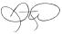

Diane Wood

Corporate Secretary

Important Notice Regarding the Availability of Proxy Materials for the Annual Meeting:

The Notice and Proxy Statement and Form 10-K Wrap are available at www.proxyvote.com.

- IF YOU HAVE NOT VOTED VIA THE INTERNET OR TELEPHONE, FOLD ALONG THE PERFORATION, DETACH AND RETURN THE BOTTOM PORTION IN THE ENCLOSED

ENVELOPE. ▼

D68752-P64991-Z81603

PROXY — Pinnacle West Capital Corporation

Notice of the 2022 Annual Meeting of Shareholders

Proxy Solicited on behalf of the Board of Directors for the Annual Meeting on May 18, 2022

The undersigned hereby appoints Jeffrey B. Guldner and Robert E. Smith, individually and together, as proxies for the undersigned, each with full power of substitution, to attend the Annual Meeting of Shareholders of Pinnacle West Capital Corporation (the "Company") to be held on May 18, 2022 at one-thirty p.m. (1:30 p.m.), Eastern Daylight Time, and at any adjournment or postponement thereof, and to vote as specified in this proxy all the shares of stock of the Company which the undersigned would be entitled to vote if personally present. The proxies of the undersigned may vote according to their discretion on any other matter that may properly come before the meeting.

If the undersigned has voting rights with respect to shares of Company common stock under the Pinnacle West Capital Corporation Savings Plan (the "Plan"), then the undersigned hereby directs the trustee of the Plan to vote the shares equal to the number of share equivalents allocated to the undersigned's account under the Plan on all matters properly coming before the Annual Meeting, and at any adjournment or postponement thereof, in accordance with the instructions given herein. Shares under the Plan for which instructions are not received by midnight on May 15, 2022, will be voted by the trustee in accordance with the plan and trust documents. This proxy will be considered to be confidential voting instructions to the Plan trustee and to any entity acting as tabulating agent for the Plan trustee.

ALL SHARES OF COMMON STOCK REPRESENTED HEREBY WILL BE VOTED AS SPECIFIED. IF NO SPECIFICATION IS MADE, THOSE SHARES WILL BE VOTED FOR THE NOMINEES LISTED IN PROPOSAL 1, FOR PROPOSALS 2 AND 3 AND AGAINST PROPOSAL 4.

In their discretion, the proxies are authorized to vote on such other matters as may properly come before the meeting or any adjournment or postponement thereof.

Address changes and comments can be sent to Pinnacle West's Shareholder Services Department: shareholderdept@pinnaclewest.com

(Items to be voted appear on reverse side.)

